**Chapter 5**

**Induction and Recursion（归纳和递归）**

**（5.1）Mathematical Induction（数学归纳法）**

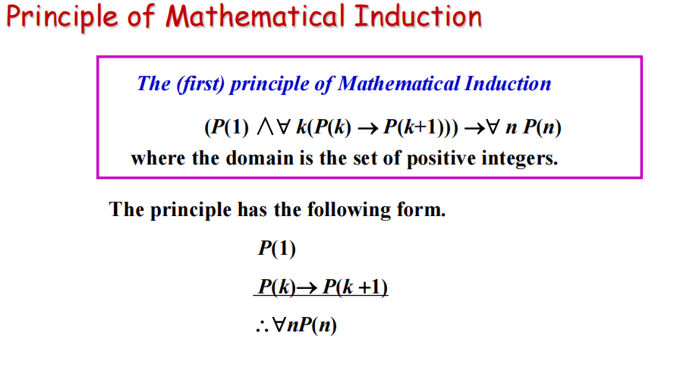

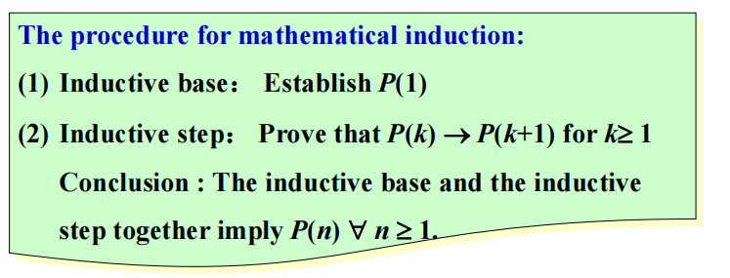

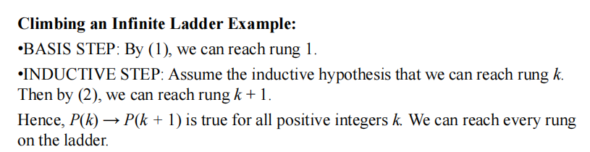

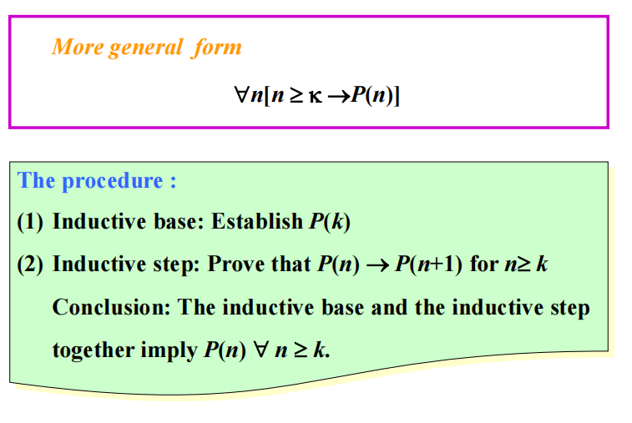

**The validity of mathematical induction follows from the well-ordering property （良序性）*.***

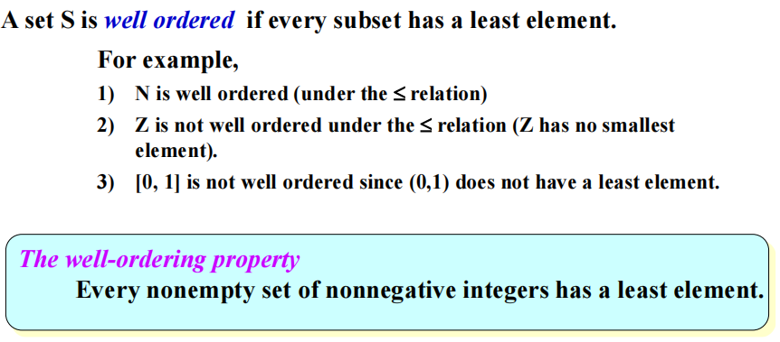

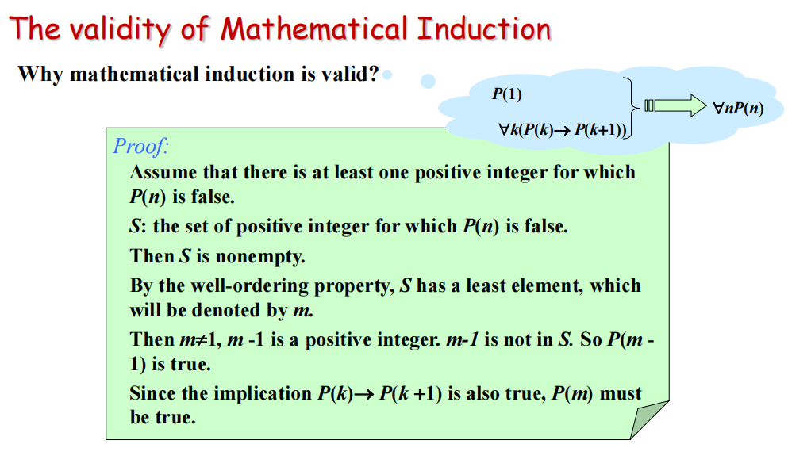

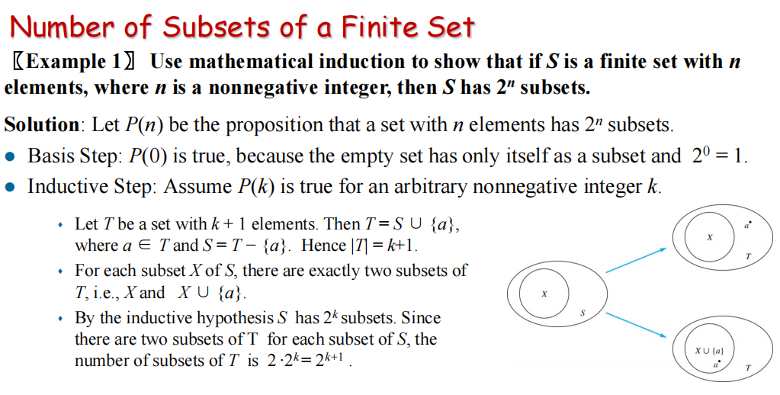

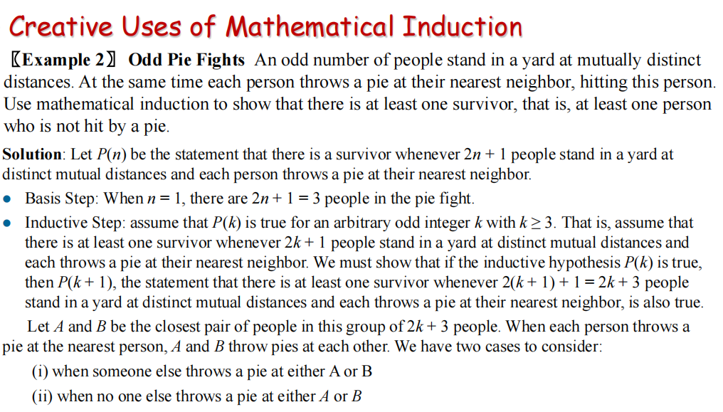

1. A和B互相扔，如果剩下2k+1的人有人扔向A或B，那么剩下2k+1个人最多只剩下2k个pie，那么必然至少有一个survivor
2. 剩下2k+1个人的情形符合前面的假设，成立。

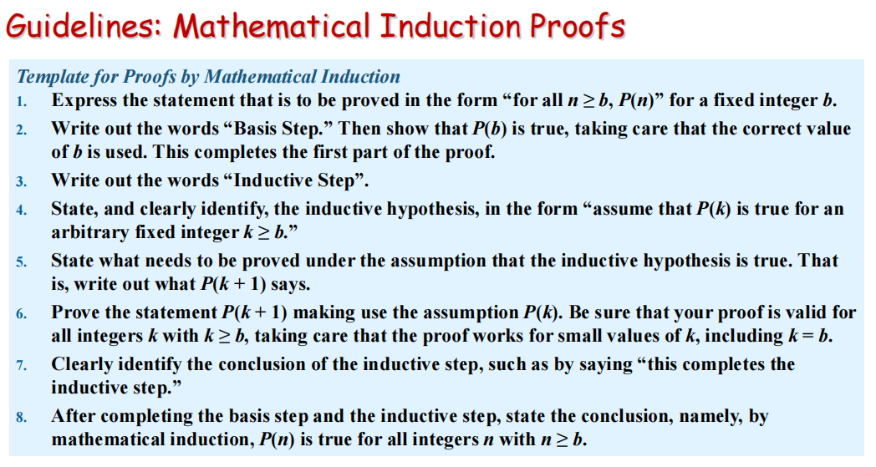

**（5.2）Strong Induction and Well-ordering**

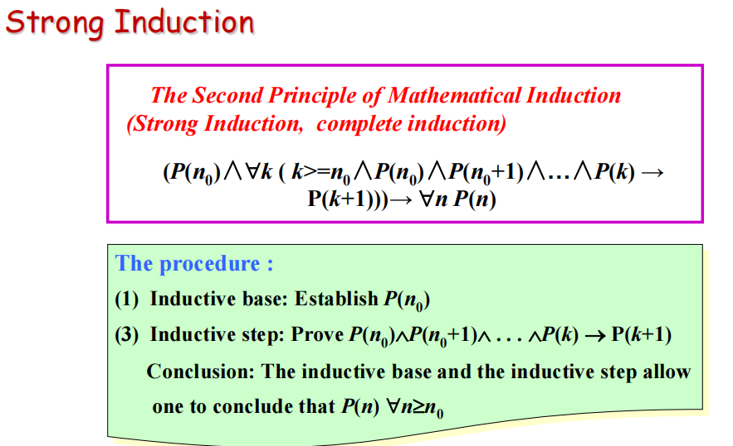

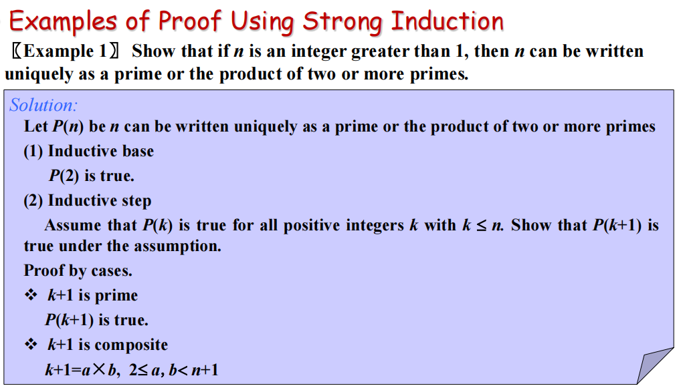

勘误：最后一行那个n+1是k+1

a,b<k+1 => a,b<=n => a,b can be written uniquely as a prime or the product of two or more primes，那么k+1=ab can be written uniquely as a prime or the product of two or more primes

**Some terms:**

● **polygon （多边形）**

● **side（边）, vertex（顶点）**

● **a polygon is simple**

● **Every simple polygon divides the plane into two regions: its interior, its exterior.**

● **convex（凸的）, nonconvex（凹的）**

● **diagonal（对角线）, interior diagonal** （内对角线）

● **triangulation（三角化）**

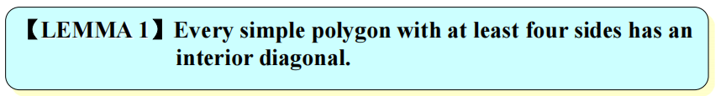

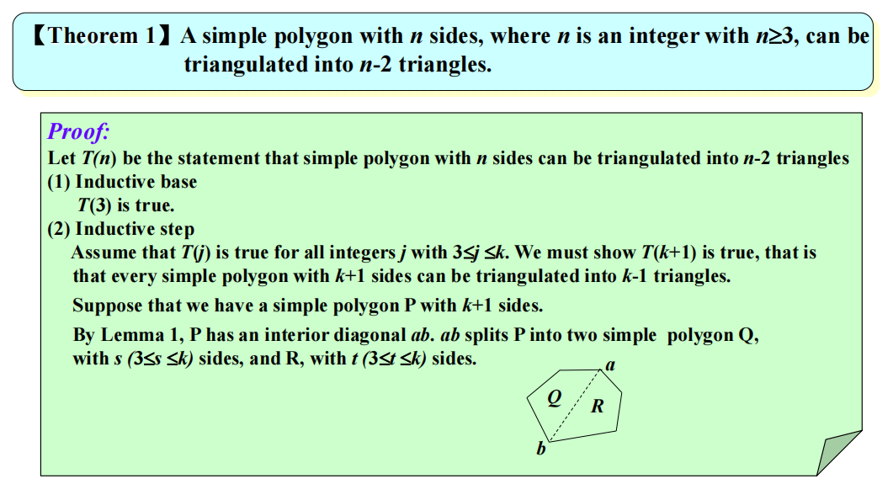

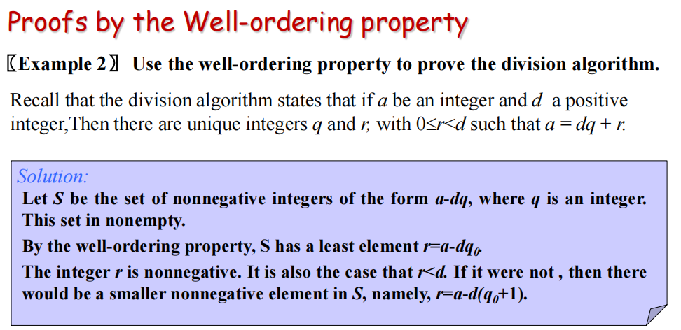

**（5.3）Recursive Definition and**

**Structural Induction（递归定义和结构归纳）**

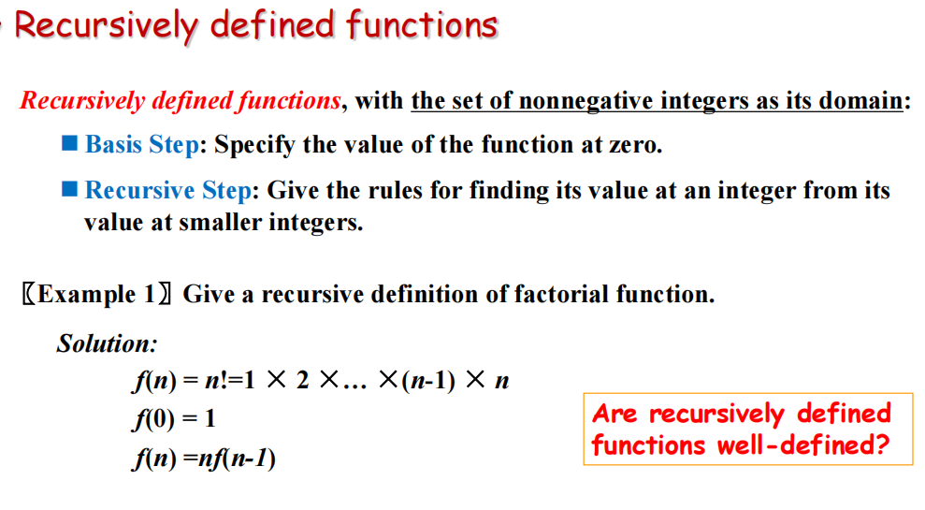

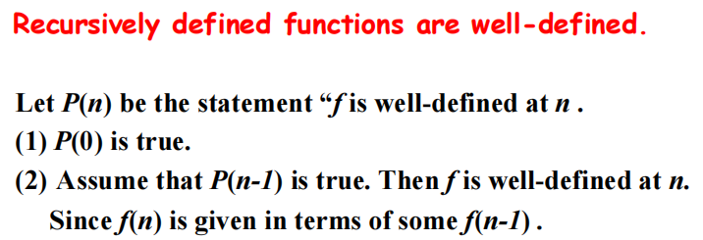

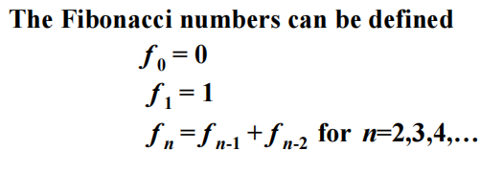

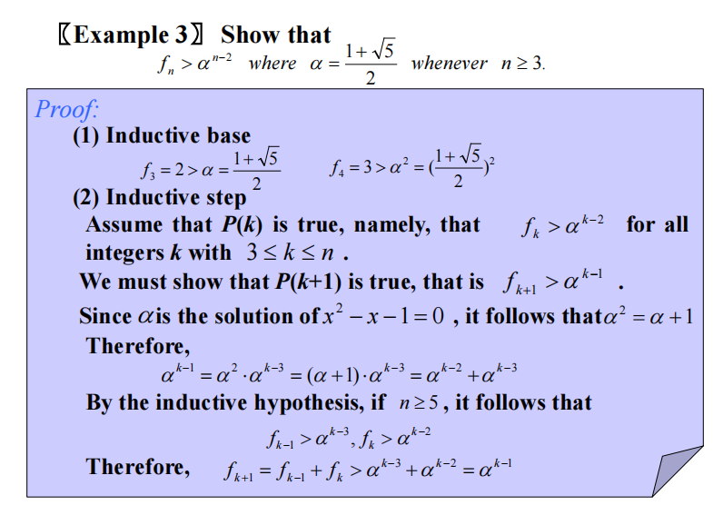

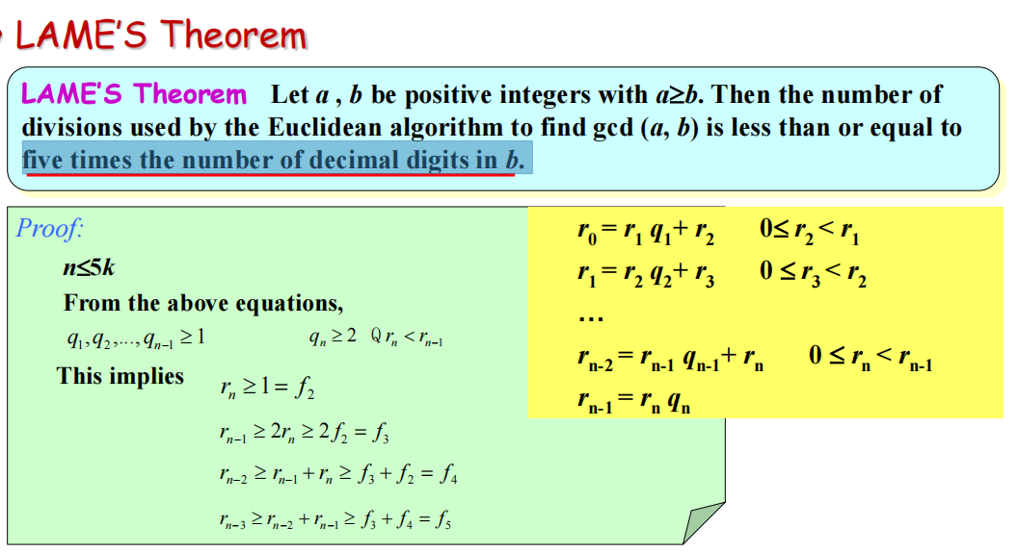

（b十进制位数的5倍）

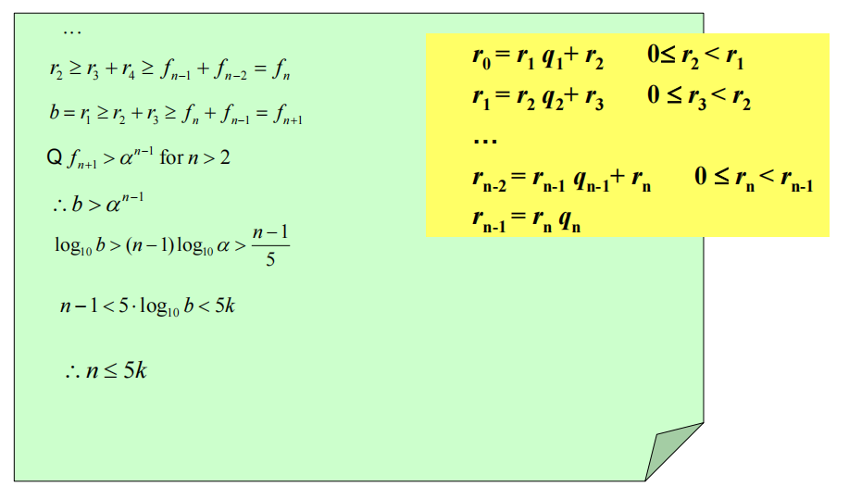

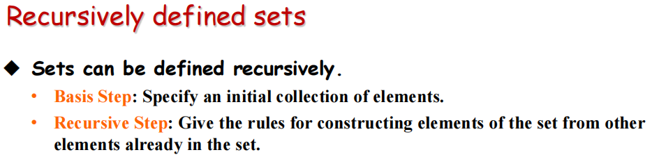

• Sometimes the recursive definition has an ***exclusion rule（排斥原则）***, which specifies that the set contains nothing other than those elements specified in the basis step and generated by applications of the rules in the recursive step.

• We will always assume that the exclusion rule holds, even if it is not explicitly mentioned.

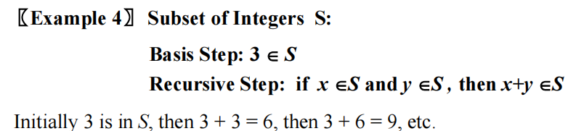

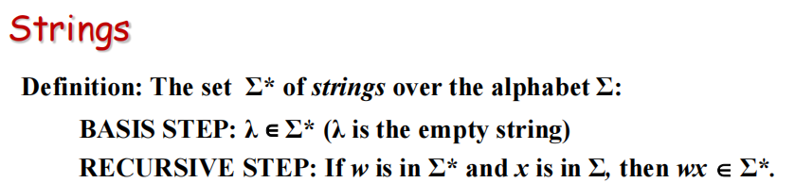

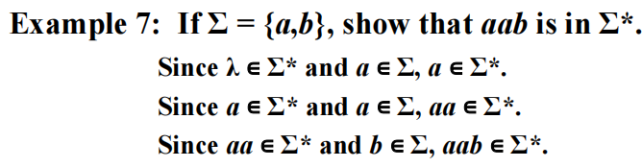

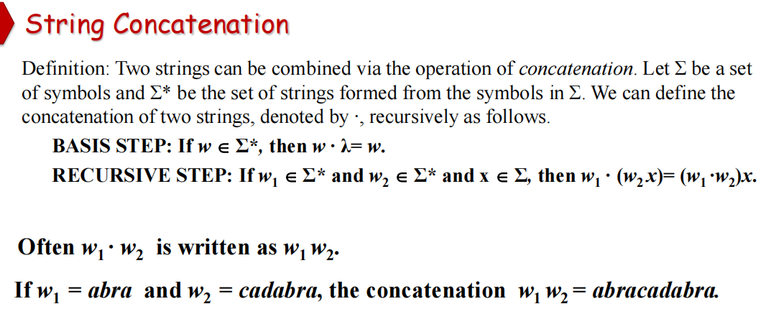

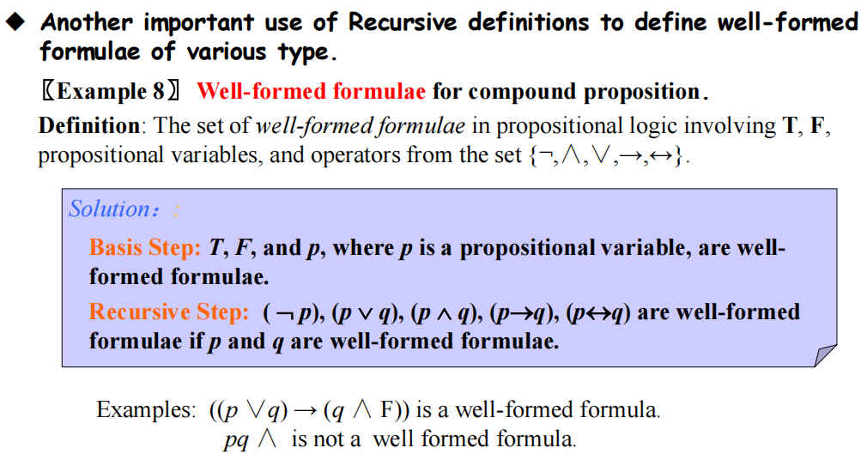

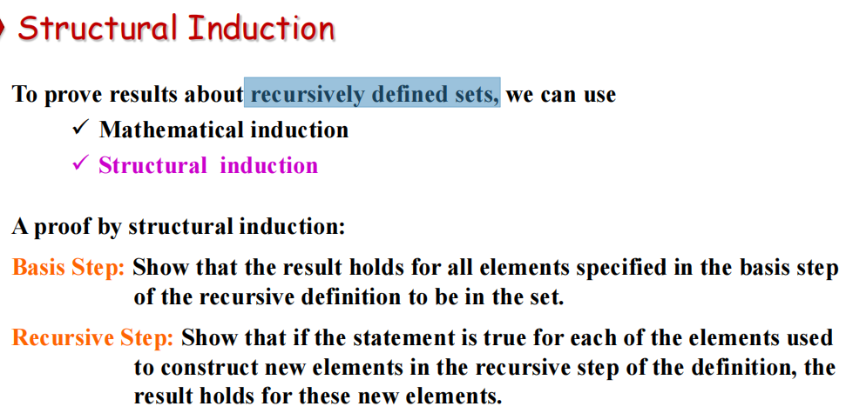

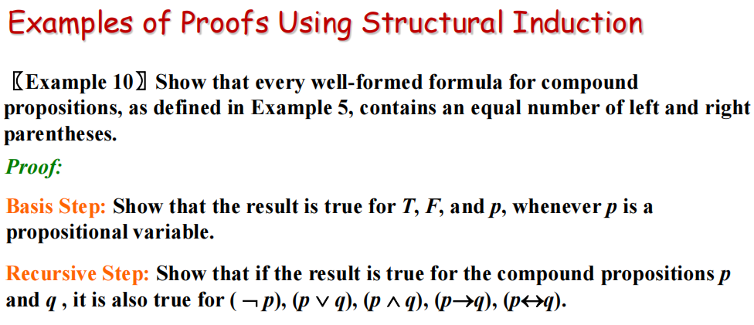

（well-formed：良定义，即对每个正整数，对应的函数值应该是清楚的）

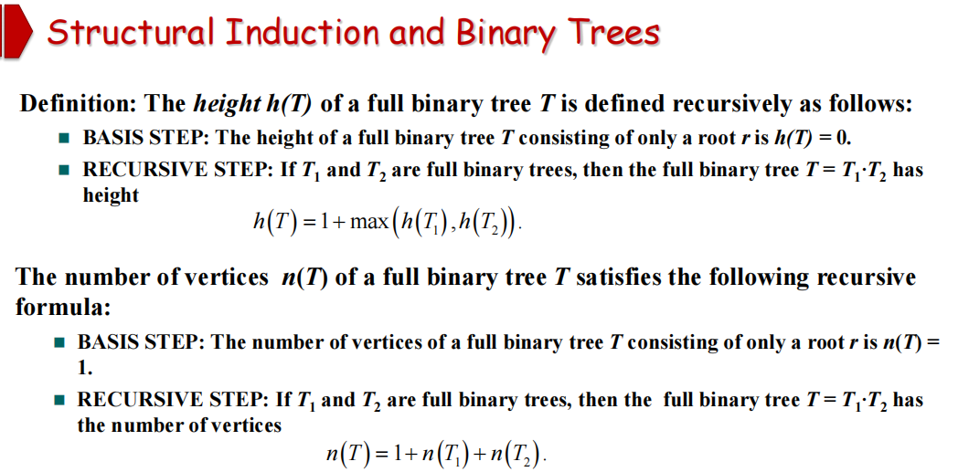

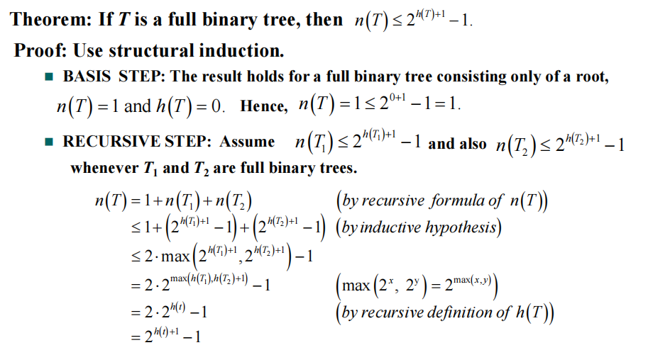

**（5.4）Recursive Algorithms**

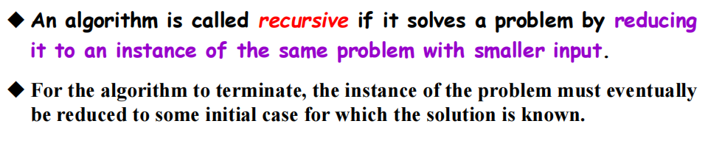

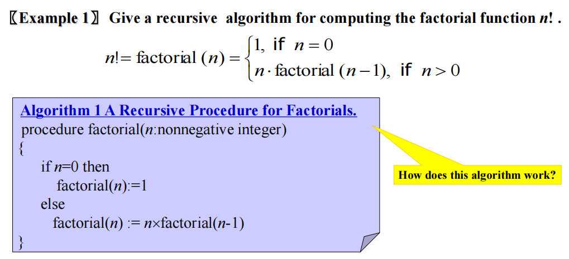

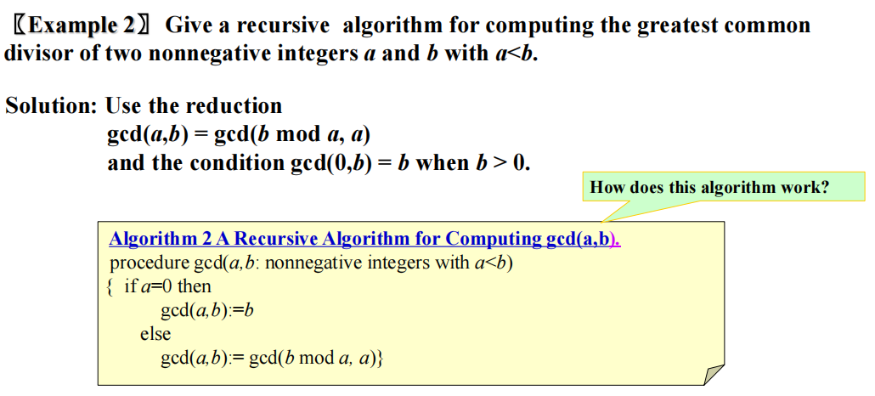

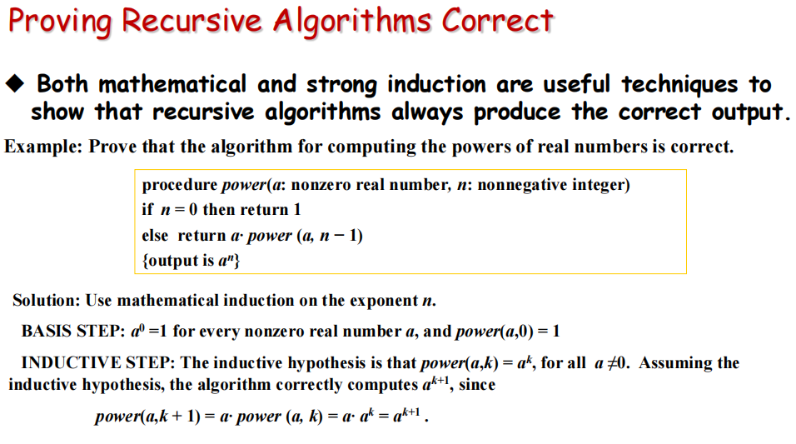

Recursion and Iteration（递归和迭代）

