 | TECHNICAL UNIVERSITY OF MOLDOVA  Faculty of Computers, Informatics, and Microelectronics  Department of Software Engineering  Software Engineering Study Programme

INTERNSHIP REPORT
RoadFix – Secure Mobile Application for Reporting Road Infrastructure Issues

Team members:

Student 1: | Augustin Carazanu, FAF-243 (team leader)
Student 2: | Vlad Buliga, FAF-243
Student 3: | Chiril-Adam Macari, FAF-243
Student 4: | Adrian Cojan, FAF-243
University Internship Mentor | GROSU Olga, univ. assist.

*By signing the cover page of this report, each student confirms their active involvement in both the development of the project and the writing of the report. Students who did not contribute meaningfully are not permitted to sign.

Submission date: ....... / ....... / ..............

Chisinau, 2026
TABLE OF CONTENTS
ABSTRACT 3
LIST OF ABBREVIATIONS 4
INTRODUCTION 5
1 DOMAIN AND SECURITY ANALYSIS 7
1.1 Problem domain and existing solutions 7
1.2 Users, use cases and MVP scope 9
1.3 Security analysis and security requirements 11
2 SYSTEM DESIGN 13
2.1 Architecture and technology stack 13
2.2 Data model and data flow 15
2.3 User interface design 17
3 IMPLEMENTATION AND SECURITY MEASURES 19
3.1 Live map and control of data exposure 19
3.2 Report submission and input validation 21
3.3 Report detail, staff dashboard and access control 23
3.4 Data layer, Firebase groundwork and authentication 24
4 TESTING, LIMITATIONS AND DEVELOPMENT PLAN 25
4.1 Testing of the implemented security measures 25
4.2 Limitations and development plan for October–December 27
CONCLUSIONS 29
REFERENCES 30
APPENDICES 32
APPENDIX A – Sequence diagram 32
APPENDIX B – Userflow diagram 33
Internship Summary Report_Augustin Carazanu 34
Internship Summary Report_Vlad Buliga 36
Internship Summary Report_Chiril-Adam Macari 38
Internship Summary Report_Adrian Cojan 40

ABSTRACT
This report presents the work carried out by a team of four students during the production internship at JCODE SOLUTIONS SRL (Chisinau, 1–26 September 2026) within the Development of Secure Applications (DAS) project-based learning module. The team defined, designed and started implementing RoadFix – an iOS application through which citizens of Chisinau report road infrastructure problems such as potholes, broken streetlights, damaged sidewalks and faded road markings, while municipal staff track each report until it is resolved.
The report describes the domain and security analysis of the application, including a STRIDE-based threat model and the prioritisation of security requirements for the first Minimum Viable Product (MVP). It then presents the system architecture based on Swift, SwiftUI, MapKit, CoreLocation and PhotosUI, with Firebase selected as the backend, together with the data model, the data flow and the user interface design.
The implemented MVP allows a citizen to submit a report with a category, a description, an optional photo and the current location, to browse all reports on a colour-coded live map, to open report details and to upvote reports, while a separate staff dashboard allows the status of each report to be changed. For every component the implemented security measure is documented according to the DAS format: security problem, relevance, implementation, testing and limitations. The measures covered in September are client-side input validation, restricted photo access, privacy-oriented location access, minimisation of personal data exposed on the public map and user-interface separation of the staff role. The report concludes with the test results, the remaining limitations and the development plan for October–December, which includes Firebase Authentication, Firestore Security Rules, role-based access control and location privacy improvements.
Keywords: secure mobile application, iOS, SwiftUI, input validation, role-based access control, location privacy, Firebase.

LIST OF ABBREVIATIONS

API | – Application Programming Interface
DAS | – Development of Secure Applications (Dezvoltarea aplicațiilor securizate)
EXIF | – Exchangeable Image File Format (photo metadata, may include GPS coordinates)
GPS | – Global Positioning System
HTTPS | – Hypertext Transfer Protocol Secure
IDOR | – Insecure Direct Object Reference
iOS | – Apple mobile operating system
MFA | – Multi-Factor Authentication
MVP | – Minimum Viable Product
OWASP | – Open Worldwide Application Security Project
PBL | – Project-Based Learning
RBAC | – Role-Based Access Control
SDK | – Software Development Kit
STRIDE | – Spoofing, Tampering, Repudiation, Information disclosure, Denial of service, Elevation of privilege
TLS | – Transport Layer Security
UI | – User Interface
UUID | – Universally Unique Identifier

INTRODUCTION
Road infrastructure problems are among the most visible issues of urban life. Potholes, non-working streetlights, cracked sidewalks and faded pedestrian crossings affect the safety of drivers, cyclists and pedestrians every day. In Chisinau such problems are usually reported by telephone, through messages to local authorities or in posts on social networks. These channels have three important weaknesses: a report rarely contains an exact location or a photo, the citizen receives no feedback about what happens after the report is sent, and the same problem is reported many times by different people without anyone seeing that it is already known.
The purpose of the project is to design and develop RoadFix, a secure iOS application that connects citizens and municipal services around a single, public map of road infrastructure problems. A citizen can create a report with a category, a short description, an optional photo and the current location, and can see all existing reports as colour-coded pins on the map. Municipal staff can review the reports and move each one through the statuses Reported, In Progress and Resolved, so that the progress of the work becomes visible to everyone.
Because the application collects personal data – the exact location of the reporter, photos taken on the reporter's device and free text – and because it has two roles with different permissions, security had to be considered from the first day of the project. The DAS guidelines [15] require that security is integrated in every stage of the development lifecycle and that, for every selected security measure, the team can explain the security problem, its relevance, the implementation, the testing method and the remaining limitations.
The internship took place from 1 to 26 September 2026 at JCODE SOLUTIONS SRL in Chisinau, under the guidance of the company mentor Viorel Iordăchiță. The team consisted of four students of the Software Engineering study programme:
– Augustin Carazanu (team leader) – data layer, Report model, ReportService, Firebase project set-up and coordination of the security documentation;
– Vlad Buliga – live map (MapView) and the tab structure of the application (ContentView);
– Chiril-Adam Macari – report submission (NewReportView, LocationManager) and contribution to the user interface design;
– Adrian Cojan – report detail view and staff dashboard (ReportDetailView, StaffDashboardView).
The tasks of the internship, as set in the internship programme, were the following:
– to choose a realistic MVP idea that can be extended after the internship;
– to analyse the application domain and identify the main security risks;
– to select the technologies, define the architecture and organise the project structure;
– to decide which security measures are necessary for the first MVP and which can be implemented later;
– to implement the essential functionality and several basic security controls;
– to test the implemented protections, document the limitations and prepare the development plan for October–December.
The report is organised in four chapters. Chapter 1 presents the domain analysis, the users and use cases, and the security analysis with the prioritised security requirements. Chapter 2 describes the architecture, the technology stack, the data model and the user interface design. Chapter 3 presents the implementation of each component together with the security measure it contains. Chapter 4 summarises the testing, the remaining limitations and the development plan. The sequence diagram of report submission and the user-flow diagram are included in the appendices.

1 DOMAIN AND SECURITY ANALYSIS
This chapter analyses the problem that RoadFix addresses, compares the idea with existing solutions, defines the users and the MVP scope, and identifies the main security threats together with the security requirements selected for the first version of the application.

1.1 Problem domain and existing solutions
The road infrastructure of a large city is maintained by municipal services that need two kinds of information: where a problem is and how urgent it is. Citizens are the people who notice problems first, because they use the streets every day, but the communication between citizens and the responsible services is usually informal. A telephone call or a social network post describes the problem in words ("a big hole near the park"), the location is approximate, there is often no photo, and the report cannot be followed after it is sent. As a result, the municipal services receive incomplete and duplicated information, and citizens have the impression that nothing happens.
Similar problems have been addressed in other countries by civic reporting platforms. FixMyStreet, developed by mySociety in the United Kingdom, lets citizens place a pin on a map and sends the report to the responsible council [12]. SeeClickFix, used by many municipalities in the United States, combines public reports with an internal work-order system for city staff [13]. These platforms confirm that the map-based approach is useful, but they are not integrated with the municipal services of Chisinau and are not adapted to the local context. Table 1.1 compares the current reporting channels and existing platforms with the approach chosen for RoadFix.
Table 1.1 – Comparison of reporting channels
Criterion | Phone call / social network post | Existing platforms (FixMyStreet, SeeClickFix) | RoadFix (proposed)
Exact location | No, described in words | Yes, pin on a map | Yes, device location captured automatically
Photo evidence | Sometimes | Yes | Yes, attached from the photo library
Visible progress | No | Yes | Yes, three colour-coded statuses
Duplicate detection | No | Partial | Existing reports visible on the map, upvote instead of a new report
Local integration (Chisinau) | Partial | No | Designed for municipal staff of Chisinau
Privacy of the reporter | Name or profile often public | Depends on platform | Reporter identity never shown on the public map

The comparison shows that the main value of RoadFix is the combination of an exact location, photo evidence and visible progress in a single mobile application, while keeping the identity of the reporter private. The last criterion is important from a security and privacy point of view: a public map of reports that shows who reported what and from where would expose the movements of citizens and could discourage people from reporting problems near their home.
The domain also defines the main constraints of the project. The application must work on a mobile device, because problems are noticed on the street; it must be simple enough to create a report in less than a minute; it must work with the location and camera permissions of iOS, which are strictly controlled by the operating system; and it must separate the actions of citizens from those of municipal staff, because only the responsible services may change the status of a report. These constraints directly influenced the choice of a native iOS application and the security requirements presented in subchapter 1.3.

1.2 Users, use cases and MVP scope
Two user roles were defined for RoadFix. The citizen is any resident who notices a problem and wants to report it or to see what has already been reported. The municipal staff member is an employee of the responsible service who reviews reports and updates their status. The two roles have different permissions, which makes the application a natural candidate for role-based access control. The use cases of both roles are shown in Figure 1.1.
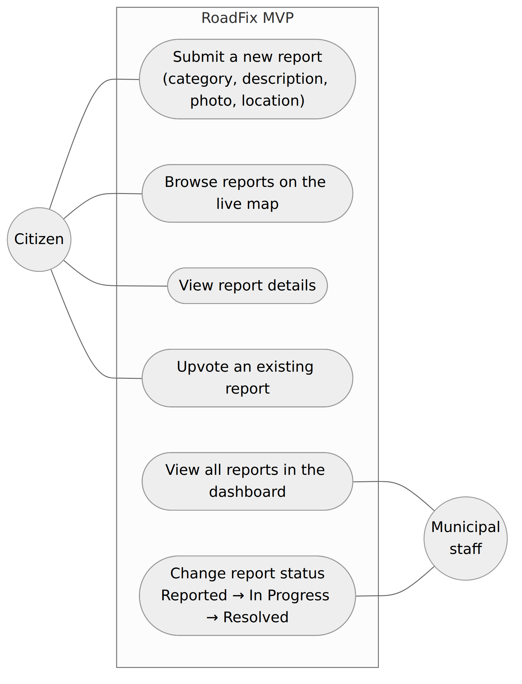
Figure 1.1 – Use case diagram of the RoadFix MVP
The functional requirements derived from the use cases are summarised in Table 1.2. They define the scope of the September MVP; all of them are implemented in the current version of the application, with data stored locally until the Firebase backend is connected.
Table 1.2 – Functional requirements of the MVP
ID | Requirement | Role | Status
FR-1 | Display all reports on a map as pins colour-coded by status (red – Reported, orange – In Progress, green – Resolved). | Citizen | Done
FR-2 | Open the details of a report by tapping its pin (photo, category, description, status, date). | Citizen | Done
FR-3 | Upvote an existing report instead of creating a duplicate. | Citizen | Done
FR-4 | Create a report with category, description, optional photo and current location. | Citizen | Done
FR-5 | List all reports in a staff dashboard. | Staff | Done
FR-6 | Change the status of a report: Reported → In Progress → Resolved. | Staff | Done
FR-7 | Sign in and store reports in a shared online database. | Both | In progress

Several features were deliberately left outside the MVP scope: user accounts with profiles, push notifications about status changes, comments on reports, statistics for municipal services and an administration panel. These features are useful, but they do not change the core idea of the application and would have reduced the time available for the security work required by the DAS module. User accounts are the exception – authentication is a prerequisite for server-side access control and is therefore the first item of the October plan.

1.3 Security analysis and security requirements
The security analysis started by identifying the assets of the application: the location of the reporter, the photo attached to a report, the free-text description, the identifier of the reporter, the status of each report and the availability of the service itself. The threats to these assets were then classified using the STRIDE model [10], which groups threats into six categories. Table 1.3 presents the threats identified for RoadFix, their risk level and the selected mitigation.
Table 1.3 – STRIDE threat model of RoadFix
Category | Threat in RoadFix | Risk | Mitigation
Spoofing | Anyone can submit reports or act as a staff member, because there is no authentication yet. | High | Firebase Authentication; staff accounts created only by an administrator.
Tampering | A modified client sends malformed reports or changes fields it should not change. | High | Client-side validation now; Firestore Security Rules validate every write.
Repudiation | A status change cannot be attributed to a specific staff member. | Medium | Store the staff identifier and time of every status change.
Information disclosure | The public map reveals who reported a problem and from exactly where; photos may contain GPS metadata. | High | reporterId never displayed; photo metadata removed before upload; location rounding.
Denial of service | Automated submission of many reports or very large uploads. | Medium | Length and size limits, Firebase App Check, rate limiting.
Elevation of privilege | A citizen reaches the status control of the staff dashboard. | High | UI separation now; RBAC enforced by custom claims and Security Rules.

The threat model shows that the highest risks are related to authentication, integrity of the data and disclosure of personal information. These risks are also present in the OWASP Mobile Top 10 [8] and in the verification requirements of OWASP MASVS [9], in particular insufficient input/output validation, insecure authentication and authorisation, and inadequate privacy controls. Based on this analysis, the following security requirements were formulated:
– SR-1: every report must be validated before it is accepted (required fields, allowed categories, maximum length);
– SR-2: only image files may be attached, and the application must not receive access to the whole photo library;
– SR-3: location must be requested only when a report is created, never tracked in the background;
– SR-4: the identity of the reporter must never be visible to other users;
– SR-5: only staff members may change the status of a report;
– SR-6: all communication with the backend must be encrypted in transit and stored data must be encrypted at rest;
– SR-7: the service must be protected against automated abuse.
Not all requirements could be implemented in four weeks. Following the DAS guidelines, the team selected the measures that protect the parts of the application built in September and planned the remaining ones for October–December. Table 1.4 presents this prioritisation.
Table 1.4 – Prioritisation of security measures
Security measure | Req. | September MVP | October–December
Input validation of reports | SR-1 | Client-side gate on Submit | Firestore Security Rules
Secure photo upload | SR-2 | Image-only picker, in-memory image | Size/type limits, metadata stripping
Privacy-oriented location access | SR-3 | "When In Use", single request | Reduced accuracy for storage
Data exposure minimisation | SR-4 | No reporterId on map or detail | Location rounding (~50 m)
Role-based access control | SR-5 | Separate Staff tab (UI only) | Custom claims + write rules
Authentication | SR-5 | Firebase project configured | Firebase Auth, MFA for staff
Encryption in transit / at rest | SR-6 | TLS by Firebase SDK (by design) | Google Cloud default encryption
Anti-abuse protection | SR-7 | – | App Check, rate limiting

2 SYSTEM DESIGN
This chapter presents the design decisions taken in the second week of the internship: the architecture of the application, the technology stack, the data model and data flow, and the design of the user interface. Security principles – least privilege, data minimisation and defence in depth – were considered in each of these decisions.

2.1 Architecture and technology stack
RoadFix is a native iOS client connected to a managed cloud backend. The client is organised in two layers, as shown in Figure 2.1. The presentation layer consists of SwiftUI views [4], one for each screen of the application. The service and model layer contains the Report model, the ReportService class, which holds the list of reports and exposes operations such as submitting, upvoting and changing the status, and the LocationManager class, which wraps CoreLocation. All views share a single ReportService instance, so a change made in one screen – for example a new report or a new status – is immediately visible in the others.
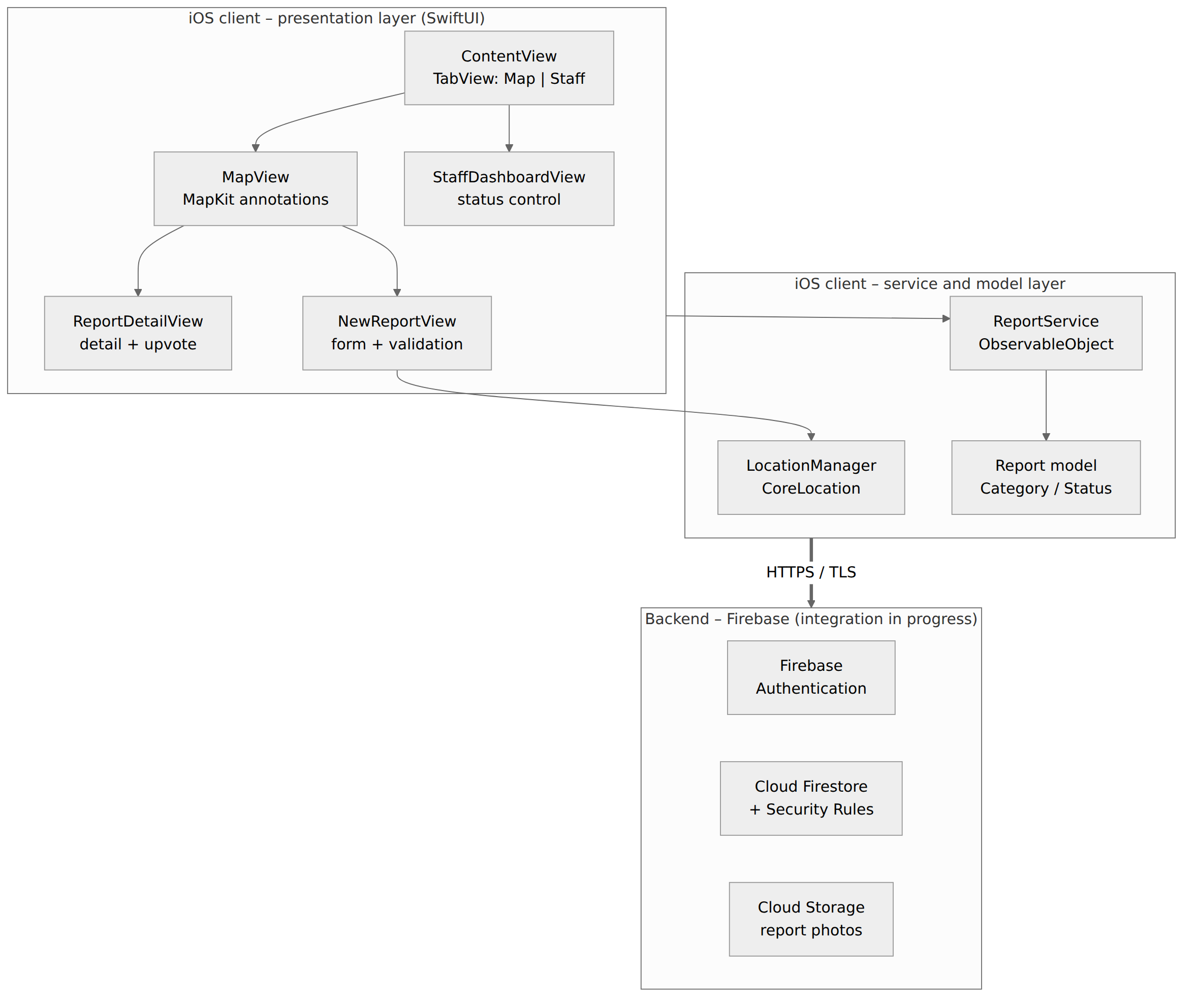
Figure 2.1 – Architecture of the RoadFix application
The backend is Firebase: Firebase Authentication for user accounts, Cloud Firestore for reports and Cloud Storage for photos. The Firebase project has already been created and the iOS application registered in it; the connection of the client to the backend is currently being implemented. Until it is finished, ReportService works with in-memory sample data, and its methods keep the same signatures, so the views do not need to change when the backend is connected. The technologies and the reason for choosing each of them are listed in Table 2.1.
Table 2.1 – Technology stack
Technology | Use in RoadFix | Reason for selection
Swift, SwiftUI | Language and UI framework of the client | Native performance, declarative UI, memory safety of Swift
MapKit | Live map with report annotations | Native maps without extra SDK or API key [3]
CoreLocation | Location of a new report | Fine-grained permission model controlled by iOS [1]
PhotosUI (PhotosPicker) | Attaching a photo | Runs out of process, gives access only to selected items [2]
Firebase Auth, Firestore, Storage | Accounts, reports, photos | Security Rules, TLS and encryption at rest by default [5], [14]
Xcode, iOS Simulator, GitHub | Development, testing, version control | Standard iOS tooling; shared repository and code review

The choice of Firebase was driven mainly by security. Firestore Security Rules allow every read and write to be checked on the server against the identity and role of the user and against the content of the document [5]. This is where the client-side checks of September become a real security boundary. The Firebase SDK communicates only over HTTPS with TLS, which covers encryption in transit, and Google Cloud encrypts stored data by default [14]. In the Firebase configuration of the project, analytics and advertising identifiers are disabled, so no additional tracking data is collected about citizens.
The project is organised by feature: one Swift file for each screen (MapView, NewReportView, ReportDetailView, StaffDashboardView), one for the tab container (ContentView), and separate files for the model (Report), the service (ReportService) and the location wrapper (LocationManager). Each team member worked on a separate feature branch in the shared GitHub repository, and the branches were merged into the main branch after a review by the team.

2.2 Data model and data flow
All the information of the application is organised around a single entity, the report. Its fields, together with their sensitivity and the place where they are displayed, are presented in Table 2.2. Classifying the fields in this way made it clear which data must never leave the backend and which data can be shown publicly.
Table 2.2 – Fields of the Report model
Field | Type | Sensitivity | Visibility
id | UUID | Low | Internal identifier
category | ReportCategory (5 values) | Low | Map, detail, dashboard
description | String | Medium (free text) | Detail, dashboard
photoURL / localImage | String / UIImage | High (may contain metadata) | Detail
latitude, longitude | Double | High (personal location) | Map position only
status | ReportStatus (3 values) | Low | Map colour, detail, dashboard
upvoteCount | Int | Low | Detail
reporterId | String | High (identity) | Never shown in the UI
createdAt | Date | Low | Detail

The categories and statuses are defined as Swift enumerations (ReportCategory and ReportStatus). Using enumerations instead of free strings is a simple secure-coding measure: the client can only produce one of the known values, and the same list of allowed values will be enforced in the Firestore Security Rules. Each category also defines its own icon, which is reused on the map, in the form and in the dashboard.
Figure 2.2 shows the data flow of a report and the trust boundaries of the system. The citizen's device is treated as untrusted: the application running on it can be modified, so any check performed there improves usability but does not guarantee security. The backend is the trusted zone in which validation and access control must be enforced. The public view – the map – receives only the fields that are needed to display a pin.
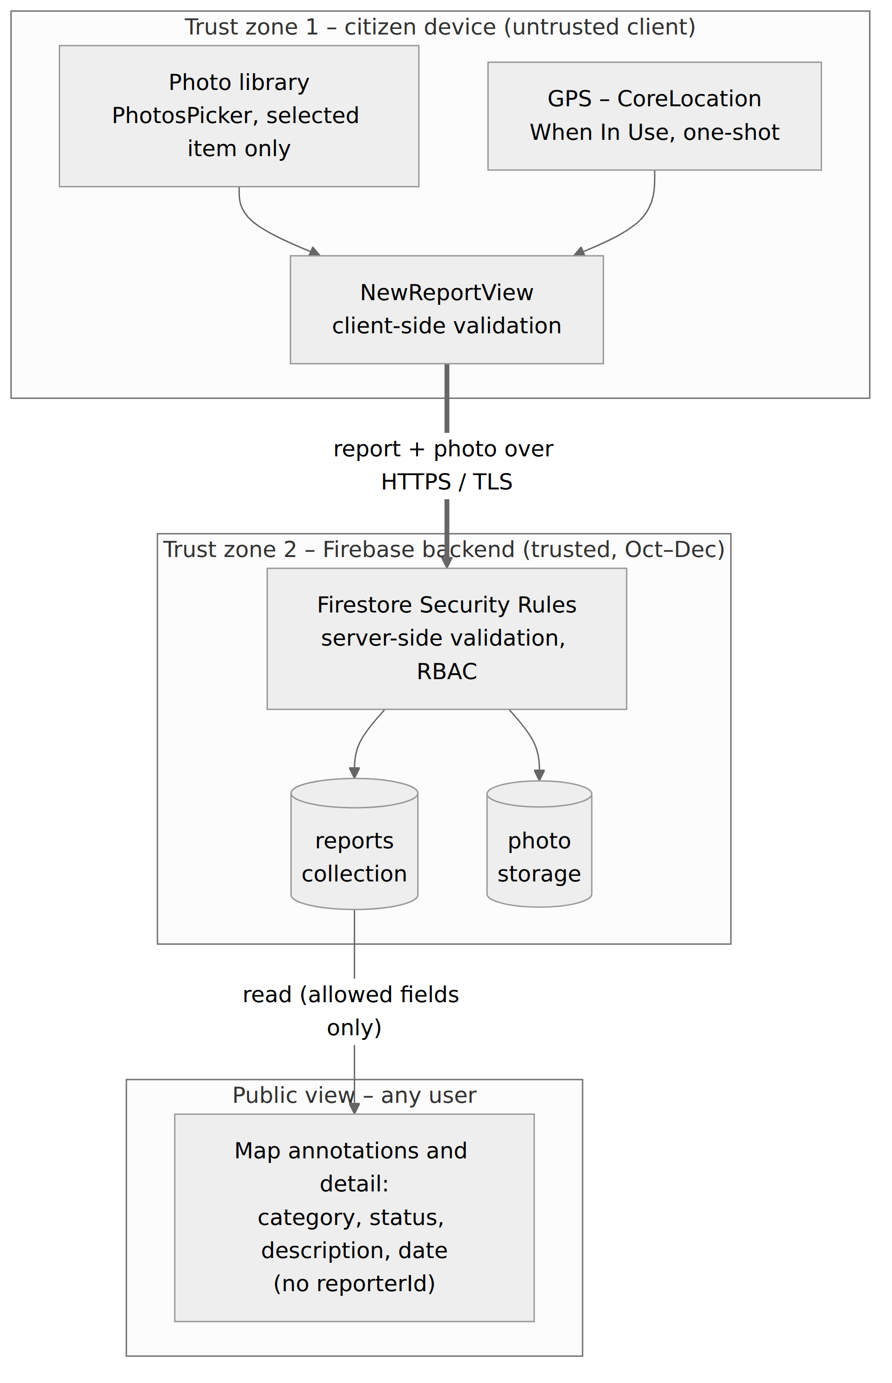
Figure 2.2 – Data flow and trust boundaries of a report
Two data sources on the device require particular attention. The location comes from CoreLocation and is requested only once, when the New Report form is opened. The photo comes from the photo library through PhotosPicker, which returns only the item selected by the user. The photo picker of iOS explicitly shows that location metadata is included in the selected photo (Figure 2.5); for this reason the photo must be re-encoded without metadata before it is uploaded, which is part of the October plan.

2.3 User interface design
The user interface was designed by the whole team during the second week, with the goal that a report can be created in less than a minute. The main screen is the live map (Figure 2.3, a), because the map is both the way to discover existing problems and the starting point for new reports. Each report is shown as a pin with the icon of its category, and the colour of the pin shows the status: red for Reported, orange for In Progress and green for Resolved. The same three colours are used in the status badges of all other screens, so the user learns them only once. A floating "+" button in the bottom-right corner opens the New Report form, and a tab bar at the bottom switches between the Map and Staff tabs.
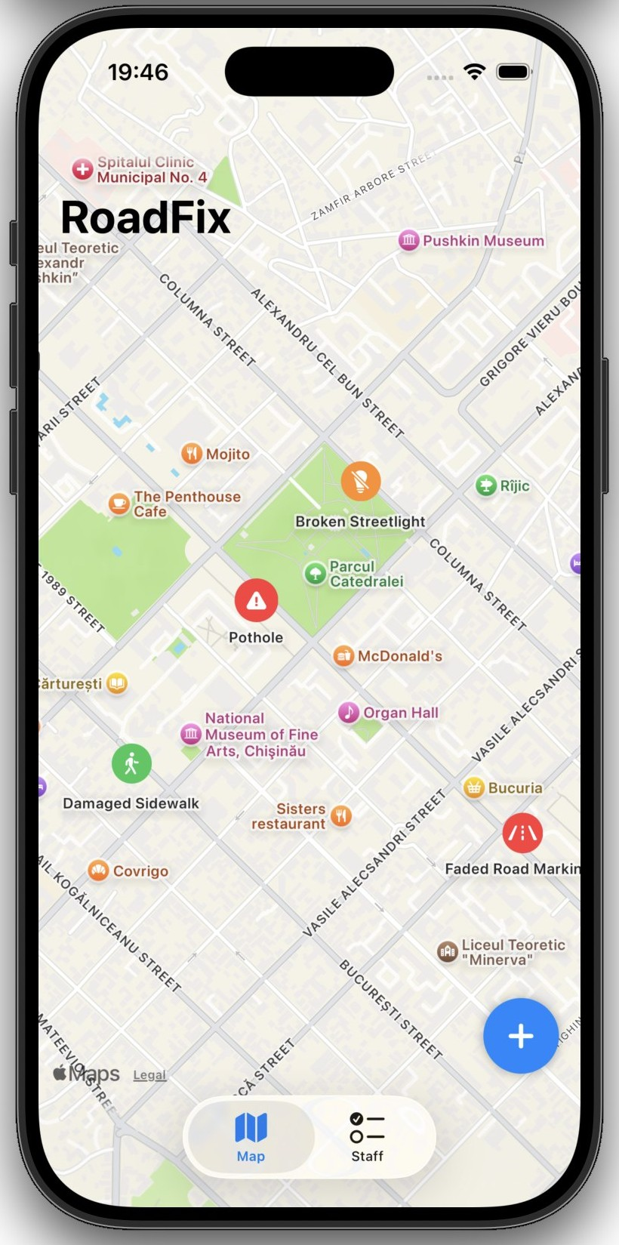 | 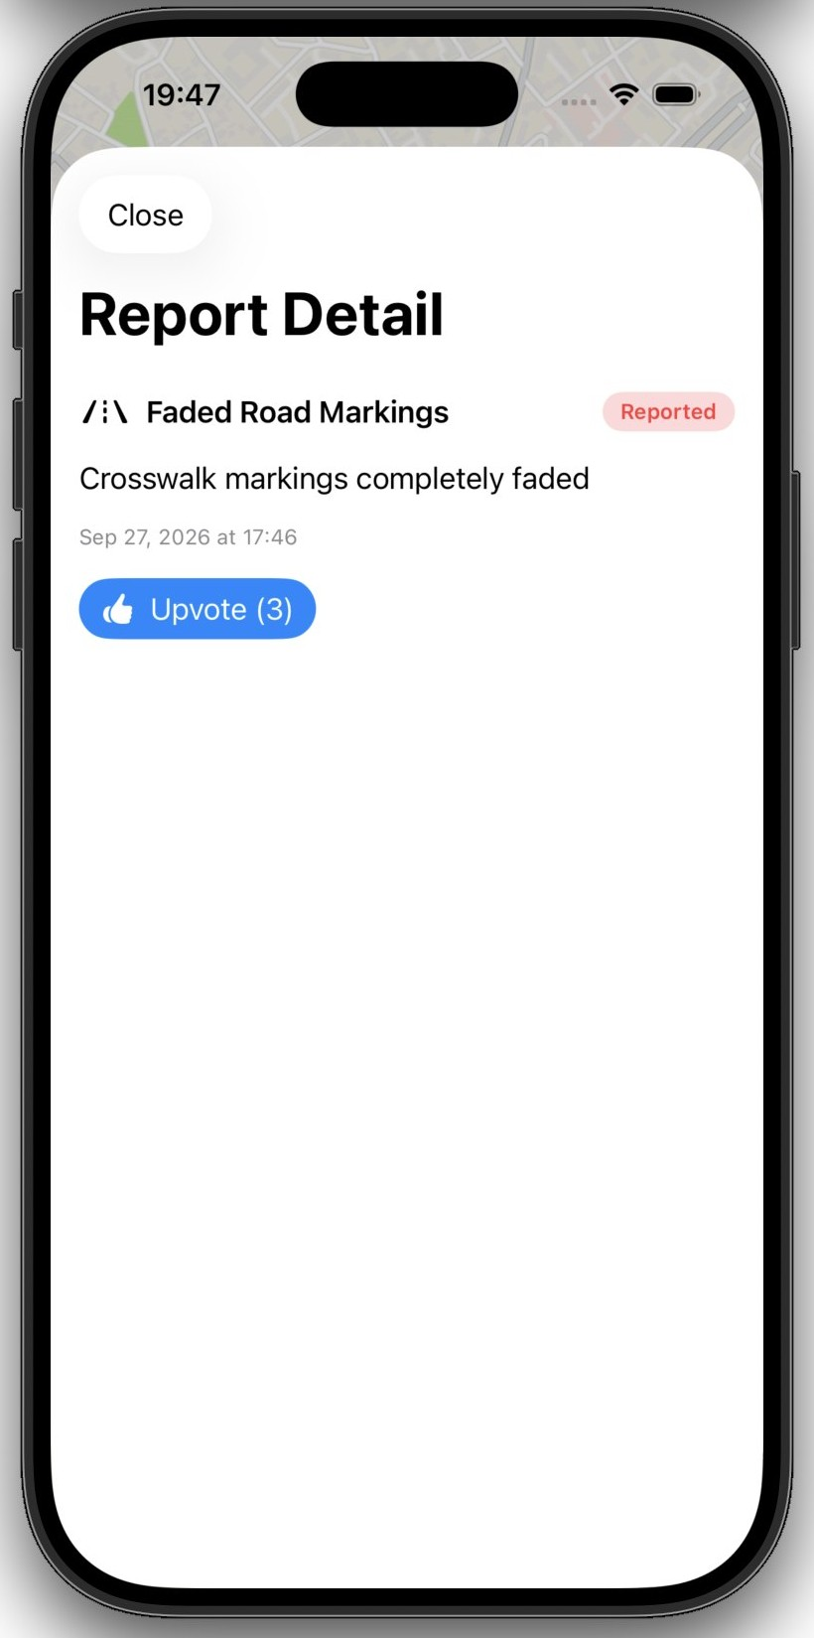
a) | b)
Figure 2.3 – Live map (a) and report detail (b)
Tapping a pin opens the report detail as a sheet (Figure 2.3, b). The detail shows the category, the status badge, the description, the date of creation and an Upvote button. By design, the detail does not show who created the report. The New Report form (Figure 2.4, a) is divided into four sections – Photo, Category, Description and Location – with Cancel and Submit in the toolbar. The Submit button is greyed out until the form is valid. The staff dashboard (Figure 2.4, b) lists all reports with a segmented control for the three statuses.
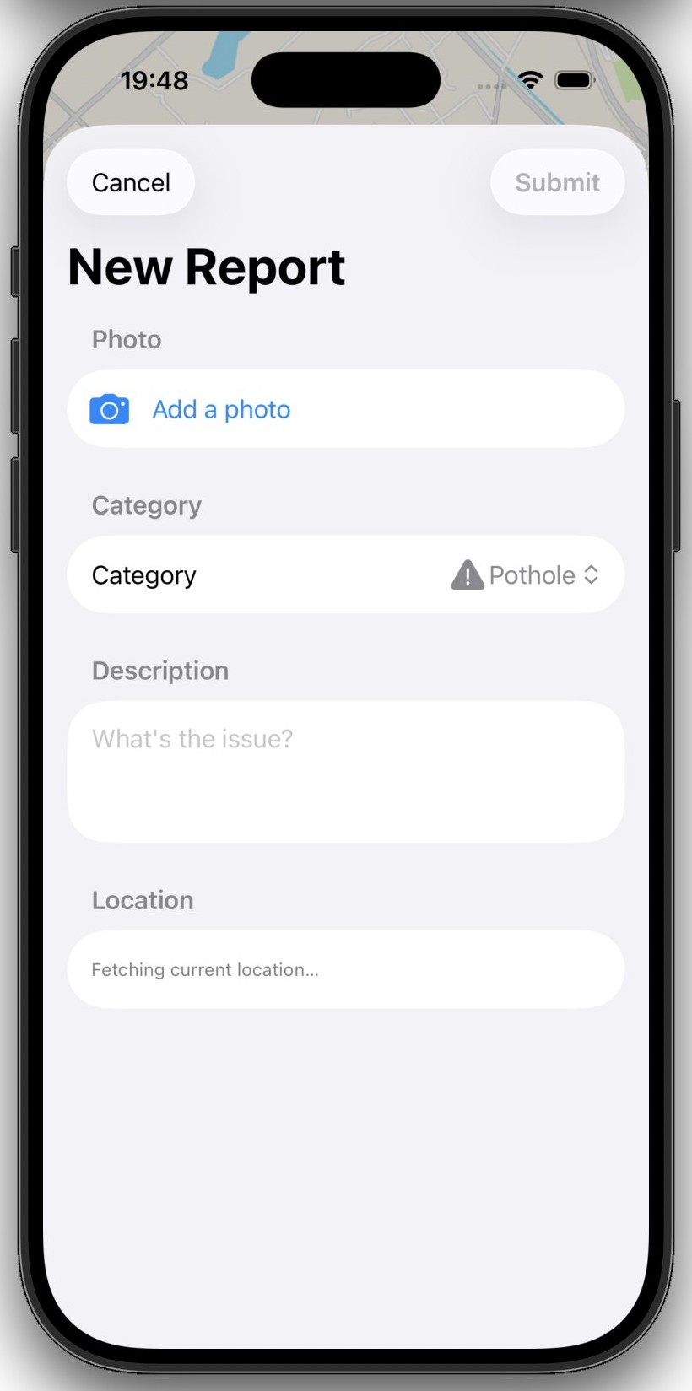 | 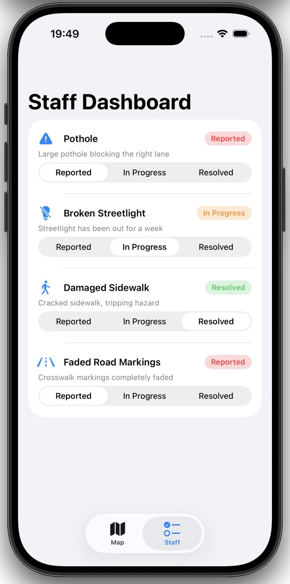
a) | b)
Figure 2.4 – New Report form (a) and staff dashboard (b)
The interface follows the standard iOS components – Form, Picker, sheets, TabView and segmented controls – so that it is familiar to iPhone users and automatically supports accessibility features such as Dynamic Type and VoiceOver. System components also have a security benefit: the photo picker and the location permission prompt are provided by iOS and cannot be imitated or bypassed by the application.

3 IMPLEMENTATION AND SECURITY MEASURES
This chapter describes the implementation of the four components of the MVP. Each component was developed by one team member and contains at least one security measure, which is explained using the five points required by the DAS guidelines: security problem, relevance, implementation, testing and limitations [15]. The distribution of the work is summarised in Table 3.1.
Table 3.1 – Components and security measures by team member
Team member | Component and files | Security topic | Security measure
Vlad Buliga | Live map – MapView.swift, ContentView.swift | Data exposure | No reporter identity on the public map
Chiril-Adam Macari | Report submission – NewReportView.swift, LocationManager.swift | Input validation, secure file upload, privacy | Validation gate, image-only picker, one-shot location
Adrian Cojan | Detail and dashboard – ReportDetailView.swift, StaffDashboardView.swift | Access control (RBAC) | Status control available only in the Staff tab
Augustin Carazanu | Data layer – Report.swift, ReportService.swift, Firebase | Authentication, encryption, database security | Backend design with Security Rules and TLS

3.1 Live map and control of data exposure
The live map was implemented by Vlad Buliga in MapView.swift using the SwiftUI Map API of MapKit [3]. For each report in ReportService an Annotation is created at the coordinate of the report. The label of the annotation is the category name, and its content is a circular button with the category icon on a background whose colour depends on the status. Tapping the button stores the selected report and opens ReportDetailView as a sheet. The floating "+" button that opens the New Report form and the TabView that separates the Map and Staff tabs (ContentView.swift) are also part of this component.
Security problem. A public map is a view that any user of the application can open. If it displayed the identity of the reporter or linked each report to a user profile, anyone could find out which citizen reported which problem and, indirectly, where this person was at a given time. This is an information disclosure threat and a privacy risk for citizens.
Relevance. Every report contains the exact location where the citizen was when creating it, and many reports are made near the reporter's home or workplace. Combining several reports of the same person would reveal their daily routes. Such exposure would also discourage people from reporting problems, which contradicts the purpose of the application.
Implementation. The annotation and the detail view use only the fields category, status, description, date and upvote count. The field reporterId exists in the model, because the backend needs it to check who may edit a report, but it is never passed to any view. The principle applied is data minimisation [11]: each screen receives only the data it needs to display.
Testing. Several sample pins with different categories and statuses were opened on the simulator, and it was confirmed that the detail shows only category, description, status, date and upvote count, and never the identity of the reporter (Figure 2.3, b). The colour of each pin was checked against its status after status changes in the staff dashboard.
Limitations. The coordinates of the pins are still the exact GPS points of the reports. Even without a name, an exact location can identify a person, for example when a report is created in front of a private house. The planned improvement is to round or "fuzz" the displayed coordinates to about 50 m, which is precise enough to find a pothole but not to identify a house entrance. When the backend is connected, the Firestore rules must also make sure that reporterId is not readable by other users, since hiding a field in the interface does not prevent a modified client from reading it.

3.2 Report submission and input validation
The report submission component was implemented by Chiril-Adam Macari in NewReportView.swift and LocationManager.swift. The form is presented as a sheet from the map and contains four sections. The Photo section uses PhotosPicker restricted to images; the selected item is loaded asynchronously with loadTransferable, converted to a UIImage and kept in memory, with a preview in the form. The Category section is a Picker over all values of ReportCategory. The Description section is a multi-line text field. The Location section shows the coordinates or the message "Fetching current location…" while no location is available.
LocationManager wraps CLLocationManager. When the form appears, it asks for "When In Use" authorisation and requests a single location fix with requestLocation(). The location is requested again only after the user grants the permission, and the result is published to the form through the currentLocation property. No continuous location updates are started, and the application never asks for background ("Always") location.
Security problem. The submission form is the main place where users send data into the system, so it is the largest input and abuse surface of the application: empty or meaningless reports, extremely long texts, unexpected file types, repeated submissions and collection of more personal data than necessary.
Relevance. Every accepted report is shown on a public map and handled by municipal staff. Invalid or spam reports would reduce the trust in the map and waste the time of the services, and uploaded files are one of the most common attack vectors in applications that accept user content [8].
Implementation. Three measures were implemented. First, a validation gate, following the principle that input is validated as early as possible [16]: the Submit button is disabled while the description is empty, while no location has been received and while a submission is already in progress; the isSubmitting flag prevents duplicate reports from repeated taps. Second, secure file selection: PhotosPicker with the filter .images makes it impossible to select other file types, in line with the recommendation to accept only the file types that are strictly needed [17], and because the picker runs outside the application process, RoadFix receives only the selected photo and never access to the whole photo library [2]. Third, privacy-oriented location access: location is requested only when a report is created, with the least permissive authorisation that is sufficient [1].
Figure 3.1 shows the form in the state where no location is available: the Submit button remains disabled. It also shows the system photo picker, which informs the user that RoadFix can access only the selected items.
 | 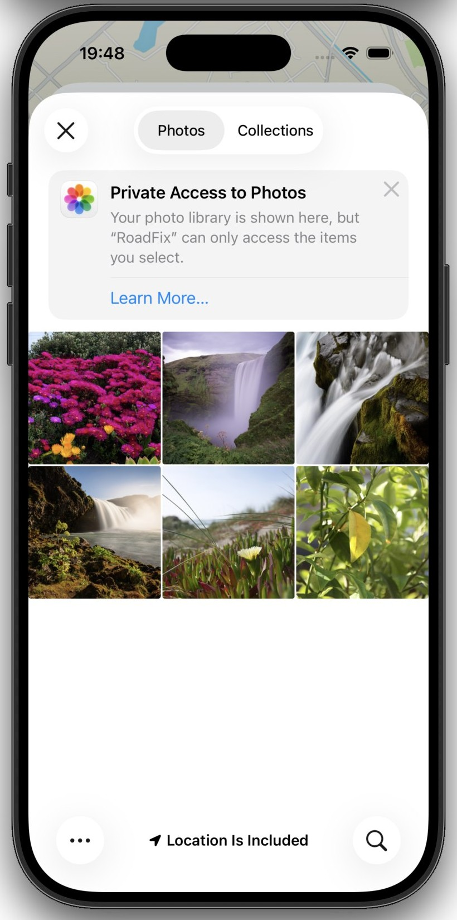
a) | b)
Figure 3.1 – Submit disabled without location (a) and private photo access (b)
Testing. The following cases were tested manually on the simulator: an empty description keeps Submit disabled; a very long description is accepted without errors and the field scrolls; files other than images cannot be selected in the picker; without a location fix the form shows "Fetching current location…" and Submit stays disabled. During the code review it was also confirmed that isSubmitting blocks a second submission while the first one is being processed.
Limitations. The validation is performed only on the client, so it is not a security boundary: a modified client or a direct call to the backend can bypass it. The same rules – required fields, allowed categories, maximum description length, valid coordinates – must be enforced by Firestore Security Rules. The code review also showed that a description containing only spaces passes the check, because only isEmpty is tested, and that there is no maximum length; trimming and a length limit will be added. The photo is currently kept with its original metadata, which may include GPS coordinates; before uploading, the image will be re-encoded without EXIF data and its size will be limited. Finally, if the location permission is denied, the form waits indefinitely, so a clear message will be added.

3.3 Report detail, staff dashboard and access control
The report detail and the staff dashboard were implemented by Adrian Cojan. ReportDetailView.swift displays the photo of the report (either the local image or an image loaded from photoURL), the category with its icon, a StatusBadge component coloured according to the status, the description, the date and an Upvote button that calls ReportService.upvote. The StatusBadge component is reused in the dashboard, which keeps the colour scheme consistent across the application.
StaffDashboardView.swift displays all reports as a list. Each row contains the category, the status badge, the first two lines of the description and a segmented Picker with the three statuses. Selecting a new status calls ReportService.updateStatus, and because the service is shared, the colour of the corresponding pin on the map changes immediately (Figure 2.4, b).
Security problem. Changing the status of a report is a privileged action. If a citizen could perform it, reports could be marked as resolved without any work being done, which is a privilege escalation (elevation of privilege) and an integrity problem.
Relevance. The status is the main information that the application communicates to citizens and the main tool that municipal services use to organise their work. A false "Resolved" status would hide real problems, and a false "In Progress" status would create wrong expectations. The status control is therefore the clearest access control surface of RoadFix.
Implementation. In the MVP the separation of roles is implemented at the level of the user interface. The status-changing control exists only in StaffDashboardView, which is reachable only from the Staff tab. The citizen-facing screens – the map and the report detail – have no navigation path to it, and the detail view offers only read access and the upvote action.
Testing. All navigation paths starting from the Map tab were checked: pins open only the read-only detail, and the "+" button opens only the New Report form. It was confirmed that no path leads from the citizen screens to the status picker, and that a status change in the dashboard is reflected correctly on the map and in the detail.
Limitations. This is the most important limitation of the current MVP and is the first priority for October. Since there is no authentication yet, every user of the application can open the Staff tab, so the separation is only visual. Hiding a control in the interface is not access control: a real RBAC mechanism must be enforced on the server. The planned solution is to assign a "staff" role to staff accounts through Firebase custom claims and to allow writes to the status field only to users with this role in the Firestore Security Rules [5], [6]. The Staff tab will be shown only to staff users, and every status change will store the identifier of the staff member and the time of the change, which also addresses the repudiation threat from Table 1.3. The upvote action will be limited to one vote per user.

3.4 Data layer, Firebase groundwork and authentication
The data layer was implemented by the team leader, Augustin Carazanu. Report.swift defines the Report structure, which conforms to Identifiable so that it can be used directly in SwiftUI lists and maps, the ReportCategory enumeration with a system icon for each category, and the ReportStatus enumeration. ReportService.swift is an ObservableObject that publishes the list of reports and implements submitReport, upvote and updateStatus. For the MVP it is initialised with four sample reports located in the centre of Chisinau, so that the map is not empty on first launch; the methods startListening and stopListening are already called by the views and will contain the Firestore listener.
In parallel, the Firebase project was created, the iOS application was registered with its bundle identifier and the configuration file was added to the project. The team leader also translated the work of all members into the Security Measure Explanation format and kept the list of measures deferred to October–December.
Security problem. Without authentication, the backend cannot know who sends a request, so it cannot apply any access control. Without encryption, reports – including locations and photos – could be intercepted in transit or read from storage.
Relevance. RoadFix processes personal data (location, photos) and has a privileged role (staff). Both the RBAC gap described in subchapter 3.3 and the client-side-only validation described in subchapter 3.2 can be closed only in the backend.
Implementation. Firebase Authentication and Cloud Firestore were selected precisely because Firestore Security Rules are the place where server-side validation and role checks are enforced, based on the authenticated identity of the user [5], [6]. The Firebase SDK communicates only over HTTPS/TLS, which covers encryption in transit without additional work, and Firestore and Cloud Storage encrypt data at rest by default [14]. The service layer was designed with the same interface that the backend version will have, so that connecting Firebase requires changes only in ReportService. At the time of writing, the authentication screens and the connection to Firestore are being implemented.
Testing. Because the backend is not yet connected, the security of this component could not be tested in September. The tests planned for October are presented in subchapter 4.2 and include unauthenticated writes, writes of invalid documents and status changes by non-staff accounts, which will be executed with the Firebase Emulator Suite before deployment.
Limitations. The encryption and authentication measures are, for now, design decisions rather than tested controls. The Firebase configuration file is stored in the repository; its keys identify the project and are not secret in themselves, but access to the backend must be protected by Security Rules and Firebase App Check [7], and the repository must remain private. Multi-factor authentication will be required for staff accounts, which have the highest privileges.

4 TESTING, LIMITATIONS AND DEVELOPMENT PLAN
This chapter summarises the testing of the security measures implemented in September, the limitations that remain in the MVP and the plan for their resolution in the October–December period, including a first version of the incident response plan required by the DAS module.

4.1 Testing of the implemented security measures
The security measures were tested manually on the iOS Simulator (iPhone 17 Pro, iOS 26.3), and some properties were verified by code review of the merged main branch. Each test case was linked to a security requirement from subchapter 1.3. The results are presented in Table 4.1.
Table 4.1 – Security test cases and results
ID | Req. | Test case and expected result | Method | Result | Author
TC-01 | SR-1 | Empty description – Submit stays disabled. | Manual | Pass | C. Macari
TC-02 | SR-1 | No location fix – "Fetching current location…", Submit disabled. | Manual | Pass | C. Macari
TC-03 | SR-1 | Very long description – accepted without errors. | Manual | Pass (no limit yet) | C. Macari
TC-04 | SR-1 | Description with only spaces – should be rejected. | Code review | Fail | C. Macari
TC-05 | SR-1 | Repeated taps on Submit – only one report created. | Code review | Pass | C. Macari
TC-06 | SR-2 | Non-image file – cannot be selected in the picker. | Manual | Pass | C. Macari
TC-07 | SR-3 | Location requested only when the form opens, "When In Use" only. | Manual | Pass | C. Macari
TC-08 | SR-4 | Map pins and detail never show the reporter identity. | Manual | Pass | V. Buliga
TC-09 | SR-5 | No navigation path from the Map tab to the status control. | Manual | Pass | A. Cojan
TC-10 | SR-5 | A citizen cannot open the Staff tab. | Manual | Fail (no auth yet) | A. Cojan

Eight of the ten test cases passed. The two failures are expected and confirm the analysis from Chapter 3: TC-04 shows a gap in the client-side validation, which is easy to fix, and TC-10 shows that the separation of roles cannot work without authentication. Both are included in the development plan.
The testing also led to several observations about the process. Testing in the simulator made it possible to reproduce situations that are hard to create on a real device, such as a missing location fix. At the same time, some properties – for example that no navigation path leads to the status control – are easier to prove by reading the code than by tapping through the interface, which is why code review was used as a complementary method. For the backend, the plan is to add automated tests of the Security Rules with the Firebase Emulator Suite, so that every change of the rules is verified before it is deployed.
Finally, the testing confirmed that the functional flow of the MVP works end to end: a report created in the form appears immediately as a red pin on the map, its status can be changed in the staff dashboard, and the new status is reflected in the colour of the pin and in the badge of the detail view. This flow was used for the MVP demonstration prepared at the end of the internship.

4.2 Limitations and development plan for October–December
The September MVP establishes the foundation of the project, but it has clear limitations. The most important are the absence of authentication, the enforcement of validation and roles only in the user interface, the storage of exact locations and photo metadata, and the use of local sample data instead of a shared database. These limitations were known and accepted when the security measures were prioritised (Table 1.4). The plan for their resolution is presented in Table 4.2.
Table 4.2 – Development plan for October–December 2026
Period | Functionality | Security improvements
October | Firebase Authentication (sign-up, sign-in, sign-out); reports stored in Firestore with real-time listener; photos in Cloud Storage. | Firestore Security Rules for validation; staff role via custom claims; Staff tab only for staff; reporterId not readable by others.
November | Status history for each report; one upvote per user; clear message when location permission is denied. | Photo re-encoding without EXIF, size and type limits; trimming and maximum length of description; location rounding (~50 m) on the public map; MFA for staff.
December | Notifications about status changes; final testing and presentation. | Firebase App Check and rate limiting; security logging of status changes; automated rules tests; incident response plan finalised.

The DAS module also requires an incident response plan. A first version was defined based on the phases recommended by NIST [18] and will be finalised in December:
– Preparation: security logging of sign-ins and status changes, alerts in the Firebase console, a contact person in the team for each component;
– Detection and analysis: monitoring of unusual activity, such as many reports from one account in a short time or status changes by non-staff accounts;
– Containment: disabling compromised accounts, revoking their sessions and temporarily blocking writes through the Security Rules;
– Eradication and recovery: removing spam or tampered reports, restoring data from backups, fixing the rule or code that allowed the incident;
– Post-incident activity: documenting the incident and updating the threat model and the tests.
The work for October–December will continue to follow the component structure of September, so that each team member extends the security of the part of the application already known to them: the backend rules and authentication will be developed together with the data layer, role-based access control together with the staff dashboard, location rounding together with the map, and server-side validation and photo processing together with the submission form. Every new security measure will be documented in the same format as in Chapter 3 – security problem, relevance, implementation, testing and limitations – so that the final report and the presentation of December can show the full evolution of each protection.
With these improvements, the application will move from an MVP in which security is mostly enforced by the client to a system in which every critical decision – who can write, what can be written and who can change a status – is enforced on the server, while the client-side checks remain as a first line of defence and a usability feature.

CONCLUSIONS
During the production internship at JCODE SOLUTIONS SRL the team defined, designed and implemented the first version of RoadFix, an iOS application for reporting road infrastructure problems in Chisinau. All the objectives set for September by the DAS guidelines were reached: a realistic MVP idea was chosen, the domain and the main security risks were analysed, the architecture and technologies were selected, the security measures were prioritised, and the essential functionality was implemented together with several basic security controls.
The MVP allows citizens to browse reports on a colour-coded live map, open report details, upvote reports and submit new reports with a category, a description, a photo and the current location, while staff members can change the status of each report in a dedicated dashboard. The security measures implemented in September – a validation gate on the submission form, image-only photo selection without access to the whole library, a one-shot "When In Use" location request, the removal of the reporter's identity from all public views and the separation of the staff role in the interface – were tested manually and by code review, with eight of ten test cases passing.
The most important lesson of the internship is the difference between a measure that improves usability and a measure that provides security. Client-side validation and hiding a control in the interface make the application easier and safer to use, but they can be bypassed by a modified client. For this reason, the analysis of each measure ended with an honest description of its limitations, and the development plan for October–December focuses on moving the critical checks to the server: authentication, Firestore Security Rules, role-based access control, location privacy and protection against abuse.
The internship also developed practical teamwork skills: dividing an application into independent components, working with feature branches and code review on GitHub, and documenting security decisions in a common format. The foundation built in September gives the team a clear starting point for the continuation of the project at the university.

REFERENCES
1. Apple Inc. Requesting authorization to use location services. Available online: https://developer.apple.com/documentation/corelocation/requesting-authorization-to-use-location-services (accessed on 27 September 2026).
2. Apple Inc. PhotosPicker. Available online: https://developer.apple.com/documentation/photokit/photospicker (accessed on 27 September 2026).
3. Apple Inc. MapKit for SwiftUI. Available online: https://developer.apple.com/documentation/mapkit/mapkit-for-swiftui (accessed on 27 September 2026).
4. Apple Inc. SwiftUI. Available online: https://developer.apple.com/documentation/swiftui (accessed on 27 September 2026).
5. Google. Firebase Security Rules. Available online: https://firebase.google.com/docs/rules (accessed on 27 September 2026).
6. Google. Firebase Authentication. Available online: https://firebase.google.com/docs/auth (accessed on 27 September 2026).
7. Google. Firebase App Check. Available online: https://firebase.google.com/docs/app-check (accessed on 27 September 2026).
8. OWASP Foundation. OWASP Mobile Top 10. Available online: https://owasp.org/www-project-mobile-top-10/ (accessed on 27 September 2026).
9. OWASP Foundation. Mobile Application Security Verification Standard (MASVS). Available online: https://mas.owasp.org/MASVS/ (accessed on 27 September 2026).
10. SHOSTACK, A. Threat Modeling: Designing for Security; Wiley: Indianapolis, IN, USA, 2014.
11. European Parliament and Council of the European Union. Regulation (EU) 2016/679 (General Data Protection Regulation), Article 5 – Principles relating to processing of personal data. Available online: https://eur-lex.europa.eu/eli/reg/2016/679/oj (accessed on 27 September 2026).
12. mySociety. FixMyStreet. Available online: https://www.fixmystreet.com/ (accessed on 27 September 2026).
13. SeeClickFix. Available online: https://seeclickfix.com/ (accessed on 27 September 2026).
14. Google Cloud. Default encryption at rest. Available online: https://cloud.google.com/docs/security/encryption/default-encryption (accessed on 27 September 2026).
15. Technical University of Moldova. Development of Secure Applications (DSA) – PBL Project Development, Internship Guidelines; Chisinau, Republic of Moldova, 2026.
16. OWASP Foundation. Input Validation Cheat Sheet. Available online: https://cheatsheetseries.owasp.org/cheatsheets/Input_Validation_Cheat_Sheet.html (accessed on 27 September 2026).
17. OWASP Foundation. File Upload Cheat Sheet. Available online: https://cheatsheetseries.owasp.org/cheatsheets/File_Upload_Cheat_Sheet.html (accessed on 27 September 2026).
18. NIST. Incident Response Recommendations and Considerations for Cybersecurity Risk Management: A CSF 2.0 Community Profile, SP 800-61 Rev. 3; National Institute of Standards and Technology: Gaithersburg, MD, USA, 2025.

APPENDICES

APPENDIX A – Sequence diagram
Figure A.1 presents the sequence of interactions when a citizen submits a new report, including the location permission flow and the validation gate of the form.
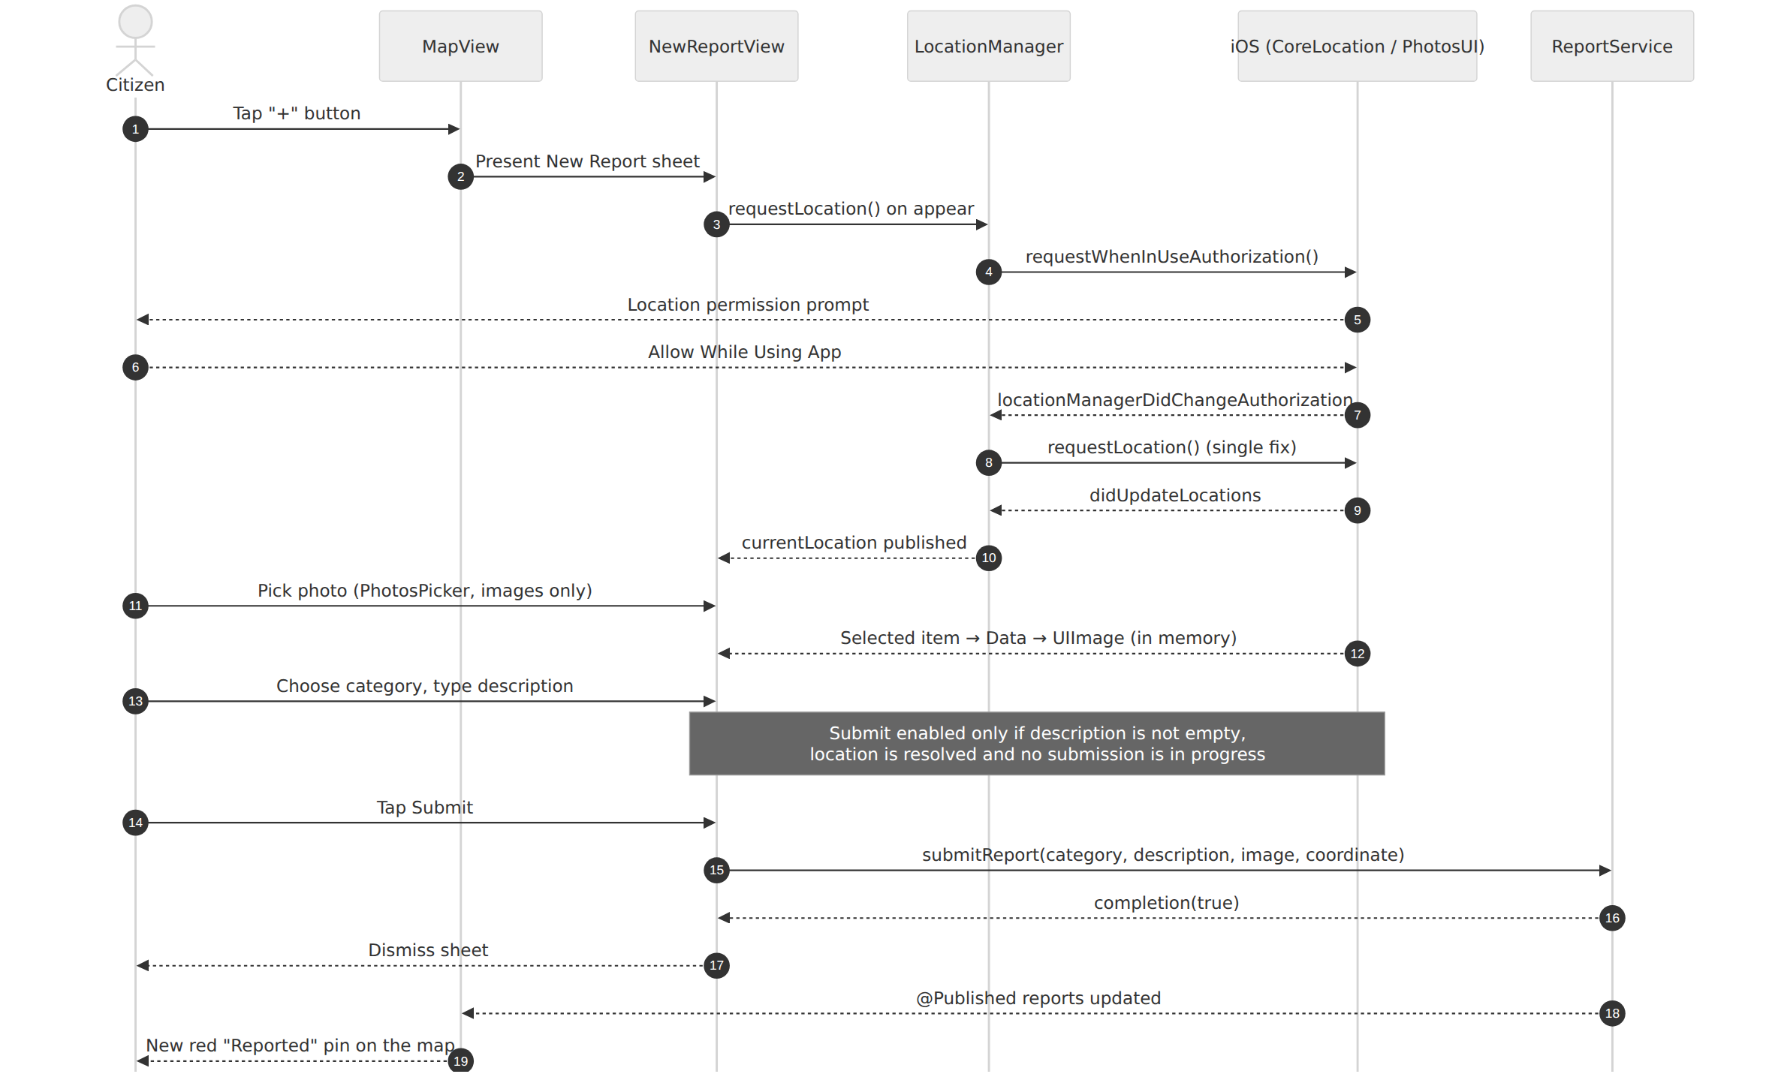
Figure A.1 – Sequence diagram of report submission

APPENDIX B – Userflow diagram
Figure B.1 presents the user flow of the application, starting from the live map, for both the citizen and the staff role.
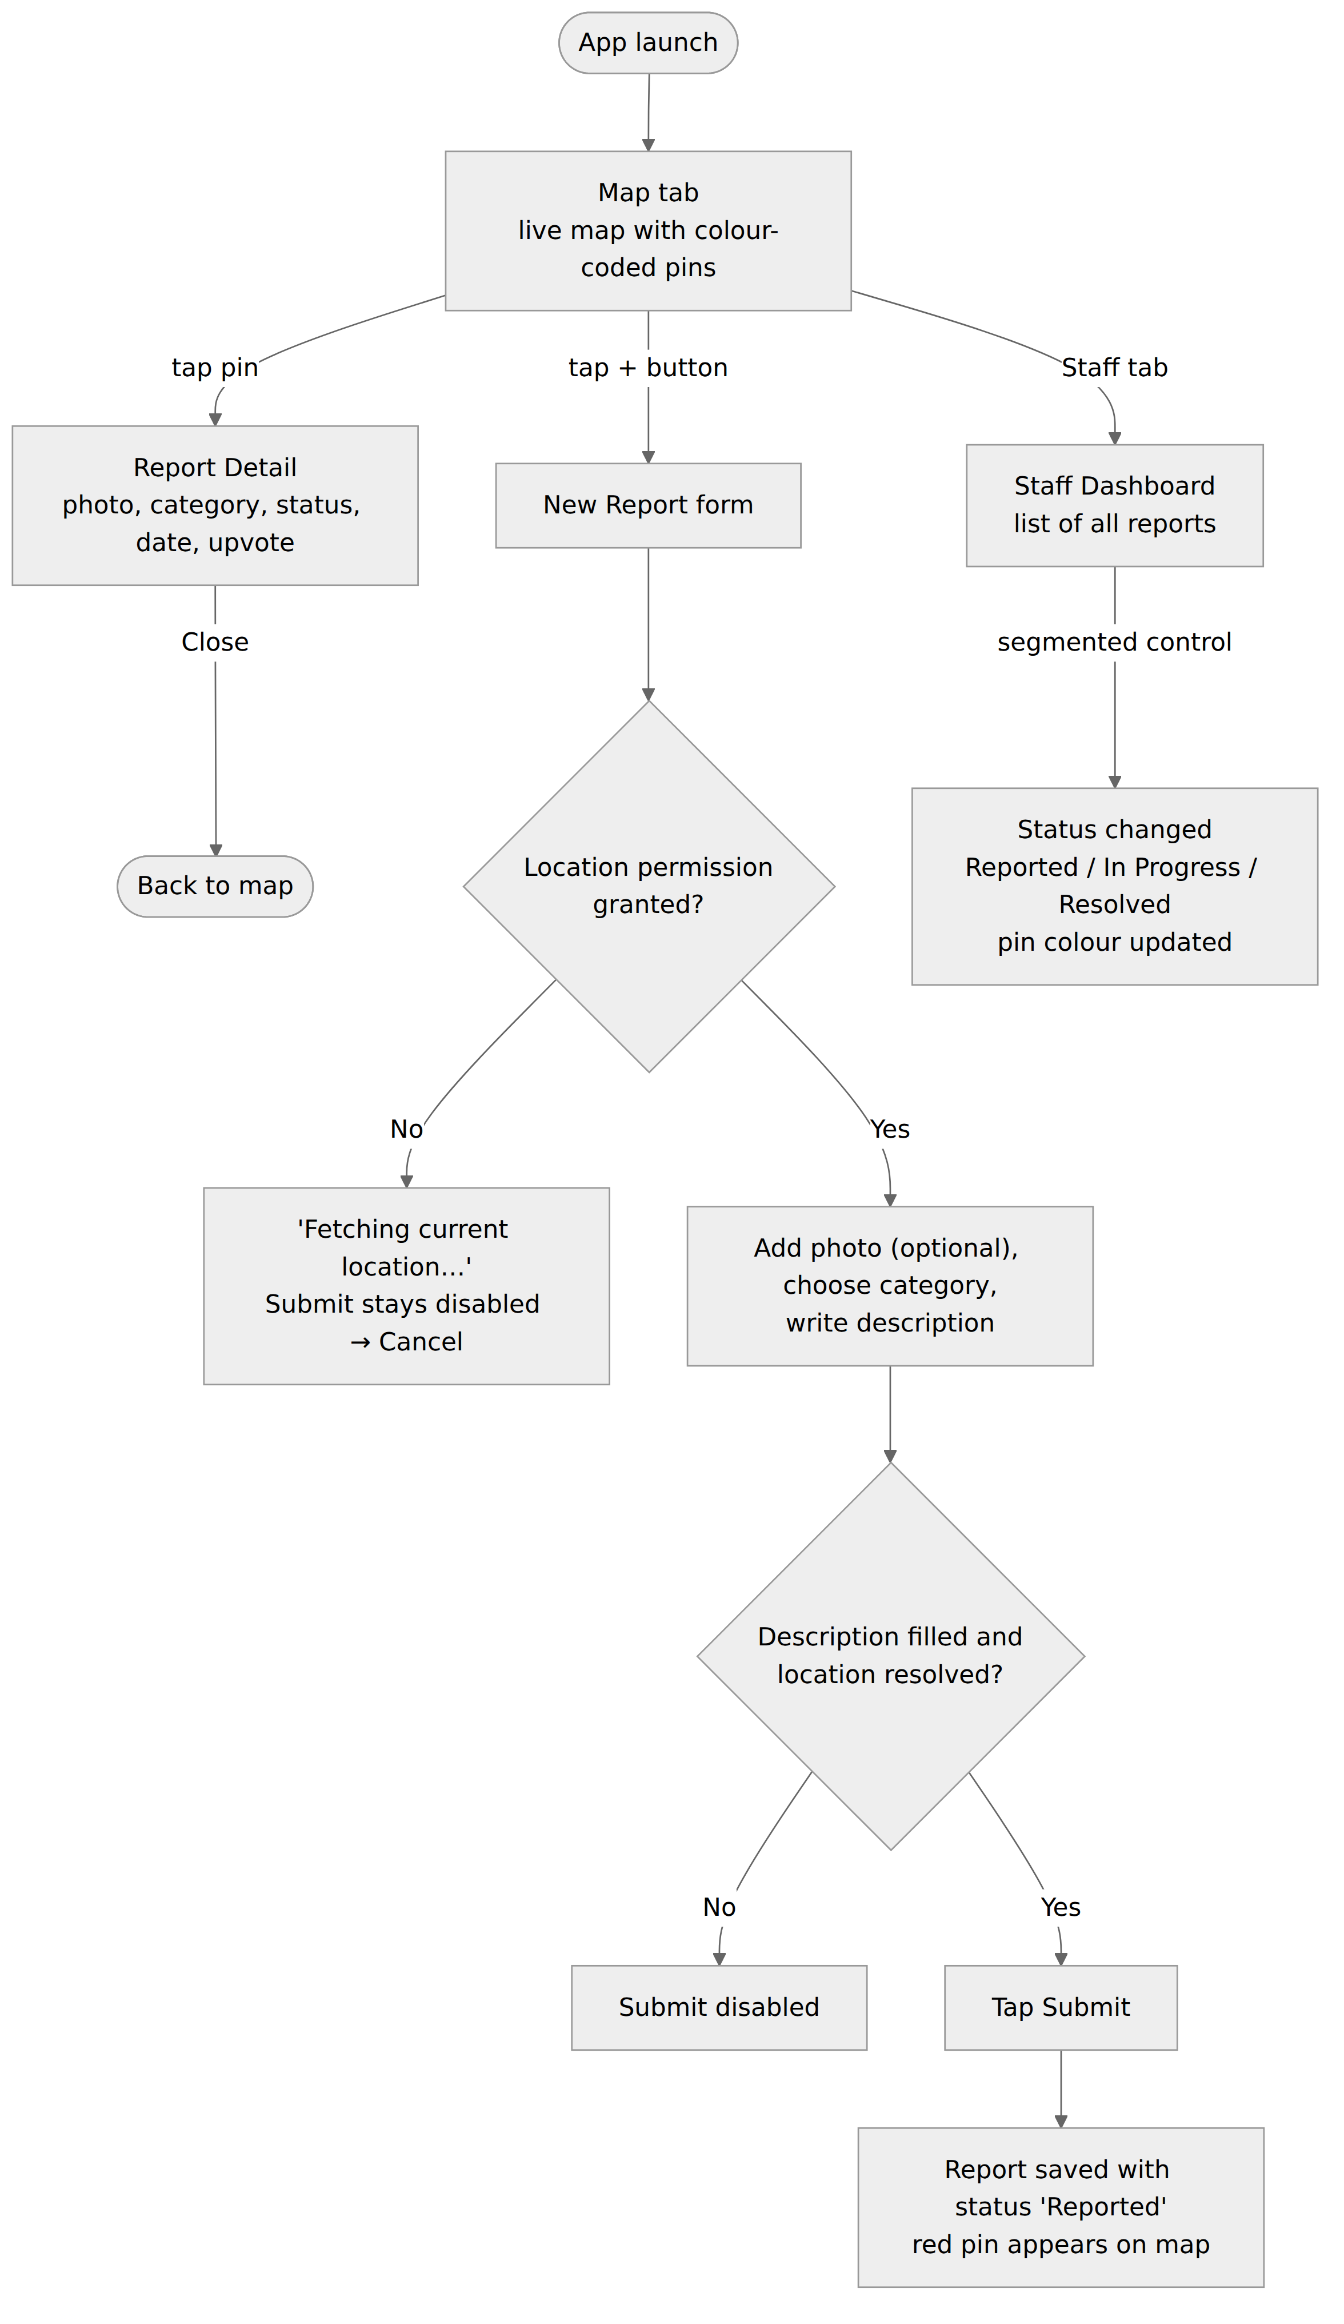
Figure B.1 – User-flow diagram of RoadFix

Internship Summary Report_Augustin Carazanu
INTERNSHIP SUMMARY REPORT
on the activities carried out during the internship
Host organisation JCODE SOLUTIONS SRL
Department (unit)
Faculty of Computers, Informatics, and Microelectronics
Study programme Software Engineering
Mode of study full time
Year of study: III Group: FAF-243
Internship period: from 01.09.2026 to 26.09.2026
Activities carried out and results obtained:
Activities carried out:
As team leader, my work during the four weeks was split between coordinating the team and building the foundation that the other three members relied on. Instead of a week-by-week list, the activities are grouped below by area of responsibility.
– Coordination. Organised the choice of the MVP idea in the first days, split the application into four components with one owner each, set up the shared GitHub repository with feature branches, and followed the progress of the team against the four-week internship plan.
– Architecture and data layer. Proposed a native SwiftUI client with one shared service and Firebase as backend. Wrote Report.swift, with the ReportCategory and ReportStatus enumerations, and ReportService.swift, which handles submitting, upvoting and status changes and is seeded with sample reports placed around the centre of Chisinau.
– Firebase groundwork. Created the Firebase project, registered the iOS app under its bundle identifier and added the configuration file, keeping analytics and advertising disabled. In the last week I started work on Firebase Authentication and on the connection to Firestore.
– Security documentation. Collected the security measure of every member, rewrote each one in the DAS format (problem, relevance, implementation, testing, limitations), built the prioritisation table and wrote the October–December plan for the group report.

Results obtained:
At the end of September the team had a working MVP that was demonstrated end to end. My direct results were the data layer used by every screen, a Firebase project ready for the next stage, and a service interface designed so that the backend can later be connected by changing ReportService only. On the documentation side, the team finished the internship with a threat model, a list of prioritised security measures and a concrete plan for authentication, Firestore Security Rules and role-based access control.

Difficulties encountered during the internship:
The main difficulty was time. Connecting Firebase took longer than I had estimated, and at the start of the last week it was clear that the backend would not be finished in time for the demonstration. I decided together with the team to keep the MVP on local sample data and to preserve the same method signatures, so that no screen would need to change later. Coordination was the second challenge: even with separate files per person, merging four branches produced conflicts, and I had to agree with the team on a merge order and on who reviews what.

Conclusions and recommendations:
For me the internship was as much about leading a small team as about writing code. I learned that dividing the work by component, with a clear owner for each file, saves more time than any tool, and that a common documentation format should be agreed on the first day, not the last. The main technical lesson is that the backend is where the real protections of an application live, so its security design has to be settled before the client grows around it.
On the positive side, the team cooperated well and we ended the month with something that actually runs. On the negative side, I would have liked to finish the Firebase integration within the internship. My recommendation for the programme is a short introductory workshop on the cloud services the teams plan to use, so that backend work can start in the first week.
As for the host organisation, JCODE SOLUTIONS SRL left the team room to organise its own work while giving guidance at the moments that mattered most – when the scope was fixed and when the security priorities were chosen. In my view the company fully allowed the internship objectives to be reached, and the cooperation with our mentor, Viorel Iordăchiță, was efficient and constructive.

Date of completion: ____ / ____ / 20__
Signature of the student: _______________________

Internship Summary Report_Vlad Buliga
INTERNSHIP SUMMARY REPORT
on the activities carried out during the internship
Host organisation JCODE SOLUTIONS SRL
Department (unit)
Faculty of Computers, Informatics, and Microelectronics
Study programme Software Engineering
Mode of study full time
Year of study: III Group: FAF-243
Internship period: from 01.09.2026 to 26.09.2026
Activities carried out and results obtained:
Activities carried out:
My area in the RoadFix project was the live map and the tab structure of the app. I also set up the Xcode project that the rest of the team built on.
– 01–04.09 – project kick-off; helped define the two user roles and decided, together with the team, which report fields can be shown on a public map.
– 07–11.09 – learned the new SwiftUI MapKit API (Map, Annotation, MapCameraPosition); agreed on the pin colours for the three statuses.
– 14–18.09 – prototyped the map screen: one annotation per report with the category icon, colour by status and a tap that opens the report detail.
– 21–25.09 – created the shared RoadFix Xcode project, moved the map into it as MapView.swift, built ContentView.swift with the Map and Staff tabs, merged the team branches on GitHub, tested the map on sample data and wrote my security measure for the group report.

Results obtained:
– Live map with colour-coded pins that update as soon as a staff member changes a status.
– Tab navigation between the citizen map and the staff dashboard, and the "+" entry point to the New Report form.
– Minimal public data on the map: category, description, status, date and upvotes – the reporter is never shown.
– Planned next step: rounding displayed coordinates to about 50 m (group report, subchapter 3.1).

Difficulties encountered during the internship:
– MapKit for SwiftUI works differently from the older UIKit version, so placing custom annotations took some trial and error.
– The report detail could only be opened with sheet(item:) after the Report model was made Identifiable.
– At first the tabs did not share data; the fix was to create ReportService once in ContentView and pass it to every screen.
– While merging the branches, one file ended up with conflict markers left inside it, which taught me to check the build after every merge.

Conclusions and recommendations:
I did not expect a map to be a security topic, but it turned out to be one: whatever a public screen shows, anyone can see. Working on RoadFix showed me that even without a name, an exact GPS point can point to someone's home, and that the safest data is the data a screen never receives.
The best part of the internship was building something visible that the whole team used every day. The weaker part was that a lot of time went into learning new APIs, which left less time for testing. I would suggest a joint session at the beginning of the internship where all teams go through the DAS security format together.
JCODE SOLUTIONS SRL was a good place for this kind of project: the working environment felt close to a real product team, and our mentor, Viorel Iordăchiță, was easy to reach when the team needed advice. The company gave us what we needed to reach the goals of the internship.

Date of completion: ____ / ____ / 20__
Signature of the student: _______________________

Internship Summary Report_Chiril-Adam Macari
INTERNSHIP SUMMARY REPORT
on the activities carried out during the internship
Host organisation JCODE SOLUTIONS SRL
Department (unit)
Faculty of Computers, Informatics, and Microelectronics
Study programme Software Engineering
Mode of study full time
Year of study: III Group: FAF-243
Internship period: from 01.09.2026 to 26.09.2026
Activities carried out and results obtained:
Activities carried out:
During the internship I was responsible for the report submission part of RoadFix – the only screen through which citizens send data into the system – and I took part in designing the user interface of the whole application.
– Week 1 – worked on the MVP definition; wrote the user stories for creating a report and listed what personal data a report collects (exact location, photo, free text, reporter ID) and how the form could be abused.
– Week 2 – studied SwiftUI state, CoreLocation permissions and PhotosPicker; designed the New Report form (Photo, Category, Description, Location) and contributed to the floating "+" button and the common status colours.
– Week 3 – implemented LocationManager.swift, which makes a single "When In Use" location request, and NewReportView.swift, with image-only photo selection, a category picker, a description field and live coordinates; added the validation gate that keeps Submit disabled until the form is valid and blocks double submissions.
– Week 4 – tested the form on the iOS Simulator, reviewed how location and photos are handled from a privacy point of view, wrote subchapter 3.2 of the group report and helped prepare the MVP demonstration.

Results obtained:
– A working submission flow: a new report appears immediately as a red pin on the live map.
– Three security measures in my component: client-side input validation, secure photo selection and privacy-oriented location access.
– Seven test cases checked by manual testing and code review; six passed, and one gap – a description made only of spaces is accepted – was found and planned for correction.
– Concrete proposals for October–December: Firestore Security Rules for validation, stripping EXIF/GPS metadata from photos before upload, a maximum description length and a message when location is denied.

Difficulties encountered during the internship:
– The permission flow of CoreLocation is asynchronous, so the location request had to be repeated in the authorisation callback.
– The simulator has no GPS; until a simulated location was set, the form stayed on "Fetching current location…" – which I later turned into a test case.
– Photo loading needed Swift concurrency (async/await, Task), which I had not used much before.
– It was not obvious at first which checks belong on the client and which only make sense on the server.

Conclusions and recommendations:
The internship was very relevant for my studies, because it combined mobile development with the security topics of the DAS module on a real project, from idea to working MVP. The lesson I will remember is the difference between a check that improves usability and a check that provides security: a disabled Submit button protects honest users from mistakes, but only server-side rules can stop a modified client. I also learned to design a feature around privacy by asking only for the permissions that are really needed.
I liked the clear division of responsibilities and the fact that every decision had to be documented. The downside was the short duration – four weeks were not enough to connect the backend and test the server-side protections. My suggestion is to give teams access to the backend services earlier and to reserve more time for security testing.
I assess the cooperation with JCODE SOLUTIONS SRL positively. The company provided the conditions needed to work on the project, and the company mentor, Viorel Iordăchiță, helped us keep the scope of the MVP realistic and focus on the risks that really matter for a reporting app. Thanks to this, the objectives set for September were achieved.

Date of completion: ____ / ____ / 20__
Signature of the student: _______________________

Internship Summary Report_Adrian Cojan
INTERNSHIP SUMMARY REPORT
on the activities carried out during the internship
Host organisation JCODE SOLUTIONS SRL
Department (unit)
Faculty of Computers, Informatics, and Microelectronics
Study programme Software Engineering
Mode of study full time
Year of study: III Group: FAF-243
Internship period: from 01.09.2026 to 26.09.2026
Activities carried out and results obtained:
Activities carried out:
My responsibility in the RoadFix team was the report detail screen and the staff dashboard, which together form the main access control surface of the application. I describe my activities by development phase.
– Analysis – with the team, defined what a citizen and a staff member are allowed to do, and identified privilege escalation (a citizen changing the status of a report) as one of the main risks.
– Design – studied SwiftUI lists, sheets and segmented pickers, and proposed a separate Staff tab and a single status badge reused on every screen.
– Implementation – wrote ReportDetailView.swift (photo, category, status, description, date and upvote) and the StatusBadge component, then StaffDashboardView.swift with a list of all reports and a segmented control for Reported, In Progress and Resolved.
– Testing and documentation – checked every navigation path from the citizen screens to confirm that none leads to the status control, and wrote subchapter 3.3 of the group report on role-based access control.

Results obtained:
The detail screen and the staff dashboard are both working: when a staff member changes a status, the pin on the map and the badge in the detail change colour immediately. The StatusBadge component keeps the three colours consistent across the app. Testing confirmed that the status control can only be reached from the Staff tab. The main outcome for the next stage is a clear plan for real role-based access control – Firebase custom claims plus Firestore Security Rules – with every status change recorded together with the staff member who made it.

Difficulties encountered during the internship:
Connecting a segmented picker to one report inside a list was harder than expected and needed a custom Binding that calls ReportService.updateStatus. During testing I also noticed that the detail sheet works with a copy of the report, so the upvote counter only refreshes after the sheet is reopened; the fix is to read the report from the shared service by its ID. The biggest limitation, however, was not technical: without login, any user can open the Staff tab, so the role separation could only be shown in the interface and not truly enforced.

Conclusions and recommendations:
This internship turned access control from a theoretical topic into something very concrete for me. Hiding a button is not the same as protecting an action – real protection has to be checked on the server against the role of an authenticated user. I also improved my SwiftUI skills, especially building reusable components and handling data that several screens depend on.
A positive aspect was that the DAS security requirements could be applied directly to our own code. A negative aspect was that, without authentication, I could not test the access control part properly within September. For future internships I would recommend regular short code review sessions with the mentor, because they help find problems like the upvote refresh early.
The cooperation with JCODE SOLUTIONS SRL was constructive. The discussions with the company mentor, Viorel Iordăchiță, about which risks are realistic for an application like ours helped the team decide that role-based access control should be the first priority for October. The host company allowed us to achieve the objectives of the internship.

Date of completion: ____ / ____ / 20__
Signature of the student: _______________________

