Movie library(mymovies)

1. Create ToR(Term of reference) for final project

The user logs in to the page, choose what he wants to watch (movie / serial / trailer), genre and movie in final. Or add the movie to personal library.

1. Create UML structural diagram for entities

type of (movie / serial / trailer) -> genre -> movie.

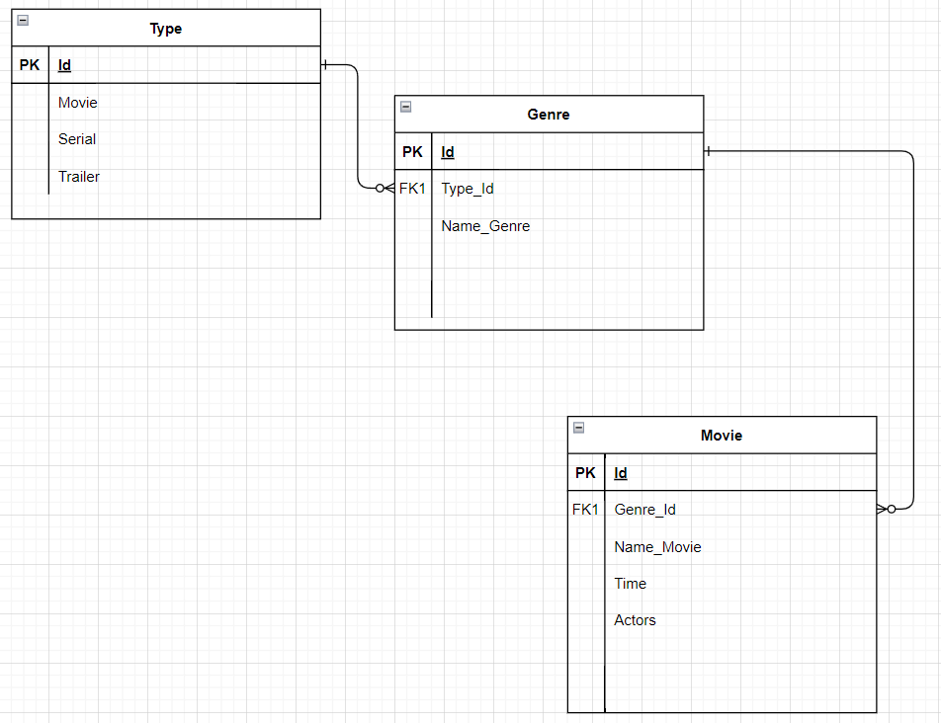

1. Create database according to ToR.