Stochastic AGV Dispatching in Automated Container Terminals:
A Deep Reinforcement Learning Approach

Niraj Prashant Kamble^{1*}, Jayendran Venkateswaran¹

¹Department of Industrial Engineering & Operations Research, IIT Bombay, Mumbai, India
*25m1528@iitb.ac.in

ABSTRACT
Automated Container Terminals (ACTs) rely on fleets of Automated Guided Vehicles (AGVs) to transport containers between Quay Cranes (QCs) and storage yards. Efficient AGV dispatching is critical, as QC idle time caused by delayed AGV arrivals directly increases ship turnaround time and operational costs. Liu et al. [1] reported QC idle rates as high as 31.7% in simulated terminal operations.
Despite extensive research, the majority of AGV scheduling models assume deterministic and static operating conditions, with task arrivals, travel times, and crane handling times treated as known constants. Recent studies [2, 3] explicitly acknowledge this limitation and call for scheduling methods that address real-world uncertainties such as dynamic task arrivals and multi-AGV traffic congestion. A comprehensive survey of 119 papers [4] identifies online and real-time scheduling as the most critical unsolved challenge in automated terminal operations.
This work addresses this gap by formulating AGV dispatching as a Markov Decision Process (MDP) within a custom stochastic discrete-event simulation calibrated to real port settings. Task arrivals follow a Poisson process, and AGV travel times incorporate congestion penalties derived from lane occupancy. We train a Proximal Policy Optimization (PPO) agent using curriculum learning, progressively increasing terminal complexity and stochasticity. The framework is further extended to Multi-Agent PPO (MAPPO), enabling decentralized, cooperative AGV coordination where each vehicle acts as an independent intelligent agent.
A rigorous comparative evaluation benchmarks five scheduling approaches: Greedy, Genetic Algorithm, DQN, centralized PPO, and decentralized MAPPO, under identical stochastic scenarios, providing the first controlled multi-method comparison in a stochastic ACT environment.

Graphical Abstract

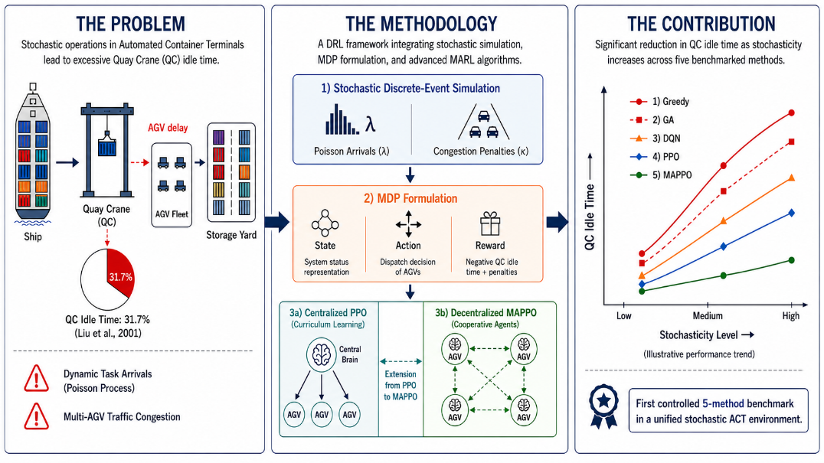

Keywords: Automated Container Terminal; AGV Scheduling; Stochastic Scheduling; Discrete-Event Simulation; Markov Decision Process; Proximal Policy Optimization; Multi-Agent Reinforcement Learning; Quay Crane Idle Time

References:
[1] C.I. Liu et al., Proc. European Control Conference (2001) 295–300.
[2] X. Yang et al., International Journal of Production Research 63:23 (2025) 9269–9297.
[3] T. Xie et al., Flexible Services and Manufacturing Journal (2025) DOI: 10.1007/s10696-025-09631-8.
[4] X. Li et al., Transport Economics and Management 3 (2025) 269–280.

