TOOLS & CALCULATION LOGIC
Avatar-Astro
How every reading and Inner Voice tool works
Branch dev-vishwa · commit 58a6f0e · prepared 21 October 2026

Scope: every user-facing reading and Inner Voice tool — what the user enters, exactly how the result is calculated, where AI is used, and what happens when something fails. Accounts, admin, the devotion shop and Live Darshan are covered in the main project documentation, not here.
Item | Value
Document | ASTRO_TOOLS_LOGIC_GUIDE.md
Source basis | Investigation notes for branch dev-vishwa, commit 58a6f0e (code read 2026-10-19)
Companion | COMPLETE_ASTRO_PROJECT_DOCUMENTATION (§4, §6, §7 there hold the same facts in fuller context)
Runtime verification | None. No tool was run; all logic below is as read from source
The one thing to know before reading on. None of the tools calculates real planetary positions. There is no ephemeris, ascendant, moon sign, house, dasha or transit calculation anywhere in the code. Every number a user sees is one of: a real local calculation (numerology, date cutoffs), a pseudo-random number derived from a hash of the user's input, a hard-coded value, or text written by an AI model.

How to read the provenance tags
Every output in this guide is tagged so you can tell what is genuinely calculated.
Tag | Meaning | Same input → same output?
LOCAL-CALC | Real arithmetic or rules in our code | Yes
PSEUDO | Number made from a hash or seeded random generator, shown to the user as a "score" | Yes (it only looks like a measurement)
LLM | Text or numbers written by an AI model | No
STATIC | Hard-coded content or fallback | Yes
MOCK | A simulated result (pretends something happened) | Yes

Contents
- Tool overview
- Shared building blocks (sun sign, life path, hash scores, AI calls)
- Palm Reading
- Name Destiny Report (numerology)
- Birth Chart ("Cosmic Identity")
- Compatibility Checker
- Daily Horoscope
- Zodiac Signs and the Daily Panel
- Tarot (Life Timeline and Karma Mirror)
- Inner Voice: AI Guru Consultation and Diagnosis Report
- Inner Voice: Voice Consultation
- Inner Voice: Karma Score Dashboard
- Inner Voice: Karma Journal
- Inner Voice: Shloka Wisdom
- Side-by-side comparison
- Known issues per tool
- Open questions
- Verification statement

1. Tool Overview
Tool | Route | Where the work happens | What is real | Status
Palm Reading | /palm-reading | Browser only (MediaPipe) | Hand detection and quality checks | Partially implemented
Name Destiny Report | /name-destiny-report | Browser maths + backend AI text | All numerology numbers | Implemented, not verified
Birth Chart | /birth-chart | Browser maths + backend AI text | Sun sign, life path | Partially implemented
Compatibility Checker | /compatibility | Browser only | Nothing used in the scores | Mocked
Daily Horoscope | /horoscopes | Backend AI | Nothing calculated | Implemented, not verified
Zodiac Signs + Daily Panel | /zodiac, /zodiac/:sign | Browser only | Static sign information | Daily panel mocked
Tarot | /tarot | Browser shuffle + backend AI | Card meanings (static) | Implemented, not verified
AI Guru + Diagnosis | /inner-voice/chat | Browser → Groq AI | Nothing calculated | Implemented, not verified
Voice Consultation | /inner-voice/chat | Browser speech + Groq + backend TTS | Speech pipeline | Implemented, not verified
Karma Score | /inner-voice/dashboard | Browser → Groq AI + one local formula | The final sum | Partially implemented
Karma Journal | /inner-voice/journal | Browser → Groq AI | Streak counters | Implemented, not verified
Shloka Wisdom | /inner-voice/wisdom | Browser → Groq AI | Nothing calculated | Implemented, not verified
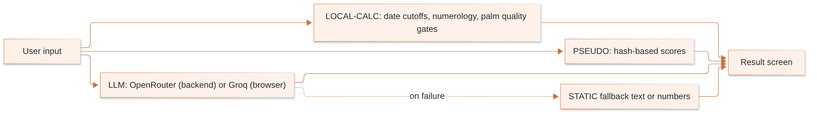
No tool requires login, and no tool saves anything to the database. Inner Voice tools keep their data in the browser's localStorage; everything else is lost on refresh.

2. Shared Building Blocks
Several tools reuse the same small pieces. They are defined once here.

2.1 Sun sign from date of birth — LOCAL-CALC
Used by Birth Chart, Compatibility and Name Destiny. Only the day and month matter; year and time of birth are ignored.
Sign | Up to and including
Capricorn | 19 January
Aquarius | 18 February
Pisces | 20 March
Aries | 19 April
Taurus | 20 May
Gemini | 20 June
Cancer | 22 July
Leo | 22 August
Virgo | 22 September
Libra | 22 October
Scorpio | 21 November
Sagittarius | 21 December
Capricorn | anything later
These are Western (tropical) cutoffs. Vedic astrology uses sidereal signs, which are shifted by roughly 23–24 days, so a Vedic user may see a different sign than they expect.
Example (hypothetical): 14 May → after 19 April, not after 20 May → Taurus.

2.2 Life path number — LOCAL-CALC
Add every digit of the date of birth, then keep adding the digits of the result until a single digit remains — except for "master numbers", which are kept.
Implementation | Master numbers kept | Used by
lib/numerology.ts#lifePathNumber | 11, 22, 33 | Name Destiny Report
BirthChart.tsx#getLP | 11, 22 only | Birth Chart
Example (from the notes): 1990-05-14 → 1+9+9+0+0+5+1+4 = 29 → 2+9 = 11 (master number, kept).
Inconsistency: a date whose digits reduce to 33 shows 33 in the Name Destiny Report but 6 on the Birth Chart page.

2.3 Hash-based "scores" — PSEUDO
Birth Chart and Compatibility turn the user's text into a number with this hash:
hash(s) = for each character c in s: a = (a × 31 + charCode(c)) AND 0xFFFF (start a = 0)
The result is a number from 0 to 65 535. The tools then take a remainder (%) of it to get a "score". This is deterministic — the same name and date always give the same score — but it has no astrological meaning. Changing one letter of a name can swing a score by many points.

2.4 How the AI calls work
Route | Provider | Called from | Key exposure
Daily horoscope, Birth Chart, Name narrative, Tarot | OpenRouter | backend | key stays on the server
All Inner Voice tools | Groq | browser | key (VITE_GROQ_API_KEY) is visible in the website's JavaScript
Voice playback | Sarvam AI | backend /api/tts | key stays on the server
Common behaviour of every AI call: no login required, no rate limit, no caching, no timeout (provider default), and JSON replies are pulled out with a regex or by stripping code fences — no schema validation. User text goes straight into the prompt.

3. Palm Reading
Route: /palm-reading · Files: pages/PalmReading.tsx, lib/palmAnalysis/ (engine.ts, handLandmarkDetector.ts, imagePreprocessing.ts, lineEstimator.ts, index.ts, types.ts), components/palm/{MetricDashboard, PalmLineOverlay, ScanSequence}.tsx · Status: Partially implemented
Summary: the app genuinely detects the hand and checks photo quality. It does not detect the actual palm lines. The lines drawn on screen are template curves placed on the detected hand, and the reading text is canned.

3.1 What the user does
- Opens /palm-reading.
- Takes a photo with the camera or uploads one.
- Watches a scanning animation (ScanSequence).
- Sees the palm with lines drawn over it (PalmLineOverlay), a metrics dashboard (MetricDashboard) and a written reading.
Everything runs inside the browser. The photo is never uploaded to our server.

3.2 Processing pipeline
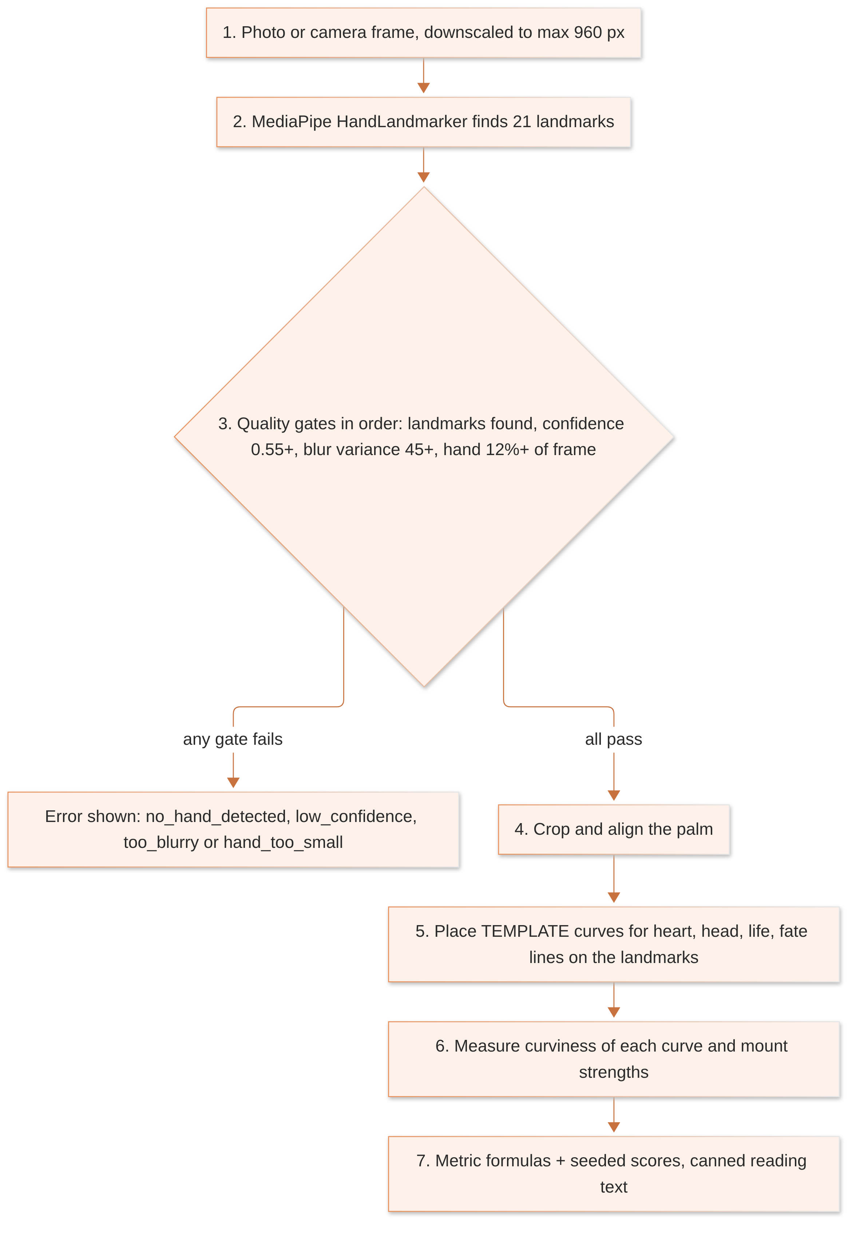

Step 1 — Hand detection (real)
handLandmarkDetector.ts loads Google's MediaPipe HandLandmarker. Its WebAssembly runtime and model file are downloaded at runtime from jsDelivr and storage.googleapis.com, so the tool needs internet access to those hosts. It returns 21 landmarks (wrist, knuckles and fingertip joints) plus a confidence value.

Step 2 — Quality gates (real), checked in this order
Order | Check | Threshold (constant) | Error code
1 | Were any landmarks found? | – | no_hand_detected
2 | Detection confidence | < 0.55 fails | low_confidence
3 | Image sharpness — Laplacian-style variance computed in imagePreprocessing.ts | below BLUR_VARIANCE_THRESHOLD = 45 fails | too_blurry
4 | Size of the hand's bounding box relative to the frame | below MIN_HAND_FRACTION_OF_FRAME = 0.12 fails | hand_too_small
How the blur check works in general terms: a Laplacian filter highlights edges; a sharp photo has strong, varied edges and therefore a high variance, while a blurry one is smooth and scores low. Images are first downscaled to at most MAX_WORKING_DIM = 960 px.

Step 3 — Line placement (template, not detection)
lineEstimator.ts does not look for creases in the skin. It takes predefined curve shapes for the heart, head, life and fate lines and positions them in a coordinate frame anchored to the detected landmarks, so the curves follow the size, angle and position of the user's hand. The source code itself states this is not crease segmentation. Two different people with similarly shaped hands will get very similar lines.

Step 4 — Metrics (formula over the template curves)
estimatePalmFeatures measures how curved each placed curve is (curviness) and how strong each mount is, then blends these with seeded personality scores. The formulas recorded in the notes:
Metric | Formula | Range
Love | clamp(35, 98, 55 + curviness(heart) × 22) | 35–98
Career | 55 + curviness(fate) × 18 | not clamped in the recorded formula
Health | 55 + curviness(life) × 20 | not clamped in the recorded formula
The scale of curviness and the exact seeding of the personality scores were not recorded in the notes [UNKNOWN], so worked numbers cannot be given without guessing.

Step 5 — Reading text
The written reading is canned text chosen locally. No AI is called.

3.3 Unused AI palm endpoint
The backend also has POST /api/palm-reading (index.ts), which sends the photo to anthropic/claude-3.5-sonnet via OpenRouter as a vision request (3000 tokens) with {imageBase64, imageType, fingerprint?}. Its seed is parseInt(fingerprint) % 1000, or random. The prompt claims "the seed ensures a consistent reading", but no seed or temperature is actually sent to the model, so results would vary. The website never calls this endpoint. It is public, unauthenticated, accepts up to 20 MB, and costs money per call if anyone does.

3.4 Outputs and provenance
Output | Provenance
"Hand detected / photo too blurry" messages | LOCAL-CALC (real)
Lines drawn on the palm | LOCAL-CALC over templates
Love / career / health metrics | LOCAL-CALC over templates + seeded scores
Reading text | STATIC

3.5 Limitations
- Not real palm-line detection; any accuracy claim is unsupportable.
- Depends on CDN downloads at runtime.
- Nothing is saved.

4. Name Destiny Report (Numerology)
Route: /name-destiny-report · Files: lib/numerology.ts, components/NameDestinyReport/*, useNameReport.ts, lib/fetchNarrative.ts, lib/pdfExport.ts; backend routes/nameAnalysisRoutes.ts · Status: Implemented, not verified
Summary: this is the most genuinely calculated tool. All numbers come from deterministic numerology code. The AI only writes the explanatory paragraphs, and is told to use only the numbers it is given.

4.1 What the user does
Enters a name and date of birth. The numbers appear instantly; the written narrative loads from the backend. The report sections are: core numbers, aura, future timeline, life heatmap, name variants, celebrity carousel and lucky numbers. A ₹499 "premium unlock" and a PDF export are offered.

4.2 Step 1 — Clean the name
cleanName converts to uppercase and removes everything except A–Z. Spaces, accents, digits and non-Latin scripts (such as Devanagari) are silently dropped. An empty result gives a destiny number of 0.

4.3 Step 2 — Letter values
Value | Pythagorean | Chaldean
1 | A, J, S | A, I, J, Q, Y
2 | B, K, T | B, K, R
3 | C, L, U | C, G, L, S
4 | D, M, V | D, M, T
5 | E, N, W | E, H, N, X
6 | F, O, X | U, V, W
7 | G, P, Y | O, Z
8 | H, Q, Z | F, P
9 | I, R | — (Chaldean conventionally has no 9)

4.4 Step 3 — Reduce numbers
reduceNumber(n): while n > 9 and n is not 11, 22 or 33, replace n with the sum of its digits.

4.5 Step 4 — Core numbers
Number | Calculation
Destiny (Expression) | reduce(sum of Pythagorean values of all letters)
Soul Urge | reduce(sum over the vowels A, E, I, O, U)
Personality | reduce(sum over the consonants)
Chaldean name number | reduce(sum of Chaldean values)
Life Path | reduce(sum of all DOB digits) — keeps 11/22/33
Birth number | reduce(day of month)

4.6 Step 5 — Ruling planet of each number
1 | 2 | 3 | 4 | 5 | 6 | 7 | 8 | 9 | 11 | 22 | 33
Sun | Moon | Jupiter | Rahu | Mercury | Venus | Ketu | Saturn | Mars | Moon | Saturn | Jupiter
Planet compatibility between the destiny planet and life-path planet uses the matrix PLANET_RELATIONSHIPS (its source is not documented):
Relationship | Score | Label
Same planet | 92 | friendly
Friend | 82 | friendly
Neutral | 60 | neutral
Enemy | 38 | friction

4.7 Step 6 — Overall name alignment score
lifePathCompat = planet compatibility score (38, 60, 82 or 92)
chaldeanFav = 90 if Chaldean number is 1, 3, 5 or 6
55 if it is 2 or 9
70 otherwise
vowelRatio = vowels ÷ letters (0.4 if the name has no letters)
balanceScore = clamp(0, 100, 100 − |vowelRatio − 0.4| × 150)
lengthPenalty = −8 if more than 14 letters; −3 if more than 10; else 0
overall = clamp(0, 100, round(0.4 × lifePathCompat
+ 0.3 × chaldeanFav
+ 0.2 × balanceScore
+ 7
+ lengthPenalty))
The weights (0.4 / 0.3 / 0.2 / fixed 7) are product choices, not traditional numerology.

4.8 Worked example (from the notes, calculated by hand)
Name ARUN, DOB 1990-05-14:
Step | Working | Result
Destiny | A1 + R9 + U3 + N5 = 18 → 1+8 | 9 → Mars
Chaldean | A1 + R2 + U6 + N5 = 14 → 1+4 | 5 → favourable, 90
Life path | 1+9+9+0+0+5+1+4 = 29 → 2+9 | 11 (kept) → Moon
Compatibility | Mars's friends are Sun, Moon, Jupiter → Moon is a friend | 82
Vowel balance | A, U = 2 vowels of 4 → ratio 0.5 → 100 − 0.1 × 150 | 85
Length penalty | 4 letters | 0
Overall | 0.4×82 + 0.3×90 + 0.2×85 + 7 = 32.8 + 27 + 17 + 7 = 83.8 | 84

4.9 Step 7 — Name variants ("Name Evolution Lab")
generateNameVariants(name, 12) works on the first word only and creates candidates by:
- Doubling each letter in turn (e.g. ARUN → AARUN, ARRUN…).
- Phonetic swaps: k ↔ c, i ↔ y, s ↔ z.
- Appending one of a, e, h, s, r.
- Dropping a trailing vowel, or adding a.
Duplicates and the original are removed; at most 12 remain. rankNameVariants scores each with the same overall formula and calculates diff = variant score − original score, then predicted changes:
Area | Change shown
Career | round(0.9 × diff)
Business | round(1.1 × diff)
Wealth | round(0.8 × diff)
Relationship | round(0.6 × diff)
The top 5 variants by score are shown. The multipliers are product constants.

4.10 Step 8 — Lucky values
- Lucky numbers: the unique values of {destiny, life path, reduce(destiny + life path), reduce(2 × destiny)} (no master numbers kept in the last two), first 4.
- Lucky dates: b, b+9, b+18, b+27 that fall between 1 and 31, where b = life path (9 if 0).
- Lucky colours: fixed mapping LUCKY_COLOR_BY_NUMBER.
- Handle suggestion: first 8 letters of the name + destiny number.

4.11 Step 9 — AI narrative
POST /api/name-analysis/narrative receives the computed numbers and the top variant. Model: google/gemma-4-31b-it:free via OpenRouter, 900 tokens. The prompt says to use only the numbers provided and to describe possibilities, not guarantees. It returns: frictionExplanation, wealthPotential, relationshipEnergy, careerAlignment, remedies[4], signatureAnalysisNote, topVariantExplanation.
Fallback: if the key is missing, the provider fails or the JSON can't be parsed, the backend returns mockNarrative() template text with HTTP 200. The user cannot tell it from a real narrative.

4.12 Paywall and PDF
The ₹499 "Unlock" button only sets a local unlocked flag ("Demo unlock — real payment coming soon"). No payment happens, nothing is stored, and a reload locks it again. The PDF is created in the browser with jsPDF.

4.13 Provenance summary
Output | Provenance
All core numbers, planets, overall score, variants, lucky values | LOCAL-CALC
Narrative paragraphs | LLM (or STATIC mock on failure)
Celebrity carousel | STATIC (celebrityData.ts, source unknown)
Premium unlock | MOCK

5. Birth Chart ("Cosmic Identity")
Route: /birth-chart · Files: pages/BirthChart.tsx; backend routes/birthChartRoutes.ts · Status: Partially implemented
Summary: despite the name, no birth chart is calculated. Birth time and coordinates are collected but never used. The score bars are hash-derived; the descriptive text is AI-written.

5.1 What the user does
Enters first name (required), last name, date of birth (required), optional time (hour, minute, AM/PM) and optional place (autocomplete from OpenStreetMap Nominatim, called directly from the browser). Presses generate, waits on an animated loading screen, sees the results.

5.2 Calculation steps
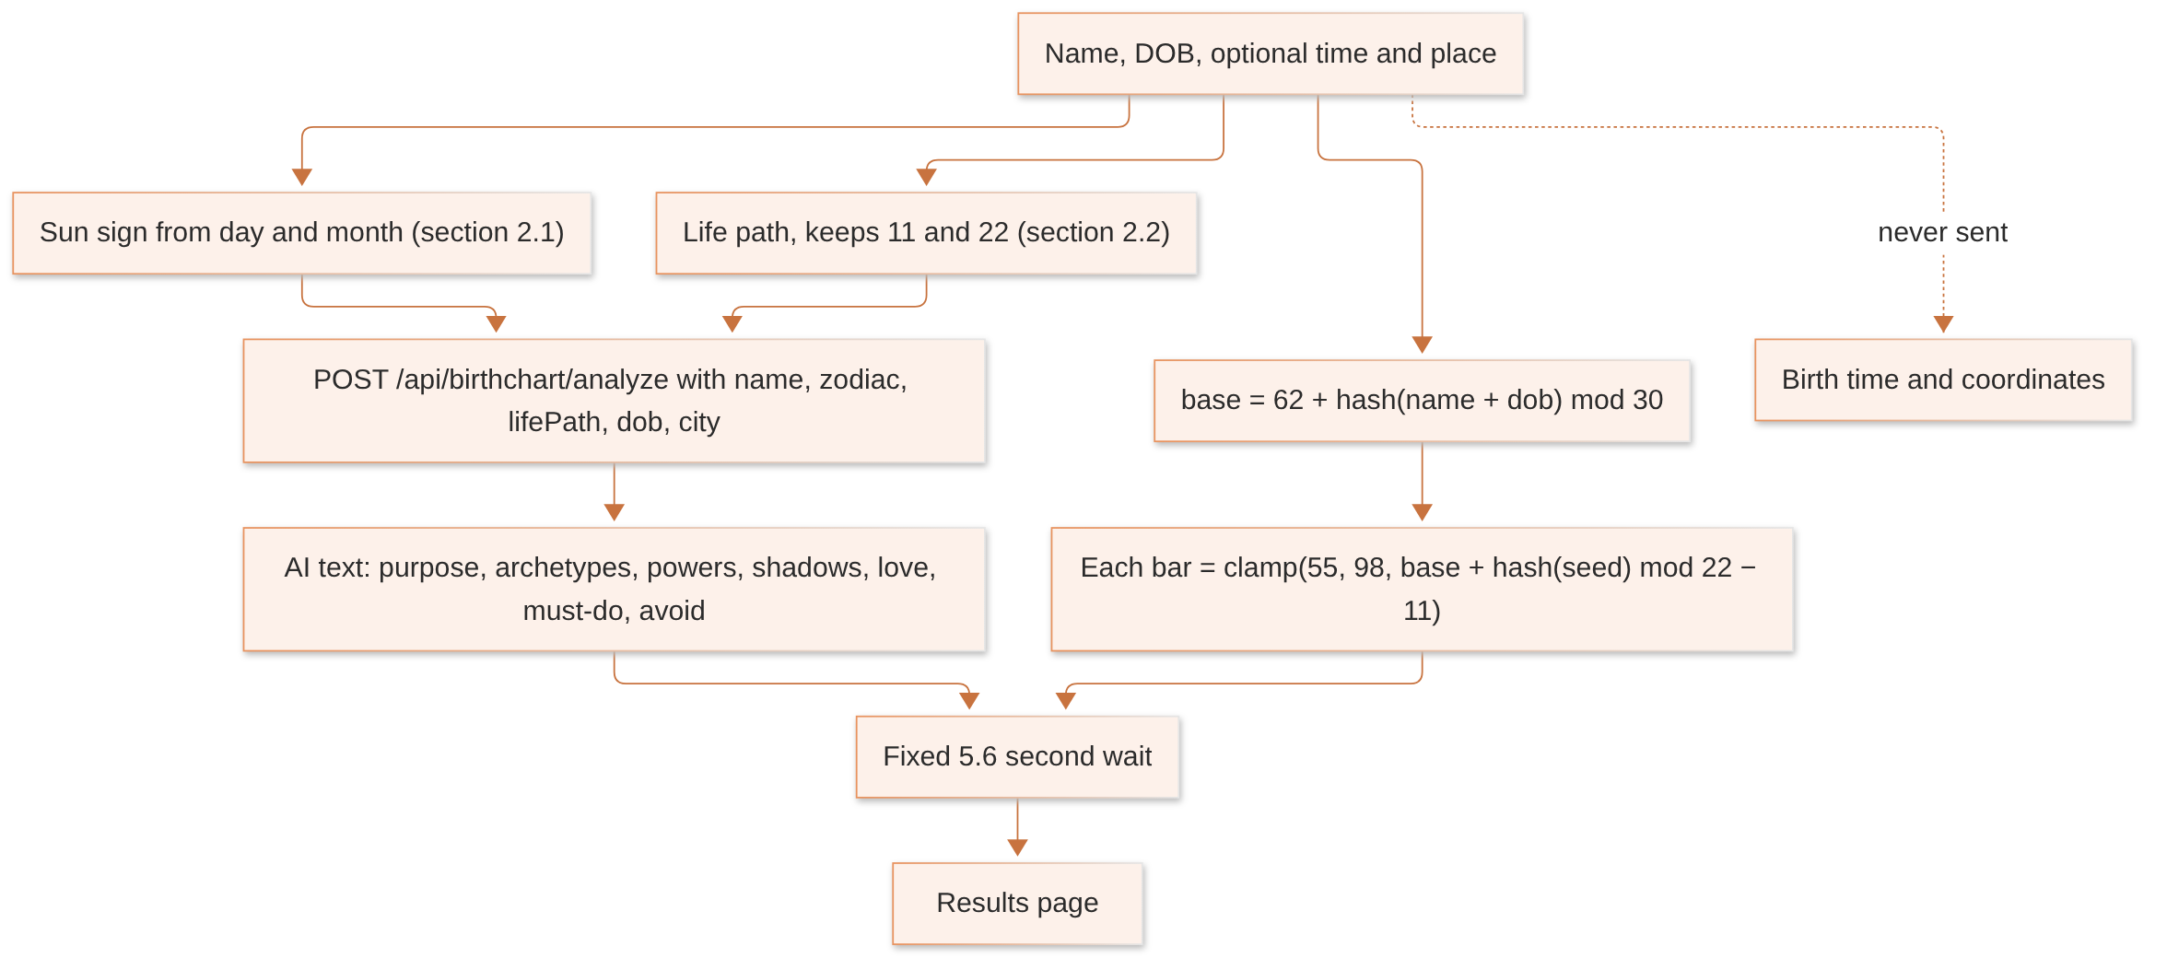
Step | Logic | Provenance
Sun sign | date cutoffs, year and time ignored | LOCAL-CALC
Life path | digit sum, keeps 11 and 22 | LOCAL-CALC
Base value | 62 + hash(name + dob) % 30 → 62 to 91 | PSEUDO
LOVE, CAREER, MONEY, HEALTH, GROWTH bars and insight scores | dv(base, seed) = clamp(55, 98, base + hash(seed) % 22 − 11) | PSEUDO
Wait | fixed setTimeout of 5.6 s regardless of how fast the AI replies | –
Text | AI: google/gemma-4-31b-it:free, 1800 tokens, persona "world-class vedic astrologer". Returns purpose, archetypes[3], powers[5], shadows[4], loveLanguage, relStyle, attachment, idealPartner, emotionalNeed, spiritMeaning[4], mustDo[5], mustAvoid[5] | LLM
Fallback: if the AI call fails, the error is swallowed and the page shows built-in static text plus the pseudo-scores.

5.3 What is missing for a real chart
Ascendant (rising sign), moon sign, planetary positions, houses, aspects, dashas, timezone and daylight-saving handling, and use of the birth coordinates. None exist. A backend "chart chat" endpoint exists but nothing on the website uses it, and it expects moon and rising values that nothing calculates.

6. Compatibility Checker
Route: /compatibility · File: pages/CompatibilityChecker.tsx · Status: Mocked
Summary: every compatibility score is a hash of the two names and dates. Zodiac signs and life paths are calculated but not used. The chat replies are canned text.

6.1 What the user does
Enters name and date of birth for two people (time and place optional), waits 5.6 seconds, sees eight category scores, an overall score, "who loves more", and a chat box.

6.2 Score calculation — PSEUDO
seed = name1 + name2 + dob1 + dob2
base = 60 + hash(seed) % 35 → 60 to 94
for each category tag in: love, emotional, physical, friendship,
marriage, financial, family, spiritual
score = clamp(52, 99, base + (sum of character codes of (name1 + name2 + tag)) % 20 − 10)
overall = min(99, base + 5)

6.3 "Who loves more"
Person | Weighted sum
Person 1 | 0.35 × emotional + 0.25 × love + 0.20 × friendship + 0.20 × marriage
Person 2 | 0.35 × spiritual + 0.25 × physical + 0.20 × family + 0.20 × financial
The higher sum "loves more".
Hypothetical example: if emotional = 80, love = 70, friendship = 60, marriage = 90, then Person 1 = 28 + 17.5 + 12 + 18 = 75.5.

6.4 Chat
Questions are matched against keywords and answered from canned text (getCompatFallback) after a 900 ms delay. The backend AI endpoint POST /api/compatibility/analyze exists but the call to it is commented out.

6.5 Consequences
- The same two names always produce the same scores.
- Swapping the order of the two people changes the seed, so it can change the scores.
- Two people with the same signs but different names get different results; astrology plays no part.

7. Daily Horoscope
Route: /horoscopes · Files: pages/DailyHoroscopes.tsx, hooks/useInterpretation.ts; backend services/chatgptService.ts#generateDailyHoroscope · Status: Implemented, not verified
Aspect | Detail
Input | one of 12 signs, chosen in the UI
Request | GET /api/interpretation/horoscope/:sign (sign is not validated)
Model | openai/gpt-4-turbo-preview via OpenRouter, temperature 0.8, 800 tokens
Prompt asks for | overall energy, love, career, health, a lucky tip — in Hinglish
Date | not in the prompt; the server adds today's date to the response only as a label
Caching | none — every click is a new paid AI call and gives different text
Output | free text, shown with line breaks preserved
Failure | HTTP 500 → "Failed to generate horoscope"
Provenance | LLM
Nothing about real planetary transits is used; two users with the same sign on the same day see different horoscopes.

8. Zodiac Signs and the Daily Panel
Routes: /zodiac, /zodiac/:sign · Files: pages/ZodiacSigns.tsx, pages/ZodiacDetail.tsx, data/zodiacData.ts · Status: static content; daily panel mocked

8.1 Sign information — STATIC
Traits and descriptions come from data/zodiacData.ts. The backend's /api/zodiac/signs endpoints exist but the pages don't use them.

8.2 Daily "lucky" panel — PSEUDO
seed = (year × 10000 + month × 100 + day) × 1000 + sum of character codes of the sign name
The date is the browser's local date. A seeded random generator rng(seed) then picks, from hard-coded lists: lucky colour, lucky number, gemstone, direction, moon phase, planets, mood, challenge, compatible signs and messages.
Hypothetical example: for 21 October 2026 the date part is 20261021 × 1000 = 20 261 021 000, plus the character-code sum of the sign name.
Consequences: the same sign on the same day on the same device always gets the same panel; the moon phase and planets shown are random picks, not real astronomy. The "spin the wheel" feature uses Math.random and changes every time.

9. Tarot (Life Timeline and Karma Mirror)
Route: /tarot · Files: pages/TarotExperience.tsx, data/tarotData.ts, components/tarot/TarotLandingScene.tsx; backend inline route in index.ts · Status: Implemented, not verified

9.1 Flow
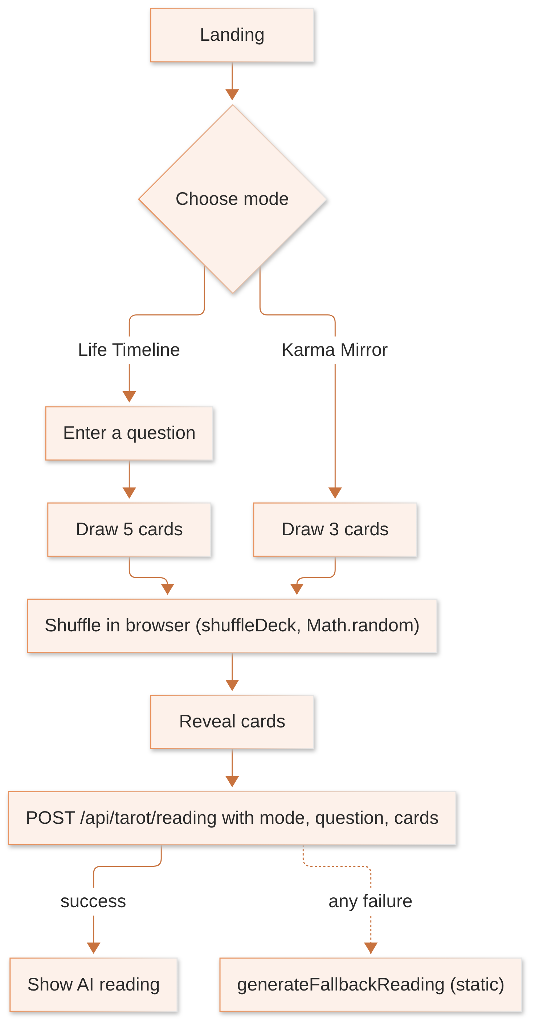

9.2 Details
Step | Logic | Provenance
Deck and card meanings | data/tarotData.ts (name, meaning, keywords, symbol) | STATIC
Shuffle and draw | shuffleDeck in the browser, random each time | random
Request | {mode, question, cards[{name, meaning, keywords, symbol}]}; server checks only that mode and a cards array exist | –
Prompt choice | mode === "timeline" → timeline prompt, otherwise karma prompt | –
Model | google/gemma-3-27b-it via OpenRouter, 2000 tokens; first {…} in the reply is parsed | LLM
Timeline output | 8 text fields, probabilityScore, timelineNarrative[5] | LLM
Karma output | text fields, energyScore, karmaBlockScore, spiritualGrowthScore, cardInsights[3] | LLM
Notes: all scores are invented by the AI; the prompt contains example numbers (78, 68, 72, 61) that the model may copy. The server does not check the card count, although the timeline prompt reads cards[0] to cards[4]. Readings are not saved.

10. Inner Voice: AI Guru Consultation and Diagnosis Report
Route: /inner-voice/chat · Files: pages/InnerVoiceChat.tsx, components/ai-guru/* · Status: Implemented, not verified
Summary: a chat with an AI persona, "Pandit Rameshwar Ji", powered by Groq directly from the browser. After a few exchanges it can produce a detailed "diagnosis report". All scores, dates and planetary claims in it are invented by the AI.

10.1 Consultation chat
Aspect | Detail
Input | typed text, or dictated (Web Speech API, hi-IN); empty messages ignored; input blocked while waiting
Prompt | PANDIT_CONSULTATION_SYSTEM: greet, then gather information one question at a time; avoid coaching clichés; reply in the user's language without Devanagari script; set readyForDiagnosis: true after 3–5 exchanges
Model | VITE_GROQ_MODEL or default openai/gpt-oss-120b, temperature 0.7, 1000 tokens, JSON mode
Memory | the whole conversation is resent on every turn (grows with each message)
Output | {reply, progress (0–100), readyForDiagnosis}
Saved | only the first message as a title (40 characters, last 10 chats) in localStorage; the conversation itself is lost on refresh
Failure | bad JSON → canned greeting; network error → apology bubble

10.2 Diagnosis report
Unlocked when readyForDiagnosis is true. The full transcript is sent with PANDIT_DIAGNOSIS_SYSTEM (temperature 0.6, 4000 tokens). The AI returns a large JSON: diagnosis, forecast, remedies, mantra, puja recommendation with estimatedCost, gemstone, donations, timeline, karma score and a planet dashboard. The prompt contains example 2025 dates that may leak into output. A PDF can be downloaded (jsPDF, in the browser). If parsing fails, no report is shown.
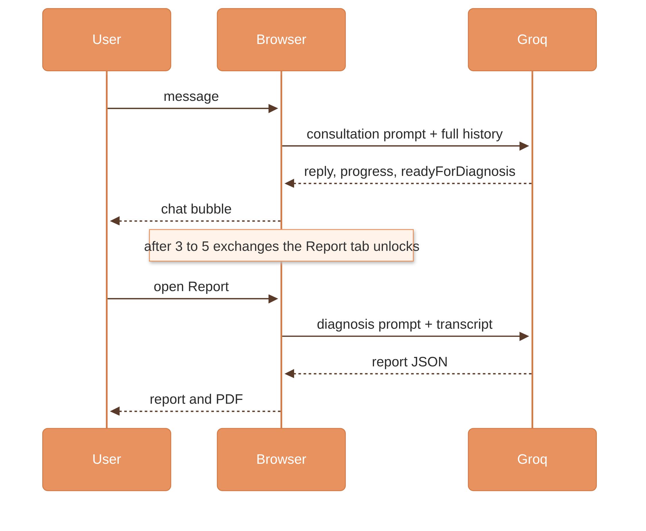

10.3 Cautions
No safety handling for crisis, medical or financial topics; remedies and costs are not vetted; the text chat has no off-topic filter (the voice mode does); the Groq key is visible in the browser.

11. Inner Voice: Voice Consultation
Files: components/VoiceConsultation.tsx, hooks/useSpeechRecognition.ts, hooks/useTextToSpeech.ts, hooks/useLanguageDetection.ts, hooks/useConsultationGuard.ts; backend POST /api/tts · Status: Implemented, not verified
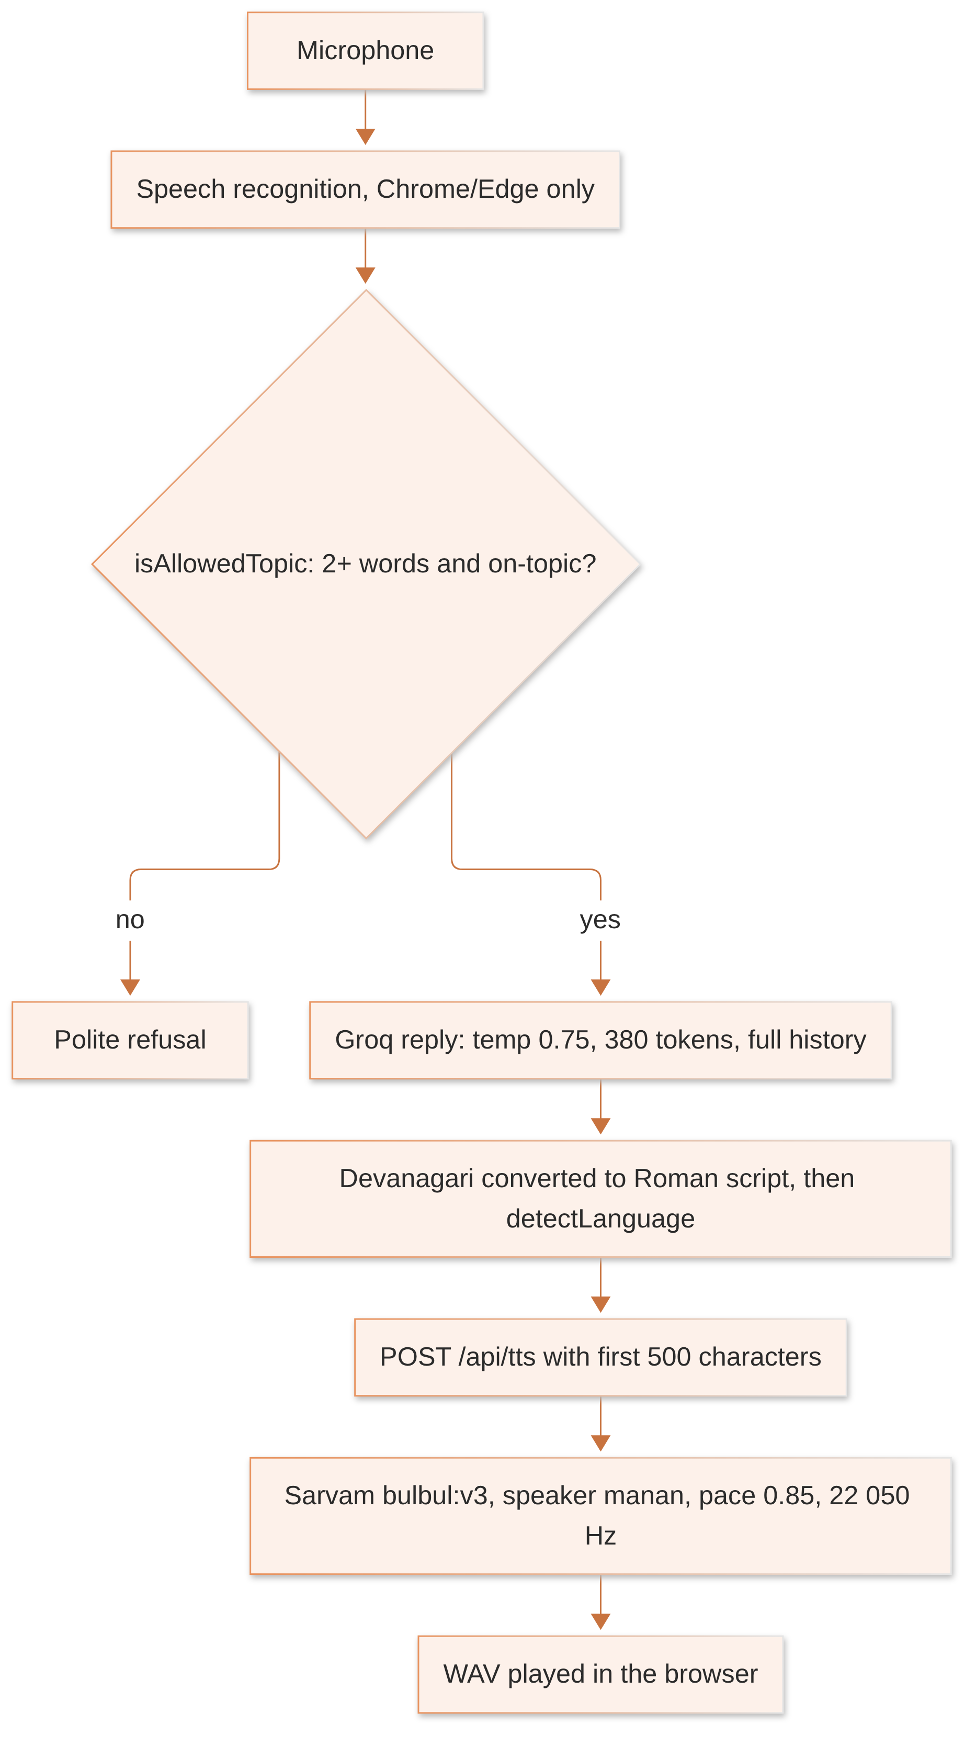
Step | Rule
Topic guard | regex deny-list (programming, sports, recipes etc.); inputs under 2 words rejected
Language for speech | starts with en → en-IN; anything else → hi-IN
Length | only the first 500 characters are spoken
Translation | any reply can be translated on demand via Groq (temperature 0.3, 400 tokens), Hindi kept in Roman script
Failure | Sarvam error → backend 502; whether the browser then falls back to its built-in speechSynthesis was not traced [UNKNOWN]
No audio is cached, so every playback costs a Sarvam call.

12. Inner Voice: Karma Score Dashboard
Route: /inner-voice/dashboard · File: pages/InnerVoiceDashboard.tsx · Status: Partially implemented
Summary: the user types their own nakshatra and dasha; the AI "calculates" three components (it cannot really); the app adds them to points from daily good actions the user ticks.

12.1 Steps
- User saves a profile: name, DOB, sign, nakshatra, dasha (stored locally, key iv_profile).
- Groq is asked to return {composite, natalBase, transitBonus, behaviorBase, scoreMessage, currentDasha, transitAlerts[], radarData[6]}.
- User ticks completed daily actions; each has points, totalling 68.
- The app computes the final score locally.

12.2 Formula
behaviorPts = sum of points of ticked actions (0 to 68)
composite = min(100, natalBase + transitBonus + round(behaviorPts ÷ 68 × behaviorBase))
Component | From | Range asked for
natalBase | AI | 0 to 40
transitBonus | AI | −20 to +30
behaviorBase | AI | 0 to 30
behaviorPts | user ticks | 0 to 68
Hypothetical example: natalBase 28, transitBonus 5, behaviorBase 29, ticked actions worth 34 points → 28 + 5 + round(34 ÷ 68 × 29) = 28 + 5 + round(14.5) = 28 + 5 + 15 = 48 (JavaScript Math.round rounds 14.5 up).

12.3 Edge cases
- No lower limit: if the AI returns a low natalBase and a negative transitBonus, the score can go below zero [inferred from the formula].
- Fallback: on any error a hard-coded result is shown as if real: composite 62, natalBase 28, transitBonus 5, behaviorBase 29.
- History: one entry per date, newest first, up to 60 days (iv_karma_v2); the chart shows the last 14.

13. Inner Voice: Karma Journal
Route: /inner-voice/journal · File: pages/InnerVoiceJournal.tsx · Status: Implemented, not verified
Aspect | Detail
Prompts | three Groq prompts: DASH_SYSTEM (daily prompts/dashboard), REFLECTION_SYSTEM (analysis of an entry), EOD_SYSTEM (end-of-day)
Entry analysis | AI returns karmaImpact, karmaScore (1–10), an affirmation and related fields
Streaks | counted locally in the browser
Storage | localStorage keys ivj_entries_v3, kj_*
Failure | static FALLBACK content
Model settings | temperature 0.7, JSON mode, token limit set per call

14. Inner Voice: Shloka Wisdom
Route: /inner-voice/wisdom · File: pages/InnerVoiceWisdom.tsx · Status: Implemented, not verified
The user describes a situation, mood and life domain. Groq (temperature 0.7, 1500 tokens, JSON mode) returns a Sanskrit verse in Devanagari, its transliteration, its source text and its meaning. Favourites are saved locally (iv_shlokas, iv_saved_mantras). The verse, its source and its translation are not checked, so the AI could misquote or invent a verse.

15. Side-by-side Comparison

15.1 Which inputs actually change the result
Input | Palm | Name report | Birth chart | Compatibility | Horoscope | Tarot | Karma
Photo of hand | landmarks + quality | – | – | – | – | – | –
Name | – | all letter numbers | hash + AI prompt | hash | – | – | AI prompt
Date of birth | – | life path, birth number | sign, life path, hash | hash only | – | – | AI prompt
Birth time | – | – | ignored | ignored | – | – | –
Birth place | – | – | city name to AI only | ignored | – | – | –
Sign chosen | – | – | – | – | AI prompt | – | AI prompt
Question | – | – | – | – | – | AI prompt | –
Daily ticks | – | – | – | – | – | – | formula

15.2 Determinism
Same input again gives… | Tools
Exactly the same result | Name Destiny numbers, Birth Chart bars, Compatibility scores, Zodiac daily panel (same day, same device), Karma formula (same components)
A different result | Daily Horoscope, Birth Chart text, Name narrative, Tarot, all Inner Voice AI output, zodiac spin-wheel

15.3 AI models by tool
Tool | Provider | Model | Temp | Max tokens
Daily Horoscope | OpenRouter | openai/gpt-4-turbo-preview | 0.8 | 800
Birth Chart | OpenRouter | google/gemma-4-31b-it:free | default | 1800
Name narrative | OpenRouter | google/gemma-4-31b-it:free | default | 900
Tarot | OpenRouter | google/gemma-3-27b-it | default | 2000
Palm (unused endpoint) | OpenRouter | anthropic/claude-3.5-sonnet | default | 3000
AI Guru chat | Groq | gpt-oss-120b (default) | 0.7 | 1000
Diagnosis | Groq | same | 0.6 | 4000
Inner Voice hub | Groq | same | 0.7 | 1500
Karma Score | Groq | same | 0.7 | 1000
Journal | Groq | same | 0.7 | per call
Wisdom | Groq | same | 0.7 | 1500
Voice reply / translate | Groq | same | 0.75 / 0.3 | 380 / 400
Speech | Sarvam | bulbul:v3, speaker manan | 0.4 | ≤ 500 characters
Whether each model ID is still available from its provider is unknown.

15.4 What happens when something fails
Tool | Failure | What the user sees
Palm | quality gate fails | specific error message
Name report | AI fails | template text, indistinguishable from real
Birth Chart | AI fails | static text + pseudo-scores, no error
Compatibility | – | no AI involved
Horoscope | AI fails | "Failed to generate horoscope"
Tarot | AI fails | static fallback reading
AI Guru | bad reply / network | canned greeting / apology
Diagnosis | bad reply | no report
Karma Score | AI fails | hard-coded 62 shown as real
Journal | AI fails | static fallback
Voice | Sarvam fails | backend 502; browser behaviour not traced

16. Known Issues per Tool
Tool | Issue | Priority
All Inner Voice tools | Groq API key visible in the website's JavaScript; anyone can copy and use it | P0
All backend AI tools | no login, rate limit or timeout; 20 MB request limit; costs can be run up by anyone | P0
Palm | lines are templates, not detected; unused paid AI endpoint left open | P1 / P2
Name report | AI failure returns fake text with success status; non-Latin names lose letters; table sources undocumented | P1
Birth Chart | not a real chart; time unused; fixed 5.6 s wait; silent failure | P1
Compatibility | scores ignore astrology; chat canned; AI call commented out | P1
Horoscope | not cached, not dated, sign not validated | P1
Zodiac panel | random moon phase and planets presented as daily facts | P1
Tarot | card count not validated; example numbers in prompt | P2
AI Guru | no safety handling; conversation not saved; history grows without limit | P1
Karma Score | AI asked to "calculate" values it cannot; no lower clamp; fake fallback | P1
Shloka Wisdom | verses unchecked | P2
Shared | two different life-path implementations (33 handled differently) | P2
Shared | /inner-voice marketing copy claims natal/transit/dasha calculation that does not exist | P1

17. Open Questions
- Should these tools be positioned as entertainment (with disclaimers) or as accurate astrology? If accurate, a real ephemeris, sidereal zodiac, timezone handling and geocoding are needed.
- Should palm reading keep templates, attempt real line detection, use the vision AI endpoint, or be removed?
- Should compatibility use a recognised method such as Ashtakoota (Guna Milan)?
- Who approves the numerology tables, the planet-relationship matrix and the score weights?
- Should the daily horoscope be generated once per sign per day and cached?
- Should Inner Voice conversations and readings be saved per user, and with what consent and retention?
- What disclaimers and safety rules should the AI Guru follow for health, money and crisis topics?
- What are the exact curviness scale and personality-score seeding in the palm engine? (Not recorded in the notes.)

18. Verification Statement
This guide was prepared solely from the supplied investigation notes. No tool, server, AI provider or test was run to produce it. Formulas, constants and thresholds are as recorded from the source code; worked examples are either taken from the notes or are clearly labelled hypothetical and calculated by hand from the recorded formulas. Items marked [UNKNOWN] could not be established from the notes. No credentials or secret values are included.

