PROJECT DOCUMENTATION
Astro Platform
Astrology · Guru Ji Consultations · Devotional Services
Product, business and technical overview · 22 October 2026

Contents
About this document 3
1. Project Overview 3
1.1 What the platform is 3
1.2 Problems it solves 3
1.3 Types of users 3
2. Main Modules and Features 4
3. Guru Ji Onboarding 5
4. Guru Ji Dashboard 6
5. Admin Panel 7
6. Booking and Payment Workflows 7
6.1 Guru Ji consultation 8
6.2 Pooja booking 8
6.3 Exceptions 8
7. Astrology and AI Guru 9
7.1 Calculation vs AI — the key difference 9
7.2 What exists today vs what is needed 9
7.3 How AI Guru should work (proposed) 9
8. Supporting Features 10
9. How the Modules Connect 10
10. Development Roadmap 11
11. Important Business Rules 11
12. Open Questions and Next Steps 12
Summary 12

About this document
This document explains what the Astro platform is, what already exists, what needs to be built, and in what order. It is written for developers, stakeholders and non-technical team members.
Item | Detail
Sources | The project brief, and the earlier code investigation of branch dev-vishwa (commit 58a6f0e)
Prepared | 22 October 2026
Testing | No feature has been tested end-to-end. "Exists" means the code is there, not that it is proven to work
Status labels used throughout
Label | Meaning
Exists – needs verification | Code is present and connected, but has not been tested end-to-end
Partial | Some parts exist; important parts are missing or only shown on screen
Proposed | Not built yet. A recommendation or new requirement
Decision required | Cannot be built until the business decides something

1. Project Overview

1.1 What the platform is
The Astro platform is a website where people can:
- get astrology readings and reports,
- book consultations with verified astrologers and priests (Guru Jis),
- book poojas and offerings at temples,
- watch temples live (Live Darshan),
- chat with an AI Guru for guidance.
An admin team runs the platform: it approves Guru Jis, manages services and prices, and handles bookings, payments and complaints.

1.2 Problems it solves
For | Problem today | What the platform gives them
Customers | Hard to find a trustworthy astrologer or book a pooja at a distant temple | Verified Guru Jis, clear prices, online booking and payment, status updates
Guru Jis | Hard to reach customers and manage bookings and earnings | A profile, a booking calendar, and a dashboard showing earnings and payouts
Admin team | Manual handling of people, bookings and money | One panel to approve, manage, track and report on everything

1.3 Types of users
User | What they do | Status
Visitor | Browses readings, temples and Live Darshan without logging in | Exists – needs verification
Customer | Has an account; books, pays, reviews | Accounts exist; booking and payment are Proposed
Guru Ji | Offers consultations; manages schedule and earnings | Proposed (no Guru Ji role exists yet)
Admin | Manages Guru Jis, services, bookings, content | Admin role exists; most admin tools are Proposed
Super Admin | Controls admin roles and platform settings | Role exists; no extra tools yet
Support staff | Handles complaints and disputes | Proposed
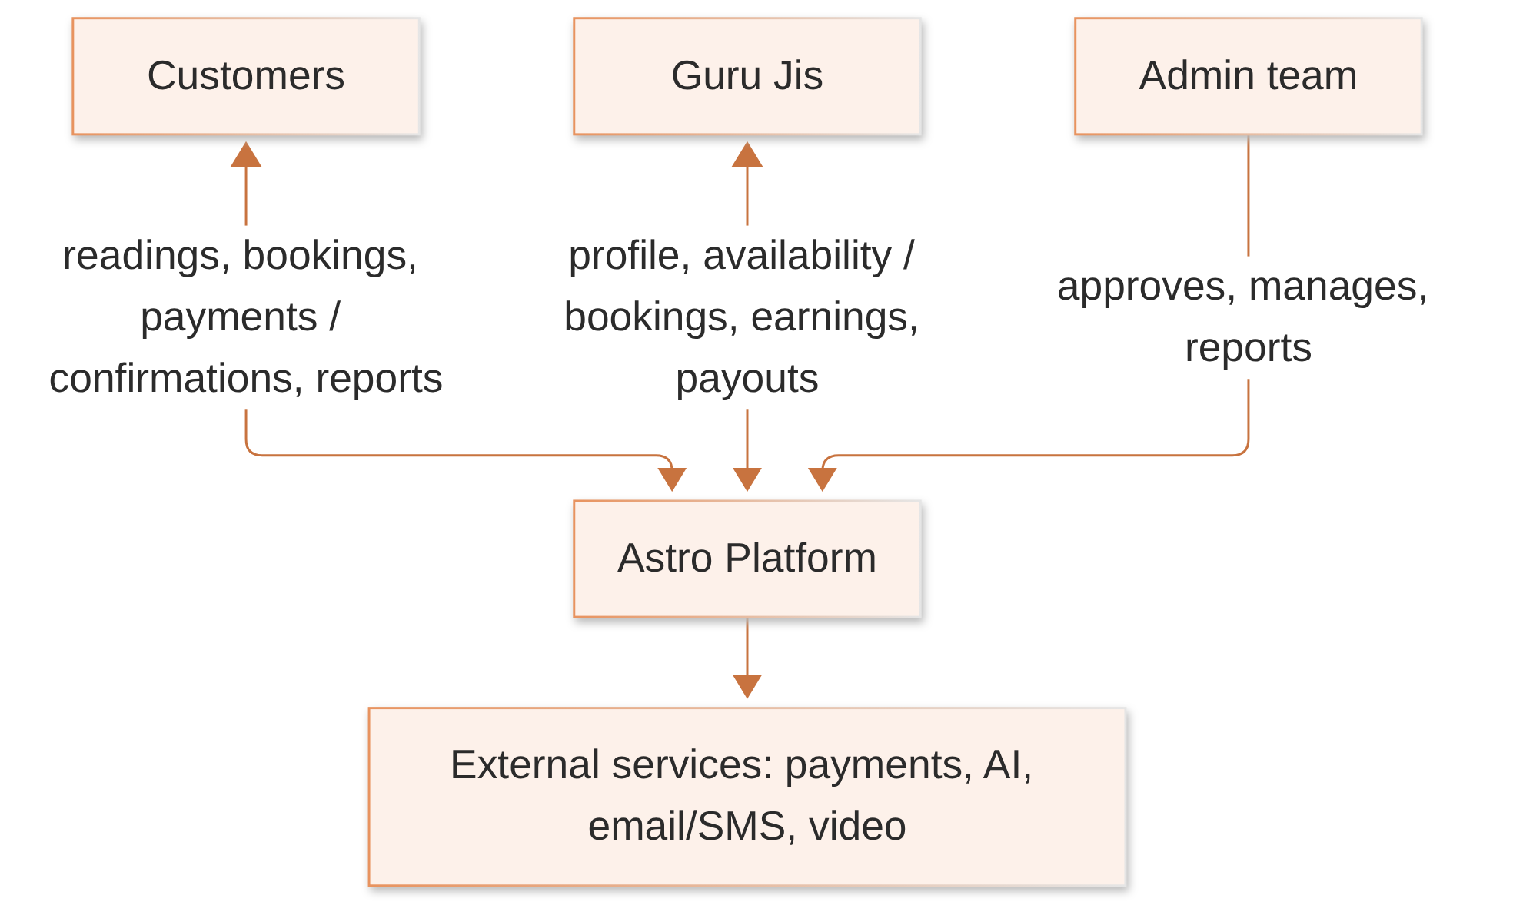

2. Main Modules and Features
# | Module | Main features | Status
1 | Customer Website and Accounts | Email/password sign-up, email OTP, phone OTP, Google sign-in, password reset. Proposed: profile page, saved family profiles, account deletion | Exists – needs verification (accounts); Proposed (profile features)
2 | Guru Ji Registration and Onboarding | Sign-up, profile, documents, admin approval | Proposed
3 | Guru Ji Dashboard | Bookings, availability, earnings, payouts, reviews | Proposed
4 | Admin Panel | Exists: manage temples, poojas, offerings (chadhawa), shop products and images. Proposed: everything else in Section 5 | Partial
5 | Guru Ji Discovery and Consultation Booking | Search, filter, Guru Ji profiles, book a slot | Proposed
6 | Pooja and Temple Booking | Exists: temple and pooja listings with prices. Missing: the "Book" button does nothing; no booking records | Partial
7 | Astrology and Kundli | Exists: sun sign by date, numerology. Not real: birth-chart and compatibility scores. Missing: Kundli | Partial
8 | AI Guru Chat | Chat, diagnosis report, voice replies. Runs from the browser; history not saved | Partial
9 | Payments, Refunds, Commissions, Payouts | No payment system exists (the ₹499 "unlock" is a demo) | Proposed
10 | Content Management | Catalogue editing exists; blog and page content are hard-coded | Partial
11 | Notifications and Communication | Only sign-up OTP and password-reset emails, and phone OTP | Partial
12 | Customer Support and Disputes | Contact form only pretends to send | Proposed
13 | Reviews, Ratings and Verification | None | Proposed
14 | Marketing and Retention | Newsletter form only pretends to subscribe; referral code is accepted but unused | Proposed
15 | Technical Infrastructure and Security | Login roles, hashed tokens, image hosting. Known gaps: exposed AI key, no rate limits, weak OTP protection, no monitoring or backups | Partial

3. Guru Ji Onboarding
Status: Proposed. Nothing in this section exists yet.
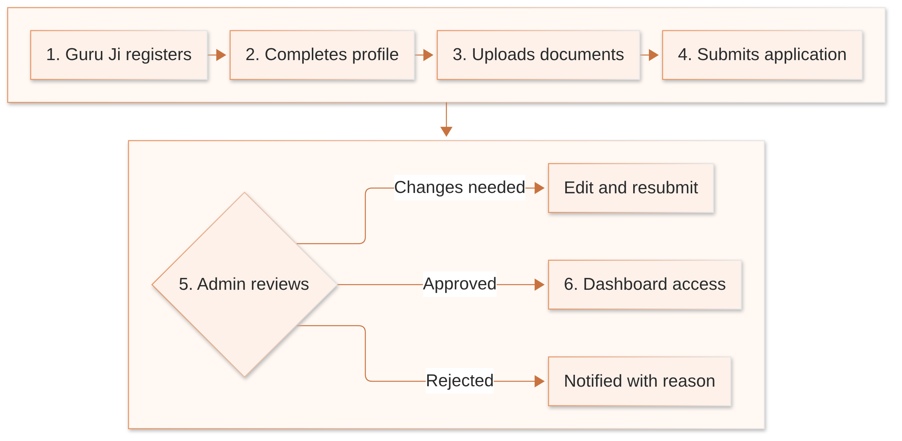
Step | What happens
1. Register | Guru Ji signs up and verifies email and phone with a one-time code (OTP). The account starts as Applicant, not yet visible to customers.
2. Personal and professional details | Full name, city, contact details, years of experience, languages spoken.
3. Profile | Photo, short biography, specializations (e.g. Vedic, Numerology, Tarot, Vastu, Pooja services).
4. Services and pricing | Services offered, consultation type (chat, call, video — Decision required), price per session or per minute.
5. Availability | Working days, hours and time slots.
6. Documents | Identity proof and any qualification certificates. The exact list is a Decision required. Documents are visible only to the Guru Ji and admins.
7. Submit | Application is locked and sent for review. Guru Ji is notified that it was received.
8. Admin review | Admin checks the profile and documents, and may add internal notes.
9. Decision | Approved: profile goes live. Rejected: reason shared. Changes requested: Guru Ji edits and resubmits.
10. Notifications | Guru Ji gets a message at each status change (channel: Decision required).
11. Dashboard access | Full Guru Ji Dashboard opens only after approval.
Application statuses (proposed): Draft → Submitted → Under review → Approved / Rejected / Changes requested → Resubmitted.

4. Guru Ji Dashboard
Status: Proposed.
Area | What the Guru Ji can do
Profile and documents | Update photo, biography, languages, services; replace expired documents (big changes may need re-approval)
Availability | Set working hours, block leave days, pause bookings
Bookings | See upcoming, ongoing and completed sessions; join a session; mark it complete
Earnings | See earnings per booking, platform commission deducted, and balance due
Payouts | See payout history and status
Reviews | Read ratings and reviews; reply if allowed
Performance | Sessions completed, average rating, repeat customers, cancellations
Notifications and support | New bookings, reminders, payout alerts; raise a support ticket
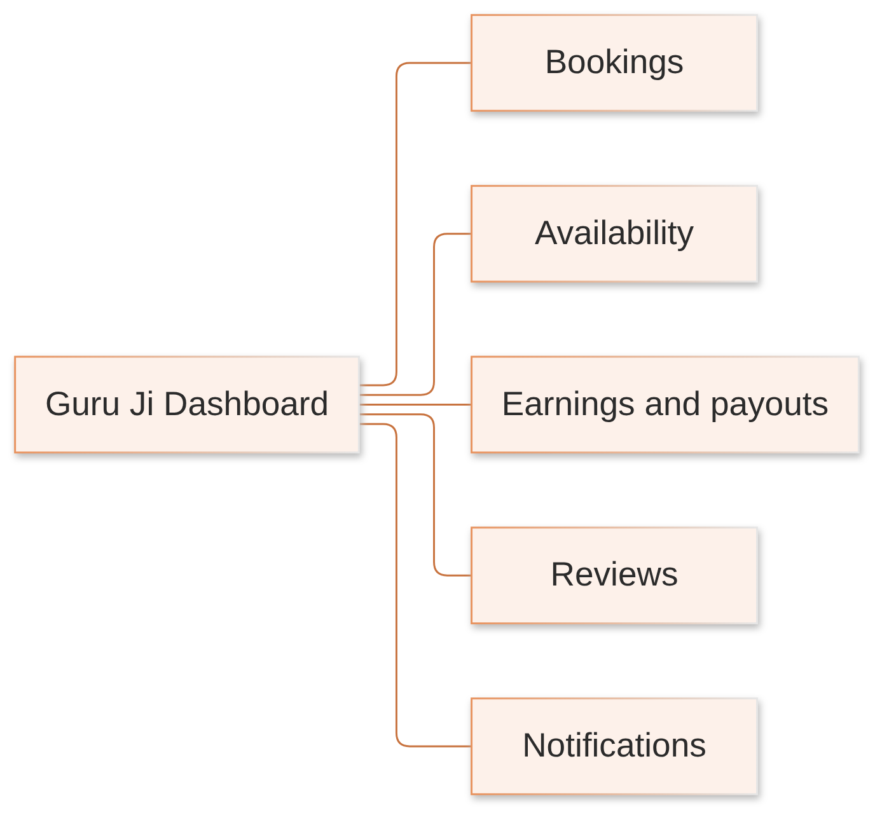
Access rule: a Guru Ji sees only their own profile, bookings, earnings and reviews. Customer contact details are shown only where needed for a booking.

5. Admin Panel
The Admin Panel is the control room of the platform.
What exists today: admin login, and screens to manage temples, poojas, offerings (chadhawa), shop categories and products, with image upload. The admin home page shows only the admin's own name. Everything else below is Proposed.
Group | Features | Status
Overview | Business statistics: bookings, revenue, new users, pending applications | Proposed
People | Guru Ji applications and verification; customer accounts; block or deactivate users | Proposed
Services | Services, prices, temples, poojas, offerings, products | Partial (catalogue exists)
Bookings and money | Consultation and pooja bookings; payments, refunds, commissions, payouts | Proposed
Content | Pages, blog, temple information, Live Darshan channels | Partial (temple content only)
Trust and safety | Reviews moderation, complaints, disputes | Proposed
Growth | Coupons, promotions, referrals | Proposed
Communication | Send notifications and announcements | Proposed
Reports | Reports and exports (bookings, revenue, payouts) | Proposed
Control | Admin roles and permissions, audit log of admin actions, platform settings | Partial (roles exist; no role management screen, no audit log)
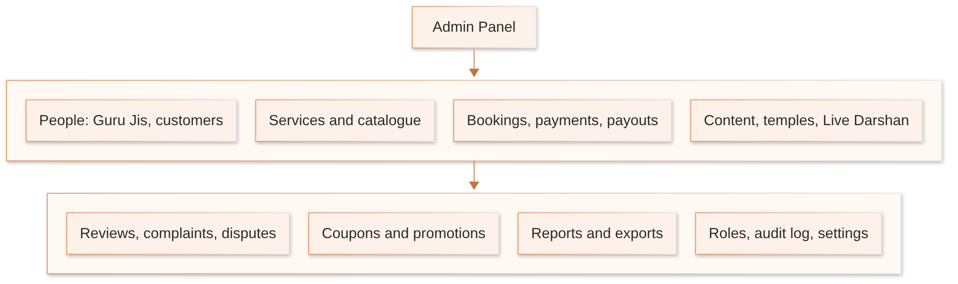

6. Booking and Payment Workflows
Status: Proposed. Today there are no booking, order or payment records. The pooja, offering, shop and donation buttons are on screen but do nothing.
Payment timing depends on business policy. Options include full prepayment, a deposit, or pay-after-service. This is a Decision required, so the flows show "payment if required".

6.1 Guru Ji consultation
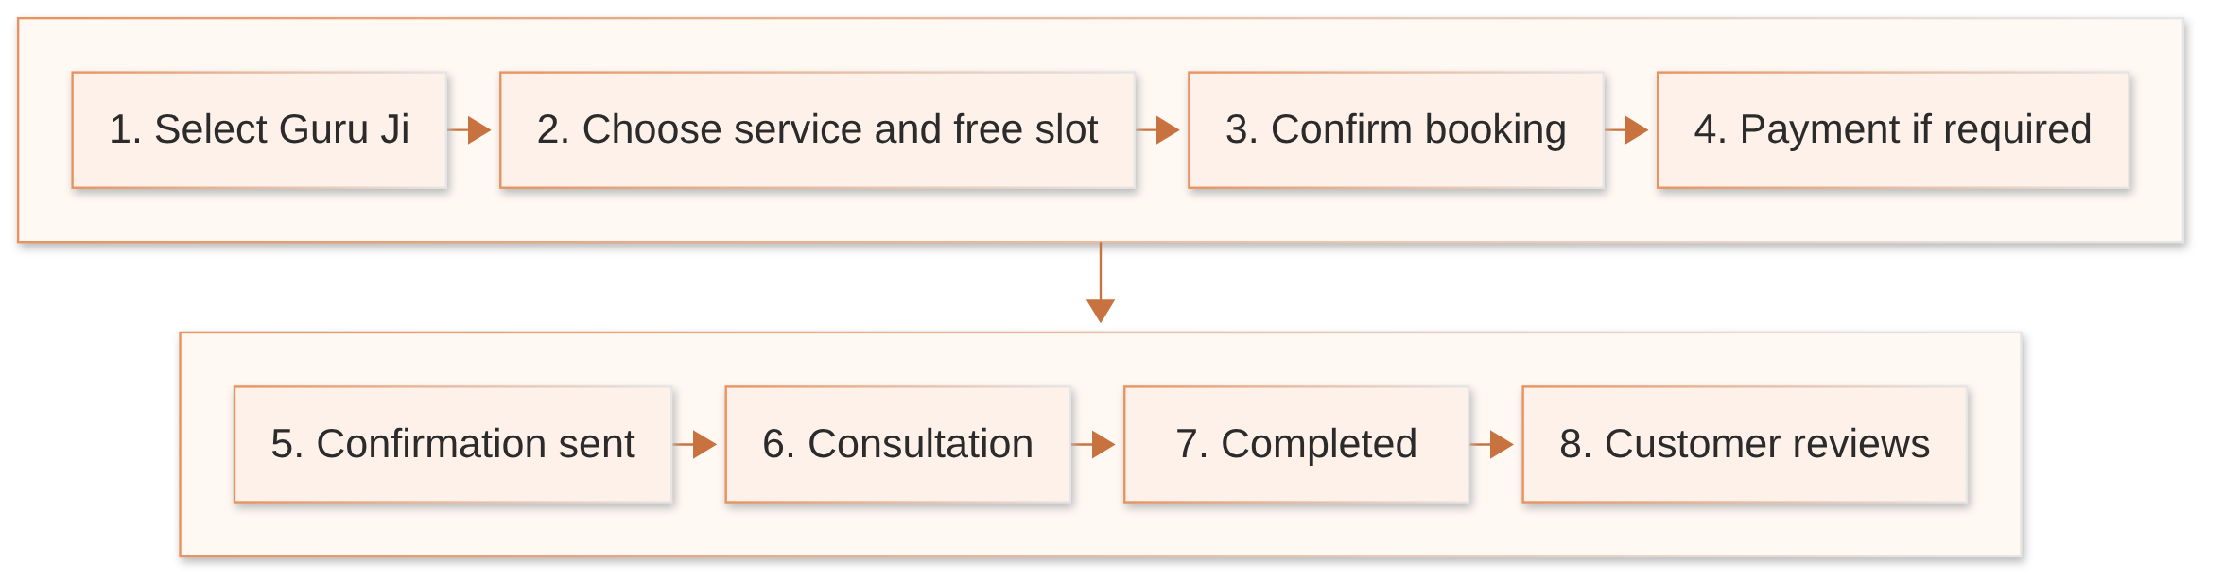
Key points:
- The slot is checked again just before confirmation, so two people can't book the same slot.
- Reminders go to both sides before the session.
- After completion, the Guru Ji's earning (price minus commission) is recorded for payout.

6.2 Pooja booking
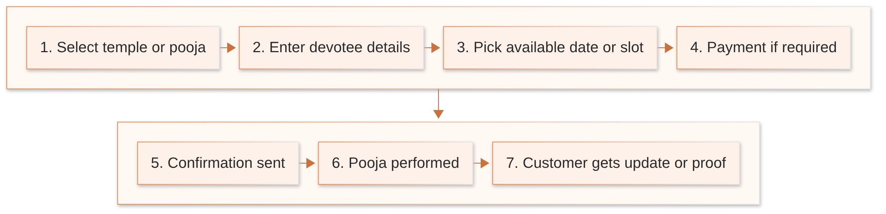
Devotee details might include name, gotra, family names and a wish (sankalp). The exact fields are a Decision required. What proof is sent (photo, video, prasad delivery) is also undecided. Current page text promises a certificate and prasad that nothing supports yet.

6.3 Exceptions
Situation | Proposed handling
Customer cancels | Allowed until a cut-off time; refund amount per refund policy (Decision required)
Guru Ji cancels / no-show | Full refund or free rebooking; counts against Guru Ji performance
Reschedule | Move to another free slot, within a limit on how many times
Payment fails | Booking stays "Payment pending" for a short time, then the slot is released
Refund | Requested → approved by admin (or automatic by rule) → sent back through the payment provider → recorded
Booking statuses (proposed): Pending payment → Confirmed → In progress → Completed / Cancelled / Refunded / Disputed.

7. Astrology and AI Guru

7.1 Calculation vs AI — the key difference
Type | What it means | Can be trusted to be the same every time?
Calculation | Maths based on birth date, time and place (e.g. planet positions) | Yes
AI interpretation | Text written by an AI model explaining or advising | No — wording changes each time
The platform must always show users which is which.

7.2 What exists today vs what is needed
Feature | Today | Proposed
Birth details | Entered on each page; not saved | Saved birth profiles, including family members
Sun sign | Calculated from date only (Western dates) | Confirm system (Vedic or Western)
Numerology | Real calculation | Keep; get rules approved by an expert
Birth chart / Kundli | Not real. Scores come from a formula on the name, not astrology; birth time is ignored | Real Kundli using accurate planet calculations, time zone and birth place
Daily horoscope | AI-written on each click; not tied to the date | One horoscope per sign per day, saved
Compatibility | Not real. Scores come from the two names | Real matching method (e.g. Guna Milan) — Decision required
Palm reading | Detects the hand; the lines shown are templates | Keep, improve, or remove — Decision required
AI Guru chat | Works; history lost on refresh; AI key exposed in the browser | Run through the server; save history; usage limits

7.3 How AI Guru should work (proposed)
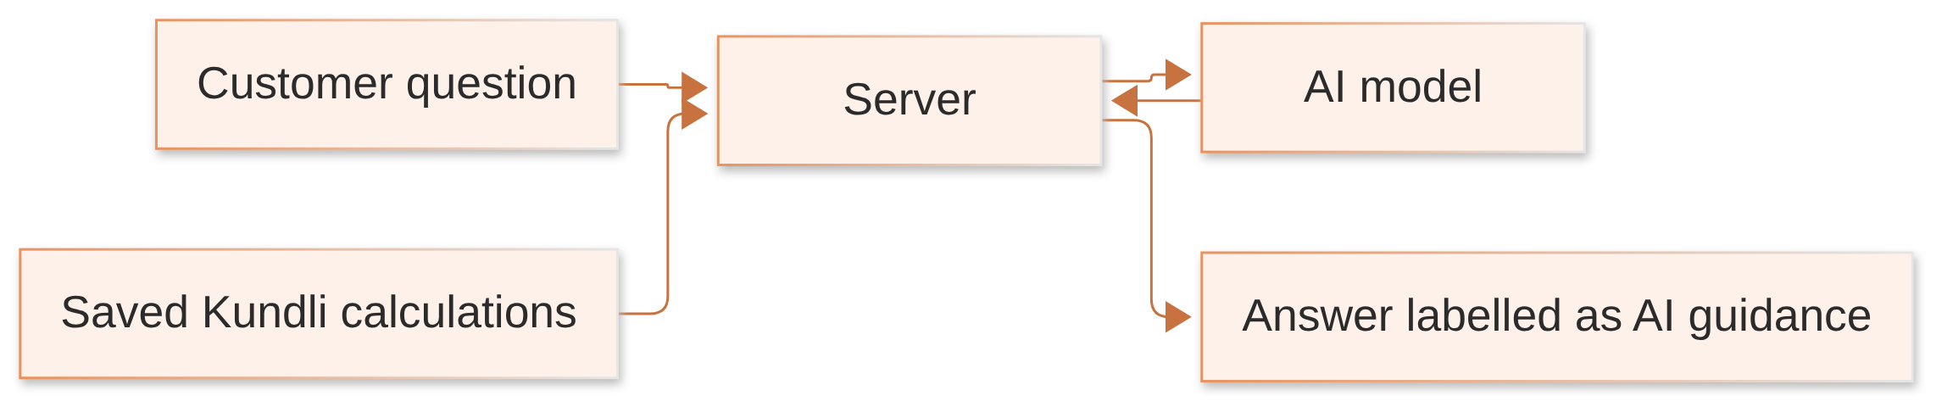
- Uses real data: the server gives the AI the customer's calculated chart. The AI explains it but never invents planet positions.
- Languages: reply in the customer's language. Hindi, English and Hinglish exist today in parts. The launch list is a Decision required.
- Suggested questions: shown to help users start (a version exists today).
- History: saved per customer, with the option to delete.
- Limits and cost: daily message limit or paid credits per user, plus admin view of AI cost.
- Errors: show a clear "please try again" message. Today some tools silently show made-up fallback numbers instead.
- Safety: add disclaimers for health, money and emotional-crisis topics.

8. Supporting Features
Feature | Today | Proposed
Content management | Temples, poojas, offerings, products editable by admin | Pages, blog, banners, FAQs editable without code changes
Temples and Live Darshan | Temple listings; Live Darshan detects when a temple's YouTube stream is live | Fix fake "LIVE" labels and viewer counts; admin can manage channels
Notifications | OTP and password-reset emails; phone OTP | Booking, payment, reminder and payout messages by email, SMS or WhatsApp (Decision required)
Support and disputes | Contact form pretends to send | Ticket system; dispute flow linked to bookings and refunds
Reviews and ratings | None | Only customers with completed bookings can review; admin moderation
Promotions and referrals | None working | Coupons, referral rewards; a coins wallet with a joining bonus has been discussed (Decision required)
Reports and analytics | None | Revenue, bookings, Guru Ji performance, AI usage
Security and operations | Roles, hashed tokens | Fix exposed AI key and weak OTP protection first; rate limits, backups, monitoring, audit logs

9. How the Modules Connect
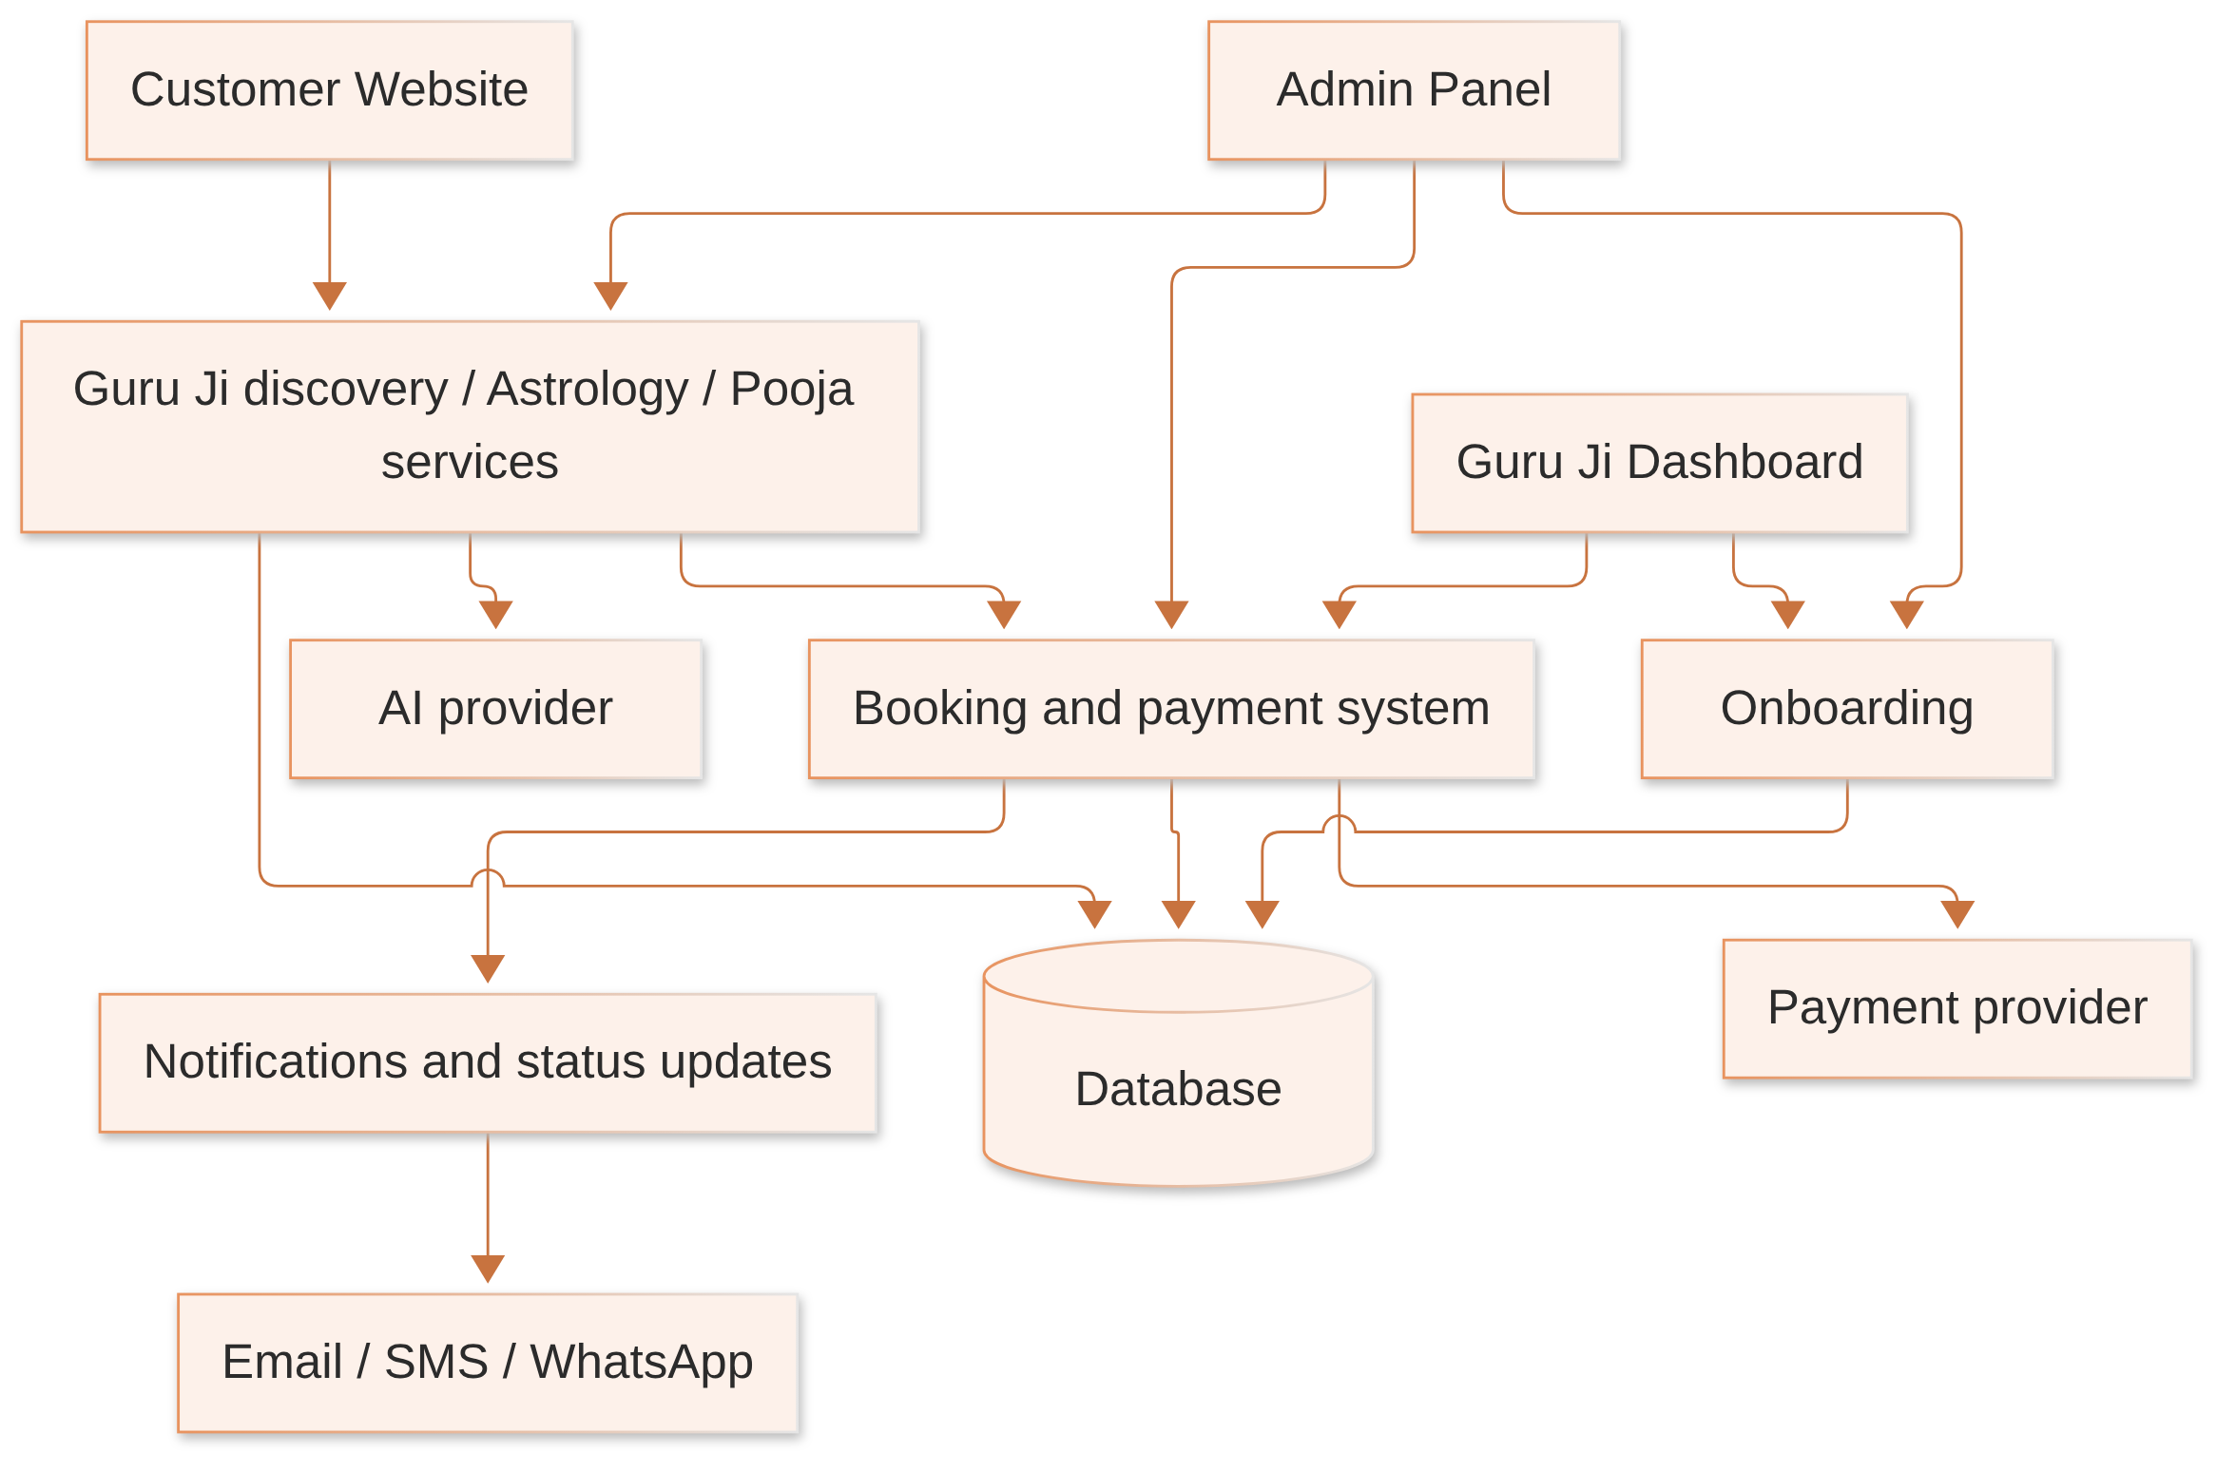
- Customer Website: where customers find services and book.
- Booking and payment system: the centre. It checks availability, takes payment, and records every booking and its status.
- Guru Ji Dashboard: reads the Guru Ji's own bookings and earnings, and writes their availability.
- Admin Panel: manages users, Guru Jis, services, bookings, payments and content.
- Database: stores accounts, Guru Ji profiles, services, bookings, payments, payouts, reviews and content. Today it holds only accounts, the temple/pooja/shop catalogue and Live Darshan channels.
- External services: a payment gateway, an AI provider, messaging providers, and video/call tools if needed. Image hosting and YouTube are already used.

10. Development Roadmap
Before Phase 1 (Proposed): fix the critical security issues already found: the AI key exposed in the browser, missing rate limits, and weak OTP protection.
Phase | Objective | Includes | Expected outcome
1 — Platform Operations | Let the team run the platform | Guru Ji onboarding and verification, Admin Panel, Guru Ji Dashboard, customer profiles, service and pricing management | Approved Guru Jis with live profiles; admins in control
2 — Bookings and Payments | Let customers book and pay | Consultation booking, full pooja booking, payments and refunds, commissions and payouts, notifications and support | First paid bookings completed end to end
3 — Astrology and AI | Make readings accurate and trusted | Real Kundli calculations, horoscope and compatibility reports, AI Guru using real chart data, consultation channels for launch | Reliable reports; AI answers based on real calculations
4 — Growth and Automation | Grow and keep customers | Content management, promotions and referrals, analytics, retention, advanced moderation and automation | Repeat customers and less manual work
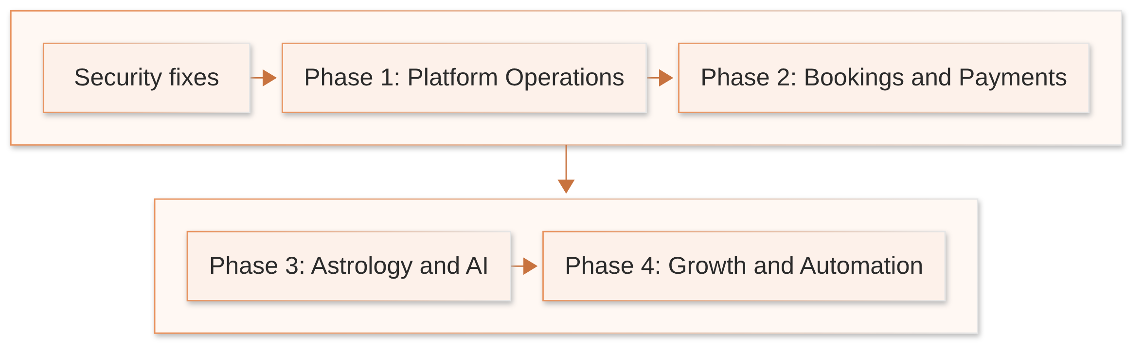
No deadlines or effort estimates are given; these depend on team size and the open decisions below.

11. Important Business Rules
All rules are Proposed unless the "Today" column says otherwise.
Rule | Today
Only approved Guru Jis can offer services | Not applicable yet (no Guru Jis)
Users only see information they are allowed to see | Admin pages are protected; other roles don't exist yet
Availability is checked before a booking is confirmed | No bookings yet
A booking is marked "paid" only after the payment provider confirms it | No payments yet
Refunds follow an approved process | No refunds yet
Every commission and payout can be traced to its booking | No payouts yet
Admin changes to important records are logged | No audit log today
Calculations and AI text are clearly labelled | Not today: some AI and made-up numbers look like real results

12. Open Questions and Next Steps
# | Question | Status
1 | Which consultation types launch first (astrology, numerology, tarot, pooja guidance…)? | Decision required
2 | Chat, audio, video, or a mix? Which provider? | Decision required
3 | Which documents verify a Guru Ji? | Decision required
4 | Commission rate, payout schedule and minimum payout | Decision required
5 | Payment gateway; prepaid vs deposit vs pay-later rules | Decision required
6 | Refund and cancellation policy | Decision required
7 | Messaging channels: email, SMS, WhatsApp | Decision required
8 | Coins wallet and joining bonus: in or out of the first release? | Decision required
9 | Vedic or Western astrology; which calculation library or service | Decision required
10 | Pooja fulfilment: who performs it, what proof is sent, prasad delivery | Decision required
11 | Which features must be ready for the first release? | Decision required
12 | Database: the code uses PostgreSQL, but a move to MongoDB/Neon has been mentioned. Which is final? | Needs verification
13 | Where will the platform be hosted? | Decision required
Next steps
- Answer questions 1–8 and 11.
- Fix the security issues listed in Section 10.
- Start Phase 1.

Summary
What this document covers: the platform's purpose and users, all 15 modules with honest status, Guru Ji onboarding, the Guru Ji Dashboard, the Admin Panel, booking and payment flows, astrology and AI Guru, supporting features, how the parts connect, a four-phase roadmap, business rules and open decisions.
Needs verification (code exists, untested): customer sign-up and login, the temple/pooja/offering/shop catalogue and its admin screens, Live Darshan live detection, AI Guru chat.
Needs to be built: Guru Ji onboarding and dashboard, most of the Admin Panel, all bookings and payments, refunds, commissions and payouts, real Kundli and compatibility, reviews, support, promotions, reports, and monitoring.
Open business decisions: consultation types and channels, Guru Ji documents, commission and payout rules, payment and refund policy, messaging providers, coins wallet, astrology system, pooja fulfilment, first-release scope, database and hosting.
This document was prepared from the supplied brief and the earlier code investigation. Nothing was run or tested to produce it. No passwords, keys or other secrets are included.

