Question 1

Frequent patterns:

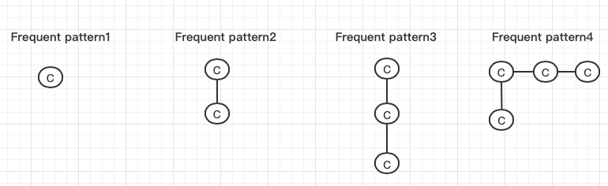

*Figure 1*

For frequent pattern1, it appears 5 times in the graph database D.

For frequent pattern2, it occurs 5 times in the graph database D.

For frequent pattern3, it occurs 5 times in the graph database D.

For frequent pattern4, its occurrence frequency is 4.

Question2

(1)

$$Rank\left(u_{0}\right)=\frac{1}{3}=0.3, Rank\left(u_{1}\right)=\frac{2}{4}=0.5 , Rank\left(u_{2}\right)=\frac{1}{4}=0.25$$

$$Rank\left(u_{3}\right)=\frac{2}{2}=1 , Rank\left(u_{4}\right)=\frac{2}{2}=1, Rank\left(u_{5}\right)=\frac{1}{2}=0.5$$

$Rank\left(u_{6}\right)=\frac{2}{1}=2, Rank\left(u_{7}\right)=\frac{3}{1}=3 , Rank\left(u_{8}\right)=\frac{3}{1}=3$.

Hence, $u_{2}$ is selected as the root node.

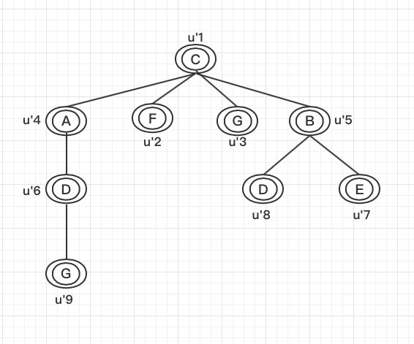

NEC tree $q^{'}$

$u_{1}^{'}$ has been selected as the root node in the previous step, then performing BFS from root node and merging vertices from same NEC into a single vertex.

(2)

In query q, non-tree edges include AB, AC, BC, BD, DE, BE in any spanning tree.

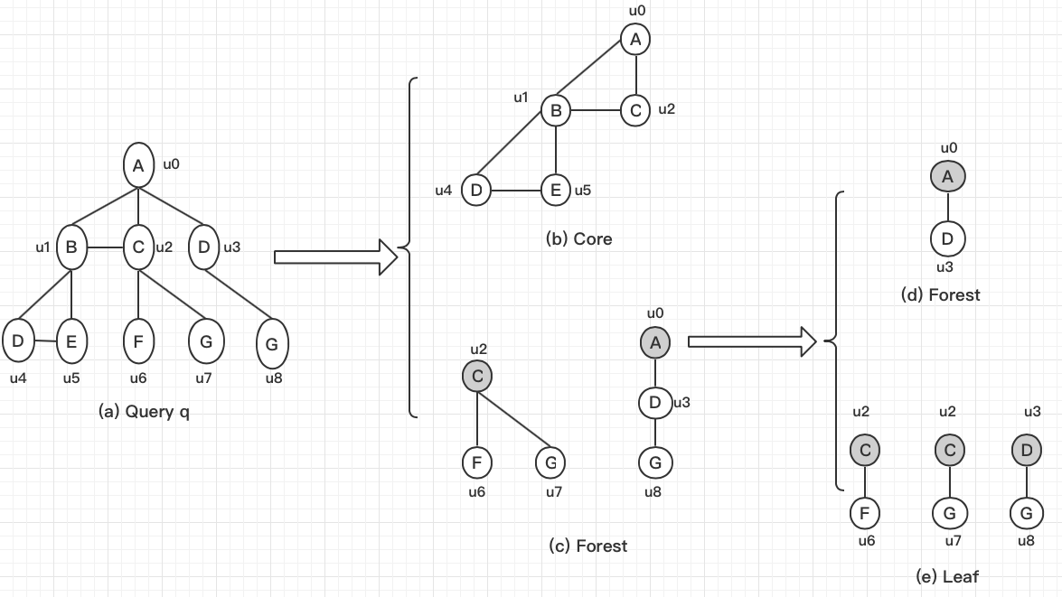

The Core-Forest-Leaf decomposition of query q

Question 3

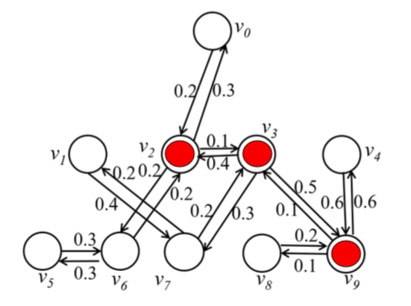

*Figure 2*



Table 1

As can be seen from table1, v3 as an activated seed would produce largest influence spreads. In fact, from figure 2, we could find that the vertex having more degree such as v2, v3, v9 and being regarded as seed would generate larger influence spreads. Moreover, the largest sum of factors derived from the vertex having the most degree after first expanding may produce the largest influence spreads.