Description of the Java project with class diagram

Class diagram of the project:
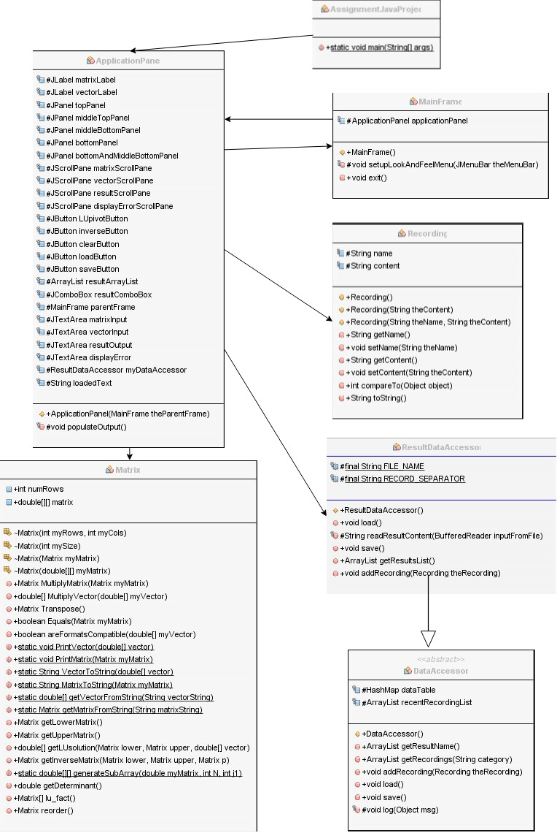
Description of the structure of the project:

Our projects consists in seven classes in a java package. In the following figure is an example of use of our project.
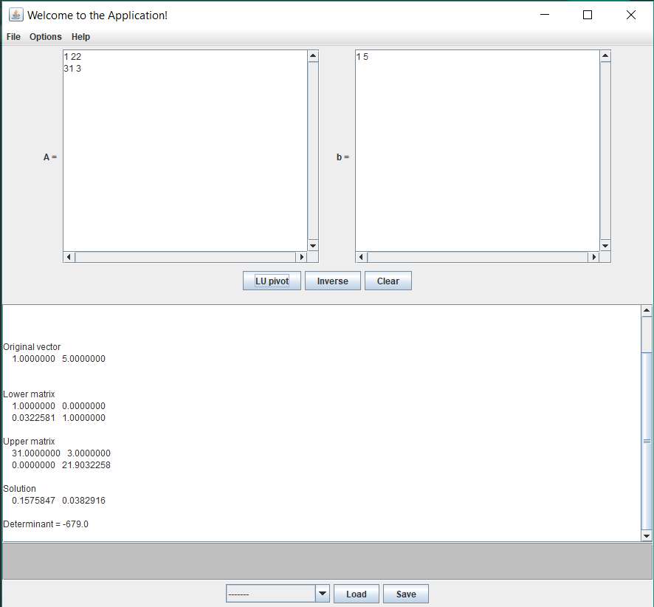
Figure 1: Usage of our application to calculate a LU pivot of a matrix 2x2

As can be seen, a matrix A can be input in the top left part of our application. At the top right part a vector b can also be input. Once that is done, the user can click on the “LU pivot” button to generate a lu pivot in the output at the bottom. He can also generate the inverse of the matrix by clicking on the “Inverse” button. If the bottom text is not empty, the user can clear it using the clear button. He can then save his result by clicking on the “Save” button. All the saved results are put inside of the result.db file in the project. Every result saved this way can be loaded by choosing one of the results in the combo box and clicking on the load button, as shown in the next figure.
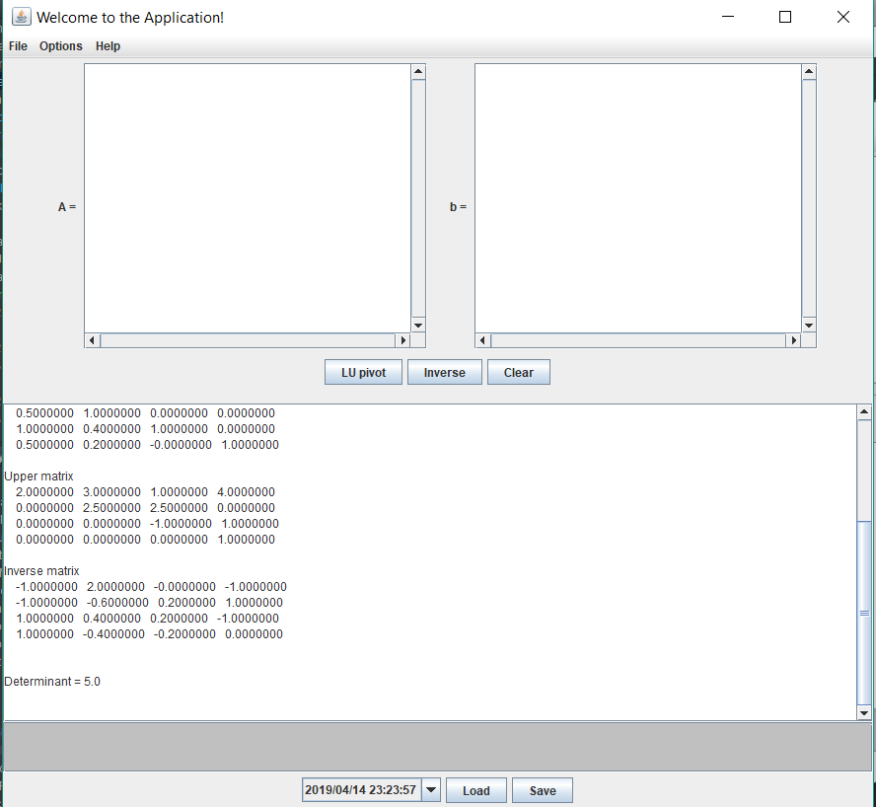
Figure 2: Loading a previous result

As can be seen, every result is saved with the current date in the format yyyy/mm/dd hh:mm:ss as its name and as its key in the datatable. This is to make the saving of results really easy, just by clicking on the save button. We have also decided to keep the bottom part possible to edit if the user wants to change the result in some way. Moreover, if the matrix cannot be pivoted, an appropriate error message is shown as can be seen in the next figure. A similar message is shown if the matrix cannot be inverted.
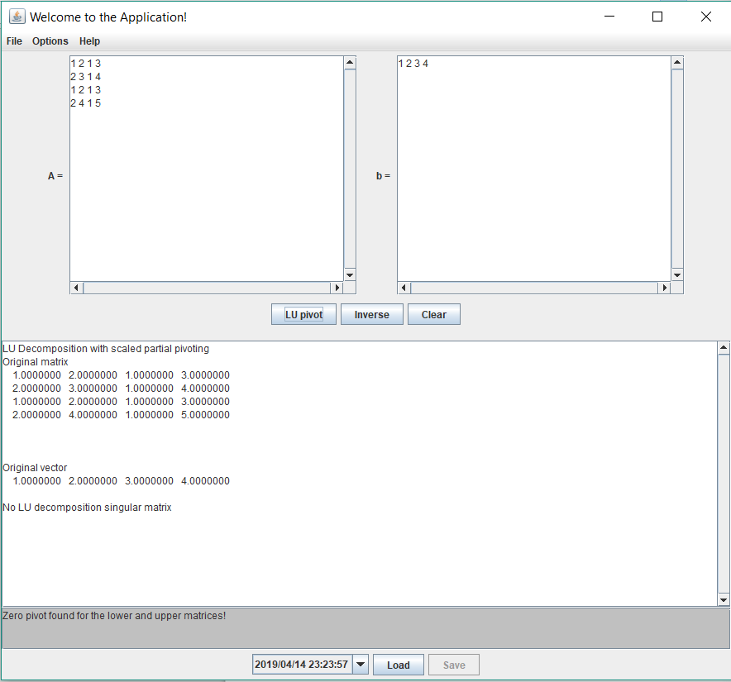
Figure 3: error message shown when the matrix cannot be pivoted

This interface was coded by using swing. We save the results as recordings, objects of the Recording class that have a name (string) and content (string), where the name is the current date as previously described, and the content is what is shown in the output at the bottom of the page. We have used for the database a similar approach to that seen during the exercises with data accessors and result.db that contains all our saved results. Additionnaly, we have implemented a Matrix class that handles all the calculations related to the matrices and the format of the matrices themselves. This is how we can find the LU pivot and the inverse for the input of the user. The output at the very bottom of the application contains the errors and cannot be edited. It has a length of three lines because it is the size of our longest error message. With this structure, we were able to implement the interface for the user to find LU pivots and inverses, and save and load his results.

