As per discussion over skype call I made below flow chart with requirement which users will have. Please check below chart and please add requirements if I forget to mention.

**Scenario**

* SMME will do application to the Incubator
* Admin will approve the application for the selected incubator
* Incubator will got notification on dashboard
* Incubator will contact SMME and make agreements based on application
* Once Agreement ready incubator will upload and it will shown to Admin and SMME

**Questions**

* What is the functionality after incubator made agreement with SMME?
* Who will upload Knowledge Centre Resources?
* What will calendar show and who will insert data into the calendar?
* If anything else please let us know

**SMME**

Dashboard

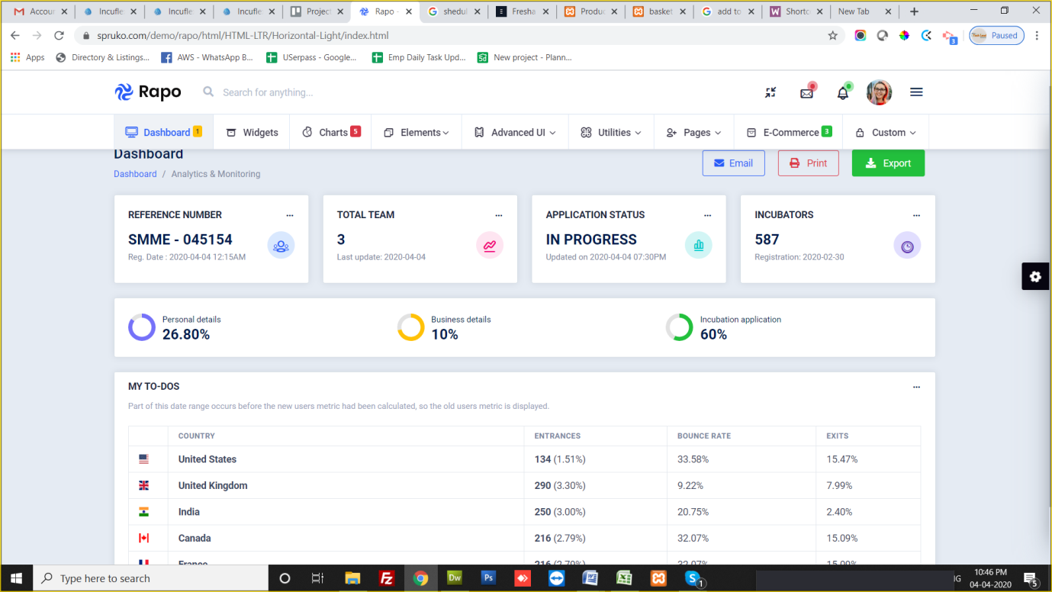

Business Details

* Will have Business details form, where user can update their business details
* <https://www.spruko.com/demo/rapo/html/HTML-LTR/Horizontal-Light/editprofile.html>

Incubation

* Application
  + <https://www.spruko.com/demo/rapo/html/HTML-LTR/Horizontal-Light/editprofile.html>
* Boards
  + <https://www.spruko.com/demo/rapo/html/HTML-LTR/Horizontal-Light/darggablecards.html>
* Milestones
  + <https://www.spruko.com/demo/rapo/html/HTML-LTR/Horizontal-Light/timeline.html>

Resources

* Knowledgebase Canter
  + <https://www.spruko.com/demo/rapo/html/HTML-LTR/Horizontal-Light/blog.html>
* FAQs
  + <https://www.spruko.com/demo/rapo/html/HTML-LTR/Horizontal-Light/accordion.html>

Reports & Feedbacks

* Progress Report
* Feedback

TO-DO

* Calendar
  + <https://www.spruko.com/demo/rapo/html/HTML-LTR/Horizontal-Light/calendar.html>
* To-Do Task
  + <https://www.spruko.com/demo/rapo/html/HTML-LTR/Horizontal-Light/todotask.html>

ADMIN (BEDCO) DASHBOARD

* Manage Admin Users
* SMME Management
* Incubator Management
* Manage Resources
* Manage Applications

Login with user/pass

SMME user

Incubator User

Registration (Sign up)

Admin (BEDCO)

**Incubator DASHBOARD**

-Personal Details

-Business Details

- Get notification from admin (BEDCO) for selected application by SMME

- Will discuss with SMME by personally and agree to incubate that specific SMME.

- After agreement done, the legal papers will uploaded by incubator and it will shown to SMME and Admin (BEDCO)

**SMME DASHBOARD**

-Personal Details

-Business Details

- Create and application with some details inputs, can select incubator they want incubation from

-Application will goes to the Admin (BEDCO) and they will Approve or Reject

- Once Admin (BEDCO) Approved SMME Application, selected incubator will have notification on the dashboard with Application details