As per discussion over skype call I made below flow chart with requirement which users will have. Please check below chart and please add requirements if I forget to mention.

**Scenario**

* SMME will create an account (Unique reference number)
* SMME will update his personal details and business details – 20 hours
* SMME will process the application for incubation – 16 hours
  + SMME will choose the incubator and attach the motivation letter
* SMME should be able to access resources
  + Information about BDSP – 5 hours
  + Information about the Incubators – 5 hours
  + Knowledge base (links, articles, videos, FAQ) – 8 hours
* Admin will approve the application for the selected incubator – 4 hours
* Incubator will get notification on dashboard – 4 hours
* Incubator will contact SMME and make agreements based on application
* Once Agreement ready incubator will upload and it will be shown to Admin and SMME – 8 hours
* Once the agreement is signed, the incubation process starts
* Admin will assign BDSP (Mentors and Coaches) to the SMME – 8 hours
* The BDSP will setup coaching or mentoring meetings / workshops or training with the SMME – 16 hours

**Questions**

* What is the functionality after incubator made agreement with SMME?
  + The incubator should be able to put together an incubation plan for the SMME and this plan should be accessible by the BDSP so that they can be able to do proper mentoring and coaching. – 16 hours
* Who will upload Knowledge Centre Resources?
  + The admin will be the one uploading information or data to the Knowledge Center – 12 hours
* What will calendar show and who will insert data into the calendar?
  + Calendar will show all the training, workshops, meeting that are set by the incubator or the BDSP – 16 hours
* If anything else please let us know
  + Once we have the framework (front end) , I can assist in putting together the menus of what is needed for the SMME, the BDSP and the INCUBATOR….. The menu for the admin is accessible from the current system.
* Which are the menus for the BDSP and what will they can do, please brief us on this?

**Menus for BDSP**

* + - Dashboard
  + - To-do & Calendars
  + - SMME Management
  + - Progress Report

BDSP will be just coaching and mentoring SMMEs based on the plan that the INCUBATOR put together – 16 hours

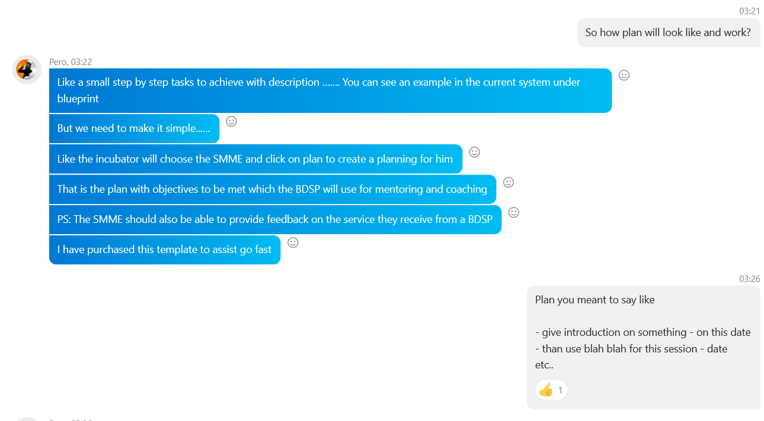

* Dashboards – 24 hours
* Reports – 8 hours/each
* Registrations / logins – 12 hours
* Profiles – 8 hours

ADMIN (BEDCO) DASHBOARD

* Manage Admin Users
* SMME Management
* Incubator Management
* Manage Resources
* Manage Applications

Login with user/pass

SMME user

Incubator User

Registration (Sign up)

Admin (BEDCO)

**Incubator DASHBOARD**

-Personal Details

-Business Details

- Get notification from admin (BEDCO) for selected application by SMME

- Will discuss with SMME by personally and agree to incubate that specific SMME.

- After agreement done, the legal papers will uploaded by incubator and it will shown to SMME and Admin (BEDCO)

**SMME DASHBOARD**

-Personal Details

-Business Details

- Create and application with some details inputs, can select incubator they want incubation from

-Application will goes to the Admin (BEDCO) and they will Approve or Reject

- Once Admin (BEDCO) Approved SMME Application, selected incubator will have notification on the dashboard with Application details