1

When The variable hits a multiple of 10 (or 100 or 313212212 or whatever) run a animation

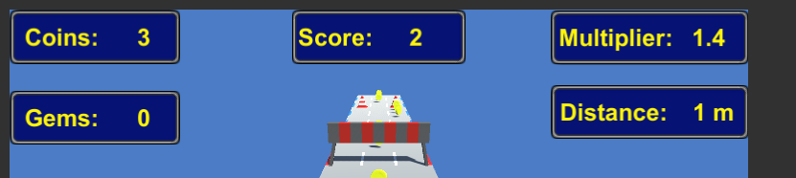

Public int ThePlayersScore;

UPDATE{

If (ThePlayersScore) is divisible by 10

Play an animation on the display text

[TheAnimationIdLikeToRun.Enable ]

}

You know how in candy crush or pacman or whatever, every time the score hits a milestone the number font gets bigger for a second, and some particles flash or the like?

I thought Modolus would be a go way to trigger this (hit 10, 100, 1000 etc, do a juice animation)

Doing it this way, how would I reset the animation back to disabled without cutting it short??

Set a separate Modolus to disable at 9 instead of 10??

That seems inefficient

2

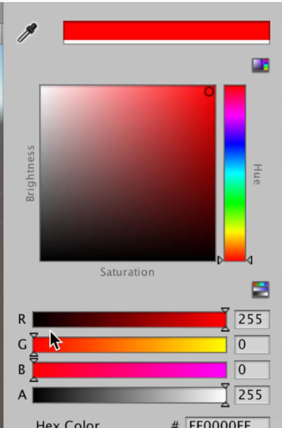

How do I lerp the Hue value (From 0 – 255 or from 0-1)

Currently, each section of road has a different colour for the dotted lines, but I gave each section a unique colour.

The goal is to have every section have the same material, and then modify that mat’s colour along the HUE spectrum (going from red – orange – yellow… purple – red ) according to the distance traveled (Or Time or whatever)

Is there no easy way to handle this??? I don’t want to have to assign 10 RGB values and then lerp cycle through each one.

Is there no Color.Hue = 0 or something???

3

What is the best way to flip between animations?

(Imagine hitting the punch button, and every time you punch, it switches from right handed to left handed punch animation)

Every time I jump, an animation plays spinning the character around (Crash Banicoot spin attack) I want the character to spin clockwise on first press and counter clockwise the next

Two Ideas

A: Everytime the button is pressed (And Independent of actually jumping) the animation assigned is changed from clockwise to counter clock wise

Update

{

On Button press

{

Do Animation

Toggle Bool

}

}

B: Use the animation system to first run the spin animation, then assign a new animation to the animator using the animation system???

Honestly, I haven’t really used the animation system too much, so I don’t know if this route is even possible like this