**KC Games**

Krista Forsythe

Colby Leclerc

Submitted to —

Dr. Bo Hatfield

for

**CSC 263 Database Systems**

**Contents**

1. Executive Summary 3

2. Problem Specification 4

3. Solution Design 5

3.1 Conceptual Design 5

3.2 Logical Design 7

4. Tools List 9

5. Project Implementation 9

* 1. Actual Time-line vs. Proposed Time-line 9
  2. Team Member Individual Achievements 10

6. Queries 11

7. Deliverables 16

8. References 17

**1. Executive Summary**

KC Games aims to create a centralized web store front for customers to view and interact with game listings. Through extensive research, we've determined the most important characteristics present in current web store fronts to allow us to become a competitive business within our market vertical. We've concluded some of the most important features present in our web store front include the following: Game details; Sales information; the ability to read, write, and rate reviews; Development studios involved in development; Platforms the game supports.

Our aim is to provide a clean and concise location for users to view only the most important details of our games. Thus, we've decided on the following designs when creating our entities and their relationships. Looking at the features derived from our research, we have an entity to represent the game listing itself. This is our main entity in that we will use this game's identifier to associate all other game listing information. This entity has the main attributes associated with each game. We have Sales as its own entity, where the attributes describe the units sold and their unit price. Next, we have a review entity to store each game's zero or more reviews. Each game has one or more game studios associated with it, which we will define with the game studio entity. Lastly, each game is released on one or more platforms to play on, which we've defined as the platform entity.

**2. Problem Specification**

Database Users

* + Front-end application - The client or customers using the store front page. They have mostly read permissions, but for reviews, they have the ability to write to the database, and change only their own reviews. Furthermore, each customer can rate a review with a +1 or –1, so this is also an update privilege. This user cannot delete any content.
  + Administrator – The user responsible for adding and updating games in the database.

Customer Needs

* + Ability to query database for a game listing. A game listing consists of the following entitles: Game, Review, Sales, Platform, Development Studio. (permission to select)
  + Ability to update review table to add review (permission to add, not delete)
  + Ability to update review table for review rating (permission to add, not delete)

Potential Queries Stories

John Smith wants to buy some games for his child’s birthday, but does not know what to get. John wants to be able to view all the top rated games for the console his child has, an Xbox 360. John then wants to see all the games in stock. After, John wants to read a couple of reviews before making a final selection. (Colby)

Carry wants to buy a new game for her Nintendo DS, but only has enough money for one game. Carry knows what game she wants, but can’t remember the title, only the first letter of the game, and a rough estimate of a release date. If Carry saw the name of the game, she would know that’s the game she’s looking for. Carry wants to be able to search all games that start with the letter ‘S’. (Colby)

Jack runs a competing game-review website that launched last year, and he wants to view what other people are saying about a game before writing a review. Jack wants to search the game by the title, and sort the reviews to find the highest rated review, as well as the lowest rated review. (Colby)

Veronica just finished playing a game on her PS4 after reading an excellent review from our website. She wants to go back to the game she looked up and find out what category it falls under. (Colby)

Sarah is writing a report on a few game studios and wants to see the newest review for a specific game. She wants to be able to select which game to lookup the newest review for. (Colby)

Sally wants to find out why some reviews are rated so low. She wants to select a game, and find the lowest rated review and write a report on why some reviews are rated so poorly. (Colby)

Janice wants to see all the basic available info for a game. Using this knowledge, she can more appropriately select the next game she will rent. (Krista)

Bob wants to know if a certain game can be played on his PS4 before going to the store to check and purchase it. He would like to select the game, and view all the available platforms for the game. (Krista)

Ben loves game development studios, and in his ever dying passion to become a game developer, he wants to check out all the games a certain development studio makes. Ben would like to select the development studio, and view a list of all the games they’ve made. (Krista)

Olga made some cookies and would like to distribute them out to her favorite game studio. However, she doesn’t know where they’re located. Olga would like to select a game studio, and view their official address to deliver her freshly baked cookies. (Krista)

Chase only buys the best games. He doesn’t even look at games with a star rating lower than 4. Chase would like to view all the games with a star rating of 4 or more. (Krista)

Marry is attempting to find new clients to push her new email marketing platform, however she’s only interested in clients whom have sold more than 10,000 copies. Marry would like to see a list of all games that have sold more than 10,000 copies. (Krista)

Jake is an admin for the website KCGames, and would like to add a game. He wants to be able to add all the details associated with a game, for instance, if a new game is released. (Colby)

Bobby loves his new game, and would like to post his thoughts on it. Bobby would like to post a review on the site of the game, and be able to rate the game, with a small description and title of the review. (Krista)

Cooper would like to remove a game from the site, since it’s an older game and manufacturing has discontinued due to a lawsuit against the game developers. This rarely happens; However, Cooper wants the option to delete the game if they’re not allowed to post information about it. (Colby)

**3. Solution Design**

**3.1 Conceptual Design**

/Users/colbyschool/Documents/School/Salem State/CSC 263/Project/ERD Diagrams/KCGamesERD.png

* Game
  + This is our main table which we link all the other entities against. When querying for games, we will use this entity's primary key to collect the information associated with the game listing. Our project revolves around games and their characteristics in a game-listing environment (such as a store).
* Sales
  + Since our project revolves around game listings, and we're trying to imitate online store front, we need to have sale info to convey to our customers if a game is in stock, and to show the units sold, as well as the unit price to display the total sales of the game.
* Review
  + Most competitive websites have reviews for their products (Amazon being a major example) and we want to allow our customers to write, rate, and read reviews for games. A game can have any amount of reviews. Users can write their own reviews, with a star rating and a description. Furthermore, users can rate other people's reviews with a +1 or a –1.
* Platform
  + Every game has a supported platform. Some games have one, while most games have more than one platform supported. A game must have at least one platform, or else it cannot be played. A platform may be PC, Xbox, Nintendo DS, or a wide variety of other platforms. When a user sees a game listing, they want to know if they own the correct platform for the game. Thus, we want to display all supported platforms for a game.
* Development Studio
  + A game must have a creator. A development studio is a place where a group of developers create a game. A game can also have more than one development studio, where multiple studios collaborate to create a game. When a user sees a game listing, they may want to know who created the game, since certain development studios have a better reputation for game quality than others. Thus, a customer may want to know a game's development studio before purchasing the game.

Relationships

* Game Has Sales
  + Each game has a single record defining the sales information. With the units sold and unit price data, we can derive the total revenue.
* Game Has Reviews
  + Each game can have 0 or more reviews.

Business Rules

* Game has sales
* Game has one sale, and sale can have one game
* Attributes of game are game id, title, genre, suggested, release date, rating, description, image, stock status
* Attributes of sale are sales id, unit price, unit sold, total price
* A game has many reviews, reviews has one game
* Review has attributes review id, description, title, rating, post date, author, and star rating
* Game has many or one development studio
* Development studio makes many games
* Development studio has attributes address and studio name
* Game is made on one or more platforms
* A platform has one or many games
* Platform has attributes platform id, name, year released, and company

**3.2 Logical Design**

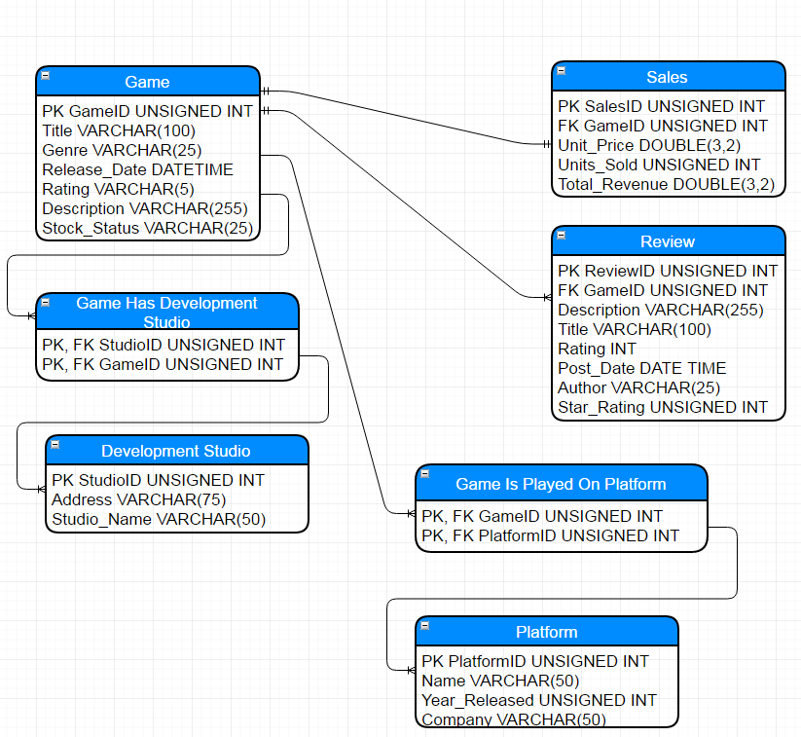

Constraints

* Game: Primary Key (GameID), NOT NULL for all attributes.
* Sales: Primary Key (SalesID), Foreign Key (GameID), NOT NULL for all attributes.
* Review: Primary Key (ReviewID), Foreign Key (GameID), NOT NULL for all attributes.
* Game Is Played On Platform: Primary Key and Foreign Key (PlatformID, GameID), NOT NULL for all attributes.
* Platform: Primary Key (PlatformID), NOT NULL for all attributes.
* Game Has Development Studio: Primary Key and Foreign Key (StudioID, GameID), NOT NULL for all attributes.
* Development Studio: Primary Key (StudioID), NOT NULL for all attr

**4. Tool List**

* Windows 10
* Mac OSX
* Trello
* PhPMyAdmin
* <https://draw.io>
* MySQL
* Microsoft Word
* Microsoft Excel
* Sublime Text
* NotePad++
* IntelliJ IDEA

1. **Project Implementation**
   1. **Actual project time-line vs. proposed project time-line**

Our original timeline had multiple parts different from the actual final timeline. For one, we had originally planned to do a large amount of extra work, through the enthusiasm we had for the project. Then, we had some estimates on when these tasks would be accomplished. After a few weeks, and receiving more course work from other classes, we quickly realized we were a bit too ambitious with what was reasonably attainable in the time allotted.

We ended up removing some extra features, and focused our efforts on the core of the project requirements. Our rough timeline was continuously changing throughout the weeks, as some tasks took shorter, and longer, than we originally planned. We learned that project time estimation is very difficult, and after talking to some people in the industry, and reading forums, we weren’t alone. Project time management, and time estimation, is a learned skill that must be developed, and luckily we were able to notice this in our college career, so we can plan for it and be ready for the challenge once we’re in the field.

* 1. **Team Member Individual Achievement**

**Colby Leclerc**

Self-evaluation:

At the start of the project, Krista and I split up the tasks at hand and discussed how we could both contribute to the project equally. Thus, I completed my tasks on time, and gave my full effort on each task assigned to me. Through constant discussion, both Krista and I worked together to solve the hurdles we came across during the project. Krista and I split up equally the job of designing and creating the tables, populating them with data, and creating each query shown in the presentation. Note Krista went the extra mile and made the interface pop with awesome colors and graphics.

What I Learned:

From the beginning, we both had huge ambitions for what we wanted the project to be about, and were thrilled to execute on our goals. However, after evaluating the tasks at hand, and the available time allotted, we decided to cut back on the extra “fluff” we wanted to add, and stick to the core responsibilities of the project. I learned it’s fun to brainstorm and record what we would like to accomplish, but we should also be realistic in our goals, and find a balance between making goals challenging enough to push ourselves, but not too challenging as to set ourselves up for failure. Furthermore, I learned about proper project proposal formatting, and what kind of information may be expected from such proposals, which is a great way to expose us to the kinds of things we’ll see when working in the industry.

**Krista Forsythe**

Self-evaluation:

From the day we chose each other as partners, Colby and I have stayed in contact about what we wanted to do for our project. Since then, I've tried to stay on top of things by meeting deadlines and pacing myself nicely. Any problems that we faced, we tackled them together. All of the tasks were split equally, and eventually we finished a project that I can say that I'm proud of.

What I Learned:

From the start of this project, I was able to learn many things about how to formally create a database. I've learned about how to create an ERD diagram, as well as a database schema. Both of these things are vital to making sure that a database can be implemented correctly. I was also able to learn about how things might be proposed in the real world. Most importantly, I've learned that I want to take on a career that heavily relates to database design and creation.

**6. Queries**

1. I would like to see the platforms that support this game
   1. Explanation: The user selects a game from the dropdown to get all the platforms supported for the specified game.
   2. Query: SELECT p.Name FROM Platform p, G_PlayedOn_P gp, Game g WHERE g.Title = '$game AND p.PlatformID = gp.PlatformID AND gp.GameID = (SELECT GameID FROM Game WHERE Title = '$game)
   3. Query Result:



1. I would like to see all games made by game studio ‘y’
   1. Explanation: The user can select, from a dropdown, a specific game studio. Then the user is shown all games developed by the game studio.
   2. Query: SELECT g.Title FROM Development_Studio ds, G_CreatedAt_DS gds, Game g WHERE ds.Studio_Name = '".$devstu."' AND gds.GameID = g.GameID AND gds.StudioID = (SELECT StudioID FROM Development_Studio WHERE Studio_Name = '".$devstu."')
   3. Query Result: 
2. I would like to see the following details of the game: publisher, platform, release date, sales, price, development studio, related/suggested games.
   1. Explanation: The user selects a game from the dropdown to get each attribute of the game listed: Publisher, Platform, Release Date, Sales, Price, Development Studio.
   2. Query: SELECT DISTINCT g.Title, g.Release_Date, s.Total_Revenue, s.Unit_Price, ds.Studio_Name FROM Game g, G_CreatedAt_DS gds, Development_Studio ds, G_PlayedOn_P gp, Platform p, Sales s WHERE g.Title = '$game' AND s.GameID = (SELECT GameID FROM Game WHERE Title = '$game') AND gds.GameID = (SELECT GameID FROM Game WHERE Title = '$game')
   3. Query 2: SELECT GROUP_CONCAT(p1.Name SEPARATOR ', ') AS Platforms FROM Platform p1, G_PlayedOn_P gp1, Game g1 WHERE g1.Title = '$game' AND p1.PlatformID = gp1.PlatformID AND gp1.GameID = (SELECT GameID FROM Game WHERE Title = '$game') GROUP BY g1.Title
   4. Query Result:



* 1. Notes: To get all info, we used two queries in the php file.

1. I would also like to see the development studio’s location
   1. Explanation: Each game is made at a certain development studio, and for this query the user can select the game to see the development studio(s) associated with the game.
   2. Query: SELECT ds.Studio_Name, ds.Address FROM Development_Studio ds WHERE ds.Studio_Name = '".$devstu."' AND ds.StudioID = (SELECT StudioID FROM Development_Studio WHERE Studio_Name = '".$devstu."
   3. Query Result:
2. I would like to see all games with a rating of 4 or more
   1. Explanation: The user sees a list of all games with a star rating of 4 or more.
   2. Query: SELECT g.Title, FLOOR(AVG(r.Star_Rating)) AS Star FROM Game g, Review r WHERE g.GameID = r.GameID GROUP BY g.Title HAVING Star >= 4 ORDER BY g.Title ASC
   3. Query Result:

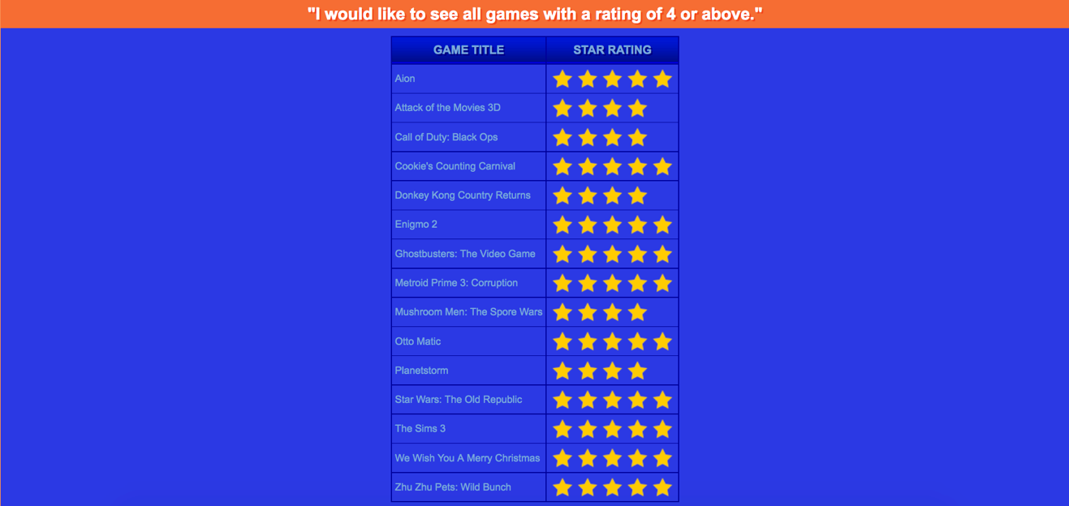

1. I would like to see all games with more than 10,000 sales
   1. Explanation: The user can see each game with over 10,000 sales.
   2. Query: SELECT DISTINCT g.Title, s.Units_Sold FROM `Game` g, `Sales` s WHERE s.Units_Sold >= 10000 AND g.GameID = s.GameID
   3. Query Result:



1. I would like to see the total rating for the game
   1. Explanation: The user selects a game from the dropdown to get the total rating for a game. Note this is done via the average function, because we want to get the cumulative rating of the game, which is the combined rating of each reviewer.
   2. Query: SELECT AVG(rv.Star_Rating) as 'avg' FROM Game as gm, Review as rv WHERE gm.GameID = rv.GameID AND gm.GameID = $game
   3. Query Result:
2. I would like to see all games that start with the specified letter
   1. Explanation: The user can view all games that start with a specific letter displayed in the dropdown.
   2. Query: SELECT Title FROM Game WHERE Title LIKE '$gameLetter%
   3. Query Result:



* 1. Notes:
     1. The only letters available are the ones that exist in the dataset.

1. I want to find out what category game ‘x’ falls under
   1. Explanation: The user selects a game, and the query returns the category the specified game falls under.
   2. Query: SELECT Genre FROM Game WHERE GameID = '$game'
   3. Query Result:



1. I would like to see the highest rated game
   1. Explanation: The user can see which game has the highest rated review. Note this is the review which other people rate, with the +1 or -1 system.
   2. Query: SELECT gm.Title as title, gm.Genre, gm.Description, MAX(rv.Star_Rating) as Rating FROM Game as gm, Review as rv WHERE rv.GameID = gm.GameID GROUP BY title, gm.Genre, gm.Description ORDER BY Rating DESC LIMIT 1
   3. Query Result:



1. I would like to see the highest rated review for game ‘x’
   1. Explanation: The user can select a game from a dropdown menu, then get the highest rated review for the specified game.
   2. Query: SELECT gm.Title, rv.Description, rv.Star_Rating, rv.Author FROM Game as gm, Review as rv WHERE gm.GameID = rv.GameID AND gm.GameID = $game GROUP BY rv.Star_Rating, gm.Title, rv.Description, rv.Author ORDER BY rv.Star_Rating DESC LIMIT 1
   3. Query Result:



1. I would like to see all games that are in stock
   1. Explanation: The user can view all the games which are currently listed as ‘In Stock’.
   2. Query: SELECT Title FROM Game WHERE Stock_Status = 'In Stock'
   3. Query Result:



1. I would like to see all games released between January 1st 2005, and January 1st 2010
   1. Explanation: The user can view all the games whose release date are between the dates of January 1st, 2005 and January 1st, 2010.
   2. Query: SELECT * FROM Game WHERE Release_Date BETWEEN '2005-01-01' AND '2010-01-01'
   3. Query Result:

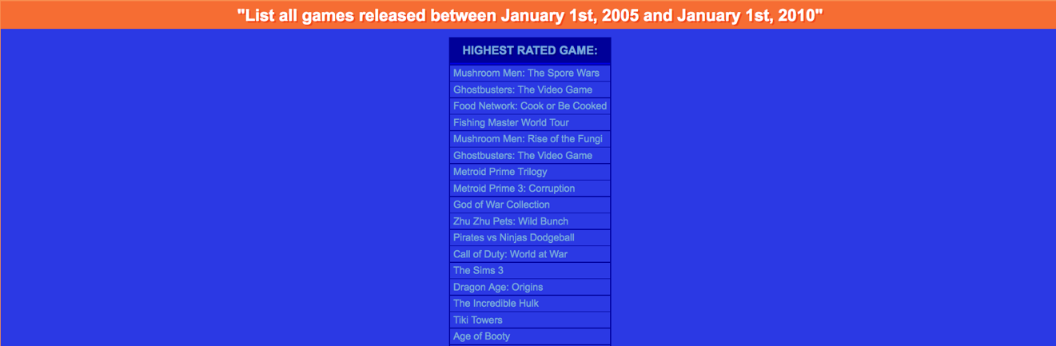

1. I would like to see the newest review for game ‘x’
   1. Explanation: The user can select a game from a dropdown to view the newest review for the specified game.
   2. Query: SELECT * FROM Review WHERE GameID = $game ORDER BY Post_Date DESC
   3. Query Result:



1. I would like to see the lowest rated review for game ‘x’
   1. Explanation: The user can select a game from a dropdown to view the lowest rated review for the specified game.
   2. Query: SELECT gm.Title, rv.Description, rv.Star_Rating, rv.Author FROM Game as gm, Review as rv WHERE gm.GameID = rv.GameID AND gm.GameID = $game GROUP BY rv.Star_Rating, gm.Title, rv.Description, rv.Author ORDER BY rv.Star_Rating ASC LIMIT 1
   3. Query Result:



1. I would like to add a game to the website
   1. Explanation: The user can add a new game to the site.
   2. Query: INSERT INTO `Game` (`GameID`, `Title`, `Genre`, `Release_Date`, `Rating`, `Description`, `Stock_Status`) VALUES (NULL, 'League of Legends', 'MOBA', '2017-05-03', '44', 'A very popular moba game', 'In Stock');
   3. Query Result:

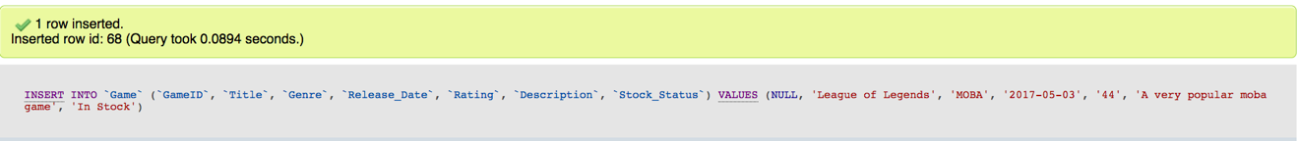

1. I want to add a review for a game
   1. Explanation: A user can enter the title, description, author, and their star rating for a game.
   2. Query: INSERT INTO Review (GameID, Title, Author, Description, Star_Rating, Post_Date, Rating) VALUES (23, 'Love This Game!', 'Jacob', 'This game is awesome!', 4, CURRENT_TIME, 0))
   3. Query Result

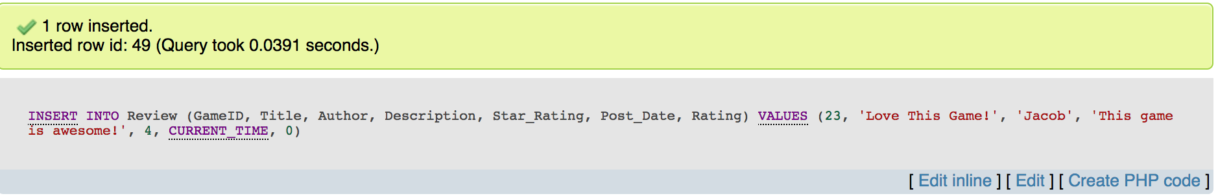

1. Delete a game from the website
   1. Explanation: A user admin can delete a game from the Game table
   2. Query: DELETE FROM Game WHERE GameID = 68
   3. Query Result

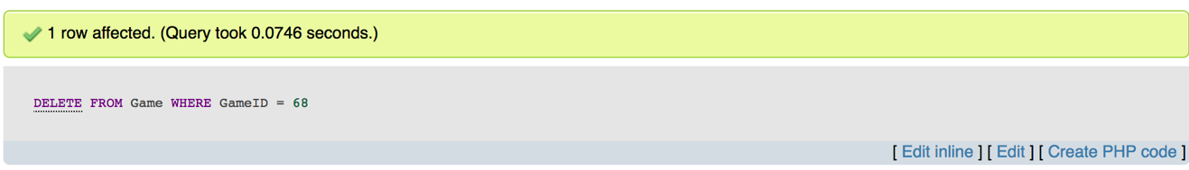

**7. Deliverables**

**A DVD that contains the electronic versions of all of the following items:**

* a “readme” file that explains what files were on the DVD and what each file is for.
* a copy of the original proposal
* a copy of this report
* the ER diagram for the project (multiple pages if needed)
* a backup database file of your project
* This is an important file that allows one to restore the database. Therefore, the team must make sure that the database can be restored from this backup file
* Include explanation in the readme file that specify how to use your backup file to restore the database.
* a SQL script file that contains ALL the queries in your project
* This is also an important file because it allows one to run all the queries you generated for the project. Include necessary explanation in the “readme” file.
* team project presentation (e.g., PowerPoint presentation)

**8. References**

URLs

* StackOverflow.com

SQLServerCentral.com

* W3Schools.org

Books

Class assigned text book