Jack

Pemberton

<https://port-1cfx.onrender.com/> | 0493 127 599| [jackpemberton@outlook.com.au](mailto:jackpemberton@outlook.com.au)

**Professional Summary**

Hi, my name is Jack, I'm personally a very friendly person and love to work with other people. I'm competent in tasks and am great at problem solving, working in a team, staying calm under stressful situations, and helping people in need. My dream job is to be either a lead developer or something to do with aircraft like an aeronautical engineer. I am quite a reliable person to trust, for example: I take part in musical ensembles, and a jazz band representing my school. Rarely ever missing a rehearsal. I am a fast learner who is willing to give anything a go, I’m quick on my feet and can take complex instructions well.

# Experience

Helper at Boat craft pacific:

* Helped in labeling, stocking shelves, talking to customers at shows and helping setup shows.

# Education and Accomplishments

High School Diploma: Expected in 11/2026

The Springfield Anglican College – Springfield QLD

* Reached regionals for tennis 2021.
* Completed SHEP strings (State Honors Ensemble Program) in 2020.
* GPA of B+

Python Intermediate Course Completed 2024 (SoloLearn):

* <https://www.sololearn.com/certificates/CC-EIC5Q9MB>
* Found on page 2.

# Hobbies

* Design and Technologies
* Building different contraptions
* Programing

**Skills**

* Fluent in python, html, CSS
* Creative minded
* Good at problem solving.
* A good leader for a team

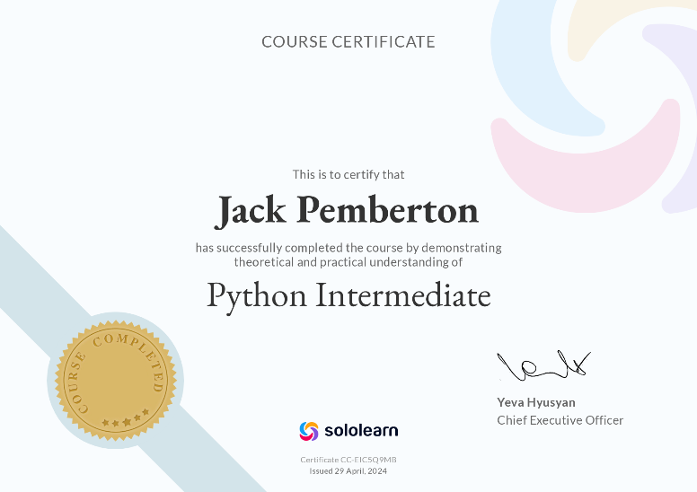

**Availability**

Monday – After school

Tuesday – After school

Wednesday – After school

Thursday – After school

Friday – After school

Saturday – All Day

Sunday – All Day