Final Exam – Spring MVC + REST+ Jackson FrameWork + MongoDB +Thymeleaf.
Instructions and Rules
This assessment should be completed by every student individually and submitted as per the deadline given.
Name your Eclipse project according to the following rule:
Your Name_ITE5435_FinalExam
Example: John_ ITE5435_ FinalExam
Description – Spring Boot app with Client.
Husky Air wants to develop online web application for their reservation/itinerary. They have approached you to develop application to cater their requirements. Presently they have console-based application but would like to migrate to web based application.
Instructions:
Create a New Project -> Spring Starter Project with appropriate dependencies required.
Group: com.yourinitialsofurname.final [for example com.va.finalexam]
Artifact: final_YourFullName_StudentId
Package: com.yourinitialsofurname.spring.finalex
On the click on Next button -> post method is called that takes client-side data to -> Json data and processes the results. (use Jackson framework) using static JSON or dynamic URI.
To consume the data from the api application design use Jackson framework.
You are only asked to prepare one web form such as shown below and implement the live working of PART A and PART B together.
Database processing is– mongodb to be used.

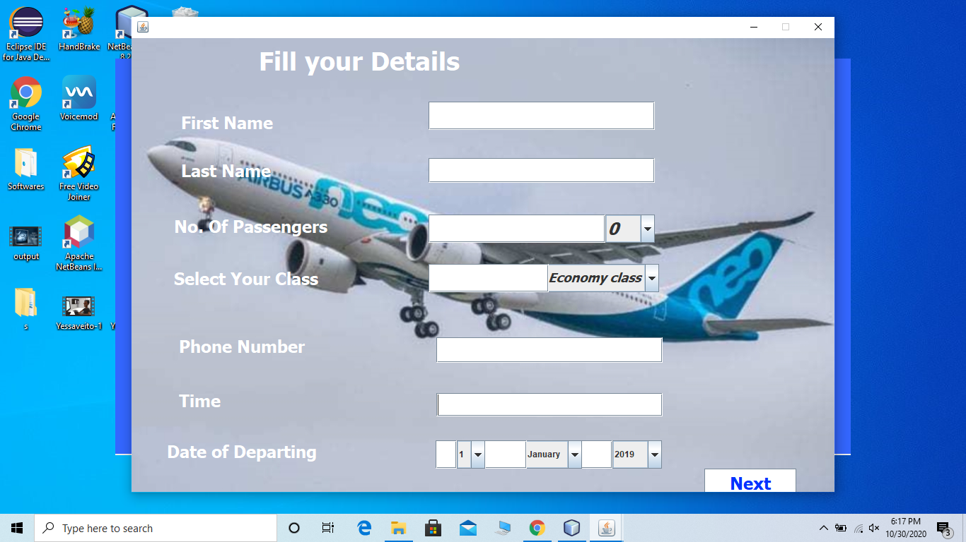

Reservation Form is mapped to Other Entities such as Customer, Payment, Airline Ticket etc..
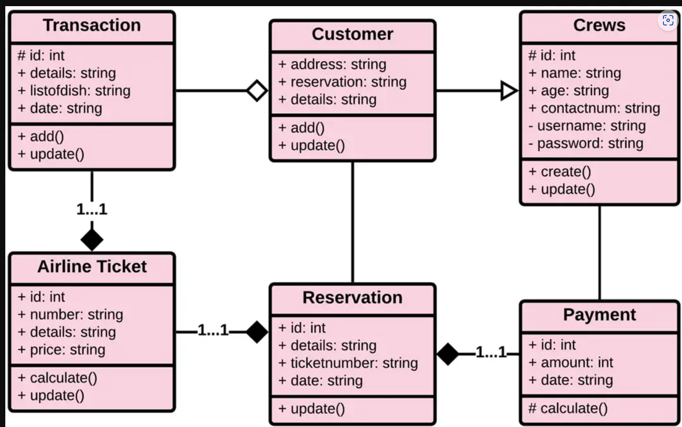
Design for the application for one web entity ie Reservation and 2 more entities of your choice. – This is not a microservices application.
Submit individual files: Submission source code Git link URL and video URL (3 mins).

Assessment Rubrics
View and UI Design: Task 1  Setting the project with appropriate dependencies with showing POM, application. Prop configuration file with latest dependencies. | 20%
Demonstrating implementing Postman with REST framework with Jackson | 20%
Demonstrating and defining a controller class to implement REST functionalities like get post, put method with Jackson. | 20%
Designing client-side application using Thyme leaf to provide user-friendly forms. | 20%
Submission source code gitlink and video URL | 20%
Total | 100%
Submission Rules
Provide not more than 4 mins video demonstrating all the code first then the run of the application. -code include all the files including pom, properties, database validation etc.
To earn full credit – all code must be shown in the recording including tasks that could be done and what is pending.
If you are partially successful you will get partial credit.

