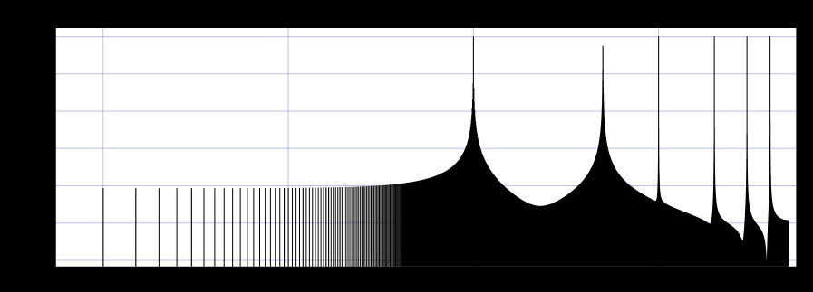

The original signal

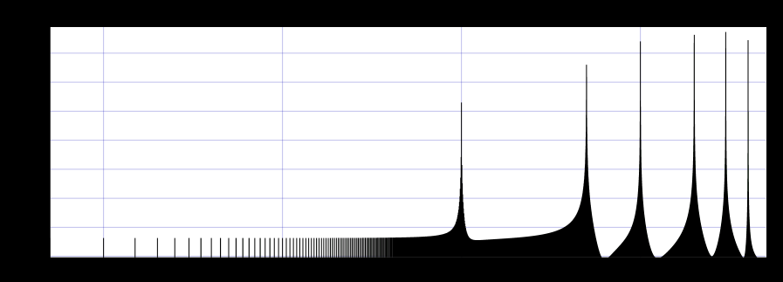

Simple first deriv.

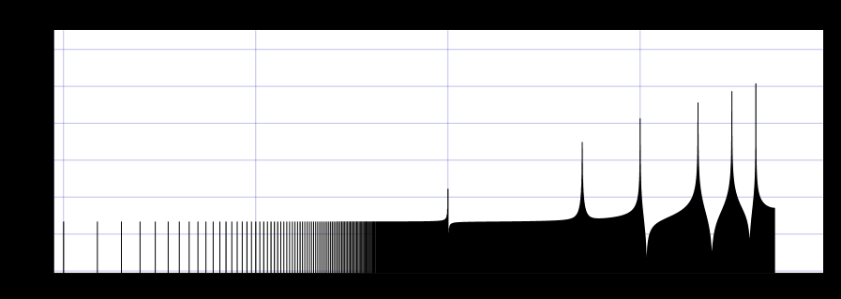

Simple second deriv.

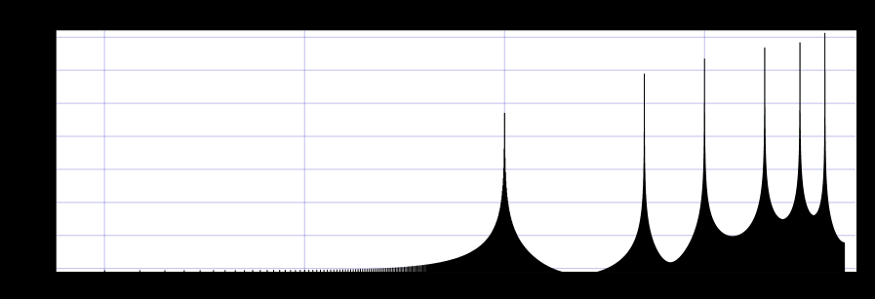

Forward 1st

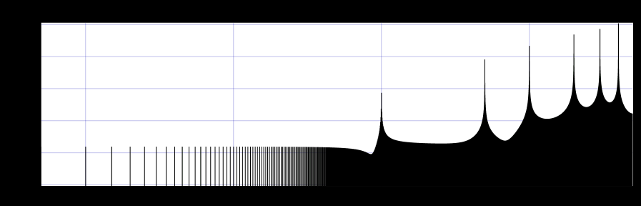

Forward 2nd

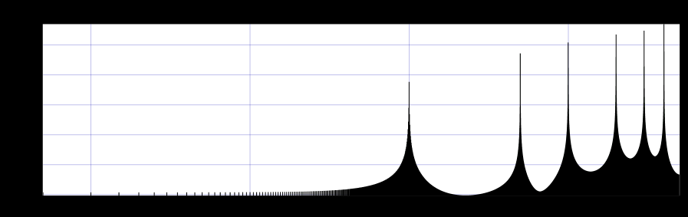

Backward 1st

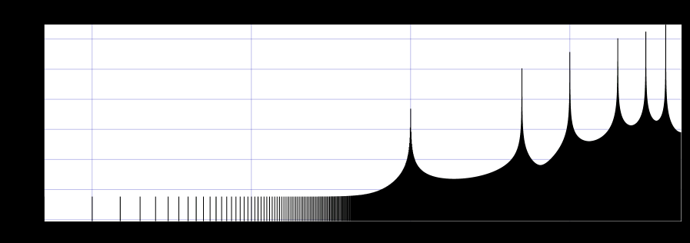

Backwards 2nd

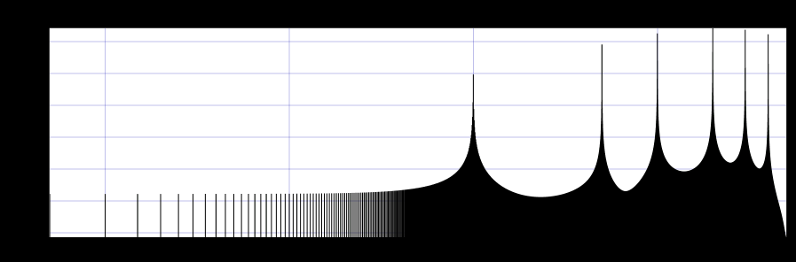

SecondOrderCentral 1st

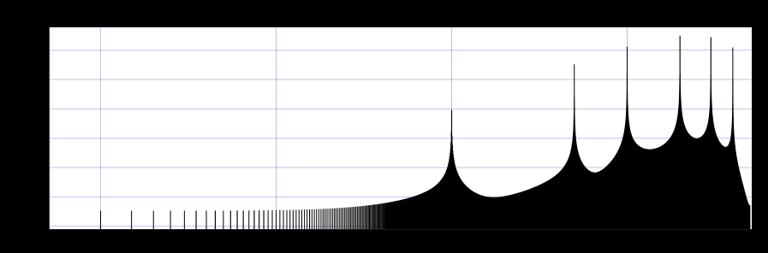

SecondOrderCentral 2nd

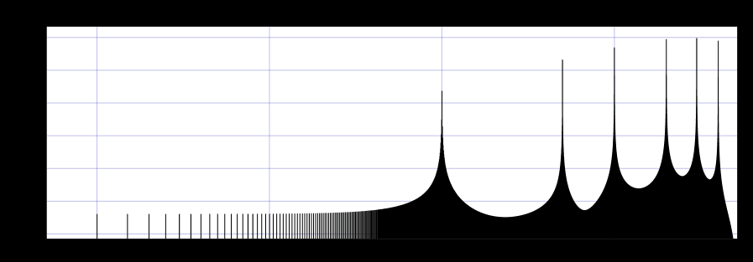

FourthOrderCentral 1st

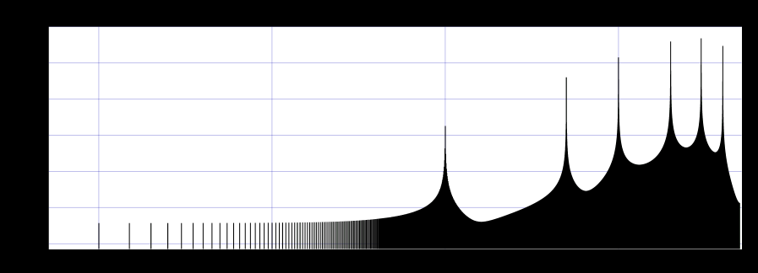

FourthOrderCentral 2nd

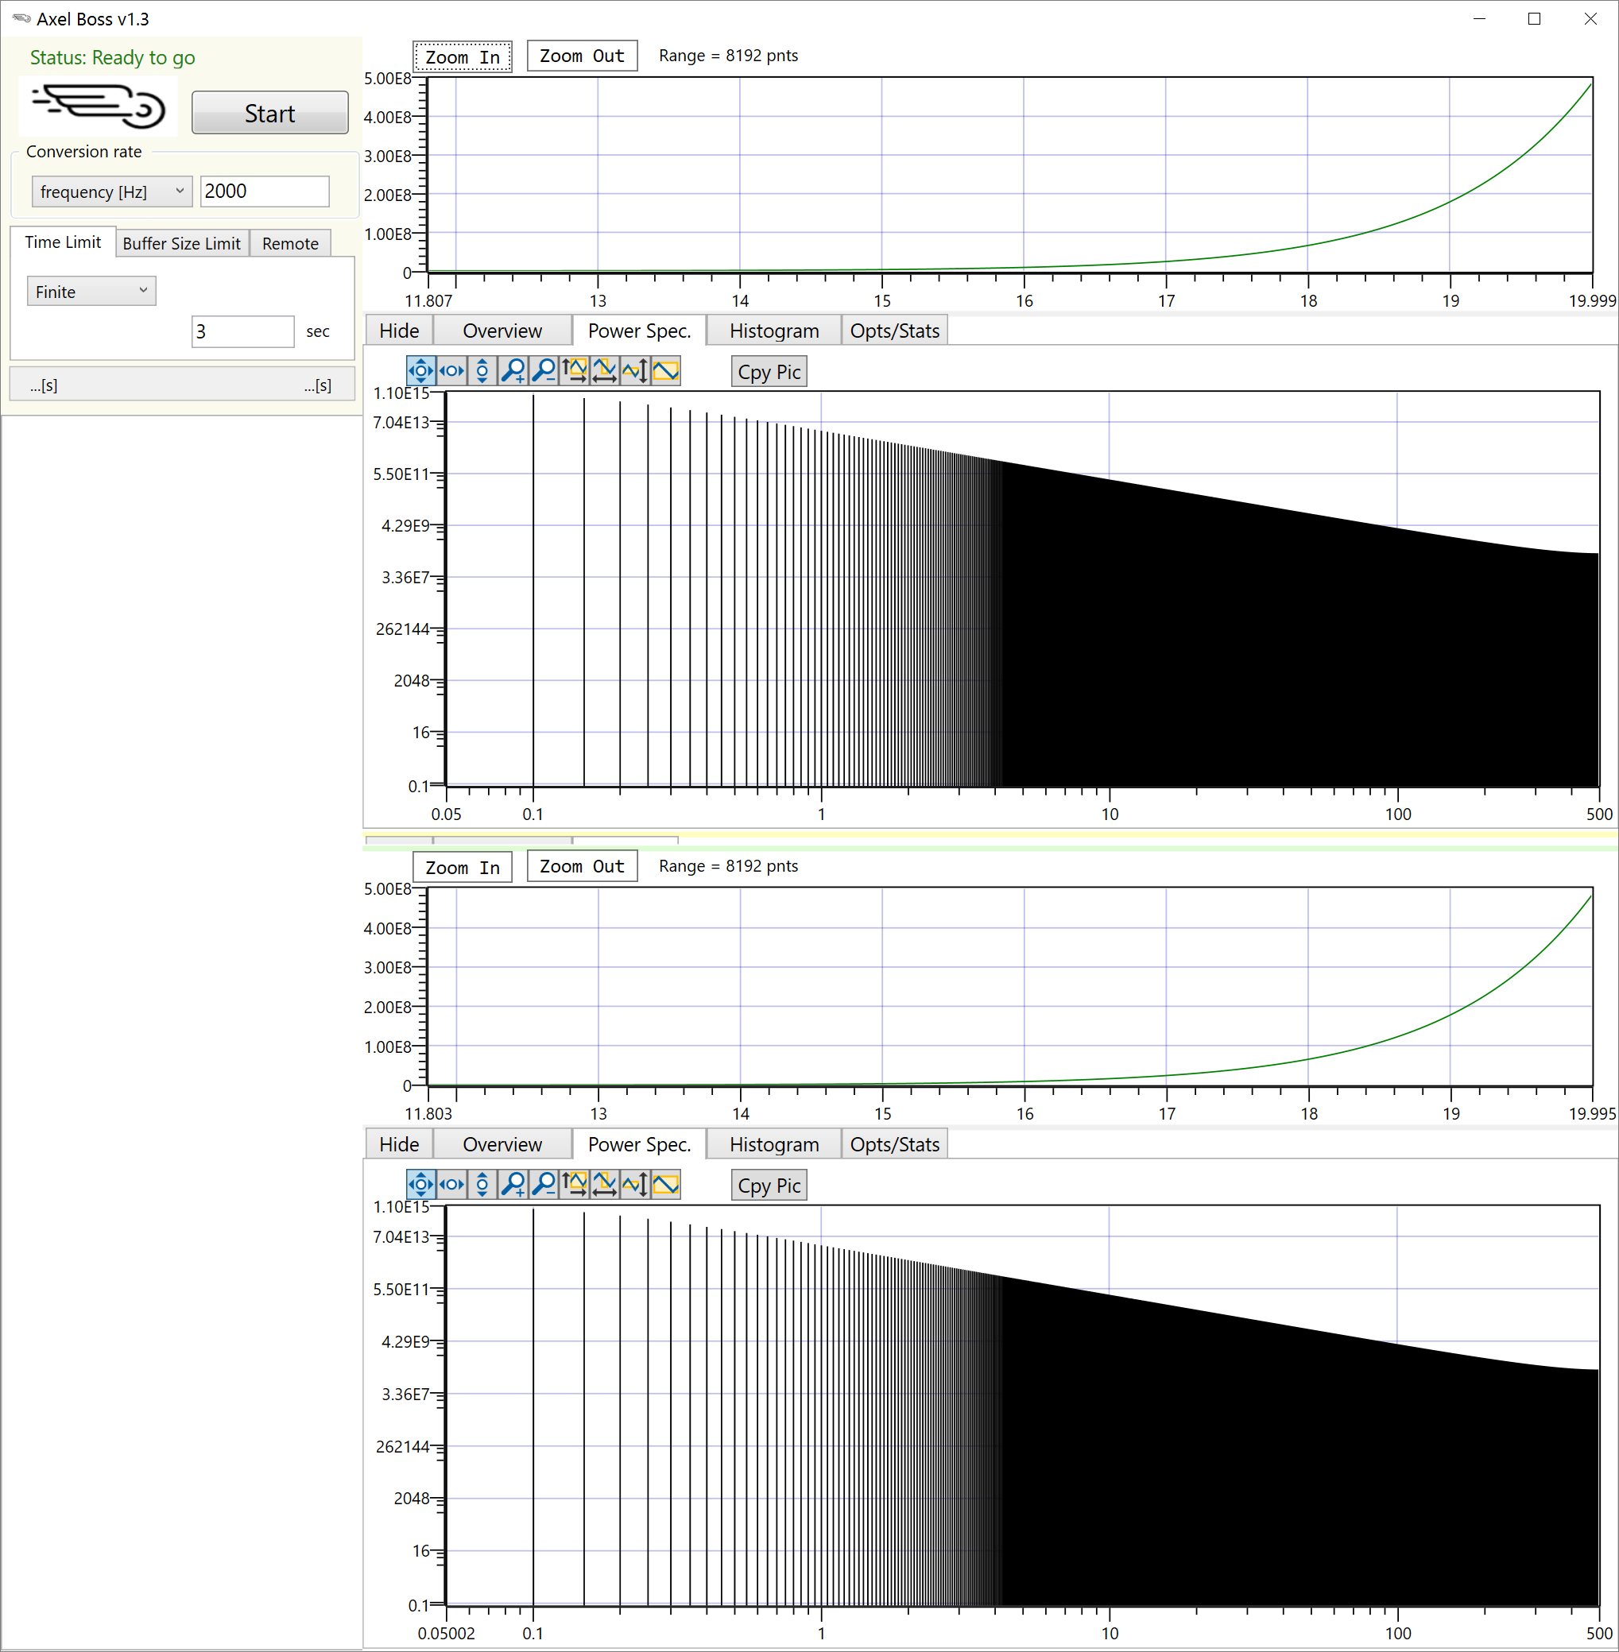

FourthOrderCentral 1st