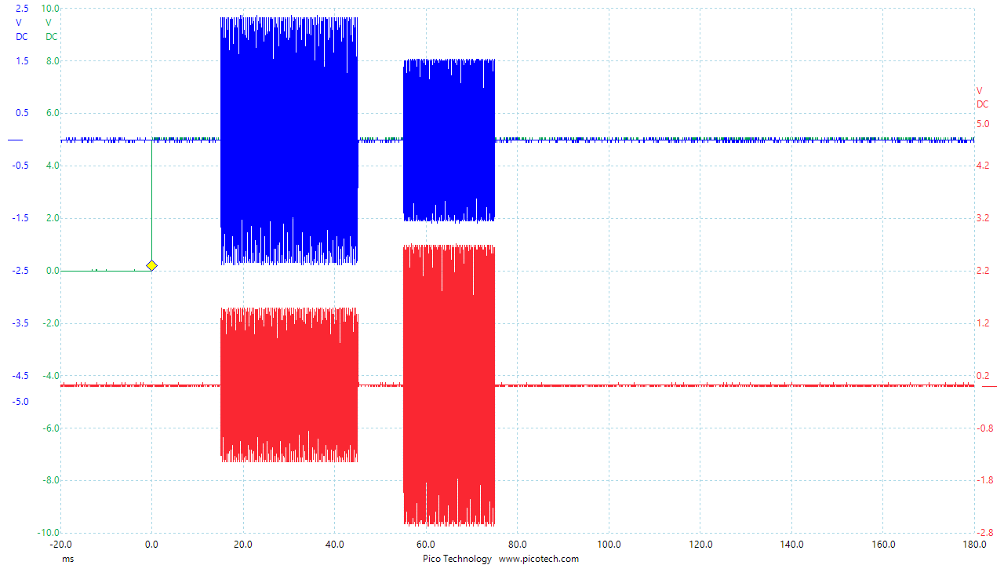

[script]

dds reset

dcp spi:CFR2=0x1000080

dcp spi:STP0=0x418937

dcp wait::$select-bnc.trigger$

dcp update:u

dcp 0 spi:STP0=0x$a0x1$$p0x1$$f0x1$

dcp 1 spi:STP0=0x$a1x1$$p1x1$$f1x1$

dcp wait:$dly1$:

dcp update:u

dcp 0 spi:STP0=0x2D0E560

dcp 1 spi:STP0=0x2D0E560

dcp wait:$dr1$:

dcp update:u

dcp 0 spi:STP0=0x$a0x2$$p0x2$$f0x2$

dcp 1 spi:STP0=0x$a1x2$$p1x2$$f1x2$

dcp wait:$dly2$:

dcp update:u

dcp 0 spi:STP0=0x2D0E560

dcp 1 spi:STP0=0x2D0E560

dcp wait:$dr2$:

dcp update:u

dcp start

[factors]

dly1=Delay 1 [ms]

a0x1=Amplitude 0x1 [ampl]

f0x1=Freq 0x1 [MHz]

p0x1=Phase 0x1 [deg]=0

a1x1=Amplitude 1x1 [ampl]

f1x1=Freq 1x1 [MHz]

p1x1=Phase 1x1 [deg]=0

dr1=Duration 1 [ms]

dly2=Delay 2 [ms]

a0x2=Amplitude 0x2 [ampl]

f0x2=Freq 0x2 [MHz]

p0x2=Phase 0x2 [deg]=0

a1x2=Amplitude 1x2 [ampl]

f1x2=Freq 1x2 [MHz]

p1x2=Phase 1x2 [deg]=0

dr2=Duration 2 [ms]