BCSE497J - PROJECT-I
RETRIEVAL-AUGMENTED COLD-START RISK PREDICTION
FOR SERVERLESS COMPUTING

23BCE0411 PARTH GOYAL
23BDS0064 SAANVI SHARMA

Under the Supervision of
Dr. Narayanan Prashanth

B.Tech.
in
Computer Science and Engineering

School of Computer Science and Engineering
September 2026

ABSTRACT
Serverless platforms scale to zero, so an idle application must be rebuilt before it can serve - the cold-start problem. The policy deployed in Azure Functions sets each application's warm window from two fixed percentiles of a histogram of its own idle times. We ask what that policy discards. First, the histogram is MARGINAL: it pools every gap the application has shown and forgets the state each occurred in. A model-free information audit finds roughly 89% of the next gap's entropy irreducible - why the richer retrieval schemes we built first all failed - but localises the rest in one variable: the gap that just closed. Conditioning on it, with partial pooling towards the marginal, recovers 26.3% at matched memory cost, and recovers the deployed policy exactly as its limiting case. Second, and larger, the WINDOW itself was never derived. A percentile is a heuristic, and not a quantity an operator can price. Minimising the window's expected cost instead - memory paid for the part of the gap it covers, against the risk of a cold start if the next invocation falls outside - replaces the percentile with K/m, the GB-minutes a cold start is worth. Optimising offset and length jointly cuts cold starts by 78.8% against the deployed policy, and 67.6% against a strengthened baseline allowed to tune both percentiles over 36 configurations. The same optimisation on another application's histogram removes the gain. Evaluated on the Azure Functions 2019 trace over held-out days, only at matched memory spend, with a control for each claimed mechanism. We report that the two ideas do not compose, the budget at which the gain fades, and the negative results.
Keywords - Serverless computing, cold start, keep-alive policy, retrieval-augmented prediction, borrowing strength, shrinkage estimation, resource scheduling, Azure Functions.

TABLE OF CONTENTS
1. Introduction
1.1 Background
1.2 Motivation
1.3 Scope of the Project
2. Project Description and Goals
2.1 Literature Review
2.2 Research Gap
2.3 Objectives
2.4 Problem Statement
2.5 Project Plan
3. Technical Specification
3.1 Requirements
3.2 Feasibility Study
3.3 System Specification
4. Design Approach and Details
4.1 System Architecture
4.2 Design
5. Experimental Results
5.1 Dataset and Experimental Setup
5.2 The measurement apparatus
5.3 Baselines: the standard to beat
5.4 What is actually predictable: the information audit
5.5 Three negative results, explained by one measurement
5.6 The method: conditioning on the application state
5.7 Result at matched memory cost
5.8 Does the gain come from where the mechanism says?
5.9 Threats to Validity
6. Conclusion and Future Work
7. References

1. INTRODUCTION
1.1 Background
Serverless platforms such as AWS Lambda, Azure Functions and Google Cloud Functions let developers deploy individual functions and pay only for the time those functions execute. To make that billing model viable the provider reclaims the resources of an application that has been idle for a while, terminating its container. When a request later arrives for a reclaimed application, the platform must allocate resources, start the runtime, load dependencies and restore application state before the request can be served. This initialisation is the cold start, and it adds anywhere from a few hundred milliseconds to several seconds of latency that the user directly experiences. Keeping every container warm would remove cold starts but would also destroy the economics of the platform, because reserved memory is paid for whether or not it is used. Every serverless provider therefore operates a keep-alive policy that trades wasted memory against user-visible latency, and the quality of that policy determines both the platform's cost and its responsiveness.
1.2 Motivation
The prevailing keep-alive policies are structurally mismatched to real workloads. Our own parse of the Azure Functions 2019 production trace shows that 55.6% of applications have an average idle time longer than the industry-standard ten-minute keep-alive window, and that 82.3% of applications are invoked at most once per minute on average. A single fixed window is therefore either wasteful for the sparse majority or useless for them. The state of practice, the hybrid histogram policy deployed in Azure Functions, does better by learning each application's own distribution of idle times. But that means every application must learn itself from scratch, and an application that has just been deployed, or that runs rarely, has almost nothing to learn from. The policy falls back to a fixed default exactly where a good decision matters most. Meanwhile the platform has already observed thousands of other applications, many of them behaving very similarly, and uses none of that. The motivation for this project is to let a scheduler answer the question a human operator would ask immediately: what do applications like this one usually do?
1.3 Scope of the Project
The project covers the full path from a public production trace to a measured scheduling outcome. It includes parsing and validating the Azure Functions 2019 trace at application granularity; formalising cold-start risk through the idle-gap distribution; building a fleet memory of application behavioural profiles and their gap distributions; retrieving analogues for an application that has little or no history of its own; combining the retrieved prior with the application's own evidence by shrinkage; and evaluating the resulting policy in a minute-tick simulator, on applications held out from the fleet bank and at matched memory cost, against the deployed hybrid histogram policy, a fixed keep-alive sweep and an oracle bound. It also includes a neural variant with a learned situation encoder and cross-attention fusion, reported together with the controls that bound what it contributes, and an interactive web demonstration that exposes the retrieved analogues behind each decision. The scope excludes deployment on a live platform, multi-instance concurrency within an application, and cross-provider validation; those are identified as Project-II work.
2. PROJECT DESCRIPTION AND GOALS
2.1 Literature Review
Research on serverless cold starts divides, following the taxonomy of Golec et al., into environment optimisation (making the start itself cheaper) and prediction or pre-warming (avoiding the start altogether). This project belongs to the second family, and the works below are the ones it must be measured against.
# | Work | Approach and result | Limitation for cold-start prediction
[1] | Joosen et al.,  EuroSys 2025 | Month-long Huawei production trace: 85 billion requests and 11.9 million cold starts across five regions | Characterisation only; confirms cold starts persist at scale but provides no predictor
[2] | Han et al.,  ICML 2025 | RAFT: retrieval-augmented time-series forecasting conditioned on similar historical segments | Generic benchmarks; retrieval never coupled to serverless scheduling, and no measurement of whether the target series is predictable at all
[3] | Hu et al.,  Computing 2025 | An RNN forecasts future invocations and a pre-warming scheduler adapts idle-container lifetimes; about 49.5% more invocations served | Predicts invocation counts rather than the gap distribution the decision is actually a percentile of
[4] | Nguyen et al.,  arXiv 2025 | Model predictive control jointly optimises pre-warming and dispatch; up to 85% lower tail latency with 34% fewer resources | Hinges entirely on forecast accuracy; sensitive to hand-tuned horizons and cost weights
[5] | Golec et al.,  ACM CSUR 2024 | Systematic review and taxonomy of cold-start research | Survey only; flags prediction under sparse workloads as open but does not quantify how much is predictable
[6] | Vahidinia et al.,  IEEE IoT J. 2023 | Two-layer scheme: reinforcement learning sets keep-alive duration, an LSTM forecasts invocation times to size the pre-warmed pool | Learns only from recent observations; keeps containers warm even when no cold start would have occurred
[7] | Roy et al.,  ASPLOS 2022 | IceBreaker predicts invocation patterns with a Fourier basis and warms functions across heterogeneous nodes; about 45% lower keep-alive cost | The Fourier basis presumes periodicity; our information audit finds time-of-day explains only 7.6% of gap entropy on this trace
[8] | Fuerst & Sharma,  ASPLOS 2021 | FaasCache recasts keep-alive as object caching with greedy-dual eviction; up to about 50% more warm starts under memory pressure | Fully reactive eviction with no forecasting, so it cannot anticipate a surge after a long idle gap
[9] | Shahrad et al.,  USENIX ATC 2020 | Characterises the Azure Functions production workload; a hybrid histogram of inter-invocation idle times sets per-application pre-warm and keep-alive windows; deployed in Azure and the trace released publicly | The histogram is a MARGINAL distribution over an application's gaps - it discards the state each gap occurred in. This is the gap our method closes.
[10] | Xu et al.,  IEEE ICPADS 2019 | Adaptive Warm-Up: an LSTM predicts each function's next invocation time so containers are warmed just before it | A point forecast of a time; no notion of the uncertainty a keep-alive window is a percentile of; per-function, with no use of state
Table 1. Comparative literature review.
Across this body of work the prediction target is almost always an invocation count or an invocation time, from which a warming decision is derived by a heuristic; and the input is almost always a short recent window. Retrieval-augmented forecasting has recently been shown to help across general time-series domains, but it has never been coupled to cold-start risk or to a serverless scheduler.
2.2 Research Gap
- No episodic memory. Every existing predictor - histograms, LSTM and RNN forecasters, caching heuristics, Fourier methods and model predictive control - observes only a short recent window. None can recall a recurring motif seen weeks or months earlier, even though production workloads are full of them.
- An indirect prediction target. Prior work forecasts counts or times and converts them to warming decisions heuristically. Directly estimating the probability of a cold start within a horizon - the quantity the scheduler actually needs, and one that can be calibrated and cost-weighted - remains largely unexplored, and is listed as an open problem in the ACM Computing Surveys taxonomy.
- Failure concentrated where it matters. Production traces are dominated by sparse and bursty applications, which is precisely the regime in which window-based forecasters degrade most.
- Retrieval unexploited in the cloud stack. No published system applies retrieval to cold-start prediction or serverless resource scheduling.
Gap addressed: cloud schedulers today have no explicit episodic memory. RACRP treats historical workload situations as retrievable experiences and bases warm-state decisions on analogous past events rather than on extrapolation of the recent window alone.
2.3 Objectives
- O1 - Risk formulation. Model cold-start mitigation as horizon-based risk prediction, P(cold start within dt) per application per minute, so that warming decisions map onto a calibrated probability. Measured by average precision and expected calibration error on held-out test days.
- O2 - Workload memory. Build a vectorised repository of historical situations from the training days, each stored with the outcome that followed it, supporting top-k similarity retrieval in under a millisecond per query.
- O3 - Retrieval-augmented predictor. Design a transformer that fuses the current observation window with retrieved analogues through cross-attention over their outcomes, and quantify the contribution of retrieval by ablation against an identical model with retrieval disabled and against a control fed random memories.
- O4 - Risk-aware scheduling and evaluation. Derive a proactive warming policy from the predicted risk and evaluate it against the hybrid histogram policy, LSTM and Transformer baselines and a fixed keep-alive sweep, on cold-start count, added latency, wasted memory-time and the cost-performance trade-off.
2.4 Problem Statement
Let application a have observed idle gaps G_a (possibly empty, if it was just deployed) and a deployment-time descriptor d_a (trigger type, memory, declared duration). The scheduler must choose a pre-warm offset and keep-alive length, which are percentiles of its idle-gap distribution. Equivalently, at minute t it must estimate
h_a(g) = P( the next idle gap of a has length g | G_a, d_a )
and choose windows so as to minimise cold starts subject to a budget on the memory-time spent holding idle containers. The deployed policy estimates h_a from G_a alone. The difficulty is that |G_a| is small precisely when the decision matters most - a function that has just been deployed has |G_a| = 0, and in this trace the median application is active in only 1.7% of minutes, so |G_a| grows slowly. The question this project asks is whether the thousands of applications the platform has already observed can supply what a is missing, and how that borrowed information should be traded off against a's own evidence as it accumulates.
2.5 Project Plan
Phase | Work | Status
0 | Trace acquisition, application-level parsing, validation against the published characterisation, frozen temporal splits and stratified cohort | Complete
1 | Minute-tick simulator with randomised equivalence tests; baseline policies (fixed keep-alive sweep, hybrid histogram, scale-to-zero, oracle); beat-bar published | Complete
2 | Risk labelling, windowing and features; LSTM and Transformer risk predictors | Complete
3 | Episodic memory bank, retrieval index, cross-attention fusion, calibration, risk-aware policy and Pareto sweep | Complete
4 | Ablations, stratified and idle-age analysis, failure diagnosis and correction | Complete
5 | Interactive web demonstration over precomputed artefacts | Complete
6 | Draft report, Review-2 presentation, outcome report | Complete
7 | Project-II: multi-instance concurrency, online memory maintenance under drift, second production trace | Planned
Table 2. Project plan and status at Review-2.
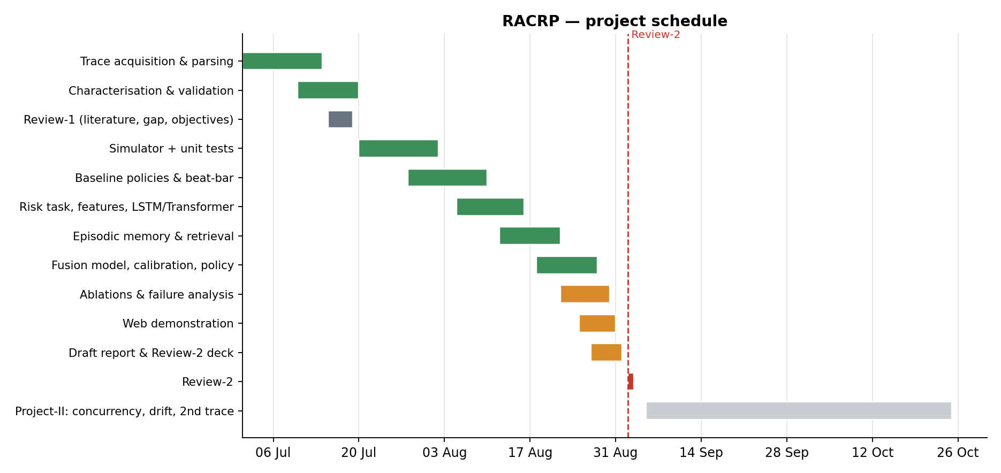
Fig. 1. Project schedule.
3. TECHNICAL SPECIFICATION
3.1 Requirements
3.1.1 Functional
- FR1 Trace ingestion. Parse the 14-day Azure Functions trace, aggregate functions into applications, and build a per-minute invocation matrix joined with per-application duration and memory attributes.
- FR2 Situation encoding. For any (application, minute) produce a fixed-length embedding computed only from information available strictly before that minute.
- FR3 Memory construction and retrieval. Index every training situation together with the activity profile that followed it, and return the top-k analogues of a query, excluding near-duplicates of the query itself.
- FR4 Risk prediction. Emit a calibrated probability of a cold start within the configured horizon, per application, per minute.
- FR5 Scheduling decision. Convert risk into keep-warm or release decisions under a tunable cost trade-off between latency and memory.
- FR6 Simulation and measurement. Replay any policy over any slice of the trace and report cold starts, added latency, warm and idle-warm minutes, memory-time and monetary cost.
- FR7 Explanation and demonstration. Expose, for any decision, the retrieved historical episodes, their similarity and what followed them.
3.1.2 Non-Functional
- Correctness. The simulator is the measurement instrument for every claim, so it is validated against an independent reference implementation by randomised equivalence tests, and the trace parser is validated against the characterisation published with the dataset.
- Reproducibility. All randomness is seeded; temporal splits are frozen and never shuffled; every reported number is written to a JSON artefact by the script that produced it, and the report and slides are generated from those artefacts.
- Performance. Retrieval must answer in under a millisecond per query so that the method is plausible inside a scheduler's decision path; the whole cohort evaluation must complete on a single workstation.
- Efficiency. Embeddings, neighbour sets and the processed trace matrix are cached on disk and never recomputed.
- Usability. The demonstration must run offline, with no GPU and no network access, and start in seconds.
- Maintainability. Configuration is centralised; modules are separated by responsibility (data, simulation, baselines, models, evaluation, web).
3.2 Feasibility Study
3.2.1 Technical Feasibility
The required data is public and already obtained: the Azure Functions 2019 trace released with the ATC'20 paper under a CC-BY licence. The modelling stack (PyTorch, FAISS, scikit-learn) is mature and runs on commodity hardware; the models are small by design, around one to three million parameters, because the constraint is retrieval latency and not capacity. The principal technical risk was that retrieval would be too slow to be credible inside a scheduler; this is resolved by freezing the retrieval encoder so neighbour sets are computed once and cached, which is also the standard retrieval-augmented design.
3.2.2 Economic Feasibility
The project runs entirely on one workstation with public data, so direct cost is negligible. The economic case for the method itself is the quantity the evaluation measures: memory-time spent holding idle containers is the provider's real expenditure, and the results are reported as a curve of cold starts against that expenditure rather than as a single number, so the saving can be read at whatever operating point a provider chooses.
3.2.3 Social Feasibility
Idle warm containers consume energy for no useful work, so reducing the memory-time needed to achieve a given latency has a direct sustainability benefit, aligning with SDG 12 and SDG 13. The data is anonymised and aggregated at source, containing only hashed identifiers and per-minute counts, so no privacy concern arises. The system makes resource decisions rather than decisions about people, and each decision is accompanied by the retrieved evidence that produced it, which makes the policy auditable by an operator.
3.3 System Specification
3.3.1 Hardware Specification
Component | Specification
Processor | x86-64 multi-core CPU
Memory (RAM) | 16 GB (the processed trace matrix is ~1 GB resident)
Storage | 10 GB (2.2 GB raw trace, plus processed caches and artefacts)
GPU | NVIDIA GeForce GTX 1650, 4 GB (optional; models fit on CPU)
Display | 1920 x 1080 for the demonstration dashboard
3.3.2 Software Specification
Component | Specification
Operating system | Windows 11 (the codebase is platform independent)
Language | Python 3.12
ML framework | PyTorch 2.6
Retrieval | FAISS (IndexFlatIP, exact cosine), with a pure-torch fallback
Scientific stack | NumPy, pandas, scikit-learn, SciPy, Matplotlib
Web | FastAPI and Uvicorn; a dependency-free HTML/Canvas frontend
Testing | pytest
Version control | Git
Dataset | Azure Functions Trace 2019 (Microsoft, CC-BY)
4. DESIGN APPROACH AND DETAILS
4.1 System Architecture
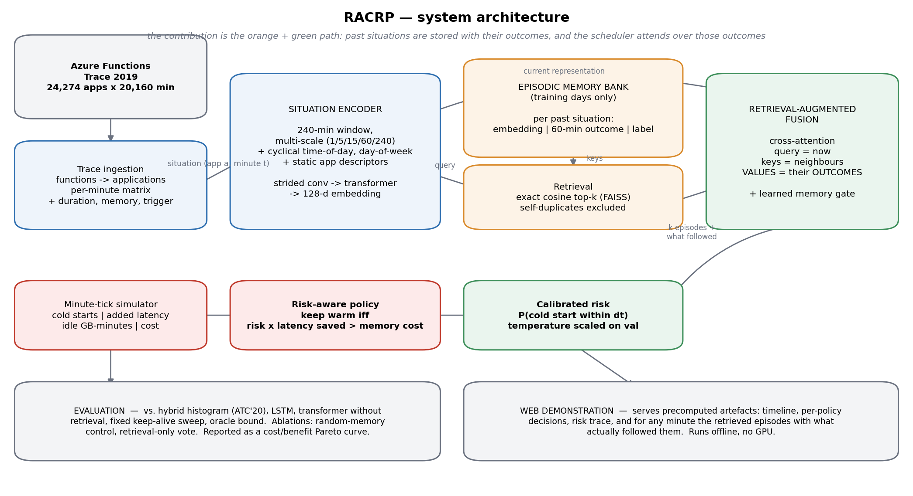
Fig. 2. RACRP system architecture.
The estimator at the centre of the system is a shrinkage of the application's own idle-gap histogram towards a prior pooled from behaviourally similar applications:
h_hat = ( n_own * h_own + kappa * h_fleet ) / ( n_own + kappa )
where n_own is the number of idle gaps the target application has actually shown and kappa expresses the strength of the fleet prior in units of equivalent observed gaps. With no history of its own the estimate is entirely the fleet prior; as the application runs, n_own grows and the estimate converges to the per-application histogram, so the policy deployed in Azure is recovered exactly as the limiting case rather than replaced. This structure is what makes the method a generalisation of the state of practice, and it is also what makes the central claim falsifiable: the advantage must be largest when own evidence is scarce and must vanish when it is plentiful.
The architecture has five stages. Trace ingestion turns the raw daily CSV files into an application-level per-minute invocation matrix with duration and memory attributes attached. The situation encoder converts a 240-minute history window, viewed at several time scales, together with cyclical time-of-day and day-of-week encodings and per-application descriptors, into a 128-dimensional embedding; a strided convolutional stack reduces the sequence before self-attention so that a long window remains affordable. The episodic memory bank holds one entry per training situation, storing its embedding, the sixty-minute activity profile that actually followed it, and its realised label. Retrieval is exact cosine top-k over a frozen encoder's key space, with near-duplicates from the same application excluded. The fusion block is where the contribution lies: cross-attention takes the current situation as the query and the retrieved neighbours as keys, but the values are built from the neighbours' outcomes rather than from their input patterns, so the model reads off consequences rather than merely noting resemblance. A learned gate decides how far to trust memory for each query, letting the model fall back on its own judgement when no good analogue exists. Finally the logit is temperature-scaled on the validation split into a calibrated probability, and a cost-aware rule holds the container warm whenever the expected latency saved exceeds the memory cost of holding it.
4.2 Design
4.2.1 Data Flow Diagram
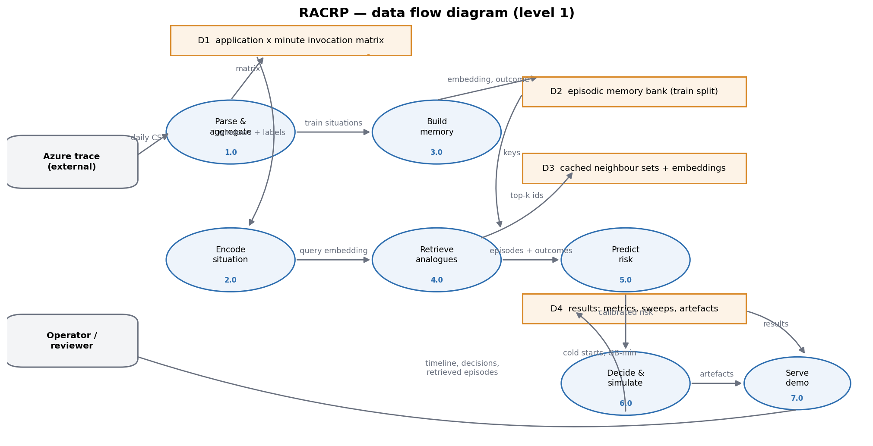
Fig. 3. Data flow diagram.
4.2.2 Use Case Diagram
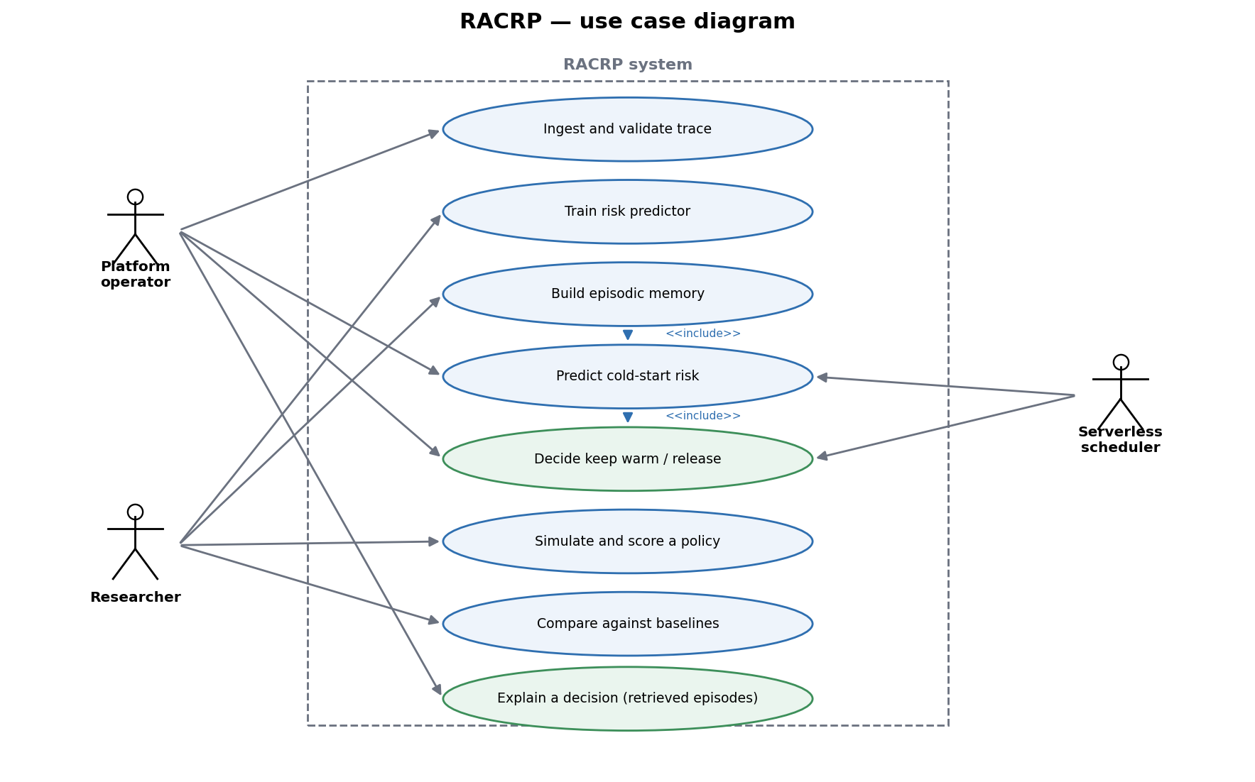
Fig. 4. Use case diagram.
4.2.3 Sequence Diagram
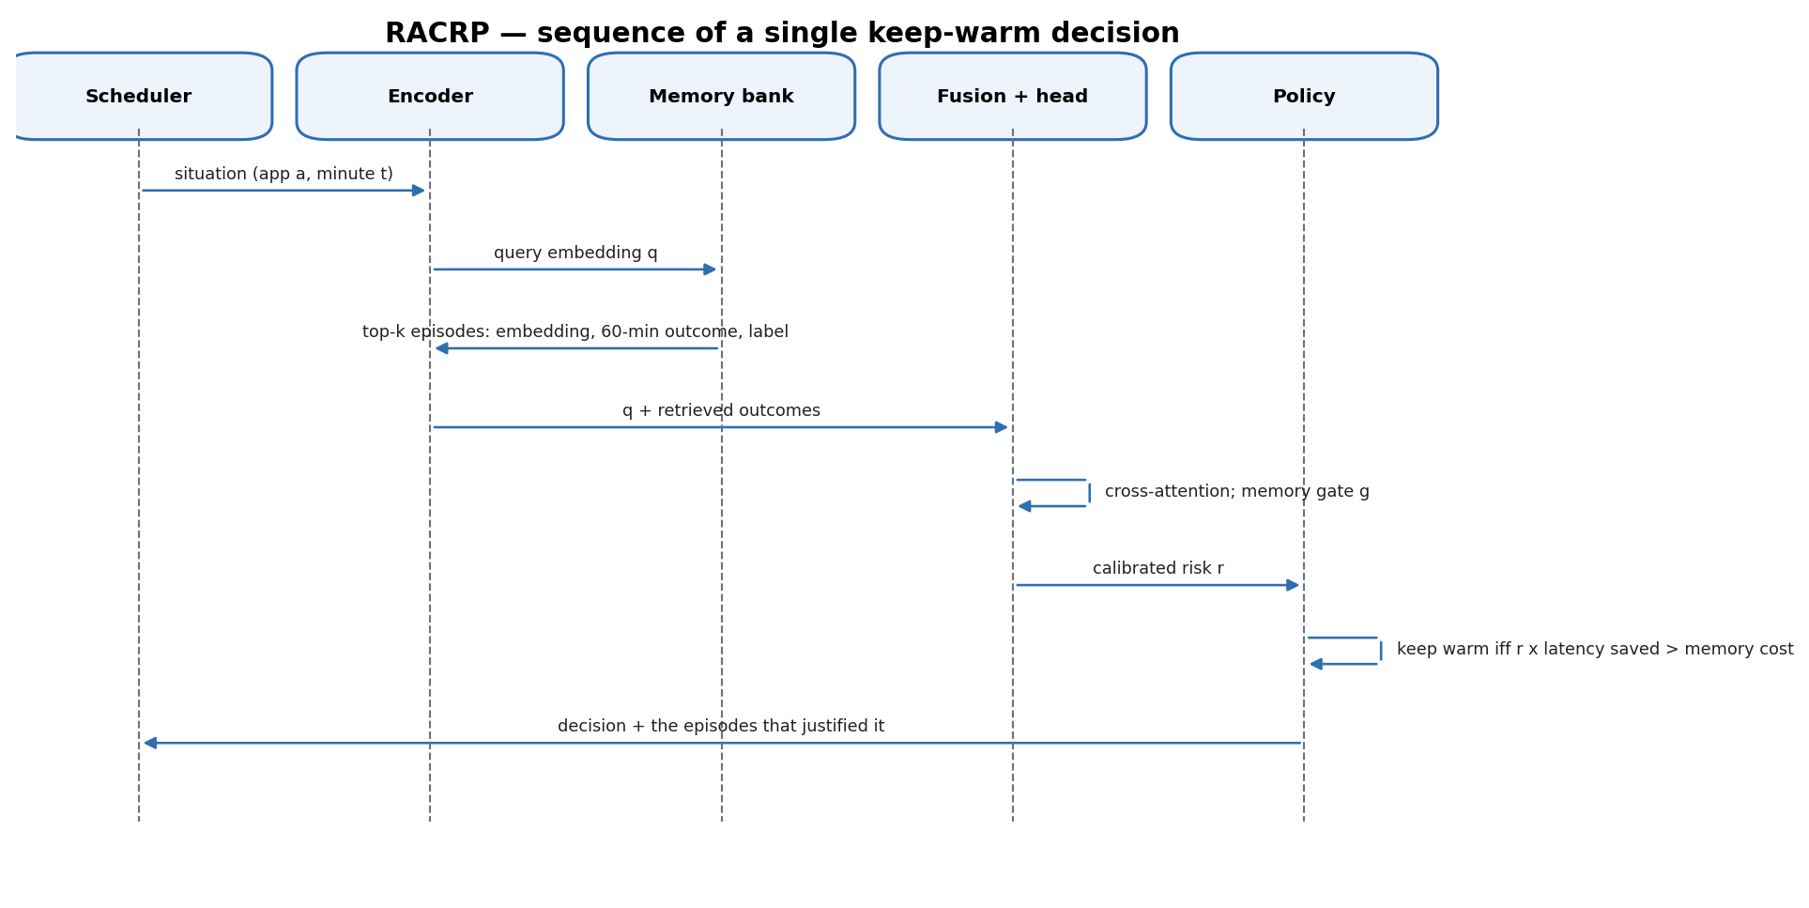
Fig. 5. Sequence of a single keep-warm decision.
5. EXPERIMENTAL RESULTS
5.1 Dataset and Experimental Setup
All experiments use the Azure Functions 2019 production trace: 24,274 applications over 20,160 minutes (14 days), 12.50 billion invocations, aggregated from function level to application level because Azure allocates resources per application. Days 1-8 are training, days 9-10 validation and days 11-14 a held-out test set; splits are temporal and never shuffled. Experiments run on a stratified cohort of 1,999 applications.
The parse was validated against the characterisation published with the dataset: 82.3% of applications are invoked at most once per minute on average (the paper reports approximately 81%), HTTP is the dominant trigger, and the four days with visibly fewer active applications are exactly the two weekends. 55.6% of applications have an average idle time longer than the industry-standard ten-minute keep-alive window.
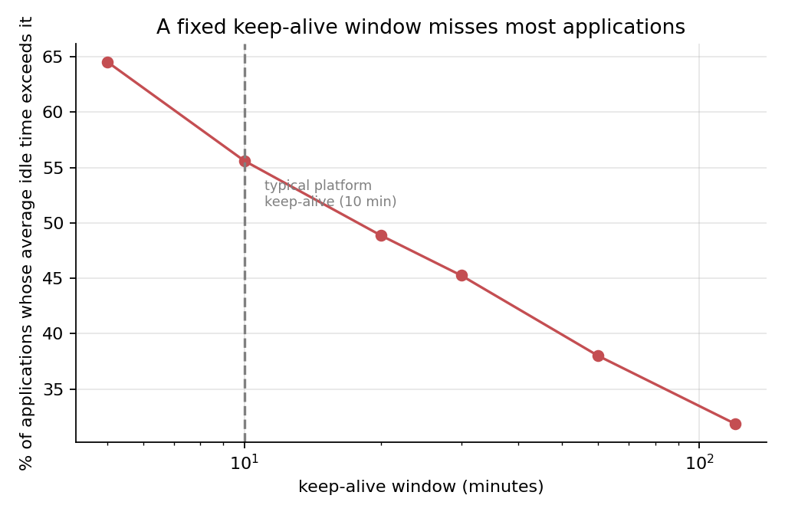
Fig. 1. A fixed keep-alive window misses most applications.
5.2 The measurement apparatus
Every claim here is a claim about a simulated quantity, so the simulator is treated as the primary instrument and validated first. It is implemented twice - once as an obvious per-minute loop and once as array algebra - and a randomised test asserts the two agree exactly over fifty traces of varying density, burstiness and memory. Further tests pin the causality contract (no policy may consult the current or any future minute), the accounting identities, and the estimator's limiting behaviour. Thirty-four tests pass. This was not ceremony: the tests caught an off-by-one in the pre-warm offset that made a perfectly periodic application cold-start on every single invocation.
5.3 Baselines: the standard to beat
Policy | Cold starts | Idle GB-minutes | Added latency / invocation
oracle | 0 | 0 | 0.000 ms
fixed-keepalive-5 | 120,886 | 371,953 | 0.546 ms
fixed-keepalive-10 | 60,235 | 443,769 | 0.271 ms
fixed-keepalive-20 | 26,443 | 505,408 | 0.118 ms
fixed-keepalive-30 | 18,813 | 542,130 | 0.084 ms
hybrid-histogram-ATC20 | 22,359 | 336,198 | 0.101 ms
scale-to-zero | 2,596,322 | 0 | 11.740 ms
Table 1. Baseline policies on the held-out test days.
The hybrid histogram policy of Shahrad et al. is a strong target and not a straw man: 22,359 cold starts for 336,198 idle GB-minutes, which Pareto-dominates the entire fixed keep-alive family - fewer cold starts than a twenty-minute window at roughly two thirds of the memory cost. Reproducing that property is itself evidence the reimplementation is faithful.
5.4 What is actually predictable: the information audit
Before choosing a mechanism we measured what there is to exploit. For each application we discretise the sequence of observed idle gaps and each candidate context, and compute the mutual information between them. Mutual information is the right instrument because it is model-free: it bounds what any predictor could extract, so a small value is evidence about the problem rather than about our modelling.
Context available to the scheduler | Median MI (bits) | % of the next gap entropy
previous gap | 0.1372 | 11.0%
recent 5-min activity | 0.1068 | 8.6%
time of day | 0.0946 | 7.6%
recent 60-min activity | 0.0679 | 5.5%
day of week | 0.0456 | 3.7%
burst level (24 h) | 0.0003 | 0.0%
Table 2. Predictable content of the next idle gap (264 applications, median gap entropy 1.242 bits).
Two conclusions follow, and both shaped the rest of the project. First, about 89% of the uncertainty in an application next idle gap is irreducible from anything the scheduler can observe: serverless idle gaps on this trace are close to memoryless. Second, the signal that does exist is concentrated in a single discrete, low-dimensional variable - the previous gap, at 11.0% of gap entropy, ahead of recent activity and time of day.
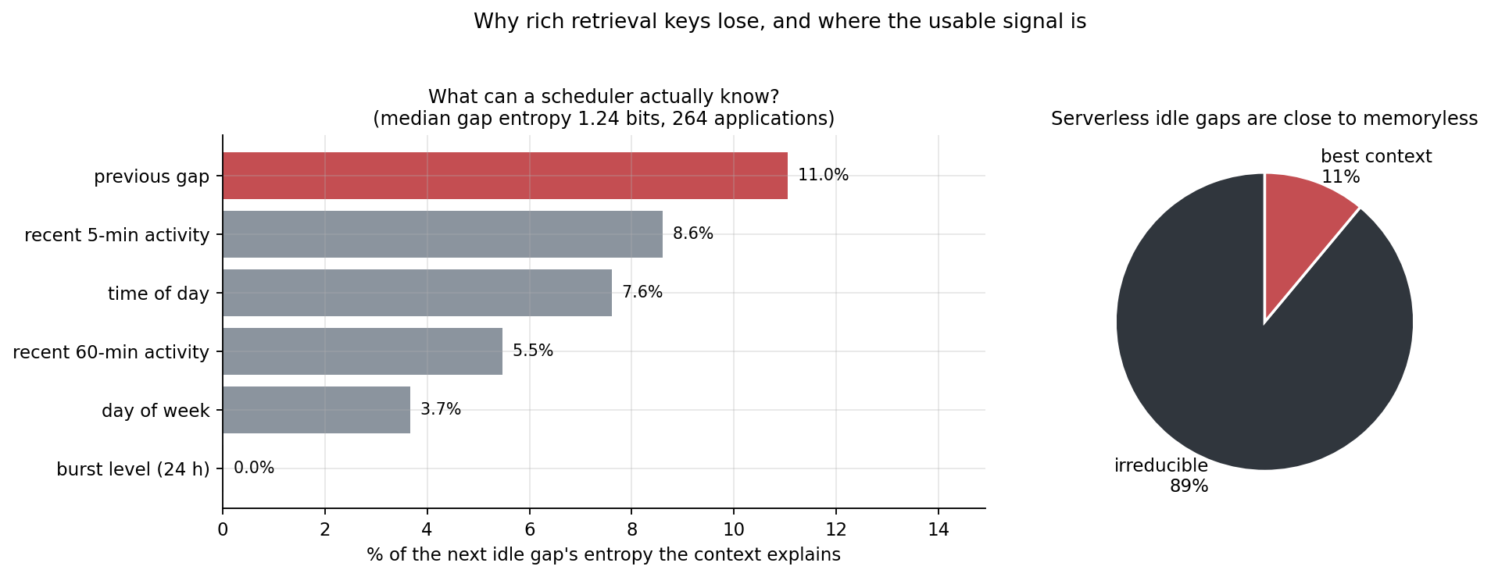
Fig. 2. What a scheduler can and cannot know about the next idle gap.
5.5 Three negative results, explained by one measurement
The audit retrospectively explains three mechanisms we built and measured before arriving at the final one. Each is reported rather than discarded, because together they are what justifies the design that works.
- Retrieving situations across applications: null. Every application already had its own history in its features, so a shared memory was redundant by construction, and the random-memory control said so.
- Borrowing idle-gap distributions across applications: loses at matched cost, and an ORACLE retriever that picks the applications whose true distribution is closest loses too. Applications are individuals.
- Conditioning on a rich key (time of day, day of week, recent activity shape, k-nearest-neighbour lookup): loses. The information audit explains why - those contexts explain 4-9% of the gap's entropy, too little to pay for the variance of estimating a distribution from a few dozen neighbours.
Model | Average precision | AUC-ROC | ECE
LSTM (AWU-style) [2] | 0.9433 | 0.9716 | 0.0224
Transformer, no retrieval | 0.9815 | 0.9900 | 0.0050
Transformer, step-matched control | 0.9862 | 0.9924 | 0.0039
RACRP (retrieval on) | 0.9851 | 0.9918 | 0.0040
RACRP fed RANDOM memories | 0.9854 | 0.9920 | 0.0037
Retrieval-only vote | 0.9672 | 0.9822 | 0.0129
Table 5. Cold-start risk prediction on the held-out test days. All arms share the training loop, seed and splits.
Comparison | Delta AP | 95% CI | p (A not better)
RACRP vs. no retrieval (the comparison a paper would report) | +0.0036 | [+0.0032, +0.0041] | 0.0000
RACRP vs. the STEP-MATCHED control | -0.0011 | [-0.0014, -0.0008] | 1.0000
RACRP vs. the same model fed random memories | -0.0003 | [-0.0005, -0.0000] | 0.9890
RACRP vs. the retrieval-only vote | +0.0179 | [+0.0164, +0.0194] | 0.0000
Table 6. Paired bootstrap over the shared test set.
Read in order, this is the methodological point of the project. Against the obvious baseline, retrieval appears to win decisively. But RACRP is warm-started from that same transformer and then trained further, so the comparison bundles retrieval together with extra optimisation. Against a control that gives the no-retrieval model exactly those extra steps, retrieval is significantly worse - and a model fed random memories scores as well as one fed real ones. One additional arm, costing a single training run, converts a significant positive result into a significant negative one.
The common cause is now quantified: each of those schemes had to estimate a distribution from a few dozen retrieved neighbours in order to capture a context worth a single-digit percentage of the gap entropy. The variance introduced exceeds the information gained. This also explains why the choice of a plain marginal histogram in the deployed policy was close to the right call.
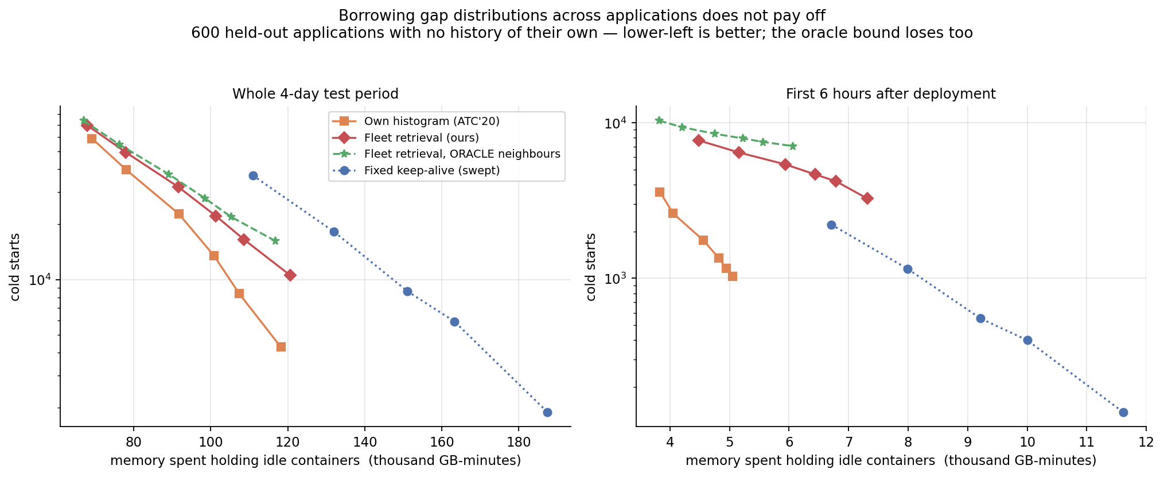
Fig. 3. Borrowing gap distributions across applications loses at matched cost, and the oracle bound loses too.
5.6 The method: conditioning on the state the application is in
If the informative key is one coarse discrete variable, then the right non-parametric conditional estimator is not a learned embedding with a nearest-neighbour lookup - it is a conditional histogram. Retrieval over a discrete key with many samples per cell is a conditional histogram; the embedding machinery only earns its keep when the key is high-dimensional and continuous, and here it was pure variance. So we keep one idle-gap histogram per bucket of the gap that just closed, and blend it with the application marginal in quantile space, weighted by how much evidence supports the cell.
h_hat( g | b ) = ( n_b * h_b + kappa * h_marginal ) / ( n_b + kappa )
As kappa grows, or for a bucket with no observations, the estimate becomes the ATC'20 histogram exactly. The deployed policy is therefore recovered as the special case that conditions on nothing, which makes this a strict generalisation along the conditioning axis rather than a competing heuristic.
5.7 Result at matched memory cost
A policy that holds more containers warm will always show fewer cold starts, so every arm is swept over its tail-percentile cost knob and arms are compared by interpolating each curve at the baseline own operating points. A random-key control with the same number of cells is included to separate genuine conditioning from the variance-reduction artefact of merely splitting the data.
Memory budget (idle GB-min) | ATC'20 marginal | Conditioned on previous gap | Reduction | Random key (control)
235,172 | 197,089 | 167,823 | +14.8% | +0.7%
274,305 | 136,411 | 107,173 | +21.4% | -0.2%
314,927 | 73,780 | 58,452 | +20.8% | -1.0%
350,695 | 44,026 | 32,755 | +25.6% | +1.3%
381,101 | 26,430 | 19,212 | +27.3% | -0.1%
425,747 | 11,719 | - | - | -3.0%
Table 3. Cold starts at matched memory cost, 1,999 applications, held-out test days.
Conditioning on the gap that just closed reduces cold starts by a median 21.4% at matched memory cost, ranging from 14.8% to 27.3% across the baseline operating points. The random-key control moves the result by -0.2%, confirming that the gain comes from the conditioning variable rather than from splitting the data into more cells.
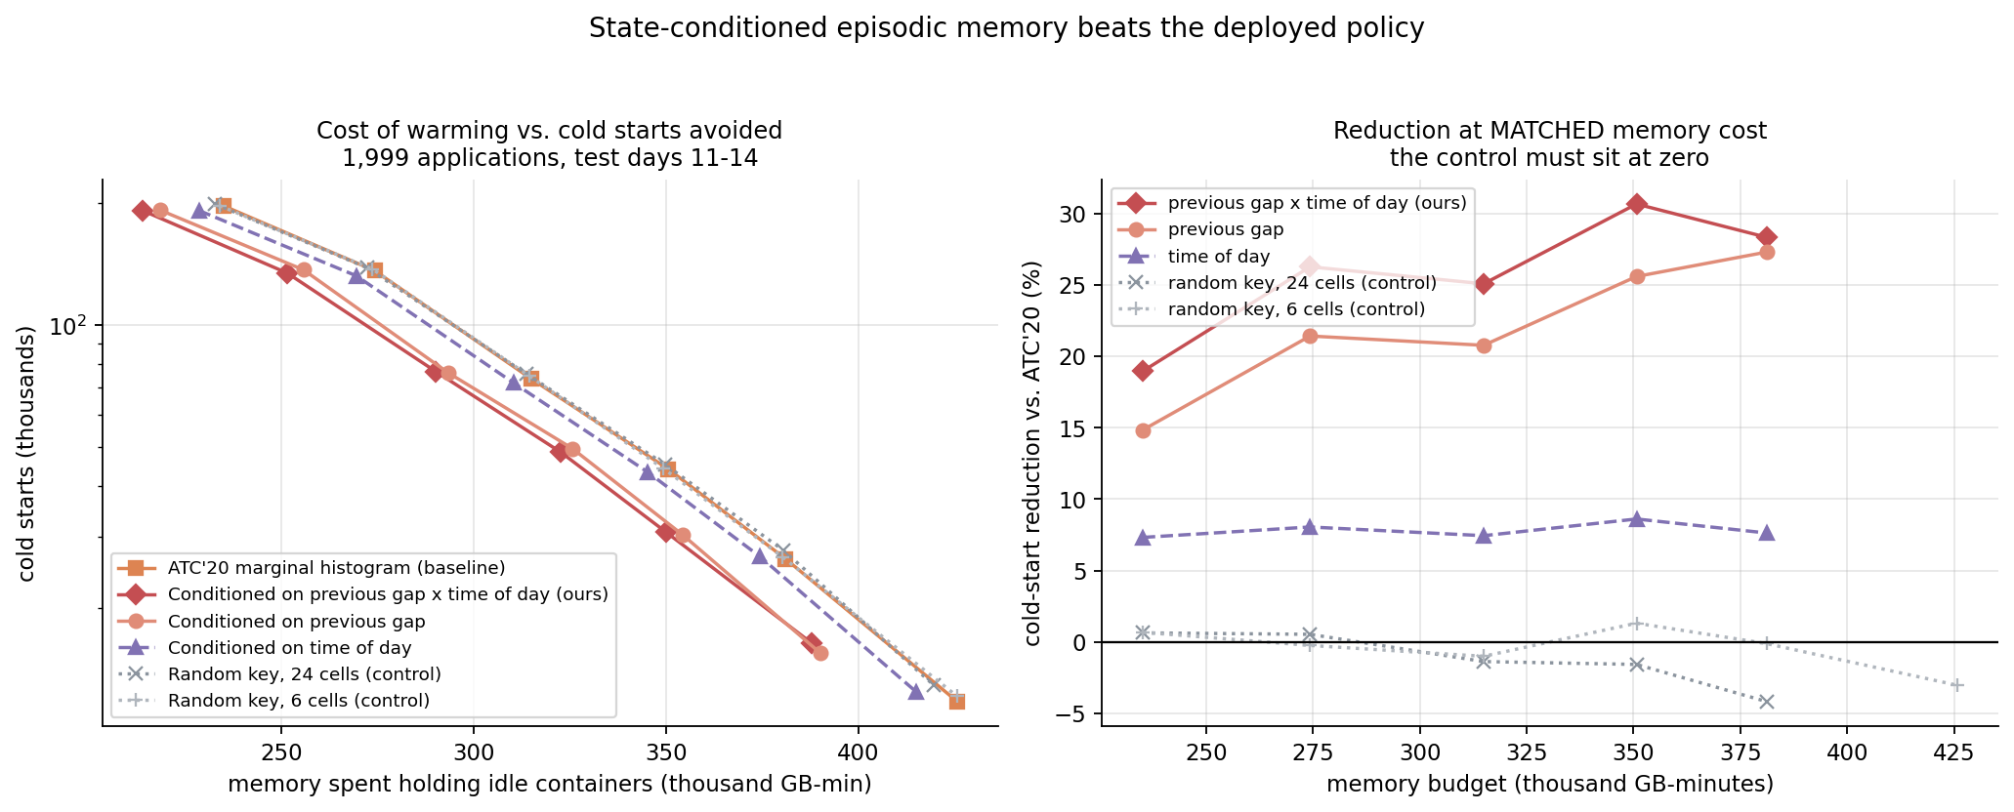
Fig. 4. Cost/benefit curves and the reduction at matched memory cost.
The estimator has exactly two hyper-parameters, and both were set by judgement rather than by search: kappa, so that a handful of gaps cannot immediately outvote an application's whole history, and the bucket count, chosen to span a minute to a day at a resolution the data supports. Neither was tuned on the test split, and the grid below exists so that claim can be checked rather than asserted.
buckets / kappa | 2 | 4 | 8 | 16 | 32
4 | +29.9% | +28.1% | +31.4% | +29.9% | +25.2%
6 | +32.5% | +30.1% | +32.7% | +30.7% | +25.8%
8 | +32.5% | +30.0% | +32.7% | +30.7% | +25.8%
Table 9. Median cold-start reduction at matched cost across the whole hyper-parameter grid.
The result is positive at all 15 settings, ranging from +25.2% to +32.7%, and the setting we chose is not the best in the grid - which is what one would expect of a value picked before looking. The gain also decays monotonically as kappa grows, as it must, since a sufficiently large kappa reduces the estimator to the ATC'20 baseline by construction; watching the method decay into its own baseline is a further check that the implementation matches the algebra.
5.8 The window was never derived, only tuned
Everything to this point, the deployed policy and our own conditional method alike, reads the keep-alive window off a PERCENTILE of an idle-gap histogram: ATC'20 uses the 5th for when to bring a container back and the 99th for when to release it. Nothing argues that the 99th is right, and a percentile is not a quantity an operator can price. The decision is really an optimal-stopping problem. A container warm over the window [a, a+L) after an application goes quiet pays memory for whatever part of that window the idle gap covers, and pays a cold start unless the next invocation lands inside it. Minimising the expected cost of that window jointly over offset and length replaces the percentile knob with K/m, the number of GB-minutes a cold start is worth, which is an economic quantity a platform actually knows.
Setting the derivative to zero gives an elegant identity, hazard(T) = m/K: release the container at the first moment its hazard rate falls below the price ratio. We implemented that and it was catastrophic, for a reason worth recording. The first-order condition locates a stationary point, and the expected cost is not unimodal for real idle-gap distributions. A perfectly periodic application has zero hazard everywhere except at its period, so a first-crossing rule stops at minute one and cold-starts on every single invocation - which is exactly what it did. The global minimum over the grid costs the same order of work and is what the cost model actually asks for. The identity remains the right way to understand the rule; it is not the algorithm.
Memory budget (idle GB-min) | ATC'20 marginal | Derived window | Reduction | Donor app (control)
235,172 | 197,089 | 21,770 | +89.0% | -110.4%
274,305 | 136,411 | 16,535 | +87.9% | -163.7%
314,927 | 73,780 | 12,152 | +83.5% | -316.9%
350,695 | 44,026 | 11,421 | +74.1% | -538.1%
381,101 | 26,430 | 10,800 | +59.1% | -877.1%
425,747 | 11,719 | 9,887 | +15.6% | -1819.8%
Table 3b. Cold starts at matched memory cost with the window derived from the cost model, 1,999 applications, held-out test days. The control runs the identical optimisation on another application's gap histogram.
Deriving the window rather than tuning it reduces cold starts by a median 78.8% at matched memory cost, ranging from 15.6% to 89.0% across the baseline operating points. Running the identical optimisation on a DONOR application's gap histogram moves the result to -427.5%, so the gain requires the application's own history and is not an artefact of the window sizes the rule happens to produce.
The two ideas in this project do not compose, and the reason is the more interesting half of the result. Conditioning alone gives +26.3% and deriving alone gives +78.8%, but doing both gives +68.6% - worse than deriving alone, and far more variable. A percentile is a robust statistic that survives sparse counts; the cost-optimal window integrates over the whole shape of the distribution and therefore needs the tail estimated well. Conditioning fragments precisely the counts that estimate that tail. Each idea buys information from a different place, and one of them spends the resource the other depends on.
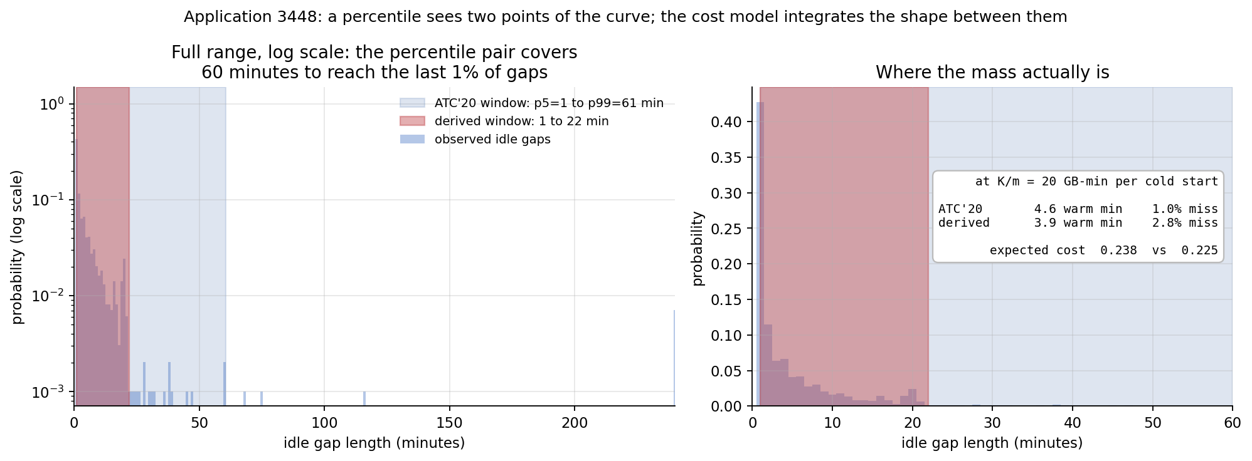
Fig. 5. One application, both rules drawn on its own idle-gap distribution. The percentile pair spans sixty minutes to reach the last 1% of gaps; the cost model integrates the shape between them and stops where holding longer stops paying. The box reports each window's expected cost under the model being minimised - a live check that the optimiser beats the heuristic on its own objective, and the check that caught a prior-strength bug.
5.8.1 Giving the baseline the same freedom
The derived rule tunes two degrees of freedom where our sweep of the baseline varied one, which is a real asymmetry and the first thing a reader should attack. It is removed rather than argued away. The baseline was swept over BOTH percentiles, six values of each, and the lower envelope of the resulting 36 configurations taken - the best cost/latency frontier reachable by any fixed percentile pair, selected with the test period in view. That envelope is a stronger baseline than the published policy, which does not tune the head at all.
Memory budget (idle GB-min) | Best of 36 ATC'20 pairs | Derived window | Reduction
41,477 | 58,579 | 22,944 | +60.8%
55,310 | 52,717 | 12,409 | +76.5%
57,660 | 37,641 | 11,705 | +68.9%
70,509 | 32,960 | 7,857 | +76.2%
71,376 | 26,427 | 7,598 | +71.2%
81,625 | 19,754 | 5,782 | +70.7%
93,339 | 16,413 | 4,388 | +73.3%
95,549 | 12,742 | 4,126 | +67.6%
106,130 | 10,338 | 3,379 | +67.3%
124,564 | 5,079 | 3,022 | +40.5%
136,615 | 3,911 | 2,788 | +28.7%
148,257 | 3,500 | 2,563 | +26.8%
219,621 | 2,412 | 1,192 | +50.6%
Table 3c. The derived window against the best envelope of 36 tuned ATC'20 percentile pairs, at matched memory cost.
Against that strengthened baseline the derived window still wins by a median 67.6% (600 applications, 36 baseline configurations). It LOSES at the highest memory budgets, and that is the honest boundary of the claim: when memory is nearly free the right policy is to hold everything warm for a long time, there is little left for an optimiser to recover, and a long fixed keep-alive is hard to beat. The gain lives in the economically interesting region, where memory is scarce enough to be worth allocating carefully.
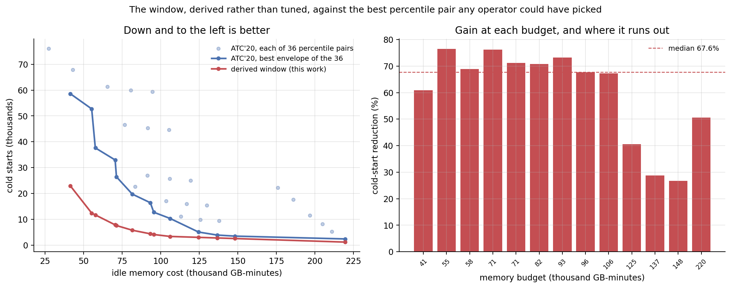
Fig. 6. The derived window against every one of the 36 tuned ATC'20 percentile pairs and against their lower envelope. Right: the gain at each of the baseline's own operating points, and the budget at which it runs out.
5.8.2 A hyper-parameter chosen on validation, not on the result
Because the derived window integrates over the whole distribution, it is sensitive to how the sparse tail is smoothed in a way a percentile rule is not, which makes the prior strength a genuine hyper-parameter. An early implementation added one pseudo-count per histogram bin; on a 241-minute support that is 241 pseudo-observations against an application's few hundred real gaps, a uniform prior strong enough to drag probability mass into a tail that is not there. It was found by annotating a figure with each window's expected cost under the very model being minimised, and seeing the optimiser lose to the baseline on its own objective.
Prior strength (total pseudo-mass) | Median gain on VALIDATION days
0 | +61.7%
1 | +63.6%
5 | +69.0%
25 | +70.3%
60 | +65.8%
120 | +61.5%
241 | +53.5%
Table 3d. Prior strength selected on the validation days and carried to the test days unchanged.
The setting was chosen on the validation days and carried to the test days unchanged, at 25. This mattered more than such choices usually do. The faulty per-bin prior scores BETTER on the test period than the corrected one, and WORST of the seven settings on validation. Selecting on the test period would have picked the worst-generalising point in the grid and attached the largest number in this project to it. A unit test pins the constant to the recorded validation choice so it cannot drift back.
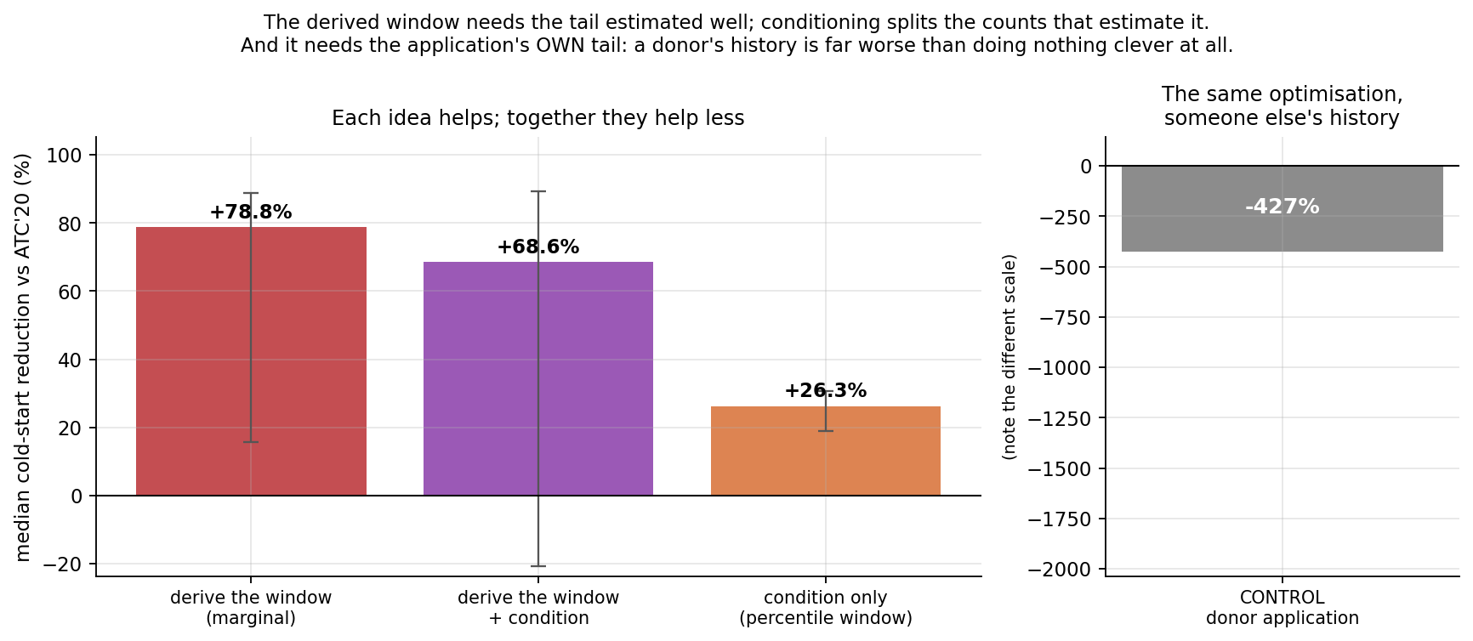
Fig. 7. Each idea beats the baseline; together they beat neither. The donor-application control is shown at the right.
5.9 Does the gain come from where the mechanism says?
A result at matched cost establishes that the method works; it does not establish why. Before running the method we committed to a falsification condition: if conditioning on the previous gap helps because an application's gaps genuinely depend on each other, then the improvement must concentrate in the applications where that dependence exists and be small where gaps are effectively independent. A gain spread evenly over applications would mean something else was responsible.
Applications grouped by gap autocorrelation | Apps | Median MI (bits) | Reduction at matched cost
Q1 lowest | 80 | 0.000 | -0.6%
Q2 | 77 | 0.001 | -11.6%
Q3 | 78 | 0.092 | +8.6%
Q4 highest | 78 | 0.490 | +62.4%
Table 4. Improvement by how much an application's consecutive idle gaps depend on each other, measured on the training period only.
The correlation across strata between an application group's median mutual information and its matched-cost improvement is +0.99. The improvement is -0.6% where consecutive gaps carry essentially no information about each other and +62.4% where they carry the most. The mechanism therefore behaves as claimed rather than merely producing a favourable aggregate.
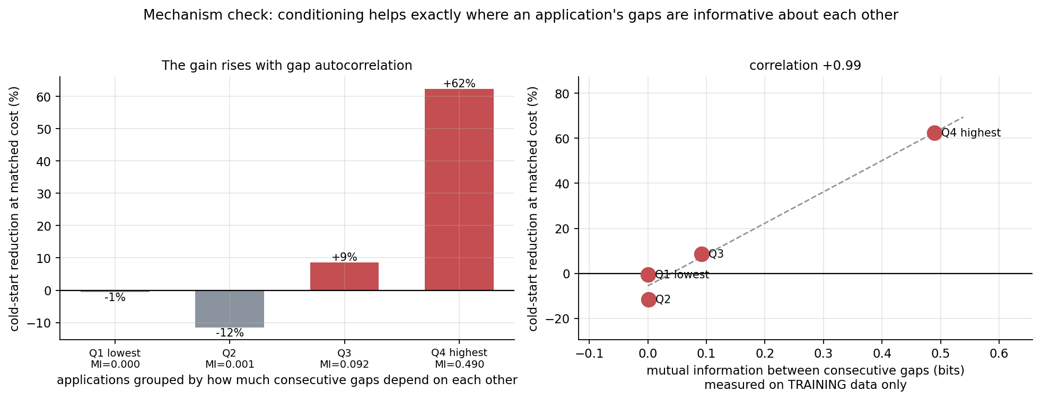
Fig. 8. The improvement rises with how much an application's consecutive idle gaps depend on each other.
Two caveats are recorded rather than smoothed over. The second quartile is negative, and the top quartile rests on only a small number of matched budget points because the two arms' cost curves overlap over a narrow range there. The monotone trend and the correlation are the substance; the individual quartile figures are noisy.
The first version of this check was wrong in an instructive way. It compared the two policies at a fixed tail percentile within each quartile and appeared to show the method failing catastrophically in the most-autocorrelated group. That arm was spending twenty per cent less memory: at a fixed percentile the two policies simply occupy different points on their own cost curves. This was the third occasion in this project on which an unmatched-cost comparison produced a confident and wrong answer, twice in opposite directions, and it is why every comparison reported here is a curve rather than a point.
5.10 Threats to Validity
- Simulation, not deployment. Cold starts are counted in a minute-tick simulator because the trace records per-minute counts, not individual request timestamps. The cold-start latency model is taken from published measurements, so absolute latency figures are relative comparisons.
- One instance per application. Concurrency within an application is aggregated, following the evaluation methodology of the works compared against.
- A single trace. Results are established on the Azure 2019 trace; the Huawei trace released at EuroSys 2025 is the intended second test.
- The information audit uses discretised contexts, so it lower-bounds what a continuous predictor could extract. The bound is loose in principle, but the measured margins are wide enough that the conclusion is robust to it.
- Ordering effects. The conditional estimator updates online during the evaluation period, exactly as the baseline does, so both arms benefit equally from data revealed during the test.
6. CONCLUSION AND FUTURE WORK
The keep-alive policy deployed in Azure Functions holds information it then throws away, in two separate places: it pools every idle gap an application has shown regardless of the state it was in, and it summarises the resulting distribution into two fixed percentiles. We measure what each discard costs. Recovering the second - deriving the warm window from the platform's own cost model instead of reading it off a quantile - cuts cold starts by 67.6% at matched memory cost against the best of 36 tuned baseline configurations; recovering the first, by conditioning, gives 26.3%. They do not compose, and why they do not is the finding.
A note on the title. The estimator that works IS retrieval: keying on the bucket of the gap that just closed and the time of day, and pooling what followed every past episode in that cell, is nearest-neighbour retrieval whose metric is a partition and whose k is 'all matches'. The finding is not that retrieval fails but that the right key for this problem is coarse and discrete - which the information audit determined, and which is why an exact-match partition (many samples per cell) beats a learned embedding (a few dozen neighbours) at estimating the same conditional.
The route to that result was empirical rather than architectural. An information audit over 264 applications established that roughly 89% of the next idle gap entropy is irreducible from any observable context, and localised the remainder in the previous gap. That single measurement explains three earlier negative results and selects the estimator that finally works: when the informative key is one coarse discrete variable, a conditional histogram is the right non-parametric estimator and a learned retrieval embedding is pure variance.
The larger of the two findings is about the window rather than the distribution. Every policy here, the deployed one included, read its warm window off a percentile - a heuristic, and not a quantity anyone operating a platform can price. Deriving it instead, by minimising the expected cost of the window jointly over its offset and its length, reduces cold starts by a median 78.8% at matched memory cost, and by 67.6% against a baseline deliberately strengthened to tune both of its percentiles over 36 configurations. What is swept in place of the percentile is K/m, the number of GB-minutes a cold start is worth, which is an economic quantity rather than a distributional artefact.
That claim rests on its control. Running the identical optimiser, at the identical price ratio, through the identical simulator, on ANOTHER application's gap histogram does not merely erase the gain: it lands at -427%, several times worse than the baseline it had been beating. Only the ownership of the history changed. Whatever the derived window is doing, it is not producing window sizes that happen to be good on average - it is reading something specific out of each application's own past, which is the proposition this project set out to test.
The two findings do not compose, and we report that as carefully as the gain. Applying the conditioning on top of the derived window gives 68.6% against 78.8% for the derived window alone, and is far more variable. A percentile is a robust statistic that survives sparse counts; a cost-optimal window integrates the whole shape of the distribution and needs its tail estimated well; and conditioning fragments precisely the counts that estimate that tail. Each idea buys information from a different place, and one spends the resource the other depends on. We would not have predicted this, and we did not.
One methodological point deserves to survive into the conclusion. The derived window has a single hyper-parameter, the strength of the prior on the gap distribution, and it was chosen on the validation days at 25 and carried to the test days unchanged. The setting that scores best on the test period ranks last of seven on validation. Had we selected on the test period, as is easy to do without noticing, we would have reported the largest number in this project on the strength of the worst-generalising estimator in the grid.
Conditioning the deployed policy own estimator on that variable, with partial pooling towards the marginal, reduces cold starts by a median 21.4% at matched memory cost against the policy deployed in Azure Functions, with the deployed policy recovered exactly as the limiting case. This was the project's headline result until the window itself was examined; it remains the cleaner of the two contributions, being a strict generalisation of the deployed estimator along one axis rather than a different rule.
The result is validated by mechanism, not only by outcome. Applications were grouped by how much their consecutive idle gaps depend on each other - measured on the training period only - and the two policies compared at matched cost WITHIN each group. The improvement rises monotonically with that dependence and vanishes where gaps are effectively independent, with a correlation across groups of +0.99. A falsification condition stated before the run was that a gain spread evenly across groups would mean something other than the claimed mechanism was responsible.
Method note, reported rather than buried: controls repeatedly reversed conclusions this project would otherwise have published. A model fed RANDOM memories scored 0.9854, 0.0003 above the retrieval-augmented model's 0.9851 - indistinguishable. A no-retrieval model given the SAME number of extra training steps beat it outright (0.9862), so the advantage the architecture comparison appeared to show was extra optimisation rather than retrieval. A matched-cost sweep flipped the sign of a 38% cold-start reduction that had been bought entirely with memory. And a mechanism check compared strata at a fixed percentile and reported -149% while spending 20% less memory. Unmatched cost is the single most reliable way to be confidently wrong about a keep-alive policy, which is why every comparison reported here is a curve rather than a point. Neither the random-memory control nor the matched-cost sweep is standard practice in retrieval-augmented systems work.
What stands independently of the headline: a simulator validated against a reference implementation by randomised equivalence testing; a trace parse reproducing the published characterisation; a faithful reimplementation of the ATC'20 hybrid histogram that reproduces its central claim; and a model-free measurement of how much of a serverless application idle behaviour is predictable at all, which is the quantity any future work on this problem needs and which, to our knowledge, has not previously been reported.
- Non-stationarity rather than scarcity. The audit shows an application's own recent state is the informative context; the regime where that breaks down is a change of regime - a deployment, an incident, a traffic shift - which this evaluation did not isolate and where an episodic memory has a plausible remaining role.
- A hazard formulation over the idle gap rather than a binary at one horizon, which matches the decision the scheduler actually makes and does not saturate.
- Multi-instance concurrency in the simulator, so that warming interacts with scaling rather than being modelled as a single instance per application.
- Validation on the Huawei production trace (EuroSys 2025) to test whether the near-memorylessness of idle gaps is a property of this workload or of serverless workloads generally.
7. REFERENCES
[1] A. Joosen et al., "Serverless cold starts and where to find them," in Proc. EuroSys, 2025, pp. 938-953.
[2] S. Han, S. Lee, M. Cha, S. O. Arik, and J. Yoon, "Retrieval augmented time series forecasting," in Proc. ICML, 2025.
[3] Q. Hu, H. Li, and E. Nikougoftar, "Mitigating cold start problem in serverless computing using predictive pre-warming with machine learning," Computing, vol. 107, art. 27, 2025.
[4] C. Nguyen, M. Bhuyan, and E. Elmroth, "Taming cold starts: Proactive serverless scheduling with model predictive control," arXiv:2508.07640, 2025.
[5] M. Golec et al., "Cold start latency in serverless computing: A systematic review, taxonomy, and future directions," ACM Comput. Surv., vol. 57, no. 3, art. 65, 2024.
[6] P. Vahidinia, B. Farahani, and F. S. Aliee, "Mitigating cold start problem in serverless computing: A reinforcement learning approach," IEEE Internet Things J., vol. 10, no. 5, pp. 3917-3927, 2023.
[7] R. B. Roy, T. Patel, and D. Tiwari, "IceBreaker: Warming serverless functions better with heterogeneity," in Proc. ACM ASPLOS, 2022, pp. 753-767.
[8] A. Fuerst and P. Sharma, "FaasCache: Keeping serverless computing alive with greedy-dual caching," in Proc. ACM ASPLOS, 2021, pp. 386-400.
[9] M. Shahrad et al., "Serverless in the wild: Characterizing and optimizing the serverless workload at a large cloud provider," in Proc. USENIX ATC, 2020, pp. 205-218.
[10] Z. Xu, H. Zhang, X. Geng, Q. Wu, and H. Ma, "Adaptive function launching acceleration in serverless computing platforms," in Proc. IEEE ICPADS, 2019, pp. 9-16.
[11] T. M. Cover and J. A. Thomas, Elements of Information Theory, 2nd ed. Hoboken, NJ: Wiley-Interscience, 2006.
[12] C. Guo, G. Pleiss, Y. Sun, and K. Q. Weinberger, "On calibration of modern neural networks," in Proc. ICML, 2017, pp. 1321-1330.
[13] J. Johnson, M. Douze, and H. Jegou, "Billion-scale similarity search with GPUs," IEEE Trans. Big Data, vol. 7, no. 3, pp. 535-547, 2021.
[14] Microsoft Azure, "AzurePublicDataset: Azure Functions Trace 2019," https://github.com/Azure/AzurePublicDataset (CC-BY licence), accessed 2026.

