Assessment type (þ):
☐ Questioning (Oral/Written)
☐ Practical Demonstration
☐ 3rd Party Report
☒ Other – Project/Portfolio (please specify)
Assessment Resources:
- This worksheet (journal): containing both instructions and assessment tasks
- A Python environment: IDLE or PyCharm for coding your program
- Blackboard: reference materials and samples
- Access to Office 365, Microsoft Word and Excel
- A .zip file containing this worksheet, starter code, task list, and word lists required for completing the activity
- Videos and other information relevant for simulating the work environment
Assessment Instructions:
- Review all information contained in this document.
- Complete each session in a timely manner: your submission consists of both this journal and a working python application (program)
- You must carry out at least one review prior to submission on week 18
- Contextual instructions are marked with an information symbol (ℹ)
- Reflection questions are marked with a journal symbol () and are there to assist you with your learning journey but are not graded
- All questions marked with a Qn: must be answered to achieve competency
- You must follow the sequence outlined in the journal for writing your code

Timing notes
While this assessment is due on week ending session 18, you MUST review elements of this journal and your code with your lecturer before submission to pass this assessment.
You are expected to complete this assessment in the order outlined in this document using time allocated within your session and working from home. That is the sequence in which you complete this assessment is assessable, not just the outcome!
Refer to Blackboard for most accurate dates, which may alter due to unforeseen circumstances.

General instructions
The project consists of the following parts:
- This journal and embedded instructions
- At least one template Python program that you can use as a basis of your development work
Follow the steps outlined in this document and complete the required coding project.
You must follow the instructions in outlined. You may need to submit additional files

Important
If you are using a different IDEs, then assistance with those tools may be limited. You must only employ Python functions taught in the course or covered in the journal.

Scenario
You are currently working as a junior software developer at Words-R-Us, a Perth-based company that develops content and apps to capture engagement.
You have been contracted to gain a deeper understanding of the popular game Wordle and develop a prototype app that emulates the original wordle algorithm from the command line. As a junior developer, you have access to your peers, the senior developer (played by your lecturer), and occasional access to the customer (usually also played by your lecturer).

Simple application
You must submit an original simple software application (code) as part of your submission. The application must be design and built according to programming standards and program specification. You must include the submission as a separate text file with a .py extension. Your application must demonstrate that you followed the testing and documentation requirements outlined in this journal and implemented the algorithm and tests you documented here.
Your program must adhere to basic PEP8 standards (see your PEP8 checklist on Blackboard), and it must:
- demonstrate a sequence, selection, iteration
- read and write from a file
- be appropriately documented and tested
You will present your application to required personnel on at least two occasions: the first occasion is a simulated context and the second you will meet with your lecturer.
Upload any code as an archive (zip) containing your .py and .txt files. If applicable, remove the virtual environment (venv or .venv) from the zip-file before uploading it to Blackboard.

Assessed competencies
This journal provides evidence for the following aspects of your competency:
- Your ability to prioritise your own work
- Obtain feedback to validate and enhance your design decisions
- Confirm that the application meets specifications
- Conduct simple tests to confirm code meets the design specifications
- Evaluate and reflect on decisions you made in the process of development
Save the file as:
- XXX_ICTPRG302_Proj_Journal.docx
Replacing XXX with your initials.
For example, Adrian Gould would use AG_ICTPRG302_Proj_Journal.docx for his submitted filename.

Answering Questions
When a step includes a question, you must attempt to answer it. A word count is sometimes given, but most answers require at most 1-3 paragraphs.
All answers must be in complete sentences unless indicated. You must use your own words unless otherwise specified.

Generative AI and ChatGPT
Use of AI such as ChatGPT to help complete this project is not recommended and copying and pasting from ChatGPT without attribution is plagiarism. If you use ChatGPT or similar please retain all transcripts as they may be requested to validate the authenticity of your work.

Sources of Information
In industry, it is good practice to keep track of where information was obtained. This is especially true if it is a written document, or even code.
If you answer any questions using information from web sites, please include the site name and URL (Web site address) after the answer. Likewise, include the title and author for books and magazine articles. For example:
- RS Electronics Ltd: https://au.rs-online.com/
- Slack API Documentation, Users List Method: https://api.slack.com/methods/users.list

Version Control and Issue Tracking (optional)
An industry-standard tool for managing program source is git. GitHub is a free service that provides hosting for git repositories. You may choose to use this system for source control, task management, or both. However, it is not required for this project.
You may also use OneDrive within your college Office365 to store a backup of your code or keep a copy on a USB thumb drive.

This space left intentionally blank.

Journal
ℹ️ Use this section of the worksheet to demonstrate your ability to clarify tasks, identify specifications and programming standards, develop an algorithm, create, and conduct simple tests, seek feedback, and present the application to required personnel.

Session 1

Familiarisation:

Use listening and questioning techniques to confirm requirements and capture and articulate complex concepts.
Before you can start working on the project, a project induction video hosted by the client, the CEO of Words-R-Us. The video simulates an interaction with the client. To complete the simulation, you need to both listen and/or watch the video and then submit clarifying questions. It is only after you submit your clarifying questions that additional videos will be unlocked.
To start the project:
- Go to the project landing page Blackboard > Assessments > PRJ
- Find the video containing “Project Client Brief” in the title
- Watch the video in its entirety
- Find the “Clarifying Questions” submission link and submit questions as outlined on that link.
Submitting the questions will unlock the next video that you will need for subsequent sessions.
In addition to submitting the clarifying questions on Blackboard, answer the remaining questions:
- In your own words, briefly explain: what is Wordle?
Word game where player must guess a 5 letters secret words within allowed number of attempts.

Sessions 2

Requirements and design
Watch the “reply” to your clarifying questions from the previous session and use the information covered in the video to document your answers to session 2 and 3.
IMPORTANT: The second video is only revealed after you upload your clarifying questions.
- During the video briefing, the developer outlined the resources (files) that you have been supplied with to help you successfully complete the project. Enter the names of these files and a brief description below. The first file has been entered for you:
ICTPRG302-AT2-PRJ.docx:
That’s this project journal. I need to complete this journal every week so that I can make sure I am following a plan and meeting all requirements.
PRJ-Prelim.docx:
The document contains clarifying questions I have for the senior developer. The feedback from the senior developer will ensure that I understand the project’s expectations.
All_words.txt
A list of words that the player can write as a valid guess.
Target_words.txt
Collection of words that I can randomly pick as the secret word.

- In the section below, confirm that you have identified and found each of the files you listed above
I _Matias Tjandradjaja__________, have been able to attain each of the files on, _7/10/2024_____

- Below is a list of requirements for the application. Note down additional detail on the application and Propose at least one Python function (e.g. print(), input(), open(), len()), or selection (if/elif/else), or iteration (for/while) construct that the developer said could help meet the requirement . The first item has been filled in for you
- Present game instructions to player (That is, display an output to the screen)
The senior developer emphasized that the game must include instructions that apppear the first time the user plays the game and can be accessed any time by entering “HELP” in any case. The developer said I should use a print function for each line.
- Read a list of valid words
The senior developer want us extract all the words from the valid word file to check if the player guess is valid. We can read the file using open() and make the following expression to check if the word is in a list.

If guess in valid_words:

- Read a list of possible target words
The senior developer wants the application to read through a list of possible target words from the target_words.txt file. The words being read must be converted to one list then a random one will be choosen as the target words. The developer demonstrate that I can use the built-in random module. Using the choice method, I can get a random word from the list.

Target_word = random.choice(target_words)

- Prompt the user to enter a guess
I can use the input() function to prompt for guess. If invalid guess is entered, prompt for guess again.

- Check if the guess that is entered is a valid guess (ensure you refer to the two validation checks you must perform on the input
For a guess to be considered valid it must (a) the length of the target word and (b) exist in the valid words file. I will need to use if statement.

- Score the guess by providing clues on each character’s match to the target word’s characters
The senior developer wants us to score the guess by checking if the character is in the correct place in the word, if it’s in the wrong place in the word or if it’s not in the world at all.

I can utilize for loop construct to iterate through every single letter.

- End the game when the player wins or when all valid attempts are complete
If the guess is correct the developer said to end the game by printing a winning message.
If the player reached the number of allowed attempt to guess the word and still can’t guess the secret word, print a loss message.

For every tries, we can increment an integer data type. Tries =+ Tries
Then we can check if Tries > AllowedAttemptes to end the game.

- Present a completion message to the user

Display completion message to the user using print() and accompanied the message with the secret word they guessed.

Session 3

Algorithms
ℹ️ During your discussion, the senior developer drew a similar diagram to the adjacent diagram.  The developer explained that a big focus of your work is your ability to come up with a simple algorithm that will allow you to score individual guesses using the rules of the Wordle game.  In the next few sections, you will iteratively (in stages) code a function that will provide a score for the individual characters of guess following a testing methodology.  We are only concerned with this one problem: determining if characters in a guess are in the target word and if they are in the correct position.  Note: You don’t have to worry about how to score repeated characters, but you can if you want to. | 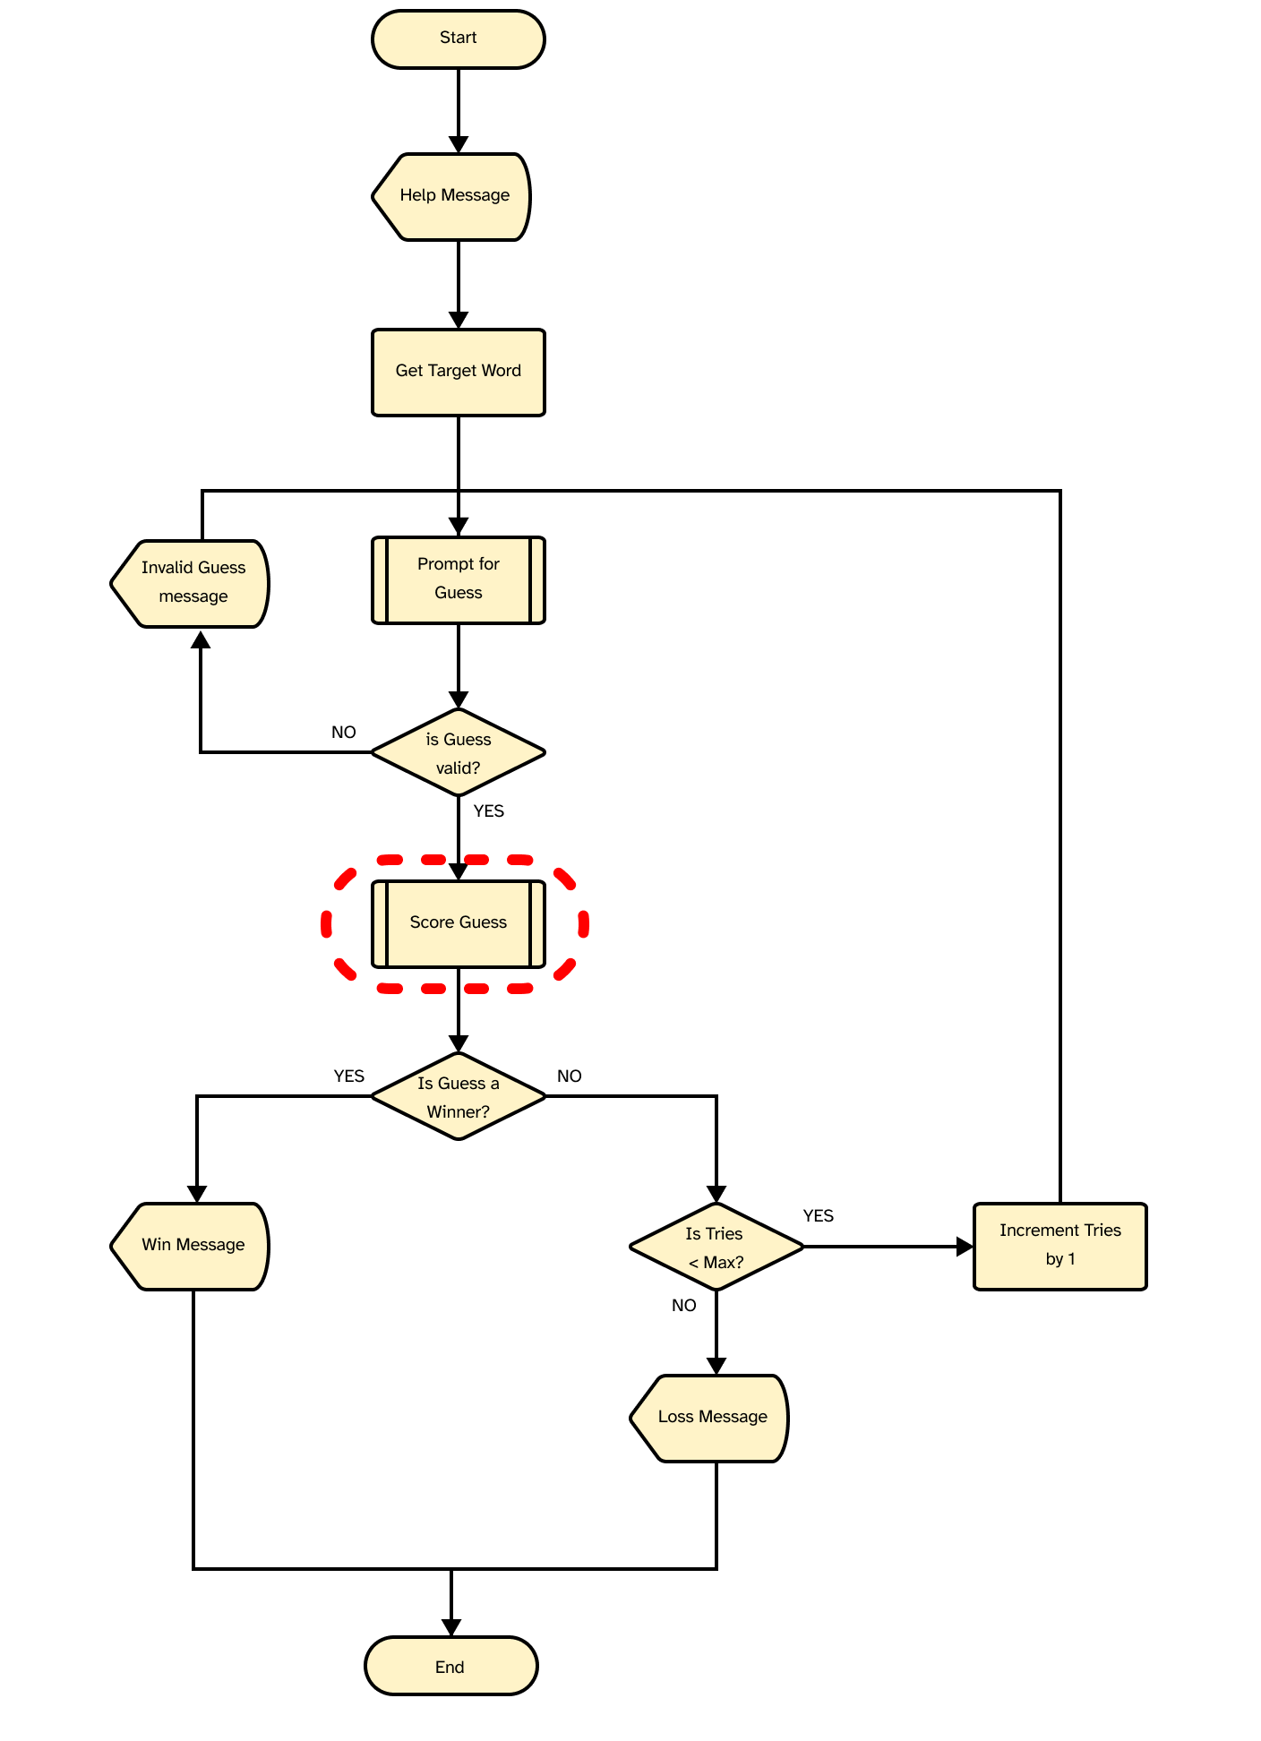

- Write a function called score_guess that matches the algorithm and passes only the test cases below.

Algorithm (flowchart) | (pseudocode)
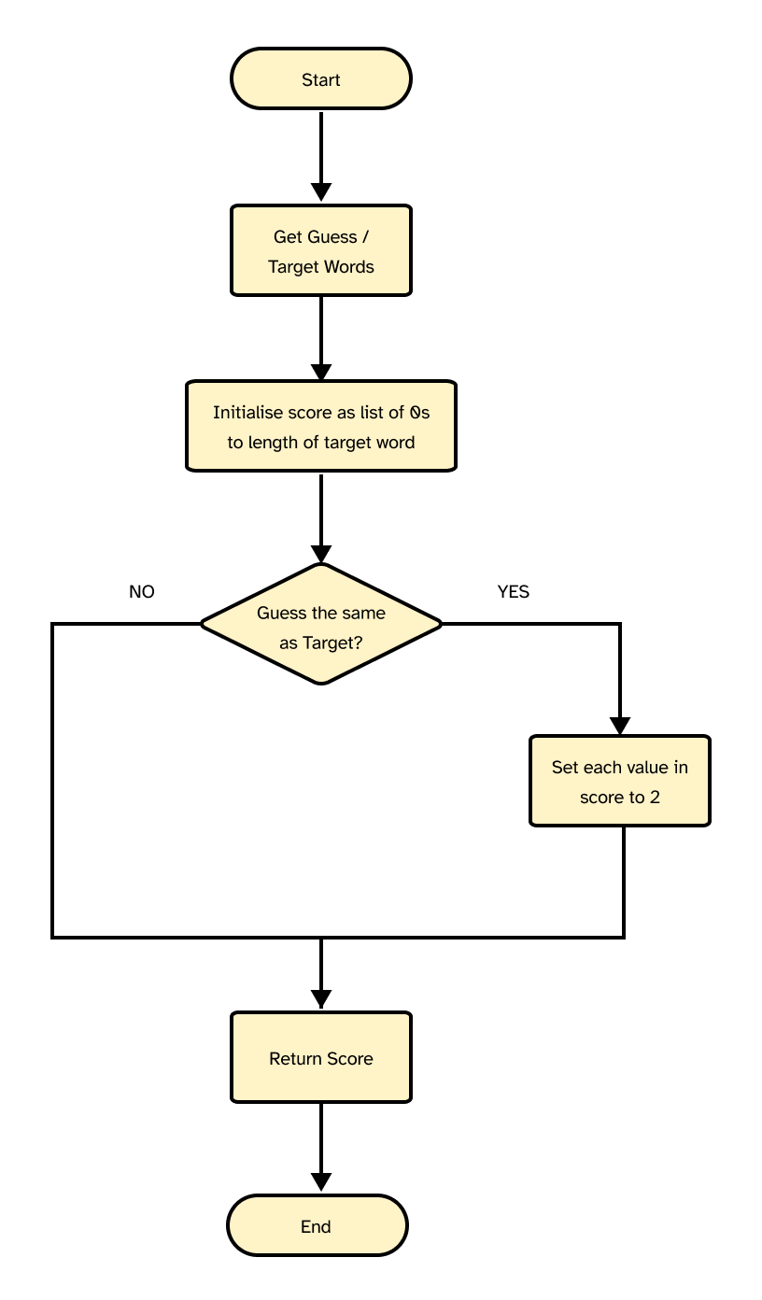 | Start:  Get guess and target words  Set score to list of 0s with len equal to len of target  If guess equals target:  Set each value in score to 2  Return score  :End
Screenshot:
Test 1:
Arrange:
Set the guess word to world and the target word to world

Act:
Call score_guess with guess, target
Assert:
Returns [2, 2, 2, 2, 2]

Test 2:
Arrange:
Set the guess word to world and the target word to hello

Act:
Call score_guess with guess, target
Assert:
Returns [0, 0, 0, 0, 0]

Session 4

Algorithms part 2

ℹ️ Now that you have done the basics it is time to develop an algorithm for scoring each character in a guess rather than the whole word as we did previously.
- Develop the scoring algorithm as either pseudocode or a flowchart, then ensure that it passes the tests. Include appropriate screenshots when requested.
Algorithm (flowchart/pseudocode)
<Insert flowchart or pseudocode of you algorithm for scoring the individual characters of a guess. >
Def mark_guess(secret_word, guess):
For every letter in secret_word
If letter in secret_word == guess letter
Mark letter as correct
Elseif letter exist in the secret word
Mark letter as exist in the secret word but not at the right position
Else
Letter is not found in the secret word, mark it as non existence

Screenshot:

Test 1:
Arrange:
Set the guess word to world and the target word to world

Act:
Call score_guess with guess, target
Assert:
Returns [2, 2, 2, 2, 2]

Test 2:
Arrange:
Set the guess word to world and the target word to hello

Act:
Call score_guess with guess, target
Assert:
Returns [0, 1, 0, 2, 0]

Documentation
Since scoring a guess correctly was a key part of the project, you need to ensure you document your work.
Include a docstring in the code that briefly explains what the function does, its parameters, and the value it returns
Sessions 5 - 7
It is now time to read the valid words and target words from their respective file. Implement this functionality in your code. We want to confirm that the variables were read correctly and for that you will use debugging technique to inspect the contents of the variable:
- Write the code to read the words in the file into a list where each item in the list is a word without any whitespaces
Confirm that all words were read by inspecting the variable into which you put both lists.
You can inspect the variable by either using a debugger or using print statements.
Code: read the valid words and the test words into distinct variables.
Debugging: inspect the first five and last five word in each list to confirm that the lists were read correctly

>>> Code the remaining requirements
- You must document at least two test cases and include screenshots to demonstrate that they have run successfully. You must also describe and capture with screenshots at least one occasion where you had to debug your code and then debugging process you followed. Debugging can involve any of the following:
- Adding print statements to understand your code’s execution better
- Using an interactive debugger
- Reasoning about your code and the errors it produces

Test 1:
Arrange:
Input guess with 3 letters
Act:
Add breakpoint on the if statement and see if it prints the invalid message
Assert:
Invalid guess message

Test 2:
Arrange:
Input guess with invalid word
Act:
Add breakpoint on the if statement and see if the guess exists in the target_words
Assert:
Invalid guess message

Debugging

Session 7

Code and client review (MANDATORY)
DO NOT COMPLETE THIS SECTION WITHOUT YOUR LECTURER
Review your code with the senior developer (lecturer) and write and document any changes you need to make before acceptance. You must complete all previous sections of this journal before you can perform your review. They provide evidence that you have tested and documented your project
- List any changes (if any) that you committed to make to your code style because it did not conform to coding standards
COMPLETE DURING REVIEW

- List any changes that occurred because you failed to meet one or more of the requirements and explain what steps could have been taken to identify such issues earlier in the project. If no such changes were found, highlight what clarifying steps you took earlier in the project to ensure your success.
COMPLETE DURING REVIEW

- List any changes that needed to be made due to a change or clarification of a requirement
COMPLETE DURING REVIEW

- Confirm that your code has been reviewed and fill in the details below.
COMPLETE DURING REVIEW

I, <your full name>, confirm that this code has been reviewed by <lecturer> on <date>.

Session 8

Final steps: submit this journal and program!
Ensure you have made the required changes in the code that you agreed to in both your developer and client reviews. Finally, submit your code along with this document and all the best! Your CO confirms acceptance by both the client and senior developer of your code.
Remember to submit your application program as a zip file along with this journal.

You DID IT!!!
Well done on completing your first software development project!
You’ve come a long way.

🎆

Lecturer Checklist

Similar to the following:
Criteria | CO | NYC | Details
Initiates Communication |  |  | Student identifies and contacts the appropriate personnel (lecturer, mentor, or team member) to confirm the task.
Reference to Specifications |  |  | Student consistently refers to the provided design specifications during the coding process.
Validation |  |  | Student cross-checks the initial algorithm against the design specifications to ensure compliance.
Test Cases |  |  | Student runs test cases that align with the design specifications to validate the algorithm's correctness.
Documentation (Validation) |  |  | Student documents the validation process, including the test cases used and the results obtained.
Active Listening |  |  | Student demonstrates active listening by accurately paraphrasing or summarizing the information provided by the personnel.
Clarifying Questions |  |  | Student asks clarifying questions to ensure a thorough understanding of the requirements.
Complex Concept Articulation |  |  | Student effectively articulates complex coding concepts and requirements when seeking or providing clarification.
Feedback Incorporation |  |  | Student incorporates feedback from personnel into their development and documentation.

Additional Space if Required

APPENDIX: MARKING GUIDE

Assessment # and title |  | Assessment 3: Project
Lecturer name |  | Rafael Avigad
Student name
Student ID number
Telephone contact number |  |  | Email:
By completing and submitting this signed form to my lecturer, I am stating that:
- The attached submission is completely my own work.
- I have correctly cited all sources of information used in this work (if required)
- I have kept a copy of this assessment (where practicable)
- I understand a copy of my assessment will be kept by the NMTAFE for their records.
- I understand my assessment may be selected for use in the NMTAFE’s validation and audit process to ensure student assessment meets requirements
Student Signature |  |  |  | Date
Assessor please note: Where verbal clarification has been sought from a student to gather additional assessment evidence from an assessment item, question/s and response/s must be recorded, signed, and dated by the assessor, against the relevant assessment item/s.
Submission 3 ☐ Assessment Result Satisfactory / Not Yet Satisfactory (please circle) Date: _________
To satisfy requirements for this assessment, you need to complete the following:
No. | Complete the task by following these steps | D or NYD
1 | Included original python application with submissions (code) | ☐
2 | Program (application code): Program runs without obvious errors | ☐
3 | Program (application code): follows standards as per MUSTS in PEP8 section | ☐
4 | Program (application code): Uses sequences, selection, and iteration | ☐
5 | Program (application code): Reads from File | ☐
6 | Program (application code): Writes to file | ☐
7 | Program (application code): Demonstrates string manipulation techniques | ☐
8 | Program (application code): Provides instructions either as help, prompts, or a readme (usable without outside assistance) | ☐
9 | Program (application code): Passes tests documented in Journal (see below) | ☐
10 | Submitted journal (journal) | ☐
11 | Journal: Documents at least one algorithm using pseudocode or flowchart | ☐
12 | Journal: Documents meeting with required personnel | ☐
13 | Journal: Documents obtaining feedback and sign off on at least two occasions | ☐
14 | Journal: Documents changes agreed to be made to code | ☐
15 | Journal: Documents at least two test cases and provides evidence they were carried out (see code) | ☐
16 | Journal: Documents evidence of own debugging | ☐

Student Feedback

Lecturer Signature: Rafael Avigad Student Signature:

