BSIT SENIOR PROJECT-1

Notification System



Project Advisor

<Dr. Khalid Almegren>

Presented by:
130054298 | Khaled Almotery
130115912 | Khalid Alonazi
140029631 | Mohammed Alolayan
130186703 | Taleb Alanber

College of Computing & Informatics

SAUDI ELECTRONIC UNIVERSITY
SENIOR PROJECT 1 REPORT
Version #1

Notification System

Project Team
Member Name | Primary Responsibility
Mohammed Alolayan | Team Leader
Khalid Alonazi | Team Member
Khaled Almotery | Team Member
Taleb Alanber | Team Member

- Contents
1. Introduction 6
1.1 Product 6
1.2 Scope 7
1.3 Business Goals 7
1.4 Document Convention 7
1.5 Literature Review 8
1.5.1 Notification System 8
1.5.2 Web services 9
1.5.3 Notification System based on Restful Web Service 14
1.6 Project plan 15
1.6.1 Project Plan Table 15
1.6.2 Gantt Chart 16
1.6.3 ADM 17
1.6.4 PDM 18
1.7 References 19
2. Overall Description 21
2.1 Product Features 21
2.2 User Classes and Characteristics 21
2.3 Operating Environment 22
2.4 Design and Implementation Constraints 22
2.5 Assumptions and Dependencies 23
3. Functional Requirements 24
3.1 Signup User 24
3.2 User Login 25
3.3 Control and monitor system 26
3.4 Control admin profile 27
3.5 Control groups 28
3.6 Control notification templates 29
3.7 Sending notifications 30
3.8 Control profile 31
3.9 Receive notifications 32
3.10 Send response 32
3.11 Control notification process 33
4. Nonfunctional Requirements 33
4.1 Performance Requirements 33
4.2 Safety Requirements 34
4.3 Security Requirements 34
4.4 Software Quality Attributes 34
Appendix A: Glossary 35
A.1 Table: Glossary 35
Appendix B: Analysis Models 36
B.1 Use Case Diagram 36
B.2 Entity Relationship Diagram (ERD): 37
B.3 Class Diagram 38
B.4 Sequence Diagram 39

Revision History
Name | Date | Reason For Changes | Version

Introduction
Technologies enter the human life through all doors, People daily use smartphones, social media and smart equipment in their homes and work. So they will always need to know everything that happens around them. The notifications become more powerful by the time, it inform us about something wrong, remained us to do scheduled work, tell us something new we need-to-know.
Although notifications are in our needs, sometimes it becomes more annoying when it works in a wrong way, the notification system should send the notification in the right time when it is useful, to the right person how needs the notification and through the right way where the notification is acceptable.
Our notification system provides an open API to integrate with multi-platforms to send and receive the notification easily. The notification has template designed by the admin user and contains list of contacts to send them the notification, the template also has dynamic content and could be scheduled for remaindering purpose.
The system consider many features in order to send the notification such as priority of the notification, availability, reliability, escalation and scheduled roasters.
The open API is easy to use when you need to control your templates, modify your contacts information and of course send/receive the notification.
Receiving the notifications could be through mobile app, desktop app, websites, social media and indoor/outdoor intelligent circuits.

Product
Notification System NS contains a Restful API to control notification template and send the notifications through specific template, also clients’ apps and systems can connect to our server to receive the notifications.
There are two main users the admin who create the template and edit templates details such as content, contact list and other properties. And modify clients privilege who can send the notifications, the second role is for client who can send notification through his granted templates and can update the contacts or disable receiving notifications.
The system can send multi-type notification in different ways (SMS, Email, runtime notifications using web sockets and through social media Ex: Facebook, WhatsApp).
The core system is a service checks the notifications in the sending queue and proceed them with considering the priority of each kind of notification template and its priority and its properties like scheduling, sending way, escalation. It also checks the availability of the receiver upon the data of clients’ response.
Developing Java restful API is useful to integrate with different type of systems. We will develop desktop client application and mobile android application for client or admin role. Web socket techniques also provide runtime notification in easy way.
The website is provided with English interface to control the system by super admin user and monitor the notification process. Also it helps the admin user to control the templates and send the notifications.

Scope
Due to simple API interface, Notification System serves multi-platforms applications and systems. It will be useful for online desktop, mobile and web applications.
The clients will check the notification that will be sent through E-mails, SMS and on pop-up windows on desktop application or internet browser or mobile application.
The system helps group of clients to receive the notifications when they are available and in the right time.

Business Goals
Our business goals are:
- Make an easy and secure way for companies, restaurants, hotels etc. to inform the clients about new information.
- Provide simple API to integrate with systems and apply reliable way to send notifications when there are important info to be sent.
- Provide clients desktop/mobile application to be updated with important notifications sent from information provider or NEWS applications.
- Provide remainder service for user’s scheduled events.
- Send the right notification to the right person in the right way and right time.

Document Convention
The conventions used in our graduation project documentation are the following:
- Naming convention:

Term | Definition
JDK | Java Developing Kit
JSP | Java Server Pages
NS | Notification System
API | Application Program Interface
REST | Representational state transfer
- Document Convention
Font | Times New Roman
Size | 12 points, 14 points for titles
Spacing | 1.5 Spacing
Margins | - Inch (Top, Bottom, Right, Left)

Literature Review

1.5.1 Notification System
Every interaction with multimedia contents in various application domains can be called an Event. Arising from an each Event there is the opportunity to describe what occurred.
The notification system should work with multi-platform systems as we can show in The ENS implemented in “Event Notification System for Multi-platform” that can be used for different kind of multi-platform environment that includes PC, mobile device, and television set. The implementation also can be used for various kind of reporting that includes monitoring of illegal copies, monitoring of performances, marketing information, copyright reports, proof of purchase, license purchase and delivery, network congestion, load balancing, and bandwidth usage and availability [1].
The event report described in the ENS works as the following, the first peer creates an Event Report Request and send it to the second one, and when the event described in the request is handled on the second peer side the second one sends the event report.
People can now receive custom-made information through smartphones, tablets or wearable devices. However, people often tend to miss vital information, even reminders, in the flood of notifications. The problem of finding convenient moments for need-to-know information should be Investigated. The challenges of context-base notification systems are: selecting fundamental context factors that influence the activity patterns of individual agents; keeping track of these factors in real-time; carefully looking into the monitoring data; and immediately coping with recognized desirable situations. Considering these challenges, there is a mobile framework, smartNoti, that provide a standardized method for finding the recognizable and available moment [2]. By logging the user activity and predicate the right moment.
The importance of notification system can be shown for example in SOA-Based Diseases Notification System [3] that uses SOA-based system to integrate between multi-business layers and inform the patients, health centers and hospitals about exchanges of diseases with fast and easy way that can be consumed by many different systems.
Notification system is useful tool for monitoring application servers, Application servers are usually deployed in clusters consisting of tens nodes. Each node contains own log file and runs on different machine that has its own performance/system logs. but there is challenge that is high load which is proceeded in NotX system by use queue and streaming notifications. [4]

While almost every information system has standard e-mail notifications, the features of SMS notifications or voice notifications (telephone calls via cellular networks) are not very common, but there are many instances, where they could be useful:
- Urgent appeal through voice calls about the rescheduling of some event
- SMS for dual authentication processes where a confirmation SMS is sent
- SMS with any information that the user should have with himself. For example, a registration code for an event
There is of course a downside with using SMS and voice notifications: the price. NS must be configurable so that the user can choose which events are so important to him that he is willing to pay the price for such notifications. [5]
In industrial building notification system is very important to inform about any issues happened during machines works, sensors creates signals to be proceeded in the control system which checks these properties and create alarm if there is something wrong, here the notifications system should be embedded with control unit to send efficient notification [6].
Sometimes the notifications should be as fast as possible, here the push notification has its opportunity, the design and implementation of push notification service use a client/ server design pattern with a distributed architecture [7].
The user interactivities with the notification system make the system knows user normal behavior and learn when and where is the notification effected, in alarming system that work with sensors, Notifications will be generated in the form of blinking light in the room where the situation is detected. If user is aware what is going on, he/she should press twice the nearest light button in order to inform the Notification system that the potential problem is solved and that everything is under control. After that action corresponding timers are reset [8].

1.5.2 Web services
Web Services Overview
Web services technology is changing the Internet augmenting the web capabilities to produce the transactional web. Because Web services are emerging to provide a systematic and extensible framework for application-to-application interaction. [16]
"Where the current web enables users to connect to applications, the web services architecture enables applications to connect to other applications. Web services is therefore a key technology in enabling business models to move from B2C (Business to Consumer) to B2B (Business to Business)". [17]
Web services technologies provide a language-neutral, environment-neutral programming model that accelerates application integration inside and outside the enterprise. Application integration through Web services yields flexible loosely coupled business systems.
Because Web services are easily applied as a wrapping technology around existing applications and information technology assets, new solutions can be deployed quickly and recomposed to address new opportunities.
So the web service is an interface that describes a collection of operations and performs a specific task or a set of tasks. These operations are network-accessible through standardized XML messaging. A Web service is described using a standard, formal XML notation, called its service description that provides all of the details necessary to interact with the service, As will be explained in the next paragraph. [16]
We will explain two kinds for web services (SOAP-Based vs. RESTful web services) to know the best way for our approach.
SOAP-Based Web Service
The Web services framework is divided into three areas -communication protocols, service descriptions, and service discovery- and specifications are being developed for each. In SOAP-Based web services the specifications in each area: SOAP, WSDL, and UDDI respectively. [18]
We will explain each standard in the next paragraphs and the web services infrastructure that is based on these standards.
SOAP-Based Web Service Architecture
In fact, the web services infrastructure can be thought of as a distributed digital library for services rather than information. This means that many of the issues must be addressed within a web services context, such as metadata for discovery, authentication and authorization, and business models for accessing intellectual property. [17]
IBM has published its web services architecture, which captures the infrastructure required to support web services in terms of three roles and three operations. [18] [19]
The three roles are:
- The service provider,
- The service requester,
- The service registry.
The objects acted upon are the service and the service description, and the operations performed by the actors on these objects are:
Publish, find, and bind.

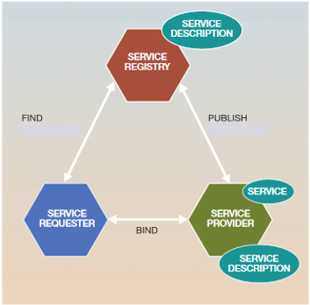
In this SOAP-Based web service architecture , the service description is the metadata that describe the service and include sufficient information for a service requestor to access the service it describes service including all of the details necessary to interact with the service, including its interface, message formats (that detail the operations), transport protocols, and location.
Then the service provider publishes a service description to a service registry and then service requester becomes able to find the service description. [17]
SOAP-Based Web Services Standards
- The first standard is "Web services description language (WSDL)" that provides a formal, computer-readable description of Web services. WSDL describes a service as a set of "ports" which group related interactions that are possible between the application (service requestor) and the web service (service provider). The interactions that are possible though a port are described as "operations" which may have an input message and optionally a resulting output message.
WSDL describes the potential information content of interactions with a web service but doesn't explain how to communicate that information between an application and a web service. For this purpose, WSDL allows a 'binding' to be specified, in the second XML-based standard, SOAP.

- Another standard is SOAP (Simple Object Access Protocol), which enables communication among Web services.
Microsoft created SOAP initially, and later SOAP was developed in collaboration with Developmentor, IBM, Lotus, and UserLand.
SOAP is an XML-based protocol for exchanging the information and messaging and remote procedure calls (RPCs). Rather than define a new transport protocol, SOAP works on existing transports, such as HTTP, SMTP, and MQSeries.
Using WSDL and SOAP we can describe web services and use web services from an application But, we don't know what web services were available in the first place? This is the purpose of UDDI.
- Another standard is UDDI (Universal Discovery, Description and Integration) directory, which is a registry of Web services descriptions. [19] [16] [17]
RESTful Web Services
Representational State Transfer (REST) has gained widespread acceptance across the Web as a simpler alternative to SOAP- and Web Services Description Language (WSDL)-based Web services. Key evidence of this shift in interface design is the adoption of REST by mainstream Web 2.0 service providers—including Yahoo, Google, and Facebook—who have deprecated or passed on SOAP and WSDL-based interfaces in favor of an easier-to-use, resource-oriented model to expose their services.
REST is an architectural style that defines a set of constraints that, when applied to the architecture of a distributed system, induce desirable properties like loose coupling and horizontal scalability. RESTful web services are the result of applying these constraints to services that utilize web standards such as URIs, HTTP, XML, and JSON. Such services become part of the fabric of the Web and can take advantage of years of web engineering to satisfy their clients’ needs.[20] [21] [22]
RESTful Web Service Architecture
REST uses a client server architecture. REST doesn’t restrict client server communication to a particular protocol, but is most commonly used with HTTP. RESTful Web services can be described using the Web Application Description Language. A WADL file describes the requests that can legitimately be addressed to a service, including the service’s URI and the data the service expects and serves. [19]
REST relies on three main design principles: addressability, uniform interface, and statelessness.
- Addressability is the idea that every object and resource in your system is reachable through a unique identifier. A resource is any form of information that can be named and that is important enough to be referenced (such as a document, a row in a database, or a search result).
Addressability is performed using URIs. When you make a request for information in your browser, you are typing in a URI. Each HTTP request must contain the URI of the object you are requesting information from or posting information to. [20] [19]
- The Uniform, Constrained Interface
HTTP based REST resources are accessible via the HTTP standard and uniform interface. The idea behind it is that you stick to the finite set of operations of the application protocol you’re distributing your services upon. This means that you don’t have an “action” parameter in your URI and use only the methods of HTTP for your web services.
Four main operations are supported by HTTP: create, read, update, and delete (CRUD), which are implemented using POST, GET, PUT and DELETE, respectively.
Constraining the interface for your web services has many more advantages than disadvantages such as Familiarity, Interoperability and Scalability. [19] [20]
- Statelessness
In REST, stateless means that there is no client session data stored on the server. The server only records and manages the state of the resources it exposes. If there needs to be session-specific data, it should be held and maintained by the client and transferred to the server with each request as needed. A service layer that does not have to maintain client sessions is a lot easier to scale, as it has to do a lot fewer expensive replications in a clustered environment. It’s a lot easier to scale up because all you have to do is add machines. [20]
JAX-RS RESTful Service
The Java API for RESTful web services (JAX-RS) is a new API that aims to make development of RESTful web services in Java simple and intuitive.
JAX-RS is one of the latest generations of Java APIs that make use of Java annotations to reduce the need for standard base classes, implementing required interfaces, and out-of-band configuration files. Annotations are used to route client requests to matching Java class methods and declaratively map request data to the parameters of those methods. Annotations are also used to provide static metadata to create responses. JAX-RS also provides more traditional classes and interfaces for dynamic access to request data and for customizing responses.
And JAX-RS framework focuses on applying Java annotations to plain Java objects and binding specific URI patterns and HTTP operations to individual methods of your Java class. It has parameter injection annotations so that you can easily pull in information from the HTTP request. It has message body readers and writers that allow you to decouple data format marshalling and un-marshalling from your Java data objects. It has exception mappers that can map an application-thrown exception to an HTTP response code and message. Finally, it has some nice facilities for HTTP content negotiation. [20] [21]

1.5.3 Notification System based on Restful Web Service
Why we use restful API? It provide an open fast connection between the client layer and the server side, consuming restful API is easy on different platforms where it could be consumed inside web application, desktop application or android app. Many researches and projects that worked in building notifications system agreed that the web service is useful component of notification system.
To proceed the notifications requests we define three notifications queues, each one of them has type of priority where the high priority queue proceeded first by the notification manager.
Notification manager is a service checks the ready notification inserted in notifications queues, and send them according to the notification template, in other hand checks availability of the clients to determine the right time to send by using the response analytic service which define the time when the client is ready to receive an useful notifications, this service works on client response time and try to know the client’s behavior after checking client’s responses.
To the high priority notification, the notification manager check if there is a scheduled roaster contains optional contacts or alternative send way to ensure that the notification could receive successfully. Escalation is optional choice makes the manager try to send the notifications through different ways in case there is no response.
Using SMS and E-mails is powerful in our system, we described the advantages and disadvantages of using SMS channel for notifications. However, E-mails and push notifications may be less cost than the SMS channel, so we use them as main sending way. In the other hand response the E-mail or real time notification is easier than the SMS.
Push notification also helps for runtime notifications when the users should be online and connected to our server.
Avoiding annoying notifications built on some important points: know the client behavior, limit user’s send rate, monitoring the system behavior to prevent any abuse or attacks and apply secure way to initialize new admin account.

Project plan

1.6.1 Project Plan Table
Tables 1.6, 1.7 show the project’s timeline plan.
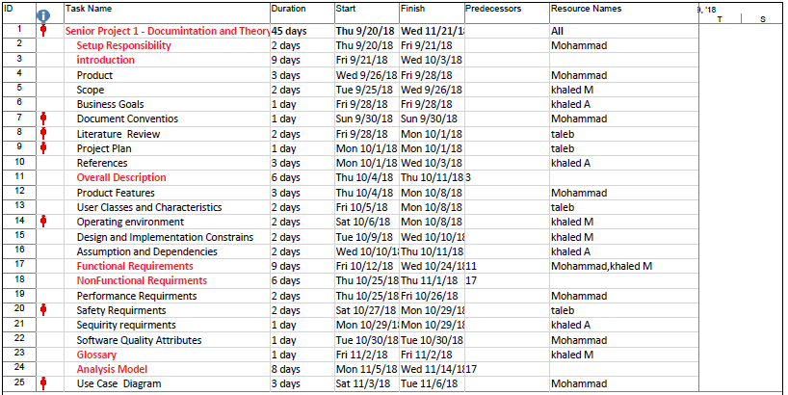
Table 1.6
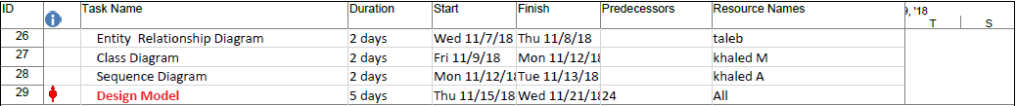
Table 1.7

1.6.2 Gantt Chart
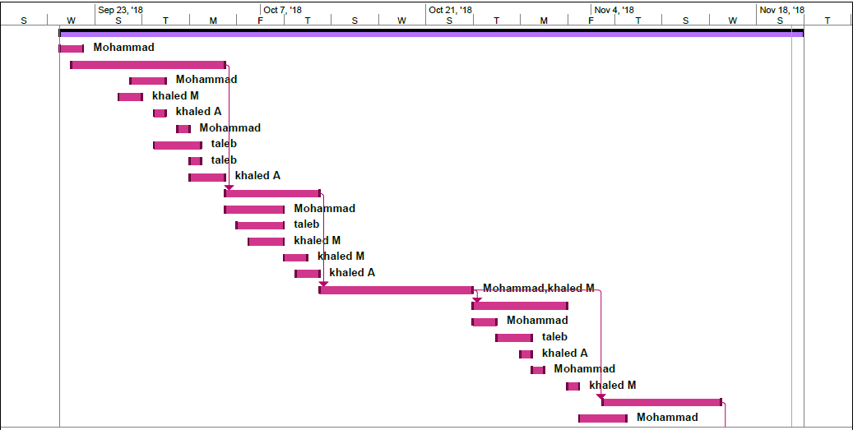
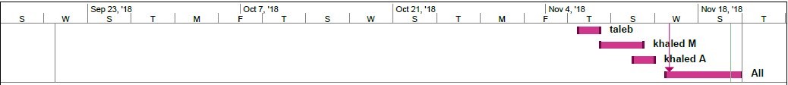
Gantt Chart (1)
Gantt Chart (2)

1.6.3 ADM
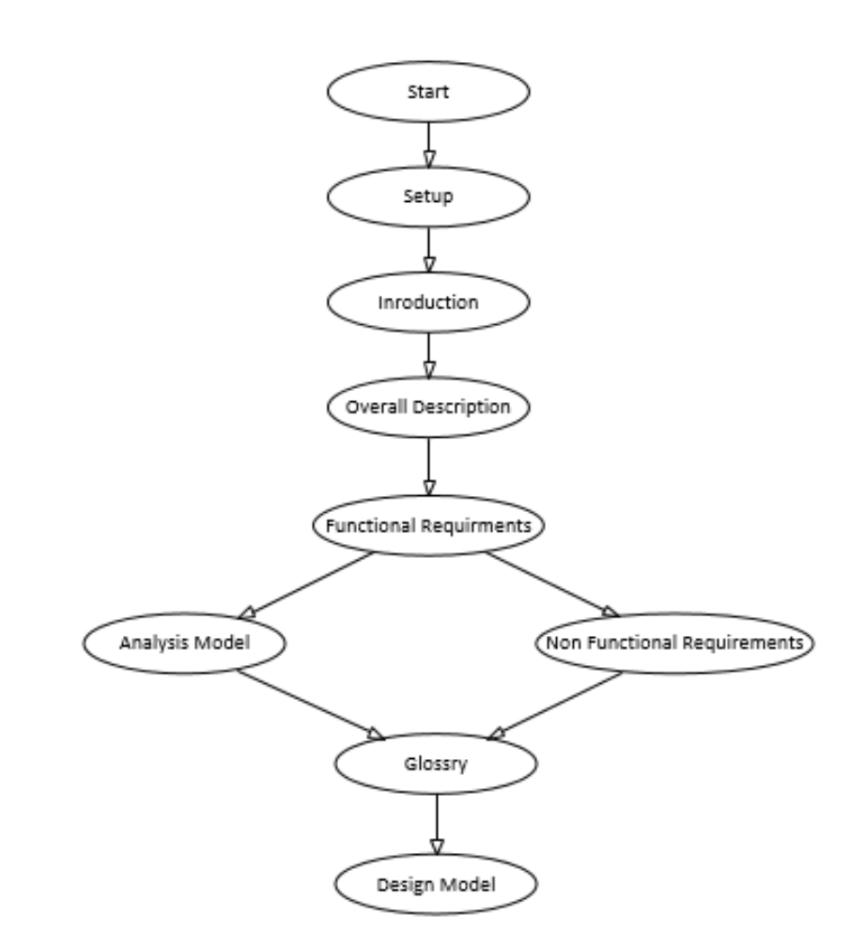

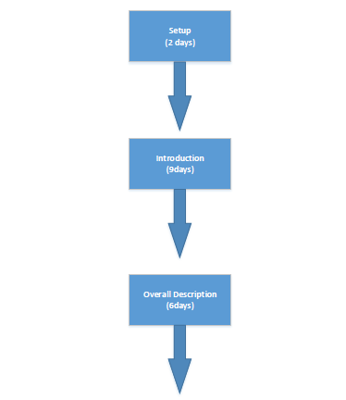
1.6.4 PDM
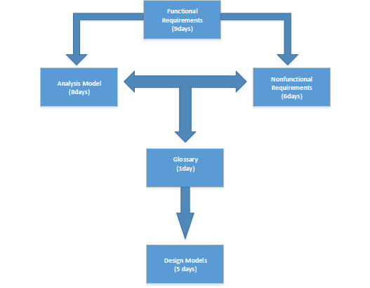

1.7 References

[1] | K. Ji, N. Moon and J. Kim, "Event Notification System for Multi-platform," 2015.
[2] | H. Oh, L. Jalali and R. Jain, "AN INTELLIGENT NOTIFICATION SYSTEM USING CONTEXT FROM REAL-TIME," 2016.
[3] | C. Chatwin and R. Young, "An SOA-Based Diseases Notification System," 2009.
[4] | F. Nguyen and T. Pitner, "Information System Monitoring and Notifications Using Complex Event Processing," 2012.
[5] | B. F. Nguyen, Advanced Notification System, 2012.
[6] | N. Yuanyuan and C. Yongliang, Design Of Emergency Notification System Based On The VC++6.0 Platform, 2012.
[7] | F. Yunisa and Suharijto, "Push Notification System to Mobile Game Player Using Distributed Event-Based System Approach," 2016.
[8] | N. Žaric and M. P. Djurišic, "Low Cost Intelligent Notification and Alarming System for Ambient Assisted Living Applications," 2017.
[9] | K. G. S. K. H. &. S. J. Gottschalk, "Introduction to Web services architecture. IBM SYSTEMS JOURNAL, VOL 41.," 2002.
[10] | Gardner, "An Introduction to Web Services. Web Magazine for Information Professionals.," 2001.
[11] | F. D. M. K. R. N. W. M. N. &. W. S. Curbera, "Unraveling the Web Services Web An Introduction to SOAP, WSDL, and UDDI. IEEE INTERNET COMPUTING.," 2002.
[12] | Belqasmi, F.Singh, J. Melhem and &. G. S., "SOAP-Based vs. RESTful Web Services A Case Study for Multimedia Conferencing. IEEE INTERNET COMPUTING.," 2012.
[13] | Burke, "RESTful Java with JAX-RS 2.0 (Second Edition).".
[14] | H. Li, "RESTful Web Service Frameworks in Java. IEEE.," 2012.
[15] | A. Rodriguez, "RESTful Web services: The basics. IBM.," 2008.
[16] | K. Gottschalk, S. Graham, H. Kreger and J. Snell, "Introduction to Web services architecture," IBM SYSTEMS JOURNAL, VOL 41, 2002.
[17] | T. Gardner, "An Introduction to Web Services," Web Magazine for Information Professionals, 2001.
[18] | F. Curbera, M. Duftler, R. Khalaf, W. Nagy, N. Mukhi and S. Weerawarana, "Unraveling the Web Services Web An Introduction to SOAP, WSDL, and UDDI," IEEE INTERNET COMPUTING, 2002.
[19] | F. Belqasmi, J. Singh, S. Y. B. Melhem and R. H. Glitho, "SOAP-Based vs. RESTful Web Services A Case Study for Multimedia Conferencing," IEEE INTERNET COMPUTING, 2012.
[20] | B. Burke, RESTfu​l Jav​a​ wit​h ​JAX​-​RS 2.​0​ (Second Edition).
[21] | . H. Li , "RESTful Web Service Frameworks in Java," IEEE, 2012.
[22] | A. Rodriguez, "RESTful Web services: The basics," IBM, 2008.
[24] | A. Quiroz and M. Parashar, "Design and Implementation of a Distributed Content-based Notification Broker for WS-Notification," 2006.

Overall Description

Product Features
Notification system provide an open API to add, edit and delete notification templates which contains the notification content with dynamic fields, recipients, send way, priority, scheduling properties. The recipients are contacts list contains the clients list with their IP addresses, phone numbers and E-mail address also their availability time.
The API also is used to send the notifications and connect to server in order to receive push notifications.
The notification system contains server manager to manage the clients connected through the internet which need to receive push notifications. Also contains notifications manager processes the notifications and do notifications requests.
We provide a website with English interface to manage the system and monitor system events, the admin user can login into the website and control his own notification templates. The sender can use the notification template and send the notifications by call the open API.
To show the multi-platform features of our system we developed three types of applications to receive the notifications.
The system could send SMS, E-mails and push notifications to the clients also use the social media to send notifications.
Also monitoring notification process provide some useful statistics about clients behavior and which the perfect way and time to use effective notifications.

User Classes and Characteristics
Our application will consist of four main users:
- Super admin
- Control system configurations add new send engine and configure the accounts related to E-mail, SMS and push notification sending channel.
- Create Admin users which should be reliable and provide them privilege.
- Monitor the system logs and show the statistics of our system to predict unusual behavior.
- Admin
- Create, edit and delete notification templates.
- Grant access on its own templates to the senders.
- Create groups of receivers.
- Sender
- Use the notification templates to send the initialized notification.
- Clients
- Make add request to join group of receivers.
- Initialize his own contact configuration (static IP, Email account, phone number so on).
- Receive the notifications and response them.

Operating Environment
Our system architecture is multi-tier system, the interface layer is an open Restful Java API with interactive web site to manage templates, accounts and system configuration.
The second layer is server side processes that proceed the notifications requests and connect to the receivers for runtime notifications, the control layer is manage the database tables which be modeled in JAVA.
Hardware Requirements | Software Requirements
Web host server | JDK (1.8 or later).
PC for client side with medium CPU performance and minimum 2GB memory | Mail and SMS libraries
Smart phone device for client side | MySQL workbench
Internet connection | Tomcat or glassfish web server
 | Windows server 64bit ,32bit or UNIX server
 | Eclipse

Design and Implementation Constraints
We need an open source SMS library and free SMS service provider for the SMS notifications, in addition, we will use the mail library in JAVA to send the E-mails through defined account on Gmail.
To host our website we will use tomcat server installed in our PC, when it can be published in the live launching time on free web hosting server.
We will ensure that the client’s data such as contacts list is secured and inserted safely in the database that has secure connection.
Time limitation existed in our project, we will fully execute the project according to the requirements and specifications falling under this proposal. We will coordinate in all the
project’s phases and will execute the project according to the time frame. Availability of the tools needed, to ensure the proper execution of the project, following are some of the most important tools we will provide:
- Project time plan to deliver the project in the estimated time.
- Detailed project work plan along with the task for each member.
- Flexible Communication plan to smoothly circulating information to the different types of the stakeholders.
- Project documentation covering both technical and functional aspects.
- Direct communication with the supervisor to ensure the quality of the project.

Assumptions and Dependencies
Assumptions:
- The coding should be error free
- The system should be user-friendly so that it is easy to use for the users
- The information of all users must be stored in a database that is accessible by the application.
- The system should have more storage capacity and provide fast access to the database
- The notifications should be received to clients in correct time with no delay.
- The server side and APIs should be available 24 hours.
- All notification requests should be proceed in correct way.
- Monitoring the system to predicate unusual behavior.
- Make sure that receiver’s contacts are secured and inaccessible for unauthorized people.
- The notification manager should be stable with overload requests.
Dependencies:
- The clients contact should be correct and accessible by the system.
- The admins should be reliable party.
- The system logs should be able to monitor.
- The project design must be updated regarding the requirements and needs.

Functional Requirements
In this section, we discuss the functional requirements of the application, use case are presented along with the steps, purpose, identifier, priority, pre-conditions and post conditions.

Signup User

Identifier |  | UC-1
Purpose |  | Signup User
Priority |  | High
Pre-conditions |  | The User should visit the notification system website
Post-conditions |  | The user should have unique ID and password
Typical Course of Action
S# | Actor Action |  | System Response
1 | User visit system web site |  | System display welcome page
2 | User click Signup button |  | System show sign up form
3 | User enter his info in the required fields
4 | User click submit button |  | System checks the inputs and store the profile in database and send confirmation mail
5 |  |  | System show need to confirm page
6 | User confirm the sign up process by browse confirm URL send to the user’s mail. |  | System show successful alert for creating new account
Alternate Course of Action
S# | Actor Action |  | System Response
1 | User leave some empty required fields |  | System alert user to ensure the correct data
2 | User not confirm his account |  | System still show the confirm window with option of resend confirm email
3 | User use existed username |  | System show error message to re -enter different username
4 | User create admin profile |  | system send confirm alert to super admin to accept this account

User Login
Identifier |  | UC-2
Purpose |  | User Login
Priority |  | High
Pre-conditions |  | The User should have account on the system
Post-conditions |  | The user access to website home page
Typical Course of Action
S# | Actor Action |  | System Response
1 | User visit login page |  | System shows login form
2 | User enter his info in the required fields |  | System checks the data
3 |  |  | System show successful alert and redirect to home page related to type of accounts
Alternate Course of Action
S# | Actor Action |  | System Response
1 | User enter wrong username |  | System alert user to ensure the correct data
2 | User not confirm his account |  | System still show the confirm window with option of resend confirm email

Identifier |  | UC-3
Purpose |  | Control and monitor system
Priority |  | High
Pre-conditions |  | The User should be super admin and signed in
Post-conditions |  | The system should apply the modification
Typical Course of Action
S# | Actor Action |  | System Response
1 | Super admin User visit home page |  | System shows control and monitor system buttons
2 | User click monitor system button |  | System redirect to system monitor page
3 | User change system configurations such as mail account, server IP address , other properties
4 | User save the new configurations |  | System save the new configurations in the database
5 |  |  | System use the new configuration in sending process
6 | User visit statistics tab |  | System shows the notification rate and the current configuration with statistics about sending way and clients behaviors
Alternate Course of Action
S# | Actor Action |  | System Response
1 | User enter wrong configurations |  | System alert user to ensure the correct data

Control and monitor system

3.4 Control admin profile
Identifier |  | UC-4
Purpose |  | Control admin profile
Priority |  | High
Pre-conditions |  | The User should be super admin and signed in
Post-conditions |  | The system should apply the changes on admins’ profiles
Typical Course of Action
S# | Actor Action |  | System Response
1 | Super admin User visit home page |  | System shows Control admin profile button
2 | User click Control admin profile button |  | System redirect to Control admin profile page
3 |  |  | System shows alerts about new admin profiles to be confirmed
4 | User confirm the admins requests |  | System save the new changes in the database
5 | User enter new admin profile |  | System add the new profile to the database
6 | User change or delete admin profile |  | System save the new changes in the database
Alternate Course of Action
S# | Actor Action |  | System Response
1 | User leaves empty columns |  | System alert user to ensure the correct data
2 |  |  | System end the sessions of admin user if the account is marked as deleted and suspend the notifications related to this profile
3 | User ignore the confirm alerts without click delete the request |  | System still resend the alert of new profiles confirmation
4 | User try to access the web site page without super admin role |  | System redirect the URL to home page.

3.5 Control groups
Identifier |  | UC-5
Purpose |  | Control groups
Priority |  | High
Pre-conditions |  | The User should be admin and signed in
Post-conditions |  | The system should apply the changes on admins’ profiles
Typical Course of Action
S# | Actor Action |  | System Response
1 | Admin User visit home page |  | System shows Control groups button
2 | User click Control groups button |  | System redirect to Control groups page
3 |  |  | System shows alerts about clients requests to add to specific group
4 | User confirm the clients requests |  | System save the new changes in the database
5 | User enter new group details (name, members so on) |  | System add the new group to the database
6 | User change or delete group or group’s member |  | System save the new changes in the database
Alternate Course of Action
S# | Actor Action |  | System Response
1 | User leaves empty columns |  | System alert user to ensure the correct data
2 |  |  | System stop the current notifications which related to deleted group or group’s member
3 | User ignore the confirm alerts without click delete the request |  | System still resend the alert of new requests confirmation
4 | User try to access the web site page without admin role |  | System redirect the URL to home page.

Identifier |  | UC-6
Purpose |  | Control notification templates
Priority |  | High
Pre-conditions |  | The User should be admin and signed in
Post-conditions |  | The system should apply the changes to the notifications templates and show all user templates
Typical Course of Action
S# | Actor Action |  | System Response
1 | Admin User visit home page |  | System shows Control templates button
2 | User click Control templates button |  | System redirect to Control templates page
3 | User enter the data for new template using the template editor, and grant access to specific senders. |  | System provide template editor to modify templates fields such as dynamic content, contacts list, send way, scheduling property, priority and escalation settings.
4 | User save the new/edited notification template. |  | System save the template in the database.
5 |  |  | System show the templates list related to the signed in user.
6 | User delete template from his own template list. |  | System remove the template from the database and end the notifications related to the deleted template.
Alternate Course of Action
S# | Actor Action |  | System Response
1 | User leave required fields in the template as empty |  | System alert user to ensure the correct data
2 | User delete template that is currently in use. |  | System alert the user to wait until continue the notification process or to kill the current process.
3 | User try to access the web site page without admin role |  | System redirect the URL to home page.
4 | User try to exit the page without saving changes |  | System alert to confirm existing without save the changes

3.6 Control notification templates

3.7 Sending notifications
Identifier |  | UC-7
Purpose |  | Sending notifications
Priority |  | High
Pre-conditions |  | The User should be sender and signed in
Post-conditions |  | The system should send the notification upon its template configurations.
Typical Course of Action
S# | Actor Action |  | System Response
1 | User open send notification page or initialize notification message and call sending API |  | System shows the notification required fields
2 |  |  | System insert the notification in sending queue
3 |  |  | Notification manager check contacts list availability and start to send them the message through the available channel.
4 |  |  | System return send status to the sender
Alternate Course of Action
S# | Actor Action |  | System Response
1 | User initialize the message in wrong way |  | System alert user to ensure the correct data and return the error message

Identifier |  | UC-8
Purpose |  | Control profile
Priority |  | Medium
Pre-conditions |  | The User should be client and signed in
Post-conditions |  | The system should show successful alert and save the modification
Typical Course of Action
S# | Actor Action |  | System Response
1 | User open control profile page |  | System shows control profile page
2 | User modify profile properties such as Email address and joined groups. |  | System shows the profile properties
3 | User submit the changes |  | System save the changes in the database and show successful message.
Alternate Course of Action
S# | Actor Action |  | System Response
1 | User leave empty columns |  | System alert user to ensure the correct data.
2 | User edit contacts info which in current notifications |  | System alert user about notifications behavior changes.

Control profile

Receive notifications

Identifier |  | UC-9
Purpose |  | Receive notifications
Priority |  | High
Pre-conditions |  | The User should be client and signed in is not necessary, in push notification channel the client should be online.
Post-conditions |  | -
Typical Course of Action
S# | Actor Action |  | System Response
1 | User open Email account and show the message, or show the sent SMS or open the connection to our server. |  | System show the message in the client side.
Alternate Course of Action
S# | Actor Action |  | System Response
1 | User cannot access his phone number or email account or cannot access to our server.

Send response
Identifier |  | UC-10
Purpose |  | Send response
Priority |  | High
Pre-conditions |  | The User should be client and receive notification message with ability to resend response message.
Post-conditions |  | System save the response details in the database
Typical Course of Action
S# | Actor Action |  | System Response
1 | User click on email response button, or resend the message to system number, or call response API. |  | System save the response with the response way and time.
Alternate Course of Action
S# | Actor Action |  | System Response
1 | User cannot access his phone number or email account or cannot access to our server.
2 | User use the response API many times |  | System ignore the responses after the first successful one.
3 | User failed to resend response after a while. |  | System resend the notification if there is any need or if it is high priority.

Identifier |  | UC-11
Purpose |  | Control notification process
Priority |  | High
Pre-conditions |  | The sender make notifications requests.
Post-conditions |  | System send the notifications and create reports and statistics on the clients’ behavior.
Typical Course of Action
S# | Actor Action |  | System Response
1 | System checks the notifications queue.
2 | System checks each notification contacts list and its availability.
3 | System checks system configurations
4 | Start sending the notification through multi-channels
5 | System generates user’s behavior according to response requests.
6 | System create notification logs to use in the monitoring process.
Alternate Course of Action
S# | Actor Action |  | System Response
1 | The mail or SMS account prevent sending message. |  | System make alert and send it to the super admin.

Control notification process

Nonfunctional Requirements

4.1 Performance Requirements
The notification system proceeds huge notification requests and integrates with multi-platforms, Also the high priority notifications is in the top of processing queue, the system needs the following performance requirements:
- The sending API response should be no longer than 10 seconds.
- The sending rate should not be less than 30 message per second.
- Sending through push notification technique must be less than 10 seconds from the send time.
- The late time for scheduled notifications should not be more than 1 minute.
- The web site will serve 150 users in the same time.
- The API should serve at least 100 requests in the same time.
The sending process should use multi-threading technique to achieve acceptable performance.

4.2 Safety Requirements
According to the needs of notification system in the high important cases, the system should be available in any time, the API should not fail to serve the clients while sending notification requests, so load balance technique is required, in the other hand the database may crash in anytime so we need to back up the data in a scheduled way.
Push notification techniques requires online server, if the server stop sometime for system failure, it should be restart sooner to return back to the normal behavior, however redundancy is important here we can use load balancing to keep the connection with clients open.

Security Requirements
The clients save their contacts info in our system and this info should be secured and encrypted to prevent hacking this data due to its high importance.
Also the user profile should be secured so the passwords also will be encrypted.
With open API technique, there is challenge to prevent abuse calls, so we need to generate unique key for each user to use it with calling the API, also the monitoring process should detect the unusual behavior for the clients and prevent attacking the system.

Software Quality Attributes
The Quality of the System is maintained in such a way so that it can be available all time and easy use for the users, also it will be:
- Secured
- Reliable
- Available any time
- Compatible with multi-platform
- Have high performance especially in the sending process.

Appendix A: Glossary

A.1 Table: Glossary

JDK | Java Developing Kit: The Java Development Kit (JDK) is an implementation of either one of the Java Platform, Standard Edition, Java Platform, Enterprise Edition, or Java Platform, Micro Edition platforms released by Oracle Corporation in the form of a binary product aimed at Java developers on Solaris, Linux, macOS or Windows.
JSP | Java Server Pages (JSP) is a server-side programming technology that enables the creation of dynamic, platform-independent method for building Web-based applications.
NS | Notification System
API | API is the acronym for Application Programming Interface, which is a software intermediary that allows two applications to talk to each other. Each time you use an app like Facebook, send an instant message, or check the weather on your phone, you’re using an API.
REST | Representational State Transfer (REST) is a software architectural style that defines a set of constraints to be used for creating web services. Web services that conform to the REST architectural style, termed RESTful web services, provide interoperability between computer systems on the Internet.
Gantt Chart | A Gantt chart is a type of bar chart that illustrates a project schedule. Gantt charts illustrate the start and finish dates of the terminal elements and summary elements of a project.
ADM | Arrow diagramming method (ADM) is a network diagramming technique in which activities are represented by arrows. ADM is used for scheduling activities in a project plan. Precedence relationships between activities.
PDM | PDM (Predecessor Diagramming Method). In PDM, an activity is represented by a box, arrows represent dependencies.
Use case Description | A use case is a written description of how users will perform tasks on your website. It outlines, from a user's point of view, a system's behavior as it responds to a request.
ERD | An Entity Relationship (ER) Diagram is a type of flowchart that illustrates how “entities” such as people, objects, or concepts relate to each other within a system.
Class Diagram | A class diagram is an illustration of the relationships of classes in the Unified Modeling Language (UML). In this context, a class defines the methods and variables in an object, which is a specific entity in a program or the unit of code representing that entity.
Sequence Diagram | Sequence diagram is an interaction diagram that shows how objects operate with one another and in what order. It is a construct of a message sequence chart.

Appendix B: Analysis Models

B.1 Use Case Diagram
Use case diagram will present the main actors involved in the application, and how they are going to interact with the application, Figure … will show the use case diagram of our application.
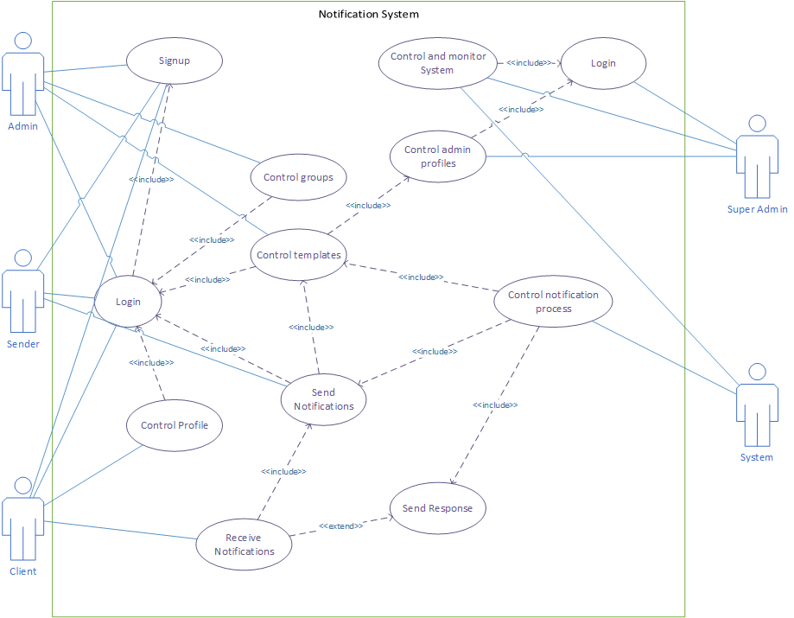

B.2 Entity Relationship Diagram (ERD):
An Entity Relationship (ER) Diagram is a type of flowchart that illustrates how “entities” such as people, objects, or concepts relate to each other within a system.
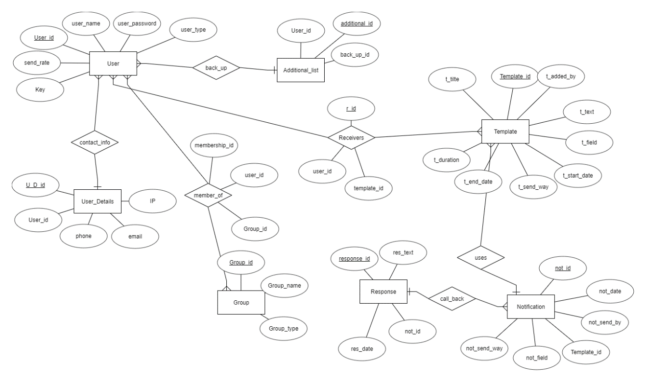

B.3 Class Diagram
In this part, the structure of the system will be discussed through the class diagram which includes the classes and its attributes and operations or methods, and the relationships among objects.
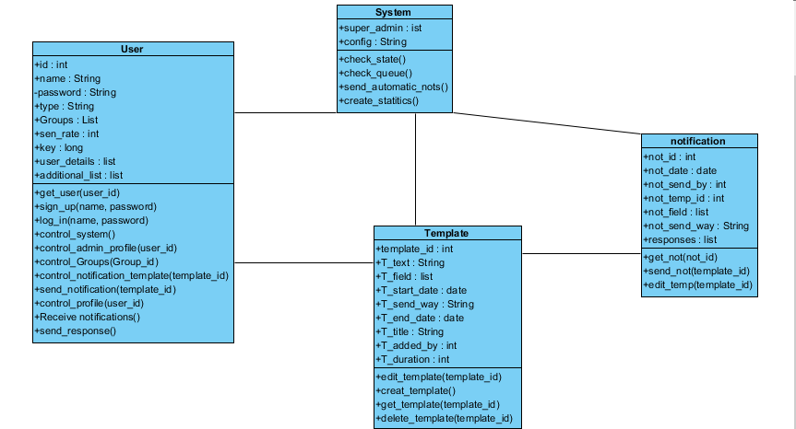

B.4 Sequence Diagram
In a sequence diagram, the main functionalities are being presented in more details form, through sequence diagram which will describe the interaction between the actors arranged in time sequence.

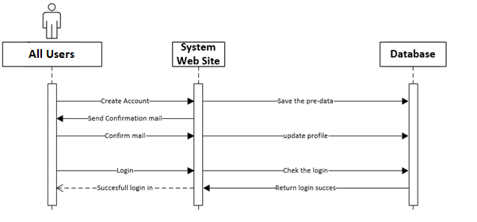
- Signup sequence diagram
Signup Sequence Diagram

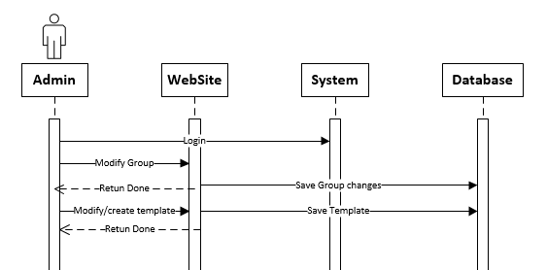
- Admin role Sequence Diagram
Admin role Sequence diagram

- Super Admin role Sequence Diagram
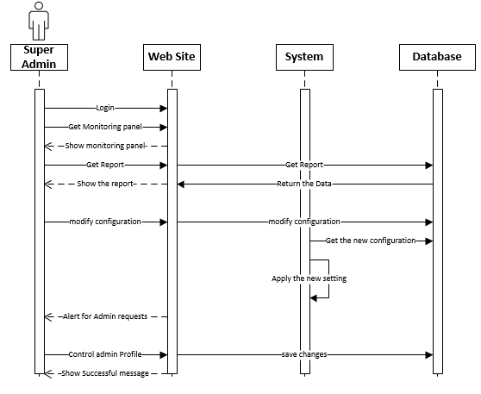
Super Admin role Sequence Diagram

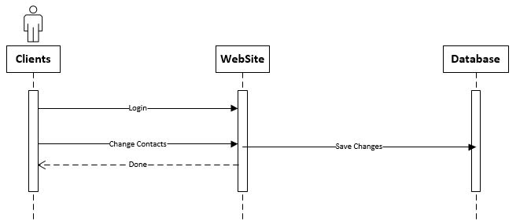
- Client role Sequence Diagram
Client role Sequence Diagram

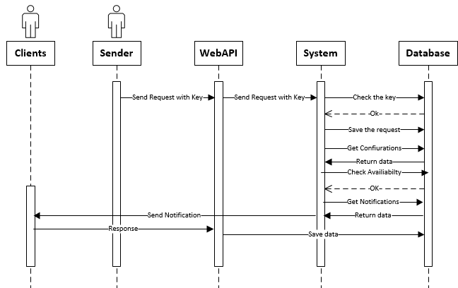
- Sending Process Sequence Diagram
Sending Process Sequence Diagram

