Classical Learners, Convolutional Networks and Vision Transformers for ICROP-3 Staging of Retinopathy of Prematurity: An Audited Development across Four Public Cohorts
Praharsh Nagpure, [FILL: R. Bait full name], [FILL: P. Rangnekar full name], [FILL: Y. Shengale full name], and [FILL: A. Kumar full name]
Abstract
Automated staging of retinopathy of prematurity (ROP) is usually reported as one accuracy on one cohort. We report a staging system’s development across two model generations, every number generated from committed result files. From 13,037 fundus photographs in 11 public sources we kept 8,024 photographs of 1,760 infants in six ICROP-3 classes from four cohorts, audited for leakage, duplicates and metadata shortcuts before training; on an earlier binary split, image dimensions alone predicted ROP with AUC 0.911. The first generation (convolutional networks) showed that the label unit decides the reported number: identical predictions score quadratic-weighted kappa (QWK) 0.473 per photograph and 0.813 per eye on a held-out cohort’s locked half. The second generation compared nine arms (retina-pretrained and natural-image vision transformers, the CNN, six variants): three fixed by a protocol committed before training, six added by dated amendments, with patient-grouped folds and an unscored locked half. The selected five-fold DINOv2 ViT-S/14 ensemble scores cross-validation QWK 0.825 [0.737, 0.911] per photograph and, on the held-out cohort’s development half (descriptive), eye-level QWK 0.756 [0.679, 0.821]. None of the twelve pre-specified contrasts exceeded the protocol’s minimum detectable difference of 0.08 QWK (the design cannot show equality); the one larger effect, training at the unit the labels describe, is exploratory. A teammate’s independent packages (classical learners on hand-crafted features, CNNs, a RETFound-DINOv2 adapter model), on a photo-level split of the same photographs, reach four-class accuracy 0.860, not comparable with any protocol result, reported to show what the split does.
Keywords: Retinopathy of prematurity, fundus photography, deep learning, vision transformers, shortcut learning, external validation.

Introduction
Retinopathy of prematurity (ROP) is a leading preventable cause of childhood blindness, with tens of thousands of infants a year left visually impaired, most in middle-income countries where neonatal survival has outpaced screening capacity [1]. The disease is staged by the International Classification of ROP, third edition (ICROP-3) [2], and treatment inside a narrow window prevents most blindness [3]. The bottleneck is readers: wide-field fundus photographs are easy to take and hard to grade. Automated staging has therefore attracted many deep-learning systems, many reporting 95–99% accuracy on a single cohort [4], for a task on which seven experts agree with Fleiss’ kappa 0.24 [5] and on which the stage disagreement rate between expert readings is 40% [6].
In earlier work [7] we showed where part of such numbers comes from: splits made by photograph on cohorts that hold tens of frames per infant, labels inherited by frames that do not show the finding, and thresholds that do not survive a change of camera. This paper reports the development that followed, end to end, because the path is the evidence: a first generation of convolutional networks (CNNs) that exposed those effects, and a second generation of vision transformers (ViTs), including retina-pretrained foundation models, compared under a protocol committed to version control before training. We also report three packages trained independently by a team member on a photo-level split of the same photographs, with classical learners on hand-crafted features, CNNs and an adapter-tuned foundation model, because they show inside one project what the field’s photo-level results carry. Those packages were not run under the protocol and are not a stage of its development.
The contributions are: (i) a four-cohort, six-class ICROP-3 staging corpus with a counted acquisition cascade, the provenance of every exclusion, and a shortcut audit run before training; (ii) a two-generation comparison of CNNs and ViTs on the same photographs under protocols of increasing strictness, with the effect of the evaluation unit measured on identical predictions and the effects of split and site illustrated, not isolated; (iii) a nine-arm transformer comparison, three arms fixed by a committed protocol and six added by dated amendments, with eye-level scoring on a held-out cohort, a fixed operating point and calibration, reported with the equivalence margins the design can support; (iv) a deployed system that serves the selected ensemble beside an independent comparison model and declines photographs either model has seen; and (v) every number traceable to a committed file through released generator scripts.

Related Work
Staging on the same cohorts. Vahidmoghadam et al. [4] report 0.98 stage accuracy on the Ostrava corpus [8] under an image-level split of frame sequences that average about thirty frames per infant; VEA-Net [12] reports 74.8% stage accuracy on three overlapping cohorts under a subject-level split. The cohorts, class sets and label units of the two studies differ, so the gap is consistent with the split rather than proof of it; the controlled version of that question is in Section 3.
Evaluation unit and aggregation. Peng et al. [13] and the i-ROP group [14, 15] score at the examination level, and Chen et al. [16] evaluate stage classifiers across populations and cameras; Wang et al. [17] report image, eye and patient levels. Lan et al. [18] pool five fixed fields of view per eye with multiple-instance learning and find feature-level fusion better than the outcome-level rule we use. What this project adds is the size of the photograph-versus-eye gap measured on identical predictions, not the unit itself.
Foundation models and classical features. RETFound [19] and RETFound-Green [20] are retina-pretrained ViTs. ROP-Bench [21] found natural-image DINOv2 [22] better than RETFound on binary ROP tasks; Mahboob et al. [23] found fine-tuned RETFound (ViT-L) no better than ImageNet classifiers for staging; in both, the compared models differ in size, patch and resolution. SABPI-Net fine-tunes RETFound on 174,540 photographs [24]; DeepAdapter pre-trains on 500,000 infant photographs and adapts to a held-out hospital for a binary task [25]. Before deep learning, ROP work relied on vessel features with classical learners; the hand-crafted features in the independent package (color statistics, local binary patterns [26], gray-level co-occurrence [27], oriented gradients [28], Frangi vesselness [29]) are the generic form of that tradition. Shortcut learning [30, 31] and hidden stratification [32] describe the failures our audits look for; CLAIM 2024 [33] and TRIPOD+AI [34] set the reporting standard we follow, including the term “reference standard” for the labels; the completed CLAIM mapping is in the supplement.

Materials

Cohorts and acquisition cascade
Table 1 lists the four cohorts (Ostrava [8], ROP-VL [9], Shenzhen [10] and Multi-View ROP [11]) and Fig. 1 counts every exclusion (the same cascade in numbers is supplementary Table S1). ROP-VL and Shenzhen were released by the same hospital; Multi-View’s hospital is not disclosed; so the four cohorts come from three named institutions plus one undisclosed, and infant overlap between the two Shenzhen releases cannot be excluded beyond the 20 re-encoded duplicates we removed. We acquired 13,037 photographs from 11 publicly released sources and kept the four with ICROP stage labels (10,427 photographs, 2,015 infants); the 2,610 photographs set aside carry plus-disease grades or segmentation masks only, are too few to fold, or are re-encoded duplicates. Clinical exclusions then removed 2,403 photographs: 1,295 labelled ROP-positive in a binary release but carrying another released diagnosis code (hemorrhage, toxoplasmosis, hamartoma, optic-nerve hypoplasia), 1,063 treated or regressed eyes whose appearance is not a stage, and 45 stage-0 photographs. These exclusions were made from the cohorts’ released diagnosis codes, not by visual review, and were not adjudicated; the first of them means that 43% of the binary “ROP-positive” class of the largest cohort carries a non-ROP code [7]. The eligible corpus is 8,024 photographs of 1,760 infants in six classes: normal, stage 1, 2, 3, stage 4/5 merged (stage 5 alone has 30 photographs, one cohort), and aggressive ROP (AP-ROP), kept off the stage ladder as ICROP-3 requires. Demographic variables are not available in the releases except for ROP-VL (gestational age and birth weight), and were not used; no cohort is from South Asia.
The four cohorts. Native size from the released files; Ostrava’s three sizes map one-to-one onto its three cameras. Label unit: what one released label describes. Photos and infants: as acquired, before exclusions. Use: after exclusions (CV = cross-validation; dev and locked = the two halves of the held-out cohort). Grader numbers and grading protocols are not stated in the releases.
Cohort | Hospital | Cameras | Native size | Label unit | Licence | Photos | Infants | Use
Ostrava | University Hospital Ostrava, CZ | Clarity RetCam 3, Phoenix ICON, RetCam Envision | 640$×$480, 1240$×$1240, 1440$×$1080 | examination session | CC0 | 6,004 | 187 | CV pool 4,285 (148 infants)
ROP-VL | Shenzhen Eye Hospital, CN | not stated | 1472$×$1472 | photograph (eye-exam id) | CC BY 4.0 | 2,020 | 1,116 | CV pool 1,675 (983 infants)
Shenzhen | Shenzhen Eye Hospital, CN | not stated | 512$×$512 | photograph | CC BY 4.0 | 1,079 | 480 | CV pool 740 (397 infants)
Multi-View | undisclosed (dataset card) | not stated | 1600$×$1200 | eye (usually 3 views) | CC BY-NC 4.0 | 1,324 | 232 | held out: dev 663, locked 661
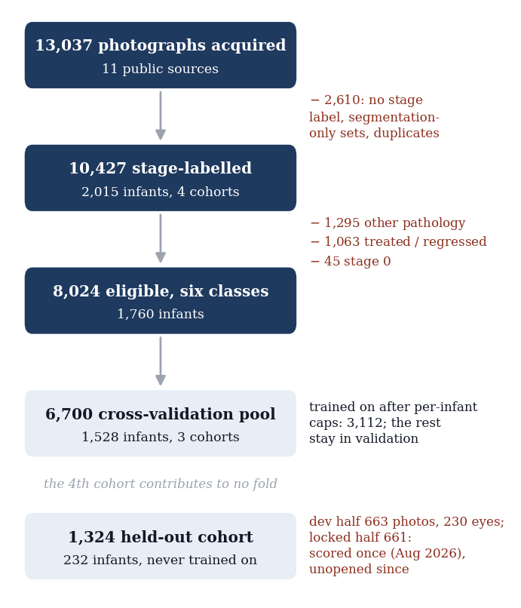
Acquisition cascade. Every exclusion is counted and the reasons sum to the drop. The fourth cohort contributes to no training fold; its locked half was scored once, for the CNN generation, and has not been opened for the transformers.

Reference standard and label unit
Labels are those released by the source institutions, graded by their clinicians against ICROP; the releases do not state grader numbers or adjudication, we did not re-grade, and we state this as the study’s principal limitation. The unit a label describes differs by cohort (Table 1) and is respected in every evaluation: Ostrava records one diagnosis per examination session, inherited by every video frame of that session, about 29.0 frames per infant; ROP-VL and Shenzhen label single photographs; Multi-View labels each eye and photographs it in usually three fixed views (1 to 4 photographs per eye in its development half). For the ordinal metric, AP-ROP is folded onto stage 4/5 (QWK5), the protocol’s definition; the six-label value is reported beside it where it matters.

Splits and the held-out cohort
Folds are patient-grouped (five-fold, stratified by class) and shared by every model from the CNN generation onward; the infant identifiers are those of the releases. Within the 6,700-photograph pool, training keeps at most 2 normal and 20 disease photographs of any one infant (3,112 training-eligible photographs; one Ostrava infant alone supplies 470 of the pool’s 618 AP-ROP frames), while validation always scores every photograph of the held-out fold. The fourth cohort is held out entirely and split by infant into a development half (663 photographs, 230 eyes, 116 infants), used for checks and for every external number reported here, and a locked half (661 photographs, 230 eyes) opened once, under a protocol committed beforehand, for the CNN generation (2026-08-18). Its aggregate results from that opening were known when the transformer arms were designed; no model, hyperparameter, checkpoint or decision rule was selected using it, and no transformer has been scored on it. 14 exact duplicates found inside the pool are excluded from every metric; the audit’s duplicate gate (Table 2) refers to cross-fold pairs and found none.

Shortcut audit
Five gates (Table 2) ran before any staging model was trained: patient leakage across folds; exact and perceptual duplicate leakage across folds; whether the cohort can be decoded from trivial metadata (balanced accuracy 0.997 against chance 0.333, which names the confound rather than removing it); a metadata-only classifier that uses no pixels, whose cross-validation macro-F1 of 0.187 is the floor every image model must clear (on the held-out cohort it collapses to one class, 0.062); and a disease-controlled probe of site information in learned features, run for the CNN generation [7]. On the earlier binary split, image dimensions alone, a perfect proxy for the camera, had reached AUC 0.911.
Shortcut audit on the staging corpus, run before training. G3 names a confound that cannot be removed from the data; G4 sets the floor; G5 is a per-model probe.
Gate | What it measures | Result
G1 | Patient leakage across folds | none
G2 | Exact (MD5) and perceptual (256-bit dHash) duplicate leakage | 0 / 0 pairs; closest distance 15
G3 | Site decodable from trivial metadata (balanced accuracy; chance) | 0.997 (chance 0.333); stage 4/5 exists in one source only
G4 | Metadata-only classifier, no pixels (macro-F1 floor) | CV 0.187, unseen hospital 0.062
G5 | Disease-controlled site probe on embeddings | per model; not run for A–I (reported for the CNN generation in [7])
– | Image dimensions alone, earlier binary split (AUC) | 0.911

Preprocessing
Every model from the CNN generation onward sees the same input (Fig. 2): the retinal disc is cropped from the camera frame, letterboxed to a square, contrast-enhanced with contrast-limited adaptive histogram equalization (CLAHE) [35] on the luminance channel (clip 2.0, $8×8$ tiles), resized ($392×392$ pixels for the transformers, $384×384$ for EfficientNetV2-S) and normalized. The same steps run at training, validation, testing and in the served application. Training-time augmentation adds flips, rotation, color jitter and a site-randomizing color transform; it never changes the test-time pipeline.
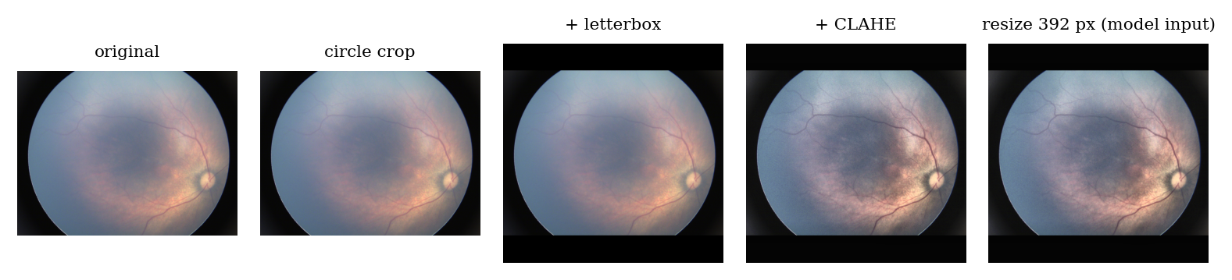
Preprocessing of one development-half photograph: circle crop, letterbox to a square, CLAHE on the luminance channel, resize to the model input.

Methods

Generation 1: convolutional networks
The project’s first model (June 2026) was an EfficientNet-B3 [41] shared between ROP yes/no and diabetic retinopathy under an image-level split (supplementary Table S2). A sweep of 5 ImageNet CNNs (EfficientNet-B0, EfficientNetV2-S [42], MobileNetV3-L [43], ResNet50 [44], DenseNet121 [45]) for binary ROP on Ostrava chose ResNet50 by sweep-validation AUC, and ResNet50 was deployed as the screening head (supplementary Table S3). The second generation of CNNs (August 2026) moved to six-class ICROP-3 staging on the audited corpus with patient-grouped folds and the held-out cohort. All arms shared an ImageNet-initialized EfficientNetV2-S backbone and the preprocessing of Fig. 2. A structured head combined a CORN ordinal branch [46] over the stages (AP-ROP masked from the ordinal loss), an independent AP-ROP sigmoid branch and a domain-adversarial site head [47]; the flat baseline is a six-way softmax. Both trained at natural class prevalence for a fixed epoch budget with last-epoch weights, never a validation-selected checkpoint, at seeds 42 and 1337. Details are in [7].

Generation 2: vision transformers
Protocol. A protocol fixing arms A–C, parity rules, label units, the selection rule, primary and secondary endpoints, the bootstrap, duplicate exclusion and the minimum detectable difference was committed to version control (ac33f29, 2026-10-20) before any transformer was trained. It is time-stamped by that commit, not by a third-party registry. 5 dated amendments, each committed before the experiment it governs and the last on 2026-10-31, added probe-chosen learning rates and the six later arms (D–I) after the earlier arms’ cross-validation and development-half results were known; they added arms and endpoints and changed none that were fixed. The primary endpoint, locked-half eye-level QWK for the contrast A$−$C, is unscored: the locked half is to be opened once, for all nine arms together, after approval. This paper therefore contains no confirmatory result for the transformers.
Arms. All nine arms share the preprocessing of Fig. 2, class-balanced cross-entropy ($β=0.999$) [53] with label smoothing, strong and site-randomizing augmentation, batch 16, 20 epochs, AdamW [51], a one-cycle cosine schedule, mixed precision, last-epoch weights without early stopping, and seeds 42 and 1337 (recipes and cost: supplementary Table S4). Only the backbone, input size, normalization and learning-rate recipe may differ. A, retinal: RETFound-Green ViT-S/14 with register tokens [20] (the authors’ released state dict), a fresh six-way head. B, natural: DINOv2 ViT-S/14 with register tokens [22, 52] (timm weights vit_small_patch14_reg4_dinov2.lvd142m), the identical architecture, so that pre-training domain is the only difference between A and B. C: the flat EfficientNetV2-S of Section 4.1, re-scored from its saved predictions under the new rules. D: B trained with a log-sum-exp loss over up to eight frames of each Ostrava session, scored against the session label. E: the mean of A, B and C’s probabilities. F: B with self-ensembling adaptation [54] on unlabelled photographs of the held-out cohort’s development half (its development numbers are therefore transductive). G: B at DINOv2’s native 518 px. H: B’s recipe on a cleaned pool (3,083 training photographs after a per-camera frame-quality rule, cap re-ranking by sharpness and near-duplicate removal). I: H plus a regularizing recipe fixed in the amendment (an exponential moving average (EMA) of the weights, head warm-up, wider rotation and crop, gamma and noise jitter, a Fourier amplitude swap, label smoothing 0.10). Transformers use layer-wise learning-rate decay 0.8, drop-path 0.1 and head dropout 0.3; the peak learning rate was chosen per arm by a probe on an inner patient-disjoint split of one fold’s training rows. Arms A–I ran on Kaggle Tesla T4 GPUs, about 33 min per fold for B.
Eye-level inference. Each photograph receives a probability vector; an eye’s stage is the most severe predicted stage over its photographs (the clinical reading rule), the photograph attaining it is the driving photograph, and its vector is the eye’s vector; the eye’s any-ROP score is $\max_{i}(1−p_{i,normal})$. A learned attention aggregator was tried on frozen features in a spike before the design and was not pursued (its development-half result is reported in [7]); the rule’s sensitivity to the number of photographs per eye is examined in Section 5.5.
Endpoints and statistics. The selection rule is cross-validation pooled out-of-fold QWK5 per photograph, computed once per arm; the v4 round (H, I) could replace B only by exceeding it by at least 0.010 QWK in cross-validation while staying within 0.010 of it on a leave-one-source-out (LOSO) guard. QWK is quadratic-weighted kappa [55]; unweighted kappa is reported because the human literature uses it. Intervals are 95% percentile bootstrap over 2,000 resamples of infants (the clustering unit), with each arm’s prediction lists (two seeds; ten fold checkpoints on the held-out cohort) averaged inside each replicate, so seed variability is not in the intervals; paired contrasts use the same resample. The protocol’s minimum detectable eye-level difference at 80% power is 0.08 QWK; we read a paired contrast whose interval lies within $±$0.08 as showing no difference larger than that margin, and never as showing none. The 12 pre-specified contrasts are reported as a set; Holm correction applies only to the locked-half secondary endpoints, which are unscored, so no cross-validation or development-half contrast is a confirmatory test. Calibration is measured as expected calibration error (ECE) [56] of the eye’s driving-photograph vector in ten bins. The screening operating point is the largest any-ROP threshold that keeps cross-validation unit-level sensitivity at or above 0.90, carried unchanged to the held-out cohort.

The independent packages
A team member trained three packages on one Windows GPU (3–5 Nov 2026), outside the protocol, on 3,141 of this project’s photographs (ROP-VL 1,438, Multi-View 896, Shenzhen 630; 177 renamed copies not matched by file name) in four classes (normal, stage 1, 2, 3), split 80/10/10 by photograph with seed 42 (the classical package: 80/20), after a black-border crop, resize and CLAHE. Their numbers are not comparable with any protocol result, for three reasons stated once here: the split is by photograph, so 73% of their test photographs and 73% of their validation photographs share an infant with their training set (99% of the Multi-View test photographs); 390 development-half and 331 locked-half photographs were used for training, so these models can never be scored on this project’s test halves; and the class set and metrics differ. (i) Classical learners: 428 hand-crafted features per 256-px photograph, training rows balanced by augmentation before the internal cross-validation that ranked twelve learners (support-vector machine [36], $k$-nearest neighbors, random forest and extra trees [37], XGBoost [38], LightGBM [39], CatBoost [40], histogram gradient boosting, logistic regression, a multilayer perceptron, soft-voting and stacking); the package’s own table is sorted by test accuracy. (ii) CNNs: six ImageNet-pretrained timm [50] networks (ResNet50, DenseNet121, EfficientNet-B2, ConvNeXt-Tiny [48], ResNeSt-50d [49], MobileNetV3-L) at 224 px with early stopping on validation macro-F1 and a soft vote of the three best by validation. (iii) Foundation model: RETFound-DINOv2 ViT-L/14 [19] kept frozen (309.7 million weights) with low-rank adapters (LoRA) [57] of rank 16 on the attention and MLP projections of all 24 blocks and a linear head (6.30 million trainable), four-view flip test-time augmentation (TTA); a sweep of one change each chose a 280-px variant on validation, trained for 30 epochs with three seeds. Full tables: supplementary Tables S5–S7. We collected the packages’ result files into one committed record without re-running any model, and report their test accuracies with an infant-clustered bootstrap (2,000 resamples; their test photographs were mapped to this project’s infant identifiers by file name) rather than photograph-level intervals.

The served system
The selected ensemble is served in a single-page application that requires the operator to declare the patient population before any model runs, gates ungradable photographs, reports the screening verdict against the fixed operating point with the measured sensitivities beside it, the six-class stage as a research output, a Grad-CAM map [58] with two measurements of where it falls, a whole-eye mode applying the most-severe-photograph rule, and a report. Beside the served stage it shows the stage of the independent three-seed RETFound-DINOv2 ensemble with an agree/disagree mark; that model never decides anything. A seen-photo guard hashes every upload against the 10,427 photographs of the project’s data and flags any that a model trained or was tested on (supplementary Fig. S10).

Results

The audit and the retired screener
The deployed binary ResNet50 scored validation AUC 0.842 and test AUC 0.927 on its own split (supplementary Table S3); image dimensions alone scored 0.911 on that split, because every ROP-positive test image came from one camera. Scored at the held-out cohort with its deployed threshold unchanged, the lowest score the head assigned any photograph exceeded its own decision threshold: it flagged all 663 development-half photographs, including every healthy eye, for specificity 0.000 and AUC 0.691 [7], the documented failure mode of cross-camera transfer [16]. The head was retired.

Generation 1: architectures indistinguishable, unit decisive
Table 3 gives the six-class CNN generation. The structured and flat heads differed in mean per-fold macro-F1 by $−0.006$ at one seed and $+0.022$ at the other [7]: opposite signs, inside the per-fold spread. On the locked half, scored once, the same predictions gave QWK5$​_{d}$ 0.473 per photograph and 0.813 per eye (accuracy 0.646) for the structured head at seed 42, and the photograph-to-eye gap was 0.32–0.34 in all four arm–seed cells. The mechanism is anatomical: the ROP ridge grows in the retinal periphery, so a posterior-pole frame of a diseased eye is, as a picture, normal, and frames inherit the eye’s or session’s label; posterior-pole frames of diseased eyes were called normal 71.7% of the time against 12.7% for temporal frames [7]. This is a property of the labels’ unit, not of the network, and from this point every eye-level result uses the most-severe-photograph rule.
Generation 1 (August 2026): EfficientNetV2-S structured head (CORN ordinal + AP-ROP branch + site adversary, 20,512,600 parameters) versus a flat softmax, natural sampling, five-fold patient-grouped cross-validation (CV). QWK$​_{6}$: legacy six-class kappa; QWK5$​_{d}$: rows with true or predicted AP-ROP removed; QWK5: AP-ROP folded onto stage 4/5, the definition used for the transformers. Dev and locked: the held-out cohort; eye = most severe photograph; locked half opened once (2026-08-18). The flat arm is re-scored as arm C in Table 4.
 |  | CV pooled OOF, 6,700 photos |  |  |  |  |  | Dev | Locked, photo |  | Locked, eye (max)
3-8(lr)9-9(lr)10-11(l)12-14 Head | Seed | QWK$​_{6}$ | QWK5$​_{d}$ | QWK5 | Acc. | mF1 | AUC | QWK5 | QWK5$​_{d}$ | QWK5 | QWK5$​_{d}$ | QWK5 | Acc.
Structured | 42 | 0.761 | 0.897 | 0.807 | 0.786 | 0.652 | 0.969 | 0.755 | 0.473 | 0.517 | 0.813 | 0.823 | 0.646
 | 1337 | 0.783 | 0.905 | 0.824 | 0.804 | 0.666 | 0.967 | 0.752 | 0.456 | 0.500 | 0.794 | 0.808 | 0.627
Flat | 42 | 0.777 | 0.897 | 0.820 | 0.789 | 0.655 | 0.968 | 0.756 | 0.492 | 0.551 | 0.808 | 0.823 | 0.635
 | 1337 | 0.770 | 0.898 | 0.813 | 0.787 | 0.658 | 0.966 | 0.764 | 0.486 | 0.543 | 0.801 | 0.818 | 0.630

Generation 2: the transformer arms
Table 4 and Figs. 3–4 give the nine arms (seven trained transformer arms, the CNN baseline C, and the ensemble E). The selection rule chose B by its cross-validation point estimate (QWK 0.825 [0.737, 0.911]; accuracy 0.766, any-ROP AUC 0.979, unweighted kappa 0.635, six-label QWK 0.779); it is a tie broken by the rule, since C, E and I lie within 0.01 of it. On the held-out cohort’s development half, per eye, B scores QWK 0.756 [0.679, 0.821], accuracy 0.630, macro-F1 0.566, any-ROP AUC 0.937, unweighted kappa 0.524, and is not the best arm there (A 0.772/0.776 by seed, I highest). The retinal-versus-natural contrast A$−$B was −0.031 [$−$0.077, +0.015] in cross-validation and +0.019 [+0.000, +0.041] per eye: the sign reverses between settings. The transformer-versus-CNN contrast A$−$C was +0.014 [$−$0.012, +0.048] per eye. Neither v4 arm met the adoption rule: I$−$B was −0.004 [$−$0.015, +0.007] and H$−$B −0.013 [$−$0.031, +0.009] in cross-validation, both intervals wholly below the $+$0.010 bar, while both passed the LOSO guard (supplementary Fig. S3). On the development half I scored I$−$B +0.020 [+0.003, +0.041] and I$−$H +0.026 [+0.006, +0.046], D$−$A −0.028 [$−$0.048, $−$0.011] and F$−$B −0.012 [$−$0.022, $−$0.002]; with A$−$B, whose lower bound is +0.0002, these are the five contrasts whose intervals exclude zero, all below 0.08, and descriptive.
Equivalence and seeds. Of the 12 paired development-half contrasts, 12 have intervals entirely within $±$0.08 and 7 include zero; in cross-validation 12 of 12 lie within the margin and 11 include zero. With two seeds per arm, seed variability is bounded only coarsely: cross-validation QWK is 0.797/0.791 for A, 0.835/0.815 for B and 0.819/0.813 for C by seed, a spread of the same order as several between-arm differences. The design can therefore say that none of the 12 pre-specified contrasts exceeded 0.08 QWK, a margin derived for the locked half’s 230 eyes and applied here to the development half and, per photograph, to cross-validation; it cannot say that the arms are equal.
Generation 2: headline results, all arms, both seeds pooled. CV: pooled out-of-fold, per photograph (6,686 photographs). Dev: held-out cohort, development half, per eye (230 eyes), descriptive. QWK5: quadratic-weighted kappa with AP-ROP folded onto stage 4/5, 95% infant-clustered CI; Acc. six-class accuracy; Bal. acc. mean per-class recall; mF1 macro-F1 over present classes; AUC and AP: any ROP vs normal. Bold letter: selected arm. $​^{†}$Transductive: saw the dev photographs unlabelled in training.
 |  | CV, per photograph (6,686 photos) |  |  |  |  | Unseen hospital, dev half, per eye (230 eyes)
3-7(l)8-12 Arm | Model | QWK5 [95% CI] | Acc. | Bal. acc. | mF1 | AUC | QWK5 [95% CI] | Acc. | mF1 | AUC | AP
A | RETFound-Green ViT-S | 0.794 [0.664, 0.915] | 0.759 | 0.656 | 0.643 | 0.977 | 0.774 [0.707, 0.828] | 0.632 | 0.563 | 0.935 | 0.984
B | DINOv2 ViT-S | 0.825 [0.737, 0.911] | 0.766 | 0.674 | 0.653 | 0.979 | 0.756 [0.679, 0.821] | 0.630 | 0.566 | 0.937 | 0.984
C | EfficientNetV2-S (baseline) | 0.816 [0.713, 0.916] | 0.788 | 0.672 | 0.656 | 0.967 | 0.760 [0.680, 0.822] | 0.624 | 0.573 | 0.943 | 0.986
D | DINOv2 + exam-level loss | 0.797 [0.699, 0.909] | 0.803 | 0.671 | 0.661 | 0.942 | 0.746 [0.671, 0.810] | 0.609 | 0.542 | 0.935 | 0.984
E | Ensemble A+B+C | 0.821 [0.708, 0.927] | 0.787 | 0.680 | 0.664 | 0.981 | 0.770 [0.697, 0.827] | 0.639 | 0.568 | 0.944 | 0.986
F$​^{†}$ | DINOv2 + adaptation | 0.812 [0.704, 0.915] | 0.761 | 0.663 | 0.644 | 0.980 | 0.744 [0.665, 0.812] | 0.624 | 0.552 | 0.940 | 0.985
G | DINOv2 at 518 px | 0.814 [0.706, 0.915] | 0.764 | 0.667 | 0.647 | 0.984 | 0.767 [0.697, 0.827] | 0.627 | 0.551 | 0.939 | 0.985
H | DINOv2 on the v4 pool | 0.813 [0.707, 0.914] | 0.765 | 0.660 | 0.646 | 0.982 | 0.750 [0.674, 0.814] | 0.620 | 0.556 | 0.941 | 0.985
I | DINOv2, v4 pool + v4 recipe | 0.821 [0.727, 0.912] | 0.750 | 0.645 | 0.618 | 0.982 | 0.776 [0.705, 0.834] | 0.633 | 0.561 | 0.944 | 0.986
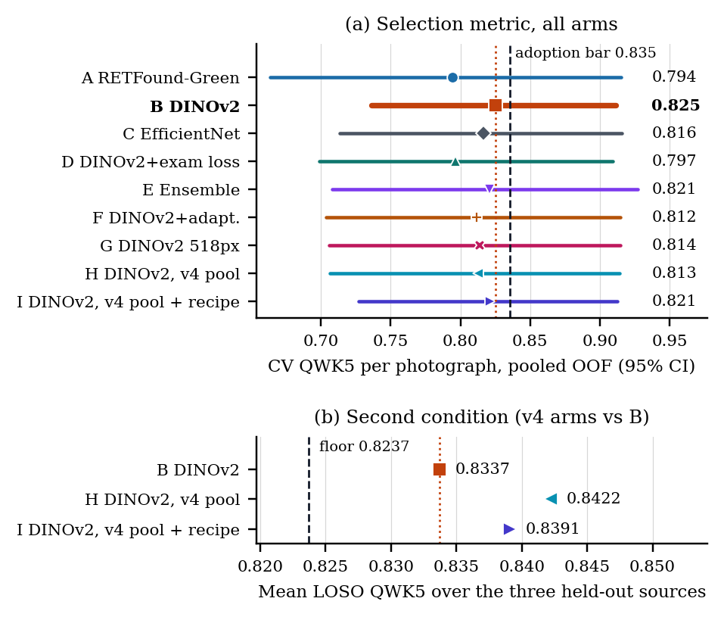
Selection. (a) Cross-validation QWK5 per photograph, pooled out-of-fold, 95% CI; dotted: B; dashed: the adoption bar (B $+$ 0.010) a v4 arm had to reach. (b) The leave-one-source-out (LOSO) guard: mean QWK5 over three held-out cohorts at least B $−$ 0.010 (dashed).
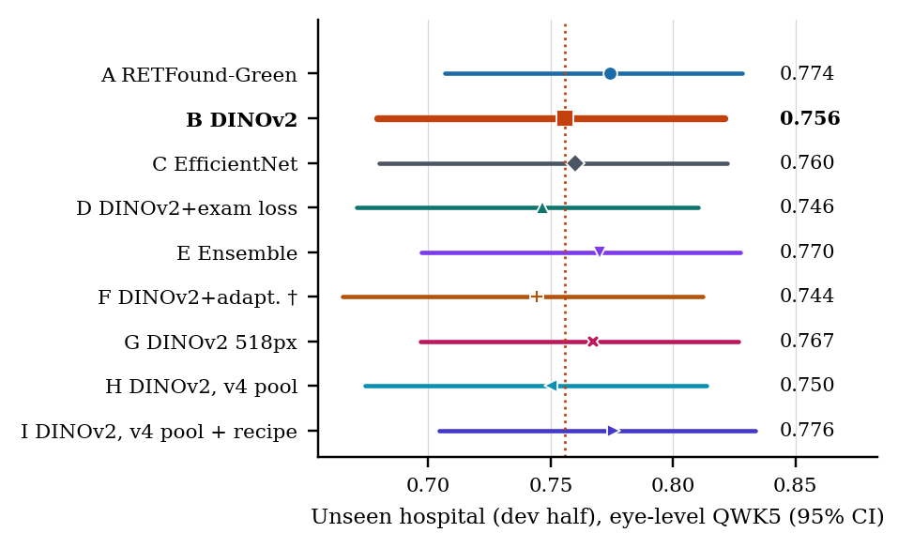
Held-out cohort, development half: eye-level QWK5 with 95% CI, 10 fold–seed models per arm. Descriptive; no selection used it. $​^{†}$Transductive.

Where the errors are
Table 5 and Fig. 5 place the errors. For B at the held-out cohort, per eye, recall is 0.948 for normal, 0.510 for stage 1, 0.546 for stage 2 and 0.566 for stage 3; most errors are between adjacent stages (normal/stage 1 and stage 1/stage 2), where human readers also disagree most [5, 6], and two-stage errors are uncommon. In cross-validation recall is 0.909, 0.583, 0.561, 0.722, 0.882 and 0.389 for the six classes; the low AP-ROP figure is dominated by the one infant whose 470 frames carry one examination label. Stage 4/5 and AP-ROP have five and two eyes at the held-out cohort and are reported as not externally validated.
Recall / precision per class, both seeds pooled. Upper block: cross-validation per photograph; lower block: held-out cohort (development half) per eye. Class counts in each block’s header. S: stage; AP: AP-ROP; bold letter: selected arm; $​^{†}$transductive.
Arm | Normal | Stage 1 | Stage 2 | Stage 3 | Stage 4/5 | AP-ROP
CV, per photograph; n photos: Normal 3,837, S1 574, S2 952, S3 617, S4/5 89, AP 617
A | 0.912 / 0.947 | 0.569 / 0.293 | 0.584 / 0.541 | 0.725 / 0.848 | 0.876 / 0.741 | 0.268 / 0.760
B | 0.909 / 0.959 | 0.583 / 0.302 | 0.561 / 0.583 | 0.722 / 0.788 | 0.882 / 0.668 | 0.389 / 0.705
C | 0.951 / 0.932 | 0.497 / 0.369 | 0.604 / 0.565 | 0.724 / 0.810 | 0.876 / 0.596 | 0.382 / 0.801
D | 0.993 / 0.893 | 0.475 / 0.582 | 0.488 / 0.646 | 0.712 / 0.772 | 0.865 / 0.553 | 0.490 / 0.581
E | 0.943 / 0.949 | 0.551 / 0.346 | 0.620 / 0.570 | 0.729 / 0.847 | 0.910 / 0.684 | 0.328 / 0.748
F$​^{†}$ | 0.911 / 0.959 | 0.570 / 0.291 | 0.562 / 0.566 | 0.722 / 0.767 | 0.888 / 0.706 | 0.327 / 0.746
G | 0.914 / 0.962 | 0.607 / 0.308 | 0.567 / 0.552 | 0.720 / 0.802 | 0.893 / 0.720 | 0.302 / 0.705
H | 0.924 / 0.952 | 0.570 / 0.326 | 0.557 / 0.520 | 0.725 / 0.807 | 0.876 / 0.740 | 0.306 / 0.682
I | 0.909 / 0.960 | 0.490 / 0.298 | 0.568 / 0.497 | 0.741 / 0.725 | 0.893 / 0.677 | 0.269 / 0.617
Unseen hospital (dev half), per eye; n eyes: Normal 50, S1 68, S2 46, S3 59, S4/5 5, AP 2
A | 0.930 / 0.620 | 0.521 / 0.595 | 0.544 / 0.621 | 0.585 / 0.888 | 0.540 / 0.725 | 0.650 / 0.106
B | 0.948 / 0.623 | 0.510 / 0.607 | 0.546 / 0.666 | 0.566 / 0.867 | 0.580 / 0.760 | 0.700 / 0.088
C | 0.972 / 0.633 | 0.404 / 0.621 | 0.591 / 0.544 | 0.598 / 0.883 | 0.660 / 0.704 | 0.850 / 0.135
D | 0.956 / 0.606 | 0.482 / 0.591 | 0.517 / 0.632 | 0.537 / 0.867 | 0.540 / 0.768 | 0.600 / 0.067
E | 0.974 / 0.627 | 0.491 / 0.623 | 0.570 / 0.625 | 0.586 / 0.887 | 0.560 / 0.718 | 0.650 / 0.096
F$​^{†}$ | 0.974 / 0.626 | 0.484 / 0.633 | 0.546 / 0.654 | 0.559 / 0.867 | 0.540 / 0.717 | 0.600 / 0.064
G | 0.962 / 0.624 | 0.507 / 0.597 | 0.522 / 0.639 | 0.571 / 0.899 | 0.540 / 0.700 | 0.550 / 0.070
H | 0.950 / 0.625 | 0.497 / 0.600 | 0.539 / 0.622 | 0.551 / 0.864 | 0.580 / 0.802 | 0.550 / 0.071
I | 0.936 / 0.649 | 0.506 / 0.648 | 0.596 / 0.628 | 0.559 / 0.821 | 0.560 / 0.783 | 0.550 / 0.067
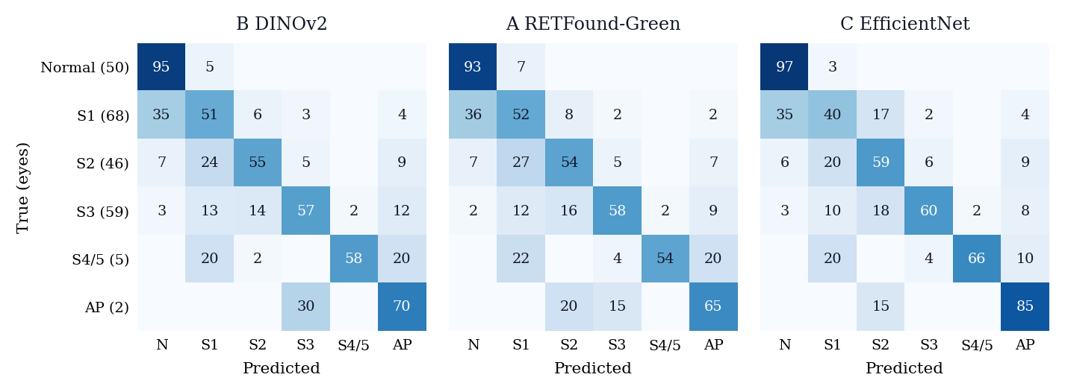
Eye-level confusion matrices at the held-out cohort (development half) for the selected arm B and its two reference arms, A (retinal pre-training) and C (CNN). Cell: share of the true-class row in %, averaged over each arm’s 10 models (diagonal = recall); blank = 0. True-class eye counts in parentheses. N: normal; S: stage; AP: AP-ROP. All nine arms: supplementary Fig. S5.

Screening operating point, calibration and the eye rule
Table 6 gives the screening behavior of every arm and seed. For the served checkpoints (B, seed 42, five folds averaged), the operating point sits at 98.94% of the any-ROP score and gives cross-validation sensitivity 0.900 at specificity 0.996. Carried unchanged to the held-out cohort it catches 0.656 [0.571, 0.740] of the 180 ROP eyes at specificity 1.000 over the 50 normal eyes (no false alarm; Wilson lower bound 0.929, too few normal eyes to claim more), and 0.924 of the 66 eyes with stage 3 or worse (Table 6 gives fold-model means instead); the eye-level any-ROP AUC there is 0.937, so the ranking transfers and the threshold does not (the average precision in Table 4 is driven by the 0.783 prevalence of ROP eyes and is not informative). The eye-level ECE at the held-out cohort is 0.157 as trained, and every cross-validation temperature made every arm more over-confident there (supplementary Fig. S7); arm I is the exception in being well calibrated as trained. The served application therefore applies no temperature and labels its scores as uncalibrated; both the threshold and the calibration must be set at the site of use, which this study did not do.
The most-severe-photograph rule could favor eyes with more photographs. At the held-out cohort the eyes carry 1–4 photographs (median 3; 186 of 230 eyes have exactly three), and the mean count is 2.94 for normal eyes, 2.87 for ROP eyes and 2.94 for stage 3 or worse, so the count carries no class information there. The served ensemble’s eye-level QWK5 is 0.752 [0.671, 0.822] over all eyes and 0.782 [0.697, 0.849] over the three-view eyes alone.
Operating point and calibration, per arm and seed. Threshold: the largest any-ROP score keeping cross-validation (CV) unit-level sensitivity $≥0.90$; carried unchanged to the held-out cohort’s development half (dev), where sensitivity and specificity are means over the seed’s five fold models. Severe: stage 3 or worse, including AP-ROP. $T$: temperature fitted on CV out-of-fold unit vectors. ECE: expected calibration error, ten bins, dev eyes, seeds pooled, as trained and after $T$.
 |  |  | Any ROP vs normal |  |  |  | Severe (S3+) vs rest |  |  |  |  | Dev-eye ECE
4-7(lr)8-11(l)13-14 Arm | Seed | Threshold | CV sens | CV spec | Dev sens | Dev spec | CV sens | CV spec | Dev sens | Dev spec | $T$​ | as trained | with $T$
A | 42 | 0.9884 | 0.900 | 0.999 | 0.650 | 1.000 | 0.952 | 0.652 | 0.924 | 0.659 | 0.840 | 0.152 | 0.205
 | 1337 | 0.9887 | 0.900 | 0.996 | 0.670 | 1.000 | 0.955 | 0.651 | 0.933 | 0.640 | 0.853
B | 42 | 0.9894 | 0.900 | 0.996 | 0.656 | 1.000 | 0.945 | 0.648 | 0.927 | 0.654 | 0.850 | 0.157 | 0.203
 | 1337 | 0.9893 | 0.900 | 0.998 | 0.676 | 1.000 | 0.957 | 0.654 | 0.942 | 0.638 | 0.851
C | 42 | 0.9850 | 0.900 | 0.991 | 0.680 | 1.000 | 0.948 | 0.646 | 0.894 | 0.613 | 0.917 | 0.183 | 0.208
 | 1337 | 0.9805 | 0.900 | 0.993 | 0.671 | 1.000 | 0.942 | 0.645 | 0.918 | 0.633 | 0.935
D | 42 | 0.9893 | 0.900 | 0.998 | 0.656 | 1.000 | 0.952 | 0.651 | 0.900 | 0.643 | 0.828 | 0.185 | 0.238
 | 1337 | 0.9876 | 0.900 | 0.999 | 0.639 | 1.000 | 0.948 | 0.650 | 0.909 | 0.665 | 0.838
E | 42 | 0.9866 | 0.900 | 1.000 | 0.650 | 1.000 | 0.945 | 0.650 | 0.912 | 0.654 | 0.747 | 0.135 | 0.214
 | 1337 | 0.9848 | 0.900 | 0.998 | 0.662 | 1.000 | 0.941 | 0.647 | 0.918 | 0.643 | 0.762
F$​^{†}$ | 42 | 0.9891 | 0.900 | 0.996 | 0.679 | 1.000 | 0.944 | 0.647 | 0.921 | 0.626 | 0.853 | 0.184 | 0.223
 | 1337 | 0.9890 | 0.900 | 0.997 | 0.669 | 1.000 | 0.959 | 0.654 | 0.933 | 0.642 | 0.863
G | 42 | 0.9882 | 0.900 | 0.996 | 0.643 | 1.000 | 0.949 | 0.649 | 0.921 | 0.665 | 0.854 | 0.174 | 0.210
 | 1337 | 0.9897 | 0.900 | 0.996 | 0.667 | 1.000 | 0.955 | 0.651 | 0.939 | 0.646 | 0.868
H | 42 | 0.9884 | 0.900 | 0.996 | 0.658 | 1.000 | 0.946 | 0.648 | 0.918 | 0.648 | 0.836 | 0.167 | 0.215
 | 1337 | 0.9898 | 0.900 | 0.998 | 0.661 | 1.000 | 0.953 | 0.652 | 0.927 | 0.648 | 0.851
I | 42 | 0.9812 | 0.900 | 0.998 | 0.676 | 1.000 | 0.937 | 0.646 | 0.912 | 0.626 | 0.620 | 0.061 | 0.196
 | 1337 | 0.9816 | 0.900 | 0.998 | 0.680 | 1.000 | 0.938 | 0.646 | 0.918 | 0.623 | 0.631

Training at the label’s unit (exploratory)
Scored at each training cohort’s own unit, arm D, whose loss sees an Ostrava examination session rather than a frame, scores QWK5 0.846 [0.692, 0.917] on Ostrava examinations against 0.701 [0.490, 0.776] for B, the same encoder trained per photograph, and 0.775 [0.522, 0.876] for the CNN; B and D are scored with the same most-severe-frame rule. On ROP-VL (0.925 against 0.930) and Shenzhen (0.967 against 0.967), whose labels are already per photograph, D is within noise of B, and on the held-out cohort it is slightly below B (−0.009 [$−$0.019, +0.001]). The paired bootstrap over the 342 Ostrava sessions in [7] put D$−$B at $+0.145$ (95% CI $+0.094$ to $+0.257$). The result is post hoc, rests on 18 diseased infants, is confounded with Ostrava’s larger share of training steps under D’s alternating batches, and its interval is cited from [7] rather than regenerated here; the 0.08 margin was derived for the held-out cohort’s eyes and does not apply to Ostrava sessions. It is the largest contrast in this generation and a hypothesis for a confirmatory follow-up, not a finding.

The independent packages
Table 7 shows the packages’ data against this project’s splits (2,964 of 3,141 photographs matched by file name) and Fig. 6 every model with its infant-clustered interval (test photographs mapped to this project’s infant identifiers by file name; the 14 unmatched ones count as singleton clusters). Within the packages, the best classical learner (SVM (RBF)) reached test accuracy 0.585 and QWK 0.547 on 629 photographs (its per-class report, from the same model’s decision-function predictions, gives 0.568); the best CNN (resnest50d) 0.835 and QWK 0.898, with convnext_tiny diverged (0.530); the three seeds of the chosen adapter configuration 0.787–0.832 (mean 0.814, SD 0.023), the attention-only adapters 0.825, and four changes combined 0.651; averaging the three seeds gave 0.844 (QWK 0.900) and adding four CNNs the best number in the packages, 0.860 [0.820, 0.896] (QWK 0.908, AUC 0.972). Two readings are safe within the packages: a frozen retina-pretrained ViT-L with 6.30 million adapted weights matched the fully fine-tuned CNNs there, and single-change recipe effects sat inside the seed-to-seed spread. Neither can be carried to the protocol results, and the packages contain no retinal-versus-natural comparison.
Independent packages: their photo-level split against this project’s splits, by file name. “Elsewhere”: renamed copies not matched. Last column: validation/test photographs whose infant also has photographs in their training set.
 |  | Their classes |  |  |  | Where the photographs sit in this project |  |  |  | Same infant
3-6(lr)7-10 Their split | Photos | N | S1 | S2 | S3 | CV pool | Dev half | Locked half | Elsewhere | as their training
Train | 2,512 | 687 | 515 | 651 | 659 | 1,647 | 390 | 331 | 144 | –
Val | 314 | 86 | 65 | 81 | 82 | 208 | 48 | 39 | 19 | 214 / 295
Test | 315 | 86 | 64 | 82 | 83 | 213 | 50 | 38 | 14 | 221 / 301
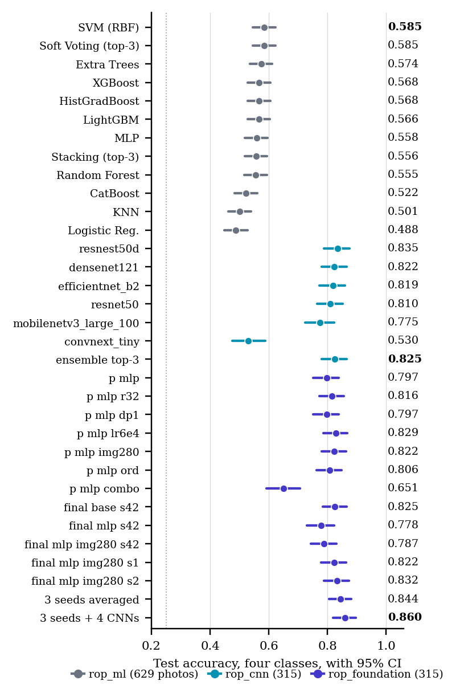
Independent packages: four-class test accuracy of every model, one color per package. 95% CI: infant-clustered bootstrap for the CNN and foundation-model packages (2,000 resamples), Wilson [59] on photographs for the classical package, whose predictions were not saved. Dotted: four-class chance. Not comparable with Figs. 3–4.

Every generation at a glance
Table 8 lists the best model of each generation under its own protocol with the reason it is or is not comparable with B (the generations in time: supplementary Fig. S2). Read down the table, the number rises and falls with the class set, the split, the unit and the test half far more than with the model family; the one controlled contrast in it is the photograph-versus-eye pair of Section 4.1.
Every generation at a glance: the best model of each under its own protocol. Only one row is the project’s selected model; every other row is listed with the reason its number cannot be read against it. Independent-package rows: four classes, photo-level split, test n = 315 (629 for the classical package); CI: infant-clustered bootstrap (Wilson for the classical package).
Generation | Best model | Task; split; unit | Headline, own protocol | Comparable with B?
v1, Jun 2026 | EfficientNet-B3, one model for ROP and DR | ROP yes/no; image-level split; photo | test acc. 0.733, ROP F1 0.706 | No: image-level split; other task (Table S2)
Jun 2026 sweep | ResNet50 | ROP yes/no; Ostrava; photo | test AUC 0.927, QWK$​_{2}$ 0.688 | No: device shortcut, AUC 0.911 from image size alone (Table S3)
v2, Aug 2026 | EfficientNetV2-S, structured head | 6 classes; patient-grouped 5-fold CV; photo / eye | CV QWK$​_{6}$ 0.761; locked eye QWK5$​_{d}$ 0.813 (seed 42) | No: own QWK definitions and checkpoint rule; re-scored as arm C (Table 3)
v3/v4, Oct 2026 | B: DINOv2 ViT-S/14, 5-fold ensemble (selected) | 6 classes; protocol v2; photo / eye | CV QWK5 0.825 [0.737, 0.911]; unseen-hospital eye QWK5 0.756 [0.679, 0.821] | Reference (Table 4); the served model
Teammate, Nov 2026 | rop_ml: SVM (RBF) on 428 hand-made features | 4 classes; photo-level 80/20; photo | test acc. 0.585, QWK 0.547 | No: photo-level split (73% of test photos share an infant with training); trained on 390 dev-half and 331 locked-half photos; four classes (Table S5)
 | rop_cnn: resnest50d | 4 classes; photo-level 80/10/10; photo | test acc. 0.835, QWK 0.898 | As above (Table S6)
 | rop_foundation: RETFound-DINOv2 ViT-L/14 + LoRA, 3 seeds averaged | 4 classes; photo-level 80/10/10; photo | test acc. 0.844, QWK 0.900 | As above (Table S7)
 | Best of the packages: 3 seeds + 4 CNNs averaged | 4 classes; photo-level 80/10/10; photo | test acc. 0.860 [0.820, 0.896], QWK 0.908, AUC 0.972 | As above; selected on validation, 314 photos (Table S7)

Discussion
Across two generations on an audited four-cohort corpus, the one methodological choice whose effect this paper isolates is the evaluation unit; two others, the site and the split, are consistent with the data but were not isolated. The unit: the same CNN predictions score 0.473 per photograph and 0.813 per eye, because labels given per eye or session are inherited by frames that do not show the finding. The site: a screening head with AUC 0.927 on its own test split flagged every photograph of the held-out cohort, and no operating point or temperature fitted in cross-validation transferred for any transformer arm, although the rankings (AUC) did; that is a threshold finding, shown on one retired head and nine arms at one site. The split, shown only by juxtaposition: the independent packages’ photo-level accuracies are consistent with, but do not test, the inflation we attribute to infant overlap, because they also differ in class set and loss. Against these, the architecture choices of two generations, ordinal versus flat heads, retinal versus natural pre-training, resolution, ensembling, unsupervised adaptation, a cleaned pool and a stronger recipe, produced no contrast larger than the design’s 0.08 margin with two seeds, and we claim nothing stronger than that.
The pre-training result differs from ROP-Bench [21], which found natural-image DINOv2 better than RETFound on binary tasks with unmatched architectures, and agrees with Mahboob et al. [23] for staging with fine-tuned RETFound ViT-L: with the architecture matched at ViT-S and the recipe fixed, we found no difference in either direction at this scale of data. Whether the same holds for ViT-L fine-tuned with larger budgets is open; the only large model here is the independent package’s, under its own split.
Our numbers are unremarkable next to the published state of the art. Against inter-expert kappa 0.24 and intra-expert 0.56 for ROP stage [5], reported accuracies above 0.95 warrant scrutiny rather than celebration; we do not compare our own kappa with those values, which are different quantities on different images against a single institution’s coding practice. The errors that remain, normal/stage 1 and stage 1/stage 2, are where experts disagree most, and a model trained on three cohorts’ reading of the stage-1 boundary cannot agree with a fourth’s reading better than readers agree with each other. The exploratory examination-level result points at the labels’ unit as the next thing to test; eye-level training labels and clinician re-grading of the photographs on which several independent models disagree with the label are the inputs most likely to move the ceiling, and a confirmatory design, not another backbone, is the next step.
Clinically, the findings argue for three practices: report the eye, not the photograph, with the driving photograph shown; set the screening threshold and the calibration at the site of use; and show the operator the model’s provenance and the limits of its evidence, which the served application does by stating its measured sensitivities, labelling its scores uncalibrated, and declining photographs it has seen. The application is research software; its verdict has a measured sensitivity of 0.656 at one held-out cohort and must not be used outside a research setting.
This study has several limitations. First, labels were not re-graded, grader counts and protocols are not stated in the releases, two cohorts label per examination or eye, and the exclusions were made from released codes without adjudication; label noise is not estimated. Second, excluding other pathology and treated eyes narrows the spectrum below that of screening practice, so the sensitivities and specificities are spectrum-biased; because the exclusion used released codes, it may also have removed true ROP with a comorbid code, and performance on the excluded photographs was not measured. Third, the held-out cohort is one site and one camera, its development half was used for design decisions in the CNN generation and has now been examined for nine transformer arms, so its numbers are descriptive; the severe classes have five and two eyes there; the locked half, which carries the primary endpoint, is unscored for the transformers, and its aggregate CNN results were known when the arms were designed. Fourth, six of the nine arms were added by amendments after earlier arms’ results were seen, the margins of the adoption rule were set at amendment time, and the protocol is time-stamped only in the authors’ repository. Fifth, two seeds per arm bound seed variability only coarsely and the intervals do not include it; the minimum detectable difference exceeds the effects of interest. Sixth, the independent packages were trained outside the protocol on a photo-level split that overlaps the test halves, their validation-based selection was made on leaky data, and a classical baseline under the full protocol was not trained. Seventh, no zone or plus-disease annotation exists in the corpus, no cohort is from South Asia, and no subgroup analysis by camera or demographics was possible. Eighth, the Grad-CAM maps are illustrative and were not validated against lesion annotations.

Conclusion
On an audited four-cohort ICROP-3 corpus, the label unit decided the reported number on identical predictions; the site decided whether a fixed threshold transferred; and none of the twelve pre-specified contrasts exceeded the two-seed design’s minimum detectable difference of 0.08 QWK, derived for the locked half’s 230 eyes, which cannot show equality. The selected five-fold DINOv2 ensemble reaches eye-level QWK 0.756 and any-ROP AUC 0.937 on a held-out cohort’s development half; retina-pretrained and CNN alternatives did not differ from it beyond that margin; a photo-level split lifts the same model families to accuracies that mean nothing outside the split. Training at the unit the label describes is the one effect large enough to pursue, and it awaits a confirmatory test, as does the locked half. We release every number with the file it comes from, and suggest that ICROP staging studies state the unit their labels describe, split by infant, score at the eye, validate at a held-out site before a threshold is deployed, and show the reader where each number came from.

Compliance with Ethical Standards
This retrospective study used only publicly released, de-identified datasets under their licences (Ostrava/RIDIRP, CC0; ROP-VL and Shenzhen, CC BY 4.0; Multi-View ROP, CC BY-NC 4.0); no new data were collected, no identifiable information was accessed, and the authors did not seek institutional review, on the basis of those licence terms. RETFound-Green’s and RETFound-DINOv2’s weights are used under their non-commercial licences, so the served application and any derivative inherit non-commercial terms. The system is research software and not a medical device. No funding was received; the authors declare no conflicts of interest.

Data and Code Availability
The four cohorts are public at the sources cited. The protocol, its dated amendments, the result files, the scripts that generate every figure, table and number of this paper and its supplement, the served application and the SHA-256 digests of every served weight file are at [FILL: repository URL, tagged release and Zenodo DOI]. No script that produced a number in this paper read a locked-half image or label, and no transformer arm trained or was scored on one; the locked-half numbers quoted are those of the single CNN-generation opening. Two things did touch locked-half photographs and are stated as such: the independent packages trained on 331 of them (Section 4.3), and the served application’s seen-photo guard computed file digests of every photograph in the project’s data, labels unread. Library versions used for serving: PyTorch 2.12, timm 1.0.28; training versions are in the committed Kaggle kernel logs. Mixed-precision GPU training is not bit-reproducible; seeds are recorded per run.

Acknowledgments
We thank the releasing institutions and Kaggle for the free GPU time on which arms A–I were trained, and [FILL: team member’s name, or list as an author] for the independent packages of Section 4.3. Claude (Anthropic) was used under the authors’ direction to draft and edit code and text in all sections, including the generator scripts; the authors verified every number against the committed result files and take full responsibility for the content. [FILL: adapt to the venue’s AI-use policy]
99
] H. Blencowe, J. E. Lawn, T. Vazquez, A. Fielder, and C. Gilbert, “Preterm-associated visual impairment and estimates of retinopathy of prematurity at regional and global levels for 2010,” Pediatr. Res., vol. 74, suppl. 1, pp. 35–49, 2013.
] M. F. Chiang, G. E. Quinn, A. R. Fielder, S. J. Ostmo, R. V. Paul Chan, A. Berrocal, et al., “International classification of retinopathy of prematurity, third edition,” Ophthalmology, vol. 128, no. 10, pp. e51–e68, 2021.
] Early Treatment for Retinopathy of Prematurity Cooperative Group, “Revised indications for the treatment of retinopathy of prematurity: results of the Early Treatment for Retinopathy of Prematurity randomized trial,” Arch. Ophthalmol., vol. 121, no. 12, pp. 1684–1694, 2003.
] M. Vahidmoghadam, P. Ghorbani, M. J. Ahmadi, et al., “Automated diagnosis of plus form and early stages of ROP using deep learning models,” Sci. Rep., vol. 16, art. 7234, 2026.
] A. Gschließer, E. Stifter, T. Neumayer, E. Moser, A. Papp, N. Pircher, et al., “Inter-expert and intra-expert agreement on the diagnosis and treatment of retinopathy of prematurity,” Am. J. Ophthalmol., vol. 160, no. 3, pp. 553–560, 2015.
] J. P. Campbell, S. N. Ryan, E. Lore, J. M. Tian, S. Ostmo, K. Jonas, et al., “Diagnostic discrepancies in retinopathy of prematurity classification,” Ophthalmology, vol. 123, no. 8, pp. 1795–1801, 2016.
] P. Nagpure, R. Bait, P. Rangnekar, Y. Shengale, and A. Kumar, “What the label unit hides: an audited multi-hospital benchmark for ICROP retinopathy of prematurity staging,” [FILL: preprint venue, DOI, 2026].
] J. Timkovič, J. Nowaková, M. Kubíček, A. Herszényi, M. Pokorný, et al., “Retinal image dataset of infants and retinopathy of prematurity,” Sci. Data, vol. 11, art. 814, 2024. [FILL: confirm author list]
] [FILL: author list], “ROP-VL: [FILL: confirm title],” Sci. Data, 2026, doi:10.1038/s41597-026-07901-0. Data: figshare, doi:10.6084/m9.figshare.30143461, CC BY 4.0, accessed Aug. 2026.
] J. Zhao, et al., “[FILL: confirm title]: a fundus image dataset for retinopathy of prematurity,” Sci. Data, vol. 11, 2024. Data: figshare, doi:10.6084/m9.figshare.25514449, CC BY 4.0, accessed Aug. 2026. [FILL: confirm authors, title and article number]
] L. Liao, et al., “Multi-View ROP dataset.” [Online]. Available: Hugging Face, lijuanliao/ROP-DATASET, CC BY-NC 4.0, accessed Aug. 2026. [FILL: confirm authors, version and any accompanying publication]
] [FILL: author list], “VEA-Net: vascular enhancement attention network for multi-task retinopathy of prematurity classification,” Front. Cell Dev. Biol., 2026. [FILL: confirm volume and article number]
] Y. Peng, W. Zhu, Z. Chen, M. Wang, L. Geng, K. Yu, et al., “Automatic staging for retinopathy of prematurity with deep feature fusion and ordinal classification strategy,” IEEE Trans. Med. Imaging, vol. 40, no. 7, pp. 1750–1762, 2021.
] J. M. Brown, J. P. Campbell, A. Beers, K. Chang, S. Ostmo, R. V. P. Chan, et al., “Automated diagnosis of plus disease in retinopathy of prematurity using deep convolutional neural networks,” JAMA Ophthalmol., vol. 136, no. 7, pp. 803–810, 2018.
] [FILL: author list] and J. P. Campbell, “External validation of the i-ROP deep learning system,” J. AAPOS, 2025. [FILL: confirm title, volume, pages]
] J. S. Chen, A. S. Coyner, S. Ostmo, K. Sonmez, S. Bajimaya, E. Pradhan, et al., “Deep learning for the diagnosis of stage in retinopathy of prematurity: accuracy and generalizability across populations and cameras,” Ophthalmol. Retina, vol. 5, no. 10, pp. 1027–1035, 2021.
] J. Wang, J. Ji, M. Zhang, J.-W. Lin, G. Zhang, W. Gong, et al., “Automated explainable multidimensional deep learning platform of retinal images for retinopathy of prematurity screening,” JAMA Netw. Open, vol. 4, no. 5, e218758, 2021.
] W.-H. Lan, C.-L. Tsai, and W.-C. Wu, “Optimizing field-of-view for type-1 retinopathy of prematurity via multiple instance learning,” Transl. Vis. Sci. Technol., vol. 15, no. 8, art. 13, 2026, doi:10.1167/tvst.15.8.13.
] Y. Zhou, M. A. Chia, S. K. Wagner, M. S. Ayhan, D. J. Williamson, R. R. Struyven, et al., “A foundation model for generalizable disease detection from retinal images,” Nature, vol. 622, pp. 156–163, 2023.
] J. Engelmann, et al., “RETFound-Green: a green retinal foundation model,” Nat. Commun., 2025. [FILL: confirm title, author list, volume, article number]
] Luo, Guo, Chen, Liang, and Lin, “ROP-Bench: a benchmark of foundation models for retinopathy of prematurity,” Zenodo record 20721027, 2026, [FILL: confirm author list and title].
] M. Oquab, T. Darcet, T. Moutakanni, H. Vo, M. Szafraniec, V. Khalidov, et al., “DINOv2: learning robust visual features without supervision,” Trans. Mach. Learn. Res., 2024.
] Z. Mahboob, A. O. Ahsan, and M. Wilms, “Using an adult retinal image analysis foundation model for retinopathy of prematurity staging: are there benefits?” in Proc. SPIE Medical Imaging 2025: Computer-Aided Diagnosis, 2025, doi:10.1117/12.3047303. [FILL: confirm volume and paper number]
] [FILL: author list], “SABPI-Net [FILL: full title],” in Proc. MICCAI, 2025.
] Zhao and Li, “DeepAdapter: self-supervised pre-training and domain adaptation for retinopathy of prematurity screening,” Br. J. Ophthalmol., 2026, doi:10.1136/bjo-2025-328559. [FILL: confirm title and authors]
] T. Ojala, M. Pietikäinen, and T. Mäenpää, “Multiresolution gray-scale and rotation invariant texture classification with local binary patterns,” IEEE Trans. Pattern Anal. Mach. Intell., vol. 24, no. 7, pp. 971–987, 2002.
] R. M. Haralick, K. Shanmugam, and I. Dinstein, “Textural features for image classification,” IEEE Trans. Syst., Man, Cybern., vol. SMC-3, no. 6, pp. 610–621, 1973.
] N. Dalal and B. Triggs, “Histograms of oriented gradients for human detection,” in Proc. IEEE CVPR, 2005, pp. 886–893.
] A. F. Frangi, W. J. Niessen, K. L. Vincken, and M. A. Viergever, “Multiscale vessel enhancement filtering,” in Proc. MICCAI, LNCS vol. 1496, 1998, pp. 130–137.
] R. Geirhos, J.-H. Jacobsen, C. Michaelis, R. Zemel, W. Brendel, M. Bethge, and F. A. Wichmann, “Shortcut learning in deep neural networks,” Nat. Mach. Intell., vol. 2, pp. 665–673, 2020.
] A. J. DeGrave, J. D. Janizek, and S.-I. Lee, “AI for radiographic COVID-19 detection selects shortcuts over signal,” Nat. Mach. Intell., vol. 3, pp. 610–619, 2021.
] L. Oakden-Rayner, J. Dunnmon, G. Carneiro, and C. Ré, “Hidden stratification causes clinically meaningful failures in machine learning for medical imaging,” in Proc. ACM CHIL, 2020, pp. 151–159.
] A. S. Tejani, M. E. Klontzas, A. A. Gatti, J. T. Mongan, L. Moy, S. H. Park, et al., “Checklist for Artificial Intelligence in Medical Imaging (CLAIM): 2024 update,” Radiol. Artif. Intell., vol. 6, no. 4, e240300, 2024.
] G. S. Collins, K. G. M. Moons, P. Dhiman, R. D. Riley, A. L. Beam, B. Van Calster, et al., “TRIPOD+AI statement: updated guidance for reporting clinical prediction models that use regression or machine learning methods,” BMJ, vol. 385, e078378, 2024.
] K. Zuiderveld, “Contrast limited adaptive histogram equalization,” in Graphics Gems IV, P. S. Heckbert, Ed. Academic Press, 1994, pp. 474–485.
] C. Cortes and V. Vapnik, “Support-vector networks,” Mach. Learn., vol. 20, pp. 273–297, 1995.
] L. Breiman, “Random forests,” Mach. Learn., vol. 45, pp. 5–32, 2001.
] T. Chen and C. Guestrin, “XGBoost: a scalable tree boosting system,” in Proc. ACM SIGKDD, 2016, pp. 785–794.
] G. Ke, Q. Meng, T. Finley, T. Wang, W. Chen, W. Ma, Q. Ye, and T.-Y. Liu, “LightGBM: a highly efficient gradient boosting decision tree,” in Proc. NeurIPS, 2017.
] L. Prokhorenkova, G. Gusev, A. Vorobev, A. V. Dorogush, and A. Gulin, “CatBoost: unbiased boosting with categorical features,” in Proc. NeurIPS, 2018.
] M. Tan and Q. V. Le, “EfficientNet: rethinking model scaling for convolutional neural networks,” in Proc. ICML, 2019, pp. 6105–6114.
] M. Tan and Q. V. Le, “EfficientNetV2: smaller models and faster training,” in Proc. ICML, 2021, pp. 10096–10106.
] A. Howard, M. Sandler, G. Chu, L.-C. Chen, B. Chen, M. Tan, et al., “Searching for MobileNetV3,” in Proc. IEEE/CVF ICCV, 2019, pp. 1314–1324.
] K. He, X. Zhang, S. Ren, and J. Sun, “Deep residual learning for image recognition,” in Proc. IEEE CVPR, 2016, pp. 770–778.
] G. Huang, Z. Liu, L. van der Maaten, and K. Q. Weinberger, “Densely connected convolutional networks,” in Proc. IEEE CVPR, 2017, pp. 4700–4708.
] X. Shi, W. Cao, and S. Raschka, “Deep neural networks for rank-consistent ordinal regression based on conditional probabilities,” Pattern Anal. Appl., vol. 26, pp. 941–955, 2023.
] Y. Ganin, E. Ustinova, H. Ajakan, P. Germain, H. Larochelle, F. Laviolette, M. Marchand, and V. Lempitsky, “Domain-adversarial training of neural networks,” J. Mach. Learn. Res., vol. 17, no. 59, pp. 1–35, 2016.
] Z. Liu, H. Mao, C.-Y. Wu, C. Feichtenhofer, T. Darrell, and S. Xie, “A ConvNet for the 2020s,” in Proc. IEEE/CVF CVPR, 2022, pp. 11976–11986.
] H. Zhang, C. Wu, Z. Zhang, Y. Zhu, H. Lin, Z. Zhang, et al., “ResNeSt: split-attention networks,” in Proc. IEEE/CVF CVPR Workshops, 2022, pp. 2736–2746.
] R. Wightman, “PyTorch image models,” GitHub repository, 2019, doi:10.5281/zenodo.4414861.
] I. Loshchilov and F. Hutter, “Decoupled weight decay regularization,” in Proc. ICLR, 2019.
] A. Dosovitskiy, L. Beyer, A. Kolesnikov, D. Weissenborn, X. Zhai, T. Unterthiner, et al., “An image is worth 16$×$16 words: transformers for image recognition at scale,” in Proc. ICLR, 2021.
] Y. Cui, M. Jia, T.-Y. Lin, Y. Song, and S. Belongie, “Class-balanced loss based on effective number of samples,” in Proc. IEEE/CVF CVPR, 2019, pp. 9268–9277.
] G. French, M. Mackiewicz, and M. Fisher, “Self-ensembling for visual domain adaptation,” in Proc. ICLR, 2018.
] J. Cohen, “Weighted kappa: nominal scale agreement with provision for scaled disagreement or partial credit,” Psychol. Bull., vol. 70, no. 4, pp. 213–220, 1968.
] C. Guo, G. Pleiss, Y. Sun, and K. Q. Weinberger, “On calibration of modern neural networks,” in Proc. ICML, 2017, pp. 1321–1330.
] E. J. Hu, Y. Shen, P. Wallis, Z. Allen-Zhu, Y. Li, S. Wang, L. Wang, and W. Chen, “LoRA: low-rank adaptation of large language models,” in Proc. ICLR, 2022.
] R. R. Selvaraju, M. Cogswell, A. Das, R. Vedantam, D. Parikh, and D. Batra, “Grad-CAM: visual explanations from deep networks via gradient-based localization,” in Proc. IEEE ICCV, 2017, pp. 618–626.
] E. B. Wilson, “Probable inference, the law of succession, and statistical inference,” J. Am. Stat. Assoc., vol. 22, no. 158, pp. 209–212, 1927.

The authors are with the Department of Automation and Robotics, Vivekanand Education Society’s Institute of Technology, Mumbai, India. Corresponding author: [FILL: name, e-mail, ORCID].
Code, result files, the protocol and its dated amendments are at [FILL: repository URL, tagged release and Zenodo DOI]. The photographs are the public datasets cited in Section [sec:data]. Supplementary material accompanies this paper.

