What the Label Unit Hides: An Audited Multi-Hospital Benchmark for ICROP Retinopathy of Prematurity Staging
P. Nagpure, R. Bait, P. Rangnekar, Y. Shengale, [CLINICAL CO-AUTHOR — required before submission], A. Kumar
Vivekanand Education Society's Institute of Technology, Mumbai, India
Prepared for IEEE ISBI 2027 · 4-page limit · submission deadline 26 October 2026
ABSTRACT
Automated ICROP staging for retinopathy of prematurity (ROP) is usually reported as an accuracy number, and that number is usually decided before the architecture is. We assemble a six-class staging corpus of 8,024 images from 1,760 infants across four cohorts, gate it with a five-part shortcut audit, and evaluate under patient-grouped five-fold cross-validation plus a held-out hospital whose second half was scored exactly once under a pre-registered protocol. Three results follow. First, the evaluation unit dominates: on the locked set the same predictions score quadratic-weighted κ of 0.51–0.56 per image and 0.79–0.80 per eye, a gap that holds across two architectures and two seeds and is therefore a property of the labels rather than of the model. The misses are anatomically directed — posterior-pole frames of diseased eyes are called normal 71.7% of the time against 12.7% for temporal frames — because a frame that does not contain the ridge is, as an image, normal. Second, a taxonomy-faithful ordinal head and a flat softmax are indistinguishable, and the sign of their difference reverses between random seeds. Third, a screening head with 0.970 internal AUC falls to 0.691 externally and flags 663 of 663 images. We report the negative results because they are the finding.
Index Terms — Retinopathy of prematurity, ICROP staging, evaluation methodology, external validation, shortcut learning
1. INTRODUCTION
Retinopathy of prematurity is a leading preventable cause of childhood blindness. The constraint on screening it is not imaging capacity but the number of clinicians able to read the images inside the narrow window where treatment still works, which is why automated ICROP staging has attracted a steady stream of deep-learning systems reporting strong image-level metrics.
We argue that a large part of those metrics is decided before any architecture is chosen, by three methodological choices that are rarely stated and never ablated: the unit the labels actually describe, the probe used to claim site-invariance, and the granularity of the data split. Each moves a reported number further than the architectural contribution in the same paper.
The label unit is the most consequential. ROP annotations are frequently not image-level facts: in several corpora, including the one we use, a diagnosis is recorded per examination session and inherited by every frame captured in it, many of them peripheral or poorly centred views that do not show the finding. Scoring per image against such labels charges the model for annotations that were never about those frames. The literature contains the symptom without the diagnosis. Wang et al. [1] report referral-warranted ROP at image, eye and patient level and observe F1 falling 0.956 → 0.915 → 0.898; the unit is acknowledged, the effect is small, and it points downward. We find the opposite sign at roughly three times the magnitude, and we show why: when the label's native unit is the eye, per-image scoring does not merely lose precision, it systematically understates agreement.
Split granularity is the second. A recent study [2] applies EfficientNetB4 to the same Ostrava corpus [3] we use and reports 0.98 stage accuracy and 1.000 test accuracy for plus disease under an 80/16/4 image-level split of a dataset averaging roughly 32 frames per infant, with no external validation and no device-stratified analysis despite three camera systems; its own limitations section names the leakage risk. We treat it as a control condition rather than as a competitor: it is what this corpus produces when the audit is skipped.
Site invariance is the third. Hospitals differ by camera, so hospital identity is written into every image; the standard remedy is domain-adversarial training [4] and the standard evidence is a linear probe whose accuracy falls. That probe is confounded by disease prevalence, which also varies by site.
Our contributions are: (i) an audited multi-hospital ICROP staging benchmark with patient-grouped folds, a metadata-only performance floor, and a locked external half scored once; (ii) a quantification of the evaluation-unit effect, decomposed into population re-weighting and frame aggregation and shown to be model-independent; and (iii) two negative results — architectural equivalence, and a disease-controlled site probe that never improves — reported at the same weight as the positive ones.
2. MATERIALS AND METHODS
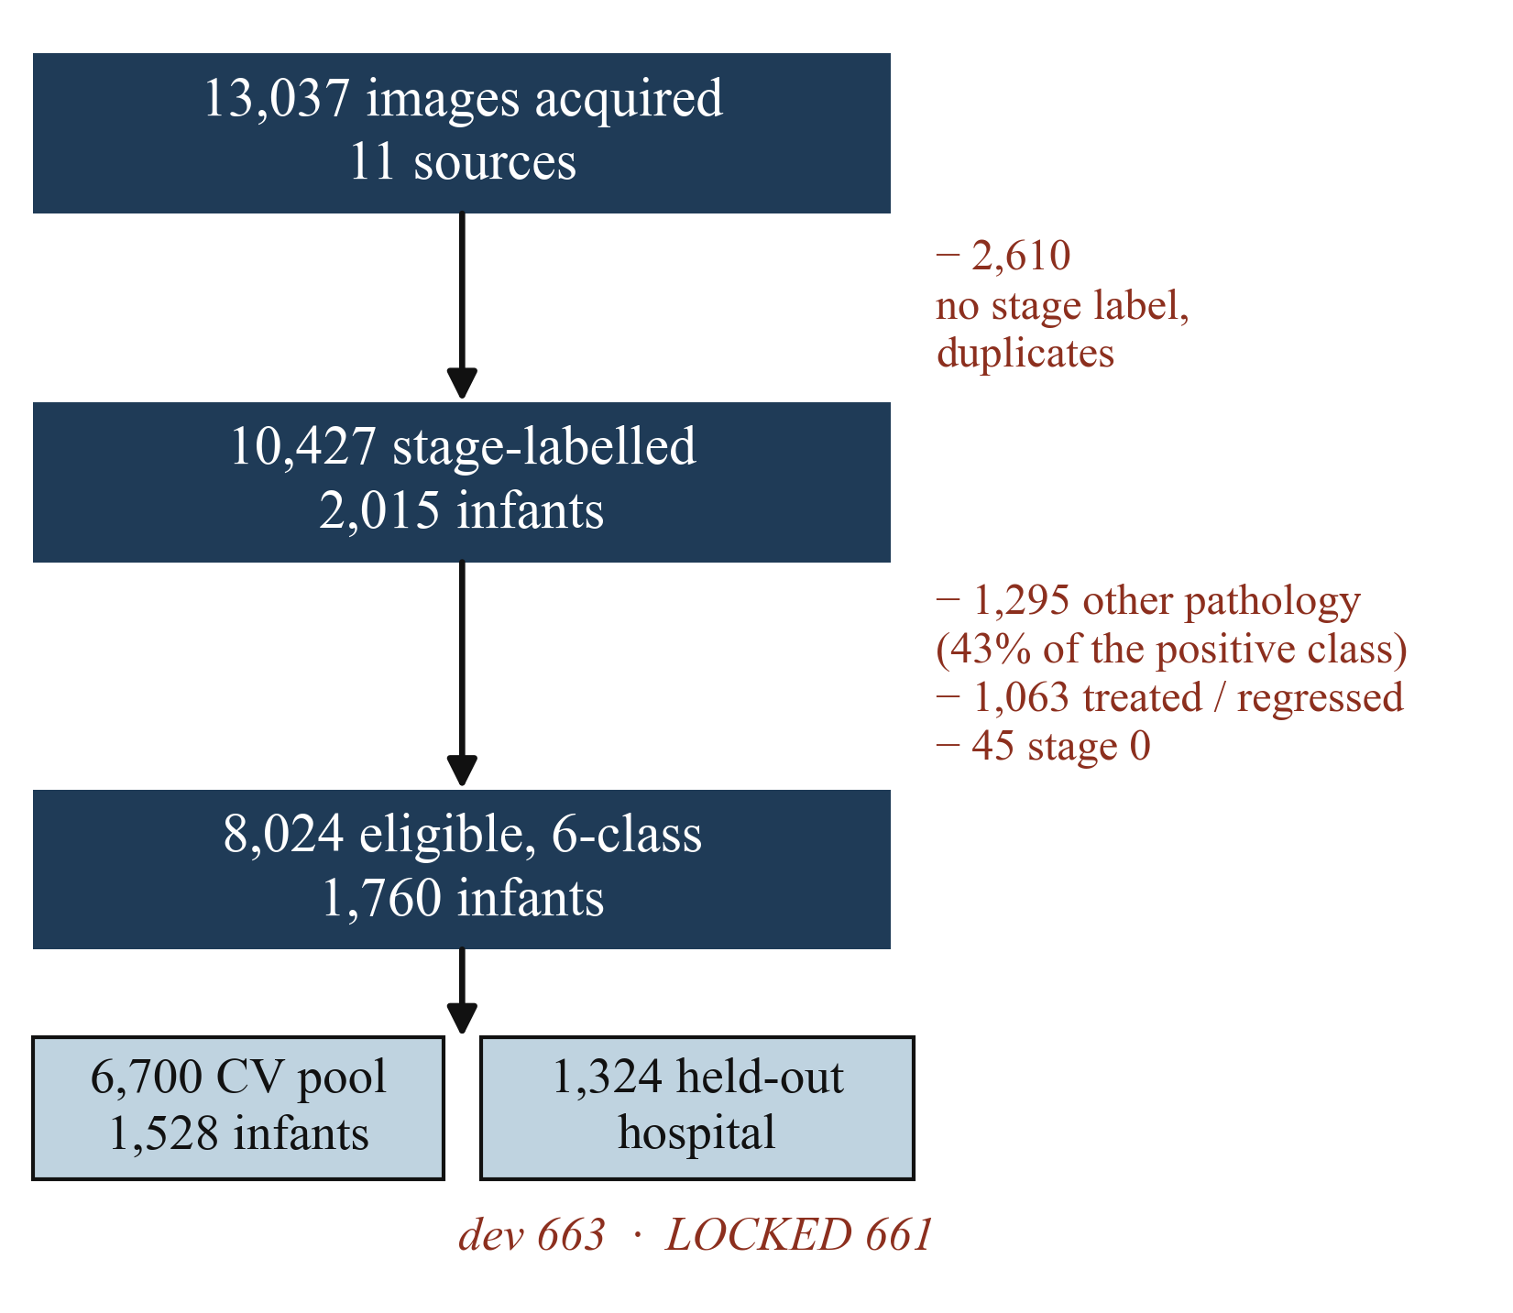
Fig. 1. Cohort cascade. Every exclusion is counted and the reasons are required to sum to the observed drop. The largest single exclusion is clinical: 1,295 images labelled ROP-positive that record other pathology, i.e. 43% of this corpus's binary positive class.
2.1 Corpus and inclusion
We pooled 13,037 images from eleven sources and reduced them to 10,427 stage-labelled images from 2,015 infants, then applied clinical exclusions: 1,295 images labelled ROP-positive that record other pathology (haemorrhage, toxoplasmosis, hamartoma, optic-nerve hypoplasia), 1,063 treated or regressed eyes whose post-treatment appearance is not a stage, and 45 stage-0 images too few to support a class. The eligible corpus is 8,024 images from 1,760 infants in six classes (Normal 3,837; S1 577; S2 959; S3 620; S4/5 89; AP-ROP 618); Fig. 1 gives the cascade. That first exclusion deserves emphasis: 43% of this corpus's binary ROP-positive class is not ROP. A model trained on the uncorrected labels is an abnormal-retina detector reported as an ROP result.
2.2 Reference standard
Stages follow ICROP-3 [5], with AP-ROP treated as an aggressive form outside the stage ladder rather than as a rung on it. Labels are as released by the source institutions; we did not re-grade, and we state plainly that this is the study's principal limitation. Independent adjudication of a stratified subsample by a paediatric retina specialist is in progress.
2.3 Splits
Folds are patient-grouped (five-fold, class-stratified), and a fourth cohort from a hospital contributing to no fold is held out entirely: 1,324 images from 232 infants, divided into a development half (663) used during method selection and a locked half (661 images, 116 infants) opened once, under a protocol committed to version control beforehand. It has not been re-scored since.
2.4 Shortcut audit
Five gates run before any model is trained: (G1) patient leakage across folds — zero; (G2) exact and perceptual duplicate leakage, MD5 plus a dHash calibrated against known byte-duplicates — zero; (G3) site decodability from trivial metadata — balanced accuracy 0.997 against a chance rate of 0.333, which names the confound rather than removing it; (G4) a metadata-only classifier using no pixels, whose cross-validated macro-F1 of 0.187 is the floor every image model must clear; and (G5) a disease-controlled embedding probe (§3.3). On an earlier binary split, image dimensions alone reached AUC 0.911 — the shortcut is not hypothetical [6].
2.5 Models
All arms share an ImageNet-initialised EfficientNetV2-S backbone [7] and identical preprocessing (circle-crop, CLAHE, letterbox, 384²). The structured head has three parts: a CORN ordinal branch [8] over stages with AP-ROP images masked from the ordinal loss, since ICROP-3 gives that form no stage; an independent AP-ROP sigmoid branch; and a DANN site adversary behind a gradient-reversal layer [4]. The flat baseline is a six-way softmax. Both are trained at natural class prevalence — an earlier version of this comparison varied the sampler as well as the head, and the sampling effect was five times the apparent architecture effect. Checkpoints are last-epoch by protocol, never selected by validation argmax.
2.6 Evaluation
The primary metric is quadratic-weighted κ (QWK). Because the human ROP literature reports unweighted κ, we report both: quadratic weighting inflates ordinal agreement when most errors are adjacent, and reporting only QWK would make our numbers incomparable to the only benchmark that matters. For context, inter-expert agreement on ROP stage among seven graders is Fleiss κ = 0.24, intra-expert κ = 0.56, with a 40% stage disagreement rate [9, 10]. Metrics are computed per image (primary) and per eye (co-primary), the latter by taking the most severe prediction across an eye's frames — the same operation by which the labels were assigned. Locked-set figures are means over five checkpoints with their standard deviation.
3. RESULTS
3.1 The evaluation unit decides the result
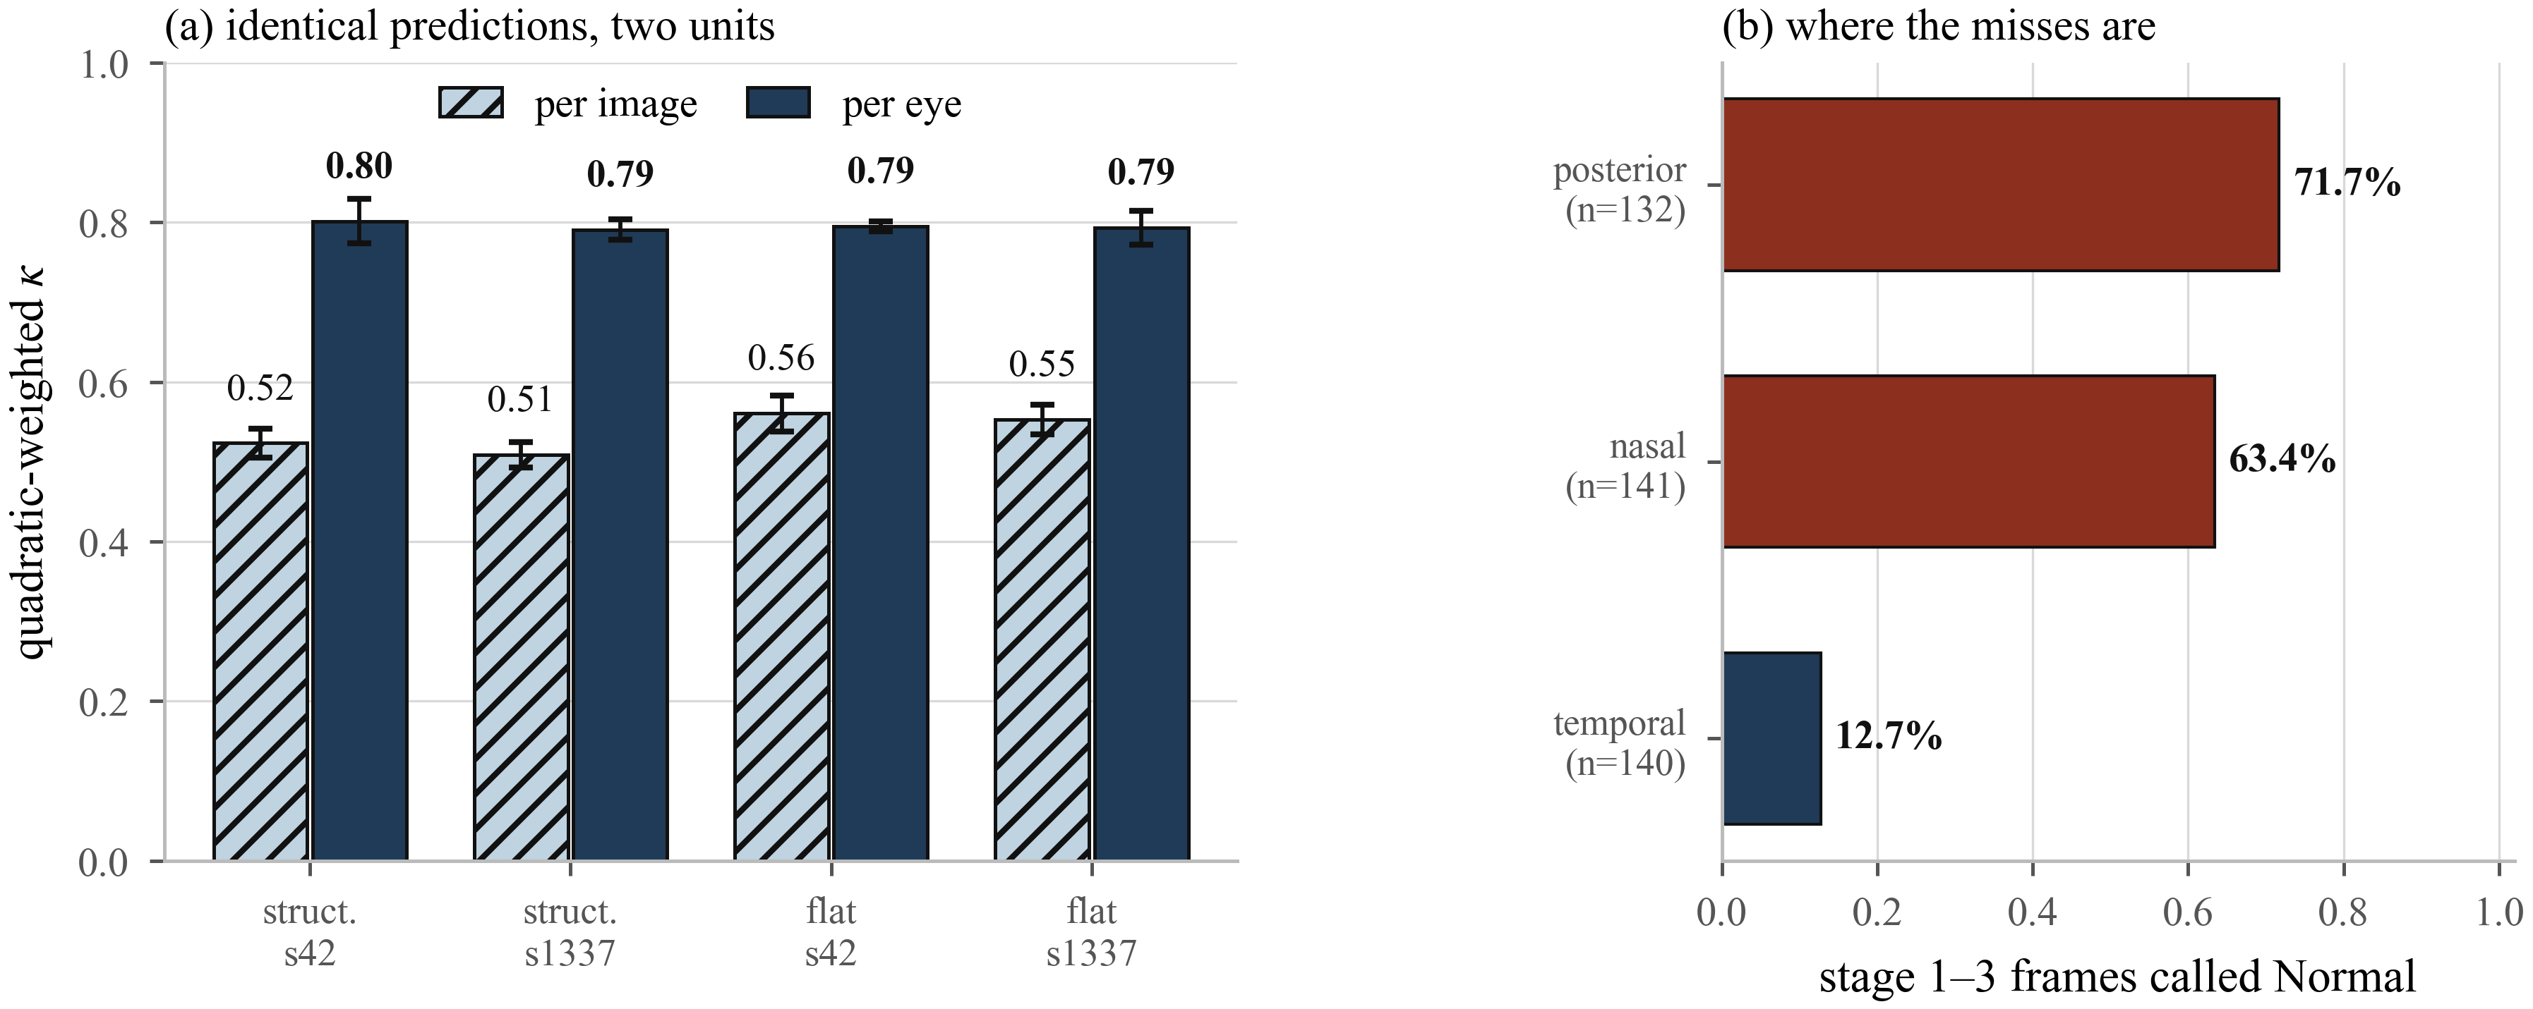
Fig. 2. (a) The same predictions scored at two units on the locked half (n = 661 images, 230 eyes, 116 infants), for two architectures at two seeds. Bars are means over five checkpoints; error bars are their standard deviation. Nothing about any model changes between the hatched and solid bars. (b) The anatomical cause, for stage 1–3 frames of confirmed-diseased eyes: frames aimed away from the temporal periphery, where the ROP ridge grows, are called Normal several times more often.
Table 1 and Fig. 2(a) give the locked-set result. Nothing about any model changes between the two columns; only the unit the score is computed over changes, and it moves QWK by 0.23–0.28 in every cell — larger than any difference between the architectures, the seeds, or the two combined. This is a property of the labels, not of the network.
Table 1. Locked half of the held-out hospital, scored once. Mean ± SD over five checkpoints.
Arm | QWK per image | QWK per eye | Δ
Structured, s42 | 0.523 ± 0.018 | 0.801 ± 0.028 | +0.278
Structured, s1337 | 0.509 ± 0.016 | 0.791 ± 0.013 | +0.282
Flat, s42 | 0.561 ± 0.023 | 0.795 ± 0.007 | +0.234
Flat, s1337 | 0.553 ± 0.018 | 0.793 ± 0.021 | +0.240

The mechanism is anatomical rather than statistical. The ROP ridge grows in the retinal periphery, so whether a frame contains the finding depends on where the camera was pointed. Frames of confirmed-diseased eyes captured at the posterior pole are called Normal 71.7% of the time; temporal frames of the same eyes, which look at where the ridge sits, are called Normal 12.7% of the time (Fig. 2(b)). The pooled confusion matrix says the same thing from the other side (Fig. 3): 73% of stage-1 frames, 44% of stage-2 and 37% of stage-3 fall into the Normal column, while the Normal row is 99% correct. Errors are not scattered around the diagonal the way genuine ordinal confusion would scatter them; they concentrate in one column, which is the signature of frames that inherited a label their pixels do not carry.
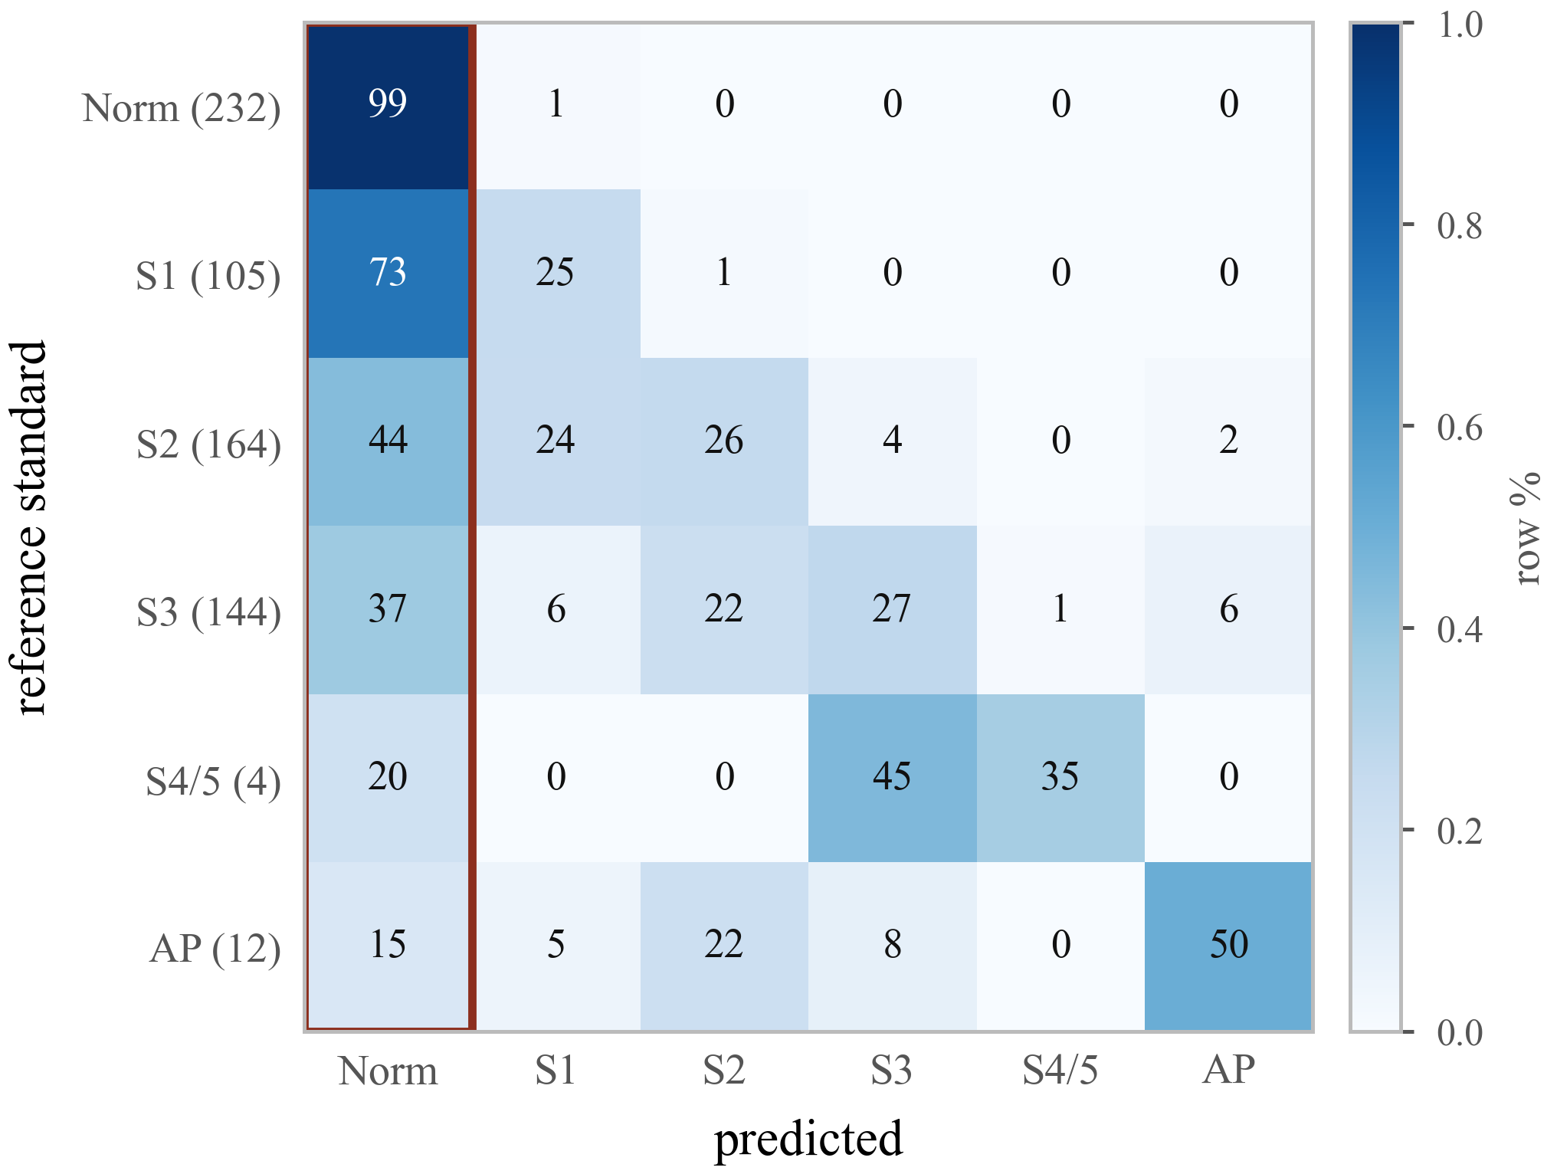
Fig. 3. Locked-set confusion (row %, five checkpoints pooled; row n in parentheses). Errors concentrate in the Normal column (boxed) rather than around the diagonal. Stage 4/5 and AP-ROP rows are too small to read as performance and are reported as not externally validated.
The same caution cuts the other way on AP-ROP, where the unit effect is real but is mostly not what it appears to be. Pooled out-of-fold, recall rises from 0.345 per image to 0.840 per session (100/119 units, CI 0.76–0.90; 0.832 at seed 1337). Decomposed, +0.348 of that is population re-weighting — one infant supplies 76% of AP-ROP images — and only +0.147 is frame aggregation. Roughly 70% of a jump routinely attributed to aggregation belongs to corpus composition instead.
3.2 The architectures are indistinguishable
Under five-fold CV the structured head scores macro-F1 0.692 ± 0.086 against the flat baseline's 0.698 ± 0.099 at seed 42, and 0.708 ± 0.097 against 0.686 ± 0.109 at seed 1337. The difference is −0.0055 at one seed and +0.0224 at the other — opposite signs, an order of magnitude below the per-fold spread of ±0.09. On the locked set the flat head is in fact ahead on image-level QWK and behind on eye-level, by margins inside one standard deviation.
We report this because our own earlier draft did not. A single fold showed the structured head failing on AP-ROP, reproducibly, across five backbones; it dissolved under cross-validation, because that fold's validation split held the one heavily imaged, session-labelled infant. Five architectures failed identically because they shared an evaluation unit, not a defect.
3.3 A naive site probe understates residual site information
Domain-adversarial training is normally validated with a linear probe over all classes. Because disease prevalence varies by site, that probe can score well by reading disease. We ran both, the controlled version on normal-class images only, with patient-clustered bootstrap confidence intervals (2,000 replicates, paired across arms); Table 2 gives the dose–response.
Table 2. Site-probe accuracy versus adversary weight (fold-0 validation, patient-clustered 95% CI).
Adversary weight | Naive probe | Disease-controlled probe
w = 0.0 | 0.790 [0.725–0.882] | 0.866 [0.807–0.917]
w = 0.5 | 0.809 [0.751–0.889] | 0.852 [0.788–0.909]
w = 2.0 | 0.867 [0.821–0.933] | 0.917 [0.869–0.958]

Two readings. The controlled probe sits above the naive one at every strength, so a paper reporting only the naive probe understates the site information its features retain. And neither probe falls as the adversary strengthens: site appearance is not removed at any setting we tested. We report the branch as a negative result.
3.4 External validation retires a model that looked excellent at home
A binary ResNet50 screening head reached sensitivity 0.990 and AUC 0.970 on its own hospitals. Scored at the held-out hospital with its deployed threshold unchanged, the lowest score it assigned any image (0.279) exceeded its own decision threshold (0.193): it flagged 663 of 663 images, including all 150 healthy eyes, for specificity 0.000 and AUC 0.691. This is the documented failure mode of cross-camera transfer — Chen et al. [11] report AUROC falling 0.99 → 0.62 in the same direction — and it is invisible to any internal metric.
We re-based screening onto the staging model's any-ROP probability using a rule fixed before the curves were drawn: the largest threshold holding sensitivity ≥ 0.90 at both sites. It yields sensitivity 0.958 / specificity 0.781 internally and 0.905 / 0.387 externally, against the retired head's 1.000 / 0.000. The external half used for selection makes those two numbers in-sample and optimistic; we say so wherever they appear.
4. DISCUSSION
The unit an ROP model is scored over changes its headline agreement by more than architecture, initialisation, or both together. That is this paper's central claim, and the locked-set design is what licenses it: four cells, two architectures, two seeds, one opening, same direction and similar magnitude.
The practical consequence is that image-level ICROP metrics are not comparable across studies unless the label's native unit is stated. A system reporting 0.98 accuracy under an image-level split on session-labelled data [2] and a system reporting 0.52 QWK per image on the same source are not necessarily describing different models; they may be describing different denominators. Our own numbers are unremarkable next to the published state of the art, and we think that is the honest position rather than a shortfall: against a human inter-expert Fleiss κ of 0.24 on this task [9], reported model agreements above 0.95 warrant scrutiny rather than celebration. This is the hidden-stratification problem [12] in a form the label schema creates directly.
Two of our three headline results are negative. The adversarial branch does not remove site information; the taxonomy-faithful head does not beat a flat softmax. We report them at full weight because the alternative — reporting the seed that agrees with us — was available, cheap, and present in an earlier version of this manuscript.
Limitations. First, we did not re-grade the labels; the 43% non-ROP contamination in the positive class is documented from source records rather than adjudicated, and expert re-grading is in progress. Second, stage 4/5 (n = 89) and AP-ROP are not externally validated — too few cases reach the held-out hospital — and we mark them so rather than quoting them, a decision taken before the locked set was opened. Third, the re-based screening threshold was selected using the development half of the held-out hospital, so its external figures are in-sample for that choice; confirmation requires a third site. Fourth, our corpus carries no zone or plus-disease annotation, so we cannot address the criteria on which treatment decisions are actually made. Fifth, the AP-ROP session analysis rests on genuine multi-frame structure from a single infant and is reported as a methodological caution, not a benchmark.
5. CONCLUSION
On a six-class ICROP staging benchmark with patient-grouped folds and an external hospital scored once, the evaluation unit moves quadratic-weighted κ from ~0.53 to ~0.80 across four independent model–seed cells, and the errors it explains are anatomically directed rather than random. Architecture choice, over the same corpus, moves nothing that survives a change of random seed. We suggest that ICROP staging results should state the unit their labels describe, report both image- and eye-level metrics, and validate externally before a threshold is deployed.
6. COMPLIANCE WITH ETHICAL STANDARDS
This research used publicly available de-identified retinal image datasets and one de-identified institutional corpus released for research use. No new patient data were collected and no identifiable information was accessed. Ethical approval was not required, as confirmed by the licence terms of each constituent dataset.
7. ACKNOWLEDGMENTS
The authors thank University Hospital Ostrava for releasing the infant retinal image database used in this work. The authors declare no conflicts of interest. No funding was received.
8. REFERENCES
[1] J. Wang, J. Ji, M. Zhang, et al., “Automated explainable multidimensional deep learning platform of retinal images for retinopathy of prematurity screening,” JAMA Netw. Open, vol. 4, no. 5, e218758, 2021.
[2] M. Vahidmoghadam, P. Ghorbani, M. J. Ahmadi, et al., “Automated diagnosis of plus form and early stages of ROP using deep learning models,” Sci. Rep., 2026.
[3] J. Timkovič, et al., “Retinal image dataset of infants and retinopathy of prematurity,” Sci. Data, vol. 11, 814, 2024.
[4] Y. Ganin, E. Ustinova, H. Ajakan, et al., “Domain-adversarial training of neural networks,” J. Mach. Learn. Res., vol. 17, no. 59, pp. 1–35, 2016.
[5] M. F. Chiang, G. E. Quinn, A. R. Fielder, et al., “International classification of retinopathy of prematurity, third edition,” Ophthalmology, vol. 128, no. 10, pp. e51–e68, 2021.
[6] A. J. DeGrave, J. D. Janizek, and S.-I. Lee, “AI for radiographic COVID-19 detection selects shortcuts over signal,” Nat. Mach. Intell., vol. 3, pp. 610–619, 2021.
[7] M. Tan and Q. V. Le, “EfficientNetV2: Smaller models and faster training,” in Proc. Int. Conf. Machine Learning (ICML), 2021, pp. 10096–10106.
[8] X. Shi, W. Cao, and S. Raschka, “Deep neural networks for rank-consistent ordinal regression based on conditional probabilities,” Pattern Anal. Appl., vol. 26, pp. 941–955, 2023.
[9] A. Gschließer, et al., “Inter-expert and intra-expert agreement on the diagnosis and treatment of retinopathy of prematurity,” Am. J. Ophthalmol., vol. 160, no. 3, pp. 553–560, 2015.
[10] J. P. Campbell, et al., “Expert diagnosis of plus disease in retinopathy of prematurity from computer-based image analysis,” Ophthalmology, vol. 123, no. 8, pp. 1795–1801, 2016.
[11] J. S. Chen, A. S. Coyner, S. Ostmo, et al., “Deep learning for the diagnosis of stage in retinopathy of prematurity: Accuracy and generalizability across populations and cameras,” Ophthalmol. Retina, vol. 5, no. 10, pp. 1027–1035, 2021.
[12] L. Oakden-Rayner, J. Dunnmon, G. Carneiro, and C. Ré, “Hidden stratification causes clinically meaningful failures in machine learning for medical imaging,” in Proc. ACM Conf. Health, Inference, and Learning (CHIL), 2020, pp. 151–159.

