What the Label Unit Hides: An Audited Multi-Hospital Benchmark for ICROP Staging of Retinopathy of Prematurity
P. Nagpure¹, R. Bait¹, P. Rangnekar¹, Y. Shengale¹, A. Kumar¹ — replace with full names in the agreed order
¹ Department of ______, Vivekanand Education Society's Institute of Technology (VESIT), Mumbai, India
Corresponding author: name, college e-mail · ORCID 0000-0000-0000-0000
Preprint — not peer reviewed.
Abstract
Background. Deep-learning systems for staging retinopathy of prematurity (ROP) are usually evaluated per photograph, although several public corpora record the diagnosis per eye or per examination and copy it to every photograph taken. We measure how much of a reported staging metric that choice decides. Methods. We assembled a six-class ICROP-3 staging corpus (normal, stages 1, 2, 3, 4–5, and aggressive posterior ROP kept outside the stage ladder) of 8,024 images from four public cohorts, ran a five-gate shortcut audit, and trained an ordinal head with an AP-ROP branch and a flat softmax head on one EfficientNetV2-S backbone at two seeds, under patient-grouped five-fold cross-validation. A held-out hospital (1,324 images, 232 infants) was split by infant into a development half and a locked half (661 images, 230 eyes, 116 infants) that was scored once under a pre-registered protocol. Results. On the locked half the same predictions scored quadratic-weighted κ (QWK) 0.51–0.56 per image and 0.79–0.80 per eye in all four model–seed cells; the gap (0.23–0.28) excluded zero in every cell. The gap is anatomically directed: stage 1–3 images taken at the posterior pole were called normal 69.1–72.9% of the time, against 11.7–14.7% for temporal images, and scoring temporal images alone, one at a time and without aggregation, reproduced the eye-level agreement (QWK 0.799 versus 0.801). The two heads were indistinguishable, and a domain-adversarial branch did not reduce site information under a disease-controlled probe. At eye level, 17.2–20.0% of stage 1–3 eyes were still called normal. Conclusions. For ROP staging, the evaluation unit and the acquisition view moved reported agreement more than the choice of model head did. We recommend that staging studies state the unit their labels describe and report image- and eye-level metrics together.
Keywords — retinopathy of prematurity, ICROP staging, evaluation methodology, external validation, shortcut learning, deep learning
1. Introduction
Retinopathy of prematurity (ROP) is a leading cause of preventable childhood blindness worldwide. The constraint on screening is rarely the camera; it is the number of clinicians able to read the images within the weeks in which treatment still works. That gap has motivated a steady stream of deep-learning systems for staging ROP according to the International Classification of ROP, third edition (ICROP-3) [1], most of which report their results per photograph.
Clinically, however, stage is a property of an eye, read from the most advanced finding across all of the views taken of it. Public ROP corpora inherit that convention in their labels. In the Ostrava database [2] one diagnosis code is recorded per examination and copied to every frame captured in it; in the Multi-View ROP dataset [3] one label is recorded per eye and repeated on each of its posterior, nasal and temporal views. A posterior-pole photograph of an eye whose stage-2 ridge lies in the temporal periphery therefore carries the label stage 2, although nothing in its pixels can show it. Scored per image, a model that correctly calls that photograph normal is counted as wrong.
The evaluation unit is not a new idea, and we do not claim it as one. DeepROP [4] predicted per eye by taking an element-wise maximum over the features of all images of that eye; J-PROP [5] reported referral-warranted ROP at image, eye and patient level (F1 0.956, 0.915 and 0.898 respectively); Peng et al. [6] evaluated staging both per image and per examination; and the i-ROP vascular severity score is applied at the examination level [7]. What has not, to our knowledge, been reported is how far the unit alone moves a multi-class staging metric when the predictions are held fixed, at a hospital the model never saw, and which photographs produce the difference.
Two further choices shape published numbers on these corpora. The first is split granularity. The Ostrava corpus contains 6,004 images of 188 infants, about 32 images per infant [2], so an image-level split places photographs of the same infant on both sides of it. Vahidmoghadam et al. [8] used an image-level 80/16/4 split of this corpus, with a four-class stage task (stages 0–3; 880 images) evaluated on a 37-image test set; VEA-Net [9] grouped by subject across three centres, mapped aggressive posterior ROP (AP-ROP) into stage 4, and applied domain adaptation without measuring the site information that remained. The second is site. Hospitals differ by camera, so the hospital is written into every image; domain-adversarial training [10] is the standard remedy, and a linear probe whose accuracy falls is the standard evidence, but that probe is confounded whenever disease prevalence also differs by site.
This paper makes four contributions. (i) An audited multi-source ICROP staging benchmark of four public cohorts, with patient-grouped folds, a metadata-only performance floor, and the defects we found disclosed rather than corrected silently. (ii) On a locked half of a held-out hospital, scored once under a pre-registered protocol, a measurement of the gap between image-level and eye-level agreement for identical predictions in four model–seed cells — a hypothesis formed on the development half and confirmed on the locked half — together with a view-based control that locates where the gap comes from. (iii) Two negative results reported with intervals: an ordinal, taxonomy-faithful head is indistinguishable from a flat softmax, and a domain-adversarial branch does not reduce site information under a disease-controlled probe. (iv) A cautionary external failure of a screening threshold. We do not propose a new architecture, and we make no claim of clinical validity.
2. Materials and Methods
2.1 Data sources
We used four public cohorts (Table 1). Ostrava [2] (Czech Republic; CC0) contributed images from three cameras with one diagnosis code per examination session. Shenzhen [11] and ROP-VL [12] (both Shenzhen Eye Hospital, China, different cohorts; CC BY 4.0) label each image. The Multi-View ROP dataset [3] (China; CC BY-NC 4.0) records the eye and the acquisition view of every image; it was never used for training and serves as the held-out hospital. Duplicates between ROP-VL and Shenzhen were removed with a 256-bit perceptual hash calibrated against known byte-identical copies.
Table 1. Eligible images by source. Classes: normal / stage 1 / stage 2 / stage 3 / stage 4–5 / AP-ROP. *Patient-ID counts; for Shenzhen and ROP-VL the identifier behaves like a record rather than a person, so these are upper bounds on distinct infants.
Source | Images | Patient IDs | Label unit | Class counts
Ostrava | 4,285 | 148 | per session | 2,980 / 252 / 458 / 125 / 0 / 470
Shenzhen | 740 | 397 | per image | 234 / 89 / 163 / 254 / 0 / 0
ROP-VL | 1,675 | 983 | per image | 623 / 236 / 338 / 241 / 89 / 148
Multi-View, dev half | 663 | 116 | per eye (de facto) | 150 / 190 / 135 / 168 / 14 / 6
Multi-View, locked half | 661 | 116 | per eye (de facto) | 232 / 105 / 164 / 144 / 4 / 12
Total | 8,024 | 1,760* |  | 4,219 / 872 / 1,258 / 932 / 107 / 636

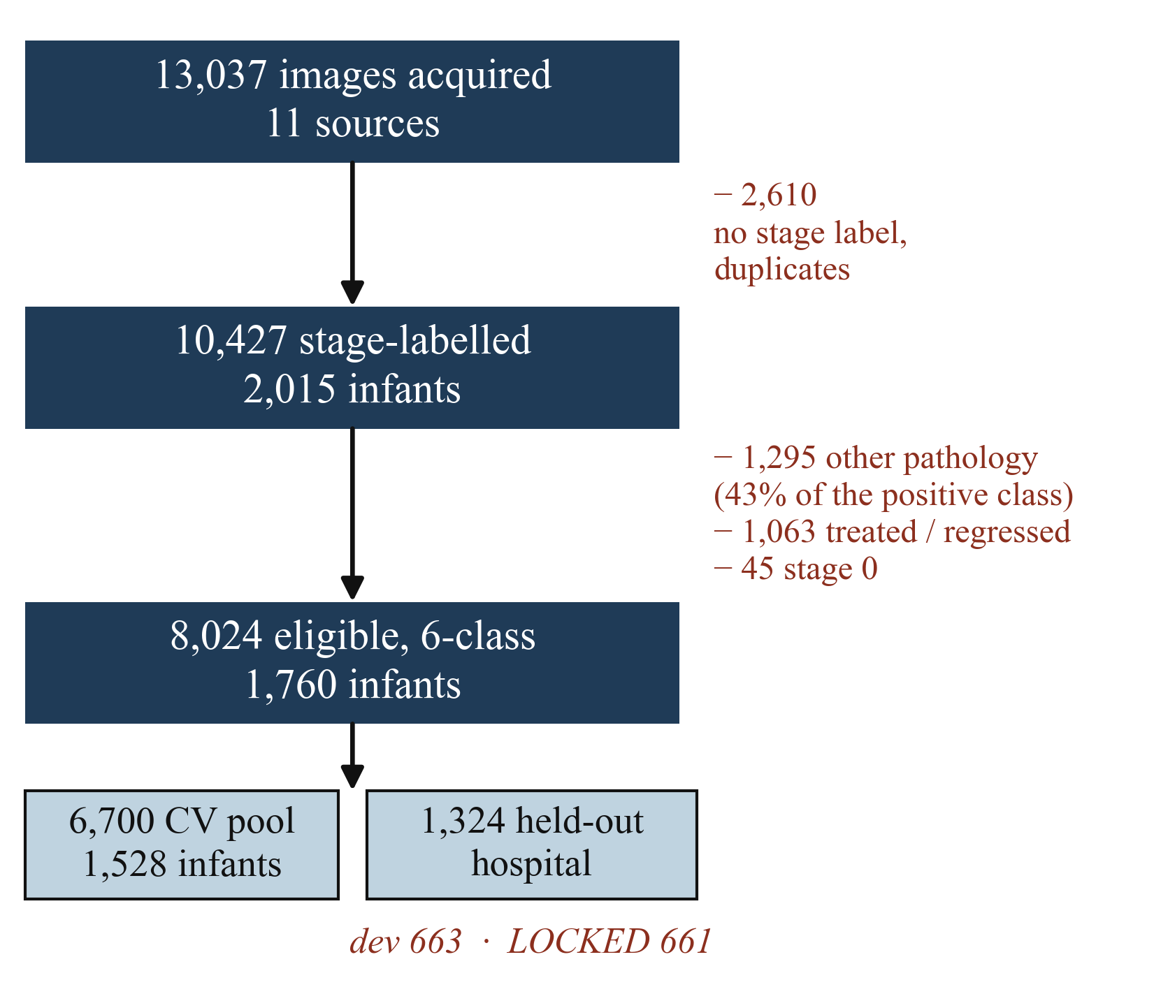
Fig. 1. Inclusion cascade. Every exclusion is counted, and the reasons sum to the observed drop. Infant counts are patient-ID counts (upper bounds; see Table 1).
2.2 Inclusion
We acquired 13,037 images from eleven public sources and reduced them to 10,427 stage-labelled images from 2,015 patient IDs (Fig. 1). We then excluded 1,295 images whose diagnosis code records a condition other than ROP (haemorrhage, toxoplasmosis, hamartoma, optic-nerve hypoplasia); 1,063 images of treated or regressed eyes, whose appearance after treatment is not a stage; and 45 stage-0 images, too few to support a class. The eligible corpus is 8,024 images from 1,760 patient IDs. The first exclusion deserves emphasis: in the Ostrava release, 43% of the images in the binary ROP-positive class record a different diagnosis, so a binary model trained on those labels detects an abnormal infant retina rather than ROP.
2.3 Reference standard
Stages follow ICROP-3 [1]. Aggressive posterior ROP (AP-ROP) is treated as a form outside the stage ladder rather than as a rung on it, and stages 4 and 5 are merged because together they number only 107 images. Labels are used as released by the source institutions; we did not re-grade them, and no clinician adjudicated any subset. The label unit differs by source: Ostrava stamps one code per examination session (both eyes) on every frame; Shenzhen and ROP-VL label single images; in Multi-View, 436 of 460 eyes carry one label across all of their views, so the label is in practice a per-eye diagnosis.
2.4 Splits
The cross-validation pool (6,700 images, 1,528 patient IDs; Ostrava, Shenzhen, ROP-VL) was divided into five patient-grouped, class-stratified folds. Normal images were capped at two per infant in the training folds only; validation folds keep their natural prevalence. The Multi-View cohort (1,324 images, 232 infants) was split by infant into a development half (663 images), used during method selection, and a locked half (661 images, 116 infants, 230 eyes). The protocol for the locked half was committed to version control before any locked inference. One amendment was made after a dry run on the development half and before the locked half was opened: eye-level scoring was added as a co-primary analysis, because the development half had shown that its labels are per-eye diagnoses. The locked half was scored once, on 18 August 2026, and has not been re-scored; every locked-half interval below re-uses the saved predictions.
2.5 Shortcut audit
Five gates were run before training. (G1) Patient leakage: no patient ID is shared across folds or between the pool and either held-out half. (G2) Duplicate leakage: no file path or byte-identical image is shared between the pool, the development half and the locked half. A later full-corpus hash found 10 exact-duplicate groups within the pool, four of which cross a fold boundary (8 images, 0.12% of the pool), three with conflicting labels; we report them rather than remove them, as they are too few to move any metric. (G3) Site decodability from trivial metadata: balanced accuracy 0.997 against chance 0.333, which names the confound rather than removing it [13]. (G4) A metadata-only classifier using no pixels reaches cross-validated macro-F1 0.187, the floor any image model must clear. (G5) A disease-controlled embedding probe (Section 3.4).
2.6 Models and training
All arms share an ImageNet-initialised EfficientNetV2-S backbone [14], selected from a five-backbone flat-softmax benchmark in which macro-F1 varied by only 0.028 across convolutional, transformer and hybrid backbones of 4–28 M parameters. Preprocessing is circle cropping, contrast-limited adaptive histogram equalisation (CLAHE), letterboxing and resizing to 384 × 384. The structured head has three parts: a CORN ordinal branch [15] over normal < stage 1 < stage 2 < stage 3 < stage 4–5, from whose loss AP-ROP images are masked because ICROP-3 gives that form no stage; an independent AP-ROP sigmoid branch with its threshold fixed at 0.5 a priori; and a domain-adversarial site branch behind a gradient-reversal layer [10]. The flat head is a six-way softmax. Both were trained at natural class prevalence for 20 epochs (AdamW, learning rate 3 × 10⁻⁴, weight decay 0.05, one-cycle schedule, batch 16, mixed precision) with flips, rotations up to 15°, colour jitter and random resized crops, at seeds 42 and 1337. The last-epoch weights are used; no checkpoint is selected on validation data.
2.7 Evaluation
The primary metric is quadratic-weighted κ (QWK) over the six labels with AP-ROP at rank 5; because the human ROP literature reports unweighted κ, we report that too. An eye is the pair (infant, left/right) from the Multi-View acquisition-view table. Its label is the most severe label among its views, and its prediction is the most severe predicted class among the same views — the same operation by which the labels were assigned. Locked-half figures are means over the five fold checkpoints. Intervals are 95% percentile intervals from 2,000 bootstrap replicates that resample infants, computing each metric per checkpoint and averaging within each replicate. The two heads are compared on the ten paired fold × seed macro-F1 differences, with the variance correction for overlapping training sets of Nadeau and Bengio [16], and an equivalence test (two one-sided tests [17]) at a margin of ±0.05 macro-F1.
3. Results
3.1 The evaluation unit moves agreement more than the model does
Table 2 and Fig. 2(a) give the locked-half result. With the predictions unchanged, QWK rose from 0.51–0.56 per image to 0.79–0.80 per eye in all four model–seed cells, and the per-cell gap (0.23–0.28) excluded zero in every bootstrap replicate. The direction and size of the effect had been seen first on the development half (QWK 0.40–0.44 per image, 0.71–0.73 per eye), which is why eye-level scoring was added to the protocol before the locked half was opened. Unweighted κ shows the same pattern (0.31–0.33 per image, 0.50–0.53 per eye).
Table 2. Locked half of the held-out hospital (661 images, 230 eyes, 116 infants), scored once. Means over five checkpoints; 95% infant-clustered bootstrap intervals in brackets. The last column is the share of stage 1–3 eyes (n = 147) predicted normal at eye level.
Arm | QWK per image | QWK per eye | Eye − image | Eye accuracy | Stage 1–3 eyes called normal
Structured, seed 42 | 0.523 [0.433, 0.594] | 0.801 [0.730, 0.857] | +0.278 [0.219, 0.340] | 0.646 | 17.8%
Structured, seed 1337 | 0.508 [0.417, 0.581] | 0.791 [0.714, 0.845] | +0.282 [0.223, 0.343] | 0.627 | 20.0%
Flat, seed 42 | 0.561 [0.464, 0.635] | 0.795 [0.725, 0.850] | +0.234 [0.180, 0.297] | 0.635 | 17.2%
Flat, seed 1337 | 0.553 [0.456, 0.629] | 0.793 [0.722, 0.850] | +0.241 [0.185, 0.304] | 0.630 | 19.3%

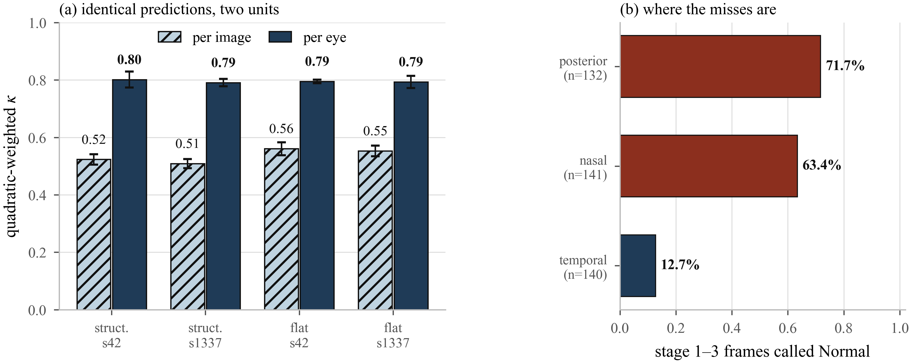
Fig. 2. (a) The same predictions scored per image and per eye on the locked half, for two heads at two seeds. Bars are means over five checkpoints; error bars show the spread across checkpoints (standard deviation), not sampling uncertainty, which is given in Table 2. (b) Share of stage 1–3 images of the locked half called normal, by acquisition view (structured head, seed 42).
3.2 Where the gap comes from
The misses depend on where the camera was pointed (Fig. 2(b)). Stage 1–3 images taken at the posterior pole were called normal 69.1–72.9% of the time across the four cells, nasal images 63.1–66.1%, and temporal images 11.7–14.7%. In ROP the temporal retina is the last to vascularise, and it is where the demarcation line or ridge is usually seen; a posterior or nasal photograph of such an eye can be normal as an image. The locked-half confusion matrix shows the same thing from the other side (Fig. 3): 73% of stage 1, 44% of stage 2 and 37% of stage 3 images fall in the normal column, while 99% of normal images are called normal. Errors concentrate in one column instead of spreading around the diagonal, which is the signature of images that carry a label their pixels do not show.
A view-based control locates the mechanism more precisely than the aggregation does. Scoring only the temporal images, one at a time and without any aggregation, gives QWK 0.799 on the locked half (227 images) against 0.801 per eye; nasal-only and posterior-only scoring give 0.375 and 0.398. The development half behaves the same way (0.718 temporal-only, 0.721 per eye). Aggregation by majority vote instead of by the most severe view does not recover agreement (0.490). The eye-level gain therefore comes from selecting the image that can show the finding, not from averaging noise away.
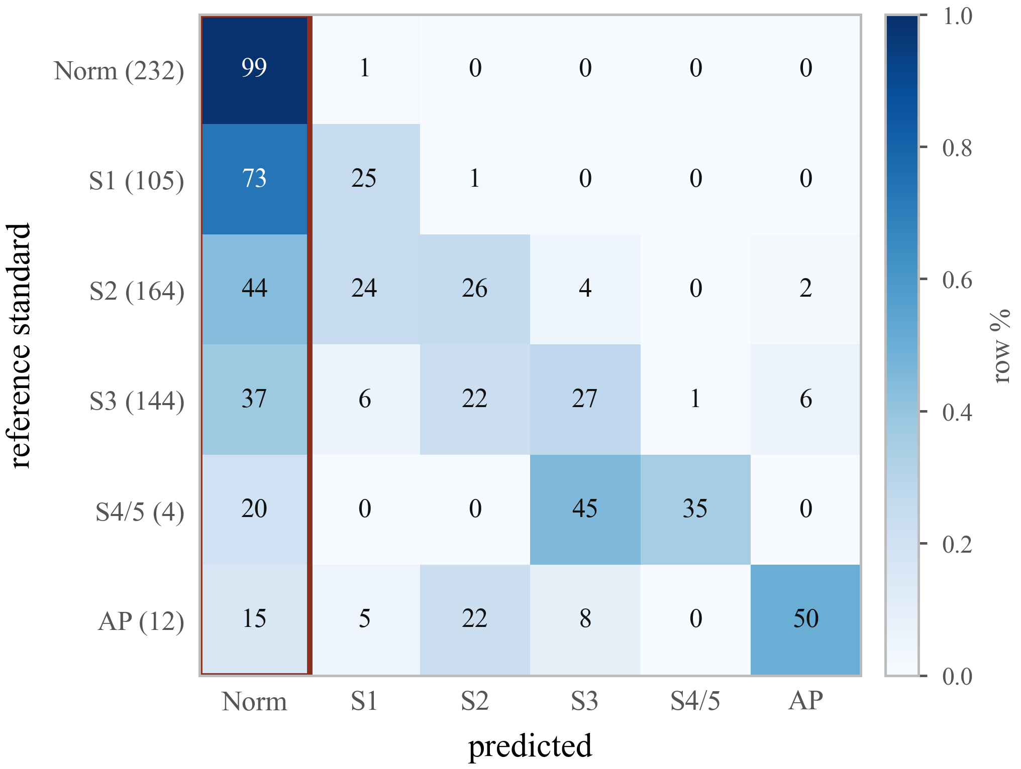
Fig. 3. Locked-half confusion matrix per image (row percentages, five checkpoints pooled; row counts in parentheses; structured head, seed 42). Errors concentrate in the normal column (boxed). Stage 4–5 and AP-ROP rows are too small to read as performance and are reported as not externally validated.
A similar pattern appears inside the cross-validation pool for AP-ROP: 70.4% (95% CI 55.9–84.0%) of AP-ROP frames from Ostrava, where one code is stamped on every frame of a session, received an AP-ROP probability below 0.1, against 10.1% (95% CI 5.5–15.1%) in the sources that label single images (103 infants). We report this as consistent with the label-unit explanation, not as independent evidence: all 470 Ostrava AP-ROP frames come from one infant across 16 sessions, so the comparison cannot separate session-stamped labels from that infant.
3.3 The two heads are indistinguishable
Under five-fold cross-validation the structured head reached macro-F1 0.692 ± 0.086 against 0.698 ± 0.099 for the flat head at seed 42, and 0.708 ± 0.097 against 0.685 ± 0.108 at seed 1337 — the sign of the difference reverses between seeds. Over the ten paired fold × seed differences the mean was +0.0085 macro-F1. Treating the ten pairs as independent gives a 95% interval of [−0.026, 0.043] and equivalence at ±0.05 (p = 0.012); with the correction for overlapping training folds [16] the interval widens to [−0.057, 0.074] and equivalence at that margin can no longer be shown (p = 0.092). We therefore claim no difference in either direction, not proven equivalence. On the locked half the flat head was ahead per image (QWK 0.553–0.561 against 0.508–0.523), while per eye all four cells lie within 0.791–0.801. What the structured head offers is taxonomy-faithful output — an ordinal stage and a separate AP-ROP probability — at no detectable cost, not higher accuracy.
3.4 A naive site probe understates the site information that remains
Domain-adversarial training is usually validated with a linear probe over all classes. Because disease prevalence differs by site, that probe can score well by reading disease. We ran it alongside a disease-controlled probe restricted to normal images (fold 0, seed 42, adversary weight w ∈ {0, 0.5, 2.0}; Table 3). The controlled probe decodes site better than the naive one at every weight, so the naive probe understates the site information the features retain. Neither probe fell as the adversary strengthened: from w = 0 to 0.5 the controlled probe changed by −0.015 [−0.073, 0.047], and at w = 2.0 it rose by +0.051 [0.006, 0.100] relative to w = 0 (naive probe: +0.077 [0.033, 0.112]). With one fold and one seed, we report this as a negative result for this configuration, not as a general property of domain-adversarial training.
Table 3. Site-probe accuracy against adversary weight (fold 0 validation, seed 42; patient-clustered 95% intervals, 2,000 replicates).
Adversary weight | Naive probe | Disease-controlled probe
w = 0.0 | 0.790 [0.725, 0.882] | 0.866 [0.807, 0.917]
w = 0.5 | 0.809 [0.751, 0.889] | 0.852 [0.788, 0.909]
w = 2.0 | 0.867 [0.821, 0.933] | 0.917 [0.869, 0.958]

3.5 A screening threshold that did not transfer
An earlier binary screening model (ResNet50, trained on Ostrava only) reached AUC 0.927 on its internal test split and, at its operating threshold 0.193, sensitivity 0.990 and specificity 0.398 (n = 1,502). On the development half of the held-out hospital its AUC was 0.691, and its lowest score on any image (0.279) exceeded its threshold, so it flagged all 663 images, including all 150 normal images. We replaced it with the structured model's any-ROP probability, using a rule fixed before the curves were drawn: the largest threshold that holds sensitivity ≥ 0.90 at both the training hospitals and the held-out development half (threshold 0.0155). This gives sensitivity 0.958 and specificity 0.781 internally (n = 6,700) and 0.904 / 0.387 externally. The external pair is in-sample for the threshold choice and therefore optimistic. Cross-camera loss of performance in ROP staging has been reported before [18]; the point here is that no internal metric anticipated it.
4. Discussion
On a locked half of a hospital the models never saw, the unit over which the same predictions are scored changed staging agreement by roughly 0.23–0.28 QWK, more than the choice of head, the random seed, or both together. The view analysis shows why: a per-eye label copied onto photographs that point away from the temporal periphery makes many of those photographs look wrongly classified when they are not.
This sits alongside, rather than against, earlier work. DeepROP [4] and the i-ROP severity score [7] already predict at the eye or examination level, and Peng et al. [6] report both units. J-PROP [5] found that F1 fell from image to eye to patient level for referral-warranted ROP, the opposite direction to ours. The two findings are compatible: when a label describes the image, taking the maximum over an eye's images can only add positives and can lower specificity; when the label describes the eye and is copied onto its images, the per-image score is the one that is biased, and aggregation recovers agreement. Which direction a study sees therefore depends on the unit its labels describe — a fact that is seldom stated, and which we suggest should be.
The comparison with published accuracies should be read in the same light. Reported stage accuracies of 0.97–0.98 on the Ostrava corpus [8] come from a four-class task with an image-level split and a 37-image test set; our six-class task, infant-level split, external hospital and per-image QWK of about 0.52 are not the same measurement, and the difference between them is not evidence about either model. The human reference is also informative: seven experts reading the same photographs agreed on stage with Fleiss κ 0.24 [19], and stage was the commonest source of disagreement between centres (40% of comparisons) [20]. Our unweighted Cohen κ against the released labels (0.65–0.68 in cross-validation; 0.50–0.53 per eye on the locked half) is a different quantity, measured against a single institution's coding, and should not be read as better-than-human agreement. It does indicate that the reference standard itself is uncertain, a form of the hidden-stratification problem [21].
Clinically, the result is sobering. Even at eye level, 17.2–20.0% of stage 1–3 eyes were called normal on the locked half, and stage 4–5 and AP-ROP could not be validated externally at all. The models described here are research instruments, not screening tools. The practical recommendations are modest: state the unit the labels describe; report image- and eye-level metrics side by side; record laterality and acquisition view when releasing ROP datasets; and validate a threshold externally before it is deployed. The view result also points to the next model: one that takes all views of an eye as its input, rather than scoring them one by one.
Limitations
This study has several limitations.
First, the labels were used as released by the source institutions and were not re-graded; no clinician adjudicated any subset. The 43% non-ROP contamination we report is documented from the source diagnosis codes, not from re-reading the images.
Second, patient identifiers in ROP-VL and Shenzhen behave like per-record rather than per-person keys (six byte-identical photographs carry two different Shenzhen identifiers). Infant counts for those sources are therefore upper bounds, and patient-clustered intervals computed on the cross-validation pool are narrower than true clustering would warrant. The held-out hospital, where the identifier is patient-like, is the least affected.
Third, stage 4–5 and AP-ROP are not externally validated: the locked half contains 4 and 12 such images. All 89 stage 4–5 images in the cross-validation pool come from one source (ROP-VL), so performance on that class may partly reflect site.
Fourth, the re-based screening threshold was selected using the development half of the held-out hospital, so its external figures are in-sample for that choice.
Fifth, the corpus carries no zone annotation and no plus-disease label usable alongside stage, so we cannot address the criteria on which treatment decisions are made.
Sixth, all models share one backbone family with ImageNet initialisation, and the held-out site is a single hospital. Ostrava records no eye laterality, so eye-level analyses on the cross-validation pool use the examination session instead.
5. Conclusion
On an audited multi-source ICROP staging benchmark with patient-grouped folds and an external hospital scored once, the evaluation unit moved quadratic-weighted κ from about 0.51–0.56 per image to 0.79–0.80 per eye in four independent model–seed cells, and the errors it explains are anatomically directed rather than random. The choice of head moved nothing that survived a change of random seed. ROP staging results should state the unit their labels describe, report both image- and eye-level metrics, and be validated externally before a threshold is used.
Data and code availability
All four cohorts are publicly available from their original repositories: Ostrava, figshare collection 6626162 (CC0) [2]; Shenzhen, doi:10.6084/m9.figshare.25514449 (CC BY 4.0) [11]; ROP-VL, doi:10.6084/m9.figshare.30143461 (CC BY 4.0) [12]; Multi-View ROP, Hugging Face lijuanliao/ROP-DATASET (CC BY-NC 4.0) [3]. The split manifests, the locked-evaluation protocol, the saved predictions and the analysis code are available at repository URL.
Compliance with ethical standards
This research study was conducted retrospectively using human subject data made available in open access by the sources listed above. Ethical approval was not required, as confirmed by the licence attached to each open-access dataset. No images were collected by the authors, and file names that encoded clinical attributes were replaced with anonymous identifiers before use.
Acknowledgments
We thank the teams who released the Ostrava, Shenzhen, ROP-VL and Multi-View ROP datasets. This work received no funding. The authors declare no conflicts of interest. Use of AI tools — edit to match what was actually done: An AI assistant (Claude, Anthropic) was used to help write analysis and figure-generation code and to draft and edit parts of the manuscript text. The authors reviewed and verified all content and take full responsibility for it.
References
[1] M. F. Chiang, G. E. Quinn, A. R. Fielder, et al., “International classification of retinopathy of prematurity, third edition,” Ophthalmology, vol. 128, no. 10, pp. e51–e68, 2021.
[2] J. Timkovič, et al., “Retinal image dataset of infants and retinopathy of prematurity,” Sci. Data, vol. 11, 814, 2024. Data: figshare collection 6626162 (CC0).
[3] Multi-View ROP dataset, Hugging Face lijuanliao/ROP-DATASET, CC BY-NC 4.0, accessed 2026.
[4] J. Wang, R. Ju, Y. Chen, et al., “Automated retinopathy of prematurity screening using deep neural networks,” EBioMedicine, vol. 35, pp. 361–368, 2018.
[5] J. Wang, J. Ji, M. Zhang, et al., “Automated explainable multidimensional deep learning platform of retinal images for retinopathy of prematurity screening,” JAMA Netw. Open, vol. 4, no. 5, e218758, 2021.
[6] Y. Peng, et al., “Automatic staging for retinopathy of prematurity with deep feature fusion and ordinal classification strategy,” IEEE Trans. Med. Imaging, vol. 40, no. 7, pp. 1750–1762, 2021.
[7] J. P. Campbell, S. J. Kim, J. M. Brown, et al., “Evaluation of a deep learning–derived quantitative retinopathy of prematurity severity scale,” Ophthalmology, vol. 128, no. 7, pp. 1070–1076, 2021.
[8] M. Vahidmoghadam, P. Ghorbani, M. J. Ahmadi, et al., “Automated diagnosis of plus form and early stages of ROP using deep learning models,” Sci. Rep., vol. 16, 7234, 2026.
[9] Y. Chen, J. Wan, T. Zhang, et al., “VEA-net: vascular enhancement attention with dual-backbone multi-task learning for comprehensive ROP management across multi-center datasets,” Front. Cell Dev. Biol., vol. 14, 1865503, 2026.
[10] Y. Ganin, E. Ustinova, H. Ajakan, et al., “Domain-adversarial training of neural networks,” J. Mach. Learn. Res., vol. 17, no. 59, pp. 1–35, 2016.
[11] Shenzhen ROP dataset, figshare, doi:10.6084/m9.figshare.25514449, CC BY 4.0, 2024.
[12] ROP-VL dataset, figshare, doi:10.6084/m9.figshare.30143461, CC BY 4.0, 2025.
[13] A. J. DeGrave, J. D. Janizek, and S.-I. Lee, “AI for radiographic COVID-19 detection selects shortcuts over signal,” Nat. Mach. Intell., vol. 3, pp. 610–619, 2021.
[14] M. Tan and Q. V. Le, “EfficientNetV2: Smaller models and faster training,” in Proc. Int. Conf. Machine Learning (ICML), 2021, pp. 10096–10106.
[15] X. Shi, W. Cao, and S. Raschka, “Deep neural networks for rank-consistent ordinal regression based on conditional probabilities,” Pattern Anal. Appl., vol. 26, pp. 941–955, 2023.
[16] C. Nadeau and Y. Bengio, “Inference for the generalization error,” Mach. Learn., vol. 52, no. 3, pp. 239–281, 2003.
[17] D. J. Schuirmann, “A comparison of the two one-sided tests procedure and the power approach for assessing the equivalence of average bioavailability,” J. Pharmacokinet. Biopharm., vol. 15, no. 6, pp. 657–680, 1987.
[18] J. S. Chen, A. S. Coyner, S. Ostmo, et al., “Deep learning for the diagnosis of stage in retinopathy of prematurity: Accuracy and generalizability across populations and cameras,” Ophthalmol. Retina, vol. 5, no. 10, pp. 1027–1035, 2021.
[19] A. Gschließer, E. Stifter, T. Neumayer, et al., “Inter-expert and intra-expert agreement on the diagnosis and treatment of retinopathy of prematurity,” Am. J. Ophthalmol., vol. 160, no. 3, pp. 553–560, 2015.
[20] J. P. Campbell, et al., “Diagnostic discrepancies in retinopathy of prematurity classification,” Ophthalmology, vol. 123, no. 8, pp. 1795–1801, 2016.
[21] L. Oakden-Rayner, J. Dunnmon, G. Carneiro, and C. Ré, “Hidden stratification causes clinically meaningful failures in machine learning for medical imaging,” in Proc. ACM Conf. Health, Inference, and Learning (CHIL), 2020, pp. 151–159.

