Table of Contents

RetinAI: Eye-Level Staging of Retinopathy of Prematurity from Fundus Photographs with a Pre-Registered Multi-Hospital Evaluation
A Project Report submitted in partial fulfillment of the requirements of the degree of Bachelor of Engineering in Automation and Robotics by Praharsh Nagpure ([FILL-08: roll no.]); [FILL-05: R. Bait, full name] ([FILL-09: roll no.]); [FILL-06: P. Rangnekar, full name] ([FILL-10: roll no.]); [FILL-07: Y. Shengale, full name] ([FILL-11: roll no.]). Supervisor: [FILL-01: guide’s full name and designation, e.g. Prof. A. Kumar]. [Institute emblem, 50 mm]. Department of Automation and Robotics, Vivekanand Education Society’s Institute of Technology, Chembur, Mumbai, University of Mumbai, 2027.

Certificate
This is to certify that the project entitled “RetinAI: Eye-Level Staging of Retinopathy of Prematurity from Fundus Photographs with a Pre-Registered Multi-Hospital Evaluation” is a bonafide work of Praharsh Nagpure ([FILL-08: roll no.]), [FILL-05: R. Bait, full name] ([FILL-09: roll no.]), [FILL-06: P. Rangnekar, full name] ([FILL-10: roll no.]), and [FILL-07: Y. Shengale, full name] ([FILL-11: roll no.]), submitted to the University of Mumbai in partial fulfillment of the requirements for the award of the degree of Bachelor of Engineering in Automation and Robotics.
[FILL-01: guide’s full name and designation, e.g. Prof. A. Kumar]
Supervisor or Guide
[FILL-03: Head of Department’s name]
Head of Department
[FILL-04: Principal’s name]
Principal

Declaration of Academic Honesty and Integrity
We declare that this written submission represents our ideas in our own words and where others’ ideas or words have been included, we have adequately cited and referenced the original sources. We also declare that we have adhered to all principles of academic honesty and integrity and have not misrepresented or fabricated or falsified any idea/data/fact/source in our submission. We understand that any violation of the above will be cause for disciplinary action by the Institute and can also evoke penal action from the sources which have thus not been properly cited or from whom proper permission has not been taken when needed. Praharsh Nagpure ([FILL-08: roll no.]) Signature:
[FILL-05: R. Bait, full name] ([FILL-09: roll no.]) Signature:
[FILL-06: P. Rangnekar, full name] ([FILL-10: roll no.]) Signature:
[FILL-07: Y. Shengale, full name] ([FILL-11: roll no.]) Signature: Date:

Abstract
Retinopathy of prematurity (ROP) is a leading preventable cause of childhood blindness, and the limit on screening it is the number of clinicians able to read fundus photographs inside the short window in which treatment still works. This project built RetinAI, a software system that takes every photograph of one infant eye, grades each photograph into the six ICROP-3 classes (normal, stages 1–3, stage 4/5 and aggressive ROP), and returns one stage for the eye by the worst-view rule that an ophthalmologist applies when reading an examination. Our first version was a photograph-level EfficientNetV2-S classifier; the post-proposal review asked for a different architecture, eye-level input and output, higher accuracy and a publishable result. This report describes the second version and its evaluation.
Rather than tuning until a number improved, we fixed an evaluation protocol before any new model was trained: patient-grouped five-fold cross-validation over 6,700 photographs from 1,528 infants at three hospitals, a fourth hospital held out entirely (663 photographs, 230 eyes, 116 infants in the development half; a locked half of 661 photographs opened only once), one pre-registered primary endpoint (eye-level quadratic weighted kappa, QWK, on the locked half), infant-clustered bootstrap intervals, and a selection rule that never looks at the held-out hospital. Under this protocol we trained and compared nine models with two random seeds each: a retina-pretrained vision transformer (RETFound-Green, A), a natural-image-pretrained transformer of identical architecture (DINOv2 ViT-S/14, B), the EfficientNet baseline (C), B trained one examination session at a time on the Ostrava cohort (D), an ensemble (E), B adapted to the new hospital’s unlabelled photographs (F), B at its native 518-pixel resolution (G), and, in a final pre-registered round (v4), B on a training pool cleaned by a per-camera frame-quality audit (H) and the same pool with a regularising training recipe (I). Every training run, every prediction and every score is committed to version control, and all 24 training sessions ran on free Kaggle GPUs, at about 33–35 minutes per fold at 392 pixels.
The measured results are: cross-validation QWK of 0.825 (95% CI 0.737–0.911) for DINOv2, the model selected by the pre-registered rule, against 0.816 for the baseline; eye-level QWK at the unseen hospital of 0.756 (0.679–0.821) for DINOv2 and 0.760 for the baseline; accuracy 63.0% per eye and 76.6% per photograph; and any-ROP detection AUC of 0.937 per eye. The application serves DINOv2 as the mean of its five fold models, which scores 0.752 (0.670–0.822) per eye at the unseen hospital. No new model beats the baseline at the unseen hospital. The data audit and the recipe did not reach the pre-set adoption margin of $+0.010$ cross-validation QWK over B (H $−0.013$, I $−0.004$), so B stays selected; model I scored best at the unseen hospital (0.776, paired gain over B $+0.020$, 95% CI $+0.003$ to $+0.041$), a descriptive result below the 0.08 difference the protocol can detect. Two gains are real. Stage-1 recall at the new hospital rises from 0.40 (baseline) to 0.50–0.52 for transformers A, B, G, H and I, and training at the unit the labels describe (model D) raises Ostrava examination-level QWK from 0.701 to 0.846 (+0.145, 95% CI 0.094–0.257). Resolution, ensembling, ordinal decoding, unsupervised adaptation, data cleaning and the recipe do not help; the nine models lie within 0.032 QWK of one another, which places the ceiling in the labels, not the model.
The contributions are an eye-level ROP screening application with a PDF report, the first architecture-matched comparison of retinal versus natural-image self-supervised pre-training for multi-class ICROP-3 staging, a pre-registered data-audit and recipe round with a leave-one-hospital-out guard, a fully reproducible multi-hospital evaluation, and the finding that matching the training unit to the labelling unit is the one change that moves the result. The main limitations are that labels were not re-graded by a clinician, that the severe classes have too few eyes at the new hospital to evaluate, that the development half has now been examined for nine models, and that the locked half awaits its single approved scoring.
Report layout
Chapter 1 gives the clinical background, problem statement and objectives. Chapter 2 reviews the literature on automated ROP staging and identifies the gaps this work addresses. Chapter 3 states the requirements, constraints and risks. Chapter 4 describes the system architecture, the design alternatives, the model and the evaluation protocol. Chapter 5 covers the implementation: data pipeline, training on Kaggle, scoring code and the web application. Chapter 6 gives the testing methodology, datasets and metrics. Chapter 7 reports and discusses the measured results. Chapter 8 concludes against the objectives and sets out future work. Appendices give the protocol amendments, raw per-fold results, reproducibility information and project records.
Keywords
Retinopathy of prematurity; ICROP-3 staging; fundus photography; vision transformer; DINOv2; RETFound; transfer learning; data quality audit; external validation; pre-registration; quadratic weighted kappa; eye-level evaluation; medical image classification.

Abbreviations Notation and Nomenclature
Symbol | Meaning | Unit
ROP | Retinopathy of prematurity | –
ICROP-3 | International Classification of ROP, third edition (2021) | –
AP-ROP | Aggressive ROP (formerly aggressive posterior ROP) | –
S1–S3, S4/5 | ICROP-3 stages 1 to 3; stages 4 and 5 merged | –
CV | Cross-validation | –
OOF | Out-of-fold (a prediction made by the model that did not train on that photograph) | –
LOSO | Leave-one-source-out (train on two hospitals, score every photograph of the third) | –
v3, v4 | The two model rounds of this version: arms A–G, and arms H and I with the audited pool | –
QWK | Quadratic weighted kappa (Cohen’s $κ$ with quadratic disagreement weights) | –
$κ$​ | Cohen’s kappa, unweighted | –
F1 | Harmonic mean of precision and recall | –
Macro-F1 | Mean of per-class F1 over the classes present | –
AUC | Area under the receiver operating characteristic curve | –
AP | Average precision (area under the precision–recall curve) | –
ECE | Expected calibration error | –
NLL | Negative log-likelihood | –
CI | Confidence interval (95%, infant-clustered bootstrap unless stated) | –
MDE | Minimum detectable effect at 80% power | –
ViT-S/14 | Vision transformer, small, 14-pixel patches | –
DINOv2 | Self-supervised vision transformer pre-trained on natural images (Meta) | –
RETFound-Green | Self-supervised ViT-S pre-trained on retinal photographs | –
EfficientNetV2-S | Convolutional network pre-trained on ImageNet (baseline) | –
CLAHE | Contrast-limited adaptive histogram equalisation | –
dHash | Difference hash: a 256-bit fingerprint of an image’s brightness gradients | –
EMA | Exponential moving average (of model weights) | –
LSE | Log-sum-exp pooling | –
AdamW | Adam optimiser with decoupled weight decay | –
AMP | Automatic mixed precision | –
GPU | Graphics processing unit | –
$N$​ | Number of photographs in a set | –
$K$​ | Number of frames sampled from one examination session (model D) | –
$τ$​ | Temperature of the log-sum-exp pooling | –
$T$​ | Temperature-scaling constant fitted on cross-validation | –
$p_{c}$​ | Predicted probability of class $c$ for one photograph | –
$η$​ | Peak learning rate | –
$λ$​ | Layer-wise learning-rate decay factor | –
$β$​ | Class-balancing hyperparameter (Cui et al.) | –
$d$​ | Decay of the weight EMA (model I) | –
$A$, $φ$ | Amplitude and phase of an image’s discrete Fourier transform | –
px | Pixel | –

1 Introduction

1.1 Background and Motivation
Retinopathy of prematurity (ROP) is a disease of the developing retinal blood vessels in infants born early or with low birth weight. If it is found in time it can be treated with laser or an injected drug, and the eye keeps its sight; if it is missed, the retina can detach and the infant is blind for life. It is one of the leading preventable causes of childhood blindness, and the number of infants at risk is growing fastest in middle-income countries, India among them, where more premature infants now survive than can be screened by the small number of paediatric ophthalmologists.
Screening is done by photographing the retina with a wide-field camera, typically several photographs per eye taken from different angles, and having a trained reader grade the images against the International Classification of ROP, third edition (ICROP-3) . The classification gives the disease a stage from 1 (a thin demarcation line at the edge of the vascularised retina) to 5 (total retinal detachment), and names a separate aggressive form (AP-ROP) that does not follow the stage ladder. The decision to treat depends on the stage, its location and the state of the vessels at the back of the eye.
The reading step is the constraint. Human experts also disagree with one another about stage far more than is generally assumed: in the largest study of its kind seven experts agreed on stage with a kappa of only 0.24, and the same expert, re-reading the same photograph eight weeks later, agreed with their earlier self with a kappa of 0.56 . Automated grading has therefore attracted a steady stream of deep-learning systems, many of which report image-level accuracies above 0.95. Our own earlier work showed why those numbers should be read with care: most of the published gains are decided by how the data are split and by the unit at which the labels are scored, rather than by the model.

1.2 Problem Statement
Build and validate a software system that takes every fundus photograph of one eye from one examination, grades each photograph into the six ICROP-3 classes, and returns one stage for the eye, in the way a clinician would read the examination, and do this with evaluation that would hold up at a new hospital and in peer review.
The specific engineering problem posed to the team at the post-proposal review was fourfold: (i) replace the EfficientNet classifier of the first version with a different, preferably self-designed, approach; (ii) move from photograph-to-photograph grading to eye-to-eye grading; (iii) raise accuracy, F1 and the other metrics; and (iv) produce a publishable result.

1.3 Aim and Objectives
The aim is an eye-level ROP staging system whose performance claims are pre-registered, reproducible and externally validated. The measurable objectives, numbered for traceability, are:
- Implement eye-level inference: all photographs of one eye in, one stage out, with the photograph that drove the decision identified, and a PDF report. Acceptance: the route returns within 10 s for 16 photographs and is covered by automated tests.
- Replace the backbone with a retina-pretrained vision transformer and compare it, under identical training recipes, with a natural-image-pretrained transformer of the same architecture and with the EfficientNet baseline. Acceptance: all arms trained with two seeds under one committed protocol.
- Fix the evaluation before training: patient-grouped folds, a held-out hospital, one primary endpoint, a selection rule that never sees the held-out hospital, clustered confidence intervals, and a stated minimum detectable effect.
- Reach a cross-validation QWK of at least 0.80 and an eye-level QWK at the held-out hospital of at least 0.75, and report every metric with its interval.
- Test at least two further pre-registered improvements chosen from the error analysis (resolution, training unit, ensembling, decision rule, adaptation) and report their effect honestly, including null results.
- Produce a manuscript whose every number traces to a committed artefact.

1.4 Scope and Limitations
In scope: stage classification from colour fundus photographs of the three public ROP cohorts (Ostrava, ROP-VL, Shenzhen) and the Multi-View held-out hospital; eye-level aggregation; the web application; the evaluation protocol and the statistical analysis. Out of scope: plus disease and zone (not labelled consistently across the cohorts), treatment recommendation, real-time camera integration, and any clinical deployment. The models are not medical devices and have not been used on patients.
The main limitations, stated here and discussed in Chapter 7, are that the labels were released by the source institutions and not re-graded by a clinician; that two cohorts attach one label to every frame of an examination, so some training labels describe the examination rather than the frame; that the severe classes (stage 4/5, AP-ROP) have five and two eyes at the held-out hospital and cannot be evaluated there; and that the locked half of the held-out hospital, reserved for the final scoring, awaits the guide’s approval for its single opening.

1.5 Project Contributions
Original work by the team:
- the eye-level screening route, worst-view aggregation, driving-photograph attribution and PDF report in the RetinAI web application;
- a pre-registered evaluation protocol (Protocol v2 with five dated amendments) committed before each experiment, with infant-clustered paired bootstrap, operating point and calibration all fitted on cross-validation only;
- the training pipeline for the transformer arms: preprocessing cache, per-layer learning-rate decay, learning-rate probe, Kaggle kernels, run collector and scorer, with 400+ automated tests;
- an examination-level training loss (log-sum-exp pooling over the frames of a session) for cohorts whose labels are per examination;
- nine trained and scored model arms in 24 training sessions, including a per-camera data-quality audit of the Ostrava frames, a near-duplicate check and a regularising training recipe tested against a pre-set adoption margin and a leave-one-hospital-out guard, and the finding that matching the training unit to the label unit is the one change that moves the result;
- the model report dashboard, this report and the manuscript draft.
Reused components, all cited: the DINOv2 and RETFound-Green pre-trained weights, the timm, PyTorch and scikit-learn libraries, the three public ROP datasets, the EfficientNetV2-S baseline predictions from our first version, and the self-ensembling adaptation method of French et al.

1.6 Organisation of the Report
Chapter 2 reviews the literature and states the gap. Chapter 3 gives the requirements, constraints and risks. Chapter 4 describes the architecture, the models, the design alternatives and the evaluation protocol. Chapter 5 describes what was built. Chapter 6 gives the test plan, datasets and metrics. Chapter 7 reports and discusses the results against the requirements. Chapter 8 concludes and lists future work.

2 Review of Literature

2.1 Review Method and Sources
We searched PubMed, Google Scholar, the MICCAI proceedings and arXiv between August and October 2026 for deep-learning work on ROP staging, with emphasis on papers that use the same public cohorts as this project (Ostrava/RIDIRP, ROP-VL, Shenzhen) and on retinal foundation models. Twelve papers were read in full for the first version of the project; a further eight were checked in October 2026 as prior art for the present design. The clinical references are the ICROP-3 classification and the two inter-expert agreement studies . Methods references are the DINOv2 and RETFound-Green pre-training papers, EfficientNetV2 , class-balanced loss , self-ensembling domain adaptation and the shortcut-learning literature .

2.2 Related Work and Existing Systems
Staging on the same cohorts. Vahidmoghadam et al. apply EfficientNet-B4 to the Ostrava corpus and report 0.98 stage accuracy and 1.000 plus-disease accuracy under an 80/16/4 split made at the image level, on a dataset that averages about 32 frames per infant and comes from three camera systems, with no external validation. VEA-Net trains on Ostrava, FARFUM-ROP and A-Fundus with a subject-level 10-fold split and reports 74.8% stage accuracy, a far more honest number from almost the same images. ROPDeepX combines three cohorts and reports 99.7% on RIDIRP under an image-level split. Together these three papers show the range a single corpus can produce depending on the split alone.
Evaluation unit. Peng et al. report both image-level and examination-level results and Campbell’s i-ROP group score plus disease at the examination level, aggregating an eye as the mean of its photographs and an infant as the maximum of its eyes. Wang et al. report referral-warranted ROP at image, eye and patient level and find F1 falling from 0.956 to 0.898 as the unit coarsens. Lan et al. pool five fixed fields of view per eye for type-1 ROP and find that fusing the photographs’ features (multiple-instance learning) beats fusing their outcomes, which is what our worst-view rule does. None of these quantifies the unit effect on identical predictions or gives its anatomical cause; our first paper did, finding the opposite sign and roughly three times the magnitude for staging .
Foundation models for the retina. RETFound-Green is a ViT-S pre-trained on retinal photographs and was evaluated on the Shenzhen ROP cohort by linear probe only. Mahboob et al. fine-tuned the adult-retina RETFound for ROP staging and found it no better than ImageNet classifiers, again with architectures that differ. ROP-Bench compares DINOv2 ViT-B/14 with RETFound ViT-L/16 on four ROP cohorts for binary tasks and finds the natural-image model wins everywhere, but its two models differ in size, patch and resolution, so the pre-training domain is confounded with architecture. SABPI-Net fine-tunes RETFound ViT-L on 174,540 photographs for five classes including AP-ROP at the image level. DeepAdapter pre-trains a ResNet-50 on 500,000 infant photographs and adds unsupervised domain adaptation for a held-out hospital, for a binary task.
Human agreement. Gschließer et al. report inter-expert kappa 0.24 for stage and 0.35 for AP-ROP; Campbell et al. report 40% expert disagreement on stage but over 95% agreement on treatment-requiring disease. Any reported machine accuracy above the human ceiling is evidence about the protocol rather than the model.

2.3 Comparative Analysis
Table 2.1 compares the closest work on the axes that matter for this project.
Comparison of related work on deep-learning ROP staging
Source | Data and split | Unit scored | Reported result | Limitation or gap
Vahidmoghadam 2026 | Ostrava only; image-level split | image | stage acc. 0.98 | frames of one infant in train and test; no external set
VEA-Net 2026 | 3 cohorts; subject-level 10-fold | image | stage acc. 74.8% | AP-ROP folded into stage 4; adaptation claim not probed
Peng 2021 | 1 centre, private | image and exam | $κ$ 0.979 | single centre; private data
i-ROP DL | multi-centre; patient split | examination | plus AUC 0.968 | plus disease only, not stage
ROP-Bench 2026 | 4 cohorts; patient split | image | DINOv2 $>$ RETFound | binary tasks; architectures not matched
SABPI-Net 2025 | 174k photos; patient split | image | acc. 95.3% | private corpus; image level
Mahboob 2025 | large public ROP set | not stated in abstract | RETFound $≈$ ImageNet models | architectures not matched
This work | 3 cohorts CV + held-out hospital; patient split; pre-registered | photograph, eye and exam | eye QWK 0.744–0.776, nine models (new hospital) | labels not re-graded; few severe eyes at new hospital

2.4 Research or Engineering Gap
Four gaps follow from the review and set this project’s objectives. First, no published study tests retinal versus natural-image pre-training for multi-class ICROP-3 staging with the architecture, resolution, preprocessing and training recipe held equal; ROP-Bench and Mahboob et al. leave exactly that question open. Second, no multi-class staging system has been evaluated at the eye level on an unseen hospital with an operating point and calibration fixed in advance. Third, no study trains at the examination unit when the labels are per examination; the field either scores per image against examination labels or discards the multi-frame structure. Fourth, no ROP staging paper pre-registers its endpoints and its selection rule before training, although the agreement studies show that the measurement, not the model, is where most of the uncertainty lies. Objectives O2 to O5 address these gaps in turn.

3 Problem Analysis and Requirements

3.1 Stakeholders and Use Cases
The users of the system are the readers of ROP screening photographs: paediatric ophthalmologists, and in a telemedicine setting, trained non-physician graders who refer suspicious cases. The operating scenario is one examination of one eye: the camera operator takes several photographs of the eye (the Multi-View hospital takes three fixed views), uploads them together, and receives one stage for the eye, the photograph that drove the decision, a per-photograph breakdown, and a PDF that can go into the record. Secondary stakeholders are the research community, who need the evaluation to be reproducible, and the examiners of this project, who need every claim to trace to evidence. The system is a decision-support and research tool, not a diagnostic device.

3.2 Functional Requirements
- The application shall accept 1 to 16 photographs of one eye with the eye’s laterality and context, and return one ICROP-3 stage for the eye, the index of the driving photograph and a per-photograph stage, as JSON. Acceptance: automated tests on the route, including malformed input, oversize uploads (JSON 413) and missing context.
- The eye stage shall be the most severe predicted stage over the eye’s photographs (worst-view rule), with AP-ROP reported as a form. Acceptance: unit test on synthetic photographs.
- The application shall produce a PDF report for the eye containing the eye summary, the per-photograph table and the driving photograph. Acceptance: report generated for the demo set and validated input.
- The training pipeline shall train any supported backbone on the committed fold manifests with one command and save per-fold predictions on the fold’s validation rows and on the held-out hospital’s development half. Acceptance: collector refuses any run whose predictions are misaligned with the manifests.
- The scorer shall compute every pre-registered metric from saved predictions only, with no model run, and refuse to write results if its reproduction check on the baseline fails. Acceptance: reproduction check equal to the committed paper-1 numbers to 3 decimals.
- No code path shall read the locked half of the held-out hospital. Acceptance: a guard that rejects any path containing test_locked, and an AST test over all training code.

3.3 Performance and Other Requirements
- Cross-validation QWK (5-class map) $≥0.80$ for the selected model, with a 95% infant-clustered confidence interval.
- Eye-level QWK at the held-out hospital $≥0.75$ for the selected model.
- Stage-1 eye recall at the held-out hospital above the baseline’s 0.40.
- Each training session (five folds and the site fold, 20 epochs) shall fit in one free Kaggle GPU kernel, i.e. under 8 h wall-clock.
- Eye-level inference for 16 photographs shall complete in under 10 s on a laptop CPU.
- Reproducibility: every reported number shall be recomputable from committed predictions by a committed script; two random seeds for every trained arm.
- Maintainability: the full automated test suite shall pass before every commit; new behaviour comes with tests.

3.4 Constraints and Feasibility
Compute: free Kaggle GPU time only (about 30 GPU-hours per week, T4 or P100 at random, two concurrent kernels, 9 h kernel limit) plus an Apple M5 laptop for CPU work. Budget: zero; no paid cloud, no paid venue. Data: public cohorts only; the Multi-View hospital is CC BY-NC and RETFound-Green’s weights are licensed for non-commercial use, which the report and the application state. Schedule: three weeks from the review to the results, which fixed the design to one pre-training comparison plus a small number of pre-registered follow-ups, not a hyperparameter sweep. Clinical input: no clinician on the team, so labels could not be re-graded; this is why the evaluation is pre-registered and every number carries an interval. Feasibility was established by a frozen-feature spike before the design: fine-tuning a retina-pretrained transformer was the one lever with a measurable effect, and a 2-epoch smoke run on Kaggle confirmed 30 photographs/s at 392 px, i.e. about 33 min per fold.

3.5 Risks and Applicable Standards
- Leakage. Frames of one infant in both training and test would inflate every number. Mitigation: patient-grouped folds, exact-duplicate exclusion (14 in-pool images), and a hospital held out entirely.
- Selection on the test set. Tuning on the held-out hospital would make its score meaningless. Mitigation: the selection rule is cross-validation only; the development half is reported as descriptive; the locked half is opened once.
- Shortcut learning. Camera colour and image size identify the hospital and correlate with disease. Mitigation: site-randomising augmentation and a metadata-only performance floor from paper 1.
- Label noise. Examination-level labels stamped on every frame. Mitigation: evaluation at the unit each cohort’s labels describe, and model D trained at that unit.
- Privacy. Some source file names encode clinical attributes. Mitigation: anonymised file names in every uploaded dataset, a sweep that refuses to build a bundle containing patient-pattern names, and private Kaggle datasets for images and weights.
- Misuse. The application could be read as a diagnosis. Mitigation: the interface and report state that the output is decision support for a trained reader.
Applicable standards and guidance: ICROP-3 for the class definitions ; the TRIPOD+AI and CLAIM reporting checklists for the manuscript; ISO/IEC 25010 quality characteristics (functional suitability, reliability, maintainability) as the framing for the software requirements.

3.6 Requirements Traceability Plan
Each requirement is linked to a design element in Chapter 4, a test in Chapter 6 and a result row in Table 7.6. Functional requirements R1–R6 are verified by the automated test suite and by the scorer’s own checks; performance requirements P1–P3 by the committed scores file; P4 by the Kaggle kernel logs; P5 by a timed request; P6 and P7 by the repository history. The protocol document and its amendments are the pre-registration record: each is dated and committed before the experiment it governs.

4 System Design and Methodology

4.1 Proposed System Architecture
Figure 4.1 shows the inference path. The system boundary is a web application: photographs come in through the browser, the stage, the driving photograph and the PDF go out. Inside, four stages are chained: fundus preprocessing, a per-photograph classifier, the worst-view aggregation rule, and the report generator. The classifier is swappable by configuration; the rest of the pipeline is model-independent, which is what allowed nine models to be compared without touching the application.
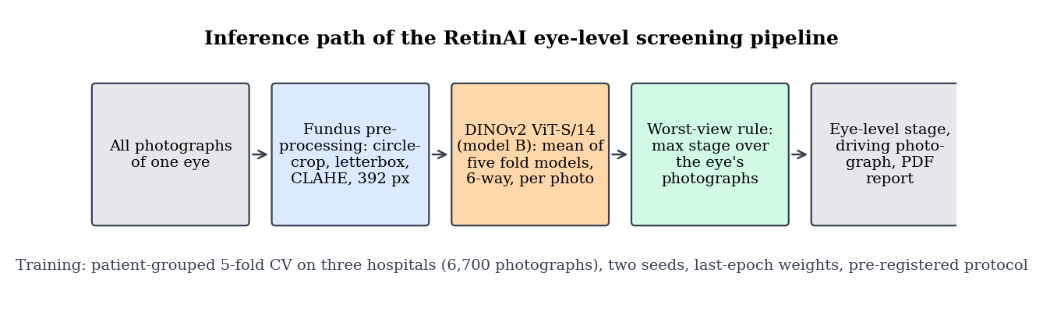
RetinAI system architecture: the inference path from the photographs of one eye to its stage
Preprocessing. Each photograph is circle-cropped to the fundus, padded to a square (letterbox), contrast-enhanced with CLAHE, and resized to 392 px. For training, this stage runs once per image and the result is cached at 768 px, so that each Kaggle session reads pre-processed files rather than repeating the work 20 times.
Per-photograph classifier. A vision transformer, ViT-S/14 with four register tokens (21.8 M parameters, 12 layers, width 384, 6 heads), takes the 392 px photograph as 784 patches, averages the patch outputs, and passes them through dropout (0.3) and a linear layer with six outputs: normal, stage 1, stage 2, stage 3, stage 4/5 and AP-ROP. The same head sits on the EfficientNetV2-S baseline. In the application the selected model B is served as the mean of the probabilities of its five cross-validation fold models (seed 42), so that no single fold’s validation infants are missing from what the served model has learnt.
Worst-view rule. The eye’s stage is the maximum predicted stage over its photographs; the photograph that attains it is the driving photograph, and its probability vector is the eye’s probability vector. This is the reading rule of ICROP: an eye is staged by its most advanced finding.
Report. The eye summary, the per-photograph table and the driving photograph are rendered into a PDF.

4.2 Design Alternatives and Selection
Three families of design were considered for the eye-level requirement and the "different model" requirement.
Learned aggregation versus the worst-view rule. A gated-attention multiple-instance model that learns how to combine the photographs of an eye was built and tested on frozen features before the main design. It tied the worst-view rule in cross-validation ($−0.006$ QWK) and lost on the held-out hospital’s eyes ($−0.080$ QWK, interval excluding zero), because the only multi-photograph training bags are mostly normal Ostrava sessions, so the learned combiner under-calls disease. The worst-view rule was selected: it needs no eye-level training data, it is the clinical rule, and it is explainable (the driving photograph is shown).
Backbone. The candidates were a retina-pretrained transformer (RETFound-Green), a natural-image-pretrained transformer of identical architecture (DINOv2 ViT-S/14), larger transformers (RETFound ViT-L, DINOv2 ViT-B), and classical CNNs (VGG, ResNet). A frozen-feature spike showed RETFound-Green with CLAHE as the best frozen encoder (0.859 CV QWK against 0.796 for frozen ImageNet EfficientNet) but behind the fine-tuned EfficientNet (0.917), so the lever is fine-tuning, not the encoder alone. Paper 1 had already shown five backbones within 0.028 macro-F1 of one another. The ViT-S pair was selected because it isolates the one variable not yet tested in the literature, the pre-training domain, with every other factor equal; larger models were rejected on Kaggle’s time limits and because the question is about domain, not size; VGG and ResNet were rejected as older designs that paper 1’s benchmark had already placed in the same band.
Training unit. For the Ostrava cohort, whose labels are per examination session, two options exist: per-image cross-entropy against the stamped label (the baseline) or a per-session loss that pools the frames. Log-sum-exp pooling of the frames’ logits with $K=8$ frames per session was selected over mean or attention pooling, because it trains all frames while letting the most abnormal frame dominate, which matches how the session label was produced.

4.3 Software and Algorithm Design
Figure 4.1 is implemented as five modules: preprocessing (transforms, cache, normalisation per arm), architectures (backbone construction, strict loading of RETFound-Green weights), optim (per-layer learning-rate groups), train_utils (training loop, bag loss, adaptation), and inference (eye-level route). The experiment side consists of the Kaggle kernel, a pusher that rewrites the kernel’s knobs, a collector that validates downloaded runs, and a scorer that computes every protocol metric from saved predictions. The eye-level inference algorithm is:
- for each photograph $i$ of the eye, compute the probability vector $p_{i}∈R^{6}$ and the predicted class ${\hat{y}}_{i}=arg\max_{c}p_{i,c}$;
- the eye’s stage is $\hat{y}=\max_{i}{\hat{y}}_{i}$ on the ordered stage axis, with AP-ROP reported when it is any photograph’s argmax;
- the driving photograph is $i^{⋆}=arg\max_{i}({\hat{y}}_{i},p_{i,{\hat{y}}_{i}})$, ties broken by its probability, and the eye’s probability vector is $p_{i^{⋆}}$;
- the any-ROP score of the eye is $\max_{i}(1−p_{i,\text{normal}})$, compared with the pre-registered threshold.

4.4 Mathematical Model and Design Calculations
Loss. Each arm minimises class-balanced cross-entropy with label smoothing. With $n_{c}$ training images of class $c$ and $β=0.999$, the class weight is the inverse effective number of samples,
wc=1−β1−β nc, L=−c​wc yclogpc,
where $\tilde{y}$ is the one-hot label smoothed by $ε=0.05$. Rare stages (89 stage-4/5 images against 3,837 normal) therefore count more per image.
Examination-level loss (model D). For an Ostrava session with frames $1..K$ and per-frame logits $z_{k}$, the session logit is the log-sum-exp pool
$$z_{\text{session}}=τlog\sum_{k=1}^{K}{exp}(z_{k}/τ), τ=1,$$
and Equation [eq:cb] is applied to it with the session’s label. A one-frame session reduces exactly to per-image cross-entropy.
Optimiser. AdamW with weight decay 0.05, a one-cycle cosine schedule with 10% warm-up, and layer-wise decay: layer $ℓ$ of the 12 transformer layers trains at $η λ^{13−ℓ}$ with $λ=0.8$, so the patch embedding trains at ${0.8}^{13}η≈0.055η$ and the head at $η$. The peak $η$ was chosen per arm by a probe on an inner split of fold 0 (never on fold 0’s validation rows): $2×{10}^{−4}$ for RETFound-Green and ${10}^{−4}$ for DINOv2, keeping the default unless a candidate beat it by more than 0.03 macro-F1.
Compute budget. At 30 photographs/s, one fold of 2,460 training images for 20 epochs takes $2,460×20/30≈1,640$ s of training plus validation and dev scoring, about 33 min measured; five folds and the site fold fit one 8 h kernel with margin (3.3 h measured). At 518 px the cost is $(518/392)^{4}≈3.0×$ in attention and 2.3$×$ measured, so model G was split over two kernels. In the v4 round each model and seed also ran two LOSO folds, of which the Ostrava fold alone takes about 50 min, so H and I used two kernels per seed (five cross-validation folds; site fold and two LOSO folds).
Statistics. All intervals are percentile bootstrap intervals over 2,000 resamples of infants (eyes of one infant kept together). A paired difference between two arms is computed on the same resample. The minimum detectable eye-level QWK difference at 80% power on the 230-eye locked half is about 0.08, which was stated in the protocol before any model was trained.

4.5 The v4 Round: Data Audit, Training Pool and Recipe
After the seven models of the v3 round had been scored, the protocol’s fifth amendment (31 October 2026, before any v4 run or locked scoring) fixed one final improvement round on the selected model B. Models A–G were frozen. Two levers were left untested by v3: the training data of the video-derived Ostrava cohort, and the training recipe. The round tests each separately: model H is B’s recipe on a cleaned training pool, and model I adds a regularising recipe on the same pool. Validation rows, folds and the duplicate exclusion are unchanged, so every model is scored on the same 6,686 photographs.
Frame quality, judged per camera. Ostrava’s frames come from three camera models whose sharpness and exposure differ systematically. The first design took its thresholds from the two single-photograph hospitals (ROP-VL and Shenzhen, whose photographs were already selected by clinicians), including a minimum field of view. The audit rejected it before the pool was built: the field-of-view minimum is a property of the camera’s aperture, and it failed 903 of the 911 frames of one camera, among them all 125 Ostrava stage-3 frames. The selected design judges each frame against its own camera: a frame fails if it is empty, if its sharpness (variance of the Laplacian) is below its camera’s 10th percentile, or if its mean luminance is outside its camera’s 2.5th–97.5th percentiles. ROP-VL and Shenzhen are not filtered, because their haze is often the disease.
Cap re-ranking and floor. The per-infant caps are unchanged (two normal frames, twenty frames per stage), but within each infant and class the kept frames are the passing frames with the highest sharpness rank, instead of the first by file name; an infant and class with fewer than two passing frames keeps its two best, so no infant loses a class.
Near-duplicates. Every pair of pool photographs at a 256-bit difference-hash (dHash) distance of at most 4 was checked by the mean absolute grey-level difference of the two images at 256$×$256 pixels; both members of a cross-fold pair with a difference of at most 5 grey levels leave the training rows. The hash alone was rejected, because it matched distinct Ostrava retinas (9–47 grey levels apart) as well as true copies (about 3 grey levels apart within a session). Pairs with different labels go to a list for clinician review; nothing is relabelled.
Recipe of model I. Every value was fixed in the amendment and none was tuned: an exponential moving average (EMA) of the weights, evaluated and saved in place of the trained weights; one epoch in which only the classification head trains; rotation by up to $±{180}^{∘}$ (a fundus has no upright orientation); a random crop of 85–100% of the image; gamma correction and pixel noise; a Fourier amplitude swap that gives a photograph the low-frequency colour and illumination of another photograph in the batch; and label smoothing 0.10 instead of 0.05. With weights $θ_{t}$ after optimiser step $t$ and decay $d=0.999$,
$${\overset{‾}{θ}}_{t}=d {\overset{‾}{θ}}_{t−1}+(1−d) θ_{t}, \text{share of the initial weights after }S\text{ steps}=d^{ S},$$
which is about 5% after the roughly 3,060 steps of a cross-validation fold. For the Fourier swap, a photograph $x$ with discrete Fourier transform $F(x)=A e^{iφ}$ and a batch partner with amplitude $A^{′}$ become
$$\hat{x}=F^{−1}​\left(\hat{A} e^{iφ}\right), \hat{A}(u,v)=\left\{\begin{matrix}A^{′}(u,v), & |u|≤1, |v|≤1, \\ A(u,v), & \text{otherwise,}\end{matrix}\right.$$
applied with probability 0.5: the image keeps its own phase, which carries the vessels and the ridge, and takes the partner’s coarsest colour and illumination.
Leave-one-hospital-out guard. A cross-validation gain could come from fitting the three training hospitals more closely. Each candidate is therefore also trained on two hospitals and scored on every photograph of the third, once for each hospital (leave-one-source-out, LOSO). Stage 4/5 exists only in ROP-VL, so the ROP-VL fold scores it with no training example.
Adoption rule. With $Q$ the cross-validation pooled out-of-fold QWK and $L$ the mean LOSO QWK over the three held-out hospitals,
$$\begin{aligned}&\text{adopt I if }Q_{I}−Q_{B}≥+0.010\text{ and }L_{I}≥L_{B}−0.010; \\ &\text{else adopt H under the same two conditions; else B stays.}\end{aligned}$$
The held-out hospital’s development half is reported but does not enter the rule, and the paired contrasts H$−$B, I$−$B and I$−$H join the pre-registered set.

4.6 Safety Sustainability Ethics and Cost Decisions
The output is labelled as decision support and never as a diagnosis; the driving photograph is shown so a reader can check the decision. The operating threshold for any-ROP screening was fixed in advance at 90% sensitivity on cross-validation and is reported, not tuned, at the new hospital. All images are from public, de-identified datasets used under their licences; file names that encoded clinical attributes were replaced before any upload. The whole project ran on free Kaggle GPUs, about 45 GPU-hours in total (about 25 for the v3 round, 18.5 timed for models H and I and about 1.5 budgeted for B’s LOSO folds), and on a laptop; its cost was zero and its energy use is that of about one day of a single T4 GPU. No funding was received and the team declares no conflicts of interest.

5 Implementation and Integration

5.1 Development Environment and Tools
The code is a Python 3.14 repository on GitHub (private), with PyTorch and the timm library for models, scikit-learn for metrics, pandas and NumPy for data, Flask for the web application and ReportLab for the PDF. Training ran in Kaggle kernels on Tesla T4 GPUs (16 GB) with CUDA; CPU work (preprocessing cache, scoring, figures) ran on an Apple M5 laptop. Development followed a reviewed, test-first process: every task had a written brief, an implementer, a code review with written findings, and a fix round; 400+ automated tests run before each commit. The repository, the protocol and the result files are version-controlled; every figure in this report is produced by a committed script from committed result files.

5.2 Subsystem Implementation
Data pipeline. Fundus preprocessing was run once over all 7,363 photographs (6,700 pool plus 663 development half) and cached at 768 px as PNG under anonymised paths; a gate compared the baseline model’s predictions from the cache with those from the originals (argmax agreement 99.2%, $|Δ$QWK$|$ 0.0006, PSNR 52.9 dB) before the cache was used. The 14 exact-duplicate images found in the pool by the paper-1 audit are dropped from every training set and every metric.
Model code. The two transformer arms are built through one function that sets the input size to 392 px, average pooling and a fresh six-way head; RETFound-Green’s weights are loaded strictly onto the backbone keys, with any non-head mismatch raised as an error. Normalisation is read from the configuration in both the training and the serving path (0.5/0.5 for RETFound-Green, ImageNet statistics for DINOv2). Per-layer learning-rate groups are built from the layer index and logged at the first step.
Examination-level loss and adaptation. For model D a batch sampler alternates image batches (16 photographs) with session batches (2 sessions $×$ up to 8 frames); the frames’ logits are pooled by Equation [eq:lse] and scored with the same loss object. For model F an exponential-moving-average teacher (decay 0.99) is updated after each step; each step adds 16 unlabelled photographs of the new hospital, read from a manifest with the label column dropped before anything parses it, and penalises the squared difference between the teacher’s prediction on a weakly augmented view and the student’s on a strongly augmented view wherever the teacher is at least 90% confident. The saved weights are the teacher’s.
Training on Kaggle. One kernel trains one arm and one seed: five folds plus the site fold (Shenzhen held out), 20 epochs each, batch 16, mixed precision, gradient clipping at 1.0, strong augmentation and site-randomising colour augmentation, last-epoch weights. A launch check verifies that the cache’s preprocessing flags match the configuration and that every manifest row has a cached file; a wall-clock guard stops before the 8 h limit. A pusher rewrites the kernel’s knobs (arm, seed, folds, learning rate, variant) by line-anchored substitution that must match exactly one line, and refuses a learning rate other than the probe’s choice. Each kernel saves per-fold validation predictions and development-half predictions as compressed arrays.
Collector and scorer. The collector downloads a kernel’s output and refuses it unless the configuration matches the kernel’s identity, each fold trained on its de-duplicated manifest, validation labels align row-for-row with the committed fold file and development predictions are in manifest order; it merges a run that was split over two kernels. The scorer computes every protocol metric from the saved predictions only (it raises if PyTorch is imported), runs a reproduction check on the baseline first, and writes one JSON with per-seed, pooled, selection-rule, paired-contrast and confusion blocks.
The v4 round. The audit script computes sharpness, luminance and emptiness for every pool photograph, derives each Ostrava camera’s thresholds from that camera’s own frames, and writes the audit report (failing frames by camera, class and reason; near-duplicate pairs by distance, kind and pixel difference) before the pool builder runs; the pool builder then writes the v4 fold files, whose validation rows are checked to be identical to v3’s, and a pool summary that was committed before any kernel was pushed. The recipe of model I is implemented in the shared training code and switched on only by its configuration: the EMA reuses the adaptation model’s teacher class; the Fourier swap runs on the normalised batch, where the zero-frequency term carries the sign of the channel mean, so the swap copies the partner’s complete zero-frequency term and only the amplitudes of the other eight low-frequency entries, which a unit test shows to equal the swap done in pixel space. Two issues found in the code review before any v4 kernel were fixed and disclosed in a dated pre-run note: a class with no training rows in a fold (stage 4/5 in the ROP-VL leave-out fold) had received the largest class weight, because its count was clamped to one, and now receives zero weight, which leaves every v3 weight bit-identical; and the EMA’s start from the pre-trained weights, which leaves about 5% of them in the final average, was recorded rather than changed. Each v4 model and seed ran in two kernels (“-a”: five cross-validation folds; “-b”: site fold and the two LOSO folds), and B’s two LOSO folds ran in one further kernel per seed.
Web application. The /predict_eye route accepts up to 16 photographs (10 MB each, 160 MB per request, JSON 413 beyond that), requires the eye’s context, runs the per-photograph model (model B, the mean of the probabilities of its five seed-42 fold models), applies the worst-view rule, and returns the eye summary; /report validates the summary and renders the PDF with the eye block on its second page.

5.3 System Integration
The interfaces between subsystems are files with checked formats: the fold manifests (CSV with image path, label, split, patient, source), the cache (PNG files at anonymised paths plus a stamp of the preprocessing flags), the kernel’s output (summary JSON plus per-fold arrays), the collected runs (one folder per arm and seed), the scores JSON and the report-data JSON. Integration tests cover each interface: the cache gate, the kernel-substitution tests, the collector’s alignment checks on synthetic kernel outputs, the scorer’s end-to-end test with the baseline’s predictions posing as a new arm, and the route tests with demo photographs. The faults found and resolved during integration are listed in Section 5.5.

5.4 Prototype and Operating Procedure
To grade one eye: start the application (python webapp/app.py), open the screening page, choose the eye (left or right) and the context, add its photographs, and submit. The page shows each photograph’s stage and probability, the eye’s stage, and marks the driving photograph; the "Download report" button returns the PDF. The application refuses photographs that are not gradable fundus images and reports a staging-unavailable error if the model is not loaded. For training and scoring, the procedure is: build the cache; push a kernel with the pusher; collect the output with the collector; run the scorer; run the report-data and figure scripts. Each step is one command and is documented in the repository.
The served model. The application serves the selected model B as the mean of the probabilities of its five seed-42 fold models, each trained on four fifths of the pool, so the served model has seen every training infant. Scored on the held-out hospital’s development half with the protocol’s own scoring code, this exact configuration reaches an eye-level QWK of 0.752 (95% CI 0.670–0.822), accuracy 63.9%, macro-F1 0.568 and stage-1 recall 0.51 on 230 eyes, in line with B’s pooled 0.756; the numbers are generated by scripts/rop_v3_report_tables.py and are descriptive, like every development-half number.

5.5 Implementation Challenges and Changes
- Slow reads from the Kaggle mount. The first smoke run trained at 2.5 photographs/s because it read the cache lazily from the mounted dataset. Fix: copy only the files the launch needs to local disk with 32 threads (50 s for 7,363 files); throughput rose to 30 photographs/s.
- JPEG cache failed the agreement gate (98.9% against the 99% threshold). Diagnosed as chroma subsampling; the cache was rebuilt as PNG at 768 px (99.2%).
- Average pooling renamed a layer in the transformer, so a strict weight load would have failed silently on the norm layer. Fix: keep the final norm in the backbone and load strictly.
- Duplicates were not removed from training in the first kernel version although the protocol said so. Found before the main runs; fixed and recorded as a protocol amendment, with the probe runs that had used them disclosed.
- Temperature scaling was fitted at the photograph level while the calibration endpoint is per eye. Fixed to fit on eye-level driving-photograph vectors and recorded as Amendment 1.
- The adaptation model’s confidence mask stayed closed in its 2-epoch test because the teacher had not yet become confident; an 8-epoch test confirmed the mask opening. No setting was changed, and the small final mask rate (about 8%) is reported as a result.
- Kaggle silently drops a third concurrent kernel, so a queue script runs two at a time and confirms each push before waiting on it.

5.6 Bill of Materials and Actual Cost
The project is software-only. Table 5.1 lists what was used and what it cost.
Resources used and actual cost
Item | Quantity and source | Cost (INR)
Kaggle GPU time (T4) | about 45 GPU-hours over four weeks: 24 main sessions (14 in v3, 10 in v4), 7 probes, smoke runs | 0
Laptop (Apple M5) | team member’s own, for preprocessing, scoring and writing | 0
Public datasets | Ostrava/RIDIRP, ROP-VL, Shenzhen, Multi-View ROP; licences respected | 0
Pre-trained weights | DINOv2 (Apache-2.0), RETFound-Green (non-commercial) | 0
Software | Python, PyTorch, timm, scikit-learn, Flask, ReportLab, Tectonic: all open source | 0
Hosting of the demo | local machine | 0
Total |  | 0
Running cost is that of one laptop for inference (about 1 s per photograph on CPU) and nothing for the trained models. Maintenance cost is the time to re-run the test suite and the scorer, both of which are one command.

6 Testing and Validation Methodology

6.1 Test Plan and Acceptance Criteria
Table 6.1 lists the tests, each linked to a requirement of Chapter 3, with its acceptance rule fixed before the test was run. The model tests (T4–T7) are governed by the pre-registered protocol (Appendix 9), which was committed on 19 October 2026 before any new model was trained and amended five times, each amendment dated and committed before the experiment it governs.
Test plan and acceptance criteria
Test | Requirement | Procedure | Acceptance criterion
T1 | R1, R2, R3 | Automated route tests with demo photographs, bad files, oversize uploads, missing context | All tests pass; 413 and 422 returned as JSON
T2 | R4 | Collector on synthetic and real kernel outputs | Refuses misaligned, duplicate-trained, wrong-lr or probe runs; accepts valid ones
T3 | R5, R6 | Scorer reproduction check; guard and AST tests | Baseline numbers reproduced to 3 dp; no code path reads the locked half
T4 | P1 | 5-fold patient-grouped CV, two seeds, pooled OOF QWK | QWK $≥0.80$ with CI
T5 | P2, P3 | Development half of the held-out hospital, 10 prediction lists per arm, eye level | QWK $≥0.75$; stage-1 recall $>0.40$
T6 | P4 | Kaggle kernel wall-clock from logs | Each session $<8$ h
T7 | P5 | Timed /predict_eye request with 16 photographs on CPU | $<10$ s
T8 | P6, P7 | Full test suite; re-run of scorer and figure scripts | All tests pass; outputs identical to committed files

6.2 Experimental Setup and Instruments
Training: Kaggle kernels, Tesla T4 (16 GB), PyTorch with automatic mixed precision, batch 16, 20 epochs, seeds 42 and 1337; the GPU model is logged at launch and recorded in every run’s summary. Scoring and statistics: laptop CPU, NumPy and scikit-learn, 2,000 bootstrap replicates with seed 42. The configuration of every run (model, preprocessing, optimiser, augmentation) is saved beside its predictions and reproduced in Appendix 10. There is no measurement instrument in the physical sense; the uncertainty of every metric is the clustered bootstrap interval, and the between-seed difference is reported as a second measure of variability.

6.3 Datasets and Test Conditions
Figure 6.1 and Table 6.2 describe the data. The cross-validation pool holds 6,700 photographs of 1,528 infants from three hospitals: Ostrava (Czech Republic; 4,285 photographs, 148 infants, video frames with one label per examination session), ROP-VL (1,675 photographs, 983 infants, one label per photograph with an eye-examination identifier) and Shenzhen (740 photographs, 397 infants, one label per photograph). Frames of one infant never cross a fold. Within Ostrava, at most two normal frames and twenty frames per stage are kept per infant, so that one long video session does not dominate. The six classes are normal (3,837), stage 1 (577), stage 2 (959), stage 3 (620), stage 4/5 (89) and AP-ROP (618); 76% of the AP-ROP photographs come from one Ostrava infant, which is disclosed wherever AP-ROP is scored.
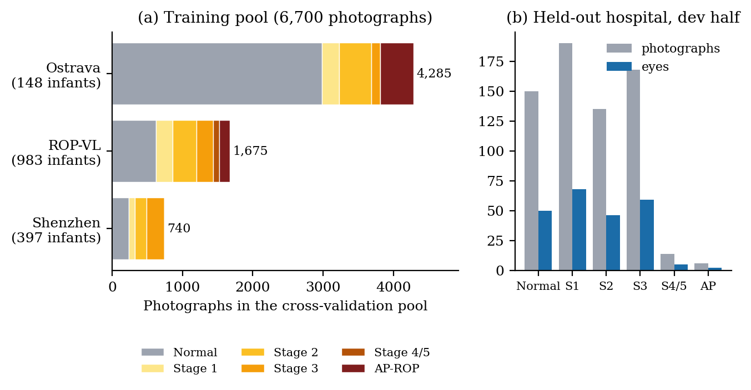
The data: (a) the cross-validation pool by hospital and stage; (b) the held-out hospital’s development half, photographs and eyes by stage
Datasets, units and roles
Cohort | Photographs | Infants | Label unit (scored at) | Role
Ostrava | 4,285 | 148 | examination session (both eyes) | CV pool
ROP-VL | 1,675 | 983 | photograph; eye-examination unit | CV pool
Shenzhen | 740 | 397 | photograph | CV pool; held out in the site fold
Multi-View, dev half | 663 (230 eyes) | 116 | eye (three views per eye) | held-out hospital, descriptive
Multi-View, locked half | 661 (230 eyes) | 116 | eye | pre-registered primary endpoint; unopened
The held-out hospital, Multi-View ROP, contributes to no fold and uses a different camera. Its 1,324 photographs are split by infant into a development half, used for the descriptive external results in this report, and a locked half opened once for the EfficientNet baseline in August 2026 and reserved for one further scoring of all arms after the guide’s approval. The development half has 50 normal, 68 stage-1, 46 stage-2, 59 stage-3, 5 stage-4/5 and 2 AP-ROP eyes; the last two classes are too few to evaluate there.
Each training session trains on about 2,460 photographs (one fold’s training rows after the caps and the duplicate exclusion) and is evaluated on the fold’s 1,252–1,691 held-out photographs; the out-of-fold predictions of the five folds are concatenated to score the whole pool once, so every photograph is scored by a model that never saw its infant.

6.4 Test Procedures and Repeated Trials
Every trained arm was run twice end to end with different random seeds (42 and 1337), each run being five folds plus the site fold, giving 10 cross-validation models and 12 trained models per arm, 14 training sessions in the v3 round. The v4 round added models H and I (five folds, the site fold and two LOSO folds per seed, in two kernels per seed) and B’s two LOSO folds (one kernel per seed): 10 further sessions, 24 in total. The learning rate for each transformer arm was chosen by a probe on an inner patient-disjoint split of fold 0’s training rows (three candidates, one seed), never on fold 0’s validation rows. Development-half predictions are made by all five fold checkpoints of each seed, giving 10 prediction lists per arm, whose metrics are averaged inside each bootstrap replicate. Each new model was first run for two epochs on the inner split as a smoke test (throughput, memory, no NaN, development scoring) before its full sessions were launched. Every kernel’s log, summary and predictions were downloaded and checked by the collector; no run was discarded or re-run on the basis of its score.

6.5 Performance Metrics and Analysis Method
The primary metric is quadratic weighted kappa on the five-class map, with AP-ROP folded onto stage 4/5 on both sides,
QWK=1−i,j​wijOiji,j​wijEij, wij=(i−j)2(k−1)2,
where $O$ is the confusion matrix, $E$ its expectation under independence and $k=5$; a miss by two stages costs four times a miss by one. Secondary metrics are accuracy, balanced accuracy, macro-averaged precision, recall and F1 over the classes present, unweighted kappa, one-versus-rest AUC, any-ROP AUC and average precision, and per-class precision, recall and specificity. Calibration is reported as expected calibration error, Brier score and negative log-likelihood before and after one temperature $T$ fitted on cross-validation. The any-ROP operating point is the largest threshold on the eye’s score $\max_{i}(1−p_{i,\text{normal}})$ that reaches 90% sensitivity on cross-validation, applied unchanged at the new hospital.
Uncertainty: 95% percentile intervals from 2,000 bootstrap resamples of infants; paired differences between arms are computed on the same resample and reported with their interval; an interval that crosses zero is read as no evidence of a difference. The selection rule, fixed in advance, is the cross-validation pooled out-of-fold image QWK, computed once per arm. The held-out hospital’s development half is reported as descriptive because it was used for design decisions in the first version; model F, which saw its photographs without labels, is marked as transductive. Failed trials are reported: the ordinal decoder’s cross-validation drop and the adaptation model’s closed confidence mask are both in Chapter 7.

6.6 Fault Safety and Robustness Tests
Software faults are covered by the test suite: malformed uploads, oversize requests, missing context, an unloaded model, misaligned predictions, a kernel that trained on excluded duplicates or at the wrong learning rate, a configuration that disagrees with its kernel, and any attempt to read the locked half. Robustness of the model was tested in four ways that the protocol allows: the site fold (Shenzhen held out entirely from training), the two further leave-one-source-out folds of the v4 round (Ostrava and ROP-VL held out in turn), the held-out hospital with a different camera, and the per-fold variability across the five folds and two seeds (Figure 7.10). The operating threshold and the temperature were tested for transfer by applying the cross-validation values unchanged at the new hospital. No test was run on patients; the data are retrospective, public and de-identified.

7 Results and Discussions

7.1 Measured Results
All numbers in this chapter are read from the committed scores file (results/rop/v3/v3_scores.json, commit b827cce) and the report-data file derived from it; every figure is drawn by a committed script from those files. Pooled numbers average both seeds; intervals are 95% infant-clustered bootstrap intervals.

7.1.1 The nine models
Table 7.1 gives the headline metrics and Figure 7.1 the QWK of every model with its interval, in cross-validation and at the held-out hospital. The pre-registered selection rule (cross-validation QWK) selects model B, DINOv2, at 0.825; the baseline scores 0.816. Across the nine models cross-validation QWK spans 0.794 to 0.825; at the held-out hospital the eye-level QWK values span 0.744 (F) to 0.776 (I) and every one lies inside the baseline’s interval (0.680–0.822).
Headline metrics of the nine models (pooled over two seeds)
Model | CV QWK (95% CI) | CV acc. | CV macro-F1 | Eye QWK at new hospital (95% CI) | Eye acc. | Eye macro-F1
A RETFound-Green & 0.794 (0.664–0.915) & 0.758 & 0.643 & 0.774 (0.707–0.828) & 0.632 & 0.563
$​^{†}$ model F saw the held-out hospital’s photographs, without labels, during training; its new-hospital numbers are transductive.
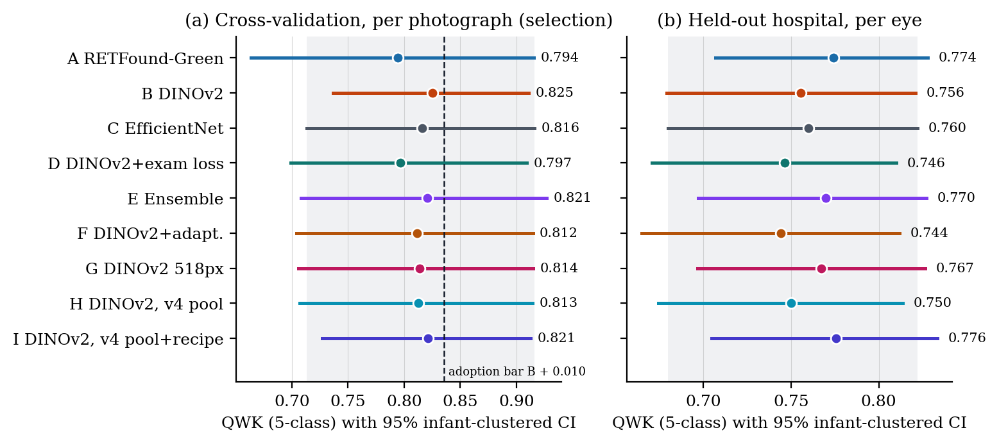
QWK of the nine models with 95% infant-clustered intervals; the shaded band is the baseline’s interval, the dashed line the v4 adoption bar (B $+$ 0.010)

7.1.2 The v4 round: data audit and recipe
The audit of Section 4.5 found 585 of the 4,285 Ostrava frames below their camera’s quality thresholds (429 for sharpness, 108 too dark, 108 too bright; a frame can fail more than one test); 584 left the training candidates and one was kept by the two-frame floor. Within the caps, 439 of v3’s 715 Ostrava training rows were replaced by 418 sharper frames, and the v4 training pool holds 3,083 photographs against 3,112 (stage 1: 497 against 515). Of 109 photograph pairs within dHash distance 4, the pixel check confirmed 72 as true duplicates; the cross-fold rule removed 8 photographs, all already among the 14 exact duplicates, so in practice it changed no trained-on photograph, and 14 pairs with different labels went to the clinician list.
Table 7.2 gives the adoption rule as scored. Neither v4 model reached the margin: I is 0.004 and H 0.012 below B in cross-validation, where $+0.010$ was required, although both passed the LOSO guard. Model B stays selected. The paired intervals confirm it: I$−$B is $−0.004$ ($−0.015$ to $+0.007$) and H$−$B $−0.013$ ($−0.031$ to $+0.009$), both wholly below the bar.
The v4 adoption rule (Amendment 5c) as scored; differences of the four-decimal selection-table values
Model | CV QWK | $Δ$ vs B | Needs | Mean LOSO | $Δ$ vs B | Needs | Outcome
I DINOv2, v4 pool + recipe & 0.821 & $−0.0038$ & $≥+0.010$ & 0.839 & $+0.0054$ & $≥−0.010$ & not adopted
Table 7.3 and Figure 7.2 give the leave-one-source-out folds. The three models are close on each held-out hospital; the Ostrava fold has intervals 0.40–0.45 wide because its 4,285 photographs come from only 148 infants, and I is 0.020 below B when Shenzhen is held out. The ROP-VL fold trains with no stage-4/5 photograph and scores none of them correctly, which is why stage 4/5 must come from more than one source before any model can be trusted on it at a new hospital.
Leave-one-source-out QWK (5-class) with 95% infant-clustered CI, both seeds pooled
Model | Pool | Shenzhen held out | Ostrava held out | ROP-VL held out | Mean
B DINOv2 & v3 & 0.962 (0.953–0.971) & 0.740 (0.398–0.845) & 0.799 (0.771–0.827) & 0.834
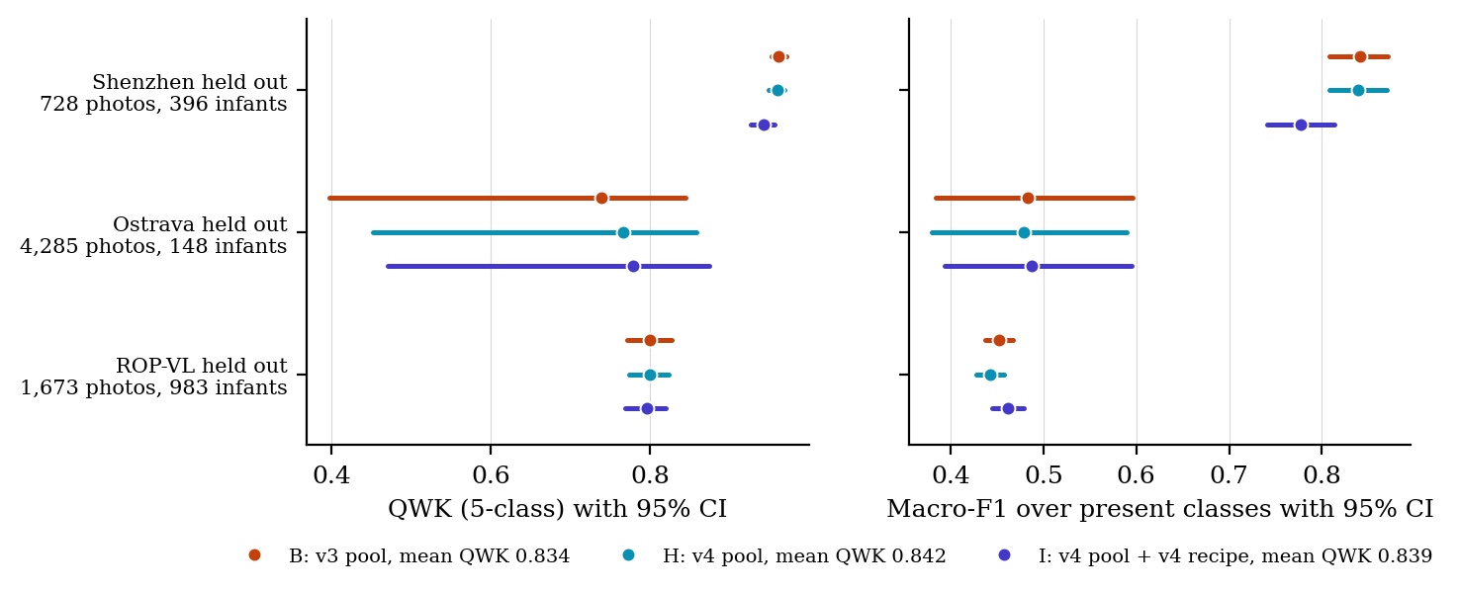
Leave-one-source-out folds of models B, H and I: QWK and macro-F1 on every photograph of the held-out hospital
At the held-out hospital, which does not enter the rule, model I scored best of all nine models (0.776, 95% CI 0.705–0.834): I$−$B is $+0.020$ ($+0.003$ to $+0.041$) and I$−$H $+0.026$ ($+0.006$ to $+0.046$), while H$−$B is $−0.005$ ($−0.015$ to $+0.003$). The gain is in QWK only (eye-level macro-F1 I$−$B $−0.005$, $−0.057$ to $+0.033$) and comes from stage 2 (recall 0.60 against 0.55) and from fewer stage-1 eyes called normal. It is descriptive: the development half has now been examined for nine models, and the gain is a quarter of the 0.08 difference that even the locked half can detect. Model I is also the best calibrated as trained (Section 7.1.6).
The cost of the v4 changes shows in cross-validation macro-F1 (I$−$B $−0.035$, $−0.053$ to $−0.001$) and in AP-ROP recall, which falls from 0.389 (B) to 0.306 (H) and 0.269 (I). The fall sits entirely in fold 0: 470 of its 476 AP-ROP validation photographs are frames of one Ostrava infant, scored by fold-0 models that train on no Ostrava AP-ROP frame. There AP-ROP recall is 0.246, 0.142 and 0.101 for B, H and I (the two seeds of B alone differ by 0.160), while on folds 1–4, whose AP-ROP photographs come from ROP-VL infants, the three models reach 0.866, 0.859 and 0.835. Both pools hold the same 168 AP-ROP training photographs. The drop is therefore a label-unit artefact: one examination label stamped on 470 near-identical frames, read slightly differently by models whose other training frames changed.

7.1.3 Paired differences
Figure 7.3 shows the pre-registered paired contrasts. At the held-out hospital, A$−$C is $+0.014$ (95% CI $−0.012$ to $+0.048$), B$−$C is $−0.004$ ($−0.038$ to $+0.030$), E$−$C is $+0.010$ ($−0.012$ to $+0.040$), G$−$B is $+0.012$ ($−0.005$ to $+0.032$) and H$−$B is $−0.005$ ($−0.015$ to $+0.003$): these intervals cross zero. Two contrasts exclude zero below it, both small: D$−$A is $−0.028$ ($−0.048$ to $−0.011$) and F$−$B is $−0.011$ ($−0.022$ to $−0.002$). Three lie above it: I$−$B $+0.020$ ($+0.003$ to $+0.041$), I$−$H $+0.026$ ($+0.006$ to $+0.046$) and A$−$B $+0.018$, whose lower bound is 0.000. In cross-validation E$−$A is $+0.026$ ($+0.008$ to $+0.045$); every other cross-validation contrast crosses zero.
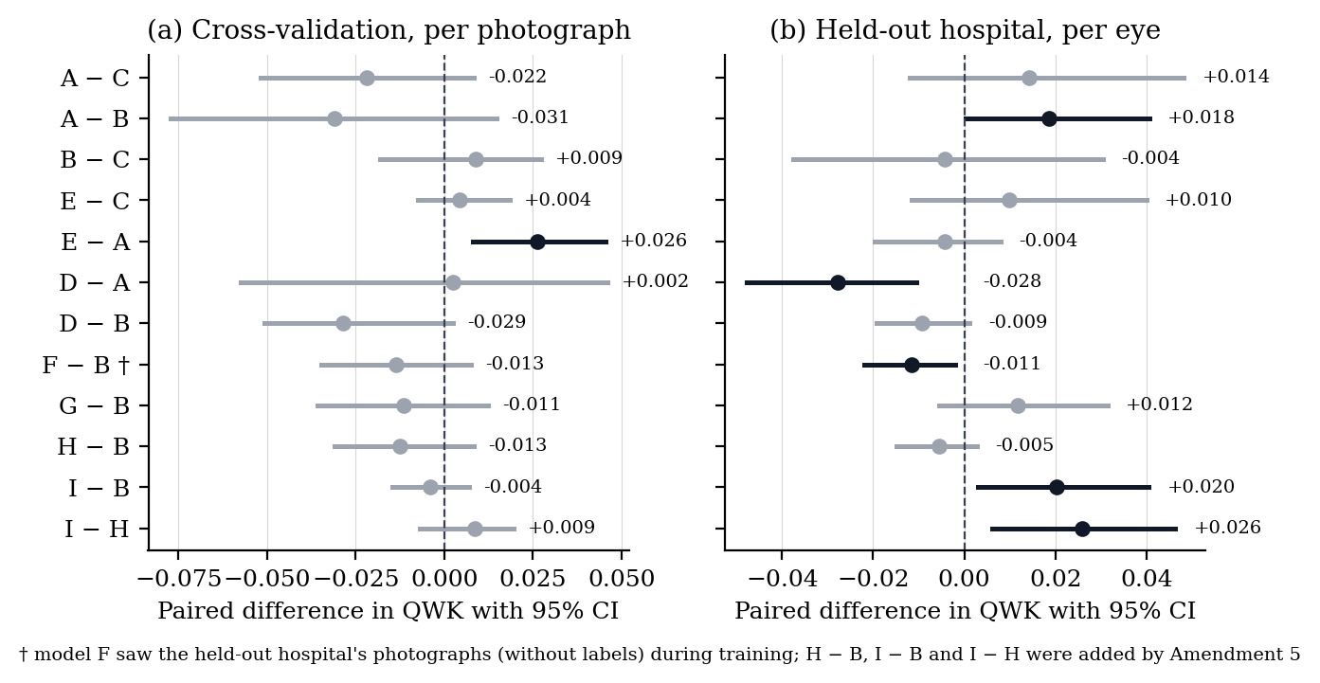
Paired differences in QWK between models, both models scored on the same resampled infants; a bar crossing zero is a tie; H$−$B, I$−$B and I$−$H were added by Amendment 5

7.1.4 Stage by stage
Figure 7.4 gives recall by stage and Table 7.4 the per-class metrics of the selected model. Stage 1 is where the transformers differ from the baseline: at the held-out hospital, stage-1 eye recall is 0.52 for A, 0.51 for B, G and I and 0.50 for H, against 0.40 for C; in cross-validation 0.57–0.61 for A, B, F, G and H against 0.50 for C. Model I is the exception in cross-validation (0.49): its recipe, not its pool, costs stage-1 recall there, since H shares the pool and keeps 0.57. The baseline is better on AP-ROP at both levels, and the models are otherwise within a few points of one another.
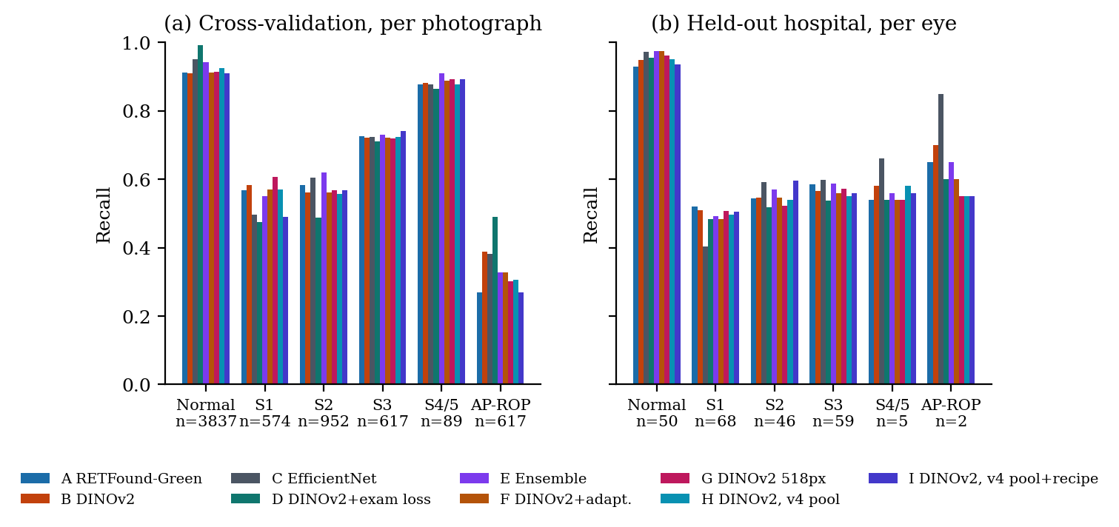
Recall by stage for every model, in cross-validation and at the held-out hospital
Per-class metrics of model B (DINOv2), pooled over seeds
 | Cross-validation, per photograph |  |  |  |  | Held-out hospital, per eye
Stage | $n$​ | Prec. | Recall | F1 | AUC | $n$​ | Prec. | Recall | F1 | AUC
Normal & 3,837 & 0.96 & 0.91 & 0.93 & 0.98 & 50 & 0.62 & 0.95 & 0.75 & 0.95

7.1.5 Confusion matrices
Figure 7.5 shows where the errors are for the selected model. In cross-validation, 332 normal photographs are called stage 1 and 251 stage-2 photographs are called stage 1; AP-ROP photographs are spread over stages 1 to 3. At the held-out hospital, per eye, 24 of 68 stage-1 eyes are called normal and 11 of 46 stage-2 eyes are called stage 1; serious errors (two or more stages) are rare. Model I’s matrices (Appendix 10) call 22.4 stage-1 eyes normal on average and keep more stage-2 eyes in their own class (27.4 against 25.1). The baseline’s matrices (Appendix 10) show the same 24 stage-1 eyes called normal per eye, and in cross-validation fewer normal photographs called stage 1 (163 against 332) at the cost of lower stage-1 recall.
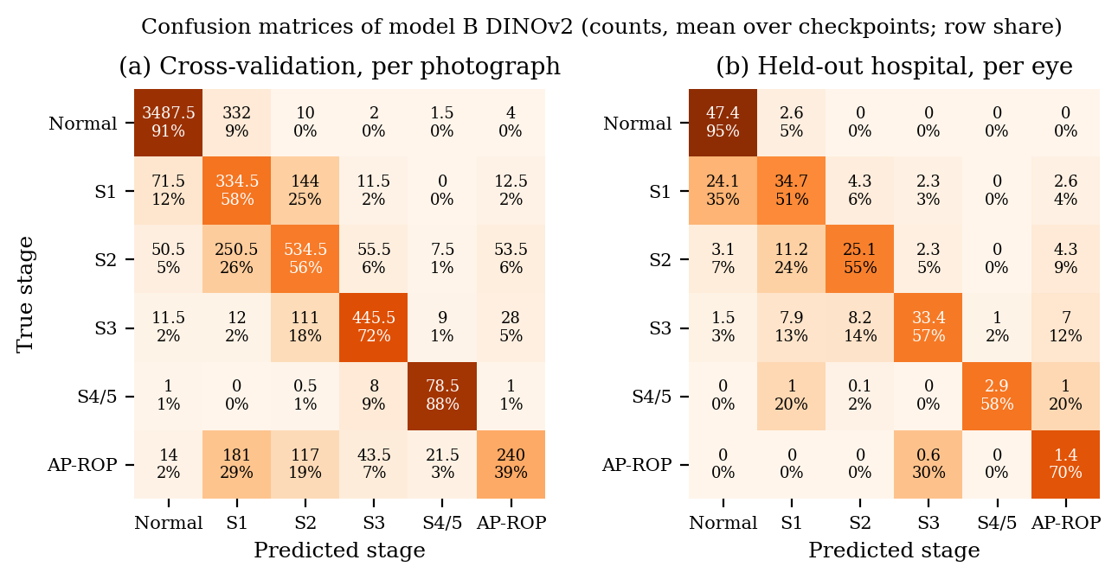
Confusion matrices of model B: counts (mean over checkpoints) and share of each true-stage row

7.1.6 Detecting any ROP, calibration and the operating point
Figure 7.6 gives the ROC and precision–recall curves for ROP against normal per eye: AUC 0.935–0.944 for every model, and average precision 0.98 (prevalence 0.78). Figure 7.7 gives the reliability curves: models A–H are over-confident at the new hospital (ECE 0.14–0.18), and model I, trained with the weight average and stronger label smoothing, is close to the diagonal (ECE 0.061). The temperature fitted on cross-validation (0.62–0.94, i.e. sharpening for every model) makes every model worse there (ECE 0.20–0.24, model I 0.196). The pre-registered any-ROP threshold, set to 90% sensitivity on cross-validation, reaches 64–68% sensitivity at the held-out hospital for every model, at 100% specificity; the threshold does not transfer.
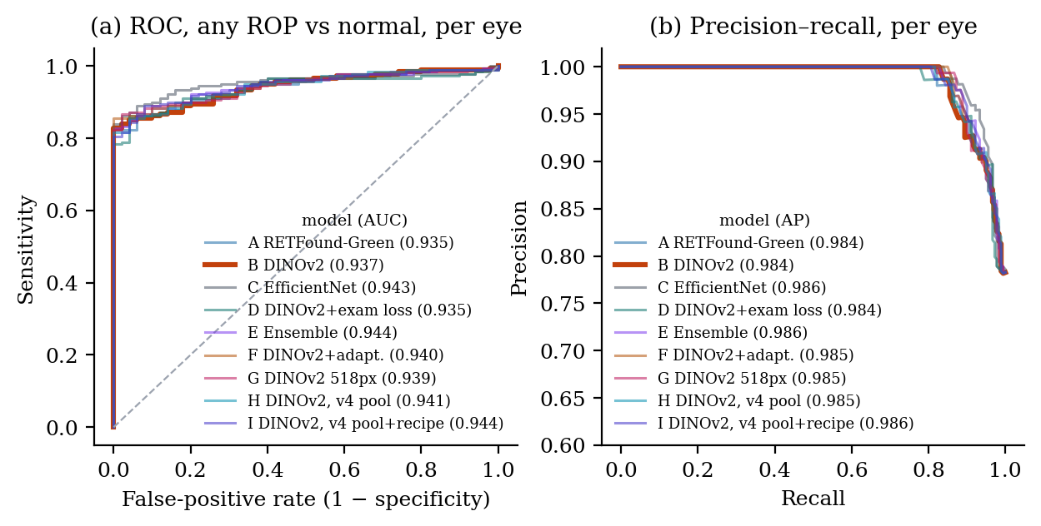
Any-ROP detection at the held-out hospital, per eye: (a) ROC curves; (b) precision–recall curves
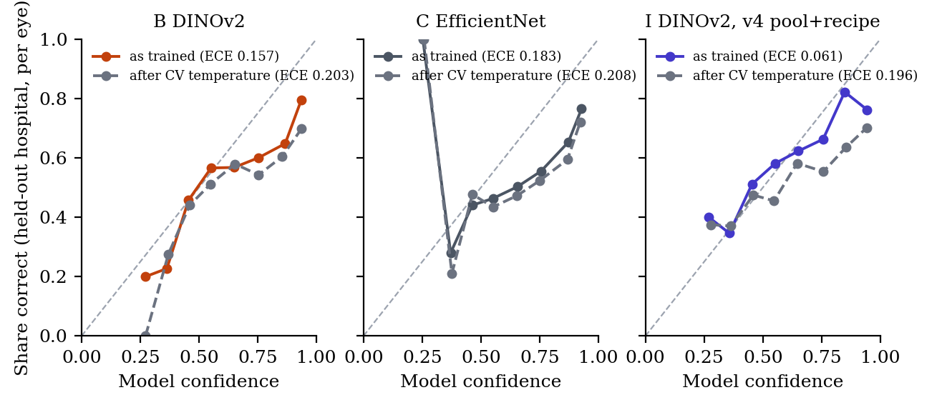
Reliability curves per eye at the held-out hospital for models B, C and I, as trained and after the cross-validation temperature

7.1.7 Results by hospital unit, and the one real gain
Figure 7.8 scores each training hospital at its own unit in cross-validation. At the Ostrava examination level, model D (trained one session at a time) scores 0.846 against 0.701 for model B, the same encoder trained per photograph, and 0.775 for the baseline; cleaning Ostrava’s frames (models H and I) gives 0.710 and 0.712, so sharper frames do not do what the examination-level loss does. A post-hoc paired bootstrap on the 342 Ostrava examinations (148 infants, 64 diseased examinations from 18 infants) gives D$−$B $+0.145$ (95% CI $+0.094$ to $+0.257$) in QWK and $+0.214$ in macro-F1; D$−$C is $+0.071$ ($+0.015$ to $+0.230$). This contrast was not pre-registered and rests on 18 diseased infants, and model D also gives Ostrava a larger share of training steps (36% against 22%), which is a confound to be disclosed.
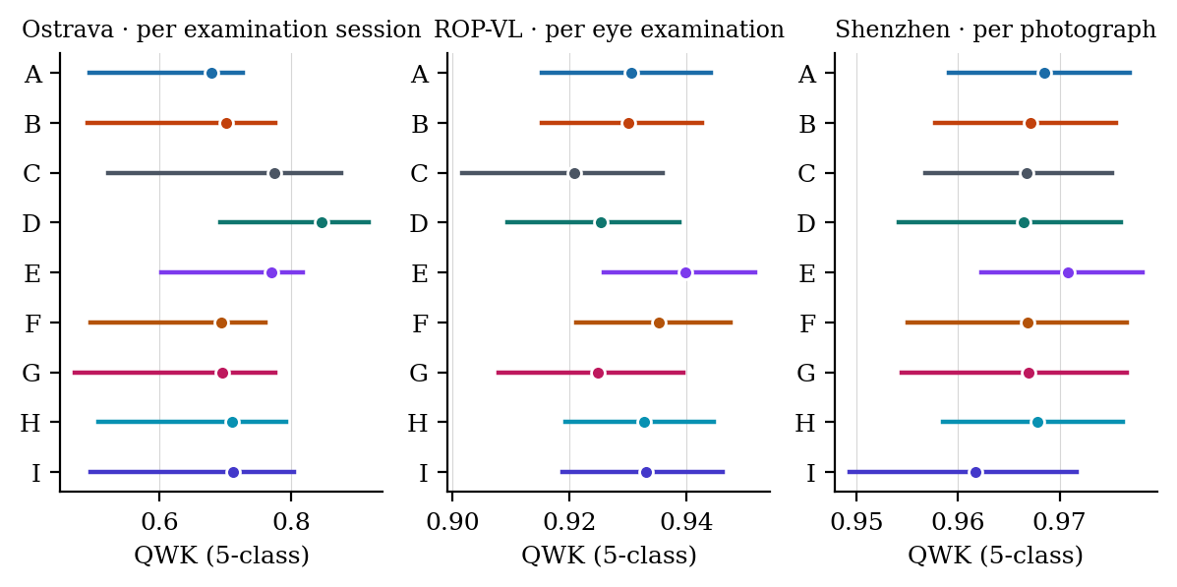
Cross-validation QWK of every model at each hospital’s own unit: Ostrava per examination session, ROP-VL per eye examination, Shenzhen per photograph

7.1.8 Inference time
Requirement P5 was measured on 27 October 2026 by calling the eye-level inference of the application with the demo photographs on the team’s Apple M5 laptop (PyTorch MPS backend, model served by the application at the time: EfficientNetV2-S): one photograph in 0.95 s and 16 photographs in 2.78 s, plus 2.1 s to load the model once at start-up. Both are under the 10 s acceptance limit. The DINOv2 model has the same input size and a similar parameter count, so its time is expected to be of the same order; it is to be re-timed when it replaces the baseline in the application [FILL-18: re-time P5 after the app switch to DINOv2].

7.1.9 Training behaviour, folds and run times
Figure 7.9 shows the training loss and the held-out macro-F1 by epoch, averaged over the ten runs of each arm; all arms converge smoothly within 20 epochs with no sign of over-fitting of the held-out fold. Model I’s loss sits higher by construction (label smoothing 0.10 against 0.05), and its held-out macro-F1 rises later because it is measured on the weight average, which early in training still carries most of the pre-trained weights. Figure 7.10 shows the score of each fold: fold 0, which holds 476 of the 617 AP-ROP photographs, is the hardest for every model (QWK 0.59–0.74), and the seeds differ by up to 0.08 on it. Table 7.5 gives the run times from the Kaggle logs.
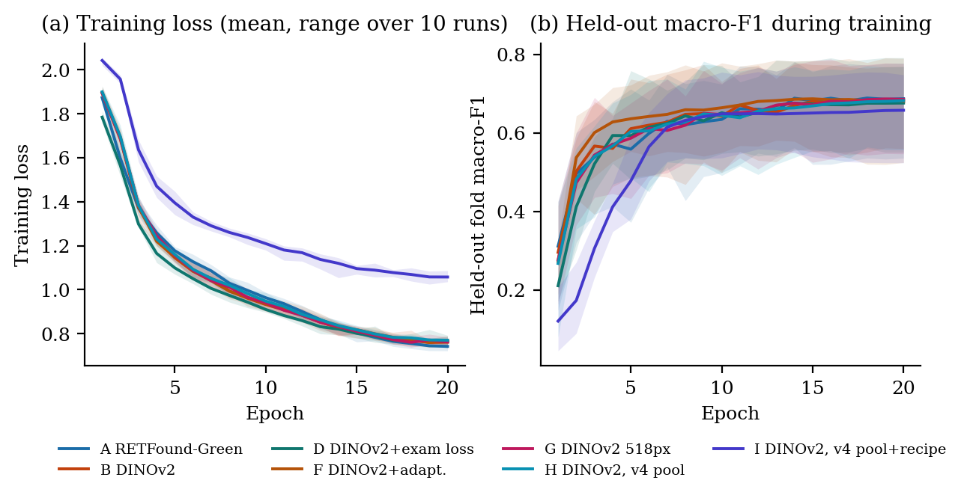
Training curves of the transformer arms: mean over ten runs with the range shaded
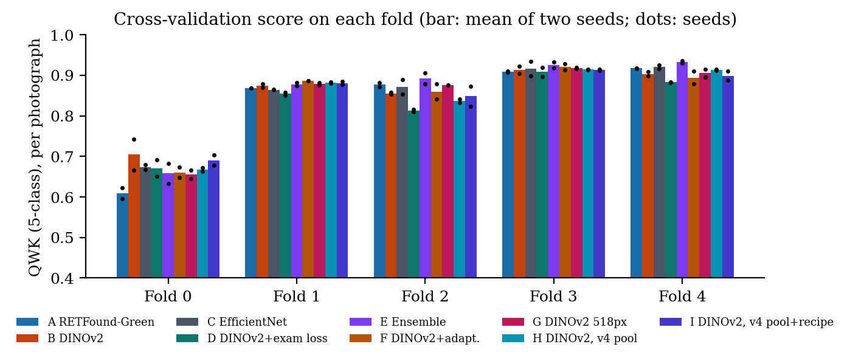
Cross-validation QWK on each fold, by model and seed
Training time on a Kaggle T4 GPU, from the kernel logs (20 epochs per fold; F and G train the five CV folds only; for H and I the session column counts the five CV folds and the site fold, without their two LOSO folds)
Model | Photos/s | Min per fold | Min per session (5 folds + site) | Kernels
A RETFound-Green & 39 & 32 & 187–189 & one kernel per seed

7.2 Verification of Project Requirements
Table 7.6 links each requirement to its test and evidence.
Verification of project requirements
ID | Requirement and criterion | Test | Actual result | Status | Evidence
R1 | Eye route: 1–16 photographs in, JSON out; errors as JSON | T1 | 200 with demo set; 413, 422, 400 cases covered | Met | tests/test_eye_route.py
R2 | Worst-view rule with AP-ROP as a form | T1 | Unit tests pass | Met | webapp/inference.py
R3 | PDF report with eye summary | T1 | Generated and validated | Met | reports/
R4 | One-command training with aligned saved predictions | T2 | 14 sessions collected; none rejected | Met | results/rop/v3/runs/
R5 | Scorer from saved predictions with reproduction check | T3 | Baseline reproduced to 3 dp; refuses otherwise | Met | v3_scores.json
R6 | Locked half never read | T3 | Guard and AST test pass | Met | tests/test_v3_uda.py
P1 | CV QWK $≥0.80$ | T4 | 0.825 (0.737–0.911) | Met | Table 7.1
P2 | Eye QWK at new hospital $≥0.75$ | T5 | 0.756 (0.679–0.821); served configuration 0.752 | Met | Table 7.1
P3 | Stage-1 eye recall $>0.40$ | T5 | 0.51 | Met | Table 7.4
P4 | Session $<8$ h on Kaggle | T6 | 3.2–3.4 h (v3); 1.7–3.1 h per v4 kernel | Met | Table 7.5
P5 | 16-photograph request $<10$ s on CPU | T7 | 2.78 s for 16 photographs; 0.95 s for one | Met | Section 7.1.8
P6 | Reproducible; two seeds | T8 | All numbers from committed files; two seeds per arm | Met | commit b827cce
P7 | Test suite green | T8 | 407 passed, 4 skipped, 1 deselected (demo-file names) | Partially met | CI log
P5 is reported in Section 7.1.8; P7 is partially met because one guard fails on 34 demo photographs whose original file names encode clinical attributes, a renaming that awaits the owner’s decision.

7.3 Comparison with Baseline or Existing System
Under identical folds, preprocessing, class balancing, augmentation, epochs and checkpoint rule, none of the six v3 models beats the first version’s EfficientNet at the held-out hospital: the paired eye-level QWK differences are $+0.014$, $−0.004$, $−0.014$, $+0.010$, $−0.016$ and $+0.007$ for A, B, D, E, F and G, with every interval crossing zero. Models H and I were compared with B, not C, as Amendment 5 prescribes; their eye-level QWK values (0.750 and 0.776) also lie inside the baseline’s interval. The new models are better on stage 1 (recall 0.48–0.52 against 0.40) and worse on AP-ROP; the baseline’s eye-level macro-F1 (0.573) is the highest by 0.005. Against the literature, our cross-validation QWK of 0.82 and eye-level QWK of 0.76 are not comparable with the 0.98 accuracies reported under image-level splits on the same Ostrava data ; they are comparable with VEA-Net’s 74.8% stage accuracy under a subject-level split , and with the human inter-expert agreement of kappa 0.24 for stage , which our unweighted kappa (0.52 per eye, 0.63 per photograph) exceeds for the reasons given in Section 7.4.

7.4 Interpretation and Engineering Tradeoffs
Why the models tie. The nine models of this version lie within 0.031 QWK of one another in cross-validation and within 0.032 at the new hospital, while a single model’s interval is 0.12–0.25 wide; the pre-training domain, the resolution, an ensemble, a learned decision rule, a cleaned training pool and a regularising recipe all fail to move the eye-level result at a new hospital. The confusion matrices show why: the errors are between adjacent stages (normal/stage 1, stage 1/stage 2), which is exactly where human experts disagree most . A model trained on one institution’s reading of the stage-1 boundary cannot be expected to agree with another institution’s reading better than two experts agree with each other. The ceiling is in the labels.
Why cleaning the data and the recipe did not move the selection metric. The audit changed what the models trained on (439 of 715 Ostrava training rows), but a sharper frame carries the same examination label as the blurred frame it replaces, so cleaning the images cannot remove the noise of frames that do not show the finding. Model D, which addresses exactly that, moved Ostrava examinations by 0.145; models H and I moved them by 0.008 and 0.011. The recipe’s regularisers target camera and illumination shift, which is consistent with I’s descriptive gain at the new hospital and its better calibration, but not with a gain on the three training hospitals, where the selection rule looks. The rule was fixed before the runs, and it kept B.
Why AP-ROP recall fell. AP-ROP in cross-validation is one infant deep: fold 0 holds 470 frames of one Ostrava infant’s examinations under one label. A model that reads that infant’s frames slightly differently gains or loses hundreds of photographs at once, which is the label-unit effect of our first paper seen in a recall. On the ROP-VL AP-ROP photographs of folds 1–4 the three models are within 0.031 of each other.
Why model D wins only on Ostrava. Ostrava’s label is a property of the examination session, stamped on every frame, including frames that do not show the finding. Training per photograph teaches the model to call those frames diseased; training per session lets the most abnormal frame carry the label. The 0.145 gain appears where the training unit now matches the label unit and nowhere else, because the other cohorts’ labels are already per photograph, and the Multi-View eyes are three fixed views of which the model’s per-photograph training is already the right unit.
Why adaptation failed. Model F learns from new-hospital photographs only where the teacher is at least 90% confident. Label smoothing and class weighting cap the attainable confidence for normal, stage 1 and stage 2 below 0.9, so only severe-stage photographs qualify (8% of them by the last epoch) and the stage-1 boundary, where the errors are, is never touched. Lowering the threshold would admit mostly photographs the model calls normal, pushing it towards the very error it should fix; this was judged in advance and the setting left as pre-registered.
Why the threshold and temperature do not transfer. The new hospital’s camera, views and case mix differ; the models are over-confident there, and the cross-validation temperature sharpens further. A screening threshold must be set on data from the hospital where it is used.
The unresolved issue is stage 1 at the new hospital: 24 of 68 eyes called normal by every model. The 518 px model shows that it is not a resolution limit; it is a view and label limit, which only clinician re-grading or a new hospital with eye-level labels can resolve.

7.5 Safety Cost and Sustainability Evaluation
The system never acts on its own output; the reader sees the driving photograph and the per-photograph table and the report says that the stage is decision support. The measured 100% specificity at the pre-registered threshold means no normal eye would be flagged at the new hospital, at the cost of a sensitivity of 64–68% rather than the 90% target, which is why the report states that the threshold must be re-set per site before any use. Total cost was zero. Energy use was about 45 GPU-hours on a T4 (about 3.2 kWh at the card’s 70 W), which is small; the preprocessing cache halved the GPU time that the same experiments would otherwise have taken. The work supports SDG 3 (good health) by lowering the reading burden of ROP screening, with the stated condition that it is validated at the site of use.

7.6 Limitations and Contribution of the Work
Limitations: the labels were not re-graded and two cohorts label per examination; the severe classes have 5 and 2 eyes at the new hospital; the development half was used for design in version 1 and is therefore descriptive; the locked half has not yet been scored for these models; model F’s new-hospital numbers are transductive; the Ostrava examination-level gain is post hoc, rests on 18 diseased infants and is confounded with Ostrava’s share of training steps; 76% of AP-ROP photographs come from one infant; the development half has now been examined for nine models, so model I’s gain there is one look of many; B’s LOSO folds ran after the v3 round, on the v3 pool; and model I’s weight average keeps about 5% of the pre-trained weights (17% on the ROP-VL leave-out fold). Contributions demonstrated by the results: an eye-level screening application; the first architecture-matched comparison of retinal and natural-image pre-training for ICROP-3 staging, with a pre-registered null result; a reproducible, pre-registered multi-hospital evaluation whose every number traces to a committed file; a pre-registered data audit and recipe round, with a leave-one-hospital-out guard, that showed cleaner frames and a stronger recipe do not move the selection metric; the finding that stage-1 recall at a new hospital improves with the transformer backbones; and the finding that training at the unit the labels describe is the one change that moves a result.

8 Conclusions

8.1 Summary of the Work
The project set out to turn a photograph-level ROP classifier into an eye-level screening system with a different model, higher accuracy and a publishable evaluation. We fixed the evaluation first: patient-grouped five-fold cross-validation over 6,700 photographs from three hospitals, a fourth hospital held out, one pre-registered primary endpoint, a selection rule that never looks at the held-out hospital, clustered bootstrap intervals and a stated minimum detectable effect. We then built the eye-level route and PDF report in the application, implemented a training pipeline for vision transformers on free Kaggle GPUs, and trained and scored seven models with two seeds each: a retina-pretrained transformer, a natural-image-pretrained transformer of identical architecture, the EfficientNet baseline, an examination-level training variant, an ensemble, an adaptation variant and a native-resolution variant. A final pre-registered round audited the training data (per-camera frame quality and a pixel-checked near-duplicate sweep) and added two more models, the selected transformer on the cleaned pool and the same pool with a regularising recipe, judged against a pre-set adoption margin and a leave-one-hospital-out guard. Every run, prediction, score and figure is committed and reproducible by one command.

8.2 Conclusions against Objectives
- O1, eye-level inference: achieved. The application takes every photograph of one eye and returns one stage by the worst-view rule, the driving photograph and a PDF; the route and its error cases are covered by automated tests.
- O2, a different backbone, compared fairly: achieved. DINOv2 ViT-S/14, selected by the pre-registered rule with a cross-validation QWK of 0.825 (0.737–0.911), replaces EfficientNet in the application, served as the mean of its five fold models (0.752 per eye at the new hospital). The retina-pretrained RETFound-Green scored 0.794 in cross-validation and 0.774 per eye at the new hospital; the difference between the two pre-training domains is $+0.018$ (0.000–0.041) per eye in favour of the retinal model and $−0.031$ ($−0.077$ to $+0.015$) in cross-validation: no consistent advantage either way.
- O3, pre-registered evaluation: achieved. Protocol v2 and five dated amendments were committed before the experiments they govern; the v4 adoption rule kept model B, as written, although model I scored better at the new hospital; the locked half remains unopened for these models.
- O4, accuracy targets: achieved for the stated thresholds, not beyond the baseline. Cross-validation QWK 0.825 against the 0.80 target and eye-level QWK 0.756 against 0.75; accuracy 76.6% per photograph and 63.0% per eye; any-ROP AUC 0.94 per eye. No model beats the baseline’s eye-level QWK of 0.760 by more than its interval (the best, model I, scores 0.776), so the review’s request for higher accuracy on every metric was not met, and we report that the ceiling lies in the labels rather than the model.
- O5, pre-registered improvements: achieved, with mostly null results. Resolution (518 px), ensembling, ordinal decoding and unsupervised adaptation did not improve the eye-level result, and neither the cleaned training pool nor the regularising recipe reached the $+0.010$ adoption margin in cross-validation (H $−0.013$, I $−0.004$). Model I’s gain at the new hospital ($+0.020$, $+0.003$ to $+0.041$ over B) is descriptive and below the detectable difference. Two gains are real: stage-1 eye recall at the new hospital rose from 0.40 to 0.50–0.52, and training at the examination unit raised Ostrava examination-level QWK from 0.701 to 0.846 ($+0.145$, 0.094–0.257, post hoc).
- O6, manuscript: partly achieved. The draft, with every number traced, is written; it awaits the single approved scoring of the locked half for its primary endpoint and the author details for submission.

8.3 Scope for Future Work
- Score the locked half once, after the guide’s approval and the log-book entry, for all nine models together; this gives the pre-registered primary endpoint and completes the manuscripts. It cannot confirm a gain as small as model I’s, but it will show whether the ordering holds on unseen eyes.
- Re-grade the stage-1 boundary with a clinician. The nine models make the same adjacent-stage errors, chiefly stage 1 called normal; re-grading the stage-1 photographs on which several models disagree with the label, together with the 14 near-duplicate pairs that carry different labels, would measure the label noise directly and is the one step that can raise the ceiling.
- Set the screening threshold per site. The cross-validation threshold transfers at 64–68% sensitivity; a small labelled calibration set from each new hospital would restore the 90% target.
- Extend examination-level training to any cohort with session or eye labels, and test it on a second hospital with eye-level labels; the Ostrava gain is the one result worth building on. More infants with stage 4/5 and AP-ROP from more than one source are the data, not the recipe, that the leave-one-hospital-out folds show to be missing.
- Clinical validation: a prospective study with a paediatric ophthalmologist as the reference standard, which is outside what a student team can do but is the precondition for any use on patients.
- Application: camera integration, plus-disease and zone outputs when consistently labelled data exist, and a model card stating the licences and the site-validation requirement.

9 Detailed Design Information

Pre-registered protocol (summary)
Protocol v2 (docs/paper/PROTOCOL_V2.md, committed 19 October 2026) fixes: the arms and their parity rules (identical folds, sampler, class balancing, label smoothing, augmentation, batch, epochs, schedule, last-epoch weights; only the backbone, input size, normalisation and learning-rate recipe may differ); the units per source; the selection rule (cross-validation pooled out-of-fold image QWK on the 5-class map); the primary endpoint (locked eye-level QWK, A$−$C, paired infant-clustered bootstrap, 2,000 replicates); Holm-corrected secondaries; descriptive endpoints; the minimum detectable difference ($≈$0.08 eye QWK); the duplicate exclusion; and the conditions of the second locked opening. Its five amendments, each dated and committed before the experiment it governs, are:
- (21 Oct) temperature fitted on eye-level driving-photograph vectors; the any-ROP threshold pooled over units and fitted on uncalibrated probabilities; headline numbers pooled over all prediction lists with one clustered interval; probe kernels’ development predictions never opened.
- (21 Oct) the learning rates chosen by the probe ($2×{10}^{−4}$ for A, ${10}^{−4}$ for B, rule: keep ${10}^{−4}$ unless beaten by more than 0.03 macro-F1); disclosure that the probes ran before the duplicate exclusion was wired in; one kernel per arm and seed.
- (22 Oct, after the A–E results) ensemble arm E; the cross-fitted ordinal decoder; arm D with log-sum-exp pooling, $K=8$, $τ=1$, on the cross-validation-selected encoder.
- (25 Oct, after the A–E results) arm G at 518 px; arm F with self-ensembling (EMA teacher 0.99, confidence 0.90, weight 1.0 ramped over two epochs) on the development half’s photographs without labels, its development numbers marked transductive.
- (31 Oct, after the A–G results, before any v4 run or locked scoring) the v4 round: (a) the data audit (near-duplicate sweep, Ostrava frame quality, cap re-ranking) applied to training rows only, with the folds, validation rows and exclusions unchanged, and two new leave-one-source-out folds (Ostrava, ROP-VL) beside the Shenzhen site fold; (b) models H (B on the v4 pool) and I (H plus the v4 recipe: EMA 0.999, one-epoch head warm-up, rotation $±{180}^{∘}$, crop 0.85–1, gamma and noise, Fourier amplitude swap, label smoothing 0.10), and B on the two new LOSO folds; (c) the adoption rule of Equation [eq:adopt], with H$−$B, I$−$B and I$−$H added to the paired contrasts and the locked half to be opened once for A–I together; (d) a budget of about 20 GPU-hours. A dated revision, written after the audit and before the pool, replaced the hospital-derived quality thresholds by per-camera thresholds without a field-of-view rule and required a pixel check for near-duplicates; a dated pre-run note, written before any v4 kernel, disclosed the zero weight for a class absent from a fold, the Fourier swap’s handling of the zero-frequency term, the cap ranking and the EMA’s start.

Training configuration of model B
Model: vit_small_patch14_reg4_dinov2.lvd142m, input 392 px, average pooling, dropout 0.3, drop-path 0.1, 6 outputs. Preprocessing: circle-crop, letterbox, CLAHE, ImageNet normalisation. Training: 20 epochs, batch 16, AdamW, peak learning rate ${10}^{−4}$, layer decay 0.8, weight decay 0.05, label smoothing 0.05, class-balanced weights ($β=0.999$), one-cycle cosine schedule (10% warm-up), gradient clipping 1.0, mixed precision, strong augmentation (affine, perspective, blur, random erasing) and site randomisation (hue jitter, random greyscale, resolution jitter, random resized crop), no weighted sampler, no early stopping. Model A differs in weights (RETFound-Green), normalisation (0.5/0.5) and peak learning rate ($2×{10}^{−4}$); D adds the examination loss; F adds the adaptation block; G sets the input to 518 px; H reads the v4 fold files; I reads the v4 fold files and adds the recipe of Section 4.5 (label smoothing 0.10, EMA decay 0.999, head warm-up 1 epoch, rotation 180, minimum crop scale 0.85, gamma 0.7–1.4 with $p=0.5$, noise $σ=0.02$ with $p=0.3$, Fourier block 3 with $p=0.5$).

10 Raw Test Records and Supporting Data

Per-fold cross-validation QWK (5-class), both seeds
 | Seed 42: folds 0–4 |  |  |  |  | Seed 1337: folds 0–4
A RETFound-Green & 0.62 & 0.87 & 0.87 & 0.91 & 0.92 & 0.59 & 0.87 & 0.88 & 0.91 & 0.92
Generated by scripts/rop_v3_report_tables.py from results/rop/v3/report_data.json; duplicates excluded; Figure 7.10 draws the exact values.

Baseline confusion matrices
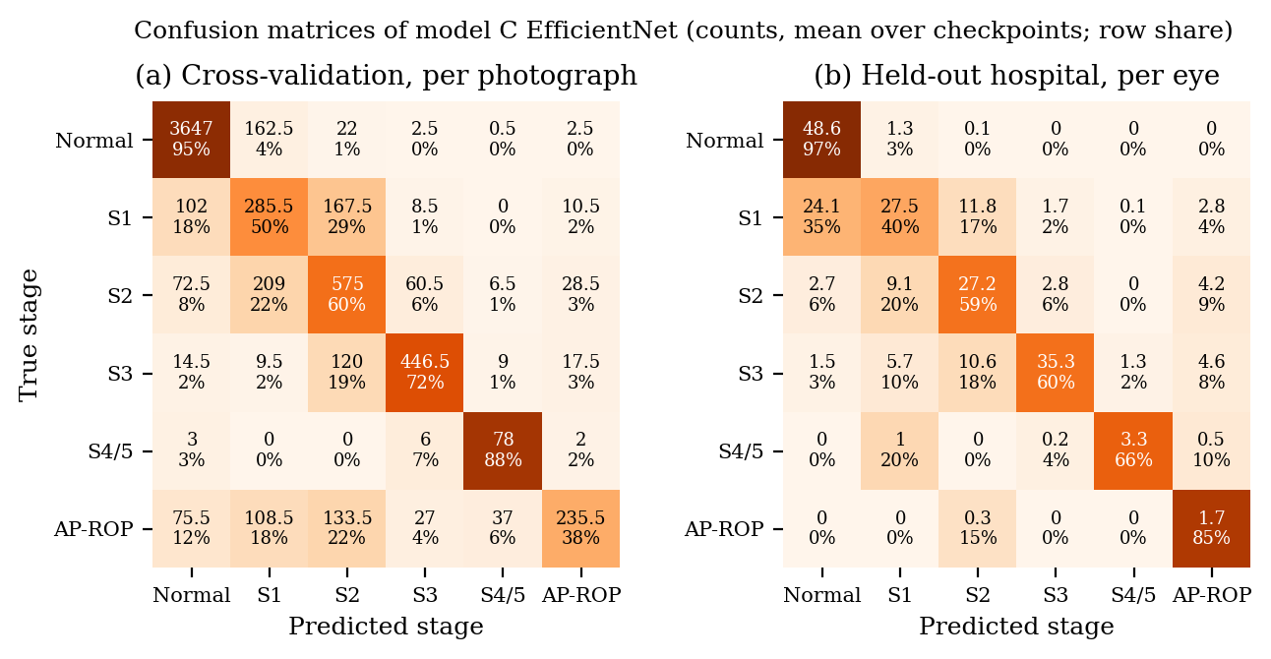
Confusion matrices of the EfficientNet baseline (model C)
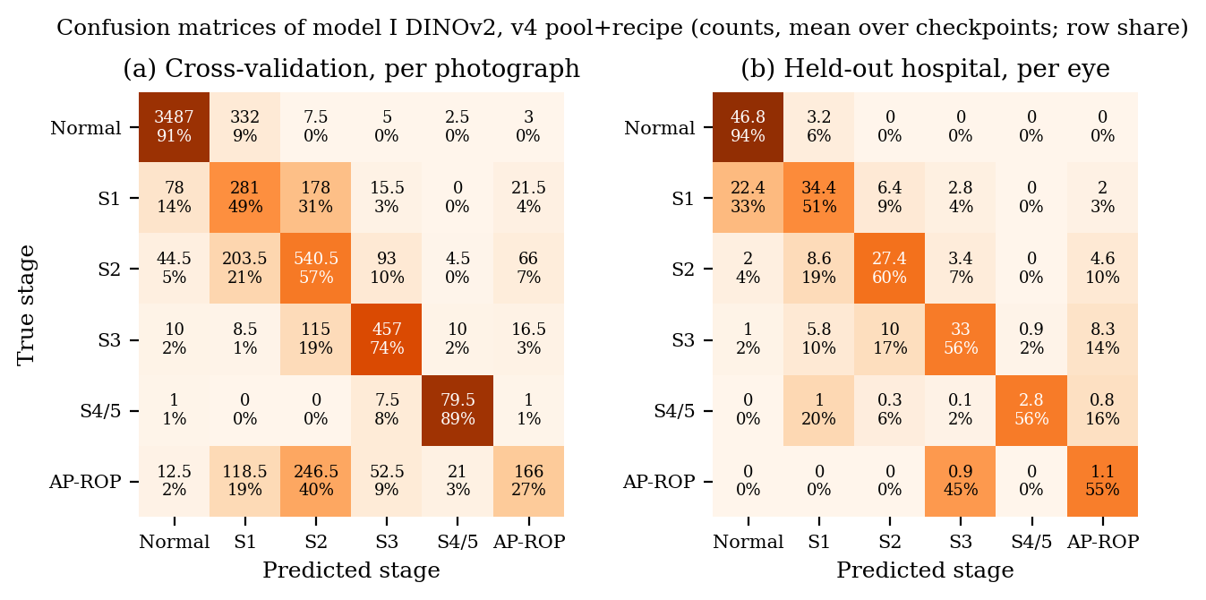
Confusion matrices of model I (v4 pool and recipe)

Learning-rate probe
Inner patient-disjoint split of fold 0’s training rows (497 inner-validation photographs), seed 42, 20 epochs, macro-F1 at $3×{10}^{−5}$ / ${10}^{−4}$ / $2×{10}^{−4}$: RETFound-Green 0.717 / 0.755 / 0.812; DINOv2 0.747 / 0.764 / 0.772. Record: results/rop/v3/lr_probe.json.

Cache gate
Fold-0 baseline checkpoint scored on fold-0 validation from the cache and from the originals: argmax agreement 0.9917, $Δ$QWK $−0.0006$, PSNR 52.85 dB over 200 images; 7,363 images cached, none missing. Record: results/rop/v3/cache_gate.json.

Kaggle sessions
Fourteen main sessions in v3 (A, B, D: one kernel each per seed; F, G: two kernels each per seed) and ten in v4 (B: one LOSO kernel per seed; H, I: two kernels each per seed, five CV folds and the site plus two LOSO folds), seven probe kernels and smoke runs, all on Tesla T4, all private. The v4 run log (docs/v4/V4_RUN_LOG.md) lists every arm, seed, fold and epoch. Kernel logs with per-epoch loss, learning rates, throughput, peak memory and (for F) the confidence mask rate are kept with the downloaded outputs.

11 Software and Reproducibility Information
Repository: private GitHub repository Coldbari/archive, branch v3-rop; the results in this report are at commit 3f7b79f (scores and report data b827cce; v3 runs 2620ba2; v4 runs e490423, 5527d74, 7b259be; v4 model report docs/v4/V4_MODEL_REPORT.md). Dependencies: Python 3.14, PyTorch, timm, scikit-learn, pandas, NumPy, Pillow, OpenCV, Flask, ReportLab, matplotlib; pinned in the repository’s requirements. To reproduce the numbers in this report without a GPU:
python scripts/rop_v3_score.py --v3 # -> results/rop/v3/v3_scores.json
python scripts/rop_v3_report_data.py # -> results/rop/v3/report_data.json
python scripts/rop_v3_figures.py # -> docs/report/figures/*.pdf
python scripts/rop_v3_report_tables.py # -> tables/*.tex (incl. served model)
python -m pytest -q # 407 tests
To retrain an arm: python scripts/build_rop_cache.py, then python scripts/push_v3_kernels.py --arch dinov2_s --seed 42, then python scripts/collect_v3_run.py kaggle_cache/v3/<kernel>. The eye-level route is POST /predict_eye with fields photos[], eye and context. The complete code is supplied as a digital attachment; the key modules are models/common/architectures.py, optim.py, bag_loss.py, uda.py, units.py, v3_launch.py, scripts/rop_v3_score.py, webapp/inference.py and kaggle_kernels/rop_v3_finetune.py.

12 Project Management and Supporting Records

Plan and execution
The work after the post-proposal review was planned as twelve tasks in a written implementation plan (19 October 2026), reviewed by a four-member panel of reviewer roles (lead, trainer, methodologist, critic) whose written reviews are kept with the plan. Each task was executed with a written brief, an implementer, a code review with findings, a fix round and a ledger entry; the ledger records every ruling and its cost if wrong. Four further rounds (ensemble and decoder; arm D; arms F and G; the v4 data audit with arms H and I) followed the same process. Dates: protocol 19–21 October; training 21–27 October; scoring 27 October; v4 amendment, audit and pool 31 October; v4 training and scoring 31 October–1 November.

Individual contributions
[FILL-12: for each student, the subsystems, experiments and report sections they were responsible for]

Guide meetings and review actions
[FILL-13: from the log-book: dated guide meetings, the post-proposal review feedback and its closure, the request for approval of the locked-half scoring]

Outcome mapping
[FILL-14: programme-outcome mapping, if the department requires it]
99 M. F. Chiang, G. E. Quinn, A. R. Fielder, et al., “International classification of retinopathy of prematurity, third edition,” Ophthalmology, vol. 128, no. 10, pp. e51–e68, 2021. A. Gschließer, E. Stifter, T. Neumayer, et al., “Inter-expert and intra-expert agreement on the diagnosis and treatment of retinopathy of prematurity,” Am. J. Ophthalmol., vol. 160, no. 3, pp. 553–560, 2015. J. P. Campbell, S. N. Ryan, E. Lore, et al., “Diagnostic discrepancies in retinopathy of prematurity classification,” Ophthalmology, vol. 123, no. 8, pp. 1795–1801, 2016. P. Nagpure, R. Bait, P. Rangnekar, Y. Shengale, and A. Kumar, “What the label unit hides: an audited multi-hospital benchmark for ICROP retinopathy of prematurity staging,” preprint, Vivekanand Education Society’s Institute of Technology, Mumbai, 2026. (Manuscript in preparation; see Publications.) M. Vahidmoghadam, P. Ghorbani, M. J. Ahmadi, et al., “Automated diagnosis of plus form and early stages of ROP using deep learning models,” Sci. Rep., vol. 16, art. 7234, 2026. [FILL-17a: author list], “VEA-Net: vascular enhancement attention network for multi-task retinopathy of prematurity classification,” Front. Cell Dev. Biol., 2026 [FILL-17a: volume and article number]. [FILL-17b: author list], “ROPDeepX: a hybrid ResNet50–EfficientNet-B4 model for retinopathy of prematurity detection,” Discov. Artif. Intell., 2026 [FILL-17b: volume, article number; confirm the 99.7% figure in the full text]. Y. Peng, W. Zhu, Z. Chen, et al., “Automatic staging for retinopathy of prematurity with deep feature fusion and ordinal classification strategy,” IEEE Trans. Med. Imaging, vol. 40, no. 7, pp. 1750–1762, 2021. J. M. Brown, J. P. Campbell, A. Beers, et al., “Automated diagnosis of plus disease in retinopathy of prematurity using deep convolutional neural networks,” JAMA Ophthalmol., vol. 136, no. 7, pp. 803–810, 2018. [FILL-17c: author list] and J. P. Campbell, “External validation of the i-ROP deep learning system,” J. AAPOS, 2025 [FILL-17c: confirm title, volume, pages]. J. Wang, J. Ji, M. Zhang, et al., “Automated explainable multidimensional deep learning platform of retinal images for retinopathy of prematurity screening,” JAMA Netw. Open, vol. 4, no. 5, e218758, 2021. J. Engelmann, et al., “RETFound-Green: a green retinal foundation model,” Nat. Commun., 2025 [FILL-17d: confirm title, volume and article number]. Z. Mahboob, A. O. Ahsan, and M. Wilms, “Using an adult retinal image analysis foundation model for retinopathy of prematurity staging: are there benefits?” in Proc. SPIE Medical Imaging 2025: Computer-Aided Diagnosis, 2025, p. 116, doi:10.1117/12.3047303. W.-H. Lan, C.-L. Tsai, and W.-C. Wu, “Optimizing field-of-view for type-1 retinopathy of prematurity via multiple instance learning,” Transl. Vis. Sci. Technol., vol. 15, no. 8, art. 13, 2026, doi:10.1167/tvst.15.8.13. Luo, Guo, Chen, Liang, and Lin, “ROP-Bench: a benchmark of foundation models for retinopathy of prematurity,” Zenodo record 20721027 and GitHub repository foye80/rop-bench, 2026, accessed 19 October 2026. [FILL-17e: author list], “SABPI-Net [FILL-17e: full title],” in Proc. MICCAI, 2025, paper 2355. Zhao and Li, “DeepAdapter: self-supervised pre-training and domain adaptation for retinopathy of prematurity screening,” Br. J. Ophthalmol., 2026, doi:10.1136/bjo-2025-328559 [FILL-17f: confirm title and author list]. M. Oquab, T. Darcet, T. Moutakanni, et al., “DINOv2: learning robust visual features without supervision,” Trans. Mach. Learn. Res., 2024. M. Tan and Q. V. Le, “EfficientNetV2: smaller models and faster training,” in Proc. Int. Conf. Machine Learning (ICML), 2021, pp. 10096–10106. Y. Cui, M. Jia, T.-Y. Lin, Y. Song, and S. Belongie, “Class-balanced loss based on effective number of samples,” in Proc. IEEE/CVF Conf. Computer Vision and Pattern Recognition (CVPR), 2019, pp. 9268–9277. G. French, M. Mackiewicz, and M. Fisher, “Self-ensembling for visual domain adaptation,” in Proc. Int. Conf. Learning Representations (ICLR), 2018. A. J. DeGrave, J. D. Janizek, and S.-I. Lee, “AI for radiographic COVID-19 detection selects shortcuts over signal,” Nat. Mach. Intell., vol. 3, pp. 610–619, 2021. L. Oakden-Rayner, J. Dunnmon, G. Carneiro, and C. Ré, “Hidden stratification causes clinically meaningful failures in machine learning for medical imaging,” in Proc. ACM Conf. Health, Inference, and Learning (CHIL), 2020, pp. 151–159. J. Timkovič, et al., “Retinal image dataset of infants and retinopathy of prematurity,” Sci. Data, vol. 11, art. 814, 2024.

Publications by the Students
- P. Nagpure, R. Bait, P. Rangnekar, Y. Shengale, and A. Kumar, “What the label unit hides: an audited multi-hospital benchmark for ICROP retinopathy of prematurity staging.” Manuscript prepared for IEEE ISBI 2027 and for a TechRxiv preprint; status: in preparation [FILL-16: update to submitted/published with venue and date].
- P. Nagpure, R. Bait, P. Rangnekar, Y. Shengale, and A. Kumar, “Retinal versus natural-image pre-training for eye-level ICROP-3 staging: a pre-registered multi-hospital comparison.” Manuscript in preparation from the work of this report; status: in preparation.

Acknowledgements
We thank our guide, [FILL-01: guide’s full name and designation, e.g. Prof. A. Kumar], for the direction given at the post-proposal review, which shaped the second version of this project, and the Department of Automation and Robotics of Vivekanand Education Society’s Institute of Technology for its support. We thank University Hospital Ostrava, the ROP-VL team, the Shenzhen Eye Hospital group and the Multi-View ROP contributors for releasing the de-identified infant retinal image datasets used in this work, and Kaggle for the free GPU time on which every model was trained. We thank the authors of DINOv2 and RETFound-Green for releasing their pre-trained weights. No funding was received for this project. [FILL-15: any individual who gave technical or clinical help, with their permission] Praharsh Nagpure ([FILL-08: roll no.]) Signature:
[FILL-05: R. Bait, full name] ([FILL-09: roll no.]) Signature:
[FILL-06: P. Rangnekar, full name] ([FILL-10: roll no.]) Signature:
[FILL-07: Y. Shengale, full name] ([FILL-11: roll no.]) Signature: Date:

Editing Checklist (delete before submission)
Every item the team must complete is marked in the text as a yellow [FILL-nn: …] tag. Search the PDF or the Word file for “FILL-” to jump to each one. When all are done, remove input backmatter/checklist from main.tex and set finalcopytrue only after the viva.
Tag | What to fill | Where
FILL-01 | Guide’s full name and designation | project_details.tex
FILL-02 | Co-guide (or set coguidefalse, already the default) | project_details.tex
FILL-03, 04 | Head of Department and Principal | project_details.tex
FILL-05 to 07 | Full names of R. Bait, P. Rangnekar, Y. Shengale | project_details.tex
FILL-08 to 11 | Roll numbers of all four students | project_details.tex
– | Institute emblem as figures/institute_logo.png (50 mm) | title page
FILL-12 | Individual contributions | Appendix IV
FILL-13 | Guide meetings and review-action log | Appendix IV
FILL-14 | Programme-outcome mapping, if required | Appendix IV
FILL-15 | Any individual to thank | Acknowledgements
FILL-16 | Publication status of the two manuscripts | Publications
FILL-17a–f | Author lists / volumes of six references | Literature Cited
FILL-18 | Re-time requirement P5 after the app switch to DINOv2 | Section 7.1.8
– | Signatures and dates on certificate, declaration, acknowledgements | front and back matter
– | After the guide approves the locked-half scoring: update the abstract, Section 7.1 and Chapter 8 with the primary endpoint | Chapters 7–8

