Summary

In this lesson, I installed Android Studio and learned some basic skills to create a new app and a virtual device for testing my app. I also learned how to run the app on my phone.

I also have a basic understanding about the structure of the project pane and the meaning of each .xml or .java file.

The most important thing is I built my first app! Here is my achievement:

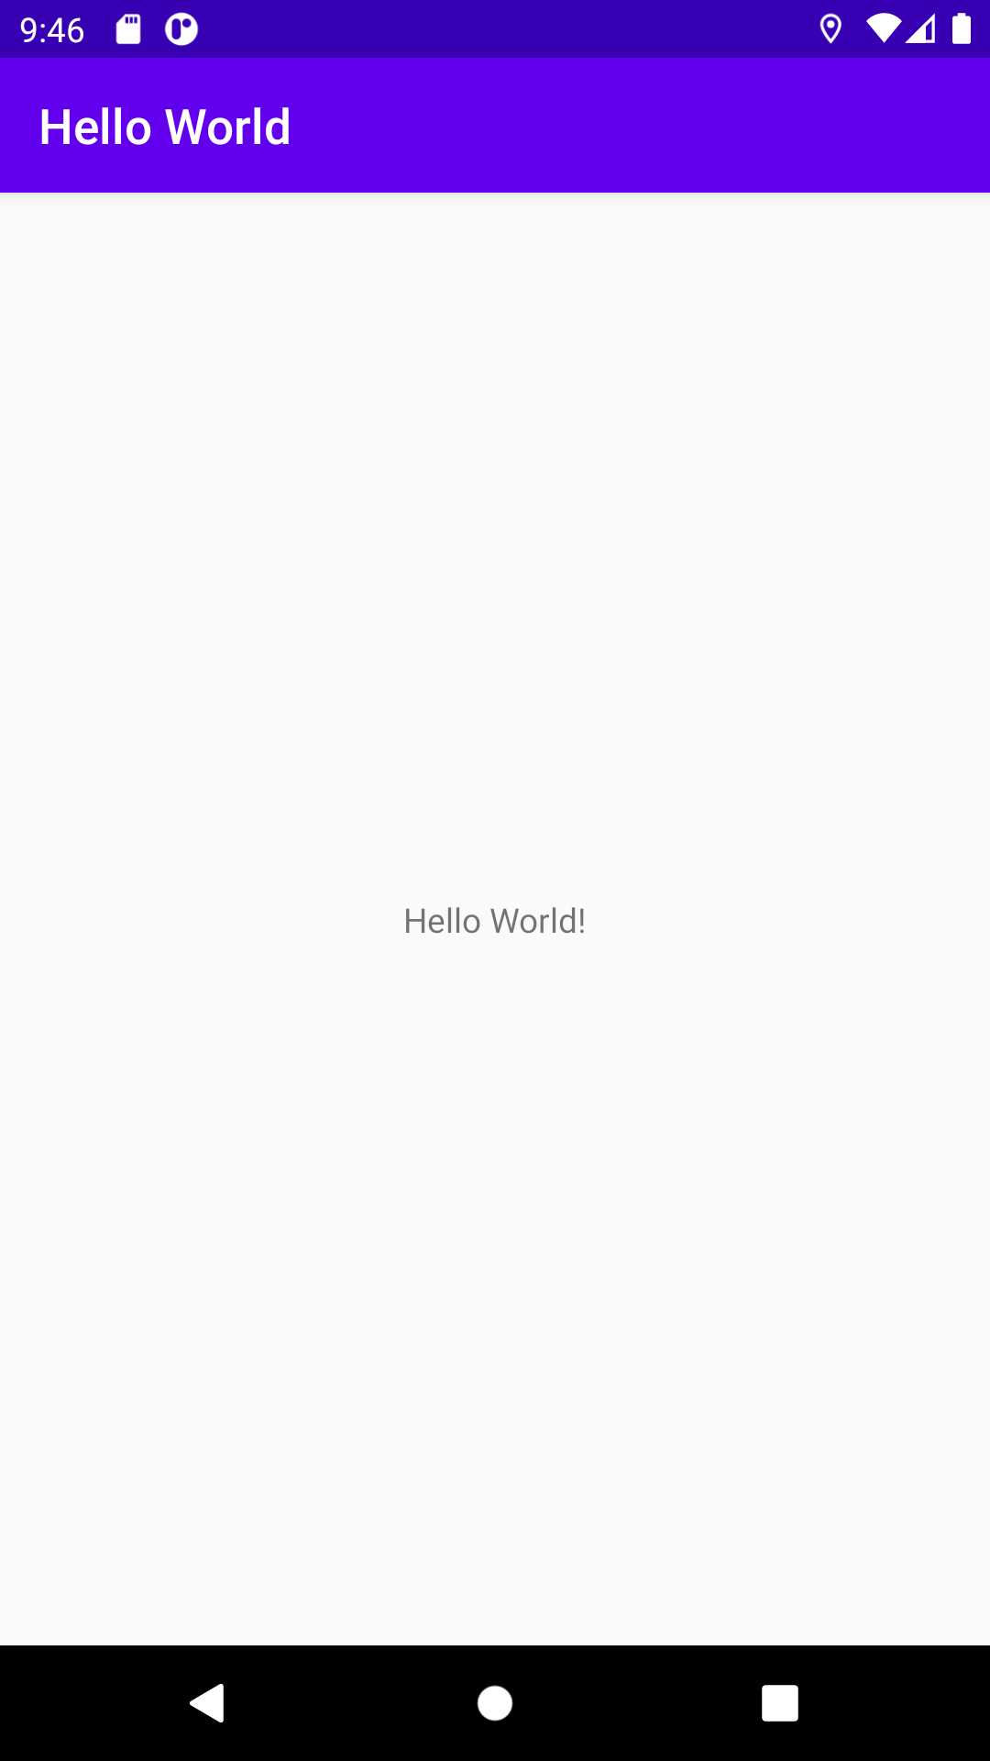

Homework

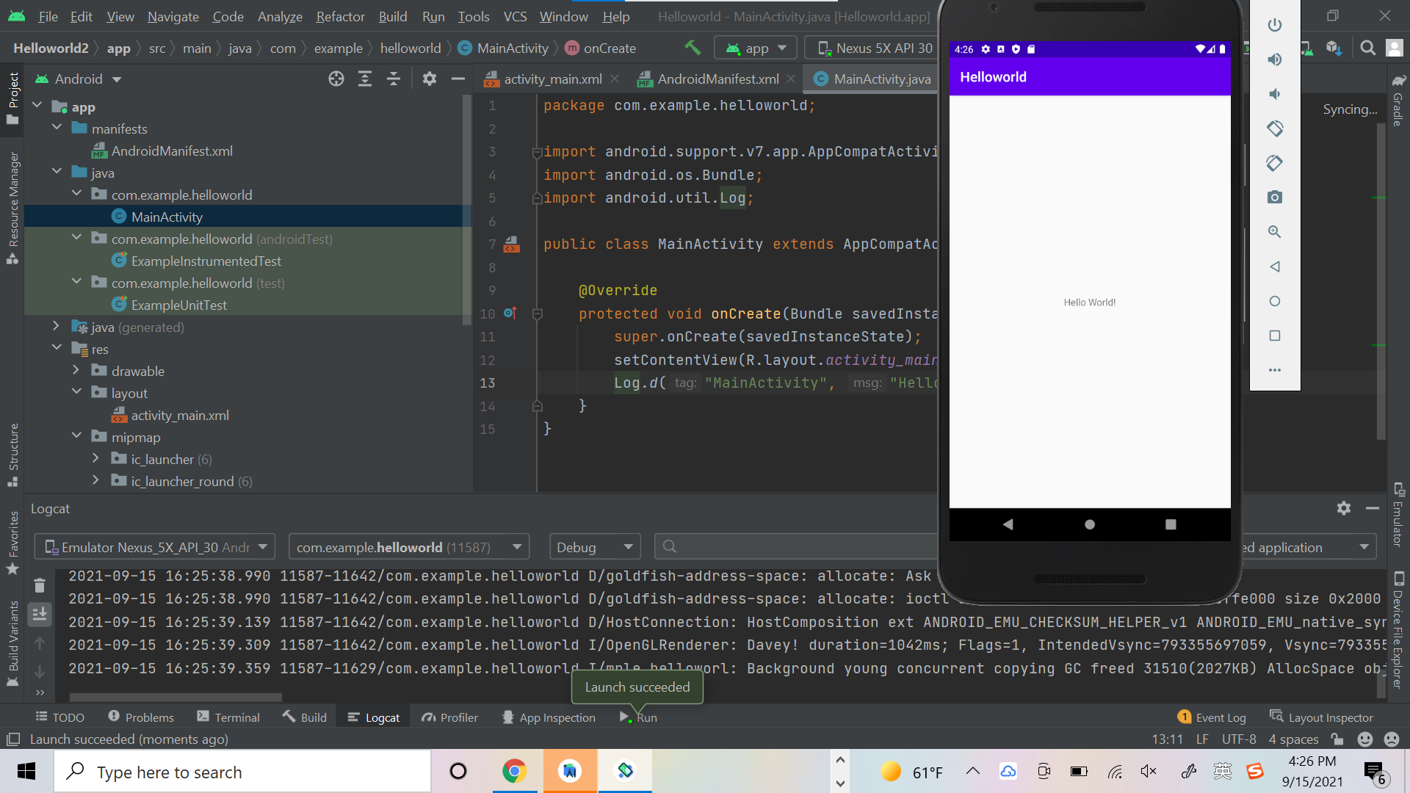

- What is the name of the layout file for the main activity?

activity_main.xml

- What is the name of the string resource that specifies the application's name?

app_name

- Which tool do you use to create a new emulator?

AVD Manager

- Assume that your app includes this logging statement:Log.i("MainActivity", "MainActivity layout is complete");You see the statement "MainActivity layout is complete" in the Logcat pane if the Log level menu is set to which of the following? (Hint: multiple answers are OK.)

Verbose and Info

