Summary

In this lesson, I mainly learned the difference between multiple layouts and how to use them.
The ConstraintLayout allows me to align one UI element that contains text, such as a TextView or Button, with another UI element that contains text. A baseline constraint lets you constrain the elements so that the text baselines match.
The LinearLayout is a ViewGroup that arranges its collection of views in a horizontal or vertical row.
The RelativeLayout is a ViewGroup in which each view is positioned and aligned relative to other views within the group.
I also learned how to create a landscape variation and how to show it on android devices.
Here are my achievements:
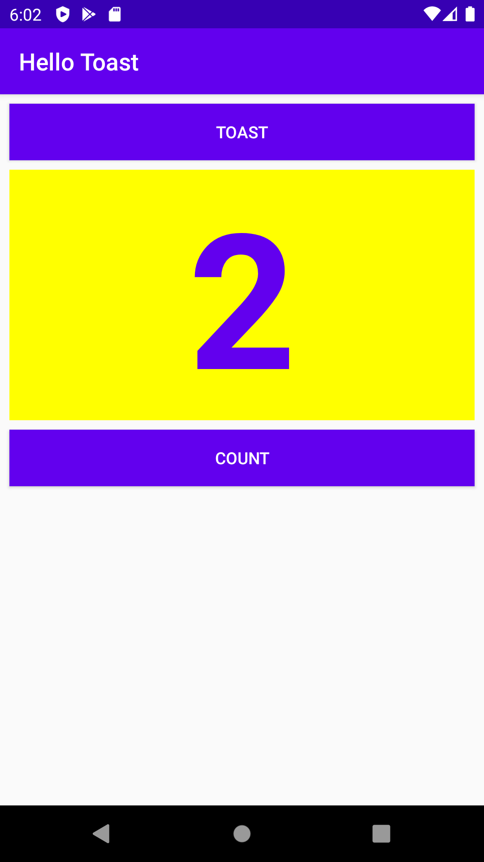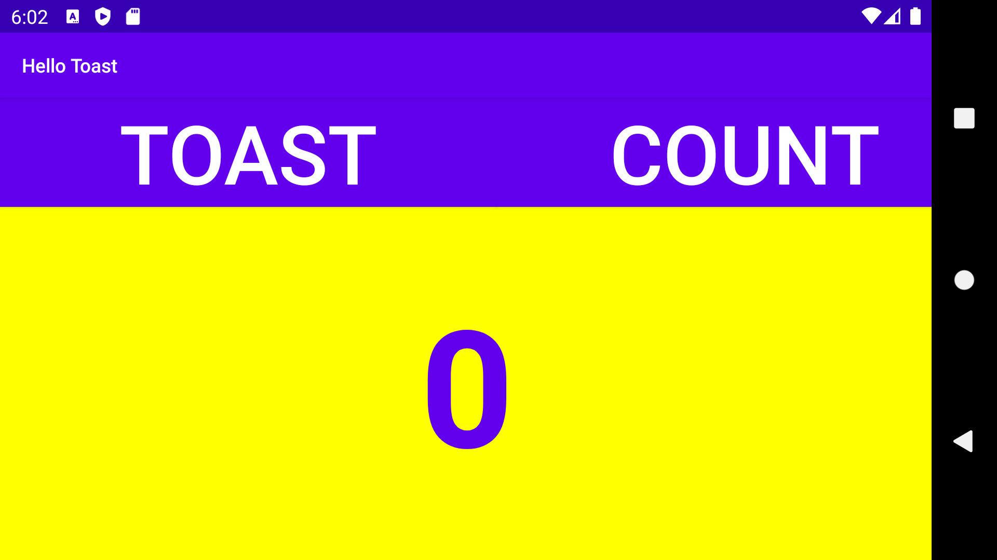

Homework

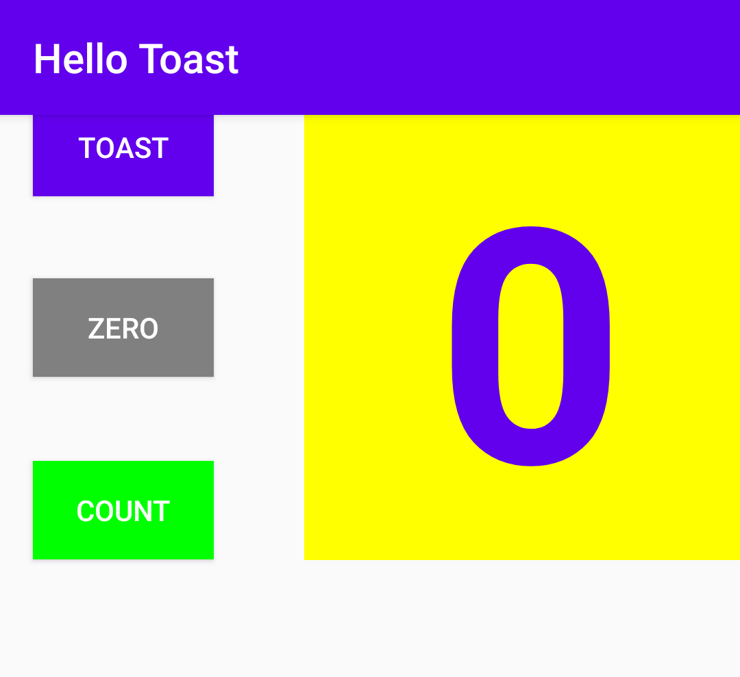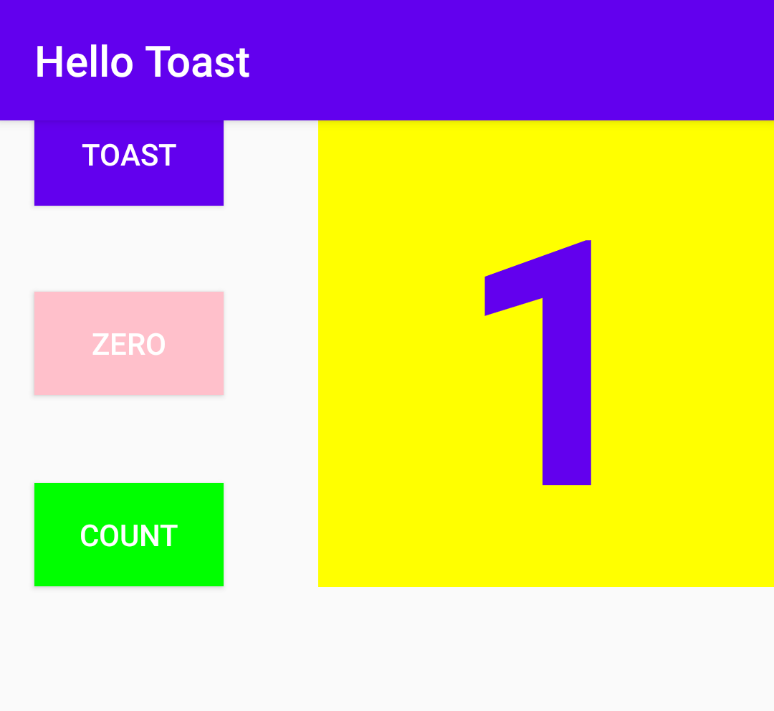
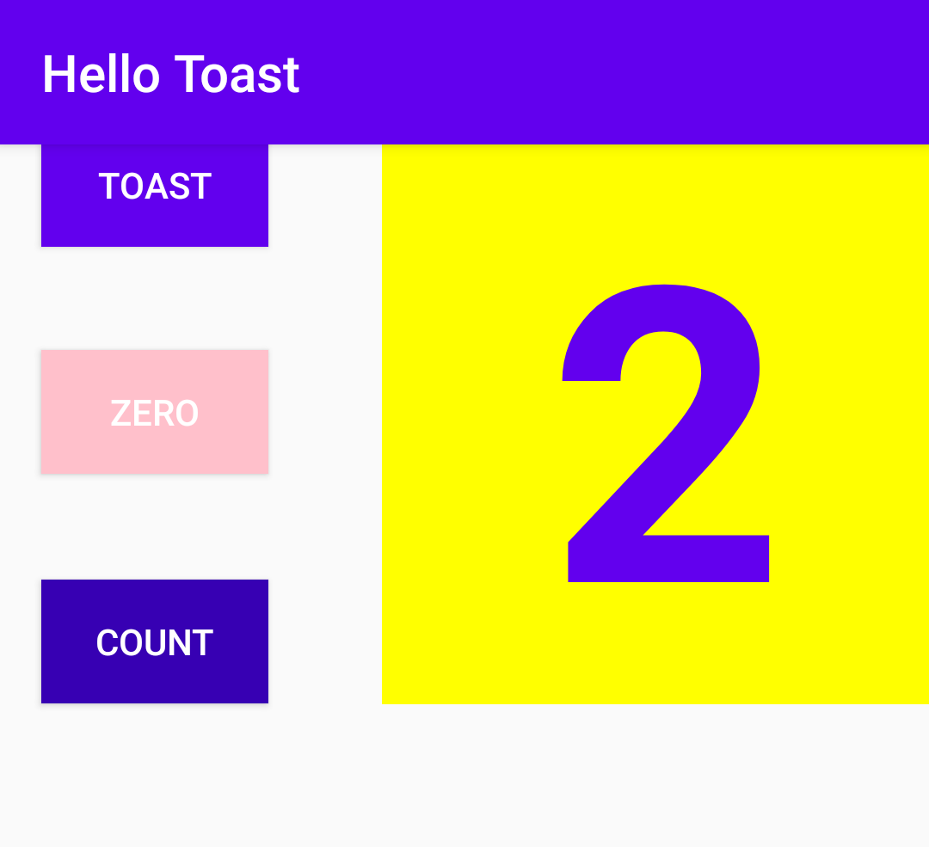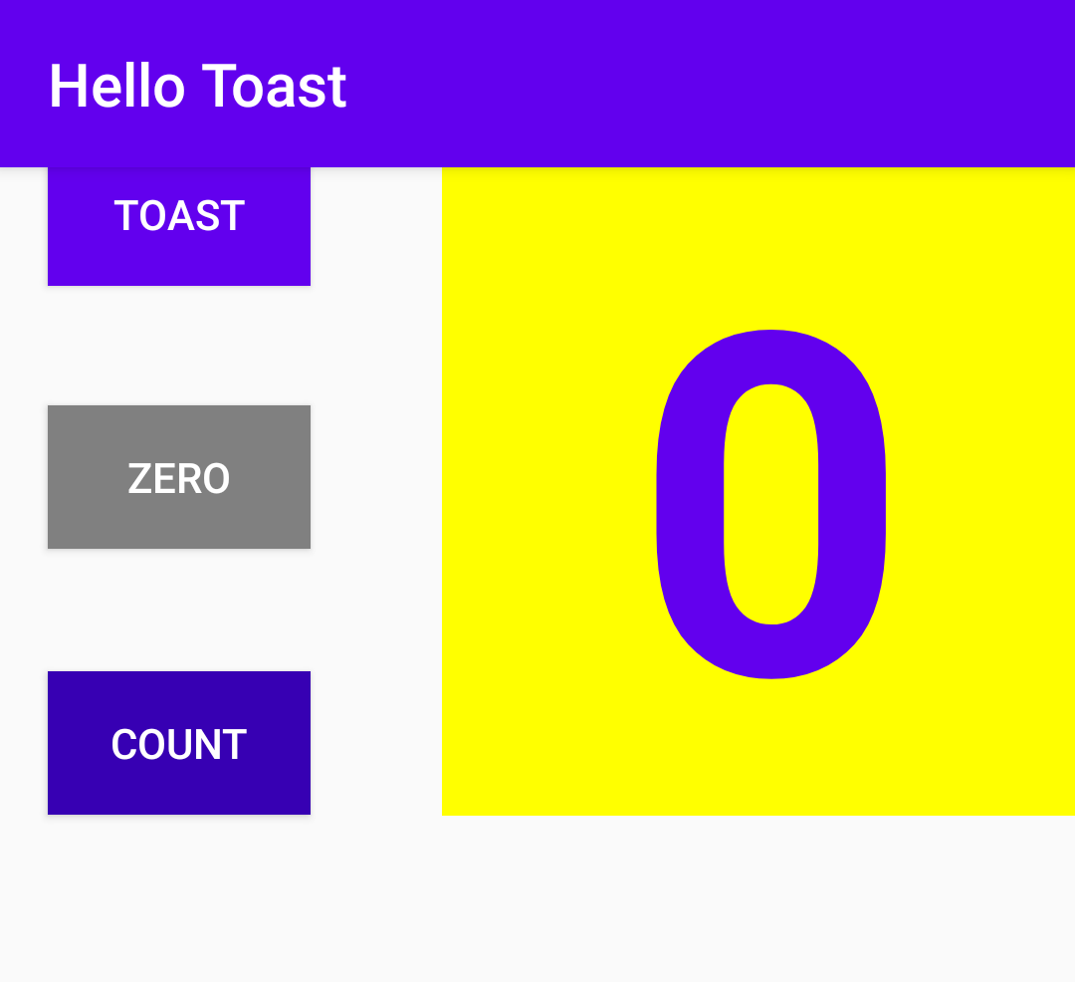
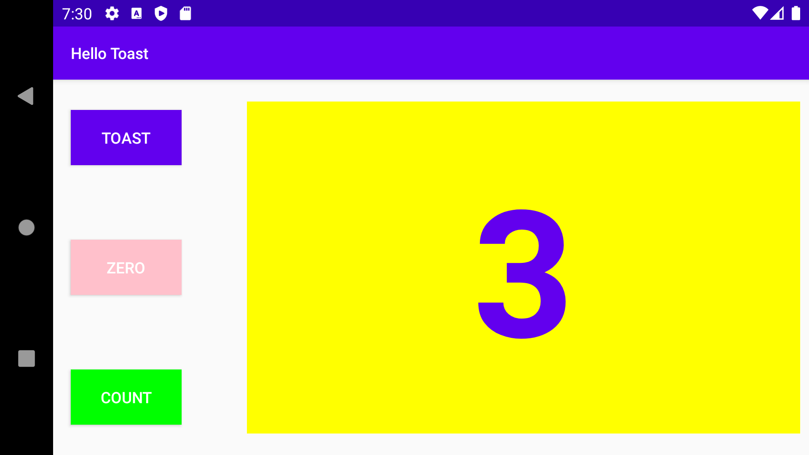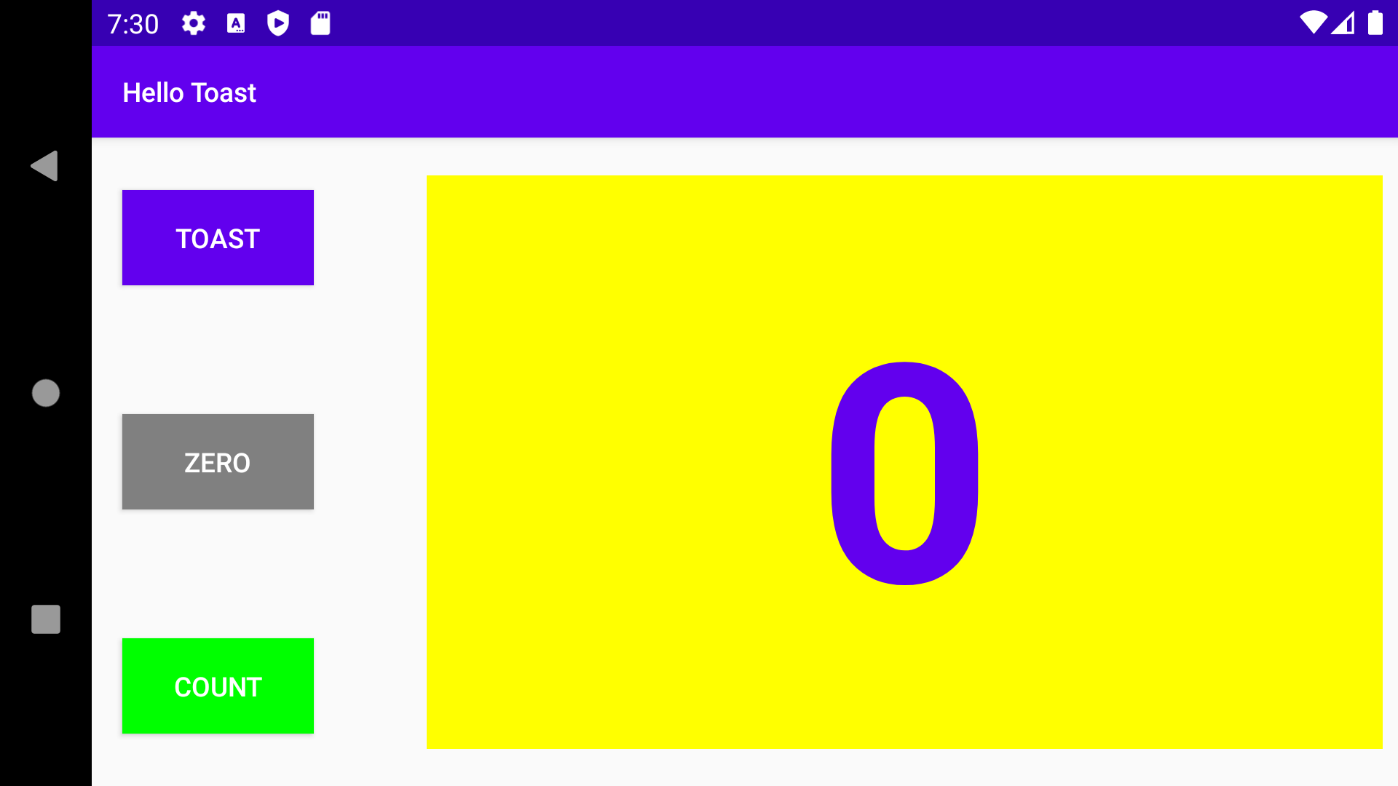

- Which two layout constraint attributes on the Zero Button position it vertically equal distance between the other two Button elements? (Pick 2 answers.)
app:layout_constraintBottom_toTopOf="@+id/button_count"
app:layout_constraintTop_toBottomOf="@+id/button_toast"

- Which layout constraint attribute on the Zero Button positions it horizontally in alignment with the other two Button elements?
app:layout_constraintLeft_toLeftOf="parent"

- What is the correct signature for a method used with the android:onClick XML attribute?
public void callMethod(View view)

- The click handler for the Count Button starts with the following method signature:
public void countUp(View view)
Which of the following techniques is more efficient to use within this handler to change the Button element's background color? Choose one:
Use the view parameter that is passed to the click handler with setBackgroundColor(): view.setBackgroundColor()

