Summary

In this lesson, I learned how to use a ScrollView to scroll a single child View (such as a TextView).
A ScrollView can hold only one child View or ViewGroup, if you want to scroll more than one View element, you should use a ViewGroup such as LinearLayout as a child View within a ScrollView to Enclose the elements within the LinearLayout.

I also learned skills to display free-form text, separate paragraphes and make web links.

Here is my achievement:



Homework

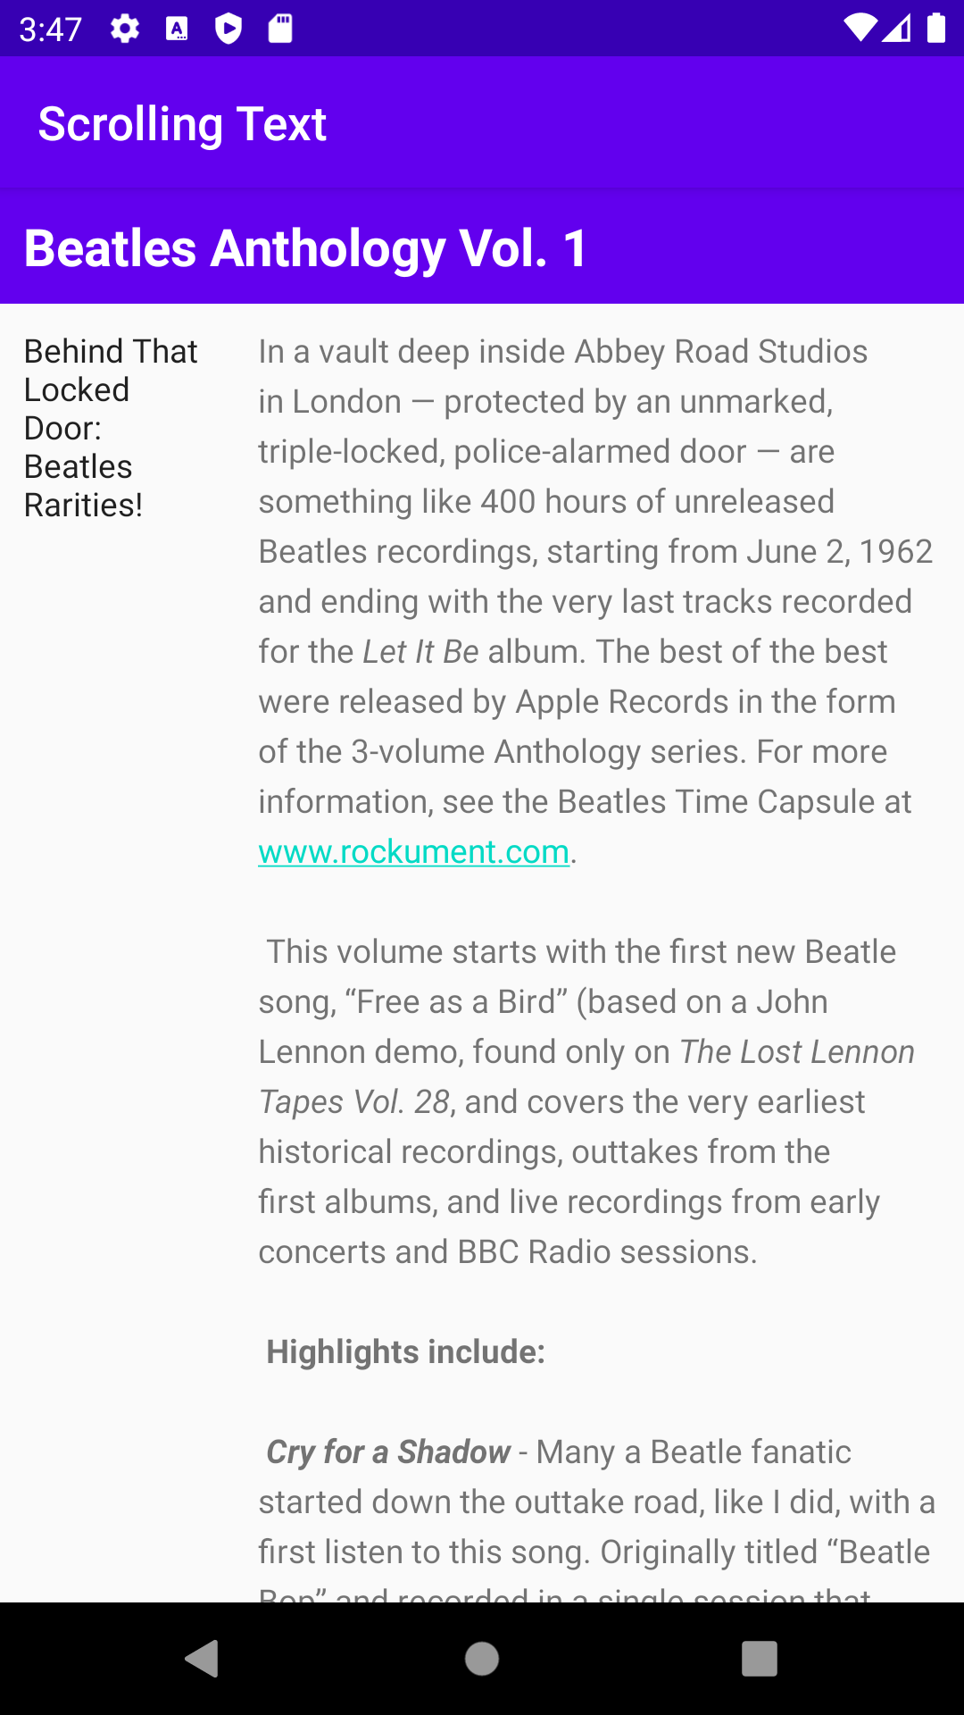

- How many views can you use within a ScrollView? Choose one:
One view or one view group
- Which XML attribute do you use in a LinearLayout to show views side by side? Choose one:
android:orientation="horizontal"
- Which XML attribute do you use to define the width of the LinearLayout inside the scrolling view? Choose one:
android:layout_width="match_parent"

