VL53L3CX
Compilation guide

&

Wiring example with VL53L3CX satellite on Raspberry Pi3 board

07/19/2021

Hardware installation (VL53L3CX satellite with Raspberry Pi3)

xsdn-gpio = <19>;
pwren-gpio = <12>; # this is for two satellites L3, can be ignored for one device.
intr-gpio = <16>;

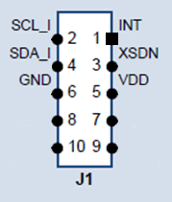
Raspberry connector pins -> VL53L3CX pins
3.3 V PWR pin 1 -> pin 5 (VDD)
I2C1 SDA pin 3 -> pin 4 (SDA)
I2C1 SCL pin 5 -> pin 2 (SCL)
GPIO19 pin 35 -> pin 3 (XSDN)
GND pin 9 -> pin 6 (GND)
GPIO16 pin 36 -> pin 1 (INT)

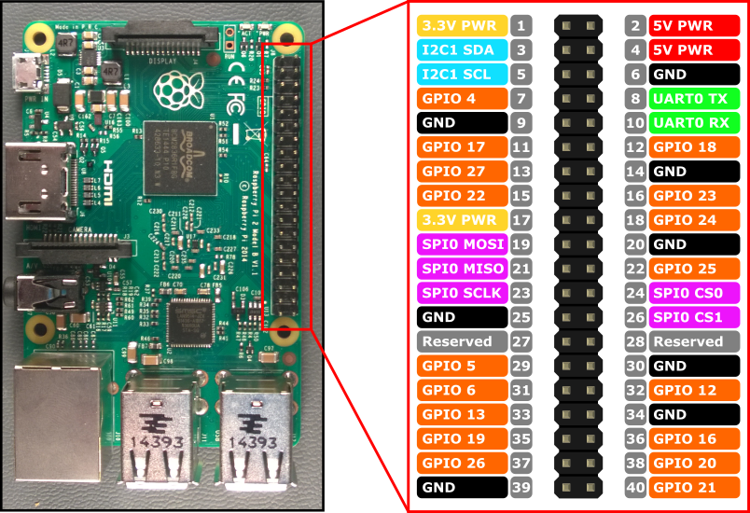

To release the XSDN and then run the VL53L3CX the GPIO19 must be programmed as output and set active
sudo su
cd /sys/class/gpio
echo 19 > export
cd gpio19
echo "out" > direction
echo "1" > value
i2cdetect -r -y 1

expected output of i2cdetect command

0 1 2 3 4 5 6 7 8 9 a b c d e f
00: -- -- -- -- -- -- -- -- -- -- -- -- --
10: -- -- -- -- -- -- -- -- -- -- -- -- -- -- -- --
20: -- -- -- -- -- -- -- -- -- 29 -- -- -- -- -- --
30: -- -- -- -- -- -- -- -- -- -- -- -- -- -- -- --
40: -- -- -- -- -- -- -- -- -- -- -- -- -- -- -- --
50: -- -- -- -- -- -- -- -- -- -- -- -- -- -- -- --
60: -- -- -- -- -- -- -- -- -- -- -- -- -- -- -- --
70: -- -- -- -- -- -- -- --
Notice that the 29 is there (0x29 is the default I²C address of the VL53L3CX device)

Software installation

H/w set up. : refer page 2 & 3.

- For compiling module :
Example of path : /home/pi/BN/L3CX_Linux_1.0.5_bare_1.2.4/driver/vl53Lx/

- Compile
cd driver/vl53Lx/
make clean
make VL53LX_FULL_KERNEL=1

- Initialize GPIOs
echo 12 > /sys/class/gpio/unexport
echo 16 > /sys/class/gpio/unexport
echo 19 > /sys/class/gpio/unexport

sudo dtoverlay -R
sudo dtoverlay stmvl53lx
sudo dtoverlay -l

- cf. Gpio.sh, execute them once for all

- run module instance and allow all access right to /dev/stmvl53lx_ranging
sudo insmod stmvl53lx.ko
sudo chmod 777 /dev/stmvl53lx_ranging

- For phio compile
cd android/hardware/vl53lx_test/

- Modifying Makefile of phio
If path error occur, use fixed path
#DRIVER_DIR = ../../../driver/vl53Lx/
CPPFLAGS=-I$(DRIVER_DIR) -I$(DRIVER_DIR)/inc
CPPFLAGS=-I../../../driver/vl53Lx -I../../../driver/vl53Lx/inc
make clean
make

Running ranging example

- Run phio for 10 times measurement.
./phio -t=100000 -s -Z=10 -S -t=16000

pi@pia7e11d4f:~/BN/3CX/LinuxDriver_1.2.4/android/hardware/vl53lx_test $ ./phio -t=100000 -s -Z=10 -S -t=16000
[V]open fd 3 for /dev/stmvl53lx_ranging
[I]set timing budget 100000
[V]keep using fd 3
[V]started status 0
[V]keep using fd 3
#I 0 dts= 0 range ts 122 StreamCount(0), SpadCount(212.34)
- [0] st 6 d= 49mm min/max= 17/ 55 sigma= 1.26 rate= 19.36/ 0.16
#I 1 dts= 99 range ts 221 StreamCount(1), SpadCount(212.34)
- [0] st 0 d= 49mm min/max= 16/ 55 sigma= 1.33 rate= 19.65/ 0.16
#I 2 dts= 99 range ts 320 StreamCount(2), SpadCount(212.34)
- [0] st 0 d= 49mm min/max= 17/ 55 sigma= 1.13 rate= 19.44/ 0.17
#I 3 dts= 99 range ts 419 StreamCount(3), SpadCount(212.34)
- [0] st 0 d= 50mm min/max= 16/ 56 sigma= 1.17 rate= 19.60/ 0.17
#I 4 dts= 99 range ts 518 StreamCount(4), SpadCount(212.34)
- [0] st 0 d= 50mm min/max= 17/ 56 sigma= 1.09 rate= 19.46/ 0.17
#I 5 dts= 99 range ts 617 StreamCount(5), SpadCount(212.34)
- [0] st 0 d= 50mm min/max= 17/ 56 sigma= 1.12 rate= 19.56/ 0.17
#I 6 dts= 100 range ts 717 StreamCount(6), SpadCount(212.34)
- [0] st 0 d= 50mm min/max= 17/ 56 sigma= 1.07 rate= 19.49/ 0.17
#I 7 dts= 99 range ts 816 StreamCount(7), SpadCount(212.34)
- [0] st 0 d= 50mm min/max= 17/ 56 sigma= 1.09 rate= 19.53/ 0.17
#I 8 dts= 99 range ts 915 StreamCount(8), SpadCount(212.34)
- [0] st 0 d= 51mm min/max= 17/ 56 sigma= 1.05 rate= 19.50/ 0.17
#I 9 dts= 99 range ts 1014 StreamCount(9), SpadCount(212.34)
- [0] st 0 d= 50mm min/max= 17/ 56 sigma= 1.07 rate= 19.53/ 0.17
[V]keep using fd 3
[V]stopped status 0
[V]keep using fd 3
[I]set timing budget 16000
d cl end

pi@pia7e11d4f:~/BN/3CX/LinuxDriver_1.2.4/android/hardware/vl53lx_test $

