PHP/HTML Tutorial Report

Since our project is a web application which consists of mostly PHP and HTML, I need to be up to date and know these languages well. Unfortunately, I have minimal web development experience and no PHP experience. Therefore, a good portion of my time spent on this project in the first few weeks has been spent familiarizing myself with PHP and HTML. Being a computer science major, I understand how the basics of the language, however, where I lacked knowledge in was the syntax of the languages and when/how to switch from page to page among other things.

The tutorial started simple, creating a simple program to display Hello World.

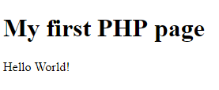

Then it went along talking about how php handles data types, variables, printing, if/else statements, while/for loops, and etc. It doesn’t do much different than some of the other programing languages I’m familiar with, but the syntax is a bit different.

The good portion of my time was spent looking into php forms and how php interacts with MySQL since that’s what the majority of our project has to deal with. All the different commands/queries you can use with php to interact with the database, its syntax and how you can store/manipulate/use that data once it returns it to you. I also spent a bit learning about session variables since they are extremely useful when you need to save information while navigating between pages.

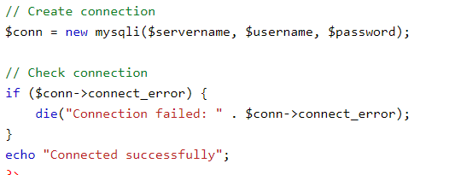The tutorials were in w3schools.com and were extremely helpful. Definitely worth the time spend on. I had to come back and reference them multiple times when I actually started coding for our web application.

