**Revision History**

|  |  |  |  |
| --- | --- | --- | --- |
| Date | Revision | Description of Changes | By |
| 2/1/2019 | 1.1 | Add use cases and functional specifications | Ernesto Rivero |
| 3/15/2019 | 2.1 | Add CRC cards and UML diagrams | Cole Hirapara |
| 4/19/2019 | 3.1 | Update UML diagrams and add implementation | Cole Hirapara |
| 4/24/2019 | 4.1 | Final Revision of Content & Format | Ernesto Rivero |
|  |  |  |  |
|  |  |  |  |
|  |  |  |  |
|  |  |  |  |
|  |  |  |  |
|  |  |  |  |

Full code implementation available at https://github.com/Colehir/COP5339-Team2-Project.

**Table of Contents**

1.0 Introduction 4

2.0 Functional Specifications 5

1. Shopping System 5

2. User Login 5

3. User Sign Up 5

4. Seller Inventory 5

5. Product List 5

6. Product Details 5

7. Shopping Cart 5

8. Check Out 6

3.0 Essential Use Cases 6

3.1 User Logs In 7

3.2 User Logs Out 7

3.3 Customer Reviews Product Details 7

3.4 Customer Adds Items to Shopping Cart 7

3.5 Customer Reviews/Updates Shopping Cart 7

3.6 Customer Checks Out 8

3.7 Seller Reviews/Updates Inventory 8

3.8 Seller Adds New Product 8

4.0 Detailed Use Cases 9

4.1 User Logs In 9

4.2 User Logs Out 9

4.3 Customer Reviews Product Details 9

4.4 Customer Adds Items to Shopping Cart 9

4.5 Customer Reviews/Updates Shopping Cart 9

4.6 Customer Checks Out 10

4.7 Seller Reviews/Updates Inventory 10

4.8 Seller Adds New Product 10

5.0 CRC Cards 11

User 11

Shopping System 11

Customer 11

Seller 12

Product 12

Product List 12

Inventory **Error! Bookmark not defined.**

Shopping Cart **Error! Bookmark not defined.**

Order/Receipt…………………………………………………………………………………………………………………………............13

6.0 UML Diagrams 14

6.1 Class Diagram 14

6.2 Store State Diagram 14

7.0 Use Case Sequence Diagrams 15

7.1 User Logs In 15

7.2 User Logs Out 15

7.3 Customer Reviews Product Details 15

7.4 Customer Adds Items to Shopping Cart 16

7.5 Customer Reviews/Updates Shopping Cart 16

7.6 Customer Checks Out 17

7.7 Seller Reviews/Updates Inventory 17

7.8 Seller Adds New Product 18

8.0 Glossary **Error! Bookmark not defined.**

# 1.0 Introduction

The purpose of this application is to simulate a shopping cart application (think of a simplified version of amazon.com). When the application begins, it shows a login window. Depending who logs in, a customer or the seller, the application performs different functions. For instance, if the seller logs in he will be able to update and manage inventory, as well as see a list of purchases. In the case a costumer logs in, he will be able to place an order after providing credit card info. Guest users are able to browse available products but not able to place an order but are given the chance to sign up if needed.

# 2.0 Functional Specifications

## 1. Shopping System

1. Keeps track of who is, logged in
2. Displays the appropriate windows dependent if seller or customer is in the system

## 2. User Login

1. User logs in with a user name and password and a window (frame) opens where he can browse through a list of available products that includes the product name, price, and available quantity.

## 3. User Sign Up

1. New users are able to sign up in order to place an order
2. The user will provide name, username, and password

## 4. Seller Inventory

1. The seller can update the inventory by adding products - specifying product name, invoice price, sell price and by updating the available quantity.

## 5. Product List

1. A list of products available in the application

## 6. Product Details

1. Description of the product
2. Quantity of the product available
3. Price
4. Add to cart

## 7. Shopping Cart

1. On the checkout window, the shopping cart can be updated by changing the item count for each product in the cart.

## 8. Check Out

1. At checkout, the customer verifies the shopping cart content and pays for the goods by supplying the credit card.

# 3.0 Essential Use Cases

Essential use cases focus on identifying actors and actor intent and provide a general idea of what the system and actors are supposed to do.

## 3.1 User Logs In

1. User connects to System.
2. User enters login info.
3. System verifies login info.

## 3.2 User Logs Out

1. User carries out Log in.
2. User presses ‘Sign Out’.
3. System signs user out of account.

## 3.3 Customer Reviews Product Details

1. Customer carries out log in.
2. Product Window displayed.
3. User clicks on a product.
4. Product information displayed.

## 3.4 Customer Adds Items to Shopping Cart

1. Customer carries out Log In.
2. Customer adds items to shopping cart.
3. Shopping Cart list updated.

## 3.5 Customer Reviews/Updates Shopping Cart

1. Customer carries out Log in and Add Items to Shopping Cart.
2. Customer selects Shopping Cart.
3. Shopping cart details displayed.
4. Customer edits products in Shopping Cart.

## 3.6 Customer Checks Out

1. Customer carries out Login, Add Items to Shopping Cart, Review/Update Shopping Cart
2. Customer enters payment information.
3. Purchase is confirmed.
4. Inventory and Product availability updated.

## 3.7 Seller Reviews/Updates Inventory

1. Seller has carried out Log in.
2. Seller’s products and product details displayed.
3. Seller updates Inventory and Product Information.
4. Inventory and Product Info updated.

## 3.8 Seller Adds New Product

1. Seller has carried out Log in, and Review/Update Inventory.
2. Seller selects ‘Add Product’
3. System prompts Seller for product information.
4. Seller enters product details.
5. Seller’s Inventory updated.

# 4.0 Detailed Use Cases

## 4.1 User Logs In

1. User arrive at the log in screen.
2. The screen displays a two textboxes labeled ‘username’ and ‘password’.
3. User enters their username and password.
4. The system verifies the user’s log in credentials and opens up a new window displaying product information.

## 4.2 User Logs Out

1. User carries out Log in.
2. Inventory window opens up displaying product info, with a ‘Log Out’ button in the corner.
3. User clicks button.
4. System signs user out of account.
5. Product window closes along with any other windows and Log in window reappears.

## 4.3 Customer Reviews Product Details

1. Customer carries out log in.
2. A window displaying all products and some product details show up.
3. User clicks on a product.
4. New window opens up displaying product information such as product description, id, price, availability etc.

## 4.4 Customer Adds Items to Shopping Cart

1. Customer carries out Log In
2. The customer selects the items and quantities they want from the inventory window.
3. These items are added to the shopping cart list.
4. Shopping cart counter updates whenever a new item is added.

## 4.5 Customer Reviews/Updates Shopping Cart

1. Customer carries out Log in and add items to shopping cart.
2. Customer clicks on shopping cart icon.
3. A new window opens displaying all items that were added to the cart and their quantities and the total price of the items in the cart.
4. User can increase or decrease quantity of items, or remove items altogether.
5. When user is finished with reviewing their product information, they click “Purchase”.

## 4.6 Customer Checks Out

1. Customer carries out Log in, Add Items to Shopping Cart, Review cart, and has clicked on the ‘Purchase’ button.
2. A new window appears where the customer can enter their payment information and a button that says ‘Done’.
3. After the customer finishes entering their information, they can click on ‘Done’ to process their purchase.
4. Product availability is updated based on the quantities of the product that was purchased.

## 4.7 Seller Reviews/Updates Inventory

1. Seller has carried out Log in.
2. A new window appears that displays the Seller’s products. It shows the product names, ids, invoice price, selling price, and quantities. The screen also displays the seller’s revenue, profits, and costs. The screen also contains a button named ‘Update Product’.
3. The seller can update any product’s attribute by clicking on it.
4. A new window appears where the seller can update its information.
5. Seller enters new info, clicks ‘Done’ and the product is updated.

## 4.8 Seller Adds New Product

1. Seller has carried out Log in, and Review/Update Inventory.
2. Seller clicks on ‘Add Product’.
3. A new window appears where the seller can enter the product’s information.
4. Seller enters product details.
5. Seller clicks on ‘Done’ and the product is added to the seller’s inventory.

# 5.0 CRC Cards

# 5.1 User

|  |  |
| --- | --- |
| User | |
| Stores user info | Customer |
| Determines if a user is a seller of customer | Seller |
|  |  |
|  |  |

**5.2 Shopping System**

|  |  |
| --- | --- |
| Shopping System | |
| Keeps track of state |  |
| Displays correct screens based on if user is customer or seller |  |
|  |  |
|  |  |

**5.3 Customer**

|  |  |
| --- | --- |
| Customer | |
| Add/Remove/Update items from shopping cart | Shopping Cart |
| Confirm order | Order/Receipt |
|  |  |
|  |  |

**5.4 Seller**

|  |  |
| --- | --- |
| Seller | |
| Add/Remove/Update products in inventory | Inventory |
| Keep track of seller statistics | Product |
|  |  |
|  |  |

**5.5 Product**

|  |  |
| --- | --- |
| Product | |
| Keep track of product information such as price, quantity, description |  |
|  |  |
|  |  |
|  |  |

**5.6 Product List**

|  |  |
| --- | --- |
| Product List | |
| Manage list of products that the Customer sees | Product |
|  |  |
|  |  |
|  |  |

**5.7 Inventory**

|  |  |
| --- | --- |
| Inventory | |
| Manage list of products that the Seller has | Product |
|  |  |
|  |  |
|  |  |

**5.8 Shopping Cart**

|  |  |
| --- | --- |
| Shopping Cart | |
| Store the products and quantities the customer selects | Product |
| Update itself whenever customer adds/removes product |  |
|  |  |
|  |  |

**5.9 Order/Receipt**

|  |  |
| --- | --- |
| Order/Receipt | |
| Display the products from shopping cart and total price | Shopping Cart |
|  | Product |
|  |  |
|  |  |

# 6.0 UML Diagrams

## 6.1 Class Diagram

## 

## 6.2 Shopping System State Diagram

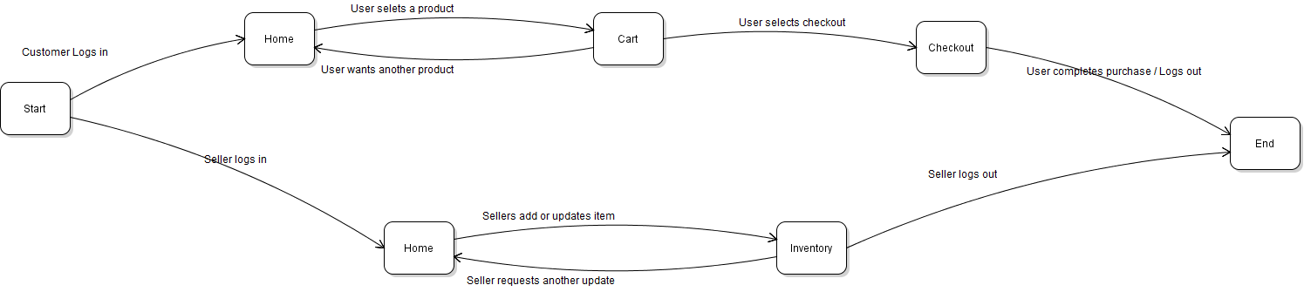

# 7.0 Use Case Sequence Diagrams

## 7.1 User Logs In

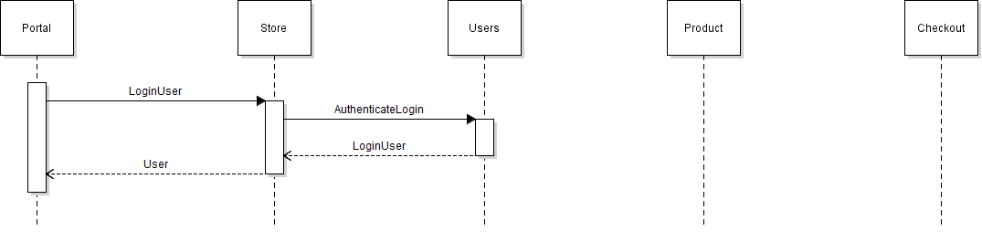

## 7.2 User Logs Out

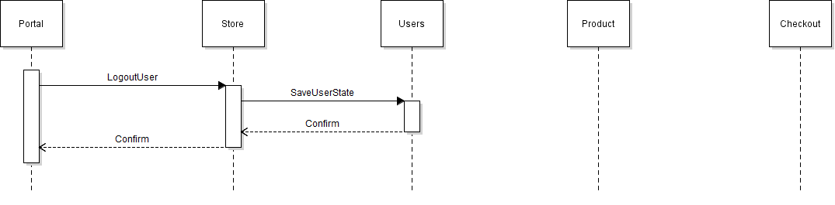

## 7.3 Customer Reviews Product Details

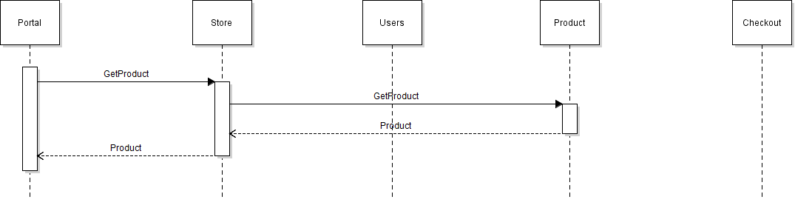

## 

## 7.4 Customer Adds Items to Shopping Cart

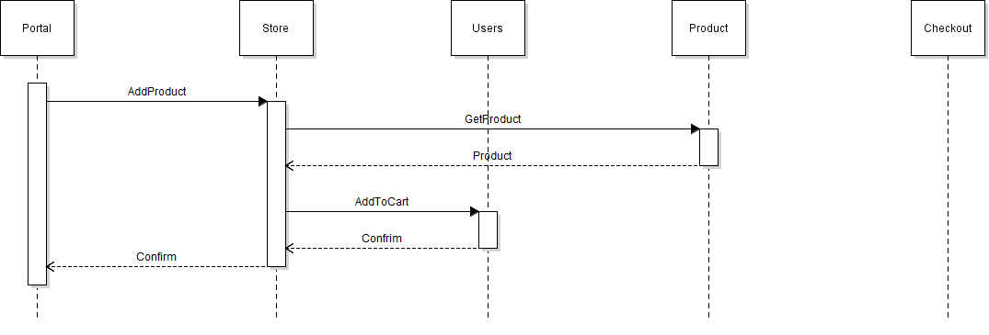

## 7.5 Customer Reviews/Updates Shopping Cart

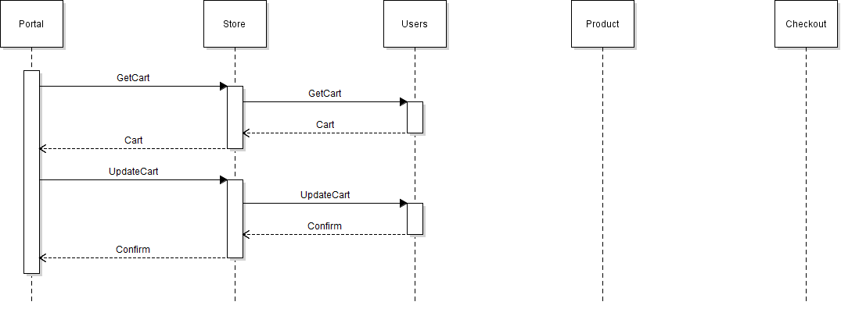

## 

## 7.6 Customer Checks Out

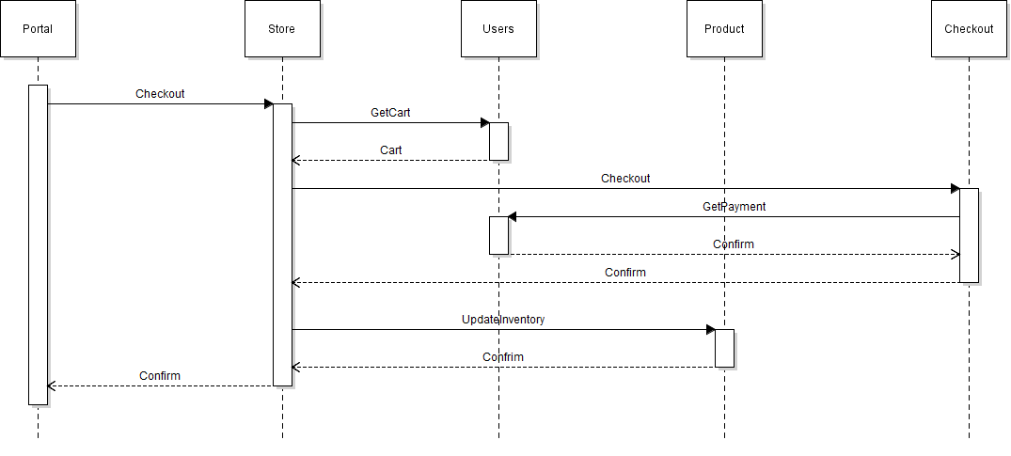

## 7.7 Seller Reviews/Updates Inventory

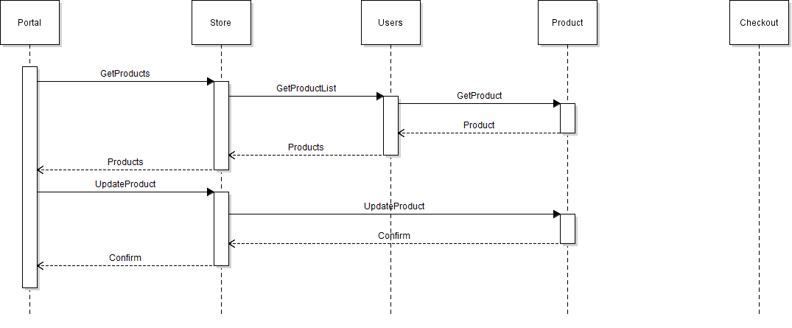

## 7.8 Seller Adds New Product

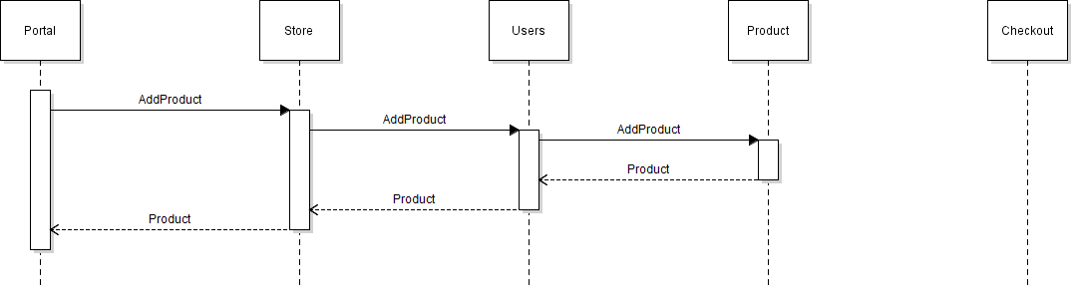

**8.0 Glossary**

Customer: A user that interacts with the system by browsing the product list and selecting products to buy.

Inventory: A list that manages all of the seller’s products. Displays the type and quantity of products as well as any revenue generated.

Order: The list of products the customer has purchased. It contains the total amount of products, the buyer’s payment information and the total cost of the order.

Product: An item that was supplied by a seller for purchase by a customer.

Product List: a list that manages all of the products in the system that is available for the Customer to buy.

Seller: A user that interacts with the system by supplying products to be displayed in the product list. They manage their list of products in their inventory.

Shopping Cart: a container that displays the list of products that the user has selected for purchase. Displays the type and quantity of products as well as the total cost.

Shopping System: The main system that contains all other systems and keeps track of the current user account, and the state.

User: Anyone that interacts with the system, by either supplying products or purchasing them. A user logs into the system with a username and password.