1. docker --version
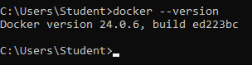
2. docker run hello-world
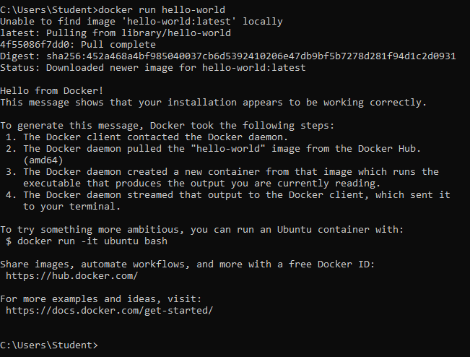
3. docker pull nginx
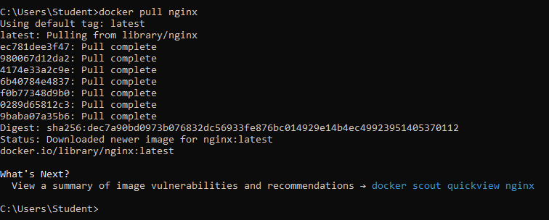
4. docker images
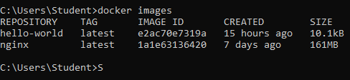
5. docker run -d nginx
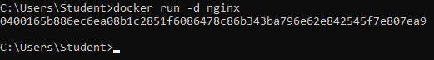
6. docker ps
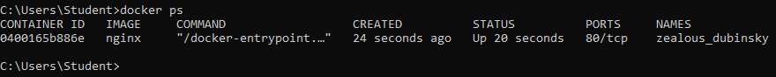
7. docker ps -a
8. docker logs <container_id>
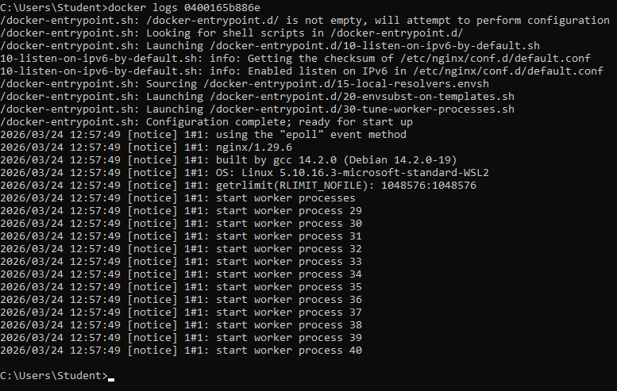
9. docker exec -it <container_id> /bin/sh
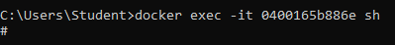
10. docker stop <container_id>
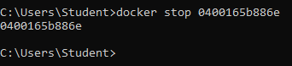
11. docker restart <container_id>
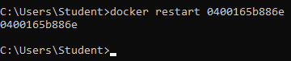
12. docker rm <container_id>
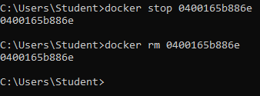
13. docker container prune
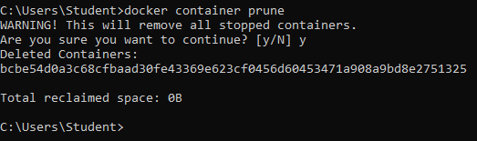
14. docker rmi <image_id>
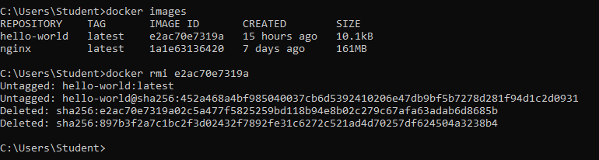
15. docker image prune -a
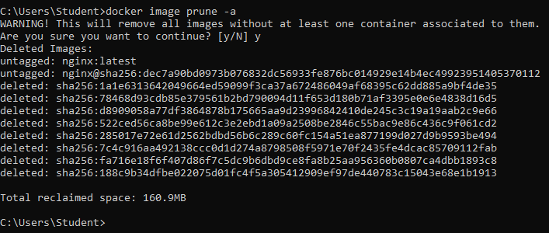
16. docker run -d -p 8080:80 nginx
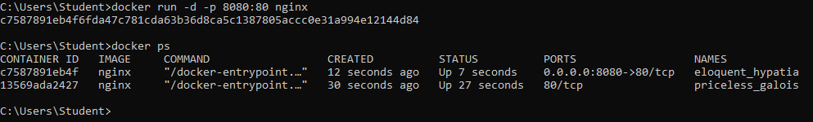
17. docker inspect <container_id>
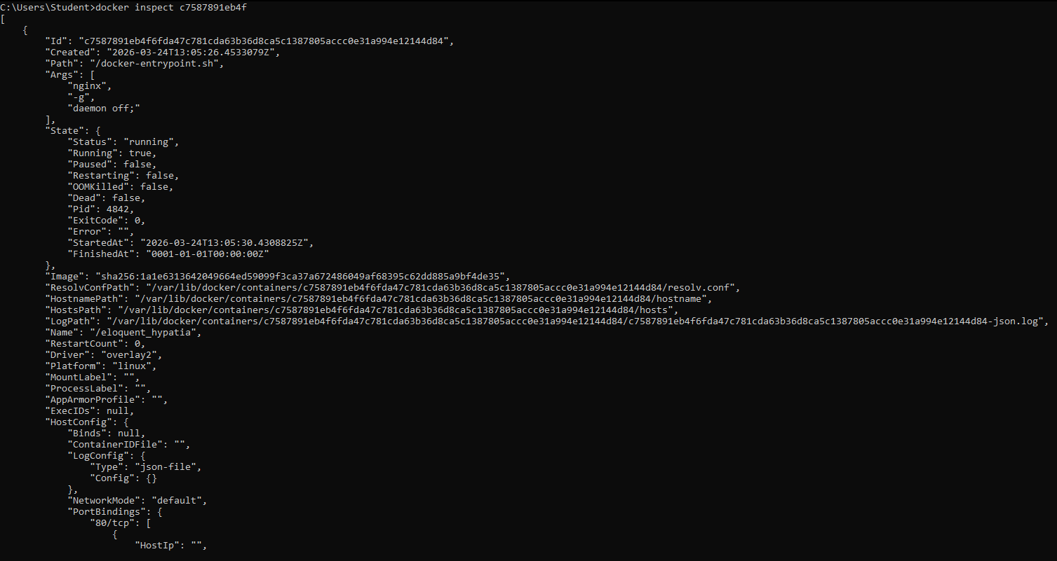
18. docker run -d -v mydata:/data nginx
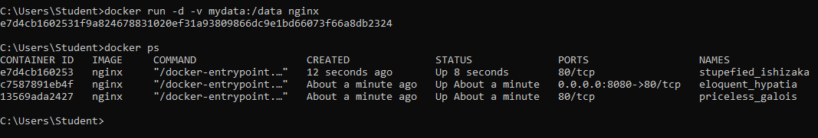
19. docker volume ls
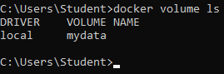
20. docker volume prune
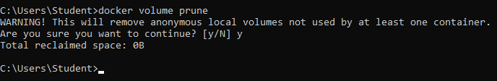
21. docker run -d --name my_nginx nginx
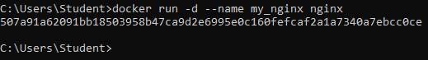
22. docker stats
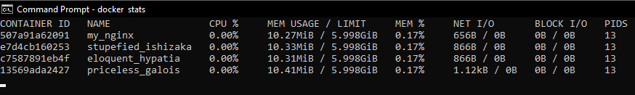
23. docker network ls
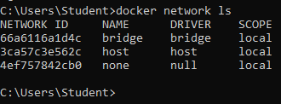
24. docker network create my_network
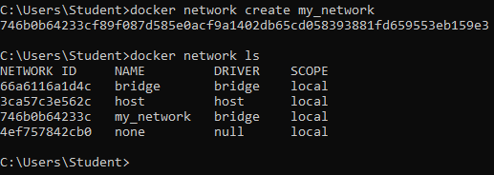
25. docker run -d --network my_network --name my_container nginx
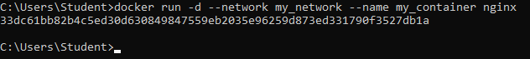
26. docker network connect my_network my_nginx
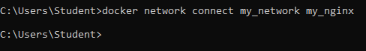
27. docker run -d -e MY_ENV=hello_world nginx
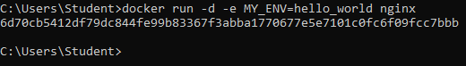
28. docker logs -f my_nginx
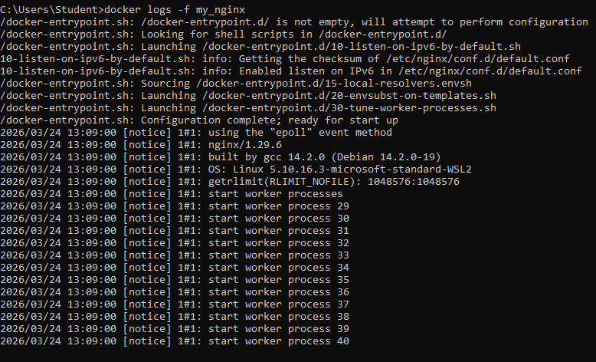
29. FROM nginx COPY index.html /usr/share/nginx/html/index.html
30. docker build -t my_nginx_image .
31. docker run -d -p 8080:80 my_nginx_image

