**A multi-lab test of the facial feedback hypothesis by The Many Smiles Collaboration**

Stage 2 Draft

|  |
| --- |
| Notes to collaborators:   * Given the Registered Report format, we can no longer make substantial changes to the Introduction or Methods section. Consequently, we are particularly interested in hearing your thoughts about the results we have obtained. The goal is to write a discussion that represents the majority view of the collaboration. Nonetheless, at the end of the project, we will allow collaborators to submit any dissenting opinions to the Open Science Framework, and we will link readers to these dissenting opinions in the Discussion section. * Per our pre-registration plan, we will also report Bayesian analyses for all primary analyses. The current draft does not currently include these Bayesian analyses because the estimated Bayes Factors slightly vary depending on various model specifications. Nonetheless, for major findings in the primary analyses, Bayesian analyses yield similar conclusions as their frequentist counterparts. * **If you have feedback that you would incorporated in the Discussion section, please send this feedback to Nicholas Coles (ncoles@stanford.edu) by end-of-day August 23rd.** |

The facial feedback hypothesis suggests that an individual’s emotional experience is influenced by their facial expressions. For example, smiling should typically make an individual feel happier and frowning should make them feel sadder. Researchers suggest that these effects emerge because facial expressions provide sensorimotor feedback that (a) contributes to the sensation of an emotion1,2, (b) serves as a cue that individuals use to make sense of ongoing emotional feelings3,4, (c) influences other emotion-related bodily responses5,6, and/or (d) influences the processing of emotional stimuli7,8. This facial feedback hypothesis is notable because it supports broader theories that contend emotional experience is influenced by feedback from the peripheral nervous system9–11, as opposed to experience and bodily sensations being independent components of an emotion response12–14. Furthermore, this hypothesis supports claims that facial feedback interventions—for example, smiling more or frowning less—can help manage distress15,16, improve well-being17,18, and reduce depression19-39.

Recently, a collaboration involving 17 independent teams consistently failed to replicate a seminal demonstration of facial feedback effects40. In the original study, participants viewed humorous cartoons while holding a pen in their mouth in a manner that either elicited smiling (pen held in teeth) or prevented smiling (pen held by lips)41. Consistent with the facial feedback hypothesis, smiling participants reported feeling more amused by the cartoons. This finding was influential because previous studies often explicitly instructed participants to pose a facial expression, raising concerns about demand characteristics42–44. Furthermore, theorists disagreed about whether these effects could occur outside of awareness45–47. Because participants in this pen-in-mouth study were presumably unaware they were smiling, the authors concluded that facial feedback effects were not driven by demand characteristics and could occur outside of awareness.

What implications does the failure-to-replicate have for the facial feedback hypothesis? One possibility is that the facial feedback hypothesis is false. However, this conclusion is unwarranted because this direct replication was limited to a specific test of the facial feedback hypothesis. Indeed, the replicators stated that their findings “do not invalidate the more general facial feedback hypothesis”40. Similarly, while arguing that the pen-in-mouth effect is unreliable, some researchers conceded that “other paradigms may produce replicable results”48.

A second possibility is that both the facial feedback hypothesis and the original pen-in-mouth effect are true. If this is the case, researchers must determine why others were unable to replicate the pen-in-mouth effect. One suggestion is that the replicators did not perform a true direct replication because they deviated from the original study by overtly recording participants (per the advice of an expert reviewer)49. According to this explanation, awareness of video recording may induce a self-focus that interferes with participants’ internal experiences and emotional behavior49,50.

A third possibility is that the facial feedback hypothesis is true, but not in the context examined in the original pen-in-mouth study. Perhaps facial feedback effects only occur when participants are aware they are posing a facial expression45,46, a mechanism that the pen-in-mouth task was designed to eliminate. Alternatively, perhaps the pen-in-mouth task is not a reliable manipulation of facial feedback. Some theorists predict that facial feedback effects will only emerge when facial movement patterns resemble a prototypical emotional facial expression5,51–55, and previous research indicates that the pen-in-mouth task does not reliably produce prototypical expressions of happiness56. Last, perhaps facial feedback only influences certain types of emotional experiences. Some researchers distinguish between self- versus world-focused emotional experiences, and facial feedback theories have traditionally emphasized self-focused emotional experience57,58. However, in the original pen-in-mouth study, participants were asked how amused a series of cartoons made them feel, which may have induced a world-focused emotional experience.

Amid the uncertainty created by the failure-to-replicate, a meta-analysis was performed on 286 effect sizes from 137 studies testing the effects of various facial feedback manipulations on emotional experience59. Results indicated that facial feedback has a small but highly varied effect on emotional experience. Notably, this effect could not be explained by publication bias. Published and unpublished studies yielded effects of similar magnitude, analyses failed to uncover significant evidence of publication bias, and bias-corrected overall effect size estimates were significant. However, this meta-analysis did not explain why facial feedback effects were not observed in the pen-in-mouth replication study. Inconsistent with preliminary evidence that video recording awareness interferes with facial feedback effects50, the meta-analysis revealed significant facial feedback effects regardless of whether studies used overt video recording59.

Although the meta-analysis suggests that the facial feedback hypothesis is valid, there are at least three limitations that could undermine this conclusion. First, because publication bias analyses often have low power60–62, it is possible that seemingly robust facial feedback effects are driven by studies with undetected questionable research practices. Second, it is possible that the overall effect size estimates in this literature are driven by low-quality studies63. Third, even relatively similar subsets of facial feedback studies varied beyond what would be expected from sampling error alone, meaning that moderator analyses had lower power and potentially contained unidentified confounds. Consequently, the meta-analysis could not reliably identify moderators that may help explain why some researchers fail to observe facial feedback effects.

Both the failure to replicate the pen-in-mouth study and the meta-analysis have a unique set of limitations that make it difficult to resolve the debate regarding whether the facial feedback hypothesis is valid. Consequently, we came together to form the Many Smiles Collaboration. We are an international group of researchers—some advocates of the facial feedback hypothesis, some critics, and some without strong beliefs—who collaborated to: (a) specify our beliefs regarding when facial feedback effects, if real, should most reliably emerge, (b) determine the best way(s) to test those beliefs, and (c) use this information to design and execute an international multi-lab experiment.

Weagreed that one of the simplest necessary conditions for facial feedback effects to emerge is that participants pose an emotional facial expression and subsequently self-report the degree to which they are experiencing the associated emotional state. Therefore, our main research question was whether participants would report feeling happier when posing happy vs. neutral expressions. Based on outstanding theoretical disagreements in the facial feedback literature, we also questioned (1) whether happy facial poses only influence feelings of happiness if they resemble a natural expression of happiness, (2) if facial poses can initiate emotional experience in otherwise neutral scenarios or only amplify ongoing emotional experiences, and (3) whether facial feedback effects are eliminated when controlling for awareness of the experimental hypothesis. These disagreements ultimately informed the final experimental design: a 2 (Pose: happy or neutral) x 3 (Facial Movement Task: facial mimicry, voluntary facial action, or pen-in-mouth) x 2 (Stimuli Presence: present or absent) design, with Pose manipulated within-participants and Facial Movement Task and Stimuli Presence manipulated between-participants (see Supplementary Information Figure 1).

To provide an easy-to-follow task that would produce more prototypical facial expressions, we used a facial mimicry task, wherein participants were asked to mimic images of actors displaying prototypical expressions of happiness64. To produce less prototypical facial expressions, some participants completed a voluntary facial action task65, wherein they were asked to move some—but not all—facial muscles associated with prototypical expressions of happiness56. We also added the pen-in-mouth task after Stage 1 reviewer feedback, wherein participants held a pen in their mouth in a manner that either elicited smiling (pen held in teeth) or prevented smiling (pen held by lips)41. While engaging in the facial movement tasks, half of the participants viewed a set of positive images57,58.

We hypothesized that participants would report experiencing more happiness when posing happy vs. neutral facial expressions. Furthermore, we hypothesized that the magnitude of this effect would be similar across tasks that produce more (facial mimicry task) vs. less (voluntary facial action and pen-in-mouth tasks) prototypical expression of happiness. We also expected that facial feedback effects would be smaller in the absence vs. presence of positive images. Last, we expected to observe facial feedback effects even when limiting our analyses to participants who were completely unaware of our hypothesis. Two pilot studies (n = 206; see Supplementary Information) confirmed these predictions. A third pilot study conducted after initial Stage 1 acceptance (n = 119; see Supplementary Information) provided preliminary evidence in favor of some—but not all—of our predictions. These pilot results led to minor refinements to the methodology but did not change our final set of predictions in our revised Stage 1 protocol. Our research questions and hypotheses are summarized in Table 1.

|  |  |
| --- | --- |
| Table 1 | |
| Research questions and associated hypotheses. | |
|  | |
| **Research Question** | **Hypothesis** |
| Does posing happy vs. neutral facial expressions cause people to feel happier? | Participants will report experiencing more happiness when posing happy vs. neutral facial expressions. |
| Do happy facial poses only influence feelings of happiness if they resemble a natural expression of happiness? | The difference in self-reported happiness when posing happy vs. neutral facial expressions will *not* be larger in tasks that produce more natural expressions of happiness. |
| Can facial poses initiate emotional experiences in otherwise neutral scenarios, or can they only modulate ongoing emotional experiences? | The difference in self-reported happiness when posing happy vs. neutral facial expressions will be significant both in the presence and absence of positive images. This difference will be larger in the presence of positive images. |
| Are facial feedback effects eliminated when controlling for awareness of the experimental hypothesis? | Participants who are judged to be completely unaware of the purpose of the experiment will report experiencing more happiness when posing happy vs. neutral facial expressions. |

Methods

**Procedure**

The experiment was presented via Qualtrics. Although many collaborators indicated a preference for in-person data collection, constraints created by the Coronavirus Disease 2019 (COVID-19) limited data collection to an online format. Before beginning the study, participants were asked to confirm that they (a) had a clean pen or pencil nearby that they are willing to place in their mouths, (b) were completing the study on a desktop computer or laptop, and (c) were in a setting with minimal distractions.

Participants were told that the study investigates how physical movements and cognitive distractors influence mathematical speed and accuracy and that they would complete four simple movement tasks and math problems. The first and last tasks were randomly presented filler trials designed to ensure the cover story is believable (Filler 1: “Place your left hand behind your head and blink your eyes once per second for 5 seconds”; Filler 2: “Tap your left leg with your right-hand index finger once per second for 5 seconds”). In the second and third tasks, participants were asked to pose happy and neutral facial expressions in randomized order through either the facial mimicry, voluntary facial action, or pen-in-mouth task (described below). While posing these expressions, some participants were randomly assigned to view positive images. To reinforce the cover story, participants were provided with an on-screen timer during all tasks.

After completing each filler and facial pose task, participants completed a simple filler arithmetic problem and the Discrete Emotions Questionnaire’s four-item happiness subscale, which asked participants to indicate the degree to which they experienced happiness, satisfaction, liking, and enjoyment during the preceding task (1 = “not at all” to 7 “an extreme amount”)66. Participants also completed two items measuring anxiety (worry, nervous). To further obscure the purpose of the study, participants also completed one anger, tiredness, and confusion filler item. All emotion items were presented in random order. By not referencing the positive stimuli, this questionnaire better captured self-focused, as opposed to world-focused, emotional experience57,58. Afterwards, participants rated how much they liked the task and how difficult they found the task and arithmetic problem. In the facial expression pose tasks, an attention check item asking participants to choose a specific response option was randomly inserted in the questions regarding the task and arithmetic problem difficulty.

In the facial mimicry condition, participants were shown a 2 x 2 image matrix of actors posing happy expressions. Participants were then instructed to either mimic these expressions (happy expression pose) or maintain a blank expression (neutral expression pose). Importantly, having participants view the happy expression matrix before both the happy and neutral expression pose trials ensured that any potentially confounding effects that images of smiling people have on emotional experience were constant across mimicry trials. The expression matrix was displayed for at least 5 seconds, and participants indicated when they were ready to perform the task. In the voluntary facial action technique condition, participants were instructed to either move the corner of their lips up towards their ear and elevate their cheeks using only the muscles in their face (happy expression pose) or maintain a blank facial posture (neutral expression pose). In the pen-in-mouth condition, participants received video instructions regarding the correct way to hold the pen in their teeth (happy expression pose) or lips (neutral expression pose). During all facial pose tasks, participants were instructed to maintain the poses for 5 seconds, the approximate duration of spontaneous happiness expressions67.

After completing the two filler and two facial pose tasks, participants answered a variety of open-ended questions regarding their beliefs about the purpose of the experiment via Qualtrics. Each research group recruited two independent, results-blind coders to review the open-ended responses. The coders were provided a written description of the study purpose and methods and subsequently reviewed participants’ open-ended responses in randomized order. Based on the open-ended responses, coders rated the degree to which each participant was aware of the true purpose of the experiment (1 = “not at all aware” to 7 = “completely aware”).

After answering questions about their beliefs regarding the purpose of the experiment, participants completed a short demographic form and the Body Awareness Questionnaire68. Participants then answered four questions related to the quality of their data. First, participants provided *compliance ratings*, wherein they were re-presented with their assigned happy pose instructions and asked to retrospectively rate how well they followed the instructions earlier in the study (1 = “not at all” to 7 = “exactly”). Second, participants provided *genuineness ratings*, wherein they were asked to repeat the task and rate the degree to which it feels like they are expressing happiness (1 = “not at all” to 7 = “exactly”). Third, if participants indicated that they were able to watch themselves repeat the task (e.g., via a mirror or camera phone), they provided *similarity ratings*. For similarity ratings, participants were asked to watch themselves repeat the task and indicate the degree to which their expression matches an image of an individual completing the task correctly (1 = “not at all” to 7 = “exactly”). Fourth, participants were asked to describe any issues that may compromise the quality of their data (e.g., distractions). The two coders from each research group reviewed the responses to this last question and rated the degree to which each participant was distracted (1 = “not at all distracted” to 7 “completely distracted”). Participants were told that there was not penalty for indicating that they did not complete the task correctly or that there are issues with the quality of their data.

Ideally, the quality of participants’ posed expression would have been assessed via video recordings or participant-submitted photos. However, many members of our collaboration expressed doubts about receiving ethical approval to collect and share images or recordings. Participants in many of our data collection region also lacked a web camera. Furthermore, researchers are still debating whether awareness of overt video recording interferes with facial feedback effects49,50,59,69. Nevertheless, pilot study recordings and self-reports confirmed that almost all participants complied with the pose instructions (see Supplementary Materials).

Materials

In the facial mimicry task, participants all viewed the same 2 x 2 image matrix of actors posing happy facial expressions from the Extended Cohn-Kanade Dataset70. All four actors posed prototypical facial expressions of happiness, as confirmed by coders trained in the Facial Action Coding System71. An image matrix of actors, as opposed to a single image, was used to ensure that participants have multiple examples of the movement and were provided with more options for a suitable facial model. In the pen-in-mouth task, instructional videos were adopted from Wagenmakers and colleagues’ replication materials40.

During the two facial pose tasks, half of participants viewed an array of four positive photos (e.g., photos of dogs, flowers, kittens, and rainbows). Multiple photos (as opposed to a single photo) were used to increase the probability that participants found at least one of the photos emotionally evocative. All photos were drawn from a database comprising 100 images from the Internet and the International Affective Picture System72 that were separately rated on how good and bad they were73. Results from three pilot studies confirmed that these images successfully elicited feelings of happiness. Due to potential cross-cultural differences in what types of photos elicit happiness (e.g., dog photos can be expected to elicit happiness in many Western European cultures, but not all African cultures), four research groups replaced photos with more culturally appropriate positive photos. For non-English speaking data collection sites, experiment materials were translated into the local language.

Power Analysis

Power analysis was performed via a linear multilevel modeling simulation. We randomly generated normally distributed data for 96 participants from 22 research groups. Effect size estimates for the hypothesized effects of pose (*d* = 0.39), stimuli presence (*d* = 0.68), and the pose by stimuli presence interaction (*d* = 0.29) were estimated from pilot studies 1 and 2. All other effects were set to zero. Pilot study 3 was run after initial in-principal acceptance was granted and yielded somewhat different effect size estimates. However, this pilot study led to minor refinements in exclusion criteria that left our original predictions unchanged.

Based on the two initial pilot studies, we simulated random intercepts for participants with *SD* = 0.70. We did not simulate random slopes for participants since there are only two observations within each participant, which would have likely led to convergence issues. Random slopes for research groups were simulated based on the values from the previous many-lab failure-to-replicate40. For hypothesized effects, we specified conservative random slopes estimates based on the standard deviation of the meta-analytic effect size from the previous many-labs failure-to-replicate (*SD* = 0.28). For effects we expected to be zero, we specified random slopes based on the random slope from the previous many-labs failure-to-replicate (τ2 ≈ 0). However, due to convergence issues, the research groups random slope for the facial feedback task factor was removed. Residual variance was set to 0.60 based on estimates from two pilot studies (see Supplementary Materials).

Results from this power simulation indicated that over 95% power for all our hypothesized effects could be obtained with at least 1,584 participants. However, based on results from a third pilot study, we estimated that 44% of participants would not meet our strict inclusion criteria (described below), leading to a desired sample of 2,281[1]. Consequently, we planned to collect data until one of the following conditions were met: (a) 22 labs had collected at least 105 participants, or (b) at least six months have elapsed since the start of data collection and we had at least 2,281 participants.

Participants

We stopped data collection once 22 labs had collected at least 105 participants, accruing complete observations from a total of 3,878 participants from 26 labs spanning 19 countries (*M*age = 26.6; *SD*age = 10.6; 71% women, 28% men, 1% other; see Figure 1). To be included in the primary analyses, participants must not have: (1) failed any attention check, (2) completed the study on a mobile device, (3) reported that they did not follow the facial expression pose instructions, (4) reported that their posed expression did not match an image of an actor completing the task correctly, (5) exhibited any awareness of the study hypothesis, or (6) indicated that they were very distracted during the study. 1,504 participants met these primary analyses inclusion criteria. For secondary and exploratory analyses, data from all 3,878 participants were used.

Ethics

Each research group received approval from their local Ethics Committee or IRB to conduct the study, indicated that their institution does not require approval for the researchers to conduct this type of research, or indicated that the current study is covered by a preexisting approval. All participants consented to participate in the study.

Figure 1.

Country-specific sample sizes. Darker shades denote larger sample sizes. Dotted countries denote countries where we did not collect data.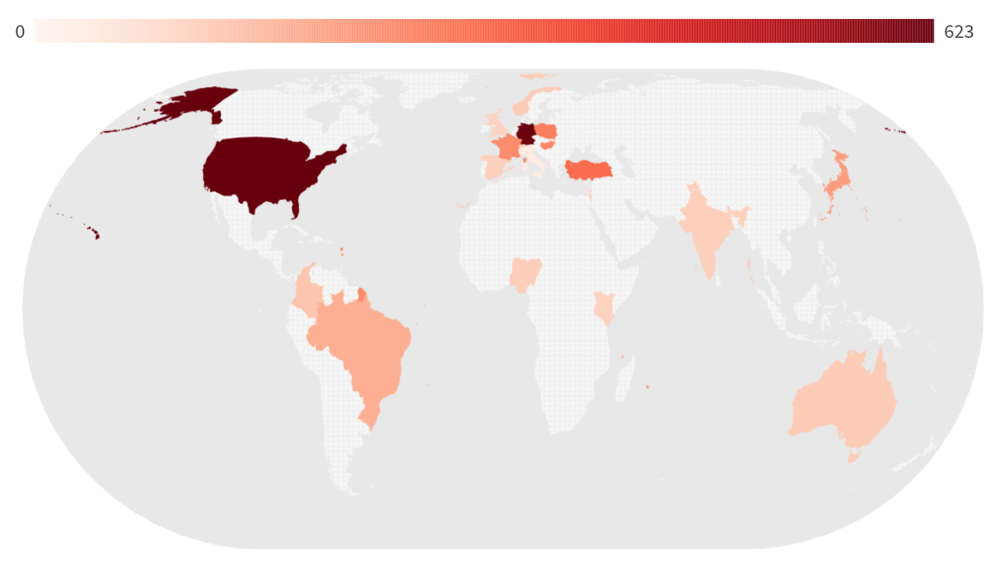

Result**s**

We used the same general approach for all analyses. Unless otherwise specified, happiness reports were modeled with (a) Pose (happy or neutral), Facial Movement Task (facial mimicry, voluntary facial action, or pen-in-mouth), and Stimuli Presence (absent, present) entered as effect-coded factors, (b) [for secondary analyses] continuous moderators entered mean-centered, (c) all higher-order interactions, and (d) random intercepts for participants and research groups. We initially planned to model random slopes for participants and research groups. However, in our primary analyses, these random slopes generally led to convergence issues without concomitant improvements in model fit and were thus (inconsequentially) removed from all reported analyses. For tests of main effects, simple effects, and interactions, we used ANOVA-like tables to derive *F*-values with Satterthwaite degrees of freedom. In instances where higher-order interactions were observed, we decomposed these interactions using simple effect tests and pairwise contrasts74.

Facial Feedback Manipulation Check

To examine the extent to which the facial movement tasks created expressions of happiness, we examined participants’ (1) compliance ratings (the extent to which they reported following the pose instructions), (2) genuineness ratings (the extent to which they reported that their posed expression felt like a genuine expression of happiness), and (3) similarity ratings (the extent to which their self-monitored expressions matched an image of actors successfully completing the task). Some participants reported that they could not self-monitor their expressions (e.g., via a camera or mirror). Thus, we observed relatively fewer similarity ratings. Task and rating-specific sample sizes, descriptive statistics, and distributions are shown in Figure 2.

Results indicated that participants reported following all facial feedback task instructions closely—but that the pen-in-mouth task did not produce a happiness expression that felt genuine. More specifically, compliance ratings were extremely high in all facial feedback tasks, with over 70% of participants indicating that they followed instructions exactly (the highest point on the scale; see Figure 2 Row 1). Similarity ratings were also high in all facial feedback tasks, with mean ratings above 5 (out of 7; see Figure 2 Row 2). Genuineness ratings, however, were not consistently high across facial feedback tasks. Participants who completed the facial mimicry or voluntary facial action tasks reported that the posed happy expressions felt moderately genuine (see Figure 2 Row 3). However, the modal response (32%) amongst participants who completed the pen-in-mouth task was that that the posed expression did not at all feel genuine (see Figure 3 Row 3). Supplemental between-task manipulation check analyses are available in the Supplemental Materials.

Figure 2.

Distribution of compliance, genuineness, and similarity ratings for each facial movement task.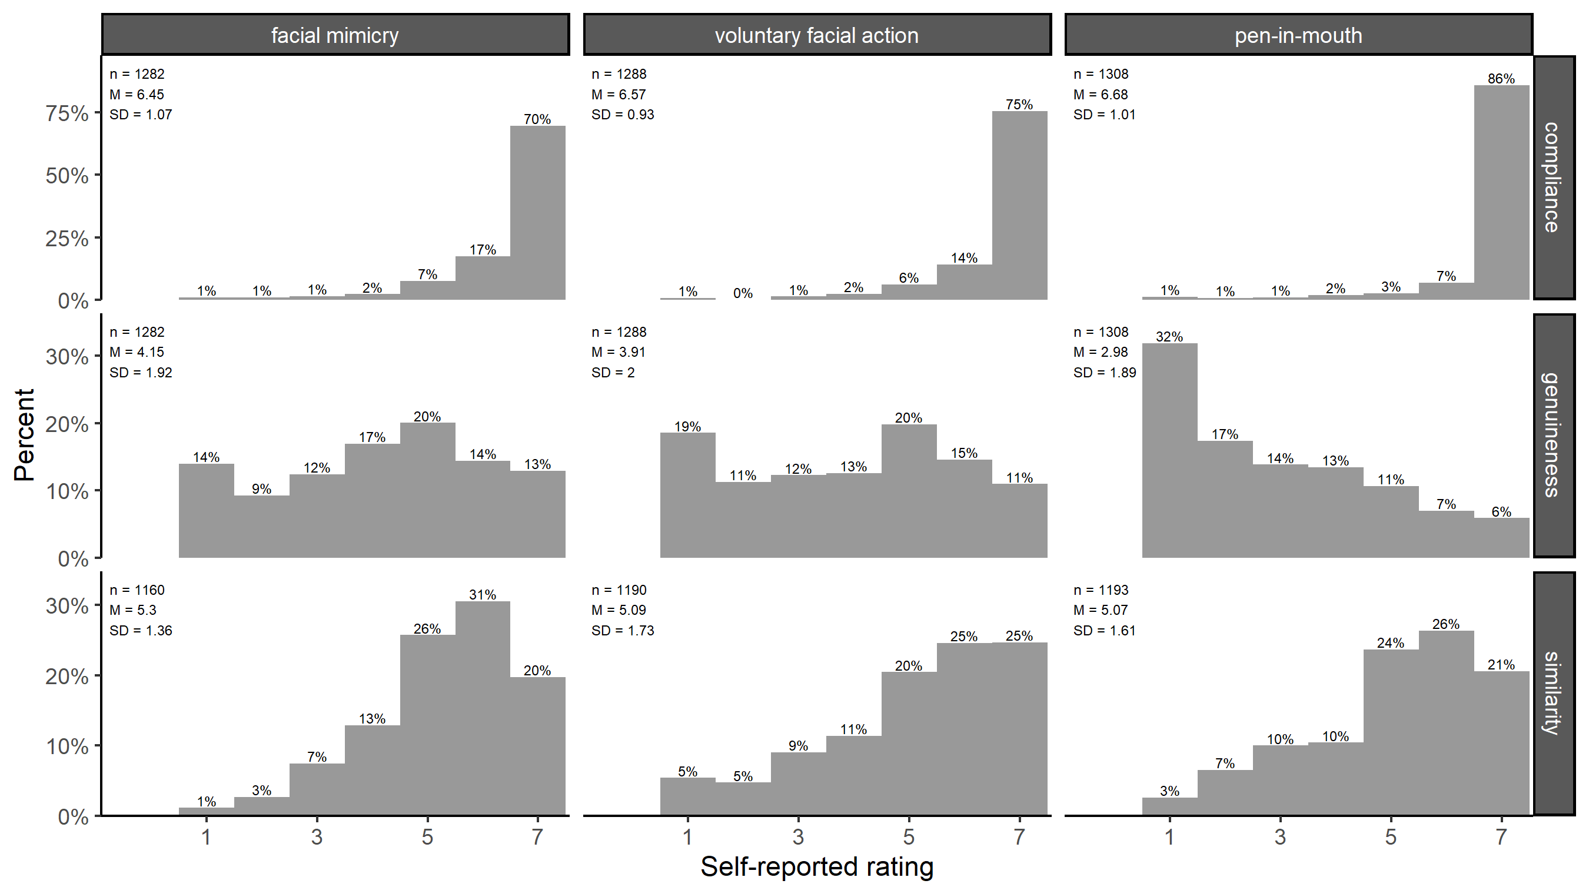

Primary Analyses

For our primary analyses, we hypothesized that (1) participants would report higher levels of happiness in the presence vs. absence of emotional stimuli (i.e., a main effect of Stimuli Presence), (2) participants would report higher levels of happiness after posing happy vs. neutral facial expressions (i.e., a main effect of Pose), (3) the magnitude of these effect would not vary across facial movement tasks (i.e., no interaction between Stimuli Presence and Facial Movement Task; no interaction between Pose and Facial Movement Task), and (3) the magnitude of the Pose effect would be larger in the presence vs. absence of positive stimuli (i.e., an interaction between Stimuli Presence and Pose).

Contrary to our predictions, we found some evidence of an interaction between Stimuli Presence and Facial Movement Task, *F*(2, 1476.7) = 3.25, *p* = .04, although Bayesian analyses were inconclusive. This two-way interaction indicated that the presence of positive images increased feelings of happiness the facial mimicry and voluntary facial action tasks—but not the pen-in-mouth task. Also contrary to our predictions, we observed a three-way interaction between Pose, Facial Movement Task, and Stimuli Presence, *F*(2, 1498) = 5.00, *p* = .007. This three-way interaction indicated that the effect of Pose on self-reported happiness was (a) significant in the facial mimicry and voluntary facial action tasks—but not the pen-in-mouth task, (b) significant in both the presence and absence of positive stimuli in all tasks besides the pen-in-mouth task, and (c) significantly stronger in the absence vs. presence of positive stimuli during the facial mimicry task (see Figure 3). We further describe these interactions by describing the Pose and Stimuli Presence effects for each facial movement task.

Facial mimicry task

In the facial mimicry task, participants reported higher levels in the presence vs. absence of positive images, *F*(1, 1475.31) = 7.90, *p* = .005 (see Figure 3, column 1). Participants also reported higher levels of happiness after posing happy vs. neutral facial expressions, *F*(1, 1498) = 99.09, *p* < .001. Results also indicated that there was a significant interaction between Pose and Stimuli Presence, *F*(1, 1498) = 10.56, *p* = .001. Nonetheless, the effect of Pose emerged both in the presence, *F*(1, 1498) = 22.81, *p* < .001, and the absence, *F*(1, 1498) = 85.92, *p* < .001, of positive images (see Figure 4, column 1). Taken together, these results suggest that mimicking prototypical expressions of happiness can both amplify and (perhaps to an even greater extent) initiate feelings of happiness.

Voluntary facial action task

In the voluntary facial action task, participants reported higher levels of happiness in the presence vs. absence of positive images, *F*(1, 1479.28) = 11.65, *p* < .001 (see Figure 3, column 2). Participants also reported higher levels of happiness after posing happy vs. neutral facial expressions, *F*(1, 1498) = 69.69, *p* < .001. We did not observe a significant Pose by Stimuli Presence interaction, *F*(1, 1498) = 0.04, *p* = .85. The Pose effect emerged both in both the presence, *F*(1, 1498) = 33.23, *p* < .001, and absence, *F*(1, 1498) = 36.85, *p* < .001, of positive images (see Figure 4, column 2). These results suggest that even the partial recreation of happy facial expressions—e.g., by simply pulling one’s lips back towards their ears—can both amplify and initiate feelings of happiness.

Pen-in-**mouth** task

In the pen-in-mouth task, we did not find that participants reported significantly higher levels of happiness in the presence vs. absence of positive images, *F*(1, 1475.09) = 0.16, *p* = .69 (see Figure 3, column 3). We also did not find that participants reported significantly higher levels of happiness after posing happy vs. neutral facial expressions, *F*(1, 1498) = 2.78, *p* = .10. Regardless of whether participants completed the pen-in-mouth task in the absence, *F*(1, 1498) = 0.32, *p* = .57, or presence, *F*(1, 1498) = 3.12, *p* = .08, of positive images, we did not find significant evidence that the pen-in-mouth task increased participants’ self-reported happiness (see Figure 4, column 3).

Although we did not find significant evidence of a pen-in-mouth effect in our pre-registered analysis strategy, we will note that other defensible data analysis strategies yielded different results. For example, when we re-fit the primary analysis model using only data from participants who completed the pen-in-mouth task, we did find significant evidence that participants reported higher levels of happiness after posing happy vs. neutral expressions, *F*(1, 604) = 5.78, *p* = .02. We also found significant evidence of a pen-in-mouth effect when we relaxed our inclusion criteria and included participants who (a) exhibited awareness of the study hypothesis and/or (b) indicated that they did not complete the pen-in-mouth task with high fidelity, *F*(1, 3848.91) = 12.75, *p* < .001. However, we pre-registered that we would consider the full model analyses containing strict inclusion criteria to be the best test of our hypotheses. Consequently, we cannot confidently conclude whether positive images or facial posing impacted feelings of happiness in the pen-in-mouth task

Figure 3.

Average self-reported happiness when positive stimuli were present or absent. Data are averaged across facial pose trials and visualized separately for each facial movement task. Grey points represent jittered participant-level observations, and blue circles represent task-level means.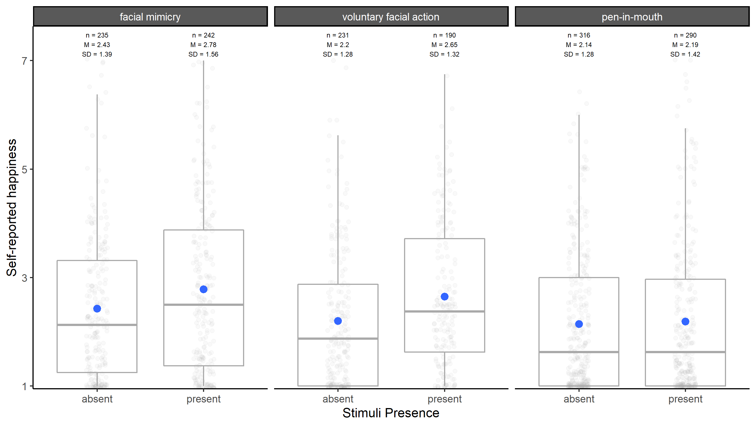

Facial feedback? Or aversion to the relatively passive neutral expression posing task?

Consistent with the facial feedback hypothesis, the above analyses provide reliable evidence that participants reported feeling happier after posing happy vs. neutral facial expressions in the facial mimicry and voluntary facial action tasks. However, an alternative explanation is that the effects were not driven by hypothesis-consistent increases in happiness after happy poses, but rather by hypothesis-irrelevant decreases in happiness after neutral poses. For example, perhaps participants found the relatively passive neutral expression tasks to be boring, which subsequently decreased participants’ feelings of happiness75.

We tested this alternative explanation by examining the extent to which participants reported feeling happy after completing two filler tasks (e.g., “Tap your left leg with your right-hand index finger once per second for 5 seconds”). We modeled happiness reports with (a) Pose (happy pose, neutral pose, filler 1, or filler 2)[2], Facial Movement Task (facial mimicry, voluntary facial action, or pen-in-mouth) and Stimuli Presence (absent, present), entered as effect-coded factors, (b) all higher-order interactions, and (c) random intercepts for participants and research groups. Below, we describe analyses that focus on participants who were not exposed to positive images because these images were only shown during the facial posing trials (thus confounding their key comparison with the filler trials). Nevertheless, we note that similar results were observed in the confounded analyses containing participants who were exposed to positive images.

Similar to the primary analyses, we observed an interaction between Pose and Facial Movement Task, *F*(6, 4494) = 11.48, *p* < .001 (see Figure 3). For both the facial mimicry and voluntary facial action tasks, participants reported higher levels of happiness after posing happy expressions vs. completing filler tasks (all *p*s < .01). These results suggest that aversion to the neutral task does not explain the observed effects of facial poses on happiness reports in the facial mimicry and voluntary facial action tasks. In the pen-in-mouth task, we sometimes observed that participants' happiness reports differed depending on which task they completed. However, in these scenarios, the observed effect was opposite of the hypothesized direction. Specifically, compared to the filler trials, we sometimes observed that participants reported *less* happiness after completing the pen-in-mouth facial movement trials (.16 < *p*s > .002).

Figure 4.

Self-reported happiness after participants posed happy facial expressions, posed neutral facial expressions, or completed two filler tasks. Data are visualized separately for the cross between (1) each facial movement task and (2) whether positive images were presented during the facial pose tasks. Grey points represent jittered participant-level observations, and blue circles represent task-level means.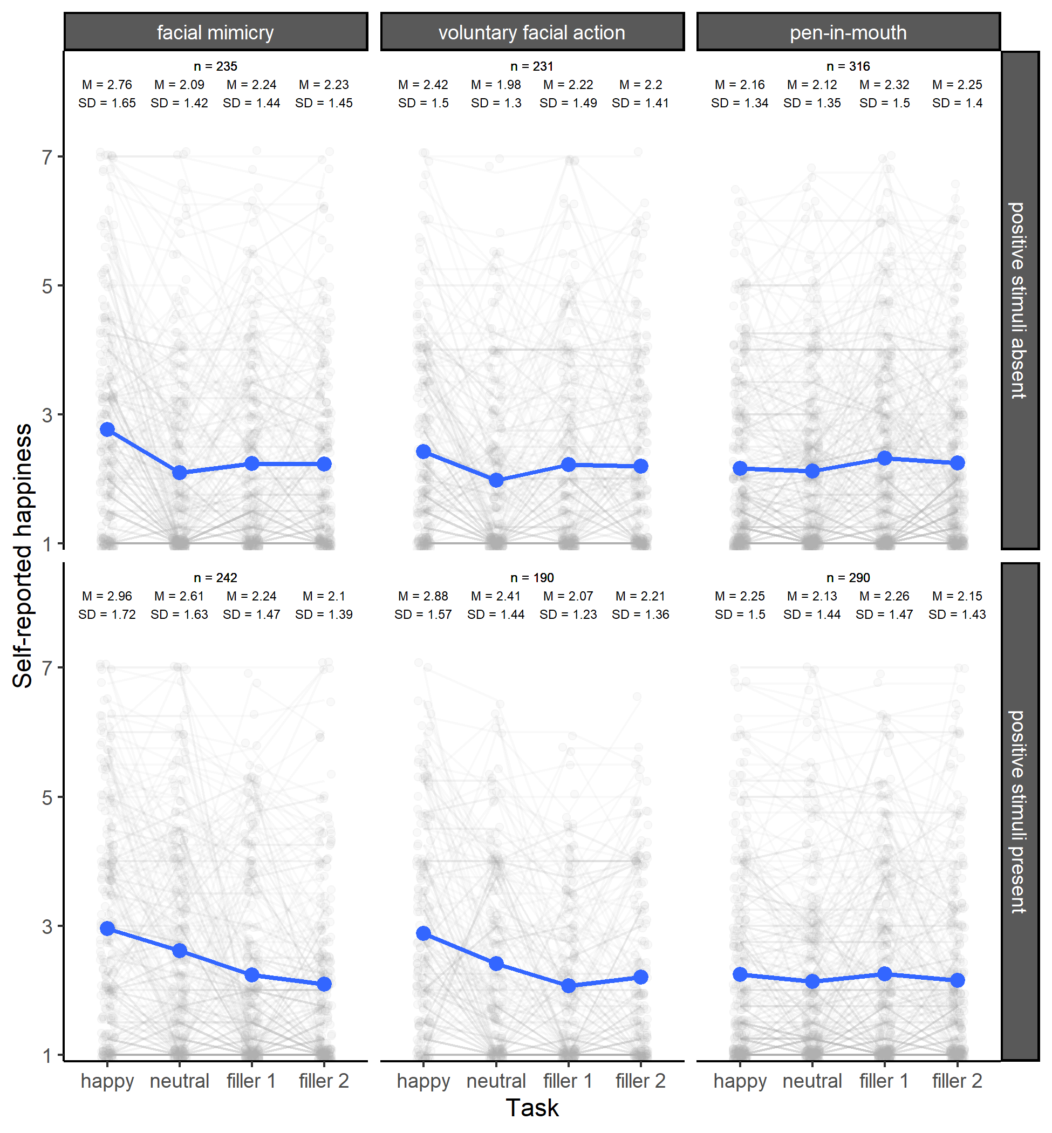

Secondary Analyses

Although our study was designed to test the hypotheses outlined in Table 1, we collected additional data that allowed us to further probe the nature of the observed effects of facial poses on happiness reports. Unless specified otherwise, these secondary analyses were pre-registered.

Do facial feedback effects vary as a function of pose quality?

Some theorists predict that facial feedback effects will only emerge when facial movement patterns resemble prototypical emotional facial expressions5,51–55. Following these theories, we examined whether the effect of facial poses on happiness would vary as a function of compliance, similarity, and genuineness ratings.

For all three quality indicators, results indicated that there were three-way interactions between Pose, Facial Movement Task, and the quality indicator (all *p* < .001; see Figure 4). Results revealed that the effect of facial poses on happiness was indeed larger among participants with higher compliance ratings—but this interaction was only significant in the facial mimicry (*p* < .001) and voluntary facial action (*p* < .001) conditions (pen-in-mouth *p* = .21). Similar patterns were observed when examining the interaction between Pose and similarity ratings (facial mimicry *p* < .001; voluntary facial action *p* < .001; pen-in-mouth *p* = .73). Nevertheless, across all facial movement tasks, we found that the effects of posed facial expressions on happiness were larger among participants with high genuineness ratings (all *p* < .001).

Based on model-derived contrasts, Figure 4 shows the estimated minimal levels of compliance, similarity, and genuineness needed to observe a significant Pose effect in our data. As shown in the shaded green regions, the estimated Pose effects were only significant when participants reported that they (a) at least moderately complied with the task instructions, (b) posed expressions that at least minimally matched actors who completed the task correctly, or (c) posed expressions that felt like at least minimally genuine. Figure 4 also compares these minimal levels to the observed modal responses within each facial feedback task. For the facial mimicry and voluntary facial action tasks, the modal responses to all three quality indicators were in the significance range (see black boxes in Figure 4; also see Figure 2). For the pen-in-mouth task, however, participants most frequently indicated that the posed expression of happiness did not at all feel genuine (see black boxes in Figure 4; also see Figure 2). These results provide one explanation for why we—and others40—failed to reliably find a facial feedback effect using the pen-in-mouth task: the task, as currently operationalized, does not typically produce a happiness expression that feels genuine.

Figure 4. Scatterplot of the association between (1) changes in self-reported happiness after participants posed happy vs. neutral facial expressions (i.e., the Pose effect) and (2) various indicators of the quality of posed happy facial expression. Data are visualized separately for each facial movement task (facial mimicry, voluntary facial action, or pen-in-mouth) and each quality indicator (compliance, similarity, and genuineness ratings). Grey points represent jittered participant-level observations, and blue lines represents estimated associations. Green panels represent quality indicator values where a model-derived Pose effect was positive and statistically significant (*p* < .05). Black boxes represent quality indicator modal responses.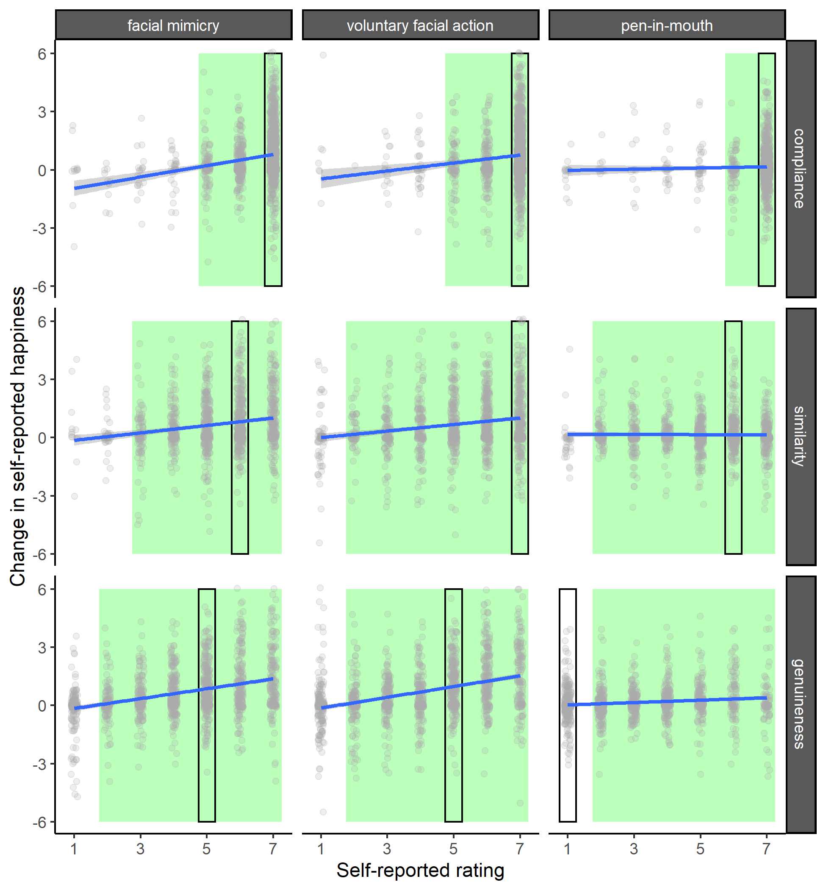

Are facial feedback effects moderated by awareness of the study purpose?

A large concern in facial feedback research is that observed effects are merely driven by demand characteristics42,48,76,77. Our primary analyses excluded participants who exhibited even slight awareness of the study hypothesis, yet we still observed robust evidence of facial feedback effects in the facial mimicry and voluntary facial action tasks. Thus, it seems unlikely that these effects were driven by demand characteristics.

Even though the observed effects of facial pose on happiness do not appear to be fully driven by demand characteristics, it is possible that they are nevertheless partially moderated by demand characteristics. In other words, perhaps facial feedback effects can emerge among naïve participants, but become magnified when these participants become aware of the study purpose. Consistent with this idea, secondary analyses indicated that the effect of facial poses on happiness were larger amongst participants who were more aware of the study hypothesis. (I.e., we found evidence of an interaction between Pose and our continuous indicator of awareness, *p* < .001.) Taken together, these results suggest that demand characteristics moderate—but do not fully account for—the effects of posed facial expressions on emotional experience.

Are facial feedback effects moderated by body awareness?

Researchers have debated the extent to which facial feedback effects occur outside of awareness45–47. If facial feedback effects reflect the operation of conscious processes, individual differences in awareness of facial activity should moderate facial feedback effects (i.e., facial feedback effects should be stronger among people who have greater awareness of their facial activity). Inconsistent with this idea, however, results did not indicate that the effect of facial pose was significantly larger amongst participants with higher levels of self-reported body awareness (*p* = .07; see Supplemental Materials for additional null findings from two pilot studies.)

Difference in anxiety and anger across conditions

To examine whether there were differences in anxiety and anger across conditions, we modeled these scores with (a) Pose (happy or neutral), Facial Movement Task (facial mimicry, voluntary facial action or pen-in-mouth), and Stimuli Presence (absent, present) entered as effect-coded factors, (b) all higher-order interactions, and (c) random intercepts for participants and research groups. These analyses served two purposes. First, these analyses allowed us to test concerns that the pen-in-mouth task may have caused increases in anxiety in the midst of the COVID-19 pandemic. Second, these analyses allowed us to examine the extent to which facial feedback influences (a) positive and negative affect more generally vs. (b) discrete emotions (e.g., anger) more specifically59. Indeed, if facial feedback influences positive and negative affect more generally, we should observe that posed happy expressions not only increases feelings of positive emotions (e.g., happiness), but also decreases feelings of negative emotions (e.g., anger and anxiety).

For both anxiety and anger, we observed main effects of Facial Movement Task and Pose (*p*’s < .001). We did not observe significant evidence of a main effect of Stimulus Presence or any higher-order interactions. For the main effect of Facial Movement Task, results indicated that participants reported higher levels of anxiety and anger in the pen-in-mouth (*M*anxiety= 1.65, *SD*anxiety= 1.10, *M*anger= 1.37, *SD*anger= 0.95) vs. facial mimicry (*M*anxiety= 1.49, *SD*anxiety= 0.97, *M*anger= 1.21, *SD*anger= 0.69) and voluntary facial action tasks (*M*anxiety= 1.48, *SD*anxiety= 0.96, *M*anger= 1.28, *SD*anger= 0.86). These results are consistent with concerns that the pen-in-mouth task caused increases in anxiety in the midst of the COVID-19 pandemic, although it is possible that these increases are driven by other factors (such as the difficulty of the task). For the main effect of Pose, results indicated that participants reported lower levels of anxiety and anger after posing happy (*M*anxiety= 1.52, *SD*anxiety= 1.01, *M*anger= 1.26, *SD*anger= 0.82) vs. neutral (*M*anxiety= 1.57, *SD*anxiety= 1.01, *M*anger= 1.31, *SD*anger= 0.86) facial expressions. However, these effects were miniscule in size.

Exploratory Analyses

Was a facial feedback effect in the pen-in-mouth effect obfuscated by increases in anxiety?

Consistent with concerns about the pen-in-mouth task causing increases in anxiety in the midst of the COVID-19 pandemic, we found that participants reported higher level of anxiety in the pen-in-mouth task. However, are these increases in anxiety large enough to obfuscate the effects of facial feedback of emotion? Preliminary evidence for such an assertion comes from our earlier examination of the simple effect of Stimuli Presence in each Facial Movement Task (see Figure X). More specifically, we found that exposure to positive images increased happiness in all tasks besides the pen-in-mouth task. These results suggest that the anxiety experienced in the pen-in-mouth task may have been powerful enough to negate the effects of other manipulations on happiness.

To examine this possibility further, we performed a variety of exploratory analyses. First, we modeled happiness reports in the pen-in-mouth task with (a) anxiety entered as a continuous moderator, (b) Pose and Stimuli Presence entered effect-coded, and (c) higher-order interactions between Pose and Stimuli presence, (d) random intercepts for lab and participants, and (e) our pre-registered primary analysis inclusion criteria. Results from this exploratory model indicated that participants reported higher levels of happiness after posing happy vs. neutral expressions in the pen-in-mouth task, *F*(1, 584.79) = 5.99, *p* = 0.01. Second, we re-ran these analyses after excluding participants who exhibited any degree of anxiety. More specifically, we modeled happiness reports in the pen-in-mouth task with (a) Pose and Stimuli Presence entered effect-coded, (b) all higher-order interactions, (c) random intercepts for lab and participants, and (e) our pre-registered primary analysis inclusion criteria. Results from this exploratory model indicated that there was a significant interaction between Pose and Stimuli Presence, *F*(1, 299.95) = 4.15, *p* = 0.04, wherein the effect of Pose was significant in the presence, *F*(1, 305.80) = 8.59, *p* = 0.004, but not the absence of positive images, *F*(1, 306.29) = 0.008, 0.93.

Taken together, results from exploratory analyses provide some evidence that increases in anxiety in the pen-in-mouth condition obfuscated a facial feedback effect. However, like our primary analyses, the patterns of results depend on the data analysis strategy and should likely be considered non-robust.

Cross-country comparisons of facial feedback effects

As an exploratory analysis, we examined the cross-country generalizability of the effect of each facial feedback task using random effects meta-analysis with Cohen’s standardized difference (*drm*) as the effect size index78,79. These meta-analyses should be interpreted with some caution for two reasons. First, although we initially planned to model random slopes for labs (a proxy for country) in our primary analyses, these models often did not substantially improve model fit or change our inferences. Those results provided preliminary evidence that facial feedback effects did not substantially differ across countries. Second, our experiment was not powered to provide high-power tests of the effects of facial feedback in each country sampled. Thus, even if facial feedback effects are real, we should expect many of the country-specific effect size estimates to be statistically non-significant. Third, like our secondary analyses, we used all available data in our exploratory analyses. This increased the number of observations in the meta-analysis, but we remind the reader that we believe our primary analyses provide the most stringent test of facial feedback effects.

Random-effects meta-analysis indicated that posed happy expressions had a medium-sized overall effect on happiness (*d* = 0.27, 95% CI [0.21, 0.33], *p* < .001) that was significantly moderated by the facial feedback task (*p* < .001). As shown in Figure 5, subgroup analyses indicated that posed happy expressions had small-to-medium effects on happiness in the facial mimicry (*d* = 0.38, 95% CI [0.29, 0.46], *p* < .001) and voluntary facial action conditions (*d* = 0.37, 95% CI [0.25, 0.49], *p* < .001). Although the more critical tests were not significant in our primary analyses, meta-analysis indicated that posed facial expressions had an extremely small and near-zero effect on happiness (*d* = 0.10, 95% CI [0.04, 0.15], *p* < .01; see Figure 5).

Although modeling random slopes for labs did not substantially improve model fit in our primary analyses, Cochrane’s Q tests indicated that the facial feedback effects in all tasks significantly varied between countries (all Q > 39.70; all *p* < .005; see Figure 5). As shown in Figure 5, the estimated effects of facial feedback in the facial mimicry and voluntary facial action tasks were positive in almost all countries sampled. However, these effect size estimates were not statistically significant in many countries (e.g., Nigeria and Italy). Although we, of course, did not power our study to detect facial feedback effects within each country, we believe that these results highlight a limitation of the present work: although we can conclude with high certainty that some facial feedback tasks have a significant overall effect *across* countries, we often cannot confidently conclude that these tasks had a significant overall effect *within* each country sampled.

Comparing the effects of positive images and facial feedback across countries

Although outside the focus of the primary analyses, results indicated that exposure to positive images significantly increased happiness (see Table 2). This was true when averaging across all conditions (i.e., main effect of Stimuli Presence) and when examining the effect within specific conditions (i.e., higher order interactions involving Stimuli Presence). To benchmark the size of our observed facial feedback effects, we compared the magnitude of facial feedback effects to the simple effect of positive images. Ideally, we would examine the simple effect of our positive images by asking participants to report their emotions after doing nothing other than viewing the positive photos. (I.e., not while simultaneously engaging in a facial pose task.) The closest we can get to those ideal conditions is to (a) focus on the relatively inactive neutral pose trials and (b) compare the emotion reports of participants who viewed vs. did not view positive images during this neutral pose trial. When we did so, random-effects meta-analysis indicated that exposure to positive images had a small-to-medium overall effect on happiness (*d* = 0.32, 95% CI [0.24, 0.41], *p* < .001; see Figure 5). These results indicate that the mood-boosting effects of the facial mimicry and voluntary facial action tasks was similar in size to the mood-boosting effects of viewing positive images.

Although we assumed that the positive images would be equally effective at eliciting happiness across countries, a Cochrane’s Q test indicated that the effect significantly varied between countries (Q = 46.04; *p* < .005; see Figure 5). The effects of the positive images were estimated to be significant in almost all countries. However, in two countries (Kenya and Italy) the non-significant estimated effects were in the negative direction. This is surprising because each lab either (a) confirmed that the images were appropriate for their sample, or (b) swapped out images they believed were not appropriate for their sample. Nonetheless, results indicated that the positive images, overall, had a small-to-medium but varied effect on emotional experience.

Figure 5. Forest plot of (a) the effects of posed happy vs. neutral expressions on happiness in the facial mimicry, voluntary facial action, and pen-in-mouth tasks (white panels) and (b) the effects of exposure to positive images on happiness across all tasks (tan panel). Cohen’s *d*rm was used as the effect size index. Grey boxes/bars represent country-level effect-size estimates and blue boxes/bars represent overall effect size estimates. Country names are denoted by International Organization for Standardization codes. A picture containing chart

Discussion

Given that our project was a massive collaboration between researchers with different perspectives, we structured the discussion of our results based on the majority opinion of collaborators. Nonetheless, we permitted collaborators to upload dissenting opinions as Supplemental Materials and encourage readers to review these dissenting opinions for additional context. [Note: no dissenting opinions have been submitted yet, but this is placeholder text in case we do not all agree!]

Weighing in on mixed evidence of facial feedback effects

Our results provide mixed evidence of facial feedback effects. When using the facial mimicry and voluntary facial action tasks, we found robust evidence that posing happy vs. neutral expressions both modulated and initiated feelings of happiness. However, contrary to our own predictions, we did not find reliable evidence of these effects when using a conceptual replication of the influential pen-in-mouth task.

Although results provided evidence of facial feedback effects in the facial mimicry and voluntary facial action tasks, a critic may argue that such effects are driven by methodological artifacts. However, our methodology allowed us to address what we believe are the two most plausible artifacts: (1) participants’ aversion to the relatively inactive (and potentially boring) neutral pose task, and (2) demand characteristics.

To examine whether our observed effects were driven by participants’ aversion to the relatively inactive neutral pose tasks, we compared participants’ happiness reports in both the facial pose trials and the filler trials. Our results indicated that participants did indeed report less happiness during the neutral vs. filler trials, suggesting that concerns about participants’ aversion to the relatively inactive control conditions are somewhat justified. However, even when we focused on the filler trials (as opposed to the neutral pose trials), we found that participants reported more happiness after posing happy expressions. These results suggest that participant aversion to the relatively inactive neutral pose task cannot explain our observed facial feedback effects.

A second concern is that the observed facial feedback effects are driven by demand characteristics80. Unlike the pen-in-mouth task, the facial mimicry and voluntary facial action tasks lead to overt changes in facial movements that may cause participants to infer the purpose of the study and change their responses accordingly. Our results, however, are not consistent with this explanation. In our primary analyses, we observed significant facial feedback effects in the facial mimicry and voluntary facial action tasks even though we excluded participants who exhibited even the slightest awareness of our hypothesis. Nonetheless, although demand characteristics cannot explain the facial feedback effects observed in the currently study, we note that our work simultaneously highlights that they can *amplify* facial feedback effects. This observation is consistent with recent facial feedback research that manipulated demand characteristics by telling participants that the purpose of the study was to demonstrate that facial feedback effects are either real or not real81. Their results indicated that this demand characteristics manipulation could moderate facial feedback effects—but that participants still exhibited these effects when they were told that the experimenter hoped to demonstrate that they are *not* real (i.e., when demand characteristics worked against facial feedback effects). Taken together, these results suggest that demand characteristics can moderate but do not fully explain the effects of facial feedback on emotional experience.

Were failures to observe facial feedback effects when using the pen-in-mouth task Type II errors?

The second possibility is that the facial feedback hypothesis is true and failures to observe effects when using the pen-in-mouth task were Type II errors. We do not believe this is the case.

The strongest argument for the presence of a Type II error is that our study was conducted in the midst of the COVID-19 pandemic. Although participants were (a) able to complete the experiment in any location of their choosing, and (b) were informed ahead of time that they may be asked to place a pen in their mouth, it is possible that the task nevertheless increased anxiety that interfered with any mood boosting effect of posed happy expressions. Consistent with this concern, we observed that participants reported a small increase in anxiety in the pen-in-mouth condition (compared to the other facial feedback conditions; *d* = .17). However, this increase in anxiety was less than half the size of the observed effect of facial feedback on happiness (Figure 5). Thus, even if anxiety is perfectly negatively correlated with happiness, the increases in anxiety created by placing a pen in one’s mouth should not have been strong enough to eclipse the increase in happiness produced by facial feedback. Similarly, results indicated that increase in anxiety did not eclipse the mood-boosting effects of positive images in the pen-in-mouth condition. If the increases in anxiety did not disrupt the mood-enhancing effects of the positive images, it seems unlikely that it could disrupt the mood-enhancing effect of facial feedback (which tended to be similar in magnitude; see Figure 5). Taken together, we do not believe that the anxiety produced by placing a pen in one’s mouth during the COVID-19 pandemic should have interfered with true facial feedback effects.

Is the pen-in-mouth task we used a valid manipulation of facial feedback?

We believe that the most plausible explanation for our results is that the facial feedback hypothesis is true, but the pen-in-mouth task we used does not reliably produce facial feedback effects. Participants reported complying with the instructions in all our facial feedback tasks quite closely. However, unlike participants who completed the facial mimicry and voluntary facial action tasks, the modal participant who completed the pen-in-mouth task reported that the happy pose did not at all feel genuine. These results provide preliminary evidence of construct validity issues with the pen-in-mouth task—or at least the version of the pen-in-mouth task used in our experiment. Facial feedback researchers have used multiple variants of the pen-in-mouth task82, and our results cannot directly speak to the validity of these other approaches. Nonetheless, we believe that future researchers should carefully examine the construct validity of facial feedback tasks, for example, by examining the extent to which these tasks activate facial muscles associated with genuine expressions of emotion.

Future researchers who examine the construct validity of facial feedback manipulations will likely have to grapple with ongoing debates about how to characterize the moderating role of the quality of the posed expression. Many researchers have characterized this moderating role in a dichotomous manner, suggesting that facial feedback effects will only emerge when the facial pose closely matches a prototypical expression of emotion. Our results, however, suggest that the relationship should be characterized in a more continuous manner. The voluntary facial action task was designed to create a non-prototypical, partial expression of happiness, but still yielded significant facial feedback effects. These results suggest that facial poses do not need to match prototypical expressions of emotion to produce facial feedback effects. Nonetheless, we found some evidence that facial feedback effects can be magnified when the quality of the posed expression is increased. In our primary analyses (but not our exploratory analyses), we found that facial feedback effects were larger when participants completed the task designed to produce more prototypical (i.e., the facial mimicry task) vs. less prototypical (i.e., the voluntary facial action task) expressions of happiness. Providing further evidence of the moderating role of pose quality, we found that facial feedback effects were larger among participants who (a) better complied with task instructions, (b) posed expressions that were more similar to the target happy expression, and (c) felt that the posed expression felt more like an expression of happiness.

Other implications for the facial feedback hypothesis

After Wagenmakers and colleagues failed to replicate the pen-in-mouth effect40, some researchers suggested that video recording interferes with facial feedback effects49,83. However, we did not record our participants and still failed to observe a significant pen-in-mouth effect. These results contribute to an already mixed literature on the disruptive effects of video recording in facial feedback research. More specifically, one team of researchers recently provided preliminary evidence that the pen-in-mouth effect only emerges among participants who are not recorded50, but their key test of the moderating role of video camera presence was not statistically significant84. Contrary to their results, a subsequent meta-analysis revealed that video recording did not interfere with facial feedback effects in general59. Combined with our own results, we believe that there is reasonable doubt about whether differences in video recording can account for mixed evidence of facial feedback effects when using the pen-in-mouth task.

Our results also provide initial evidence that facial feedback effects can vary between countries. This between-country variability could have theoretically uninteresting causes, such as differences in how well participants completed the facial pose tasks. More intriguingly, though, these results may suggest that facial feedback effects operate differently depending on culture. If true, these results would raise questions about the extent to which the effects of facial feedback on emotions are innate vs. learned. For example, some theorists posit that facial feedback impacts emotion via innate connections to neural systems that produce emotion-related changes47,85, whereas other researchers posit that such connections are learned86–88. Evidence of cross-cultural variability might suggest that these connections are at least partially moderated by learned experience.

Future researchers can use a variety of methods to examine the extent to which links between facial feedback and emotion are learned. One way to do so is to study the effects of posing culture-specific emotional expressions on emotion. For example, in the Oriya Hindu culture, Kali’s tongue is a culturally unique facial expression of shame, wherein people protrude and bite their tongue between their lips89. If facial feedback effects are driven by learned associations, posing Kali’s tongue should produce feelings of shame in individuals from the Oriya Hindu population, but not people from most other populations. Alternatively, researchers may opt to experimentally strengthen, weaken, or create novel associations between facial feedback and emotion. For example, similar to experimental work on embodied metaphorical language90, researchers can (1) repeatedly pair specific facial movements (e.g., cheek puffing) with emotionally evocative information (e.g., fear-inducing images) and (2) later examine whether the production of these facial movements can re-activate the associated emotional states.

Our results also provide evidence that facial feedback effects are not strongly moderated by individual differences in body awareness (for converging evidence from our first pilot study, see the Supplemental Materials). These results are surprising because some researchers have suggested that individuals who rely more on “self-produced cues” (e.g., facial expressions; autonomic activity) vs. “situational cues” (e.g., stimuli in the environment) should exhibit larger facial feedback effects3,46,91. Although speculative, these results may suggest that facial feedback effects operate unconsciously. Consistent with this possibility, other researchers have found that facial feedback can impact several non-experiential components of emotion, such as neural responses index by frontal EEG 6,92, late positive potential93, and fMRI94,95. Similarly, a recent study found that there were a sizeable proportion of participants who exhibited facial feedback effects but later indicated that they do not believe posed facial expressions can impact emotion81. This discrepancy between participants’ behavior and self-reports provides further evidence that facial feedback effects may occur unconsciously.

Facial feedback effects outside of experimental contexts

Although our study indicates that facial feedback can both initiate and modulate feelings of happiness, it is not yet clear how these effects may operate outside our experimental context. For example, people often pose smiles in their day-to-day life when dealing with customers, co-workers, friends, and acquaintances. However, meta-analysis indicates that this so-called “emotion labor” is often associated with *decreases* in well-being in a real-world work context96. One possibility is that the mood-boosting effects of posed smiles in these scenarios are eclipsed by the mood-dampening effect of the situations calling for this emotion labor (e.g., difficult co-workers). Future research can investigate this possibility by, for example, manipulating whether emotion labor demands changes in facial expressions. A second explanations for discrepancies between the facial feedback literature and the emotion labor literature is that the effects of posed expressions on emotion are mediated by self-perception processes. Self-perception theories posit that people’s behavior can influence their inferences about their attitudes or emotional states, but only when they have ambiguous explanations for their behavior45,46,97. Facial feedback effects may have emerged in our study because participants did not have an obvious rationale for posing smiles. However, such effects may disappear when people aware that they are posing smiles to, for example, appease a customer. Future research can test this possibility by manipulating the rationale for posing facial expressions of emotion.

Our results also have implications for ongoing discussions regarding whether facial feedback interventions can be leveraged to help manage distress15,16, improve well-being17,18, and reduce depression19-39. Our findings that facial feedback increased positive emotions (i.e, happiness) and decreased negative emotions (i.e., anxiety and anger) provide some support for these ideas. However, our results simultaneously highlight that such effects are quite small. Indeed, the estimated mood-boosting effect of facial feedback was roughly the same as that of looking at positive images, such as rainbows, flowers, and puppies. Consequently, it seems unlikely that a facial feedback.

Stimuli Presence

To examine the extent to which positive images elicited feelings of happiness, we modeled happiness reports with (a) Stimuli Presence (absent, present) and Facial Movement Task (facial mimicry, voluntary facial action, or pen-in-mouth) entered as effect-coded factors, (b) all higher-order interactions, and (d) random intercepts for participants and research groups. Although we did not pre-register this manipulation check, results surprisingly indicated that there was a significant interaction between Stimuli Presence and Facial Movement Task, *F*(2, 3855.8) = 5.44, *p* = .00

For our primary analyses, we hypothesized that (1) participants would report higher levels of happiness after posing happy vs. neutral facial expressions (i.e., a main effect of Pose), (2) the magnitude of this effect would not vary across facial movement tasks (i.e., no interaction between Pose and Facial Movement Task), and (3) the magnitude of the effect would be larger in the presence vs. absence of positive stimuli (i.e., an interaction between Pose and Stimuli Presence; see Table 1).

# References

1. Zajonc, R. B. The primacy of affect. *Am. Psychol.* **40**, 849–850 (1985).

2. Tomkins, S. *Affect imagery consciousness: Vol 1 The positive affects*. (Springer, 1962).

3. Laird, J. D. & Crosby, M. Individual differences in self-attribution of emotion. in *Thought and feeling: Cognitive alteration of feeling states* 44–59 (1974).

4. Allport, F. H. A physiological-genetic theory of feeling and emotion. *Psychol. Rev.* **29**, 132–139 (1922).

5. Levenson, R. W., Ekman, P. & Friesen, W. V. Voluntary facial action generates emotion-specific autonomic nervous system activity. *Psychophysiology* **27**, 363–384 (1990).

6. Coan, J. A., Allen, J. J. B. & Harmon-Jones, E. Voluntary facial expression and hemispheric asymmetry over the frontal cortex. *Psychophysiology* **38**, 912–925 (2001).

7. Scherer, K. R. & Moors, A. The emotion process: Event appraisal and component differentiation. *Annu. Rev. Psychol.* **70**, 719–745 (2019).

8. Stepper, S. & Strack, F. Proprioceptive determinants of emotional and nonemotional feelings. *J. Pers. Soc. Psychol.* **64**, 211–220 (1993).

9. Friedman, B. H. Feelings and the body: The Jamesian perspective on autonomic specificity of emotion. *Biol. Psychol.* **84**, 383–393 (2010).

10. James, W. Discussion: The physical basis of emotion. *Psychol. Rev.* **1**, 516–529 (1894).

11. Lange, C. G. *Om sindsbevaegelser; et psyko-fysiologisk studie*. (Lund, 1885).

12. Cannon, W. The James-Lange theory of emotions: A critical examination and an alternative theory. *Am. J. Psychol.* **39**, 106–124 (1927).

13. Cannon, W. *Bodily Changes in Pain, Hunger, Fear and Rage*. (D Appleton and Company, 1915).

14. Sherrington, C. S. Experiments on the value of vascular and visceral factors for the genesis of emotion. *Proc. R. Soc. London* **66**, 390–403 (1899).

15. Ansfield, M. E. Smiling when distressed: when a smile is a frown turned upside down. *Personal. Soc. Psychol. Bull.* **33**, 763–775 (2007).

16. Kraft, T. L. & Pressman, S. D. Grin and bear it: The influence of manipulated facial expression on the stress response. *Psychol. Sci.* **23**, 1372–1378 (2012).

17. Schmitz, B. *Art-of-Living*. vol. 63 (2016).

18. Lyubomirsky, S. *The how of happiness: A scientific approach to getting the life you want*. (Penguin, 2008).

19. Alam, M., Barrett, K. C., Hodapp, R. M. & Arndt, K. A. Botulinum toxin and the facial feedback hypothesis: can looking better make you feel happier? *J. Am. Acad. Dermatol.* **58**, 1061–1072 (2008).

20. Alves, M. C., Sobreira, G., Aleixo, M. A. & Oliveira, J. M. Facing depression with botulinum toxin: Literature review. *Eur. Psychiatry* **335**, 5290–5643 (2016).

21. Chugh, S., Chhabria, A., Jung, S., Kruger, T. H. C. & Wollmer, M. A. Botulinum toxin as a treatment for depression in a real-world setting. *J. Psychiatr. Pract.* **24**, 15–20 (2018).

22. Finzi, E. Update: botulinum toxin for depression: More than skin deep. *Dermatologic Surg.* **44**, 1363–1365 (2018).

23. Finzi, E. & Rosenthal, N. E. Emotional proprioception: Treatment of depression with afferent facial feedback. *J. Psychiatr. Res.* **80**, 93–96 (2016).

24. Finzi, E. & Rosenthal, N. E. Treatment of depression with onabotulinumtoxinA: A randomized, double-blind, placebo controlled trial. *J. Psychiatr. Res.* **52**, 1–6 (2014).

25. Finzi, E. & Wasserman, E. Treatment of depression with botulinum toxin A: A case series. *Dermatologic Surg.* **32**, 645–649 (2006).

26. Fromage, G. Exploring the effects of botulinum toxin type A injections on depression. *Aesthetic Nurs.* **7**, 315–317 (2018).

27. Hexsel, D. *et al.* Evaluation of self-esteem and depression symptoms in depressed and nondepressed subjects treated with onabotulinumtoxinA for glabellar lines. *Dermatologic Surg.* **39**, 1088–1096 (2013).

28. Krüger, T. H. C., Jung, S. & Wollmer, M. A. Botulinumtoxin - Ein neuer wirkstoff in der psychopharmakotherapie? *Psychopharmakotherapie* **23**, 2–7 (2016).

29. Lewis, M. B. & Bowler, P. J. Botulinum toxin cosmetic therapy correlates with a more positive mood. *J. Cosmet. Dermatol.* **8**, 24–26 (2009).

30. Magid, M. *et al.* Treating depression with botulinum toxin: A pooled analysis of randomized controlled trials. *Pharmacopsychiatry* **48**, 205–210 (2015).

31. Magid, M. & Reichenberg, J. S. Botulinum toxin for depression? An idea that’s raising some eyebrows. *Curr. Psychiatr.* **14**, 43–56 (2015).

32. Magid, M. *et al.* Treatment of major depressive disorder using botulinum toxin A: a 24-week randomized, double-blind, placebo-controlled study. *J. Clin. Psychiatry* **75**, 837–844 (2014).

33. Parsaik, A. K. *et al.* Role of botulinum toxin in depression. *J. Psychiatr. Pract.* **22**, 99–110 (2016).

34. Reichenberg, J. S. *et al.* Botulinum toxin for depression: Does patient appearance matter? *J. Am. Acad. Dermatol.* **74**, 171–173 (2016).

35. Wollmer, M. A., Magid, M. & Kruger, T. H. C. Botulinum Toxin Treatment in Depression. in *Practical Psychodermatology* (eds. Bewley, A., Taylor, R. E., Reichenberg, J. S. & Magid, M.) 216–219 (John Wiley & Sons, 2014).

36. Wollmer, M. A. *et al.* Agitation predicts response of depression to botulinum toxin treatment in a randomized controlled trial. *Front. psychiatry* **5**, 36 (2014).

37. Wollmer, M. A. *et al.* Facing depression with botulinum toxin: A randomized controlled trial. *J. Psychiatr. Res.* **46**, 574–581 (2012).

38. Zamanian, A., Jolfaei, A. G., Mehran, G. & Azizian, Z. Efficacy of Botox versus placebo for treatment of patients with major depression. *Iran J Public Heal.* **46**, 982–984 (2017).

39. Finzi, E. *The face of emotion: How Botox affects our moods and relationships*. (St. Martin’s Press, 2013).

40. Wagenmakers, E.-J. *et al.* Registered replication report: Strack, Martin, & Stepper (1988). *Perspect. Psychol. Sci.* **11**, 917–928 (2016).

41. Strack, F., Martin, L. L. & Stepper, S. Inhibiting and facilitating conditions of the human smile: A nonobtrusive test of the facial feedback hypothesis. *J. Pers. Soc. Psychol.* **54**, 768–777 (1988).

42. Buck, R. Nonverbal behavior and the theory of emotion: The facial feedback hypothesis. *J. Pers. Soc. Psychol.* **38**, 811–824 (1980).

43. Zuckerman, M., Klorman, R., Larrance, D. T. & Spiegel, N. H. Facial, autonomic, and subjective components of emotion: The facial feedback hypothesis versus externalizer-internalizer distinction. *J. Pers. Soc. Psychol.* **41**, 929–944 (1981).

44. Ekman, P. & Oster, H. Facial expressions of emotion. *Annu. Rev. Psychol.* **30**, 527–554 (1979).

45. Laird, J. D. Self-attribution of emotion: The effects of expressive behavior on the quality of emotional experience. *J. Pers. Soc. Psychol.* **29**, 475–486 (1974).

46. Laird, J. D. & Bresler, C. The process of emotional experience: A self-perception theory. in *Review of Personality and Social Psychology: Emotion* (ed. Clark, M. S.) 213–234 (1992).

47. Ekman, P. Biological and cultural contributions to body and facial movement. in *Anthropology of the Body* (ed. Blacking, J.) 34–38 (Routledge, 1979).

48. Schimmack, U. & Chen, Y. The power of the pen paradigm: A replicability analysis. *Replicability-Index* https://replicationindex.com/2017/09/04/the-power-of-the-pen-paradigm-a-replicability-analysis/#:~:text=The present replicability analysis showed,evidence for facial feedback effects. (2017).

49. Strack, F. Reflection on the smiling registered replication report. *Perspect. Psychol. Sci.* **11**, 929–930 (2016).

50. Noah, T., Schul, Y. & Mayo, R. When both the original study and its failed replication are correct: Feeling observed eliminates the facial-feedback effect. *J. Personal. Soc. Psychol.* **114**, 1–26 (2018).

51. Hager, J. C. & Ekman, P. Methodological problems in Tourangeau and Ellsworth’s study of facial expression and experience of emotion. *Journal of Personality and Social Psychology* vol. 40 358–362 (1981).

52. Tomkins, S. S. The role of facial response in the experience of emotion: A reply to Tourangeau and Ellsworth. *J. Pers. Soc. Psychol.* **37**, 1519–1531 (1981).

53. Matsumoto, D. The role of facial response in the experience of emotion: more methodological problems and a meta-analysis. *J. Pers. Soc. Psychol.* **52**, 769–74 (1987).

54. Levenson, R. W., Ekman, P., Heider, K. & Friesen, W. V. Emotion and Autonomic Nervous System Activity in the Minangkabau of West Sumatra. *J. Pers. Soc. Psychol.* **62**, 972–988 (1992).

55. Ekman, P. Facial expression and emotion. *American Psychologist* vol. 48 384–392 (1993).

56. Soussignan, R. Duchenne smile, emotional experience, and autonomic reactivity: a test of the facial feedback hypothesis. *Emotion* **2**, 52–74 (2002).

57. Lambie, J. A. & Marcel, A. J. Consciousness and the varieties of emotion experience: A theoretical framework. *Psychol. Rev.* **109**, 219–259 (2002).

58. Frijda, N. H. Emotion experience. *Cogn. Emot.* **194**, 473–497 (2010).

59. Coles, N. A., Larsen, J. T. & Lench, H. C. A meta-analysis of the facial feedback literature: Effects of facial feedback on emotional experience are small and variable. *Psychol. Bull.* **145**, 610–651 (2019).

60. Carter, E. C., Schönbrodt, F. D., Gervais, W. M. & Hilgard, J. Correcting for bias in psychology: A comparison of meta-analytic methods. *Adv. Methods Pract. Psychol. Sci.* **2**, 115–144 (2019).

61. Macaskill, P., Walter, S. D. & Irwig, L. A comparison of methods to detect publication bias in meta-analysis. *Stat. Med.* **20**, 641–654 (2001).

62. Stanley, T. D. Limitations of PET-PEESE and other meta-analysis methods. *Soc. Psychol. Personal. Sci.* **8**, 581–591 (2017).

63. Eysenck, H. J. An exercise in mega-silliness. *Am. Psychol.* **33**, 517 (1978).

64. Kleinke, C. L., Peterson, T. R. & Rutledge, T. R. Effects of self-generated facial expressions on mood. *J. Pers. Soc. Psychol.* **74**, 272–279 (1998).

65. Dimberg, U. & Söderkvist, S. The voluntary facial action technique: A method to test the facial feedback hypothesis. *J. Nonverbal Behav.* **35**, 17–33 (2011).

66. Harmon-Jones, C., Bastian, B. & Harmon-Jones, E. The discrete emotions questionnaire: A new tool for measuring state self-reported emotions. *PLoS One* **11**, e0159915 (2016).

67. Ekman, P. Darwin, deception, and facial expression. in *Annals of the New York Academy of Sciences* vol. 1000 205–221 (2003).

68. Shields, S. A., Mallory, M. E. & Simon, A. The body awareness questionnaire: Reliability and validity. *J. Pers. Assess.* **53**, 802–815 (1989).

69. Marsh, A. A., Rhoads, S. A. & Ryan, R. M. A multi-semester classroom demonstration yields evidence in support of the facial feedback effect. *Emotion* **19**, 1500–1504 (2019).

70. Lucey, P. *et al.* The Extended Cohn-Kanade Dataset (CK+): A complete dataset for action unit and emotion-specified expression. in *Computer Vision and Pattern Recognition Workshops (CVPRW), 2010 IEEE Computer Society Conference on* 94–101 (IEEE, 2010).

71. Ekman, P. & Rosenberg, E. L. *What the face reveals: Basic and applied studies of spontaneous expression using the Facial Action Coding System (FACS)*. (Oxford University Press, USA, 1997).

72. Lang, P. & Bradley, M. M. The International Affective Picture System (IAPS) in the study of emotion and attention. *Handb. Emot. elicitation Assess.* **29**, (2007).

73. March, D. S., Gaertner, L. & Olson, M. A. In harm’s way: On preferential response to threatening stimuli. *Personal. Soc. Psychol. Bull.* **43**, 1519–1529 (2017).

74. Lenth, R. & Lenth, M. R. Package ‘lsmeans’. *Am. Stat.* **34**, 216–221 (2018).

75. Wilson, T. D. *et al.* Just think: The challenges of the disengaged mind. *Science (80-. ).* **345**, 75–77 (2014).

76. Coles, N. A., Larsen, J. T., Kuribayashi, J. & Kuelz, A. Does blocking facial feedback via botulinum toxin injections decrease depression? A critical review and meta-analysis. *Emot. Rev.* **11**, 294–309 (2019).

77. Coles, N. A. & Larsen, J. T. Letter to the Editor: Claims about the effects of botulinum toxin on depression should raise some eyebrows. *J. Psychiatr. Res.* (2021).

78. Borenstein, M. Effect sizes for continuous data. in *The Handbook of Research Synthesis and Meta-Analysis* (eds. Cooper, H., Hedges, L. V. & Valentine, J. C.) 221–235 (Russel Sage Foundation, 2009).

79. Cohen, J. *Statistical power analysis for the behavioral sciences*. vol. 2nd (Lawrence Erlbaum Associates, 1988).

80. Orne, M. T. On the social psychology of the psychological experiment: With particular reference to demand characteristics and their implications. *Am. Psychol.* **17**, 776–783 (1962).

81. Coles, N. A., Gaertner, L., Frohlich, B., Larsen, J. T. & Basnight-Brown, D. *Fact or artifact? Methodological artifacts moderate, but do not fully account for, the effects of facial feedback on emotional experience*. (2021).

82. Cross, M. P., Gheorma, L. & Pressman, S. D. Contrasting experimentally device-manipulated and device-free smiles. *Front. Psychol.* **10**, 1–11 (2019).

83. Stroebe, W. What Can We Learn from Many Labs Replications? *Basic Appl. Soc. Psych.* **41**, 91–103 (2019).

84. Wagenmakers, E.-J. & Gronau, Q. Musings on preregistration: The case of the facial feedback effect. *Bayesian Spectacle* 1–9 https://www.bayesianspectacles.org/musings-on-preregistration/ (2018).

85. Ekman, P., Levenson, R. W. & Friesen, W. V. Autonomic nervous system activity distinguishes among emotions. *Science (80-. ).* **221**, 1208–1210 (1983).

86. Berkowitz, L. On the formation and regulation of anger and aggression: A cognitive-neoassociationistic analysis. *Am. Psychol.* **45**, 494–503 (1990).

87. Bower, H. G. Mood and memory. *Am. Psychol.* **36**, 129–148 (1981).

88. Niedenthal, P. M., Barsalou, L. W., Rig, F. & Krauth-Gruber, S. Embodiment in the acquisition and use of emotion knowledge. in *Emotion: Conscious and unconscious* (eds. Feldman Barrett, L., Niedenthal, P. M. & Winkielman, P.) 21–50 (Guilford Press, 2005).

89. Memon, U. & Shweder, R. A. Kali’s tongue: Cultural psychology and the power of shame in Orissa, India. in *Emotion and Culture: Empirical Studies of Mutual Influence* (eds. Kitayama, S. & Markus, H. R.) 241–284 (American Psychological Association, 1994).

90. Dolscheid, S., Shayan, S., Majid, A. & Casasanto, D. The thickness of musical pitch: Psychophysical evidence for linguistic relativity. *Psychol. Sci.* **24**, 613–621 (2013).

91. Laird, J. D. & Lacasse, K. Bodily influences on emotional feelings: Accumulating evidence and extensions of William James’s theory of emotion. *Emot. Rev.* **6**, 27–34 (2014).

92. Coan, J. A., Allen, J. J. B. & Harmon-Jones, E. Approach/withdraw motivational states, emotion, and facial feedback. *Psychophysiology* **36**, S41 (1999).

93. Yu, Q. & Kitayama, S. Does facial action modulate neural responses of emotion? An examination with the late positive potential (LPP). *Emotion* **21**, 442–446 (2021).

94. Kim, M. J. *et al.* Botulinum toxin-induced facial muscle paralysis affects amygdala responses to the perception of emotional expressions: preliminary findings from an A-B-A design. *Biol. Mood Anxiety Disord.* **4**, 11 (2014).

95. Hennenlotter, A. *et al.* ‘The link between facial feedback and neural activity within central circuitries of emotion—New insights from botulinum toxin-induced denervation of frown muscles’: Erratum. *Cereb. Cortex* **20**, 253 (2010).

96. Hülsheger, U. R. & Schewe, A. F. On the costs and benefits of emotional labor: A meta-analysis of three decades of research. *J. Occup. Health Psychol.* **16**, 361–389 (2011).

97. Bem, D. J. Self Perception: An Alternative Interpretation of Cognitive Dissonance Phenomena. *Psychological Review* vol. 74 183–200 (1967).

98. Pressman, S. D., Acevedo, A. M., Hammond, K. V & Kraft-Feil, T. L. Smile (or grimace) through the pain? The effects of experimentally manipulated facial expressions on needle-injection responses. *Emotion* (2020).

99. Lewinski, P., den Uyl, T. M. & Butler, C. Automated facial coding: Validation of basic emotions and FACS AUs in FaceReader. *J. Neurosci. Psychol. Econ.* **7**, 227–236 (2014).

100. Mehling, W. E. *et al.* The multidimensional assessment of interoceptive awareness (MAIA). *PLoS One* **7**, 1–22 (2012).

**Competing interests.** The authors declare no competing interests.

**Correspondence:** Correspondence and requests for materials should be addressed to ncoles@stanford.edu.

**Author contributions.** NC, DM, and FM proposed and coordinated the project, helped design the project and analysis plan, and drafted the manuscript. FS, PE, and LG served as a hypothesis-advocate, hypothesis-critic, and hypothesis-neutral consultants respectively. NC, ML, MM, and LG helped design and execute the analysis plan. All other authors (listed alphabetically) helped design the project, assisted with data collection, and helped draft the manuscript.

**Acknowledgments.** Nicholas A. Coles was supported by the National Science Foundation Graduate Research Fellowship #R010138018. Natalia Trujillo was supported by Colciencias Grant 111577757638. Yuki Yamada was supported by JSPS KAKENHI (15H05709, 16H01866, 17H00875 18H04199, and 18K12015). Hans IJzerman was supported by the French National Research Agency (ANR-15-IDEX-02). This work was also financially supported by Dr. Brad Stastny, who generously donated funds for this research in memory of his father, Bill Stastny.

The funders had no role in the project.

A multi-lab test of the facial feedback hypothesis by The Many Smiles Collaboration Supplementary Information

**Pilot Studies 1 and 2**

Pilot studies 1 and 2 were run prior to initial Stage 1 acceptance and featured a 2 (Pose: happy or neutral) x 2 (Facial Movement Task: facial mimicry or voluntary facial action technique) design. The studies differed from the procedures described in the main manuscript in the following ways: (1) the pen-in-mouth task was not included because this condition was added after peer-review, (2) participants were run in a laboratory and interviewed by an experimenter, (3) participants were covertly recorded in pilot study 1, (4) participants did not complete attention check items, and (5) there were three (as opposed to two) filler trials.

The two pre-registered pilot studies differed in whether participants viewed emotional stimuli while engaging in the critical poses, with the first pilot testing initiating effects (i.e., no stimuli present) and the second pilot testing modulating effects (i.e., stimuli present; see Supplementary Figure 1). Together, data were collected from 206 participants (67% female, 33% male; age *M* = 18.52, *SD* = 0.96). Patterns of data and inferences were identical across the two studies, so pooled analyses are reported unless otherwise noted.

Supplementary Figure 1.

*Experimental design of the Many Smiles Collaboration and pilot study 3. Pilot studies 1 and 2 did not examine the pen-in-mouth task, which was added after Stage 1 external review.*

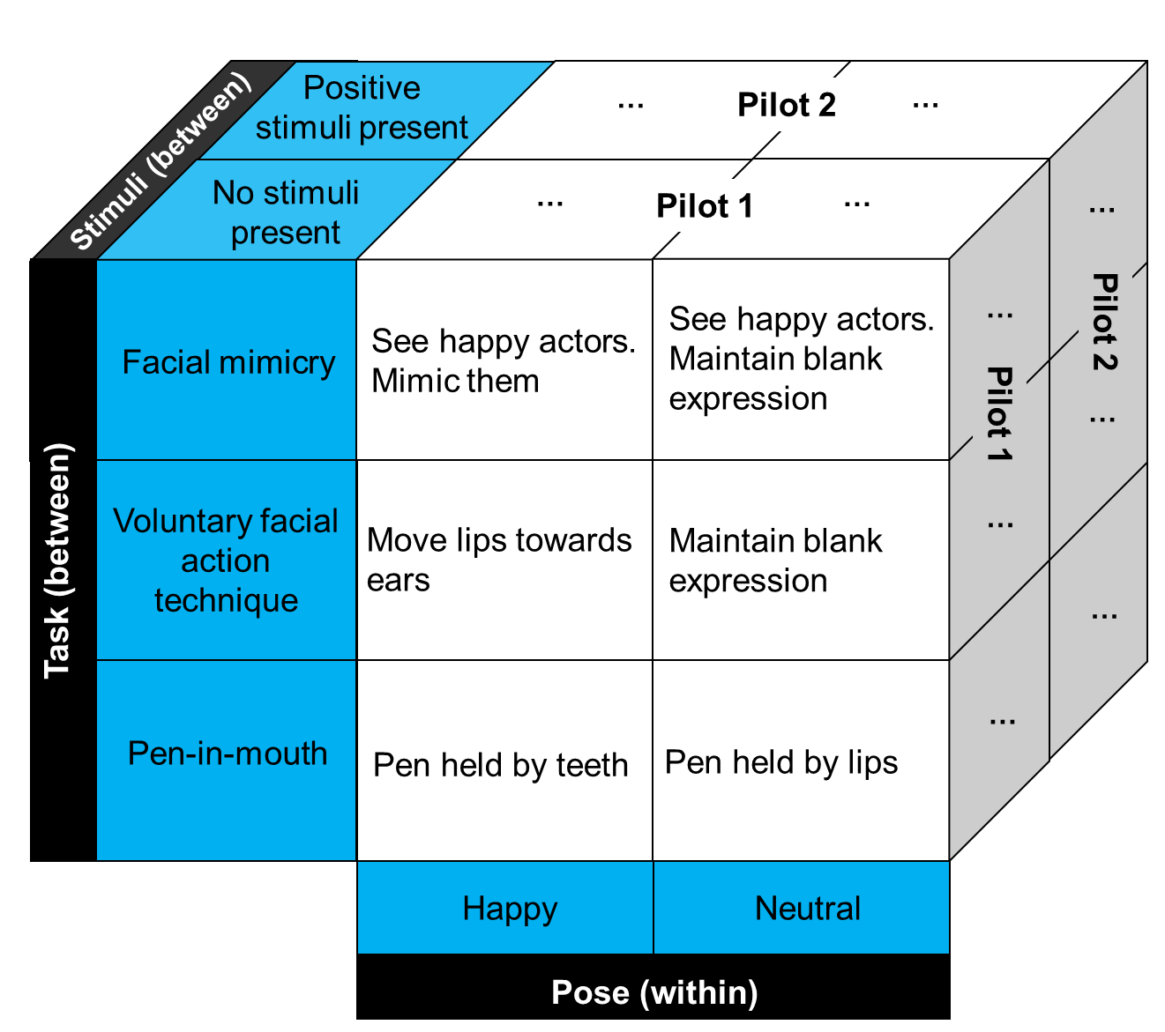

**Test of the Facial Feedback Hypothesis**

To examine whether facial feedback impacted self-reported happiness, a 2 (Pose: happy or neutral) x 2 (Facial Movement Task: facial mimicry or voluntary facial action technique) x 2 (Stimuli Presence: absent or present) mixed-effect ANOVA was fitted, with Pose included as a within-participant factor. Consistent with the facial feedback hypothesis, participants reported more happiness after posing happy (*M =* 2.47, *SD* = 1.48) vs. neutral expressions (*M =* 1.93, *SD* = 1.18), *F*(1, 202) = 43.65, *p* < .001, *η2G* = 0.04, 95% CI [0.01, 0.11]. No main effect for Facial Movement Task was detected, *F*(1, 202) = .38, *p* = .54, *η2G* = 0.00, 95% CI [0.00, 0.03]. There was a main effect for Stimuli Presence, wherein participants reported more happiness when positive stimuli were present (*M =* 2.65, *SD* = 1.54) vs. absent (*M =* 1.72, *SD* = 0.94), *F*(1, 202) = 36.06, *p* < .001, *η2G* = 0.08, 95% CI [0.02, 0.17].

Results also revealed an interaction between Pose and Stimuli Presence, *F*(1, 202) = 5.79, *p* = .02, *η2G* = 0.01, 95% CI [0.00, 0.05]. To decompose this interaction, 2 (Pose: happy or neutral) x 2 (Facial Movement Task: facial mimicry or voluntary facial action technique) mixed ANOVAs were separately fitted for each study. Effects of Pose were obtained both when stimuli were absent, *F*(1, 98) = 15.56, *p* < .001, *η2G* = 0.03, 95% CI [0.00, 0.13], and present, *F*(1, 104) = 29.40, *p* < .001, *η2G* = 0.06, 95% CI [0.00, 0.17]. These findings indicate that smiling both initiated and modulated happiness, and that smiling had an especially strong modulating effect. Some may argue that the inclusion of the mimicry task prevented a true test of the initiation hypothesis because images of smiling actors may elicit happiness. This seems unlikely because participants did not report more happiness in the mimicry vs. voluntary facial action technique tasks. Nevertheless, follow-up analyses excluding the mimicry condition confirmed that facial feedback can initiate emotional experience, *F*(1, 50) = 6.76, *p* = .01, *η2G* = 0.04, 95% CI [0.00, 0.19].

Although results are consistent with the facial feedback hypothesis, one alternative explanation is that participants found the smiling task to be less boring than the neutral task (perhaps because participants do not do anything with their bodies in this latter task). The filler trials allowed us to provide a post hoc test of this possibility because they required participants to perform affectively neutral bodily movements. We therefore compared happiness ratings during the happy vs. filler movement trials using a 2 (Movement Trial: smile or filler) x 2 (Stimuli Presence: absent or present) mixed-effect ANOVA. Consistent with the facial feedback hypothesis, results indicated that participants reported greater happiness after posing happy expressions (*M =* 2.47, *SD* = 1.48) vs. engaging in filler movements (*M =* 1.86, *SD* = 1.01), *F*(1, 204) = 56.42, *p* < .001, *η2G* = 0.06, 95% CI [0.01, 0.14]. Results also revealed an interaction between Movement Trial and Stimuli Presence, *F*(1, 204) = 35.52, *p* < .001, *η2G* = 0.04, 95% CI [0.00, 0.11]. To decompose this interaction, we re-examined the main effect of Movement Trial separately for each study. Results provided significant evidence of a Movement Trial effect when stimuli were present, *F*(1, 105) = 63.47, *p* < .001, *η2G* = 0.14, 95% CI [0.04, 0.27], but not absent, *F*(1, 99) = 2.34, *p* = .13, *η2G* = 0.00, 95% CI [0.00, 0.06].

**Participant Awareness**

Based on in-person funnel debriefings, experimenters rated the degree to which participants were aware of the purpose of the experiment (1 = “not at all aware” to 5 = “completely aware”). Results indicated that participants generally exhibited low awareness of the purpose of the experiment (*M* = 1.54, *SD* = 0.96), with 85% of participants characterized as not at all or slightly aware. To examine whether participant awareness varied across conditions, awareness ratings were modeled using a 2 (Facial Movement Task: facial mimicry or voluntary facial action technique) x 2 (Stimuli Presence: present or absent) ANOVA. Contrary to our prediction, results did not indicate that participants were more aware of the purpose of the experiment in the facial mimicry (*M* = 1.47, *SD* = 0.85) vs. voluntary facial action technique (*M* = 1.61, *SD* = 1.05) condition, *F*(1, 202) = 1.04, *p* = .31, *η2G* = 0.00, 95% CI [0.00, 0.03]. Unexpectedly, participants exhibited more awareness of the experiment’s purpose when emotional stimuli were present (*M* = 1.68, *SD* = 1.03) as opposed to absent (*M* = 1.39, *SD* = 0.86), *F*(1, 202) = 4.75, *p* = .03, *η2G* = 0.01, 95% CI [0.00, 0.06]. No interaction between awareness and stimuli presence was detected, *F*(1, 202) = 0.47, *p* = .49, *η2G* = 0.00, 95% CI [0.00, 0.03].

Although results are consistent with the facial feedback hypothesis, it is possible that observed effects were driven by participants’ awareness of the purpose of the experiment (e.g., demand characteristics). Confirmatory analyses were re-run using linear mixed-effect modeling with participant awareness included as a continuous moderator. Results from this analysis provided some evidence that facial feedback effects are larger when participants were more aware of the purpose of the experiment, pooled *F*(1, 198) = 5.48, *p* = .02; Study 1 *F*(1, 96) = 0.66, *p* = .42; Study 2 *F*(1, 102) = 6.27, *p* = .01. Consequently, all confirmatory analyses we re-run excluding participants who exhibited any degree of awareness (i.e., had an awareness score higher than 1). All aforementioned results were robust except the interaction between Facial Movement Task and Stimuli Presence. Taken together, the observation of a significant facial feedback effect in participants who were completely unaware of the purpose of the experiment indicates that awareness of the purpose of the experiment does not fully account for our results. At the same time, results from the moderator analysis suggest that being aware of the hypothesis can amplify facial feedback effects.

**Quality of Posed Expressions**

In pilot study 1, participants were covertly recorded to assess the quality of their posed expressions. For participants who consented for their videos to be analyzed (n = 80), video recordings of their happy and neutral posing trials were processed through Noldus FaceReader 7.0, which provided moment-to-moment ratings of expressed happiness (0 to 1)99. FaceReader failed to code videos from two participants, leaving a final sample of 78 pairs of videos.

Expressed happiness ratings were modeled using a 2 (Pose: happy or neutral) x 2 (Facial Movement Task: facial mimicry or voluntary facial action technique) mixed-effect ANOVA, with Pose included as a within-participant factor. As expected, participants expressed more happiness during the happy (*M* = .65, *SD* = .27) vs. neutral (*M* = .03, *SD* = .05) trials, *F*(1, 76) = 454.61, *p* < .001, *η2G* = 0.75, 95% CI [0.63, 0.83]. Participants also expressed more happiness in the facial mimicry (*M* = .39, *SD* = .39) vs. voluntary facial action technique (*M* = .28, *SD* = .34) condition, *F*(1, 76) = 14.59, *p* < .001, *η2G* = 0.09, 95% CI [0.01, 0.23]. These main effects were qualified by a significant interaction, wherein the difference in expressed happiness between the happy and neutral trials was larger in the facial mimicry condition, *F*(1, 76) = 14.68, *p* < .001, *η2G* = 0.09, 95% CI [0.01, 0.24]. These patterns of results are consistent with our prediction that the facial mimicry condition would produce more prototypical expressions of happiness than the voluntary facial action technique condition, although our results so far provide no evidence that the quality of poses influence the magnitude of facial feedback effects. In addition, all but one participant expressed more happiness during the happy vs. neutral trial, indicating that most participants can successfully execute these two facial feedback tasks.

**Individual Differences in Bodily Awareness**

Unfortunately, no measure of facial awareness has been developed59. As a proxy, we included the Multidimensional Assessment of Interoceptive Awareness (MAIA). The MAIA does not contain questions about facial activity, but it does distinguish between multiple aspects of body awareness, four which may be relevant for facial feedback effects: (1) noticing body sensations, (2) attending to body sensations, (3) being aware of the association between body sensations and emotional states, and (4) trusting body sensations100. Evidence that any of these aspects moderate facial feedback effects would provide some evidence that facial feedback effects rely in part upon conscious processes. We caution, however, that the converse is not true. Given both (a) the usual challenges in accepting the null hypothesis and (b) the fact that the MAIA does not assess awareness of facial activity, the absence of evidence for moderation should not constitute evidence that facial feedback effects rely entirely upon unconscious processes.

To examine whether individual differences in body awareness moderated facial feedback effects, we post-hocmodeled happiness ratings using a linear mixed-effect model with (a) type of pose (happy or neutral) entered as a categorical predictor, (b) the four subscales of the MAIA entered as continuous predictors, and (c) interactions between type of pose and each of the four subscales. We did not find evidence that any of these four subscales moderated facial feedback effects, noticing *F*(1, 200) = 0.00, *p* = .97; attending *F*(1, 200) = 0.49, *p* = .48; aware *F*(1, 200) = 0.29, *p* = .59; trust *F*(1, 200) = 0.00, *p* = .99.

**Pilot Study 3**

Based in part on results from pilot studies 1 and 2, a Registered Report to run an in-person study containing the conditions outlined in Supplementary Materials Figure 1 was accepted in-principle. However, due to the emergence of the Coronavirus Disease 2019 pandemic, many participating research groups had to suspend in-person data collection. Consequently, a third pre-registered pilot study was designed to examine the feasibility of conducting the study online. Results from this pilot study led to a minor amendment of the registered report.

Pilot study 3 featured the full 2 (Pose: happy or neutral) x 3 (Facial Movement Task: facial mimicry, voluntary facial action technique, or pen-in-mouth task) x 2 (Stimuli Presence: present or absent) design. The studies differed from the procedures described in the main manuscript in the following ways: participants were not asked to (1) confirm they were completing the study on a computer (although details regarding participants’ operating systems were automatically recorded), (2) confirm that they were in a setting with minimal distractions, (3) rate the degree to which they felt like they were expressing happiness during the happy pose, or (4) rate the degree to which their expression matched an image of an individual completing the happy pose task correctly. These features were added due to unexpected findings in pilot study 3.

We recruited 161 participants through the online data collection platform, Prolific, and paid participants $3 to complete the 15-minute study. Based on pre-registered criteria, we removed participants who (1) opened, but did not complete the survey (n = 7), (2) failed to pass both attention checks (n = 18), (c) failed to accurately answer the filler math problems (n = 5), (d) did not follow instructions to complete the survey on a desktop computer (n = 9), (e) self-reported that they did not accurate complete the happy pose task (n = 1), and/or (f) indicated an unwillingness to place a pen in their mouth (n = 2). After exclusions, there were 119 participants (45% female, 52% male, 2% transgender male, 1% gender variant/non-conforming; age *M* = 31.30, *SD* = 11.30). Forty-three participants completed the facial mimicry task, 42 completed the voluntary facial action technique task, and 34 completed the pen-in-mouth task.

**Test of the Facial Feedback Hypothesis**

To examine whether facial feedback impacted self-reported happiness, a 2 (Pose: happy or neutral) x 3 (Facial Movement Task: facial mimicry, voluntary facial action technique, or pen-in-mouth task) x 2 (Stimuli Presence: present or absent) mixed-effect ANOVA was fitted, with Pose included as a within-participant factor. Consistent with the facial feedback hypothesis, participants reported more happiness after posing happy (*M =* 2.51, *SD* = 1.52) vs. neutral expressions (*M =* 2.16, *SD* = 1.48), *F*(1, 113) = 10.04, *p* = .002.

No main effect for Facial Movement Task was detected, *F*(2, 113) = 0.43, *p* = .65. There was a main effect for Stimuli Presence, wherein participants reported more happiness when positive stimuli were present (*M =* 2.65, *SD* = 1.55) vs. absent (*M =* 2.02, *SD* = 1.41), *F*(1, 113) = 6.26, *p* = .01. Unexpectedly, no significant interaction between Pose and Stimuli Presence was detected, *F*(1, 113) = 0.22, *p* = .64. These results suggest that posing happy expressions can both initiate and modulate feelings of happiness. However, contrary to our prediction, the modulation effects were not larger than the initiation effects. Also unexpectedly, results revealed an interaction between Pose and Facial Movement Task, *F*(2, 113) = 4.15, *p* = .02. Follow-up contrasts indicated that participants reported more happiness after posing happy vs. neutral expressions in the facial mimicry, *F*(1, 113) = 15.54, *p* < .001, voluntary facial action technique, *F*(1, 113) = 4.69, *p* = .03, but notpen-in-mouth task, *F*(1, 113) = 0.12, *p* = .73.

Although results are somewhat consistent with the facial feedback hypothesis, one alternative explanation is that participants found the smiling task to be less boring than the neutral task. Similar to pilot studies 1 and 2, we compared happiness ratings during the happy vs. filler movement trials using a 2 (Movement Trial: smile or filler) x 3 (Facial Movement Task: facial mimicry, voluntary facial action technique, or pen-in-mouth task) x 2 (Stimuli Presence: absent or present) mixed-effect ANOVA. Consistent with the facial feedback hypothesis, results indicated that participants reported greater happiness after posing happy expressions (*M =* 2.51, *SD* = 1.52) vs. engaging in filler movements (*M =* 2.03, *SD* = 1.31), *F*(1, 232) = 29.49, *p* < .001. Results also revealed an interaction between Movement Trial and Facial Movement Task, *F*(2, 113) = 10.69, *p* < .012. Follow-up contrasts indicated that participants reported more happiness after posing happy expressions vs. engaging in filler movements in the facial mimicry, *F*(1, 232) = 37.15, *p* < .0001, voluntary facial action technique, *F*(1, 232) = 19.14, *p* < .0001, but *not* pen-in-mouth task, *F*(1, 232) = 0.36, *p* = .55. Results also revealed an interaction between Movement Trial and Stimuli Presence, *F*(1, 232) = 9.33, *p* = .003. Follow-up contrasts indicated that participants reported more happiness after posing happy expressions vs. engaging in filler movements when positive images were present, *F*(1, 232) = 35.71, *p* < .0001. However, when positive images were absent, this difference was not statistically significant, *F*(1, 232) = 2.85, *p* = .09.

Taken together, these results provide evidence that certain facial movement tasks—i.e., facial mimicry and the voluntary facial action technique—can modulate feelings of happiness. These results also provide preliminary evidence that these facial movement tasks can initiate feelings of happiness.

**Participant Awareness**

Towards the end of the experiment, participants provided written responses to a text-based funnel debriefing. Two independent raters reviewed these written responses and coded whether the participant was aware of the purpose of the study (0 = unaware, 1 = aware; 90.30% agreement; Cohen’s κ = 0.65). Participants were classified as aware if either of the coders indicated that the participant seemed aware of the purpose of the study. In total, 76% of participants were coded as unaware of the purpose of the study.

To examine whether participant awareness differed across conditions, a logistic regression was fitted with facial feedback task entered as an effects-coded factor. Results indicated that awareness differed by condition, χ2(2, N =119)= 11.28, *p* = .004. Follow-up pairwise comparisons indicated that participants were more likely to be aware of the purpose of the study in the pen-in-mouth (6% aware) vs. facial mimicry (28% aware), *z* = 2.27, *p* = .02, and voluntary facial action technique conditions (36% aware), *z* = 2.74, *p* = .006. Participant awareness did not significantly differ between the facial mimicry and voluntary facial action technique conditions, *z* = 0.77, *p* = .44.

Although pilot study 3 provides some evidence in favor of the facial feedback hypothesis, it is possible that these effects are driven by participants’ awareness of the purpose of the experiment (e.g., demand characteristics). To examine if participant awareness moderated facial feedback effects, we fit a linear mixed-effect model with (a) Pose, Facial Movement Task, Image Presence, and Awareness entered as categorical predictors, (b) two-way Pose by Facial Movement Task, Pose by Image Presence, Pose by Awareness, and Facial Movement Task by Image Presence interactions, and (c) a three-way Pose by Facial Movement Task by Image Presence interaction. Similar to our earlier tests of the facial feedback hypothesis, results confirmed that participants reported more happiness after posing happy vs. neutral expressions, *F*(1, 112) = 14.41, *p* < .001, and when stimuli were present vs. absent, *F*(1, 112) = 6.10, *p* = .01. Results also provided evidence of a Pose by Facial Movement Task interaction, wherein the effect of Pose was significant in the mimicry, *F*(1, 112) = 19.65, *p* < .0001, voluntary facial action technique, *F*(1, 112) = 6.56, *p* = .01, but *not* pen-in-mouth condition, *F*(1, 112) = 0.52, *p* = .47). Results indicated that the effect of Pose was larger when participants were aware of the purpose of the study, *F*(1, 112) = 4.10, *p* = .045. Subsequent contrasts indicated that participants who were aware of the purpose of the study reported more happiness after posing happy vs. neutral expressions, *F*(1, 112) = 10.81, *p* = .001. However, this effect was not statistically significant among participants who were unaware of the purpose of the study, *F*(1, 112) = 3.18, *p* = .08.

**Quality of Posed Expressions**

Overall, participants reported following the instructions closely (overall *M* = 6.69, *SD* = 0.69; facial mimicry *M* = 6.65, *SD* = 0.78; voluntary facial action technique *M* = 6.60, *SD* = 0.67; pen-in-mouth *M* = 6.85, *SD* = 0.56). To examine if task adherence varied across conditions, adherence ratings were modeled using a 3 (Facial Movement Task: facial mimicry, voluntary facial action technique, or pen-in-mouth task) x 2 (Stimuli Presence: present or absent) ANOVA. Results did not indicate that adherence ratings varied as a function of Facial Movement Task, *F*(2, 113) = 1.43, *p* = .24, or Stimuli Presence, *F*(1, 113) = 1.60, *p* = .21 Taken together, these results suggest that participants can successfully execute all facial feedback tasks well in an online format.

**Summary**

The primary purpose of pilot study 3 was to examine the feasibility of online data collection. Although participants had no financial incentive to exaggerate their performance, participants reported completing the facial feedback tasks accurately. Ideally the validity of these reports would be confirmed via remote video recording. However, overt video recording would raise concerns about whether video recording interferes with facial feedback effects49,50. In pilot studies 1 and 2, we addressed these concerns by covertly recording participants, but it is not possible to do so in an online format without introducing privacy concerns. Nevertheless, facial feedback effects were observed in most—but not all—conditions, suggesting that many participants completed the facial feedback tasks sufficiently well.

Although pilot study 3 was primarily designed to examine the feasibility of online data collection, the results provide preliminary but inconclusive evidence in favor of the facial feedback hypothesis. Results indicated that the facial mimicry and voluntary facial action technique—but not pen-in-mouth—tasks produced significant facial feedback effects. Results indicated that facial feedback modulated feelings of happiness, but provided only preliminary evidence that facial feedback can initiate feelings of happiness. Results provided mixed evidence regarding whether facial feedback effects can persist when participants are unaware of the purpose of the study. A marginally significant facial feedback effect was detected in participants judged to be unaware of the purpose of the experiment, but participants who completed the task that best masked the purpose of the experiment (the pen-in-mouth task) did not exhibit significant facial feedback effects.

**Reflections on the pen-in-mouth task**

Results indicated that the facial mimicry, voluntary facial action technique—but not pen-in-mouth—tasks produced significant facial feedback effects. One interpretation of these results is that the pen-in-mouth task does not reliably produce facial feedback effects. If true, it may suggest that facial feedback effects are driven by demand characteristics42,43,76. Results from the three pilot studies, however, are generally inconsistent with this explanation. Participants who were unaware of the purpose of the study exhibited significant facial feedback effects in pilot studies 1 and 2. In pilot study 3, participants who were unaware of the purpose of the study did not exhibit significant facial feedback effects, but the effect was marginally significant despite a smaller sample size. Another interpretation of the results is that facial feedback effects cannot occur outside of awareness—the mechanism the pen-in-mouth task is designed to eliminate41. However, inconsistent with this explanation, results from pilot studies 1 and 2 did not indicate that individual differences in bodily awareness moderated facial feedback effects. Nevertheless, to assess this further, the main study will include the Body Awareness Questionnaire68. Another possibility is that the pen-in-mouth effect does not produce an expression that feels like a smile. To examine this possibility, participants at the end of the main study will be asked to rate the degree to which they feel like they are expressing happiness during the happy pose.

It is possible that the pen-in-mouth effect is valid, but that participants did not accurately complete the task in pilot study 3. Although participants in the pen-in-mouth condition reported the highest adherence to instructions, they may not have understood how to correctly complete the task. To address this concern, participants at the end of the main study will rate the degree to which their expression matches an image of an individual completing the happy pose task correctly. It is also possible that the pen-in-mouth effect is not reliable in the midst and/or aftermath of Coronavirus Disease 2019. Although speculative, placing a pen in one’s mouth may elicit anxiety that interferes with the facial feedback effect. Consistent with this possibility, participants reported slightly increased levels of nervousness in the pen-in-mouth vs. facial mimicry, *t*(113) = 2.21, *p* = .07, and voluntary facial action technique conditions, *t*(113) = 2.39, *p* = .048. In the main study, we will more comprehensively measure anxiety using the Discrete Emotions Questionnaire66.

**Main Study Supplemental Analyses**

**Between-Task Manipulation Check Analyses**

To test whether these quality ratings varied between conditions, we modeled each quality rating with Facial Feedback Task as an effects-coded factor and random-intercepts for research groups. Compliance ratings were high in all conditions (see Figure 2), but did vary by condition, *F*(2, 7735.1) = 35.32, *p* < .001. Follow-up pairwise comparisons indicated that participants reported following the instructions most closely in the pen-in-mouth, voluntary facial action, and then facial mimicry conditions (all pairwise comparison *p*’s < .001). Similarity ratings were also high in all condition (see Figure 2)—although, once again, these ratings varied by condition, *F*(2, 7071.5) = 15.60, *p* < .001. Follow-up pairwise comparisons indicated that participants reported that their posed expressions matched actor images the most in the facial mimicry vs. voluntary facial action (pairwise comparison *p* < .001) and pen-in-mouth tasks (pairwise comparison *p* < .001). Similarity ratings did not significantly differ between the voluntary facial action and pen-in-mouth tasks (*p* = .47). Genuineness ratings more substantially varied by condition, *F*(2, 7735.5) = 289.88, *p* < .001 (see Figure 2). The reported genuineness of the expression was highest in the facial mimicry task, second highest in the voluntary facial action task, and lowest in the pen-in-mouth task (all pairwise comparison *p*’s < .001).

**Quality Rating Distributions in Primary Analyses**

Figure 2 in the main text shows the distribution of quality ratings for all participants. Notably, however, similar patterns were observed amongst participants who met the inclusion criteria featured in the primary analyses (see Supplemental Figure 2).

Figure 2.

Distribution of compliance, genuineness, and similarity ratings for each facial movement task amongst participants who met the primary analysis inclusion criteria.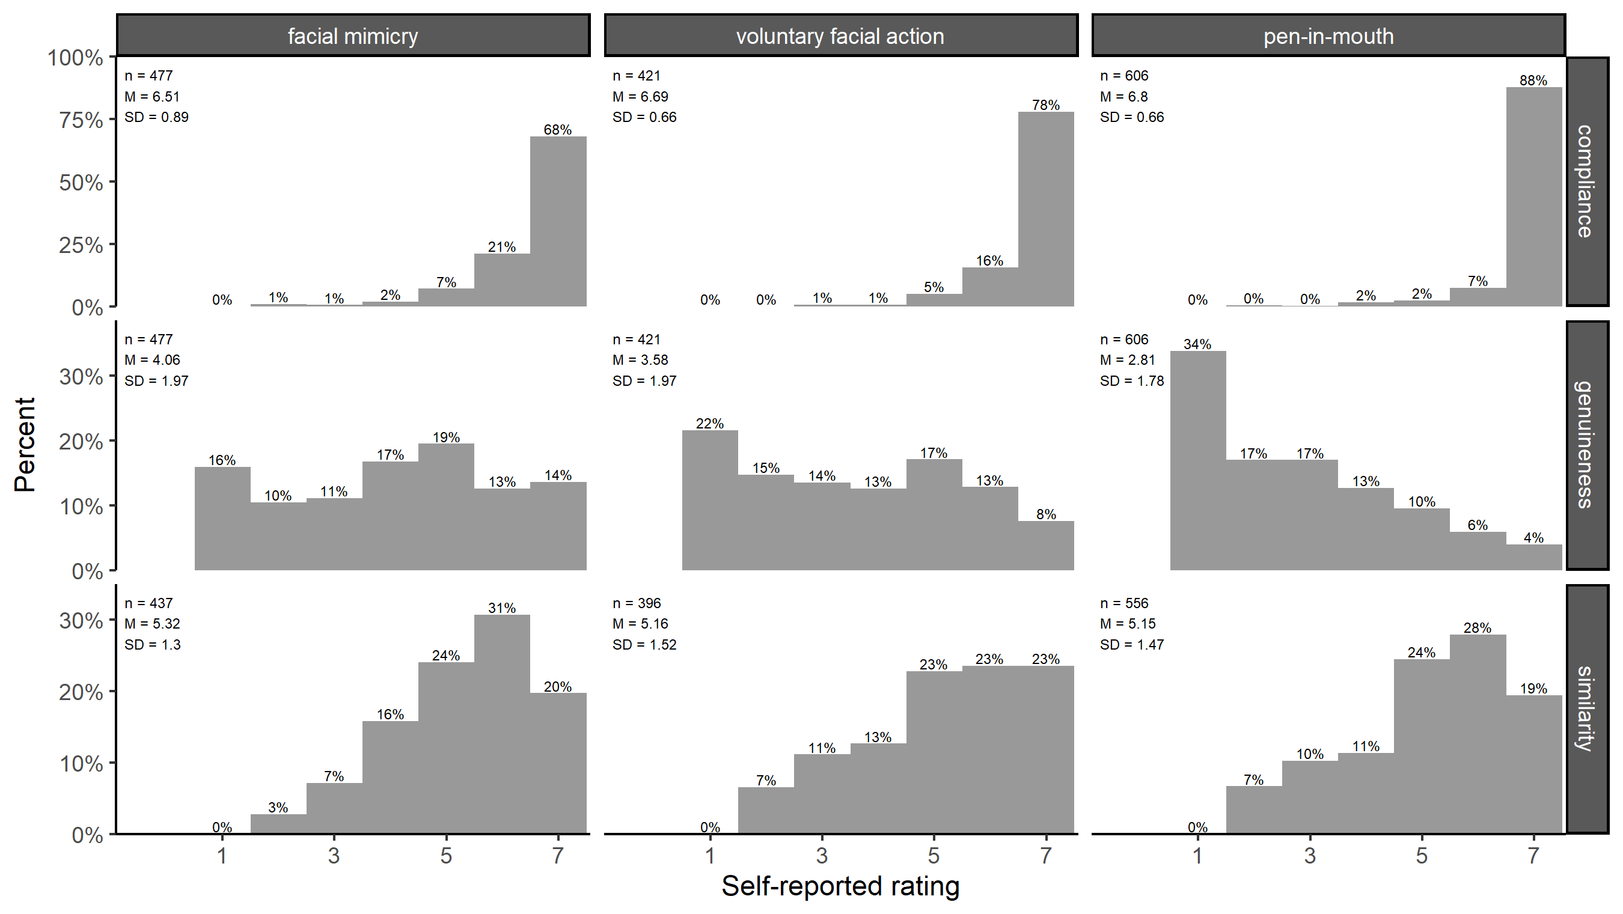

1. Our original desired sample size was misestimated. The correctly estimated desired sample size is n = 2829. Nonetheless, both sample sizes were exceeded in the present study.
2. In our comparison of happiness reports during filler and facial expression posing tasks, we originally planned to exclude data from the neutral facial expression trial. However, we decided to include these data because they provide some evidence that participants do sometimes indeed report lower levels of happiness after the neutral expression pose vs. filler trials. We also originally planned to combine observations from the first and second filler task in these analyses. However, we decided to analyze these tasks separately so that readers could observe that these two tasks elicited similar levels of happiness. These deviations from our pre-registered analysis plan do not impact our conclusions, and we believe they provide a more comprehensive overview of the results.