The impact and heterogeneity of demand characteristics: A meta-analysis of manipulations of explicit demand cues

Abstract

Demand characteristics are a fundamental methodological concern in experimental psychology. Yet, little is known about the direction, magnitude, consistency, and mechanisms underlying their effects. We conducted a three-level meta-analysis of 252 effect sizes from 52 studies that provided experimental tests of demand effects by explicitly manipulating cues about the study hypothesis. These manipulations tended to produce small overall increases in hypothesis-consistent responding (*g* = 0.21, 95% CI [0.12, 0.31]). However, effects were extremely heterogeneous (between-study = 0.28; within-study = 0.18), with the prediction interval ranging from *g* = 0.89 (a large increase in hypothesis-consistent responding) to *g* = -0.46 (a moderate *decrease* in hypothesis-consistent responding). Both the observed and estimated distribution of these effects suggested that demand characteristics can create false positives, false negatives, upward bias, and downward bias. This heterogeneity is currently difficult to explain. New participants who reviewed key study details were neither able to predict nor provide insights into psychological mechanisms theorized to underlie demand effects. Participants’ ratings of three theorized moderators – motivation to adjust responses, opportunity to adjust responses, and belief in the researcher’s hypothesis – failed to predict observed demand effects. Coded methodological features (e.g., whether participants were paid) also often failed to predict observed effects – explaining approximately 15% of in-sample variability. Although the meta-analysis did not capture the full depth of the demand characteristics construct, the synthesis of even a narrow subset of the literature suggests that their effects can be inferentially consequential, heterogeneous, and difficult to explain.

*Keywords:* demand characteristics, expectancies, meta-analysis, methodology, confound

The impact and heterogeneity of demand characteristics: A meta-analysis of manipulations of explicit demand cues

“All scientific inquiry is subject to error, and it is far better to be aware of this, to study the sources in an attempt to reduce it, and to estimate the magnitude of such errors in our findings, than to be ignorant of the errors concealed in the data” (Hyman, 1954, p. 4)

Imagine that one day a mysterious person approaches you and begins telling you about a method their friends invented for understanding humans. They tell you that their method is useful for estimating causal relationships, but add that there is an issue: it can sometimes be thrown off by a *methodological artifact*. They explain that this artifact sometimes causes them to detect an effect that is not real, and other times miss an effect that *is* real; that it sometimes makes an effect appear bigger than it actually is, and other times smaller. And that, in general, it is unclear when, why, and to what extent this artifact systematically impacts their conclusions.

If the above scenario was real, the noted limitations would likely call the whole method into question. However, in the present work, we provide a meta-analytic review of a similar puzzle in experimental psychology: the role of *demand characteristics*.

In a seminal paper published over a half century ago, Martin Orne argued that human subjects are perceptive to demand characteristics – “cues which convey an experimental hypothesis” – and generally use these cues to help the experimenter confirm their hypothesis (1962, p. 779). Orne initially presented evidence that demand characteristics can lead to false positives, such as patients exhibiting sham symptoms of hypnosis (Orne, 1959). However, demand characteristics can also lead to false negatives. For example, participants will ignore visual cues of depth when they believe that disregarding them is the purpose of the experiment (Hayes & King, 1967). In addition to creating inferential errors, demand characteristics can bias estimates of causal relationships. For example, the effects of facial poses on self-reported emotion can be exaggerated *or* underestimated depending on whether the experimenter communicates expectations of positive or nil effects (Coles, Gaertner, Frohlich, Larsen, & Basnight-Brown, 2022). Puzzlingly, though, demand characteristics do not always seem to matter. For example, in a set of large replications of classic studies in behavioral economics, explicit manipulations of demand characteristics consistently failed to produce statistically significant changes in participants’ responses (Mummolo & Peterson, 2019).

As this short review illustrates, demand characteristics presents several similarities to the mysterious methodological artifact described in the opening of this paper: it (a) can lead to both false positives and false negatives, (b) can create both upward bias and downward bias, but (c) doesn’t always appear to matter. In the present work, we take stock of progress on this puzzle via a meta-analysis of studies with experimentally-manipulated explicit demand characteristics. To begin, we review the theoretical and conceptual frameworks that guided the investigation.

## How do demand characteristics alter participant responses?

One of the most influential frameworks for conceptualizing the effects of demand characteristics was developed by Rosnow and colleagues (Rosnow & Aiken, 1973; Rosnow & Rosenthal, 1997; Strohmetz, 2008). In this framework, they described three key moderators we discuss in the present work: (1) receptivity to cues, (2) motivation to provide hypothesis-consistent responses, and (3) opportunity to alter responses.

To start, Rosnow and colleagues reasoned that participants must be receptive to demand characteristics for there to be subsequent shifts in participants’ responses. As an extreme example, imagine that a researcher hands an infant a sheet of paper that precisely explains the study hypothesis. Demand characteristics are certainly present, but they are not predicted to have an impact because the infant is not receptive to the cues. Furthermore, even if the infant possessed the astonishing ability to read, it’s possible they would misunderstand the cues (Corneille & Lush, 2023) – which could be considered another form of non-receptivity.

If participants correctly interpret demand characteristics, Rosnow and colleagues theorized that subsequent changes in participants’ responses would be driven by their motivation (or lack thereof) to provide hypothesis-consistent responses. For historical context, early work on demand characteristics was marked by debates about whether participants are motivated to adjust their responses to (a) help the researcher confirm their hypothesis (Orne, 1962), (b) receive positive evaluations (Riecken, 1962; Rosenberg, 1969; Sigall, Aronson, & Van Hoose, 1970), (c) interfere with the purpose of the study (Cook et al., 1970; Masling, 1966), or (d) follow directions as closely as possible (Fillenbaun & Frey, 1970). Rosnow and colleagues advanced this line of thinking by illustrating that participants have *multiple* shifting motivations in mind when they conceptualize their roles as subjects (Rosnow & Rosenthal, 1997; see also Silverman & Marcantonio, 1965). For example, participants appear to be motivated to increase performance on simple tasks when told that this is the experimenter’s expectation – but not when the experimenter adds that the increase in performance will be indicative of a negative personality trait (Sigall et al., 1970). Rosnow and colleagues, thus, suggested that participants in any given context can be characterized as being overall motivated to either: (a) non-acquiesce (i.e., not change their responses based on knowledge about the hypothesis), (b) acquiesce (i.e., provide hypothesis-consistent responses), or (c) counter-acquiesce (i.e., provide hypothesis-inconsistent responses).

If participants are motivated to adjust their response, Rosnow and colleagues theorized that subsequent changes in participants’ responses would then be driven by their ability to alter the outcome of interest. As elaborated by Corneille and Lush (2023), this could occur through faking, imagination, or phenomenological control (voluntary changes experienced by the participant as involuntary). Taking this third moderator – opportunity – into account, Rosnow and colleagues concluded that demand characteristics bias responses when participants (1) notice the cues, (2) are motivated to adjust their responses, and (3) can adjust their responses. This framework directly maps onto many psychologists’ typical playbook for avoiding the impact of demand characteristics: use deception and/or unobtrusive procedures (reduce receptivity), incentivize honest reporting (reduce motivation), and/or deploy difficult-to-control outcome measures (reduce opportunity to adjust responses).

Of course, other researchers have since expanded upon and/or challenged parts of Rosnow and colleagues’ framework. For example, by elaborating upon underlying mechanisms like imagination, Corneille and Lush (2023) more clearly highlight that participants can willingly change many outcomes that may initially seem outside their control. For example, a participant who wants to help a researcher confirm that a manuscript reviewing research artifacts is physiologically arousing could likely do so by simply imagining a physiologically arousing context. Relatedly, Coles et al. (2022) argued that demand characteristics may sometimes impact participants in cases where they are *not* motivated to adjust responses – e.g., via conditioned responses or other mechanisms discussed in conceptually-related work on placebo effects (Stewart-Williams & Podd, 2004). Regardless of proposed mechanisms, these frameworks map onto a prediction: the effects of demand characteristics should vary across different experimental contexts. In other words, although methodologically puzzling, theorists have predicted all along that the effects of demand characteristics *should be* inconsistent across experimental contexts.

**Experiments on demand characteristics**

"It is a wise experimenter who knows his artifact from his main effect; and wiser still is the researcher who realizes that today’s artifact may be tomorrow’s independent variable" (McGuire, 1969, p. 16)

As described by McGuire (1969), Rosnow and colleagues’ framework emerged during a time when researchers increasingly conducted experiments *on* demand characteristics. For example, Orne and Scheibe (1964) reported that participants were more likely to report sensory deprivation side-effects (e.g., hallucinations and cognitive impairments) when told that “…Such experiences are not unusual under the conditions to which you are to be subjected”. Similarly, Perry, Roots and Perry (1977) found that participants were more likely to exhibit film-induced aggressive behavior when told that the researcher anticipated increases in aggression.

Experiments on demand characteristics often manipulate the cues explicitly – and these *explicit demand characteristics* (EDCs) have caveats. First, EDCs are not representative of the broader demand characteristics construct, which Orne (1962) defined as *any* cue that may impact participants’ beliefs about the purpose of the study (including instructions, rumors, experimenter behavior, etc.). Second, EDCs are not representative of the typical experimental context, wherein experimenters do not usually disclose their hypotheses to participants. Orne cautioned against such a methodological approach, suggesting that it tends to cause participants to “lean over backwards to be honest” (i.e., non-acquiesce; Orne, 1962, p. 779).

The limitations of EDCs did not ultimately prohibit Orne (and many others) from leveraging the approach to study demand characteristics. As we review below, researchers have performed hundreds of tests using EDCs – and we review the limitations of these tests in the *Discussion* section. In the meantime, these data provide an opportunity to quantify the magnitude, consistency, and potential moderators of the effects of EDCs via meta-analysis.

# Methodology

This meta-analysis stands alongside other excellent narrative reviews of research on demand characteristics (e.g., Corneille & Lush, 2023; Rosnow & Rosenthal, 1997; Sharpe & Whelton, 2016; Strohmetz, 2008), but extends such work by including a formal analysis of the magnitude, consistency, and potential moderators of such effects

We defined the scope of the meta-analysis using the Population, Intervention, Comparison, Outcome framework (a structured approach to framing research questions; Schardt, Adams, Owens, Keitz, & Fontelo, 2007).

Our population-of-interest was human subjects participating in non-clinical psychology experiments. Given that there is a sizable literature and number of reviews on conceptually-related placebo effects, excluding clinical studies improved the feasibility and reduced the redundancy of our work. The intervention-of-interest was explicit demand cues (EDCs) – operationalized as scenarios where a researcher tells participants about the effect of an independent variable on a dependent variable. Our comparison-of-interest were conditions where either no hypothesis or a different hypothesis was communicated to participants. Our outcome-of-interest was the dependent variable described in the communicated hypothesis. For example, in a study that manipulated whether the intervention is described as “mood-boosting”, the outcome-of-interest would be any measure of mood.

### Literature search.

Figure 1 provides a PRISMA-style flowchart summarizing our literature search and screening process (Page et al., 2021).

The literature search was initially developed in consultation with a librarian at (anonymous for peer review) and later expanded based on reviewer feedback. On January 12, 2022, we searched APA PsycInfo using broad search terms: “demand characteristics” OR “hypothesis awareness” (n = 850 records identified). On April 17, 2024, we repeated the search to identify records published after the initial search (n = 29 records identified). At that time, we also expanded the search to include conceptually similar terms found in the appendix of Rosnow and Rosenthal’s (1997) book on experimental artifacts: “participant role” OR “demand effects” OR “good subject effect” OR “expectancy effect” OR “evaluative apprehension” (n = 572 records identified). We also released a call for unpublished studies on the Society for Personality and Social Psychology Open Forum, Twitter, the Facebook Psychological Methods Discussion group, and the Facebook PsychMAP group (n = 6 records identified).

Our search did not have language or date restrictions, and ultimately yielded 1457 records (168 of which were unpublished).

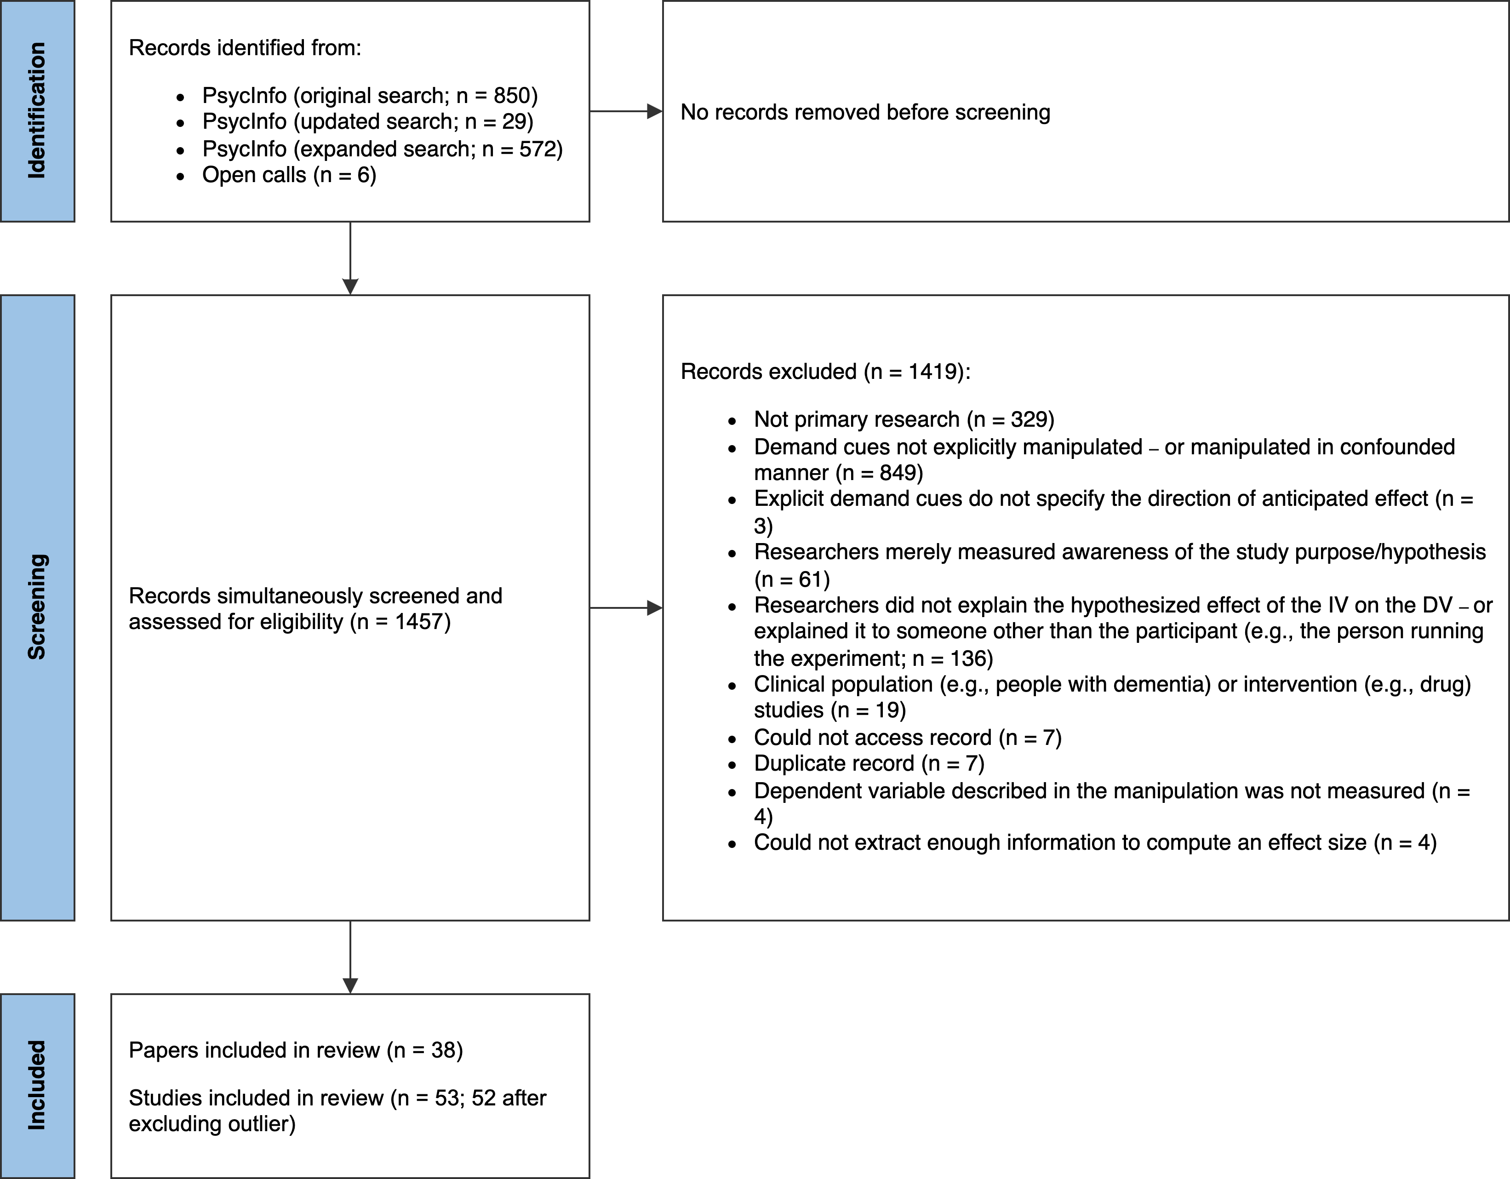

*Figure* 1. PRISMA-style flowchart illustrating the identification, screening, and selection of studies.

### Screening.

Put simply, records must have met the following criteria in order to be eligible for inclusion in the meta-analysis:

* The researcher manipulated what participants were told about the effect of an independent variable on a dependent variable.[1] In most cases, the effect of the independent variable was described explicitly, but there were some included studies where it was strongly implied.
* The demand characteristics manipulation was not strongly confounded with another manipulation. For example, we excluded a study by Sigall et al. (1970) because the manipulation of the stated hypothesis was confounded with a disclosure about the meaning of the behavior (i.e., that confirming the hypothesis would be indicative of an obsessive-compulsive personality disorder).
* A non-clinical population was studied.
* Information necessary for computing at least one effect size was included.

Figure 1 more thoroughly summarizes exclusion criteria. In instances where multiple exclusion criteria applied, coders were asked to choose only one option.

N. C. and M. W. screened records independently, reviewed potentially relevant records together, and worked together to code the information for moderator analyses and effect size computations. Any disagreements were resolved through discussion. Abstracts and (if necessary) full texts were reviewed in a single step so that records did not have to be reviewed twice during screening. In total, 53 studies from 38 records were eligible for inclusion. However, one record (Allen & Smith, 2012) was removed because the information provided led to implausibly large effect size estimates (e.g., = -209.16).

### Effect size index.

We used standardized mean difference scores with small-sample correction (Hedge’s ) as our effect size index (Borenstein, 2009; Cohen, 2013).

In X% of cases, we estimated the main effect of EDCs. For example, Coles et al. (2022) manipulated whether participants were told that posing smiles would increase happiness. Here, the main effect of EDCs was computed by comparing happiness ratings from smiling participants who were either informed or not informed of the mood-boosting effect of smiling.

In X% of cases, we estimated the *interactive* effect of EDCs. For example, in the same Coles et al. (2022) study, participants provided happiness ratings both after smiling and scowling. Participants’ mood generally improved when smiling vs. scowling (i.e., there was a main effect of facial pose). However, the difference was more pronounced when participants were told about the mood-boosting effects of smiling. In other words, there was an interaction between facial pose and EDCs. In this scenario, the interactive effect of EDCs was computed by calculating a standardized difference-in-differences score.

Effect sizes were calculated so that positive values indicated an effect consistent with the communicated hypothesis. For example, if participants were told that an intervention would be mood boosting, an increase in mood would be coded as a positive effect. If, however, participants were told that the intervention would be mood *dampening*, that same increase in mood would be coded as a negative effect.

We calculated Hedge’s by applying a small sample correction to Cohen’s (for between-subject designs) and (for within-subject designs[2]) estimates. Whenever possible, we used the *M*’s and *SD*’s reported in a paper to compute Cohen’s *d*. If these values were not reported, we used (in order of preference), (1) *t*-values, (2) descriptive statistics extracted from figures (e.g., bar charts) using the WebPlotDigitizer (Drevon, Fursa, & Malcolm, 2017), (3) *F*-values, or (4) *p*-values. In instances where relevant information was not provided but the statistical significance and direction of the effect was described, we assumed *p*-values of .04 and .50 for statistically significant and non-significant effects respectively (e.g., Kenealy, 1988). In a few instances, an outcome variable in a study was discrete, as opposed to continuous (e.g., Orne & Scheibe, 1964). In these cases, we approximated a Cohen’s *d* score based on a transformation of the log odds ratio (Borenstein, Hedges, Higgins, & Rothstein, 2011).

Nearly all studies (75%) contained multiple effect sizes of interest. For example, the full design in Coles et al. (2022) included a positive demand, nil demand, and control condition. Participants also completed several facial expression poses (happy, angry, and neutral) and self-reported several emotions (happiness and anger). To be comprehensive, we recorded all reported effect sizes and accounted for dependencies using three-level meta-analysis (described later).

### Potential study feature moderators.

The studies we included in our meta-analysis were methodologically varied (for more information, see *Results* and *Limitations*). Below, we describe study features we coded as potential moderators of the effects of EDCs:

* *Group comparison.* Most studies included in our meta-analysis examined the effects of *positive demand*, wherein participants were told that the dependent variable will increase. However, a notable subset of studies examined the impact of *negative demand* (participants told that the dependent variable will decrease) or *nil demand* (participants told the dependent variable will be unaffected). Often these conditions were compared to a *control* condition, wherein participants were not told about an effect of an independent variable on a dependent variable. Sometimes, though, one demand condition was compared to another.
* *Control vs. non-control group comparison.* Demand effects should presumably be additive. For example, imagine a study where the effect of a task is either (a) not described at all (a control condition), (b) described as mood-boosting (positive demand) or (c) described as mood-dampening (negative demand). Further imagine that participants are motivated and able to adjust their responses. Compared to the control condition, participants’ moods are predicted to be boosted in the positive demand condition and dampened in the negative demand condition. If this is the case, the mean difference in mood should be larger when the positive demand condition is compared to the negative demand condition (as opposed to the control condition). To test this, we coded whether comparisons were made to a control group or a different demand condition.
* *Control group comparison.* Instances where a demand characteristic condition was compared to a control group also allowed us to test whether participants’ responses shift more when the researcher hypothesizes an increase (positive demand), a decrease (negative demand), or no change in the dependent variable (nil demand).
* *Design of demand characteristics manipulation.* Whether EDCs were manipulation within- vs. between-subjects.
* *Participant pool.* Whether students, non-students (e.g., MTurk workers), or a mix of students and non-students were sampled.
* *Setting.* Whether the study was conducted online or in-person.
* *Payment.* Whether participants were paid or unpaid.
* *Publication status.* Whether the study was published or unpublished.

In addition, we collected data on two variables that help characterize the literature of EDCs: (1) the country where the investigation was performed, and (2) whether the researcher manipulated and/or measured mechanisms theorized to underlie the effects (receptivity, motivation, opportunity, or belief)*.*

### Meta-analytic approach.

For our meta-analytic approach, we used three-level meta-analysis (3LMA; also referred to as “multilevel” meta-analysis). Rather than assume that there is a single true effect of demand characteristics, 3LMA assumes that there is a distribution containing *multiple true effects*. To separate variability in these true effects from sampling error, 3LMA models three sources of variability: sampling error of individual studies (level 1), variability within studies (level 2), and variability between studies (level 3; often referred to as “random effects”).

We fit all models using the metafor package (Viechtbauer, 2010) in R (R Core Team, 2021). We weighed effect sizes based on their inverse-variance and used cluster-robust methods for estimating variance-covariance matrices (Pustejovsky & Tipton, 2018). To estimate the overall effect size, we fit an intercept-only 3LMA model. We conducted moderator analyses by separately entering variables into a new model. In doing so, we hoped to avoid issues with collinearity and overfitting. Categorical moderators were dummy coded. To test the statistical significance of each moderator, we used model comparison *F*-tests. To estimate effect sizes within each subgroup of the moderator, we used model-derived estimates.

#### Publication bias analyses.

Publication bias refers to the well-documented propensity for hypothesis-inconsistent findings to be disproportionately omitted from the published scientific record (Franco, Malhotra, & Simonovits, 2014). When present, publication bias can lead to inaccurate effect size estimates and inferential errors. Consequently, we used three main approaches for assessing and correcting for potential publication bias in our estimation of the overall effect of EDCs.

First, we visually examined *funnel plots,* wherein observed effect sizes are plotted against a measure of their precision (e.g., standard error). In the absence of publication bias, the distribution typically resembles a funnel; relatively large studies estimate the effect with high precision, and effect sizes fan out in *both* directions as the studies become smaller. If, however, statistically non-significant findings are disproportionately omitted from the scientific record (i.e., there is publication bias), the distribution is often asymmetric/sloped. Funnel plots traditionally contain one effect size per study, but many of our studies included multiple relevant effect sizes. Thus, we examined two funnel plots: one with all effect sizes and one with the dependent effect sizes aggregated[3].

Second, we conducted precision effect tests (PET; Stanley & Doucouliagos, 2014). In PET, the relationship between observed effect sizes and their standard errors – which is often absent when there is no publication bias – is estimated and controlled for in a meta-regression model. The slope of this model is often interpreted as an estimate of publication bias, and the intercept is often interpreted as the bias-corrected overall effect. These precision-effect tests were developed and validated for meta-analyses with independent effect sizes. Nonetheless, Rodgers and Pustejovsky (2021) demonstrated that the method retains fairly good statistical properties when (1) 3LMA is used, or (2) dependent effect sizes are aggregated and modeled using random-effects (i.e., two level) meta-regression. We used both approaches.

Third, we deployed weight-function modeling using the weightR package (Coburn & Vevea, 2019). In weight-function modeling, weighted distribution theory is used to model biased selection based on the statistical significance of observed effects (Vevea & Hedges, 1995). If the adjusted model provides increased fit, publication bias is a concern and the model can be used to estimate the bias-corrected overall effect size. Once again, weight-function modeling was designed for independent effect sizes. Nonetheless, it has fairly good statistical properties when non-independent effect sizes are aggregated, which we did here (Rodgers & Pustejovsky, 2021).

As a sensitivity analysis, we used the PublicationBias package in R (Mathur & VanderWeele, 2020a) to estimate the ratio in which publication bias would have to favor affirmative studies in order make the overall effect size in a robust random effects model statistically non-significant (Mathur & VanderWeele, 2020b). We also estimated the difference in the magnitude of published vs. unpublished effects in a moderator analysis.

### Transparency and openness.

The project pre-registration, materials, data, and code are openly available at <https://osf.io/3hkre/?view_only=2dc92af53f194e5eab0d7aecafaf01c2>. This link also contains a list of amendments/deviations we made to our pre-registration as the project evolved and reviewer feedback was received. Sample size was determined by the availability of relevant records. All code has been checked for reproducibility, including the script used to generate a computationally reproducible manuscript using the papaja R package (Aust & Barth, 2022).

## Results

In total, we extracted 252 effect sizes from 52 studies from between the years 1964 and 2024 (*M* = 2003, *SD* = 18.63). 11 of these studies were unpublished.

In order of frequency, effect sizes represented a positive demand compared to a control group (*k* = 114), positive demand to negative demand (*k* = 44), negative demand to a control group (*k* = 43), positive demand to a nil demand group (*k* = 34), or nil demand to a control group (*k* = 17).

More broadly, effect sizes tended to compare one demand condition to a control group (*k* = 174) – as opposed to a group exposed to a different type of demand condition (*k* = 78). Regardless of what type of demand manipulation was used, it was more common to manipulate the cues between (*k* = 208) vs. within subjects (*k* = 44).

Most effect sizes came from student samples (*k* = 160), although some samples were non-students (*k* = 25), a mix of students and non-students (*k* = 19), or not described thoroughly enough to make a determination (*k* = 48). Most effect sizes came from unpaid samples (*k* = 162), although some were paid (*k* = 50) and some were not described thoroughly enough to make a determination (*k* = 40). The majority of effect sizes came from in-person studies (*k* = 187), but some were from online studies (*k* = 52) or not described thoroughly enough to make a determination (*k* = 13). <Country>

### Overall results.

Overall, results indicated that EDC’s cause participants’ responses to shift in a manner consistent with the communicated hypothesis, = 0.21, 95% CI [0.12, 0.31], (47.30) = 4.53, < .001. As a hypothetical example, if participants were told that the researcher hypothesizes that an intervention will improve mood (positive demand), they would generally report slightly improved moods; if told that the researcher hypothesizes that an intervention will worsen mood (negative demand), they would generally report slightly worsened moods.

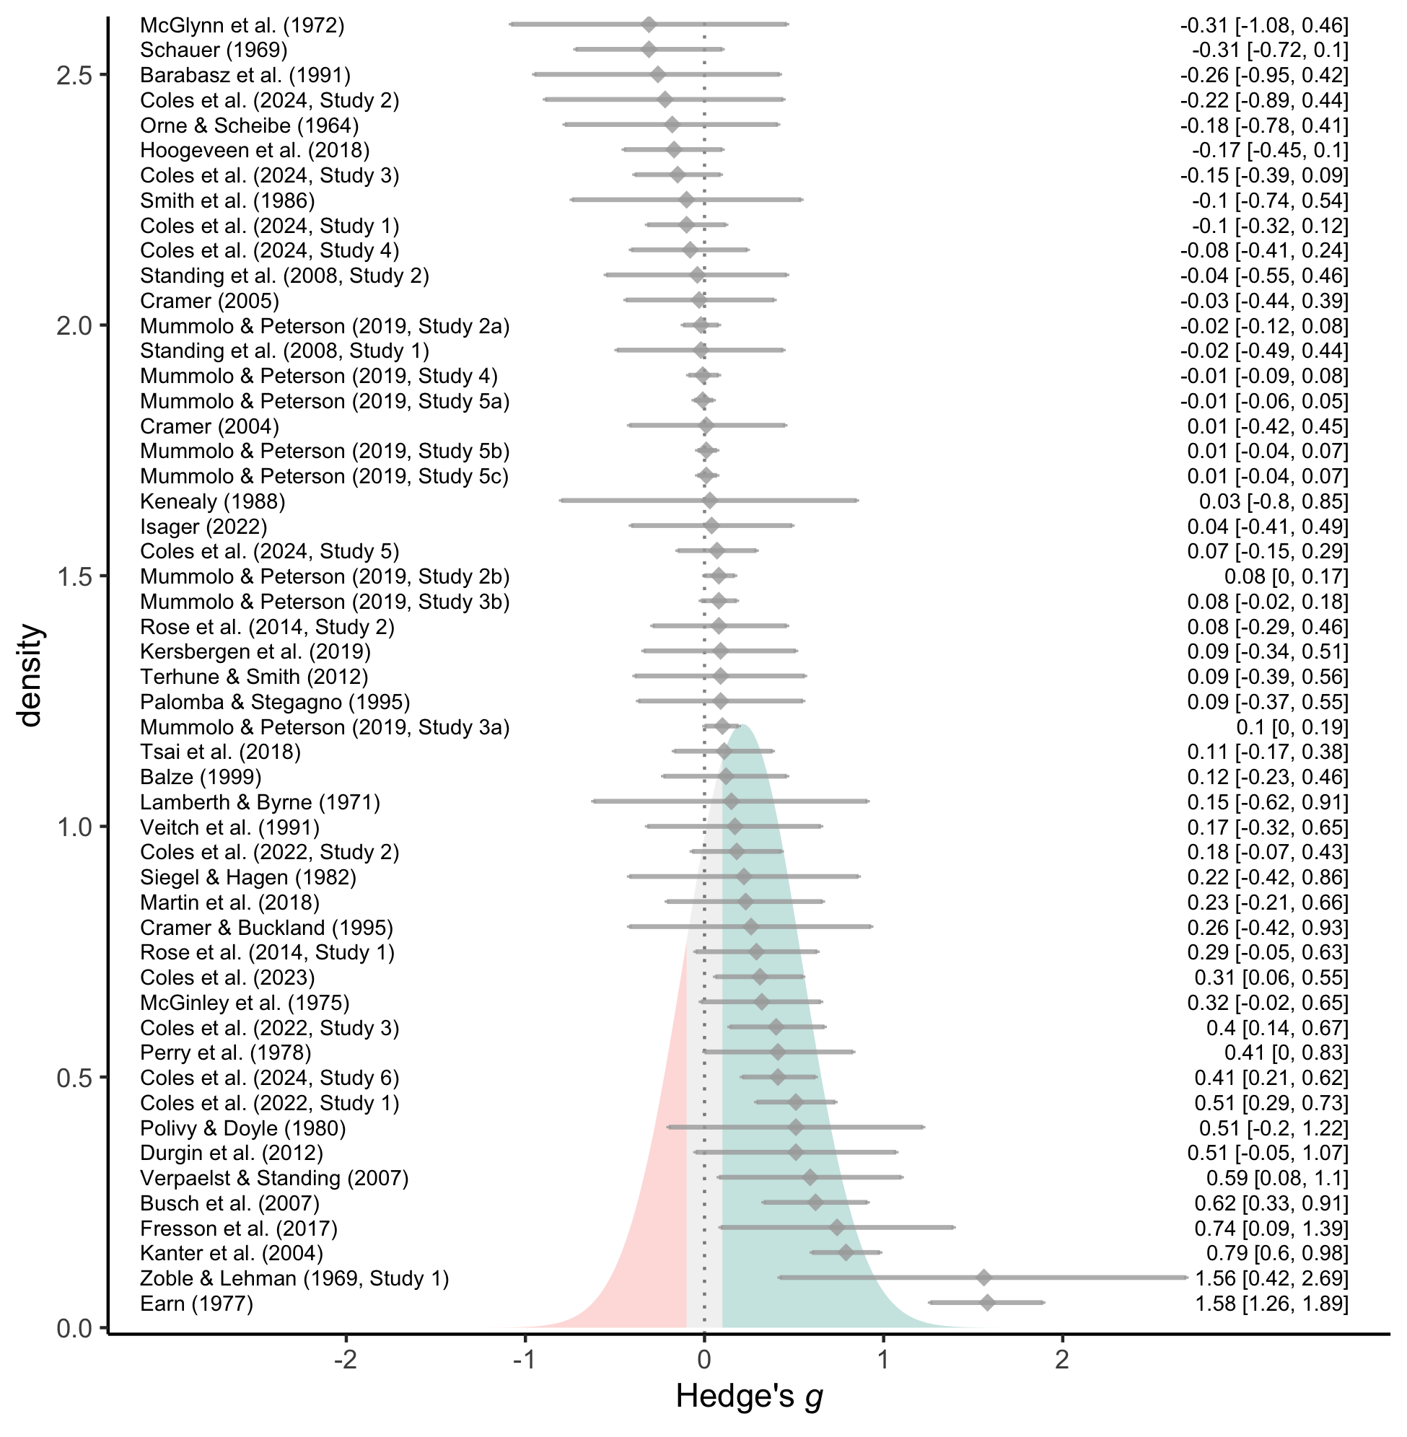

*Figure* 3. Forest plot of effect sizes (grey diamonds), their 95% confidence intervals (grey error bars), and their citations (left). For visualization purposes, effect sizes are aggregated within-studies (see openly-available data for non-aggregated effect sizes). The estimated effect size distribution is also shown and colored based on whether EDCs produce more hypothesis-consistent responding (green; *g* > 0.10), more hypothesis-inconsistent responding (red; *g* < -0.10), or negligible shifts in responding (grey; |*g*| < 0.10).

As a reminder, rather than assuming that there is a *single true effect* of demand characteristics, 3LMA assumes a distribution of *multiple true effects.* Consistent with this assumption, observed variability in the effects of EDCs exceeded what would be expected from sampling error alone (between-study = 0.28, *I2* = ??.??; within-study = 0.18, , *I2* = ??.??; total (251) = 972.42, < .001, total *I2* = 84.92). 3LMA often assumes that the multiple true effects form a normal distribution, which we recreated based on estimates of the average effect size and variability attributed to sources other than sampling error (between-study + within-study ). As shown in Figure 3, this estimated distribution illustrates that demand characteristics can have a wide range of effects. Indeed, the 95% prediction interval for a single future study ranges from = -0.46 to = 0.89.

As a heuristic, we arbitrarily classified any effect size less than 0.10 standard deviation in either direction (i.e., || < .10) as “negligible”. Based on this classification, the estimated distribution of effects suggested that EDCs most often produce hypothesis-consistent shifts (63%), but sometimes produce negligible shifts (20%) or shifts in the *opposite* direction of the communicated hypothesis (17%). Such results are consistent with Rosnow and colleagues’ prediction that demand characteristics can lead to both hypothesis-consistent and hypothesis-*inconsistent* shifts in participants’ responses.

### Moderator analyses.

When variability in effect sizes exceeds what would be expected from sampling error alone, it suggests the presence of moderators. Below, we examine several potential candidates.

#### Study features.

In general, we did not find much evidence that the effects of EDCs are moderated by study features (see Table 1). The two exceptions were (1) whether the demand characteristics condition was compared to a control group (vs. another condition with demand characteristics), and (2) whether the study was conducted in-person (vs. online).

The average effect sizes was estimated to be twice as large when two demand characteristic conditions were compared ( = 0.34, 95% CI [0.19, 0.49], < .001), as opposed to one demand characteristic condition being compared to a control group (*g* = 0.16, 95% CI [0.08, 0.25], = < .001), (1, 10.41) = 10.55, = .008. This provides preliminary evidence that the effects of EDC’s are additive. However, these results should be interpreted with some caution, as a broader test of whether *all* specific types of comparisons varied was not statistically significant, (4, 3.55) = 1.89, = .292.

Instances where a demand characteristic condition was compared to a control group allowed us to test whether participants responses shift more when they expect that the researcher hypothesizes an increase (i.e., positive demand; = 0.18, 95% CI [0.07, 0.29], = .002), a decrease (i.e., negative demand; g = 0.20, 95% CI [0.07, 0.33], = .005), or no change in the dependent variable (i.e., nil demand; = 0.27, 95% CI [-0.20, 0.75], = .169). We did not find this to be the case, (2, 4.16) = 0.18, = .842. We also did not find that the effects of EDC’s varied depending on whether they were manipulated within- = 0.23, 95% CI [0.12, 0.35], < .001) vs. between-subjects (g = 0.14, 95% CI [0.03, 0.25], = .016), (1, 10.61) = 1.76, = .213

The effects of EDC’s tended to be slightly more positive for in-person ( = 0.31, 95% CI [0.16, 0.46], < .001) vs. online ( = 0.10, 95% CI [0.01, 0.19], = .029) studies, (1, 30.58) = 5.92, = .021. However, we did not find that demand effects varied depending on whether students ( = 0.27, 95% CI [0.13, 0.40], < .001), non-students (g = 0.08, 95% CI [-0.01, 0.17], = .076), or a mix of students and non-students (g = 0.05, 95% CI [-1.00, 1.09], = .680) were sampled, (2, 2.11) = 2.20, = .304. We also did not find that the effects of EDCs varied depending on whether those participants were paid ( = 0.13, 95% CI [0.00, 0.26], = .048) vs. unpaid (g = 0.21, 95% CI [0.09, 0.32], = < .001), (1, 20.94) = 0.84, = .371.

Table 1. Study feature moderator and subgroup analyses.

| Moderator (bolded) and level | *s* | *k* | *g* | 95% CI | *F* | *p* |
| --- | --- | --- | --- | --- | --- | --- |
| **Group comparison** | 52 | 252 | – | – | 1.89 | .292 |
| positive vs. control | 41 | 114 | 0.16 | [0.05, 0.27] | 8.35 | .006 |
| nil vs. control | 4 | 17 | 0.23 | [-0.13, 0.58] | 3.15 | .152 |
| negative vs. control | 17 | 43 | 0.16 | [0.03, 0.29] | 7.13 | .016 |
| positive vs. nil | 8 | 34 | 0.37 | [0.02, 0.72] | 6.39 | .040 |
| positive vs. negative | 16 | 44 | 0.33 | [0.15, 0.51] | 15.74 | .001 |
| **Control vs. non-control group comparison** | 52 | 252 | – | – | 10.55 | .008 |
| control | 44 | 174 | 0.16 | [0.08, 0.25] | 14.15 | < .001 |
| non-control | 24 | 78 | 0.34 | [0.19, 0.49] | 22.02 | < .001 |
| **Control group comparison (see levels above)** | 44 | 174 | – | – | 0.18 | .842 |
| **Design of demand characteristics manipulation** | 52 | 252 | – | – | 1.76 | .213 |
| within-subjects | 14 | 44 | 0.14 | [0.03, 0.25] | 7.84 | .016 |
| between-subjects | 44 | 208 | 0.23 | [0.12, 0.35] | 16.48 | < .001 |
| **Participant pool** | 48 | 204 | – | – | 2.2 | .304 |
| students | 36 | 160 | 0.27 | [0.13, 0.4] | 16.16 | < .001 |
| non-students | 11 | 25 | 0.08 | [-0.01, 0.17] | 3.96 | .076 |
| mix | 2 | 19 | 0.05 | [-1, 1.09] | 0.3 | .680 |
| **Setting** | 49 | 239 | – | – | 5.92 | .021 |
| online | 18 | 52 | 0.1 | [0.01, 0.19] | 5.75 | .029 |
| in-person | 32 | 187 | 0.31 | [0.16, 0.46] | 18.03 | < .001 |
| **Payment** | 48 | 212 | – | – | 0.84 | .371 |
| yes | 13 | 50 | 0.13 | [0, 0.26] | 4.91 | .048 |
| no | 36 | 162 | 0.21 | [0.09, 0.32] | 13.75 | < .001 |
| **Publication status** | 52 | 252 | – | – | 0.11 | .748 |
| published | 41 | 239 | 0.22 | [0.13, 0.32] | 21.9 | < .001 |
| unpublished | 11 | 13 | 0.17 | [-0.17, 0.51] | 1.27 | .287 |

*Note.* *s* = number of studies; *k* = number of effect size estimates; *g* = Hedge’s *g*; 95% CI corresponds to the estimated value of Hedge’s *g*; *F*-values represent the test of moderation in bolded rows – and tests of the model-derived overall effect size in non-bolded rows; The number of studies listed for a moderator analysis is not necessarily the sum of the number of studies listed for the individual levels of the moderators because many studies yielded effect sizes for multiple levels of the moderator.

##### Residual variability.



To evaluate how much in-sample variability in the effects of EDCs is currently accounted for by study feature moderators, we calculated a pseudo- statistic. We did so by comparing the sum of the variance components (between-study + within-study ) in a model containing only an intercept and a model containing the two study feature moderators that achieved statistical significance: (1) whether the demand characteristics condition was compared to a control group (vs. another condition with demand characteristics), and (2) whether the study was conducted in-person (vs. online). Results indicated that statistically significant moderators accounted for approximately 15.52% of in-sample variability in the effects of EDCs.

### Publication bias analyses.

Overall, publication bias analyses were inconclusive. Both PET with 3LMA ( = 0.71, 95% CI [0.06, 1.37], = .033) and aggregated dependencies ( = 0.31, 95% CI [-0.60, 1.21], = .507) estimated that publication bias that favored hypothesis-consistent shifts in participants’ responses. The estimate, however, was only statistically significant when using 3LMA. The bias-corrected overall effect size estimates with both 3LMA ( = 0.05, 95% CI [-0.12, 0.23], = .562) and aggregated dependencies ( = 0.12, 95% CI [-0.05, 0.30], = .175) did not significantly vary from zero. In other words, precision-effect tests did not consistently uncover evidence of publication bias, but did consistently indicate that the overall effect size may not be robust if publication bias does exist. Further complicating matters is the unusual distribution of the funnel plots, especially in regards to two unusually large aggregated effect size estimates (see Figure 4).

Examining aggregated effect sizes using weight-function modeling – as opposed to – yields a different pattern: better fit is achieved in a model where publication bias favored statistically non-significant or hypothesis-inconsistent shifts in participants’ responses, (1) = 6.50, = .01. The bias-corrected overall effect size was thus upward-adjusted, = 0.32, 95% CI [0.15, 0.49], < .001. The discrepancy between precision-effect tests and weight-function modeling may be driven by the unusual distribution of the funnel plots (see Figure 4).

We did not find differences in the magnitude of demand effects between published ( = 0.22, 95% CI [0.13, 0.32], = < .001) and unpublished ( = 0.17, 95% CI [-0.17, 0.51], = .287) studies, (1, 14.38) = 0.11, = .748. If there is a biased selection of instances where participants responses shift in a hypothesis consistent manner, sensitivity analyses indicated that it would have to be extreme selection pressure to make the effect size statistically non-significant (Mathur & VanderWeele, 2020b). Even if hypothesis-consistent shifts were 10000000 times more likely to be published, the overall effect would still be 0.07, 95% CI [0.01, 0.12], *p* = .019.

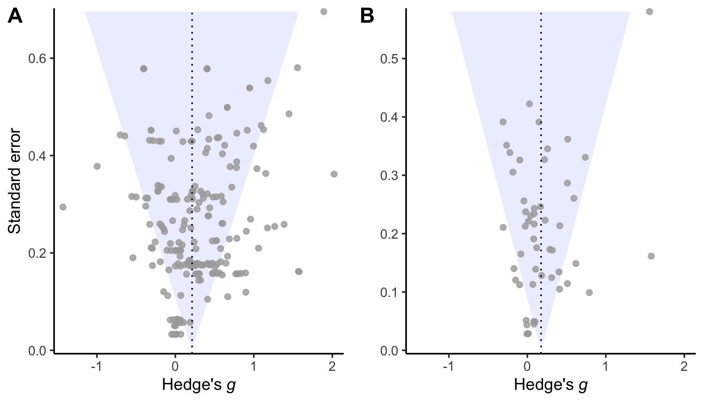

*Figure* 4. Raw (Panel A) or aggregated (Panel B) effect sizes plotted against their corresponding standard errors. Funnel plot is inverted to illustrate correspondence with slope estimates from precision-effect tests.

# Discussion

In the *Introduction*, we described a “fictitious” researcher grappling with a puzzle: a methodological artifact that (a) can lead to both false positives and false negatives, (b) can create both upward bias and downward bias, (c) has heterogeneous effects, but (d) is difficult to explain.

If one agrees that such a characterization is problematic, we argue they face an uncomfortable observation: our meta-analysis suggests that this characterization also currently applies to experimental psychology.

Since Orne popularized the concept in the mid 20th century, demand characteristics have become a literal textbook methodological concern in experimental psychology. We synthesized a subset of this literature, focusing on 252 effect sizes from 52 studies that examined the effects of explicit demand characteristics (EDCs). Like the fictitious discipline, results indicate that EDCs can create false positives (Orne, 1959), false negatives (Hayes & King, 1967), upward bias, and downward bias (Coles et al., 2022). These effects are heterogeneous – with a prediction interval ranging from = -0.46 (a medium-sized decrease in hypothesis-consistent responding) to = 0.89 (a medium-sized *increase* in hypothesis-consistent responding).

Like the fictitious discipline we described, psychologists also currently lack a validated explanation for why such heterogeneity occurs. Our investigation was shaped by an influential framework developed by Rosnow and colleagues (Rosnow & Aiken, 1973; Rosnow & Rosenthal, 1997; Strohmetz, 2008). Study level moderators – like whether studies are run in-person and include comparisons between two different demand conditions – explained up to 15% of in-sample variability in the effects of EDCs. However, we found that researchers rarely attempted to document and understand underlying mechanism(s). In the *Supplemental Materials*, we describe our own unpublished primary and meta-analytic work on this topic. However, this work ultimately failed to support Rosnow and colleagues’ assertion that the effects of demand characteristics are moderated by receptivity, motivationan, and opportunity.

## Limitations

Our meta-analysis is, of course, not without limitations. Here, we describe three: (1) operationalizing demand characteristics, (2) commensurability, and (3) non-robust evidence that participants sometimes counter-acquiesce (i.e., provide hypothesis-*in*consistent responses).

**Operationalizing demand characteristics**

At their broadest, demand characteristics are defined as almost *any* cue that may impact participants’ understanding of the purpose of the study, including instructions, rumors, and experimenter behavior (Orne, 1962). We, however, found that researchers interested in studying demand characteristics often focus on a subset of the conceptual space that is more amenable to precise definition and study: explicit demand cues (EDCs).

We suspect that researchers opt to use EDCs due to their relatively conceptual simplicity – not because they reflect typical experimental dynamics. Researchers are not usually inclined to overtly reveal their hypothesis to participants – and it is not clear if participants respond to demand characteristics similarly when the cues are overt. Indeed, Orne (1962) argued that “If… the demand characteristics are so obvious that the subject becomes fully conscious of the expectations of the experimenter, there is a tendency to lean over backwards to be honest” (p. 779). Of course, Orne too would later go on to rely on EDC’s to study demand characteristics (Gustafson & Orne, 1965; Orne & Evans, 1965; Orne & Scheibe, 1964). Furthermore, our meta-analysis refutes Orne’s claims that EDC’s would cause participants to “lean over backward to be honest” (i.e., not acquiesce). Nonetheless, it remains unclear if conclusions from research on EDC’s provides generalizable insights about the nature of demand characteristics.

Although EDC’s are not a representative definition of demand characteristics, we argue the broadening of the definition would only further increase the proportion of (yet to be explained) heterogeneity in the effects of demand characteristics. Thus, we continue to conclude from research on the more conceptually narrow subset of EDC’s that demand characteristics are inferentially consequential, heterogeneous, and difficult-to-explain.

**Commensurability**

Even with our relatively narrow subset of the demand characteristics literature, there are commensurability challenges. Researchers have tested the effects of EDCs on a variety of outcomes, including hypnosis symptoms (e.g., Orne & Scheibe, 1964), eating behavior (e.g., Kersbergen, Whitelock, Haynes, Schroor, & Robinson, 2019), visual judgments (e.g., Durgin, Klein, Spiegel, Strawser, & Williams, 2012), relationship satisfaction (e.g., Cramer, 2005), mood (e.g., Coles et al., 2022), policy support (e.g., Mummolo & Peterson, 2019), test scores (e.g., Veitch, Gifford, & Hine, 1991), and so on. Researchers also varied in how they conducted their investigations – e.g., in whether they (a) conducted their studies in-person (e.g., Orne & Scheibe, 1964) vs. online (e.g., Mummolo & Peterson, 2019), (b) sampled students (e.g., Rose, Geers, Fowler, & Rasinski, 2014) vs. non-students (e.g., Terhune & Smith, 2006), and (c) manipulated cues within- (e.g., Martin, Sackur, & Dienes, 2018) vs. between-subjects (e.g., Coles et al., 2022). We generally failed to uncover evidence that such methodological differences explain a meaningful proportion of variability in demand effects. Nonetheless, it is possible that such a large number of [often unsystematic] differences between studies limits power to detect meaningful moderators. Manipulating such differences systematically in the future may help address our concerns that the effects of demand characteristics are difficult-to-explain.

**Non-robust evidence of counter-acquiescence**

Throughout the history of research on demand characteristics, many theorists have proposed that participants occasionally counter-acquiesce – i.e., adjust their responses in the *opposite* direction they think researchers predict (Cook et al., 1970; Masling, 1966; Rosnow & Aiken, 1973; Rosnow & Rosenthal, 1997; Strohmetz, 2008). Consistent with this prediction, heterogeneity estimates in our meta-analysis suggest that counter-acquiescence occurs in approximately 20% of cases. Yet, we note that such counter-acquiescence effects were rarely observed in the meta-analysis. In 252 tests of EDC’s, only 2 (< 1%) yielded statistically significant evidence of counter-acquiescence. Furthermore, when aggregating dependent effect sizes, no test yielded statistically significant evidence of counter-acquiescence. We thus suggest that our evidence for such effects be considered non-robust.

## Concluding Remarks

Since Orne (1962) famously described the idea over 50 years ago, demand characteristics have become a literal textbook methodological concern in experimental psychology (Sharpe & Whelton, 2016). Orne (1962) further suggested that demand characteristics constituted an omnipresent threat to the validity of experimental psychology, arguing that “…all experiments will have demand characteristics, and these will always have some effects” (1962, p. 779). Consequently, it is perhaps not surprising that substantial effort has been dedicated to their study.

Unfortunately, it is not clear if much has been learned in these 50+ years since Orne warned of this “omnipresent threat”. Our review suggests that at least one type of demand characteristics – explicit demand cues – exerts effects that are inferentially consequential, but heterogeneous and challenging to explain. We imagine two potential responses from psychologists. One possibility is that we revive efforts to understand demand effects – i.e., investigate the individual differences, situational factors, and mechanisms driving their heterogeneity. A second possibility is that we continue business as usual: paying lip service to demand characteristics as a fundamental methodological issue, acknowledging that it threatens the validity of experimental psychology on multiple fronts, and making little progress towards a precise understanding of its effects. Based on what we have observed from the past half century, we pessimistically hypothesize that psychologists will continue to do the latter. Ironically, though, the effects of our explicitly stated hypothesis remain unclear.

# References

References marked with an asterisk indicate studies included in the meta-analysis.

* Allen, A. P., & Smith, A. P. (2012). Demand characteristics, pre-test attitudes and time-on-task trends in the effects of chewing gum on attention and reported mood in healthy volunteers. *Appetite*, *59*(2), 349–356. https://doi.org/0.1016/j.appet.2012.05.026

Aust, F., & Barth, M. (2022). *papaja: Prepare reproducible APA journal articles with R Markdown*. Retrieved from <https://github.com/crsh/papaja>

* Balze, E. M. (1998). *The role of expectancy in treatment efficacy: The use of a therapeutic" frame" to enhance performance* (PhD thesis).

* Barabasz, M., Barabasz, A., & O’Neill, M. (1991). Effects of experimental context, demand characteristics, and situational cues: New data. *Perceptual and Motor Skills*, *73*(1), 83–92. https://doi.org/0.2466/pms.1991.73.1.83

Bartels, J. (2019). Revisiting the stanford prison experiment, again: Examining demand characteristics in the guard orientation. *The Journal of Social Psychology*, *159*(6), 780–790. https://doi.org/10.1080/00224545.2019.1596058

Bates, D., Mächler, M., Bolker, B., & Walker, S. (2015). Fitting linear mixed-effects models using lme4. *Journal of Statistical Software*, *67*(1), 1–48. https://doi.org/10.18637/jss.v067.i01

Borenstein, M. (2009). Effect sizes for continuous data. In H. Cooper, L. V. Hedges, & J. C. Valentine (Eds.), *The handbook of synthesis and meta-analysis* (pp. 221–235). New York, NY: Russell Sage Foundation.

Borenstein, M., Hedges, L. V., Higgins, J. P., & Rothstein, H. R. (2011). *Introduction to meta-analysis*. John Wiley & Sons. https://doi.org/10.1002/9780470743386

* Busch, A. M., Kanter, J. W., Sedivy, S. K., & Leonard, J. L. (2007). A follow-up analogue study on the effectiveness of the cognitive rationale. *Cognitive Therapy and Research*, *31*, 805–815. https://doi.org/0.1007/s10608-007-9121-6

Coburn, K. M., & Vevea, J. L. (2019). *Weightr: Estimating weight-function models for publication bias*. Retrieved from <https://CRAN.R-project.org/package=weightr>

Cohen, J. (2013). *Statistical power analysis for the behavioral sciences* (Vol. 2). New York, NY: Lawrence Erlbaum Associates. https://doi.org/10.4324/9780203771587

* Coles, N. A., Gaertner, L., Frohlich, B., Larsen, J. T., & Basnight-Brown, D. M. (2022). Fact or artifact? Demand characteristics and participants’ beliefs can moderate, but do not fully account for, the effects of facial feedback on emotional experience. *Journal of Personality and Social Psychology*. https://doi.org/10.1037/pspa0000316

* Coles, N. A., McCullough, M., Oishi, S., Dang, A., McCauley, T., Pfattheicher, S., … Sarabia, V. (2024). *Six unpublished investigations of the role of demand characteristics in a conformity paradigm*.

* Coles, N. A., Wyatt, M., & Frank, M. C. (2023). *Coles, Wyatt, and Frank unpublished replication of Coles et al. 2022*.

Cook, T. D., Bean, J. R., Calder, B. J., Frey, R., Krovetz, M. L., & Reisman, S. R. (1970). Demand characteristics and three conceptions of the frequently deceived subject. *Journal of Personality and Social Psychology*, *14*(3), 185–194. https://doi.org/10.1037/h0028849

Corneille, O., & Béna, J. (2023). Instruction-based replication studies raise challenging questions for psychological science. *Collabra: Psychology*, *9*(1). https://doi.org/10.1525/collabra.82234

Corneille, O., & Lush, P. (2023). Sixty years after orne’s american psychologist article: A conceptual framework for subjective experiences elicited by demand characteristics. *Personality and Social Psychology Review*, *27*(1), 81–101. https://doi.org/10.1177/10888683221104368

* Cramer, D. (2004). Effect of the destructive disagreement belief on relationship satisfaction with a romantic partner or closest friend. *Psychology and Psychotherapy: Theory, Research and Practice*, *77*(1), 121–133. https://doi.org/10.1348/147608304322874290

* Cramer, D. (2005). Effect of the destructive disagreement belief on satisfaction with one’s closest friend. *The Journal of Psychology*, *139*(1), 57–66. https://doi.org/10.3200/JRLP.139.1.57-66

* Cramer, D., & Buckland, N. (1995). Effect of rational and irrational statements and demand characteristics on task anxiety. *The Journal of Psychology*, *129*(3), 269–275. https://doi.org/10.1080/00223980.1995.9914964

De Rooij, M., & Weeda, W. (2020). Cross-validation: A method every psychologist should know. *Advances in Methods and Practices in Psychological Science*, *3*(2), 248–263. https://doi.org/10.1177/2515245919898466

Downs, S. H., & Black, N. (1998). The feasibility of creating a checklist for the assessment of the methodological quality both of randomised and non-randomised studies of health care interventions. *Journal of Epidemiology & Community Health*, *52*(6), 377–384. https://doi.org/10.1136/jech.52.6.377

Drevon, D., Fursa, S. R., & Malcolm, A. L. (2017). Intercoder reliability and validity of WebPlotDigitizer in extracting graphed data. *Behavior Modification*, *41*(2), 323–339. https://doi.org/10.1177/0145445516673998

* Durgin, F. H., Klein, B., Spiegel, A., Strawser, C. J., & Williams, M. (2012). The social psychology of perception experiments: Hills, backpacks, glucose, and the problem of generalizability. *Journal of Experimental Psychology: Human Perception and Performance*, *38*(6), 1582-1595. https://doi.org/10.1037/a0027805

* Earn, B. M. (1979). *Experimental compensation, task interest and the cooperation with demand characteristics of volunteer and sign-up subjects.* (PhD thesis).

Fillenbaun, S., & Frey, R. (1970). More on the" faithful" behavior of suspicious subjects. *Journal of Personality*, *38*(1), 43–51. https://doi.org/10.1111/j.1467-6494.1970.tb00636.x

Flake, J. K., & Fried, E. I. (2020). Measurement schmeasurement: Questionable measurement practices and how to avoid them. *Advances in Methods and Practices in Psychological Science*, *3*(4), 456–465. https://doi.org/10.1177/2515245920952393

Franco, A., Malhotra, N., & Simonovits, G. (2014). Publication bias in the social sciences: Unlocking the file drawer. *Science*, *345*(6203), 1502–1505. https://doi.org/10.1126/science.1255484

Frank, M. C., Braginsky, M., Cachia, J., Coles, N., Hardwicke, T., Hawkins, R., … Williams, R. (2023). *Experimentology: An open science approach to experimental psychology methods*. Boston, MA: MIT Press. https://doi.org/10.25936/3JP6-5M50

* Fresson, M., Dardenne, B., Geurten, M., Anzaldi, L., & Meulemans, T. (2017). The role of self-transcendence and cognitive processes in the response expectancy effect. *Psychologica Belgica*, *57*(2), 77–92. https://doi.org/10.5334/pb.364

Gergen, K. J. (1973). Social psychology as history. *Journal of Personality and Social Psychology*, *26*(2), 309-320. https://doi.org/10.1037/h0034436

Hayes, C., & King, W. (1967). Two types of phenomenal instructions for size and distance judgments of objects presented on a two-dimensional plane. *Perception & Psychophysics*, *2*(11), 556–558. https://doi.org/10.3758/BF03210266

* Hoogeveen, S., Schjoedt, U., & Elk, M. van. (2018). Did I do that? Expectancy effects of brain stimulation on error-related negativity and sense of agency. *Journal of Cognitive Neuroscience*, *30*(11), 1720–1733. https://doi.org/10.1162/jocn_a_01297

Hyman, H. H. (1954). *Interviewing in social research*. Chicago, IL: University of Chicago Press.

* Isager, P. (2022). *Student replication of Coles et al. 2022*.

* Kanter, J. W., Kohlenberg, R. J., & Loftus, E. F. (2004). Experimental and psychotherapeutic demand characteristics and the cognitive therapy rationale: An analogue study. *Cognitive Therapy and Research*, *28*, 229–239. https://doi.org/10.1023/B:COTR.0000021542.40547.15

* Kenealy, P. (1988). Validation of a music mood induction procedure: Some preliminary findings. *Cognition & Emotion*, *2*(1), 41–48. https://doi.org/10.1080/02699938808415228

* Kersbergen, I., Whitelock, V., Haynes, A., Schroor, M., & Robinson, E. (2019). Hypothesis awareness as a demand characteristic in laboratory-based eating behaviour research: An experimental study. *Appetite*, *141*, 104318. https://doi.org/10.1016/j.appet.2019.104318

* Lamberth, J., & Byrne, D. (1971). Similarity-attraction or demand characteristics. *Personality*, *2*(2), 77–91.

* Larsen, J. T., & McGraw, A. P. (2011). Further evidence for mixed emotions. *Journal of Personality and Social Psychology*, *100*(6), 1095–1110. https://doi.org/10.1037/a0021846

Lüdecke, D., Ben-Shachar, M. S., Patil, I., Waggoner, P., & Makowski, D. (2021). performance: An R package for assessment, comparison and testing of statistical models. *Journal of Open Source Software*, *6*(60), 3139. <https://doi.org/10.21105/joss.03139>

* Martin, J.-R., Sackur, J., & Dienes, Z. (2018). Attention or instruction: Do sustained attentional abilities really differ between high and low hypnotisable persons? *Psychological Research*, *82*(4), 700–707. https://doi.org/10.1007/s00426-017-0850-1

Masling, J. (1966). Role-related behavior of the subject and psychologist and its effects upon psychological data. *Nebraska Symposium on Motivation*, *14*, 67–103.

Mathur, M. B., & VanderWeele, T. J. (2020a). *PublicationBias: Sensitivity analysis for publication bias in meta-analyses*. Retrieved from <https://CRAN.R-project.org/package=PublicationBias>

Mathur, M. B., & VanderWeele, T. J. (2020b). Sensitivity analysis for publication bias in meta-analyses. *Journal of the Royal Statistical Society Series C: Applied Statistics*, *69*(5), 1091–1119. https://doi.org/10.1111/rssc.12440

* McGinley, H., Kaplan, M., & Kinsey, T. (1975). Subject effects and demand characteristics. *Psychological Reports*, *36*(1), 267–278. https://doi.org/10.2466/pr0.1975.36.1.267

* McGlynn, F. D., Gaynor, R., & Puhr, J. (1972). Experimental desensitization of snake-avoidance after an instructional manipulation. *Journal of Clinical Psychology*. *28*(2), 224.

Morris, S. B., & DeShon, R. P. (2002). Combining effect size estimates in meta-analysis with repeated measures and independent-groups designs. *Psychological Methods*, *7*(1), 105–125. https://doi.org/10.1037/1082-989x.7.1.105

* Mummolo, J., & Peterson, E. (2019). Demand effects in survey experiments: An empirical assessment. *American Political Science Review*, *113*(2), 517–529. https://doi.org/10.1017/S0003055418000837

Orne, M. T. (1959). The nature of hypnosis: Artifact and essence. *The Journal of Abnormal and Social Psychology*, *58*(3), 277–299. https://doi.org/10.1037/h0046128

Orne, M. T. (1962). On the social psychology of the psychological experiment: With particular reference to demand characteristics and their implications. *American Psychologist*, *17*(11), 776–783. https://doi.org/10.1037/h0043424

Orne, M. T. (1969). Demand characteristics and the concept of quasi-controls. In R. Rosenthal & R. L. Rosnow (Eds.), *Artifacts in behavioral research* (pp. 143–179). New York, NY: Academic Press. https://doi.org/10.1093/acprof:oso/9780195385540.003.0005

* Orne, M. T., & Scheibe, K. E. (1964). The contribution of nondeprivation factors in the production of sensory deprivation effects: The psychology of the "panic button". *The Journal of Abnormal and Social Psychology*, *68*(1), 3–12. https://doi.org/10.1037/h0048803

Page, M. J., McKenzie, J. E., Bossuyt, P. M., Boutron, I., Hoffmann, T. C., Mulrow, C. D., et al. (2021). The PRISMA 2020 statement: An updated guideline for reporting systematic reviews. *BMJ*, *372*. https://doi.org/10.1136/bmj.n71

* Palomba, D., & Stegagno, L. (1995). Dissociation between actual and expected cardiac changes: Interoception and emotional experience. In D. Vaitl & R. Schandry (Eds.), *From the heart to the brain: The psychophysiology of circulation – brain interaction* (pp. 283–298). Peter Lang Publishing.

* Perry, D. G., Roots, R. D., & Perry, L. C. (1978). Demand awareness and participant willingness as determinants of aggressive response to film violence. *The Journal of Social Psychology*, *105*(2), 265–275. https://doi.org/10.1080/00224545.1978.9924124

* Polivy, J., & Doyle, C. (1980). Laboratory induction of mood states through the reading of self-referent mood statements: Affective changes or demand characteristics? *Journal of Abnormal Psychology*, *89*(2), 286-290. https://doi.org/10.1037/0021-843x.89.2.286

Pustejovsky, J. E., & Tipton, E. (2018). Small-sample methods for cluster-robust variance estimation and hypothesis testing in fixed effects models. *Journal of Business & Economic Statistics*, *36*(4), 672–683. https://doi.org/10.1080/07350015.2016.1247004

R Core Team. (2021). *R: A language and environment for statistical computing*. Vienna, Austria: R Foundation for Statistical Computing. Retrieved from <https://www.R-project.org/>

Riecken, H. W. (1962). A program for research on experiments in social psychology. In N. W. Washburne (Ed.), *Decisions, values and groups* (Vol. 2, pp. 25–41). New York, NY: Pergamon Press.

Rodgers, M. A., & Pustejovsky, J. E. (2021). Evaluating meta-analytic methods to detect selective reporting in the presence of dependent effect sizes. *Psychological Methods*, *26*(2), 141. https://doi.org/10.1037/met0000300

* Rose, J. P., Geers, A. L., Fowler, S. L., & Rasinski, H. M. (2014). Choice-making, expectations, and treatment positivity: How and when choosing shapes aversive experiences. *Journal of Behavioral Decision Making*, *27*(1), 1–10. https://doi.org/10.1002/bdm.1775

Rosenberg, M. J. (1969). The conditions and consequences of evaluation apprehension. In R. Rosenthal & R. L. Rosnow (Eds.), *Artifacts in behavioral research* (pp. 280–350). New York, NY: Academic Press. https://doi.org/10.1093/acprof:oso/9780195385540.003.0007

Rosnow, R. L., & Aiken, L. S. (1973). Mediation of artifacts in behavioral research. *Journal of Experimental Social Psychology*, *9*(3), 181–201. https://doi.org/10.1016/0022-1031(73)90009-7

Rosnow, R. L., & Rosenthal, R. (1997). *People studying people: Artifacts and ethics in behavioral research*. New York, NY: Freeman. http://dx.doi.org/10.34944/dspace/69

Schardt, C., Adams, M. B., Owens, T., Keitz, S., & Fontelo, P. (2007). Utilization of the PICO framework to improve searching PubMed for clinical questions. *BMC Medical Informatics and Decision Making*, *7*(1), 1–6. https://doi.org/10.1186/1472-6947-7-16

* Schauer, E. (1969). *Demand characteristics in a quasi-psychophysical experiment.* (PhD thesis).

Sharpe, D., & Whelton, W. J. (2016). Frightened by an old scarecrow: The remarkable resilience of demand characteristics. *Review of General Psychology*, *20*(4), 349–368. https://doi.org/10.1037/gpr0000087

* Siegel, W. E., & Hagen, R. L. (1982). The influence of demand characteristics and expectancies in the measurement of salivary response. *Journal of Behavioral Assessment*, *4*, 179–185. https://doi.org/10.1007/BF01321391

Sigall, H., Aronson, E., & Van Hoose, T. (1970). The cooperative subject: Myth or reality? *Journal of Experimental Social Psychology*, *6*(1), 1–10. https://doi.org/10.1016/0022-1031(70)90072-7

Silverman, I., & Marcantonio, C. (1965). Demand characteristics versus dissonance reduction as determinants of failure-seeking behavior. *Journal of Personality and Social Psychology*, *2*(6), 882–884. https://doi.org/10.1037/h0022628

* Smith, J. M., Bell, P. A., & Fusco, M. E. (1986). The influence of color and demand characteristics on muscle strength and affective ratings of the environment. *The Journal of General Psychology*, *113*(3), 289–297. https://doi.org/10.1080/00221309.1986.9711040

* Standing, L. G., Verpaelst, C. C., & Ulmer, B. K. (2008). A demonstration of nonlinear demand characteristics in the’mozart effect’experimental paradigm. *North American Journal of Psychology*, *10*(3), 553–566.

Stanley, T. D., & Doucouliagos, H. (2014). Meta-regression approximations to reduce publication selection bias. *Research Synthesis Methods*, *5*(1), 60–78. https://doi.org/10.1002/jrsm.1095

Stewart-Williams, S., & Podd, J. (2004). The placebo effect: Dissolving the expectancy versus conditioning debate. *Psychological Bulletin*, *130*(2), 324–340. https://doi.org/ 10.1037/0033-2909.130.2.324

Strohmetz, D. B. (2008). Research artifacts and the social psychology of psychological experiments. *Social and Personality Psychology Compass*, *2*(2), 861–877. https://doi.org/10.1111/j.1751-9004.2007.00072.x

* Terhune, D. B., & Smith, M. D. (2006). The induction of anomalous experiences in a mirror-gazing facility: Suggestion, cognitive perceptual personality traits and phenomenological state effects. *The Journal of Nervous and Mental Disease*, *194*(6), 415–421. https://doi.org/10.1097/01.nmd.0000221318.30692.a5

* Tsai, N., Buschkuehl, M., Kamarsu, S., Shah, P., Jonides, J., & Jaeggi, S. M. (2018). (Un) great expectations: The role of placebo effects in cognitive training. *Journal of Applied Research in Memory and Cognition*, *7*(4), 564–573. https://doi.org/10.1016/j.jarmac.2018.06.001

* Veitch, J. A., Gifford, R., & Hine, D. W. (1991). Demand characteristics and full spectrum lighting effects on performance and mood. *Journal of Environmental Psychology*, *11*(1), 87–95. https://doi.org/10.1016/S0272-4944(05)80007-6

* Verpaelst, C. C., & Standing, L. G. (2007). Demand characteristics of music affect performance on the wonderlic personnel test of intelligence. *Perceptual and Motor Skills*, *104*(1), 153–154. https://doi.org/10.2466/pms.104.1.153-154

Vevea, J. L., & Hedges, L. V. (1995). A general linear model for estimating effect size in the presence of publication bias. *Psychometrika*, *60*(3), 419–435. https://doi.org/10.1007/BF02294384

Viechtbauer, W. (2010). Conducting meta-analyses in R with the metafor package. *Journal of Statistical Software*, *36*(3), 1–48. https://doi.org/10.18637/jss.v036.i03

# Contributions

The authors made the following contributions. Anonymous for peer review (NAC): Conceptualization, Data Curation, Formal Analysis, Investigation, Methodology, Project administration, Software, Supervision, Visualization, Writing - Original Draft Preparation, Writing - Review & Editing; Anonymous for peer review (MW): Data Curation, Investigation, Project administration, Software, Writing - Review & Editing; Anonymous for peer review (MCF): Formal Analysis, Investigation, Methodology, Project administration, Resources, Software, Supervision, Visualization, Writing - Review & Editing.

# Acknowledgments

We thank (1) (anonymous for peer review; AC) for assistance with code review, and (2) (anonymous for peer review; JB) for assistance developing the initial literature search strategy.

# Funding

This work was supported by the John Templeton Foundation (grant # anonymous for peer review). The funder had no role in the preparation of the manuscript or decision to publish.

# Ethics statement

Ethics approval was not requested for the meta-analysis because no new data were collected. The vignette rating study was reviewed and approved by the (anonymous for peer review) IRB (protocol #: anonymous for peer review; protocol title: anonymous for peer review).

# Competing Interests

The authors declare no competing interests.

# Data Accessibility

The project pre-registration, materials, data, and code are openly available at <https://osf.io/3hkre/?view_only=2dc92af53f194e5eab0d7aecafaf01c2>.

1. We excluded conditions where the researcher communicated a *non-directional* effect. We did so because participants in these scenarios could not unambiguously infer how their responses were expected to change. For example, if participants were told that an independent variable would “impact mood”, it is not clear if participants should infer that the mood will be boosted or dampened.
2. For repeated-measure comparisons, the correlation between the repeated measures is needed to calculate Cohen’s . This correlation is rarely reported, so we followed a recommendation by Borenstein (2009) and performed sensitivity analyses on an assumed correlation. We preregistered a default correlation of = .50 but performed sensitivity analysis with = .10, .30, .50, .70, and .90. These sensitivity analyses produced virtually no change in overall effect size estimates, so we do not discuss them further.
3. For effect size aggregation, we assumed a default dependent effect size correlation of = .50 but performed sensitivity analysis with = .10, .30, .50, .70, and .90. These sensitivity analyses did not change our overall conclusion about publication bias, so we do not discuss them further.