Feature 1 Manual: Start Menu UI

The Start Menu Screen/UI is accessible by launching the application or pressing Main Menu on the pause menu or end of the game menu. On the start menu there are 2 buttons labeled Start and Quit. Pressing start will begin the game, changing screens to the tetris game board. Pressing the quit button will terminate the application.

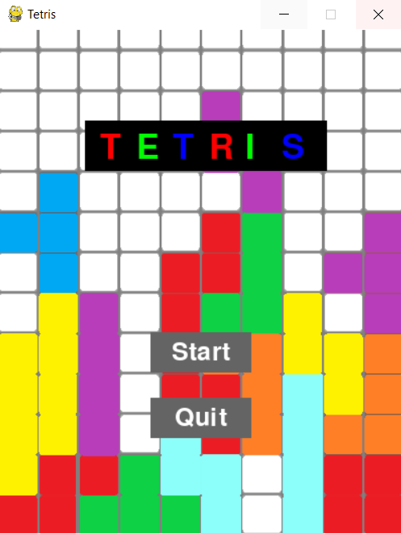

Feature 2 Manual: Pause Menu UI

The Pause Menu Screen/UI is accessible during the game. To access it, users can either press “P” during the game or they can press the pause button located on the left side of the screen. When pressed, the game will be paused, and the falling blocks will no longer fall. The game board will also no longer be visible as the pause menu will fill the screen. On the pause screen/menu there are two buttons which are Resume and Main Menu. Pressing on the Resume button will bring the user back to the tetris game screen and the blocks will continue to fall. Pressing on the Main Menu button takes the user back to the main menu screen/UI and the current game will be ended.

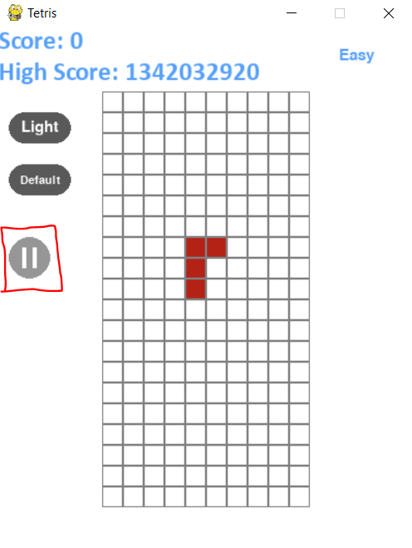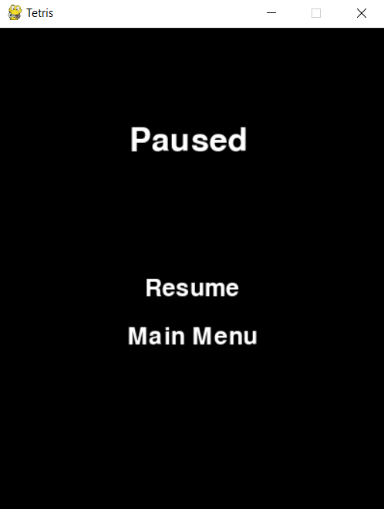

Feature 3 Manual: End Menu UI

The End Menu Screen/UI is only accessible by losing the game, when the blocks reach the top of the game board. On the end of game screen, it will display that the game is over, followed by your game's score and the highest score recorded. Following the high scores, is two clickable buttons which are Main Menu and Quit. Pressing Main Menu will return the user to the main menu screen/UI, allowing for the user to start a new game. Pressing the Quit button will terminate the application.

