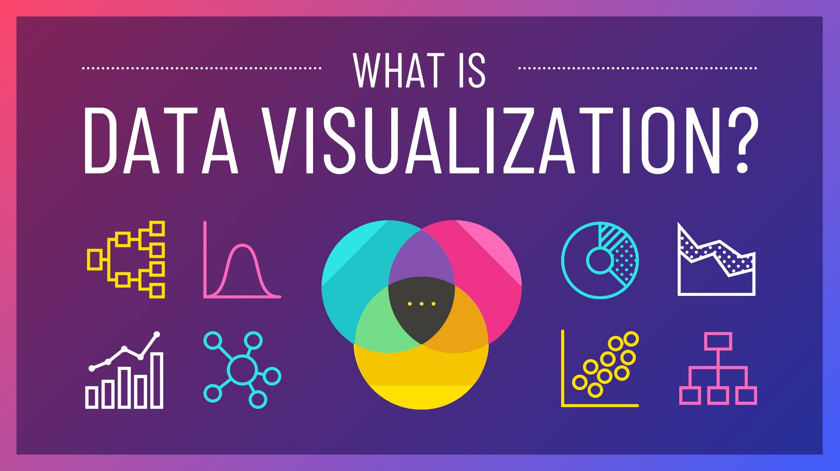

Dror Mor 312148489

Ali Shaer 307844555

|  |  |
| --- | --- |
| **Subject** | **Page number** |
| Brief summery and table of content | 3 |
| Bar Chart | 4 |
| Scatter Plot | 5 |
| Line Chart | 6 |

**Brief summery:**

D3.js is a JavaScript library that allows you to create dynamic and interactive data visualizations in web browsers. It offers a wide range of chart types that you can create, including bar charts, scatter plots, and line charts.

In this assignment we have created 3 different visualization using D3 library. Our visualizations are based on 3 csv files, each one contains different data.

In the next pages for each of the 3 graph’s that are stored in the Server (including the csv files) we wrote a textual summery about the graph and our implementation and included, as asked, a URL link to the file.

Sources of information:

<https://d3-graph-gallery.com/index.html>

**Task 1 - bar chart:**

In this task we have created a bar chart that visualizes the retail price and dealer cost of different car types. The data is stored in the "cars_types.csv" file, which is read and reformatted using D3.js.

The x-axis shows the car types, while the y-axis shows the price in USD. Each car type has two bars, one for the retail price and one for the dealer cost. The graph uses different colors to distinguish between the two price types. The tooltips are added to display the exact values for each bar. You can modify the title of the graph and axes labels to make it specific to your data.

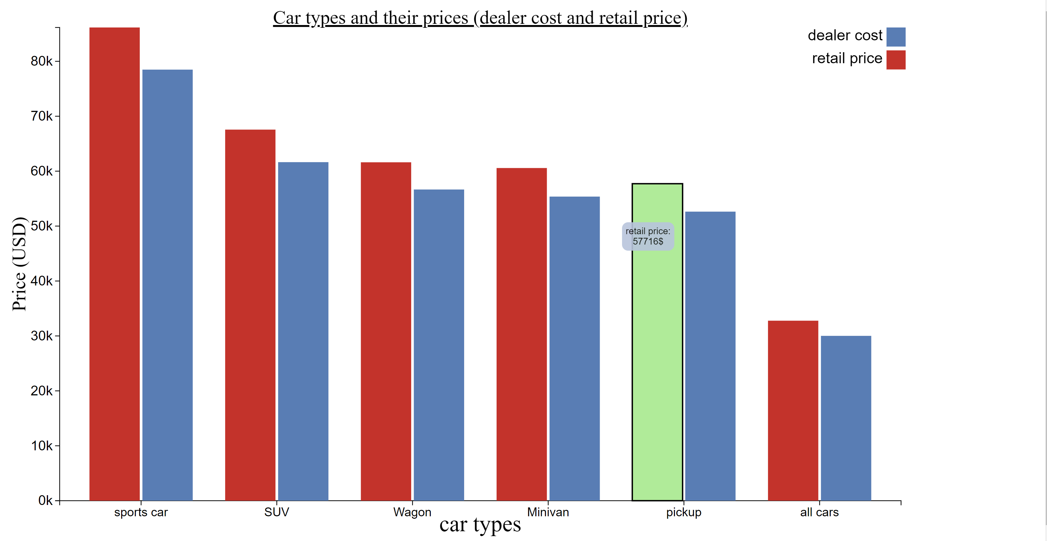

**Link to the file on the server:** [**http://34.66.223.151/~a23/q1_HW2.html**](http://34.66.223.151/~a23/q1_HW2.html)

**Task 2 - scatter plot:**

The scatterplot is created using SVG elements, with circles representing the data points. The X and Y axes are also created using SVG elements.

The color of the circles depends on the car type, with SUVs colored in red, Sports Cars colored in orange, and other cars colored in blue. A legend is added to the graph, which shows the color code for the different car types.

Tooltips are created using SVG elements, which are hidden by default and made visible when a user hovers over a data point.

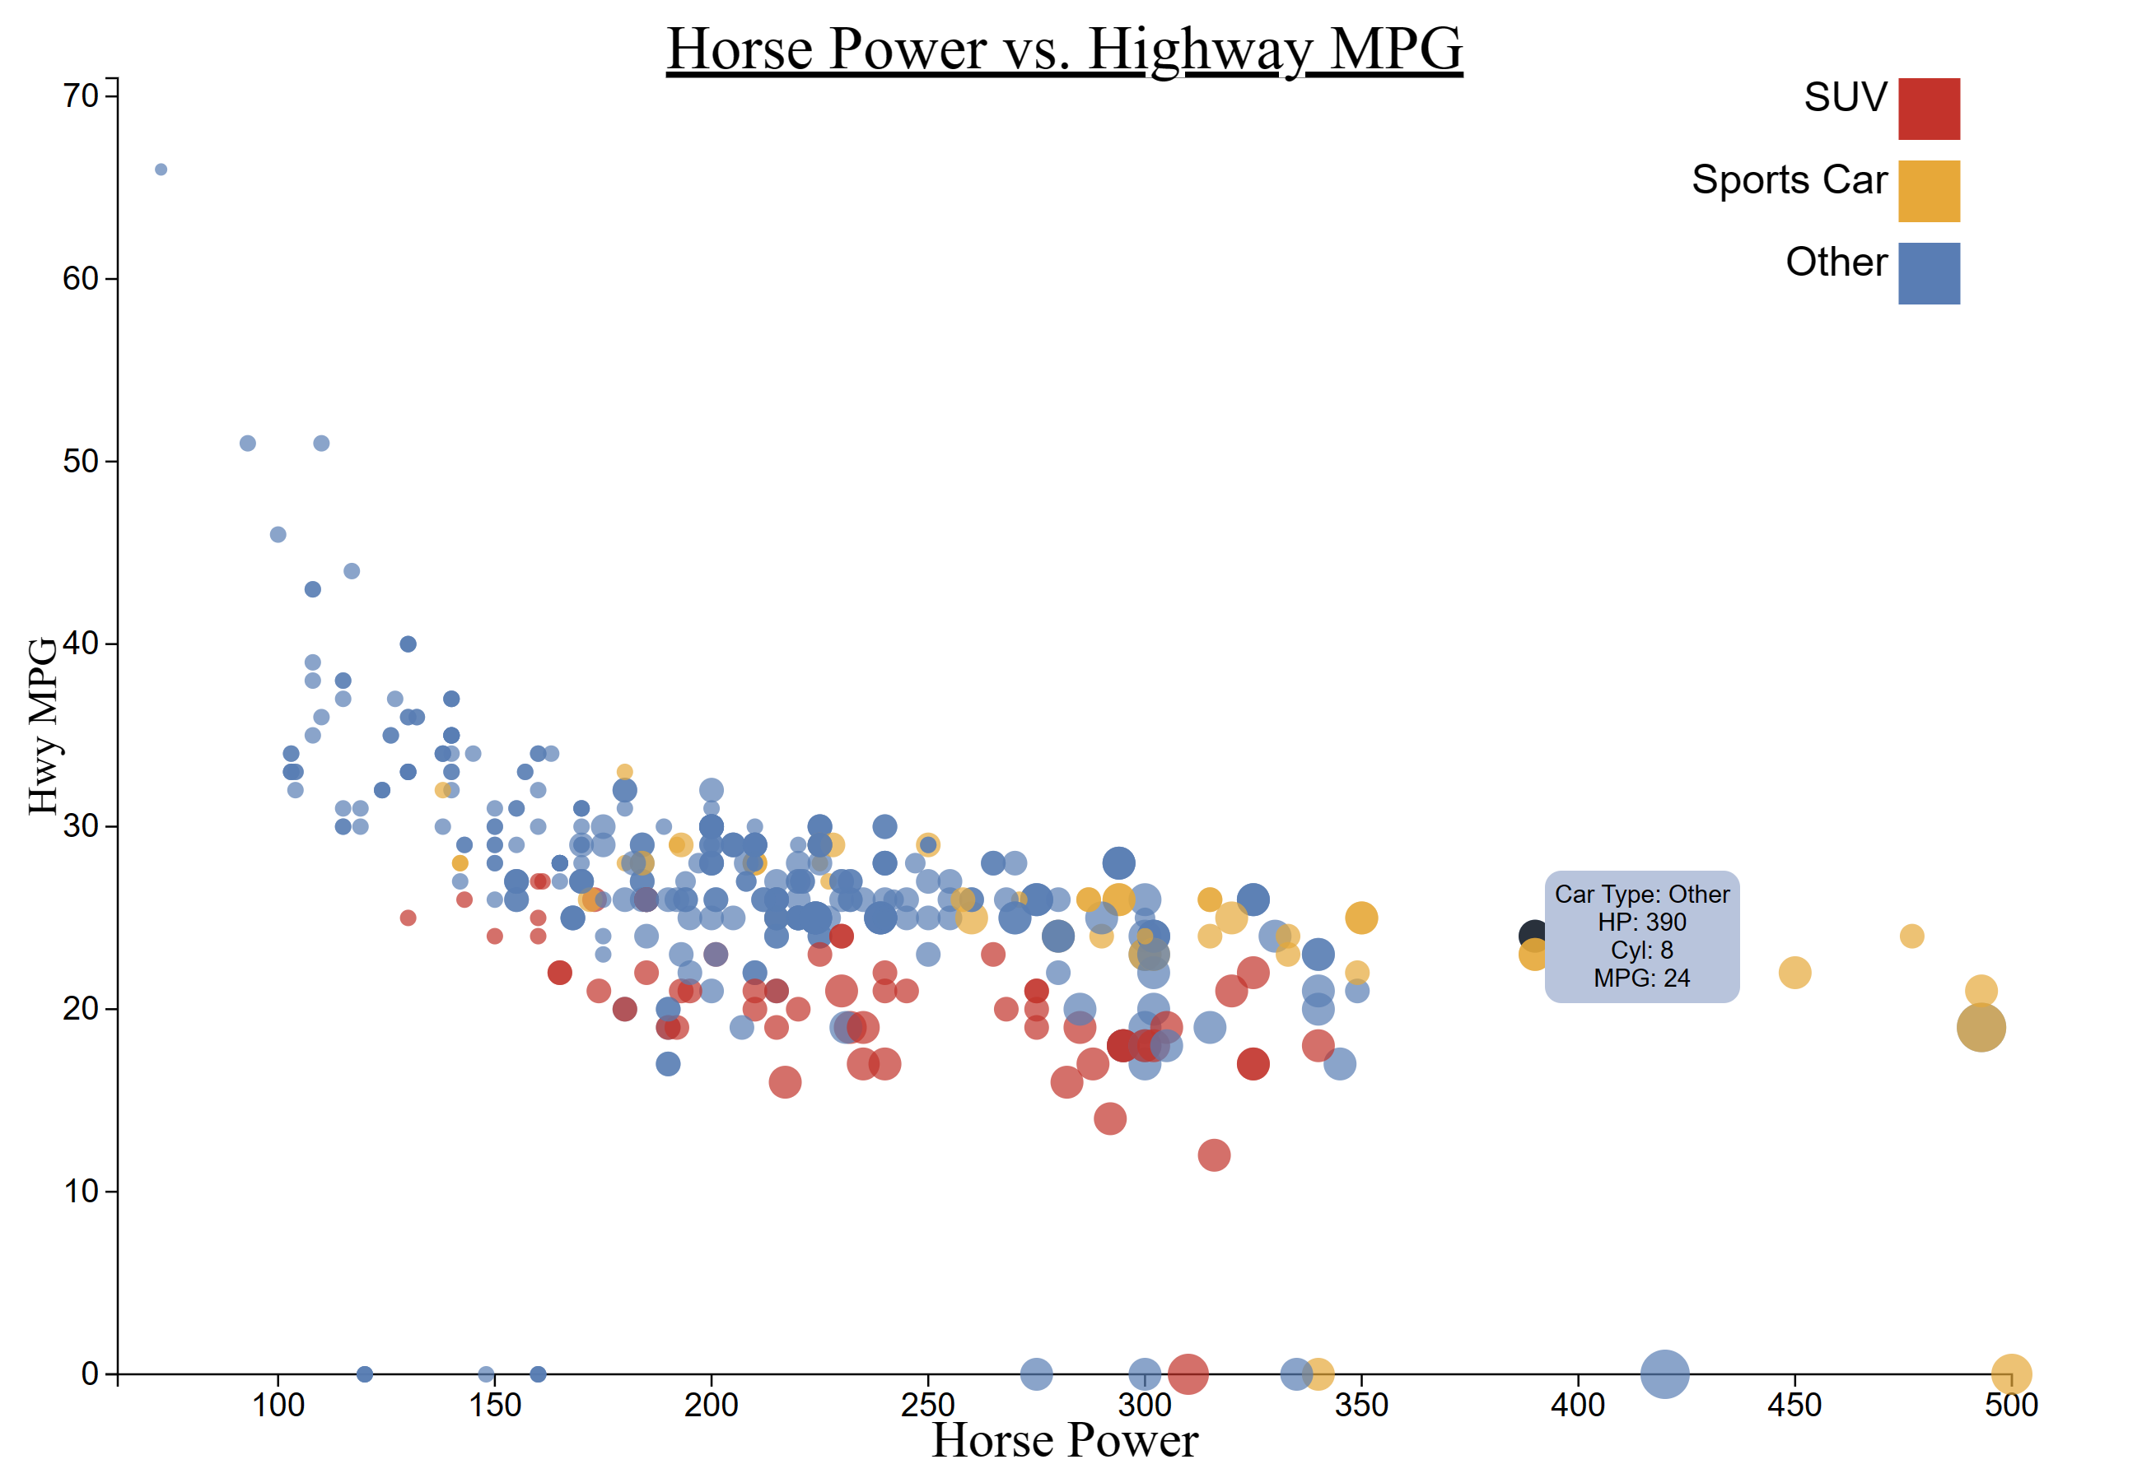

**Link to the file on the server:** [**http://34.66.223.151/~a23/q2_HW2.html**](http://34.66.223.151/~a23/q2_HW2.html)

**Task 3 – line graph:**

In this task we generated a line graph, visualizing the fuel prices in USD from 2003 to 2020. It uses a CSV file named "Fuel_Prices.csv" as the data source.

After reading the CSV file, the program reformats the data to include the date, petrol (USD), and diesel (USD) values. Creating a SVG object to the body of the page to present our graph’s, legend and axis.

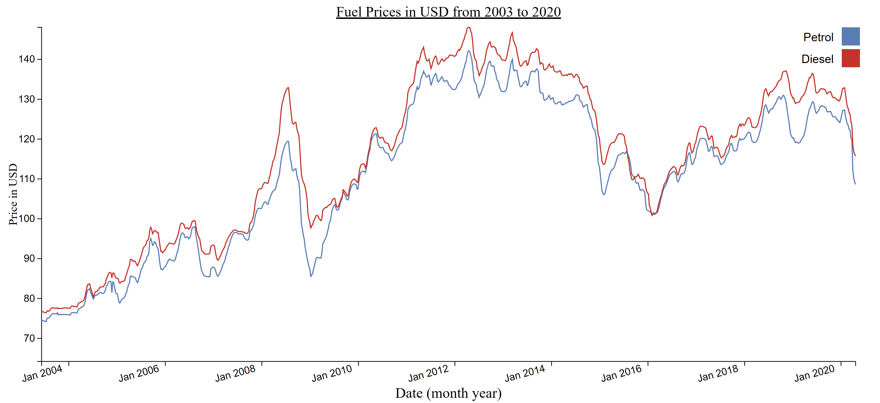

Link to the file on the server: <http://34.66.223.151/~a23/q3_HW2.html>