

|  |  |
| --- | --- |
| **Web technologies | Front-End** | |
| Student(s’) name(s): | Lukyanchuk Maxim |
| Teacher name: | Zhandos Seraliyev |
| Project name: | AnyTravel |
| Project type: | Group / Individual |

**INTRODUCTION**

I have created website for registrations on online tours in Kazakhstan. There 4 pages: main, about us, and contacts. In the main page, there all available tours and also virtual tour for one of the locations. In “about us” section there information about the guides and buttons for the tour registration. In “reports” section you can fill the form, if you had some problems during the tour and make a complaint. In “contacts” section you can find office of the company and theirs contacts. All buttons are clickable.

**MAIN PART (Practical) | Information about developers and their responsibilities.**

Main page

I have created this website fully by myself. First step was creation of the navbars for each page. So using bootstrap source code I have created it.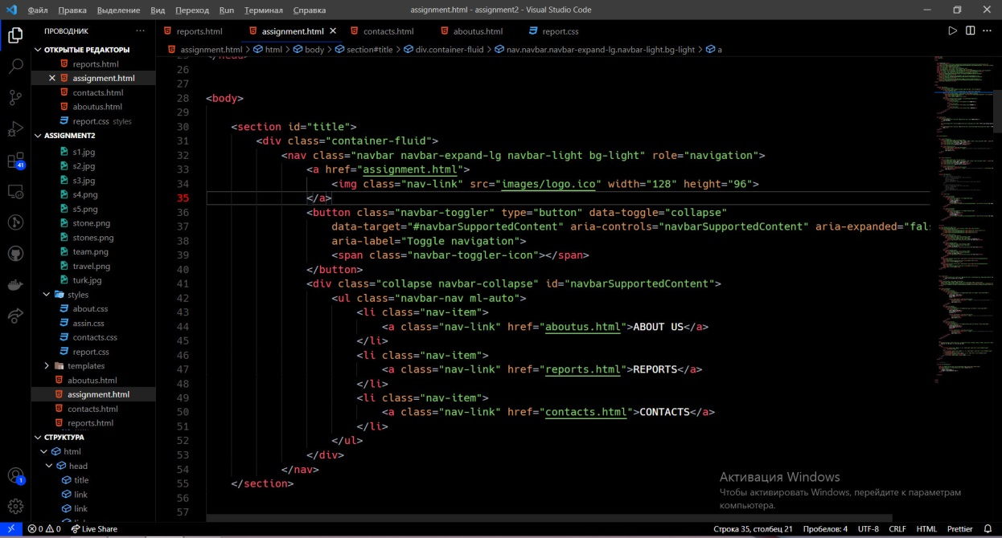

And I have repeated it for each page but in some pages, and changed the color of items using css.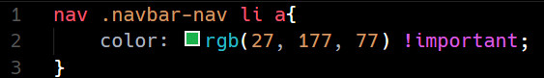

Then using bootstrap row and col and nav bar I created title section.

Following it, I have created “most wanted” tours using w3school containers, to write text on the images (classes bottom-left1..3).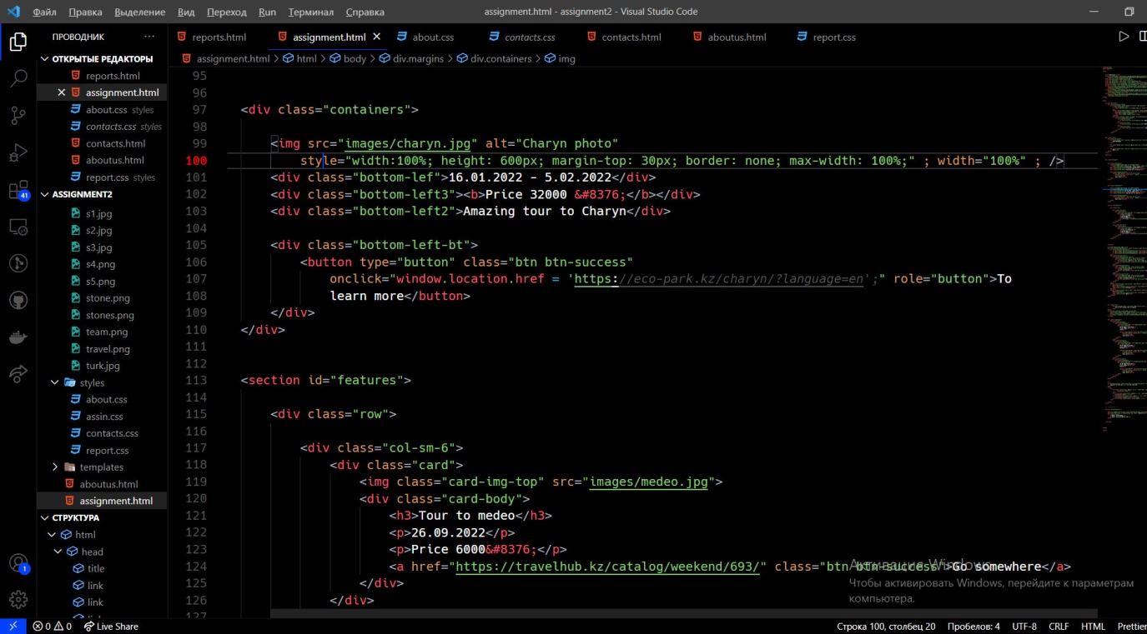

Using bootstrap carousel I have created it, using source code. And the main feature of my website it’s virtual tour which I have created using my own photos with help of webobook.com.

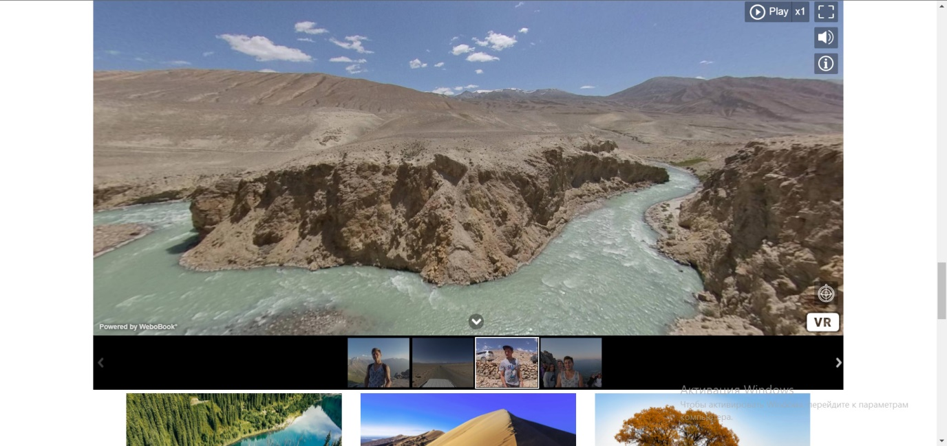Using bootstrap columns and rows I created thumbnails for tours. Also I have special form using css and html in order to register for the tour.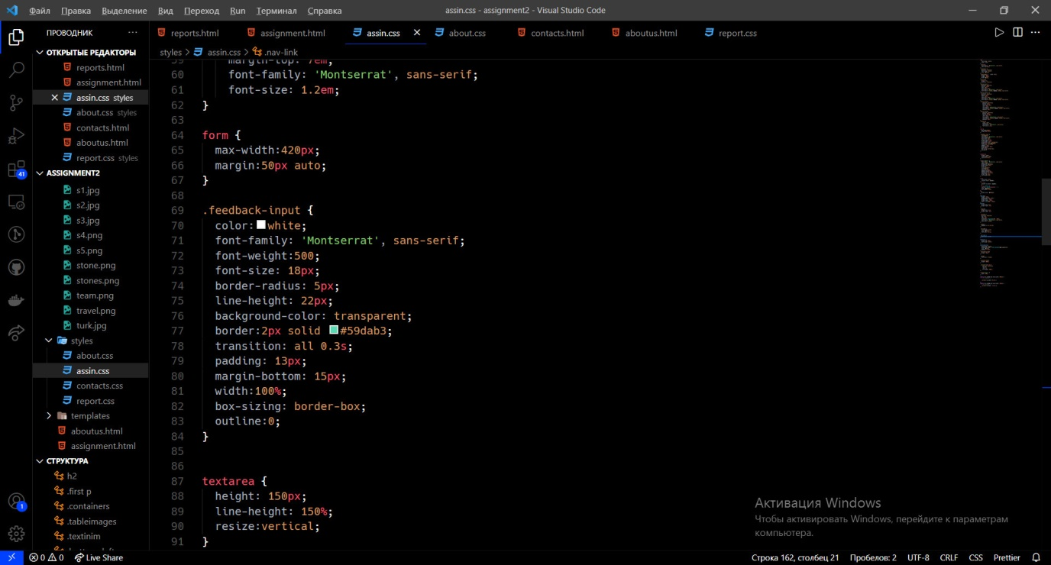

About us

In about us section I mostly uses bootstrap everywhere (columns , rows and cards). 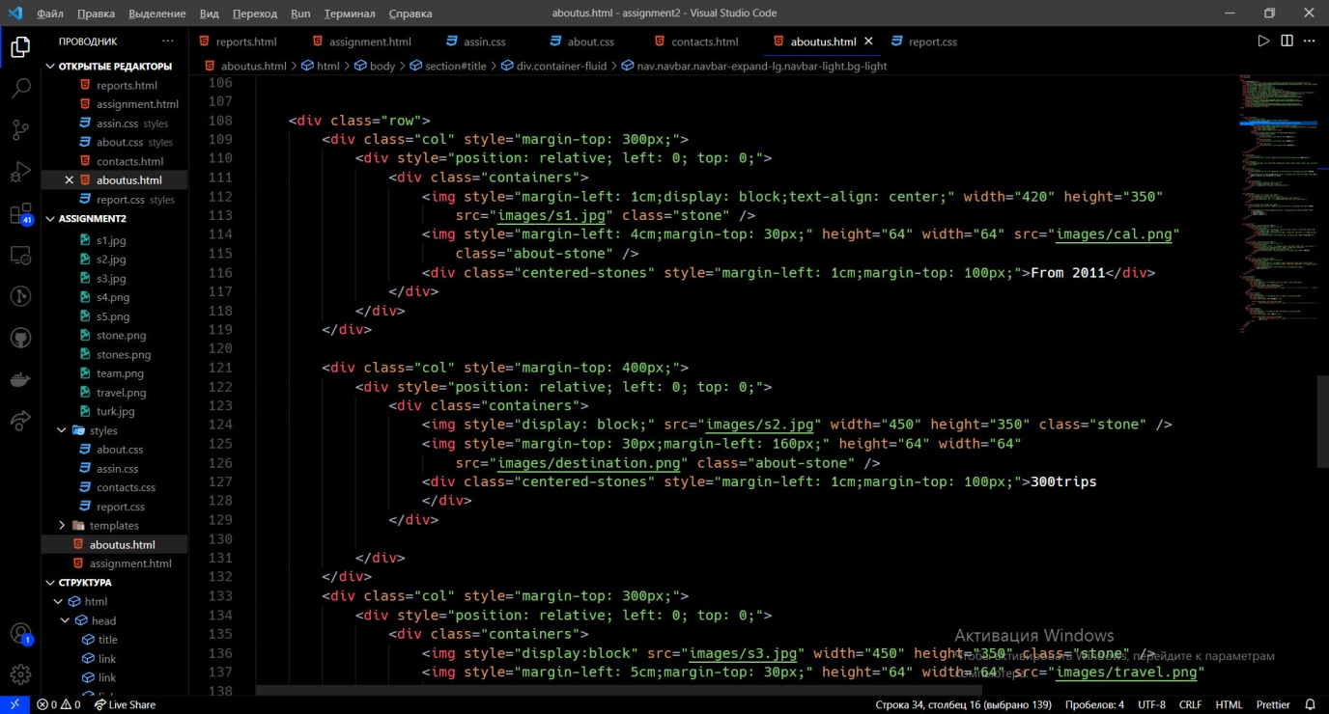

Reports

Reports sections contains only from one form and navbar. In this page you can complaint about problem for tour, for example bad guide or travel delay. I also used bootstrap for this form.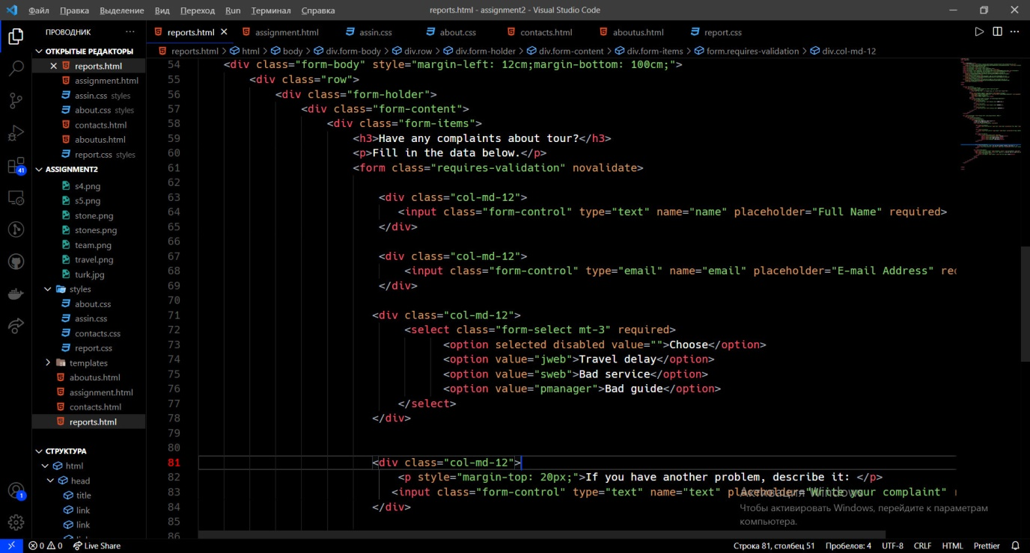

Contacts.

In contacts page, you can find office of the company and more information about them: instagram and location. As you can see in the main page also phone phone number and email, I made this because a lot people can watch web site only by it main page, and can’t see other pages. This is the code of the feedback information.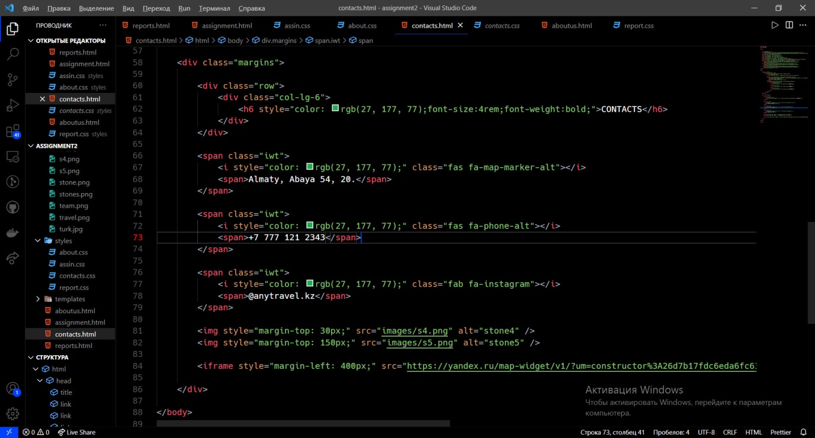

Here I used icons from kint fontawesome. Also I have taken an yandex card for location of the office using <iframe> tag, line in virtual tour.