Here are the pre-requisites for installing Radiant Command Center:

Site File Server:
- .NET Framework 2.0
- Windows® XP or later
- 512 MB of system memory
- 75 MB free hard disk space
Site Terminals:
- NET Framework 2.0
- Windows® XP or later
- 512 Mb RAM
- 75 Mb free hard disk space

For BOH computer/FileServer:

Installing CMC(Initial Install on BOH computer):

Download the CMC installer at:

https://rdf2.alohaenterprise.com/client/cmcinst.zip

Unzip/extract files to C:\ so it will be easier to uninstall and install CMC.
After extraction of file, right click on CMCinst.exe then “Properties”.

Unblock CMCinst.exe on “Attributes” section under “General” tab and file should NOT be set as read only.

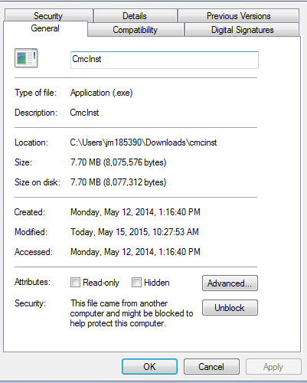

For Windows 7 and above, CMCinst.exe needs to run as admin.
On “Compatibility” tab check to run CMCinst.exe as an administrator

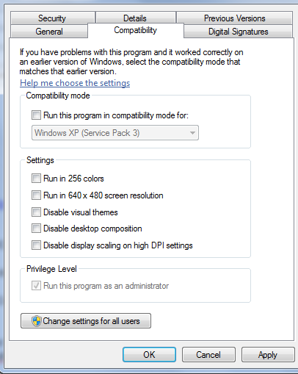

After that, run CMCinst.exe.

If site won’t show online, navigate to the C:\Program Files or Program Files (X86)\Radiant Systems\CMC
Check the commandcenter.config file configuration should be as follows

<?xml version="1.0"?>
<commandcenter>
<!-- REQUIRED: should the node behave like a gateway (on) or as a node (off - specify gateway IP or hostname) -->
<gateway mode="on" ipAddress="0.0.0.0" />
<!-- OPTIONAL: manual override only -->
<siteId value="KEY NUMBER OF SITE" />
<nodeConfig id="" />
<unitNumber value="" />
<siteInfo enterpriseId="" siteName="" phone="" phone2="" address1="" address2="" openTime="" />
</commandcenter>

Then Start>Run>Type “Services.msc” Find Radiant Command Center Agent and then Restart it
If this data is correct and Site is still showing offline then please send us the log files
C:\Prorgam Files\Radiant Systems\CMC\Logs
CmcAgent_TodaysDate.Log

If Reinstalling CMC(CMC is still installed on BOH computer):

Download the CMC installer at:

https://rdf2.alohaenterprise.com/client/cmcinst.zip

Unzip/extract files to C:\> so it will be easier to uninstall and reinstall CMC.

Open Command Prompt and make sure that we are executing commands on C:\> directory.

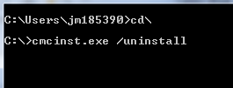

Delete these folders to make sure that you are creating new CMC files:

C:\Program Files\Radiant Systems\CMC
C:\Program Files\Radiant Systems\CmcSvcWatcher
C:\Program Files\Radiant Systems\RadSprtA

Then proceed with installation steps above starting on the step checking the properties of CMCinst.exe.

For Front Terminals:

With Direct Access to terminal:

Get a copy of the CMCinst.exe and paste it on the C:\ and run it. If you haven’t saved a copy of it, you can get one from the C:\Program Files or Program Files (X86)\Radiant Systems\CMC\Update folder on the BOH computer.

CommandCenter.config for terminals should be as follows:

<gateway mode="off" ipAddress="IP Address of BOH computer or BOH computer name" />
<!-- OPTIONAL: manual override only -->
<siteId value="KEY NUMBER OF SITE" />

Without direct access, meaning you can only access terminal files from the BOH computer:

So that you can execute commands from the BOH computer, please get a copy of PSexec file from Microsoft. You can download it from http://technet.microsoft.com/en-us/sysinternals/bb896649.aspx.

After that, put a copy of PsExec.exe file on the c:\ of BOH computer and c:\ of the terminal. Put a copy of CMCInst.exe on the c:\ of the terminal as well. You can path the folder structure of the terms using \\TermName\c$.

Run this command on the CMD of the BOH computer.

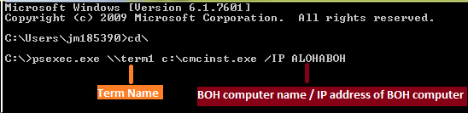

For uninstalling Command Center agent on the terms, replace “/IP AlohaBOH” with “/uninstall” command.

For Kitchen Terminals/KDS:

Same install process with the front terminals.

But C:\Program Files\Radiant Systems\CMC\Industry.config file should have the value below.

Industry name = “Generic” instead of Aloha.

