Sprint 3 Report
SlugFound | Team SlugFound | CMPS 115 – Software Methodology
Sprint Dates: May 8, 2025 – May 22, 2025 | Report Date: May 22, 2025

1. Actions to Stop Doing
The following are practices the team identified during the Sprint 3 retrospective that should be discontinued or reduced going forward.

1.1 Committing to Specific Third-Party APIs Before a Spike
The team should stop locking the sprint plan to a single external AI provider before validating access and cost. Sprint 3 specified the Google Gemini Vision API for both AI features (US 3.3 and US 3.4), but billing and key-provisioning friction on Gemini forced a mid-sprint switch to the Groq vision API for the photo-scan feature. Naming the exact provider in the plan created churn once reality diverged. A short proof-of-concept before committing the plan would have surfaced this earlier.

1.2 Treating AI Output as Trusted Without a Validation Layer
The team should stop wiring model responses directly into form state without a dedicated parsing and validation step. Early in the sprint, malformed JSON from the vision model occasionally broke the scan-to-form injection flow. Building schema validation and a graceful fallback only after the fact cost rework. This guard belongs in the design of any AI-backed feature from the start.

2. Actions to Start Doing
The following are new practices the team identified that should be adopted to improve the development process going forward.

2.1 Run a Technical Spike for External Dependencies
The team should start dedicating a short, time-boxed spike at sprint kickoff to verify any new third-party API — confirming key provisioning, quotas, billing, and response shape — before committing tasks that depend on it. This would have prevented the Gemini-to-Groq pivot from consuming time mid-sprint.

2.2 Standardize a Shared AI Response Contract
The team should start defining a single, documented JSON schema and parsing helper shared across all AI endpoints. With two AI routes built in parallel (scan-item and photo-search), a common contract for descriptors, fallbacks, and error handling would reduce duplication and make the features easier to test in isolation.

2.3 Add Manual QA Scripts for Privacy-Sensitive Paths
The team should start writing short manual QA checklists for security-critical behavior — specifically confirming that the AI API key never appears in client bundles or browser network traffic, and that RLS blocks cross-user message access. These properties are easy to regress and worth an explicit verification pass each sprint.

2.4 Reserve Capacity Buffer for High-Point Stories
The team should start sizing sprints with a deliberate buffer when two or more 8-point stories are in scope. Sprint 3 committed 52 hours across five stories, but the two AI stories ran over their estimates and forced US 3.5 to slip. Carrying lower-priority stories as explicit stretch goals — rather than firm commitments — would set more realistic expectations when the heavy stories absorb the schedule.

3. Actions to Keep Doing
The following are current practices the team found effective and intends to continue.

3.1 Regular Scheduled Meetings
The Monday lab, Wednesday evening, and Friday midday cadence continued to anchor the project. These slots kept everyone aligned through the more complex AI integration work and allowed the team to redistribute effort toward the two 8-point stories (US 3.3 and US 3.4) when they proved demanding.

3.2 Component Reuse Across Pages
The reusable Item Card primitive paid off again: it was dropped into the photo-match results list, and the new location pill slotted in cleanly, letting US 3.2 and US 3.4 reuse existing layout work rather than rebuild it.

3.3 Clear Initial Task Ownership
Assigning lead developers to distinct pillars — messaging and realtime, geolocation and mapping, and the two AI routes — kept the parallel workstreams from colliding and gave each feature a clear technical point of contact.

4. Work Completed / Not Completed

4.1 User Stories Completed
ID | Priority / Pts | User Story | Est. Hours | Status
US 3.1 | High / 5 pts | Real-time messaging between users about a lost/found item | 10 | Completed
US 3.2 | High / 5 pts | Geolocation tagging with map pin on item posts | 8 | Completed
US 3.3 | High / 8 pts | AI-powered listing creation from a single photo | 10 | Completed
US 3.4 | High / 8 pts | AI-powered photo-match search against the database | 12 | Completed
Implementation notes:
- US 3.3 was delivered against the Groq vision API rather than Google Gemini. Gemini key provisioning and billing setup proved impractical within the sprint, so the team substituted an equivalent server-side vision model. The user-facing behavior — photo-to-form auto-fill, AI-highlight styling, and graceful fallback — meets the Definition of Done, and the API key remains server-side only.
- US 3.4 was implemented as a Gemini-backed image-embedding similarity search (/api/photo-search) using stored per-item embeddings and in-process cosine similarity, rather than the originally specified keyword .ilike scoring. The ranked High / Medium / Low match-strength badges, authenticated-only access, and no-match empty state all satisfy the Definition of Done.

4.2 User Stories Not Completed
One of the five user stories planned for Sprint 3 was not completed and carries over to the next sprint.
ID | Priority / Pts | User Story | Est. Hours | Status
US 3.5 | Med / 3 pts | Map view toggle for browsing geotagged items on the UCSC campus | 6 | Not Completed
US 3.5 (Map/List toggle) was deprioritized once the two 8-point AI stories — US 3.3 and US 3.4 — proved more involved than estimated and absorbed the team’s remaining capacity. The story was a strong candidate to defer because its core dependency, the react-leaflet map and the lat/lng columns from US 3.2, was already delivered, so the map-view work can be picked up cleanly at the start of the next sprint with no rework. It carries over with its full 3 points and 6 estimated hours intact.

5. Work Completion Rate

5.1 Sprint 3 Summary
Metric | Value
User stories planned | 5
Total user stories completed | 4 of 5
Story points completed | 26 of 29 pts
Ideal work hours planned | 52 hrs
Ideal work hours completed | 46 of 52 hrs
Total calendar days in sprint | 14 days (May 8 – May 22)
User stories per day | 4 ÷ 14 = 0.29 stories/day
Ideal work hours per day | 46 ÷ 14 = 3.29 hrs/day

5.2 Cumulative Averages (Sprints 1–3)
Across all three sprints to date, the team completed 16 user stories and 130 ideal work hours over 42 calendar days. Cumulative figures count completed work only; the carried-over US 3.5 will be credited to the sprint in which it is finished.
Metric | Value
Total user stories (S1–S3) | 6 + 6 + 4 = 16
Total ideal work hours (S1–S3) | 38 + 46 + 46 = 130 hrs
Total calendar days (S1–S3) | 42 days
Average user stories per day | 16 ÷ 42 = 0.38 stories/day
Average ideal work hours per day | 130 ÷ 42 = 3.10 hrs/day
The final Sprint 3 burnup chart will be presented during the lab session and emailed to the TA and professor as required.

5.3 Sprint 3 Burnup Chart
The chart below tracks cumulative story points completed against the total planned scope of 29 points across the 14-day sprint. The actual line steps up as each user story is completed and plateaus at 26 points, leaving a 3-point gap that reflects US 3.5 carrying over to Sprint 4.
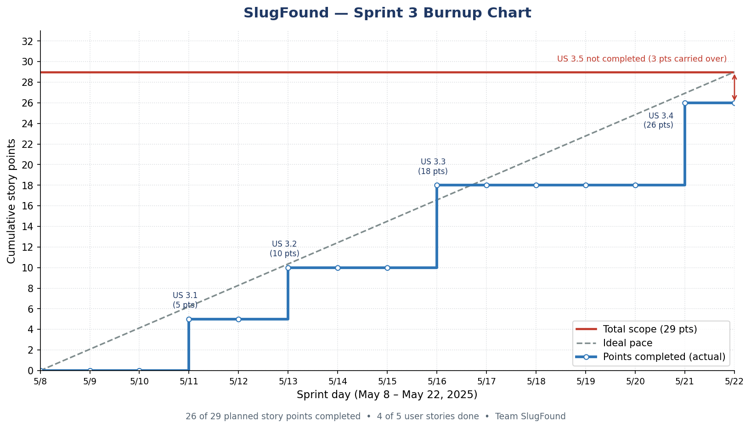
Figure 1. Sprint 3 burnup — cumulative story points vs. total scope (May 8 – May 22, 2025).

6. Team
Team Member | Email | Role(s)
Bardia Nasab | bnasab@ucsc.edu | Scrum Master
Colin Posat | cposat@ucsc.edu | Developer, UI/UX Lead
Sam Madinya | smadinya@ucsc.edu | Developer
Aidan Nguyen | anguy480@ucsc.edu | Developer

