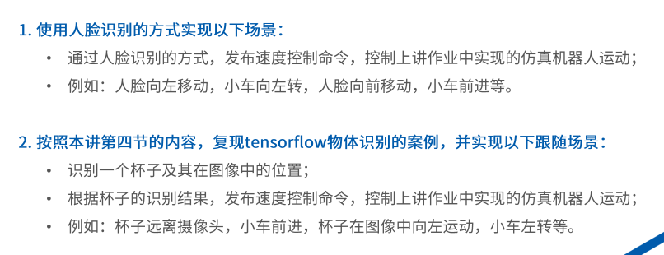

Assignment1:

1. Ctrl + Alt + T
2. roslaunch robot_vision usb_cam.launch
3. roslaunch robot_vision face_detector.launch
4. rqt_image_view
5. roslaunch mbot_gazebo robot_control.launch

Assignment2:

1. souce ~tensorflow/bin/activate
2. roslaunch tensorflow_object_dectector usb_cam_detector.launch
3. roslaunch mbot_gazebo robot_control.launch
4. rosrun vision2 vision2