HOW TO LIGHT A
BEE SMOKER
Cool smoke, dependable fuel and confident hive inspections.
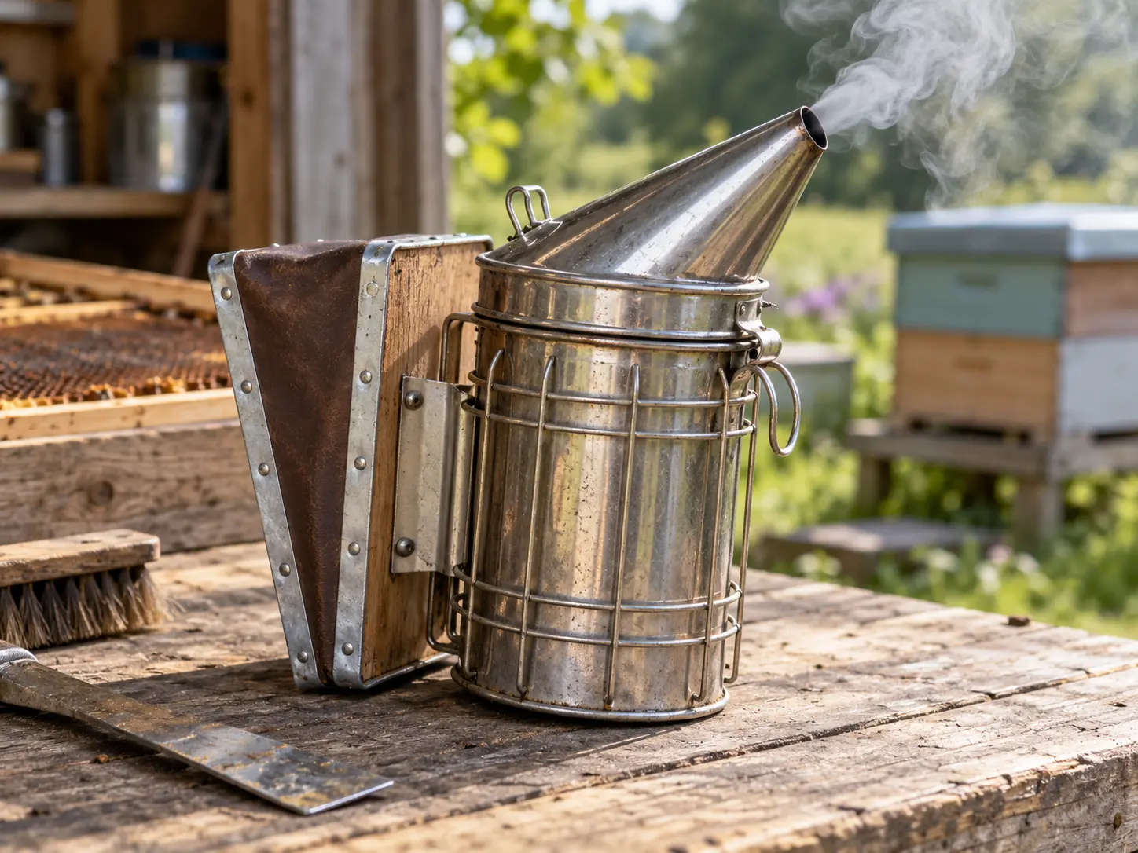

A PRACTICAL GUIDE FOR UK BEEKEEPERS
A smoker should be ready when you need it — not another job to keep relighting. This guide explains how to light one reliably, what fuel to choose, how to use smoke carefully and how to extinguish it safely.
THE THREE ESSENTIALS: LIGHT WELL • FUEL CLEANLY • SMOKE GENTLY

01 WHY SMOKE BEES?
Smoke changes how a colony responds to disturbance; it does not put bees to sleep. Small amounts can interfere with alarm signaling and encourage bees to move away from the exposed frame tops.
USE ONLY WHAT YOU NEED  One or two gentle puffs near the entrance or beneath the crown board can be enough. Give bees a moment to settle before you continue.  WHEN TO HOLD BACK  Very calm colonies may need little or no smoke. Avoid excess when finding a queen, working delicate brood or handling honey supers. | GOOD SMOKE IS COOL  Smoke should be pale and gentle. Sparks, flame or scorching heat are signs to stop and adjust the smoker.  WHAT SMOKE CANNOT DO  A smoker will not fix poor weather, rough handling or a defensive colony. Postpone a non-essential inspection if conditions are unsuitable.

02 HOW A SMOKER WORKS
A traditional smoker has a metal combustion chamber, raised grate, hinged conical lid, spout and bellows. The bellows feed oxygen from below; the burning material is established low in the chamber and slower-burning fuel is added above it.
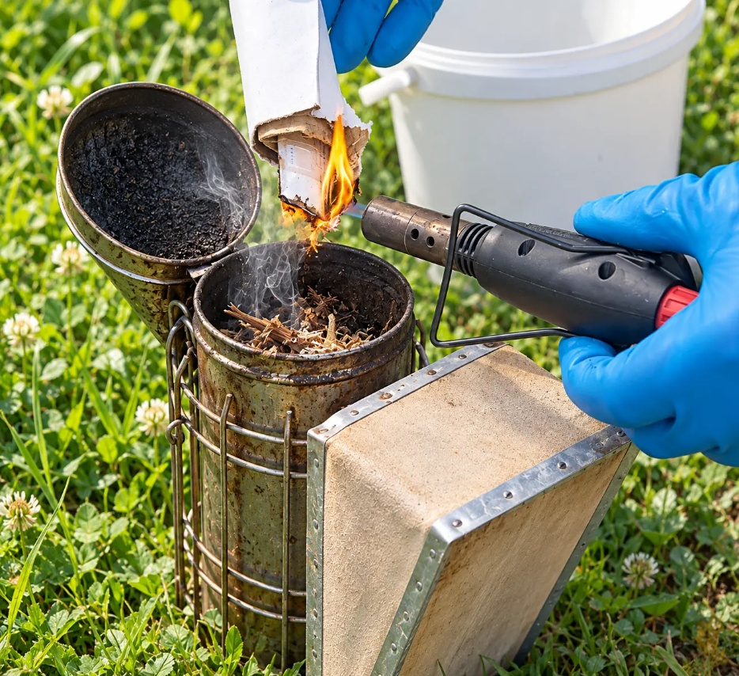
Prepare your fuel and a safe extinguishing method before lighting. Never ignite a smoker over dry grass or on a hive roof.
TIP: Prepare the smoker before opening the hive. Use it sparingly once you start
1. Start with a small amount of easy-lighting material such as crumpled plain cardboard, a small twist of hessian or fine dry shavings.
2. Light the starter material and pump the bellows steadily to create a small but lively flame. Keep the lid open until the starter catches well.
3. Add more fuel a little at a time. Do not overpack the chamber too early or you may choke the airflow and extinguish the flame.
4. Once the lower fuel is burning properly, add the main fuel and continue pumping until the smoker produces a reliable stream of smoke.

03 LIGHT IT & KEEP IT LIT
01 START SMALL
Place a little clean dry starter fuel in the bottom. Ignite it with matches, a long-reach lighter or carefully controlled butane/propane lighter.
02 BUILD THE FIRE
Pump the bellows gently until the starter burns well. Add small amounts of main fuel gradually, without choking airflow.
03 CREATE A SMOULDER
When the lower fuel is established, add more slow-burning material, close the lid and check for a steady stream of pale smoke.
04 TEST BEFORE USE
Check that smoke is cool, not hot, on the back of your hand at a safe distance from the spout. If sparks or flames appear, stop and correct the fire.
FUELS THAT WORK — AND THOSE THAT DON’T
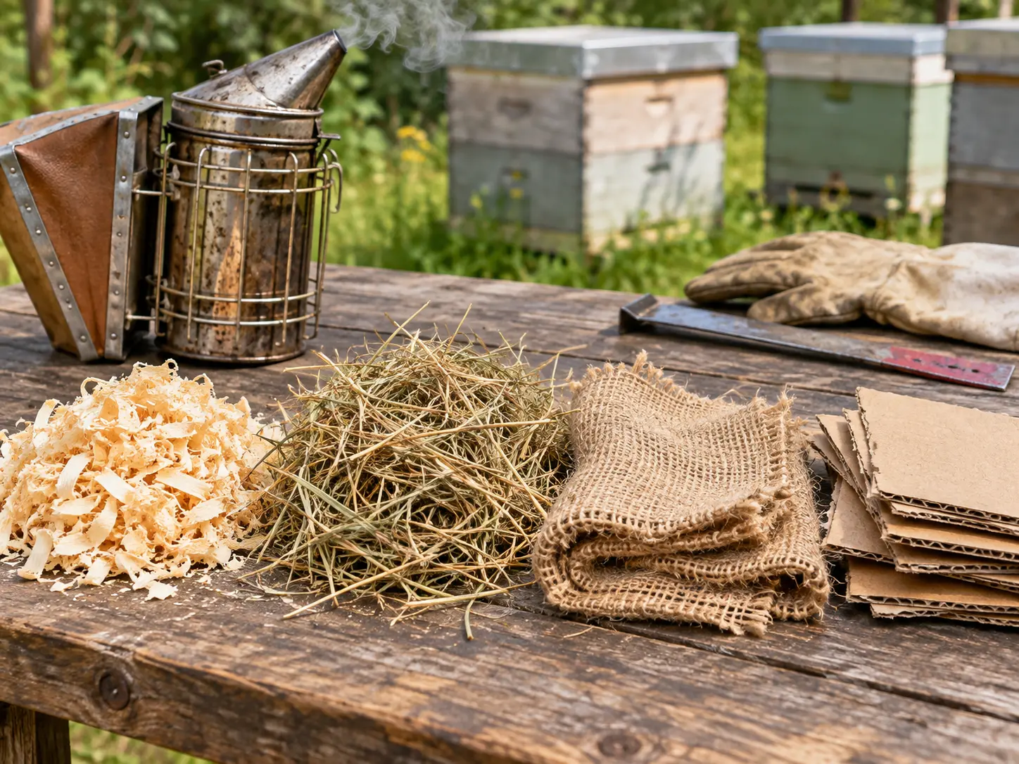
Suitable examples: untreated wood shavings, dry grass, clean natural hessian, small amounts of plain cardboard and purpose-made smoker fuel. Choose dry, clean material that smoulders steadily.
NEVER BURN
Plastic, rubber, foam, synthetic fabrics, treated or painted timber, glossy packaging, moldy fuel,
accelerants or unknown contaminated materials.

04 CHOOSE YOUR SMOKER
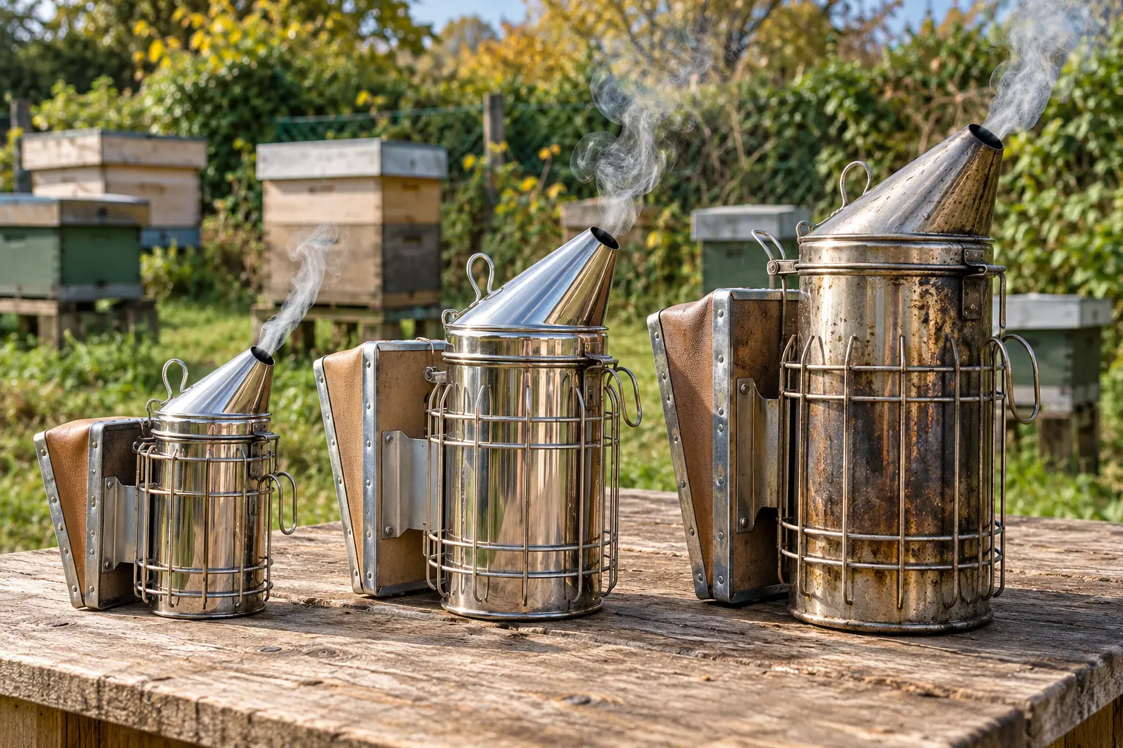
Small smokers are light and compact but run out of fuel sooner. A guarded medium smoker is a sensible everyday choice; a large barrel offers more fuel capacity for extended apiary work.
STAINLESS STEEL  Corrosion-resistant, durable and practical for regular use. Often the best all-round choice.  GALVANISED STEEL  Generally lower cost. The zinc coating and overall build quality affect its working life. | COPPER  Traditional look and attractive patina, usually at a higher price. Performance still depends on bellows and airflow.  CHECK THE DETAILS  Prioritise strong bellows, a reliable hinge, raised grate, stable base, secure hook and effective heat guard.

05 TROUBLESHOOT & FINISH SAFELY
Smoker goes out? Check that the bottom fuel was properly lit, fuel is dry and the chamber is not packed too tightly. Weak smoke often needs a little more airflow; acrid smoke or flying embers calls for stopping and replacing the fuel.
FIRE SAFETY
Keep hot smokers upright and away from dry vegetation, vehicles and plastic surfaces. Never leave one
unattended or transport it while warm. Extinguish every ember and allow complete cooling before storage.


KEEP YOUR SMOKER BURNING, NOT YOUR PATIENCE!
Scan the QR code for practical lighting tips, fuel advice and common mistakes to avoid

