

Presents

Treading Lightly

Tread Lightly

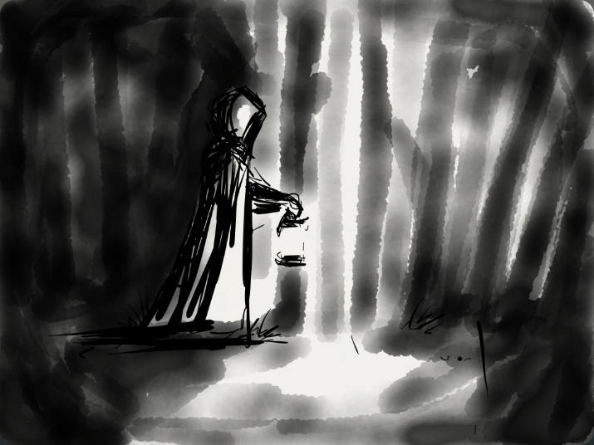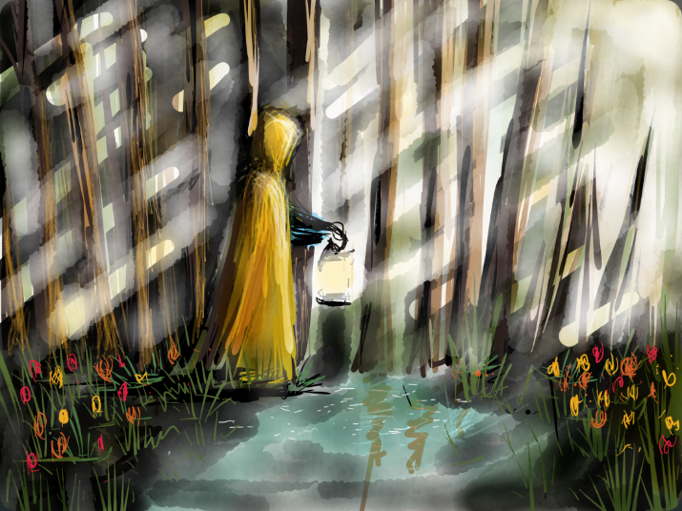

“It is during our darkest moments that we must focus to see the light.”

The Game:

A 2D poetic experience of a character treading their way through a dark and perilous world. They are faced with environmental obstacles like wind, rain, fire, as well as a personal obstacle that appears as a motif of a memory they are haunted by. To get through the darkness, they utilize a special lantern that allows them to see a light and beautiful world through it.

Environments:

There will be two environments. The dark environment is going to look very dull and dead, and will be wrought with obstacles like debris, holes, and falling objects. The light environment will be the opposite: lively, fruitful, and free from danger. There will be crows that fly around in the dark world that become doves through the special lantern.

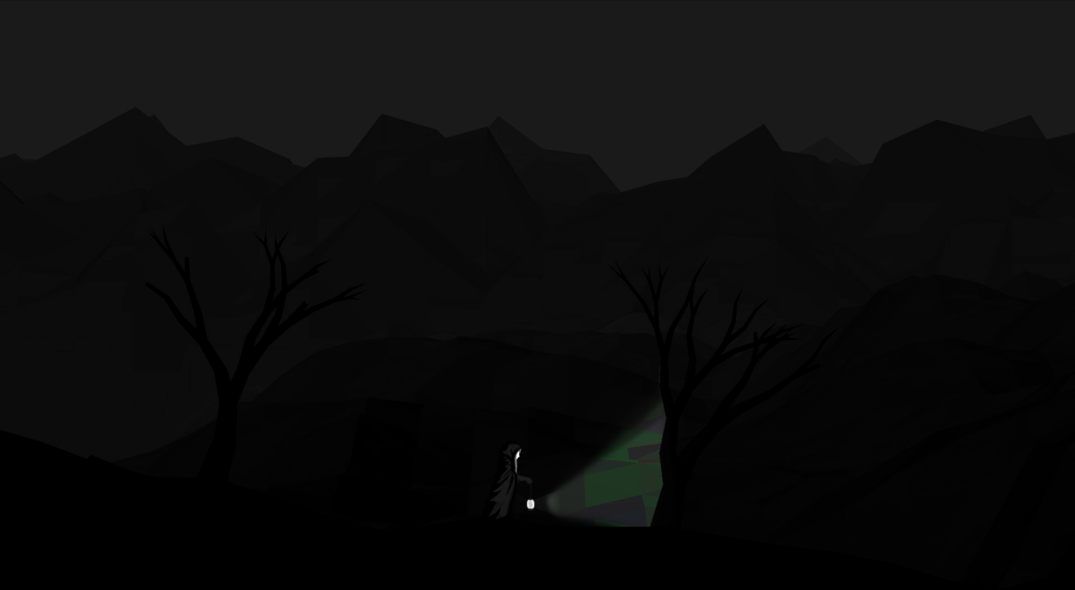

Mechanics:

1.) Flashlight/Lantern:

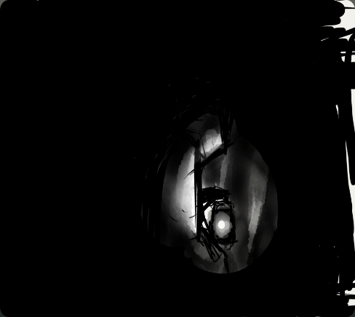 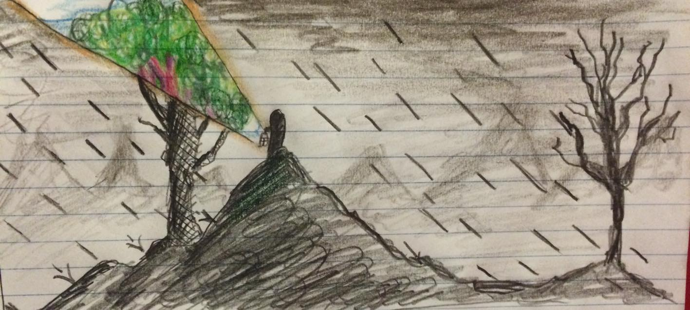

- Can counteract the direction of rain, creating an umbrella-like effect **(shown above right)**

- Used to walk through debris and over holes, creating a bridge-like effect

- Reveals hidden pathways

- Will lose fuel naturally and from the environment (getting rained on) creating a smaller light angle & can be refilled at bonfires

- If the lantern goes out, the player dies and must restart at the nearest bonfire **(shown above left)**

2.) World Switching:  
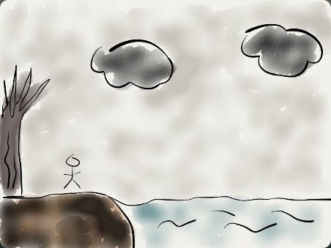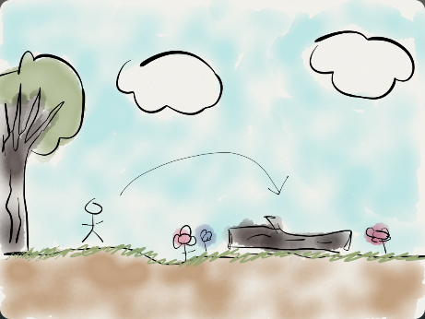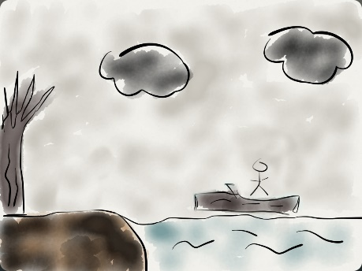

- Timed, brief burst of time in the light world

- Uses flashlight/lantern to interact with objects in one world and bring them back to the next

**Music:**

The music will change depending on the environment you are in. The dull environment would have sad/gloomy music whereas the happy environment would some more cheerful and hopeful. There will be two compositions based on the same musical melodies. The structure will remain the same but the tonality and elements would change once the player switches environments.   
  
The basic frame of the song would be the same. But new elements would be added depending on the environment you are in. The timbre of the music will change drastically. The user of filters and real-time equalization will make the song fade to a dull sounding vibe. Throughout the game the music is going to be somewhat dynamic and will be complemented with recorded nature samples.

The sound effects would be musical in nature and would complement the music being played in the background.

Ending:

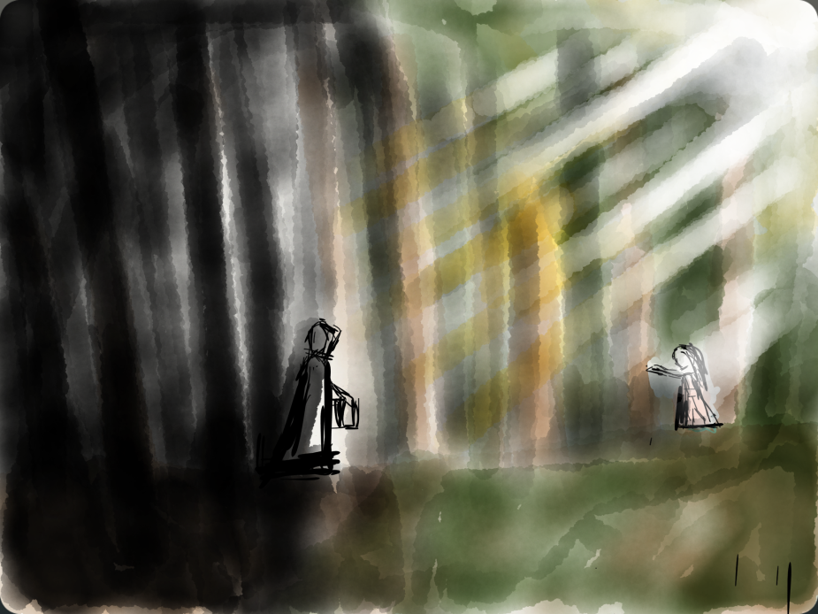

Coming Soon



**© 2015**[**Team Yarbus**](http://www.teamyarbus.com/)**| All Rights Reserved.**