Strategy-

The purpose of my site is to be a website for my baseball team. One page will have roster another will have schedule etc. The goal will be to inform the user about our team and when and where they can see our games. I also want to show the stats for the team.

My goals for this project-

1. Create a well organized easy to use website.
2. Create a website that is informative and helpful to the user.
3. Learn and understand more about databases within websites.

User Personas-



Name: Don

Age: 45

Gender: Male

Description: Don is a coach who check the website often to keep up to date on the schedule and review player’s performances.

Goals:

1. Review player’s performances.
2. Find out where and when the next game is.
3. See how are performance has been so far and what are W/L record is.



Name: Joe

Age: 23

Gender: Male

Description: Joe is a player on the team who want to check how he is doing on the website and see what’s next.

Goals:

1. Find his stats.
2. Find time and location of next game.
3. Check the team’s record



Name: Helen

Age: 32

Gender: Female

Description: Helen is the mother of one of the player’s on the team. She always likes going to her son’s games and tries to get to all of them.

Goals:

1. Figure out where the next game is.
2. Find when the next game is.
3. Find who her son’s team is playing.

Scope-

Requirements-

1. Have a schedule of the team’s games with who they play, where, and when.
2. Have a page with the stats of the players so far.
3. Show the team’s record for the year.
4. Create database for all the players on the team.
5. Create page where you can edit that database.
6. Database for the roster of the team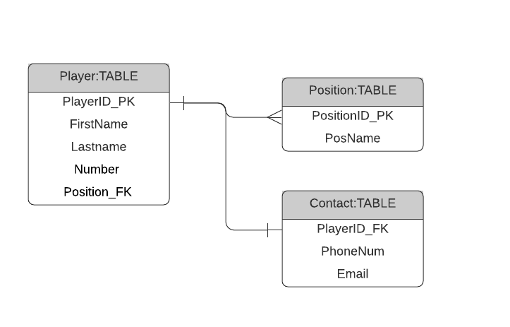

Structure- I will have the home page with the team’s name at the top and below the roster of all the players. At the top above the roster but below the team name will be our record this will be where our main navigation for site is. Next to Record will be the word Edit Roster which will take the user to a page to add/change/delete players from the roster database. Next to the Roster will be the word Schedule when you click on it takes the user to another page that is the schedule for the team with all of the previous games and their outcome. You will be able to click on a player from the roster and it will show only that player’s stats. Next to Schedule there will be the word Stats that takes you to the stats page with the whole team’s stats. I organized it this way because the information and navigation is easy to understand.

Home Page

Edit Roster

Schedule

Stats

Wire Frame-

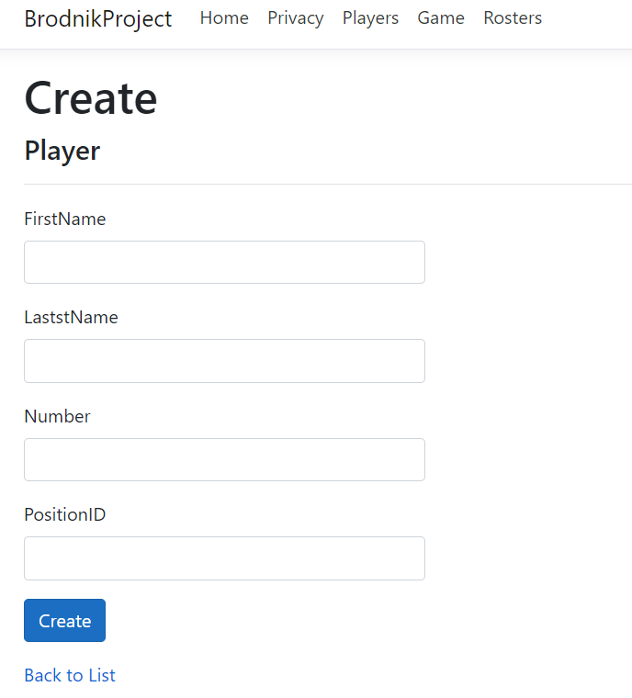

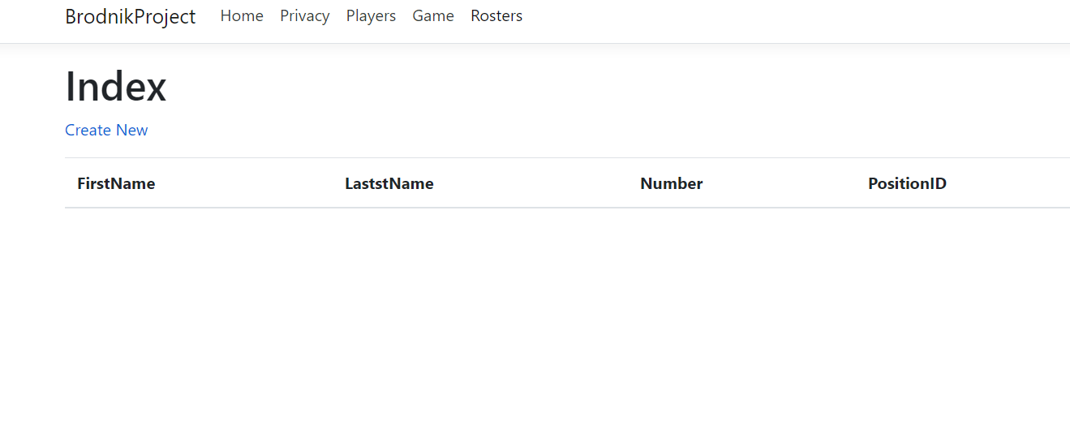

Prototype- Included in folder.