# Directions

1. You will complete 6 of the following projects. If you do more than 6, I will grade your best 6.
2. Submit screenshots of working code in this document.
3. Also zip and submit your project folders to Blackboard.
4. Be sure that everything is clearly marked.

# Clarifications

Except for the GUI 1 and GUI 2 the projects can be built using either a console or a JFrame – whichever you prefer

# Choose six projects

Choose six projects that you know that you can complete. Some are easier than others.

## Class

Create a class to store information about a car. Store the make, model, year, mileage, and price. Create setters, getters, toString, and at least two constructors.

Create a main that instantiates a few cars and displays them.

## Inherit

Inherit from the provided Product class. Add the date acquired and the number of days until bad. Override the toString, and constructors. Add appropriate setters, getters. Add the functionality to display the day the product will expire.

Create a main that instantiates a of the derived classes and displays them.

## String

Dr. Doofenshmirtz, in his undying attempt to take over the tri state area, has become a teacher at PTC. He has a very bad way to test his students. He only gives multiple choice tests. The hard part, is the student needs to input their choices as one long string. He is adamant that this is the best way to test the students.

Given this awkward setup, he gives you the answer key for his upcoming quiz.   
ADDBDCCDBABC

Create a program that allows the user to enter a string similar to the key and determine both the number of questions they got right, and display the incorrect question number(s).

Example (bolded to indicate incorrect answers)

Input -> A**B**DBDCCDBAB**B**   
10/12 correct  
Question 1 and 11 are incorrect

## Array/List

Create a program that generates 100 random numbers between 1 and 1000. Store these values in an array/list. Determine and print the following:

* Average value
* Min value
* Max value
* Standard deviation
* Mode (this is the number that appears the most often)

## Array of class

Create an array of class using the Votes class attached to the final. Use this array to solve the following problem.

Write a program that allows the user to enter the last names of five candidates in a local election and the number of votes received by each candidate. The program should then output each candidate’s name, the number of votes received, and the percentage of the total votes received by the candidate. Your program should also output the winner of the election. A sample output is – format similarly to mine

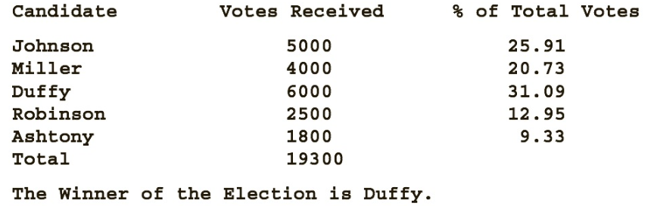

## File IO 1

Create a program that reads the file raven.txt. Count the number of times the following words appear. Note that word means just the word. This when counting ‘it’, hit and item should **not** count

Raven, nevermore, it

### MadLib Bonus

Ask the user for an animal, a girls name, and a weird word. Use these words to replace ‘raven’, ‘Lenore’, and ‘nevermore’. Then display the poem with the replacements. If you do the bonus, show me it separately from the count.

## File IO 2

Read the file cardata.csv. Create functionality that allows the user to select a car manufacturer. All cars of that manufacturer from the file are displayed on the screen.

## GUI 1

## Create a JFrame that handles one-person game play for Rock Paper Scissors Lizard Spock. Your program must be able to do the following:

## Allow the user to select the image they wish to play.

## Randomly generate a choice for the computer.

## Display an appropriate image for the computer choice.

## Compare the player's and computer choices and declare a winner, using the correct phrase.

## Scissors cuts Paper

## Paper covers Rock

## Rock crushes Lizard

## Lizard poisons Spock

## Spock smashes Scissors

## Scissors decapitates Lizard

## Lizard eats Paper

## Paper disproves Spock

## Spock vaporizes Rock

## Rock crushes Scissors

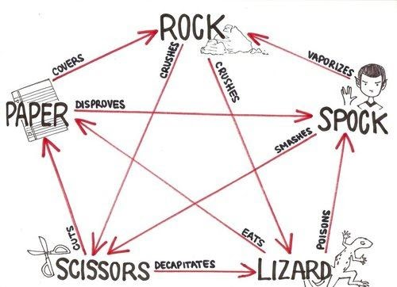

## GUI 2

Create a GUI that asks for the length, width and depth of a pool. Use spinners for the inputs. Be sure to add JLabels to describe the input and output. Display the volume of this pool in **gallons**. Assuming the cost of water is 1.50 per 1000 gallons of water, display the cost to fill the pool.