User Manual for the North Mountain Cougar Habitat Suitability Analysis Program

1. To run the North Mountain Cougar Habitat Suitability Analysis Program, you must first open QGIS version 3.38.2-Grenoble.
2. Using the Browser tool on the left side of the application, navigate to where you have stored your forestry dataset is saved, click and drag it into the Layers tab to load the data into QGIS.

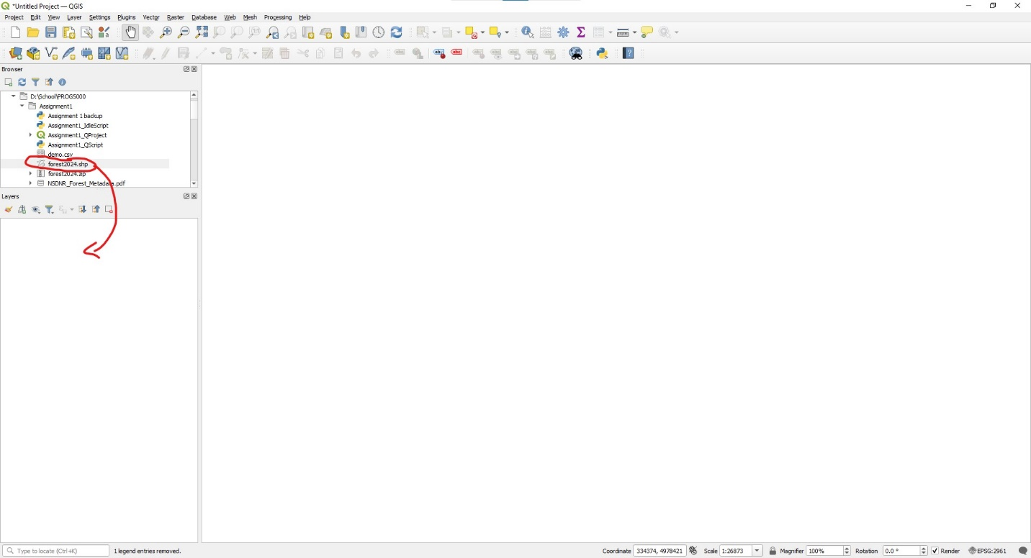

Figure : Loading forestry layer into QGIS.

1. Open the Python console from the Plugins menu of the toolbar or by pressing Ctrl + Alt + P and open the editor from the ribbon.
   1. 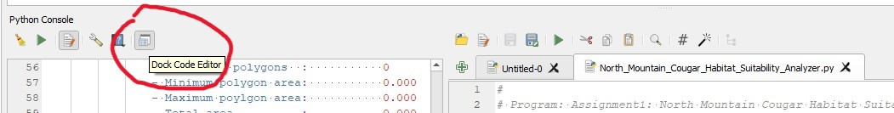To make the console easier to work with, undock the console and expand the window.

Figure : Undocking the Python Console

1. Open the program with “Load Script…” on the lefthand side of the Editor ribbon.

Figure : Opening the Suitability Analysis script.

1. 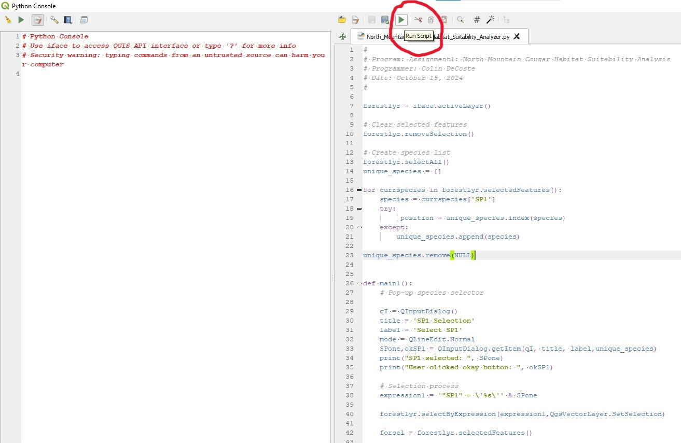Once the script has been loaded, click “Run Script” in the Editor ribbon to start the program.

Figure : Running the program from the Python Console.

1. A screenshot of a computer

   Description automatically generatedRunning the script opens a pop-up window “SP1 Selection”. Forestry stands are classified by a species code for the dominant species of tree in the stand.

Figure : Dominant Species selection

* 1. A screenshot of a computer

     Description automatically generatedA screenshot of a computer

     Description automatically generatedSelect the species for which you would like a report on habitat suitability and click OK. Below is a list of codes and their corresponding tree species.

Figure : Legend for tree species codes.

1. The program’s output will appear in the Python Console.
   1. The total number of polygons is broken down into three levels of habitat suitability with five descriptive properties.
      1. Suitability is based on tree diameter, tree height, and cover type.
      2. A screenshot of a computer

         Description automatically generatedAreas are measured in m2.

Figure : Output from the North Mountain Cougar Habitat Suitability Analysis Program

1. A screenshot of a computer program

   Description automatically generatedAfter the program has been run, you will be prompted to run the program again, if so desired. To stop the program, select “No” from the dropdown menu, or click “Cancel.”

Figure : Rerun the program or exit.