Colin Donahoe
CBB Analytics
August 2026

College Basketball In-Game Win Probability Model
A nonlinear parametric win probability model for NCAA men's basketball

1. Introduction
Few things in sports are as captivating - or as devastating for the losing side - as a historic collapse. This past June the Knicks erased a 29 point lead to win game 4 of the NBA Finals, 28-3 from the 2018 Super Bowl still haunts Falcons fans, and in 2022 Kansas came back from a 16 point deficit in the National Championship game. These incredible comebacks beg the question, “What are the odds?”. I was keen on answering this question as the goal of this project: to build an accurate, reliable in-game win probability model for College Basketball
CBB Analytics produces in-game win probabilities for NCAA men's basketball, most visibly as the live probability that powers bracket predictions during March Madness. This write-up documents a new nonlinear parametric win probability model built to replace the hand-tuned coefficients of the current production model (referred to throughout as the “Bracket model”).
The goal of the project was to take the same functional form the Bracket model already uses — a logistic function of current lead, time remaining, and pregame team strength — and fit its coefficients directly to historical possession-level data rather than setting them by hand. The result is a model that is simpler to reason about (four fitted coefficients instead of eight hand-tuned, time-varying ones) and, as shown in Section 4, better calibrated.
What this document covers: the data and feature engineering pipeline (Section 2), the model formulation and training procedure (Section 3), a head-to-head evaluation against the current production model (Section 4), derived “model insight” metrics for comebacks and probability swings (Section 5), two worked example games (Section 6), and known limitations and next steps (Section 7).

2. Data

2.1 Sources
The model is trained on possession-level play-by-play data joined with team efficiency ratings computed as of each game date. Three raw tables feed the pipeline:
- possessions.csv — one row per possession, with the possessing team, opponent, score, period, and seconds remaining in the period.
- teams.csv — team identifiers, market/name, and branding (used for chart logos and colors).
- teams_date_stats.csv — each team's adjusted offensive rating (ortg), defensive rating (drtg), net rating (netRtg), and pace as of a given game date.

2.2 Feature Engineering (data_prep.py)
Raw possessions are joined to each team's pregame efficiency ratings and to team metadata for both the possessing team and its opponent. Possessions from a team's first game of the season are dropped, since no prior-date rating exists to join against.
Every possession is then re-oriented around the pregame favorite (the team with the higher net rating at that point in the season) rather than the home or possessing team, so the model always predicts the favorite's win probability. Most of the raw possession columns are not in the required format to enter the model, so the following manipulations were made:
- score -> lead — parse the score at the end of possession and subtract the underdog's score from favorite’s score.
- poss — 1 if the favorite currently has the ball, 0 otherwise.
- spread — favorite's net rating minus underdog's net rating (a proxy for the pregame point spread).
- Seconds into game -> time_rem — minutes remaining in game, rounded to two decimal places. Divides seconds in game by 60, subtracts from 40. If in overtime, add five minutes multiplied by overtime number to time remaining.
- result — 1 if the favorite ultimately won the game, 0 otherwise (the training label).
Games are split 80/20 into train and test sets by game_id (not by possession), using a fixed random seed, so every possession from a given game stays entirely on one side of the split. This avoids leaking a game's outcome across the train/test boundary.

2.3 Dataset Size
Split | Possessions | Notes
Train | 435,928 | 3,149 games used to fit the four model coefficients (Section 3.2)
Test | 108,722 | 788 held-out games, used for all evaluation in Section 4

3. Model Formulation
Intuitively, there are three factors in a basketball game which are primary predictors in dictating the outcome: the lead, strength of the team pregame, and the time remaining (Possession as well, which can be added to the lead term). Also intuitively, the former two’s weight are inversely related, and both depend on the latter. Early in the game, the perceived strength difference between the two teams matters most. But as the time remaining diminishes, the lead becomes exponentially more important. For example, if a major underdog has a 4 point lead 3 minutes into the game, the favorite is still highly likely to win. Whereas a 4 point lead for the underdog with 30 seconds remaining translates to a very high win probability.
Of course, there are innumerable other causal features that dictate the outcome of a game. Features such as momentum, coaching adjustments, foul troubles, injuries, and many more play their part in crowning the eventual winner. However these factors are, in most contexts, negligible and difficult to quantify for practical model use. Therefore, I confined the model to four inputs: lead, adjusted spread, possession constant, and time.
The spread term is based on each team’s net rating at the time, and adjusted for pace. Base Net rating spread is calculated per 100 possessions, so the adjusted spread is the average pace of each team multiplied by net rating spread/100. The possession feature is also slightly adjusted. In most models, it is a simple .5 or 1 constant added or subtracted to the lead. Although its impact is slight, I made the model’s possession feature relative to the possessing team’s offensive rating and defending team’s defensive rating. So, the possession feature adds/subtracts the estimated points per possession for each team.
Because both lead and spread are non-linearly dependent on time remaining, the model is split into two terms, each with an exponential denominator of time, each decaying at its own rate as time runs off the clock. The output, z, then becomes the input to the sigmoid function, which is confined to be between 0 and 1, just as probabilities.
z = X₁ · (Lead ± poss) / t^Y¹ + X₂ · (t/40) · adj_spread / t^Y²
P(favorite wins) = 1 / (1 + e⁻ᶻ)
t is minutes remaining, floored just above zero to avoid dividing by zero at the final buzzer. The two terms play different roles:
- Lead term — the favorite's current point lead, nudged by a small possession-value adjustment (a normalized blend of the two teams' offensive/defensive ratings) reflecting who currently has the ball. Dividing by t^Y¹ makes this term grow sharply as time runs out, so a given lead matters far more with two minutes left than with thirty.
- Spread term — the pregame strength differential (net rating spread, scaled by the two teams' average pace), multiplied by t/40 so its influence fades over the course of the game, and further shaped by t^Y² so it becomes nearly irrelevant once the outcome is being decided possession-by-possession late in the game.

The Trained Model
The new model keeps the same four coefficients (X₁, X₂, Y¹, Y²) fixed for the entire game, and fits them directly by minimizing log loss on the training set with SciPy's optimizer. The fitted values are:
Coefficient | Fitted Value | Role
X₁ | 0.4129 | Weight on the lead term
X₂ | 2.0822 | Weight on the pregame spread term
Y¹ | 0.3445 | Time-decay exponent for the lead term
Y² | 0.7163 | Time-decay exponent for the spread term
Training log loss at convergence: 0.3705.
A third, static-coefficient variant (compute_live_win_prob, an earlier first-pass version of the model) also exists in the codebase but is superseded by the trained model above; it is retained for reference but is not part of the evaluation in Section 4.

4. Evaluation
The trained model and the production Bracket model are evaluated on the same 108,722 held-out test possessions (788 games) using four metrics: Brier score and log loss (both reward well-calibrated, confident predictions and penalize confident mistakes), and calibration MAE / RMSE (the average and root-mean-square gap, across 20 probability bins, between predicted and actual favorite win rates).
Metric | Bracket Model (production) | Trained Model | Change
Brier Score | 0.1190 | 0.1168 | ↓ 1.9%
Log Loss | 0.3685 | 0.3596 | ↓ 2.4%
Calibration MAE | 0.0437 | 0.0107 | ↓ 75.5%
Calibration RMSE | 0.0534 | 0.0133 | ↓ 75.1%
The trained model improves on every metric, and the gap is largest on the calibration metrics: its predicted probabilities track actual outcomes roughly four times more closely than the Bracket model's do. The two reliability curves below make this visible directly — the Bracket model's curve bows noticeably off the diagonal through the middle of the probability range, while the trained model's curve tracks the diagonal closely across nearly the entire range.

4.1 Calibration Curves
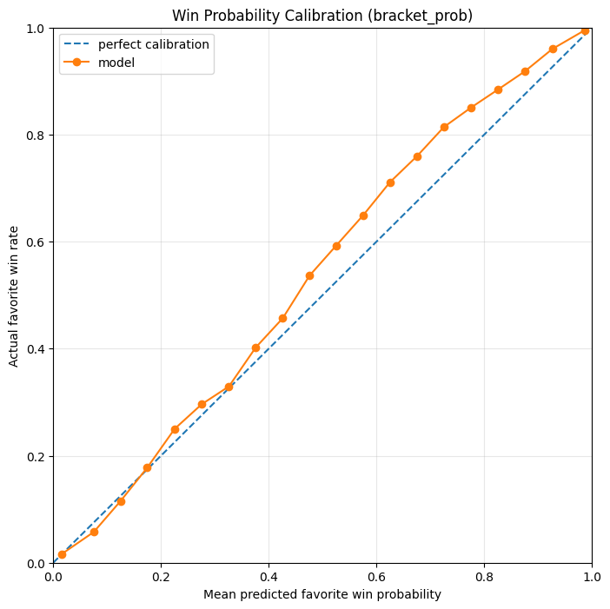
Figure 1a. Bracket model calibration — predicted vs. actual favorite win rate, 20 bins.
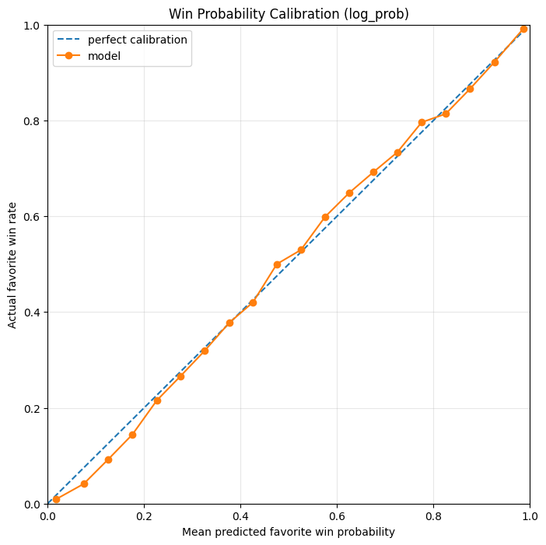
Figure 1b. Trained model calibration — predicted vs. actual favorite win rate, 20 bins.

4.2 Calibration by Predicted Probability (Trained Model)
Binning every test possession by the trained model's predicted probability shows how much of the test set falls at the extremes — roughly 30% of all possessions carry a predicted probability above 0.95. This makes sense since every probability is calculated for the favorite, and most of a game's possessions occur well after the outcome is largely decided. Even so, the model stays close to perfectly calibrated (green cells) in nearly every bucket, including the low-volume, high-uncertainty middle of the distribution.
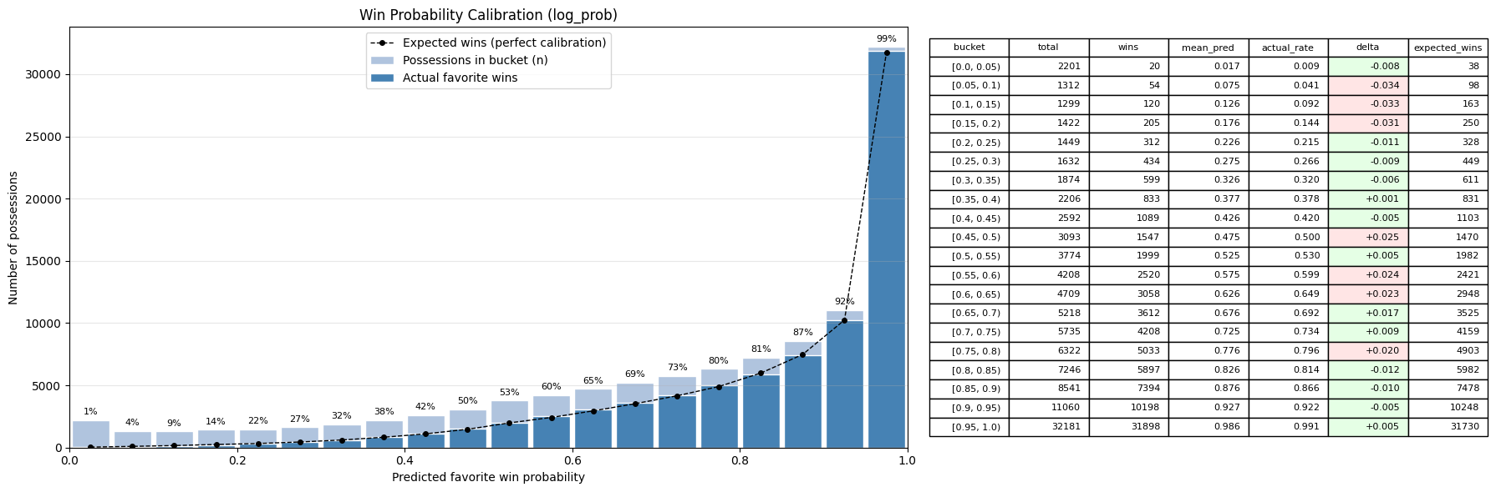
Figure 2. Trained-model calibration bucketed by predicted win probability, with per-bucket counts and calibration error.

4.3 Calibration by Time Remaining
Bucketing by time remaining instead of predicted probability tests whether the model is equally well calibrated early and late in games. Deltas stay within about one percentage point across almost the entire clock, including the final seconds of regulation.
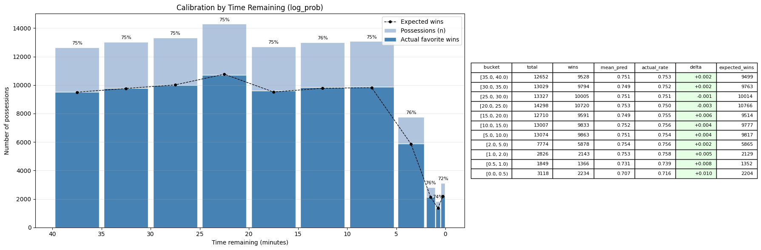
Figure 3. Trained-model calibration bucketed by time remaining, all test games.

Restricting to close games — possessions where the lead is within 4 points — is a tougher test, since these are exactly the situations where a model is most likely to either over- or under-react to a small lead. Calibration deltas grow slightly in this subset (up to about +2.7 points in the final 30 seconds) but stay small relative to the overall spread of outcomes.
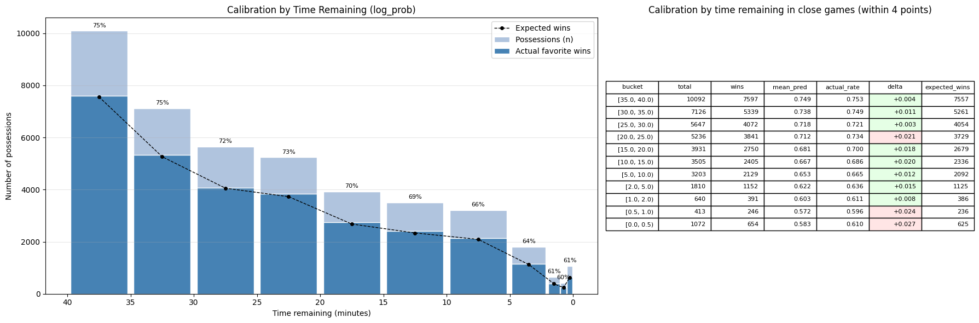
Figure 4. Trained-model calibration bucketed by time remaining, restricted to possessions within a 4-point game.

5. Model Insights: Comebacks & Swings
Beyond raw calibration, the trained model's possession-by-possession probabilities support two derived “moment finder” metrics used for game recaps and narrative content:
- Comebacks — for each game, the possession where the eventual winner's win probability was at its lowest point. A very low value means that team survived a serious threat before winning.
- Swings — for each game, the single possession-to-possession change in win probability with the largest magnitude — the game's biggest “momentum” moment.

5.1 Biggest Comebacks in the Test Set
Team | Opponent | Score | Time Rem. | Lowest Win Prob.
Belmont | Southern Ill. | 64–55 | 2:44 | 2.5%
SIUE | Little Rock | 50–34 | 16:56 | 2.0%
St. John's (NY) | Baylor | 98–93 | 0:19 | 2.0%
Boston College | Central Conn. St. | 39–28 | 17:23 | 1.9%
Saint Peter's | Rider | 70–59 | 6:11 | 1.9%
UNC Greensboro | Mercer | 44–21 | 25:01 | 1.8%
Wichita St. | Charlotte | 59–41 | 14:16 | 1.6%
Bucknell | Lehigh | 49–29 | 11:02 | 1.6%
Columbia | Princeton | 57–38 | 7:46 | 1.4%
South Alabama | Arkansas St. | 79–83 (loss) | 0:06 | 0.9%
Score/time shown are the game state at the eventual winner's lowest win-probability moment. South Alabama's is the most extreme case in the table: the model gave the eventual winner under a 1% chance with six seconds left, immediately before the deciding play.

5.2 Biggest Single-Possession Swings in the Test Set
Team | Opponent | Score at Swing | Time Rem. | WP Swing
St. John's (NY) | Baylor | 98–99 | 0:00 | 97.0%
Belmont | Southern Ill. | 67–68 | 0:00 | 90.6%
Tulane | New Orleans | 79–79 | 0:01 | 88.2%
St. Thomas (MN) | North Dakota | 66–67 | 0:00 | 85.4%
UMBC | Morgan St. | 81–79 | 0:02 | 82.0%
Syracuse | Boston College | 67–67 | 0:01 | 81.9%
UT Martin | Little Rock | 65–67 | 0:00 | 81.7%
Utah St. | Boise St. | 81–79 | 0:07 | 81.5%
Florida | Iowa | 72–73 | 0:05 | 81.0%
Wake Forest | Boston College | 67–68 | 0:01 | 79.8%
Nearly all of the largest swings occur in the closing seconds of games decided by one or two possessions — exactly where a single make or miss should carry the most win-probability weight, and a useful check that the model's late-game sensitivity is behaving as intended.

6. Example Games
The two charts below apply the trained model's win probabilities across an entire game, with comeback and swing moments annotated, using the win_prob_chart utility.

6.1 Saint Joseph's def. Rhode Island, 91–74 (March 5, 2025)
Saint Joseph's led for most of the first half, dipped narrowly below 50% around the ten-minute mark (bottoming out at 37.7% with the Hawks down 19–28), then pulled ahead for good just before halftime on a 17.1-point swing and steadily extended the lead through the second half.
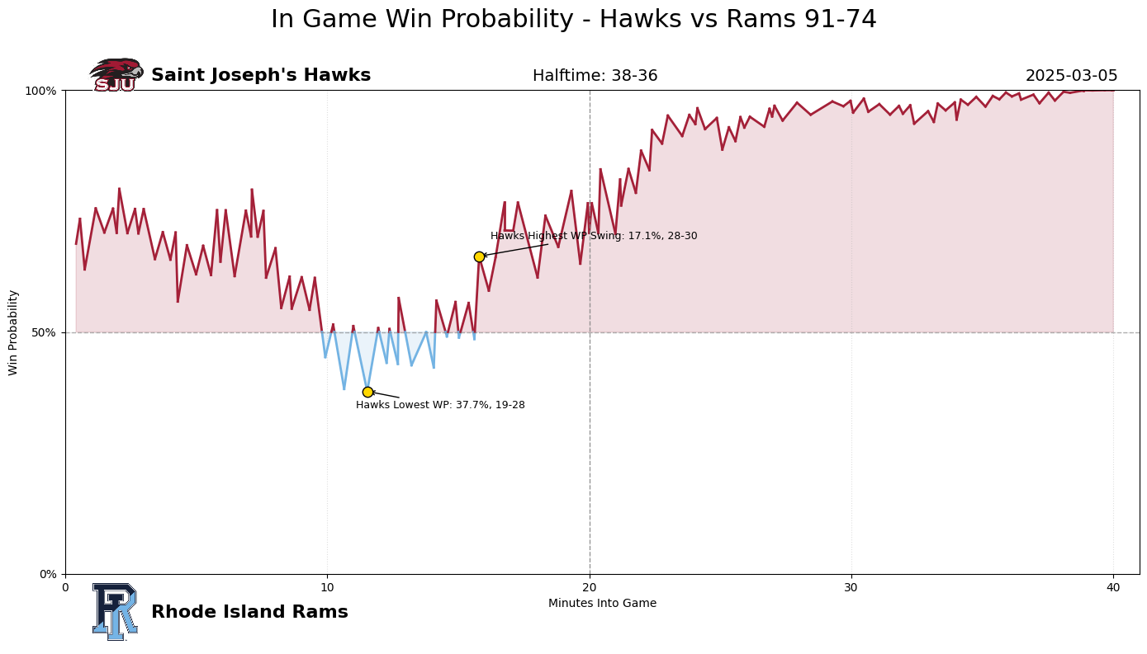
Figure 5. In-game win probability, Saint Joseph's Hawks vs. Rhode Island Rams.

6.2 Creighton def. DePaul, 85–81 in OT
A more dramatic example: DePaul controlled most of the second half, pushing Creighton's win probability down to a low of 3.6% while trailing 51–62. A 68.8-point swing tied the game late in regulation, sending it to overtime, where Creighton pulled away for the win — illustrating how quickly the model reacts once a trailing team's comeback attempt starts to land.
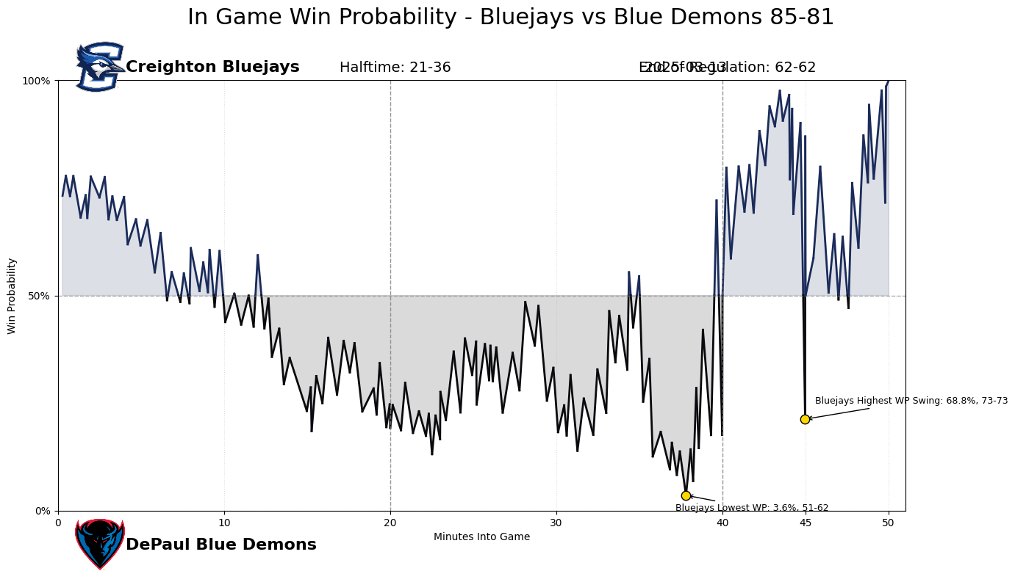
Figure 6. In-game win probability, Creighton Bluejays vs. DePaul Blue Demons (OT).

7. Limitations

7.1 Limitations
- Features are limited to score, time, possession, and pregame ratings; the model has no awareness of foul trouble, free-throw situations, timeouts, injuries, or lineup changes, all of which a human viewer would factor into an in-game probability.
- The pregame spread is derived from adjusted net ratings at the time of the game. Early in the season, these net ratings can be highly skewed as they are based on a small sample of games.
- Evaluation metrics are aggregated across the full test set; performance has not yet been broken out by team strength, conference, or game type (e.g., non-conference vs. tournament), which matters most for the tournament bracket use case.

7.

