Colin Hawkins

Module 1.2 Assignment

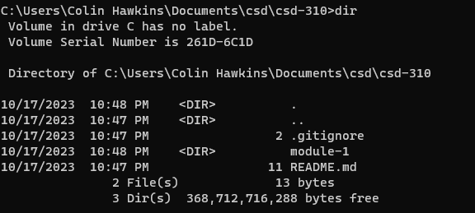

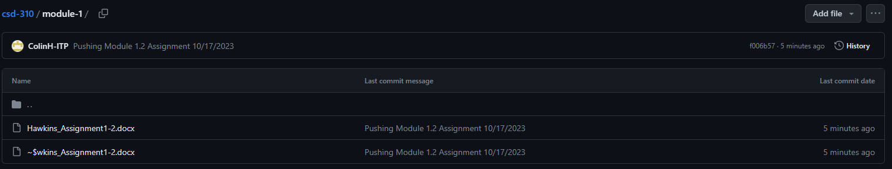

<https://github.com/ColinH-ITP/csd-310/tree/main>