Colin Hawkins

Database Development and Use

Assignment 5.2

November 11, 2023

The first function I chose is GREATEST(). This function is used to return the greatest value from a list of numerical data. This probably can return the greatest value in a column of numerical data as well. One alias you could use for the result is ‘Maximum’, which would be helpful if you are applying this value in a calculation, as using appropriate variable names is important to keep track of your data.

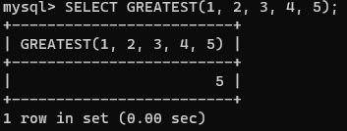

The second function I chose for this assignment is CHAR_LENGTH. There are many times you would need to find the length of a string, especially if you are working on formatting a set of data, or if you have length requirements for a user password. You could simply use ‘Length’ as an alias here.

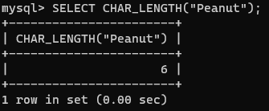

Finally, I chose LOWER as my third function. Converting strings to all lowercase makes it much easier to search through strings for a specific value, because you will not have to worry about whether or not the user entered capital letters and lowercase letters. You can simply search without needing things to be case sensitive. You could use this command to create a new column with all the formatted strings, and use the alias ‘Lowercase’ to describe this column.

