Colin Hawkins

Database Development and Use

Assignment 6.2

November 19, 2023

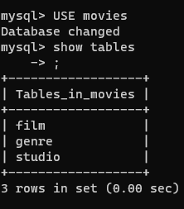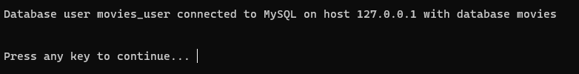

Github repository: <https://github.com/ColinH-ITP/csd-310>