Link to GitHub Repository: https://github.com/ColinH-ITP/csd-340

Initial Validation:

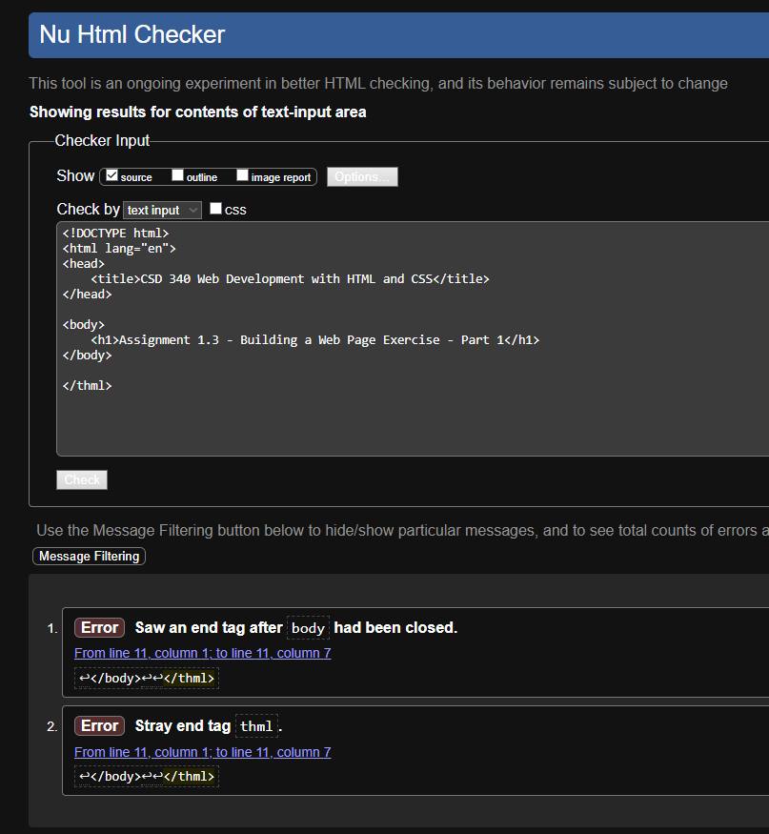

After Debugging:

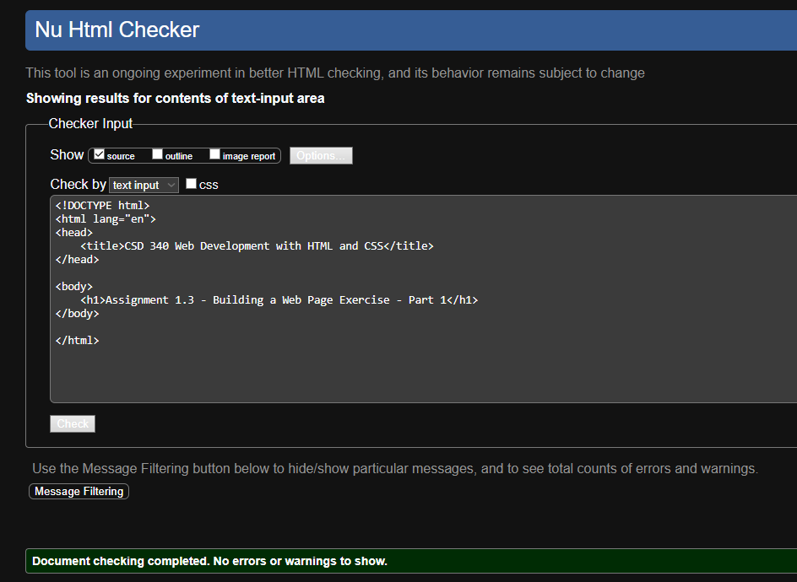

In-Browser:

