**CSC 160 - Semester Project – PasswordVault**

Create a password vault using the supplied UML Diagram.

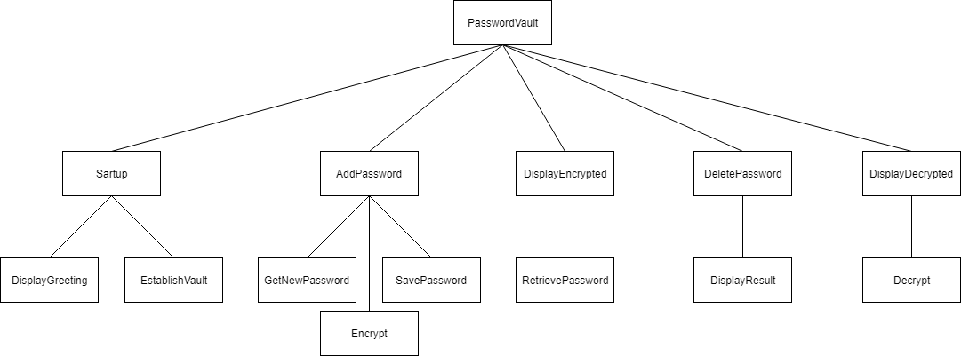

Your code must follow the UML diagram (this helps prevent simply copying a solution from the web).

Your code will hold the password vault in memory using a two dimensional array (size 20x3).

Your code should allow for displaying current password(s) in either encrypted or decrypted form inserting new passwords, updating passwords, and deleting passwords.

Each password entry should allow for three fields: Name of what the password goes to (i.e.- Gmail, School login, Discord, Instagram, etc.), the Username, and the Password. You may set limits on the length of these fields.

Your password vault should allow for 20 password entries.

Use a Ceaser cypher for your encryption scheme.