# Robot lab1

**11610310 卢宁**

1.

1. **Uniform**

V = c

1. **Perpendicular**

V = k[B, -A] (wall is on the line Ax+By+C = 0)

1. **Attractive**

V = 0 if x^2 + y^2 < r^2 or x^2+y^2>R^2

V = -k(x,y) if r^2 < x^2 + y^2 < R^2

1. **Repulse**

The formula is same with attractive feild but the direction is opposite

1. **Tangential**

V = k(-y,x)

2.

Uniform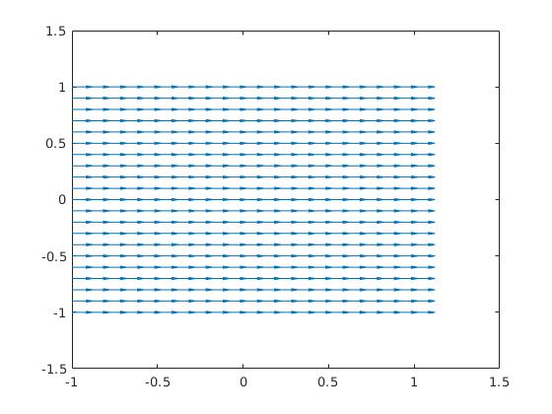

**Perpendicular**

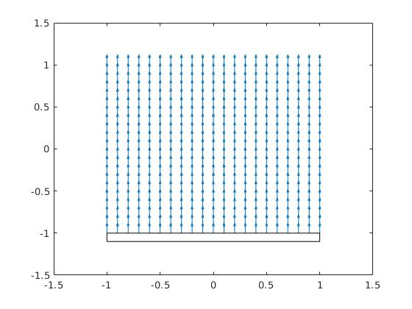

**Attractive**

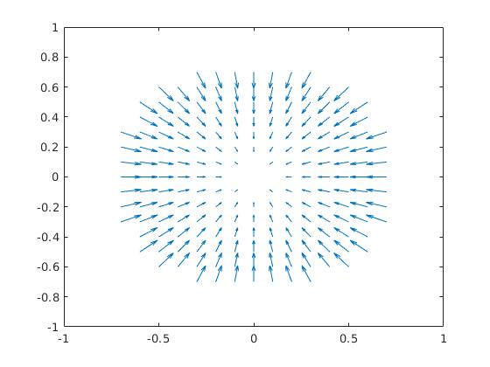

**Repulse**

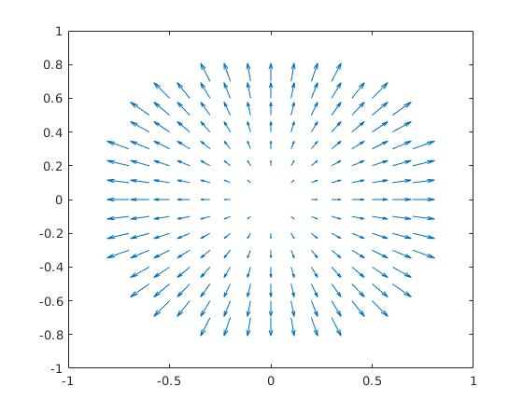

**Tangential**

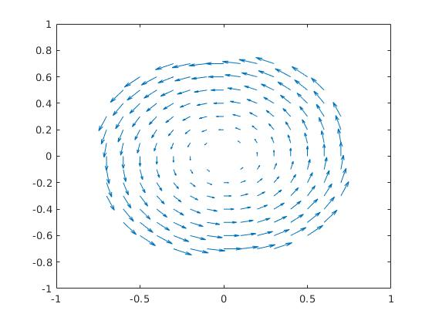

3.

**Uniform**

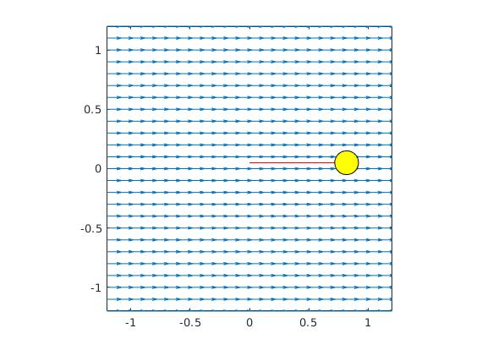

**Perpendicular**

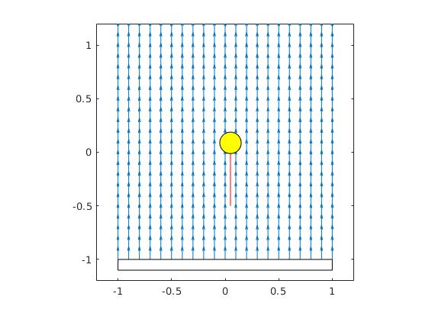

**Attractive**

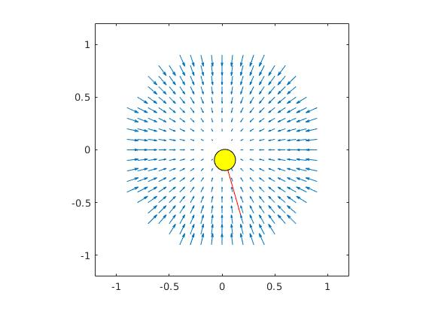

**Repulse**

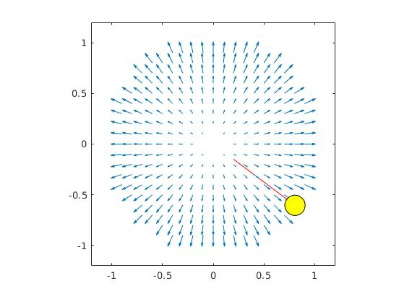

**Tangential**

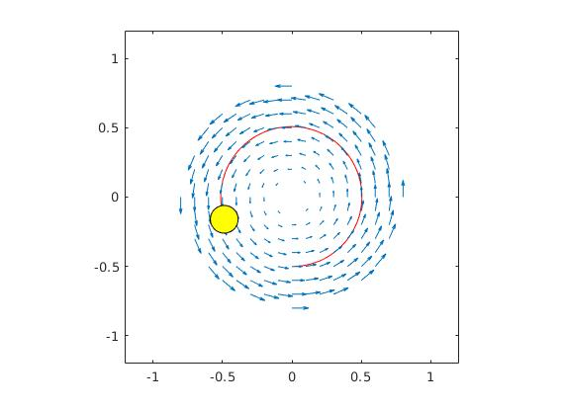

##### Extra

I use a potential field method to solve the problem.

Basic Idea:

The goal generates attractive field and the walls generate repulse field.

If the robot stop , it will only run towards the goal and with a slight influence on the perpendicular direction for a short time.

If the robot collides with the wall, it will run towards the opposite direction for a short time.

In both cases, the stop/collision point will generate a repulse field.

The generated repulse field formula:

V(P) = k * (1 / (P - Pg) - 1 / R) * (1 / (P - Pg))^2 if ||P - Pg|| < R

Else V(P) = 0

Where P is current position, Pg is the goal position, R is repulse radius.

Here is the simulation graph.

